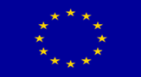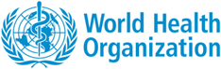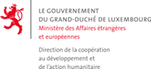

EU-Luxembourg-WHO Universal Health Coverage Partnership:

Supporting policy dialogue on national health polices, strategies and plans and universal health coverage

YEAR 4 REPORT - 2015

Table of Contents

Abbreviations 3
Executive Summary 5
Background and Introduction 8
Specific objectives and expected results 9
SO I. To support the development and implementation of robust national health policies, strategies and plans to increase coverage with essential health services, financial risk protection and health equity; 9
SO II. To improve technical and institutional capacities, knowledge and information for health systems and services adaptation and related policy dialogue; 9
UHC Partnership results and impact 18
Visibility and Communication 20
Overall achievements 21
Lessons learnt 23
Demonstrating Results 24
Principal challenges 25
Conclusion and Way Forward 25

Abbreviations

AFRO/IST – World Health Organization Africa Regional Office/Inter-country Support Team
CHPP – Country Health Policy Process
CNAM – Caisse national de l’Assurance Maladie
CoIA – Commission on Information and Accountability for Women’s and Children’s Health
CSO – Civil Society Organization
DP – Development Partners
DPS – Division Provincial de la Santé (République démocratique du Congo)
DRC – Democratic Republic of Congo
ER – Expected Results
EU – European Union
EVD – Ebola Virus Disease
HF – Health Financing
HMIS – Health Management Information System
HIS – Health Information System
HPG – Health Partnership Group
HQ – Headquarters
HRH – Human Resources for Health
HSS – Health System Strengthening
IHP+ -- International Health Partnership
JA(H)R – Joint Annual (Health) Review
JANS – Joint Assessment of National Strategies
Lao PDR - Lao People's Democratic Republic
LMIC – Low and Middle Income Countries
M&E – Monitoring and Evaluation
MoH – Ministry of Health
MOHSW – Ministry of Health and Social Welfare
MTEF - Medium-Term Expenditure Framework
NCD – Non Communicable Diseases
(I)NGO – (International) Non-Governmental Organization
NHA – National Health Accounts
NHDP – National Health development Plan
NHEF - National Health Equity Fund
NHPSP – National Health Policies –Strategies - Plans
NHSSP—National Health Sector Strategic Plan
NHSWPP – National Health and Social Welfare Policy and Plan
PHC – Primary Health Care
PNDS – Plan National du Développement Sanitaire
PNS – Politique Nationale Sanitaire
PRODESS - Five-Year Health and Social Sector Development Plan
PSM – Politique Sanitaire en Mouvement
P4H – Partners for Health
RMNCAH – Reproductive, Maternal, Newborn, Child, and Adolescent Health
RO – Regional Office
SO – Specific Objective
SARA - Service Availability and Readiness Assessment
SDG – Sustainable Development Goals
TA – Technical Assistant
UC – Universal Coverage
UHC – Universal Health Coverage
UHC-P – European Union – Luxembourg – WHO Partnership for Universal Health Coverage
UN – United Nations
UNAIDS – Joint United Nations Programme on HIV/AIDS UNDP – United Nations Development Programme
UNFPA – United Nations Population Fund
UNICEF – United Nations Children’s Fund
WCO – World Health Organization Country Office
WHO – World Health Organization
WR – World Health Organization Representative

Executive Summary

Since the inception of the European Union (EU) - World Health Organization (WHO) collaborative agreement in 2011, which initially provided support for seven priority countries to build capacities for policy dialogue on national health policies strategies and plans (NHPSP), the Partnership has expanded considerably. In 2013, Luxembourg entered into the Partnership, and now supports six countries. The EU supports fourteen, making a total at the end of 2015 of twenty countries from five WHO Regions. The expansion is not only geographic but also in terms of scope of activities, with additional emphasis on health financing policies, development effectiveness in line with International Health Partnership (IHP+) principles, and Universal Health Coverage (UHC).
The UHC Partnership, as it is now known, has achieved significant progress in strengthening countries’ capacity for the development, implementation, monitoring and evaluation of comprehensive NHPSP, and is entering Phase III (2016-2018) with increased resources and commitment from all stakeholders.
This report covers the activities and achievements of the first twenty partner countries during 2015. Individual country activities are determined during the inception phase, outlined in annual country Road Maps, and linked to three global Specific Objectives and six Expected Results (see page 6).

Cross-cutting achievements
Expected Result | Achievement | Countries
SO I
ER1: NHPSP through an inclusive policy dialogue | Inclusive and participatory policy and strategic plan development | South Sudan, Togo, Chad, Cabo Verde, Guinea, Liberia, Sierra Leone, Senegal, Tunisia, Moldova, Sudan, Niger (12)
 | Strengthened subnational planning capacity | Togo, DRC, Liberia, Sierra Leone, Timor Leste (5)
 | Evidence-based planning (resource mapping, comprehensive health situation analysis) | Liberia, Guinea, Mali, South Sudan (4)
Inputs from UHC-P | Capacity building, tools, technical support, catalytic funding
ER2: Expertise, M&E systems, annual health sector reviews | Strengthening MOH’s institutional M&E capacity | Mali, Chad, Sierra Leone, Togo, Timor-Leste, Tunisia, Guinea (7)
 | Strengthening participatory review mechanisms - JAR, NHPSP evaluation | Burkina Faso, DRC, Guinea, Mali, Senegal, Timor-Leste, Togo, Cabo Verde, Vietnam, Moldova, Sudan (11)
 | Generation of evidence to inform decision making (SARA) | DRC, Niger, Togo, Yemen (4)
Inputs from UHC-P | Capacity building, tools, technical support, catalytic funding

SO II
ER3: Financing strategies and systems to move more rapidly towards universal health coverage | Evidence-based dialogue has been supported by the UHC-P, leading to concrete actions being taken to address identified challenges:  - evidence informed development of the Health Financing Stragegy; ‘Sin’ tax introduced to support UHC - Togo  - improving financial access to medicines - Moldova | DRC, Moldova, Mozambique, Vietnam, Togo, Tunisia, Sudan (7)
 | Strengthening financial management (health sector pool fund) | Liberia (1)
Inputs from UHC-P | Capacity building, generation of evidence, technical support
ER4: Financing reforms | - review of national laws: law on public health  - estimation of catastrophic expenditures  - policy briefs to disseminate experiences on what works, and what doesn’t for UHC | DRC, Moldova, Vietnam (3)  Global
Inputs from UHC-P | Capacity building, catalytic funding, technical support
ER5: Evidence on what works, and what does not work | Generation of evidence:  - National Health Accounts  - innovative health financing mechanisms  - state of health financing  - health technology assessment | Burkina Faso, Chad, DRC, Mali, Mozambique, Sudan, Togo, Tunisia (8)
 | Capacity building in health financing | Mozambique, Moldova, Yemen (3)
Inputs from UHC-P | Capacity building, catalytic funding, technical support
SO III
ER6: Alignment and harmonization | MOH restructuring to improve coordination capacity | Sierra Leone, Liberia, Niger (3)
 | Ensuring sustained dialogue:  - subnational level (Chad, DRC, South Sudan, Sudan) | All countries
Inputs from UHC-P | Capacity building, generation of evidence, technical support

Lessons Learnt
Following experiences in the UHC Partnership countries over the past four years, a few fundamental lessons have been learnt, including:
- Policy dialogue must be grounded within the national context, and there is a need to be flexible and adapt the programme to prevailing circumstances - for instance, in the Ebola-affected countries, or during the humanitarian crisis in South Sudan and Yemen
- Political changes can threaten the continuity of the programme, and lead to reluctance to make significant changes or reforms - for instance in Tunisia
- Policy dialogue needs dedicated champions, it is not a self-driven mechanism. It is also important to identify all stakeholders, both intersectoral and at national and provincial levels
- Policy dialogue is a process that requires continuous advocacy and building of synergies between stakeholders, under a committed, high level political leadership.
Future Orientations
Countries are increasingly appreciating the benefits offered by health policy dialogue, and understanding what it entails. Sustained dialogue and inclusive participation are resulting in consensual policies and strategies, commitment to implementation, and improved alignment and accountability between partners.
As the UHC Partnership moves into Phase III (2016-2018), the focus will be on:
- Consolidation of the gains made to date, in terms of functionality of coordination structures, and improving the quality of dialogue
- Broadening membership to include new partner countries, including Kyrgyz Republic, Lesotho, Republic of the Congo. A number of small island states have also expressed interest.
- Embracing the global health agenda, and the objectives set out in the 2015 Sustainable Development Goals, including the global health security agenda and the International Health Regulations (IHR)
- Increased attention to HRH and RMNCAH
- Provision of more full-time technical advisors in countries that request this support
- The external evaluation of the first three years of the Partnership.

Background and Introduction

In 2011, the European Union (EU) and the World Health Organization (WHO) entered into a collaborative agreement to support priority countries, and build capacities for policy dialogue on national health policies, strategies and plans (NHPSP), health financing policies, and Universal Health Coverage (UHC), starting in seven countries. Luxembourg entered the Partnership in 2013. This Partnership, now referred to as the UHC Partnership, aims at building capacity in low and middle-income countries for the development, negotiation, implementation, monitoring and evaluation of realistic, comprehensive national health policies, strategies and plans, which can serve as a foundation for the implementation of UHC and are in line with IHP+ principles of development effectiveness.
The Partnership now includes twenty-seven countries from five out of six WHO Regions. The EU-supported countries were introduced into the Partnership in successive phases starting from 2011 to date:
Phase 1: Moldova, Liberia, Sierra Leone, Sudan, Togo, Tunisia, Vietnam
Phase 2: Chad, Democratic Republic of Congo (DRC), Guinea, Mozambique, South Sudan, Timor-Leste, Yemen
Phase 3: Burundi, Guinea Bissau, Morocco, South Africa, Tajikistan, Ukraine, Zambia

The countries supported by Luxembourg are: Burkina Faso, Cabo Verde, Lao PDR, Mali, Niger, Senegal.
Phase III of the UHC Partnership (2016-2018) is now underway, with increased resources and commitment from all stakeholders. The innovative nature of the Partnership meets the expectations of many donors and countries as the development agenda evolves and new models for supporting countries are being sought. Moreover, there is interest to join from several countries who can see the clear benefits of the type of support provided.
Goal 3.8 : Achieve universal health coverage (UHC), including financial risk protection, access to quality essential health care services, and access to safe, effective, quality and affordable essential medicines and vaccines for all
The launch in 2015 of the Sustainable Development Goals (SDGs), replacing the Millennium Development Goals, has given further impetus to the work of the Partnership, since health and UHC are at the heart of the SDGs.

This report covers the calendar year 2015, which represents Year 4 of the Partnership for the Phase 1 EU-funded countries, Year 3 for the Phase 2 EU-funded countries and Luxembourg-funded countries (except Lao PDR which joined in August 2015) - a total of 20 countries. After four years on the ground, the UHC Partnership brought a significant contribution to strengthening countries’ capacity in the development and implementation of NHPSPs that have the potential to improve health outcomes for populations, and achieve UHC.

Specific objectives and expected results

The 2015 activities undertaken in each of the 20 countries were determined during the inception phase and outlined in the annual country Road Maps. These activities are listed generically in the WHO-EU Action Fiche and in the WHO-Luxembourg agreement, and are linked to 6 main estimated results, and 3 specific objectives which are the target of this report. For illustrative purposes, we highlight a few country examples where the specific objectives and expected results have been achieved - but these examples are by no means exhaustive, and more details can be found in the individual country reports .

Table 1
Specific objectives (SO) | Expected Results (ER)
SO I. To support the development and implementation of robust national health policies, strategies and plans to increase coverage with essential health services, financial risk protection and health equity; | ER 1. Countries will have prepared/developed/updated/adapted their NHPSP through an inclusive policy dialogue process leading to better coverage with essential health services, financial risk protection and health equity;  ER 2. Countries will have put in place expertise, monitoring and evaluation systems and annual health sector reviews.
SO II. To improve technical and institutional capacities, knowledge and information for health systems and services adaptation and related policy dialogue; | ER 3. Countries requesting health financing (HF) support will have modified their financing strategies and systems to move more rapidly towards universal health coverage (UHC), with a particular focus on the poor and vulnerable:  ER 4. Countries receiving HF support will have implemented financing reforms to facilitate UHC;  ER 5. Accurate, up-to-date evidence on what works and what does not work regarding health financing reforms for universal coverage is available and shared across countries.
SO III. To ensure international and national stakeholders are increasingly aligned around NHPSP and adhere to other aid effectiveness principles. | ER 6. At country level, alignment and harmonization of health aid according to national health plans is consolidated and accelerated.

Expected Result 1:
Countries will have prepared/developed/updated/adapted their NHPSP through an inclusive policy dialogue process leading to better coverage with essential health services, financial risk protection and health equity.

The NHPSP development and implementation has been strengthened through different mechanisms including inclusive and participatory policy and strategic plan development, strengthened subnational capacity for planning, and evidence based planning.

(i) Inclusive and participatory policy and strategic plan development: The UHC Partnership has technically and financially supported the institutionalisation of key dialogue fora that have enabled stakeholder participation. In South Sudan for example, the institutionalised platform involving Ministry of Finance, Ministry of Health and development partners has been instrumental in negotiating health sector allocations. The support of WHO through participation and provision of relevant evidence has facilitated an informed debate. Given the conflict in South Sudan, engaging communities in planning is a challenge, but through the UHC Partnership routinely conducted consultative meetings at the subnational level, where community views are sought, has addressed this challenge.
“All stakeholders and partners from all levels of the national health system (Government, National Assembly, community associations, civil society, faith-based organizations, private sector, technical and financial partners and beneficiary associations) were involved in this process to renew Togo’s health policy and strategic and action framework” Senior MoH official, Togo
In Togo, stakeholders attest to strengthened, inclusive planning and performance assessment as a result of the UHC Partnership, support which ensures a participatory process in the development of operational plans, institutionalizing performance monitoring, development of the Country Health Policy Process (CHPP/PSM) platform for strategic analysis and sectoral dialogue, and initiation of dialogue at the level of the prefectures (districts). In addition, the National Health Forum has made it possible to involve stakeholders from the different tiers of the health system in exploring options to strengthen the health system - seen as a best practice by stakeholders.

The UHC Partnership has also supported development and costing of strategic plans through providing catalytic funding for stakeholder consultations, and provision of technical assistance through in-country HSS experts, HQ and AFRO WHO staff. Chad developed, with the additional support of P4H, an implementation plan for the national Universal Health Coverage (UHC) strategy; Cabo Verde developed a HRH strategy while Guinea, Liberia and Sierra Leone developed post- Ebola Virus Disease outbreak health sector recovery and resilience plans. Community health policy and strategic plans were developed in Liberia and Chad. South Sudan and Senegal developed Strategic Plans, and specific to Senegal is stakeholders’ appreciation of the inclusiveness of the UHC Partnership.
“The initial plans were very technical, and were often developed by sector technocrats with very little involvement of other sectors, such as the civil society. Development of these plans looked, more or less, like an intellectual exercise rather than translation of policy commitments and strategies for action of committed players. The current strategy is a complete departure from these initial plans, with its development involving all departments of the Ministry of Health and Social Action, including those in health districts and health regions, private sector, civil society, NGOs, technical and financial partners, and other related ministerial departments.” Senior MoH official, Senegal

In Sierra Leone, the Basic Package of Essential Health Services was updated as part of the development of the Health Sector Recovery Plan. Furthermore, in order to ascertain the true picture of the health workforce - numbers, geographical distribution and skills level - a head count of all health workers in the country was undertaken, and the data used to populate the Human Resource Information System. The findings will inform future health workforce priorities, and the development of an updated HRH policy and plan.

In Tunisia, a change of government did not affect the Ministry of Health’s mandate to continue the ‘societal dialogue’ which ensures citizens’ engagement , with a focus on four priority areas: NCDs, Primary Health Care, Mental Health, and RMNCAH. Following elections and finalization of the White Book for health reforms, a multi-stakeholder technical committee was appointed by the Minister of Health, with participants from civil society, unions, citizen’s jury, and the administration. The committee’s mandate is to continue the “societal dialogue for health” through thematic dialogues such as PHC reforms, and to support development of the new five-year plan.

In Moldova, as a result of the policy dialogue with the health sector and the annual National Health Forums, the Ministry of Health has updated the National Strategy for Health Sector Development to include actions related to hospital sector strengthening, improving essential health services coverage, and specifically access to medicines in a country where medicines account for the largest share of out-of-pocket payments. In 2015, following technical assistance through the UHC Partnership and a National Health Forum, Parliament passed a law on gradual mark-up for medicines sold in bulk and retail - enabling increased protection for households from financial risk and catastrophic health spending.

In Timor-Leste, the Ministry of Health (MoH) with WHO’s support developed the Primary Healthcare Programme Guidelines. WHO also facilitated the translation of the document into the national language, Tetun. In addition, guidelines for Domiciliary Visits, Domiciliary Visit Register, Village Health Register were also developed and translated. WHO also supported the finalisation of the e-Health strategy, National Laboratory Strategic Plan and the drafting of the National Mental Health Strategic Plan.

(ii) Strengthened subnational capacity for planning: Health sector strategies are implemented through operational plans at the different levels of the health system. The weak planning capacity at the subnational levels has been an issue of concern the UHC Partnership continues to address. Capacity has been strengthened through different approaches; technical, human resource, financial and logistical support was provided to district health management teams in Sierra Leone.
In Liberia, WHO was instrumental in the development of comprehensive and evidence- based bottom-up post-Ebola operational plans at the national and subnational level through provision of technical support, and the funding of critical planning processes.

In DRC, the setting up of 25 Provincial Health Divisions (DPS) has continued in 2015, and technical support provided for staff training and the provision of coaches for 12 of the DPS, whose mandate is to help the DPS become operational and able to provide effective support to the health zones.
In Timor Leste, WHO supported the development of training in planning and budgeting for MoH officials at central and district level, including for newly recruited planning officers.

(iii) Evidence-based planning: The UHC Partnership has supported countries to undertake activities towards informed planning, for example Liberia conducts resource mapping annually results of which inform planning and resource allocation. Guinea conducted a stakeholder mapping to understand which partner does what and where, while a comprehensive health situation analysis was undertaken in South Sudan to inform development of the strategic plan.

Expected Result 2: Countries will have put in place expertise, monitoring and evaluation systems and annual health sector reviews.

The UHC Partnership has supported strengthening of monitoring and evaluation (M&E) of NHPSP in several ways including: strengthening MoH’s institutional capacity for M&E, strengthening participatory review mechanisms and generation of evidence to inform decision making.

(i) Strengthening MoH’s institutional capacity for M&E: The UHC Partnership has technically and financially supported activities to strengthen MoH’s capacity to coordinate M&E for NHPSP. The partnership supported development of M&E plans in Mali and Chad which are guiding health sector performance assessments. The UHC Partnership has supported institutionalisation of structures to coordinate M&E activities. In Sierra Leone, an M&E technical working group was put in place. In Togo, WHO supported the design, implementation and development of guidelines for data collection systems (DHIS 2) and data bases (EPI-INFO) at the district level. In Timor-Leste, WHO provided technical support to the MoH to finalise the National M&E Strategic Plan 2016-2018, as well as the Community-based Monitoring Guidelines, and M&E capacity building for MoH staff from central and district level is ongoing. In Mali, a PRODESS monitoring committee is in place and functional, chaired by the ministers of health, social development and promotion of women, children and the family, with a representative of the technical and financial partners as vice-chair, and a representative of civil society. Also in Mali, M&E structures were put in place at the national, regional and district level and supported to function. A training on stakeholder dialogue in Bamako for senior representatives from the three ministries involved in the implementation of PRODESS, was viewed by participants as highly relevant to the health reform process:
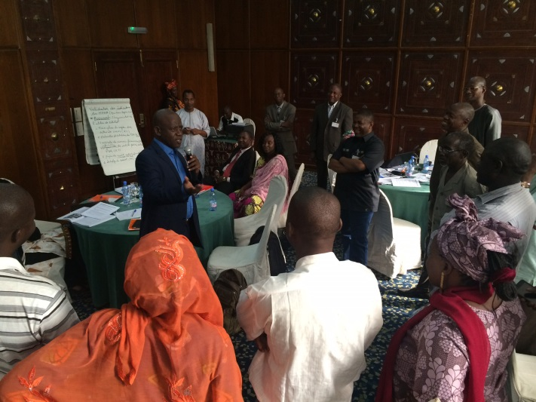
(ii) Strengthening participatory review mechanisms: Annual health sector performance assessments have been supported in Burkina Faso, Guinea, Mali, Senegal, Timor Leste and Togo through WHO technical support to compile review reports and participation in joint annual reviews. Results of these reviews have informed planning and resource allocation for the subsequent year. Evaluation of strategic plans has been undertaken in Cabo Verde, DRC, Senegal and Togo with WHO’s technical support. Although subnational reviews need to feed into overall sector reviews, capacity at decentralised level has been weak.
In Vietnam, the Joint Annual Health Review (JAHR) was conducted using the process that was defined in 2014. Development partners were involved for the first time in the initial drafting of the document and in the early prioritization exercise. It has served as a mechanism for monitoring and evaluating the implementation of the 5-year NHSP (2011-2015), as well as primary health care delivered through Vietnam’s grassroots health network. It also provided the situation analysis for the new 5-year NHSP and set directions for the Grassroots Health Reform Plan.
The WHO country office in Vietnam has reformed its approach to health systems strengthening, moving away from the six building blocks towards a systems design framework. This framework is guiding WHO’s support to the Government to build a resilient, responsive and transformative health system that can deliver health services equitably, address the social determinants of health and raise the participation and capacity of communities to contribute to their own positive health outcomes.
Facilitation of group work during training on stakeholder dialogue, Bamako, Mali, November 2015 (Photo : Collective Leadership Institute)

“Applying the acquired knowledge in practice will allow for maximizing results, because it is very important for the success of our interventions. Often we find it hard to explain why our initiatives fail, even if sometimes all that is needed to achieve a result is to engage in a constructive dialogue between stakeholders” (workshop participant, Mali)
Specifically, WHO’s approach involves supporting the Government of Vietnam to:
1) strengthen inputs and processes that will ensure a well-functioning health system (health financing, human resources for health, essential medicines and medical products, and health information).
2) redesign the health system towards resilience, by strengthening central oversight and national regulatory systems; re-aligning the distribution, reach and coverage of services/service providers to ensure equitable access to health services, particularly in hard-to-reach areas; and improving referral systems by creating service delivery networks and reinforcing vertical and horizontal linkages and coordination of health service delivery.
3) build a responsive health system to meet the changing needs of Vietnam as a middle-income country faced with growing inequities in health, the rising burden of NCDs and the ageing of the population.
4) establish the concept of a transformative health system as a mechanism for improving the health of communities, including by building the communities’ capacity to adopt health interventions and contribute to positive health outcomes.
In Moldova, for the third year in a row, four sub-national policy dialogues were held to discuss health sector reforms, bringing together representatives of local providers, public authorities and the national health insurance company to discuss hospital sector reform, health care financing and efficiency of hospitals, strengthening of primary care, and development of rehabilitation services. These local dialogues, led by the Ministry of Health, were held before the National Health Forum, to debate at local level about existing evidence and reforms planned at central level. This approach has resulted in improved consensus between stakeholders, and will contribute to the successful implementation of the planned nationwide reforms.
In Timor-Leste, WHO organized and facilitated the “Joint Health Annual Health Sector review” which involved all partners of MOH – over 200 participants. During 2015 WHO also provided support in report finalization, translation and dissemination to all health development partners. In addition, WHO provided active technical support to the preparation and co-facilitation of the MOH Semesterial Review of workplan implementation, including supporting data analysis and presentations delivered during the meeting. For the first time, the MOH invited Development Partners to present to the MOH their work that supports the MOH programmes. The final report of the Semesterial review, including the recommendations by the Health Vice-Minister chairing the meeting, were widely circulated and shared by WHO to all partners.
(iii) Generation of evidence to inform decision making: In view of the institutionalised policy dialogue mechanisms, availability of evidence presents an opportunity for an informed dialogue. The UHC Partnership has technically and financially supported undertaking of service availability and readiness assessment (SARA) in Guinea, DRC and Niger results of which have informed comprehensive review of sector performance as well as planning.
In Timor Leste, the partnership supported strengthening of the Health Management Information System (HMIS), including customization of DHIS2 and translation of the user manual and software into Tetun. Qualitative and quantitative data analysis training for HMIS staff from national and district level, as well as M&E staff from programmes and the Ministry, is ongoing.

Expected Result 3: Countries requesting health financing (HF) support will have modified their financing strategies and systems to move more rapidly towards universal coverage (UC), with a particular focus on the poor and vulnerable.

Evidence based dialogue has been supported by the UHC Partnership leading to concrete actions being taken to address identified challenges.

In Togo, in the quest to explore financing mechanisms to move towards UHC, the UHC Partnership supported a health financing dialogue based on findings of a 2014 study on a situation analysis of the health financing system. The results of the study as well as pathways for possible reforms were finalized, discussed and validated at the national workshop at the beginning of 2015. The workshop was attended by participants from the Presidency, the various ministerial departments, social partners (including representatives of the social insurance funds and of community based health insurance funds), civil society, private sector and funding partners. The proceedings of the workshop and subsequent technical consultations between the parties have led to a consensus on the future of health insurance for Togo, which will be reflected in the national health financing strategy currently in development. DR Congo is in the process of developing a health financing strategy, which should be ready for adoption by mid-2016.

In all of the three Ebola Virus Disease most affected countries (Guinea, Sierra Leone and Liberia), health financing has been highlighted as a key component of the health system recovery strategies and plans. The expertise engaged through the UHC partnership contributed to enrich the debate beyond the need for additional financial resources to rebuild health systems of the three countries, and proposed reforms in pooling and purchasing arrangements which will be crucial to sustain desired changes in service delivery. In anticipation of increasing financing to support implementation of the health system recovery and resilience plan, Liberia undertook a systematic assessment of the management and accountability mechanisms of the health sector pool fund. The main objective was to assess the readiness of the MoH to take over the management of the health sector pool fund. The assessment provided options and recommendations for efficient management to reduce overhead costs. Recommendations will be implemented gradually during the course of 2016.

In Mozambique, the UHC Partnership supported capacity building of senior MoH officials in health financing. A five-day course was attended by professionals from relevant sectors: health, economy and finance, gender, child and social welfare, labour, academia, research and civil society. Topics covered included: supply and demand of health services; basic concepts of health financing; health markets and economic evaluation; health financing and payment systems and incentives; universal health coverage; health financing models for high, low and middle income countries; innovative financing mechanisms; and the future of health financing in Mozambique. Issues around the ongoing process of developing a health financing strategy were also discussed. The course equipped MoH officials with skills in health financing which will facilitate finalization of the health financing strategy.
In Vietnam subsequent to two initial immersion missions undertaken in 2015, WHO undertook two more immersion missions and collaborated with Hanoi Medical University (HMU) on field research to assess obstacles and challenges to delivering quality and affordable services to (and uptake by) people living in hard to reach areas. This has served as further input into the health system design framework and transformative health systems policy dialogue process which is now being concretized. These missions have focused on the experience of poor and ethnic minority populations living in hard to reach areas, considering health insurance coverage, financing of health insurance and service delivery and utilization, all of which impact the country’s move towards UHC. A meeting to disseminate the findings of these missions and equity assessment, and to support provincial level planning to address the identified barriers, is planned for May 2016. Likewise, the process of developing and the production of a Health Financing Strategy was supported. A second stakeholder workshop with the Vice Minister of Health took place to discuss and review the draft version. This document outlines the remaining reform agenda after the SHI Law was amended in 2014.
In Moldova, work started in 2014 to improve access to medicines continued in 2015. This centred around pricing of medicines, centralized procurement, rational selection of medicines, communication strategies to improve rational use of drugs, and institutional strengthening of the medicines selection committee. In addition, national stakeholders were trained in pharmacoeconomics and conducting budget impact analysis for medicines, to support decision making in rational use of medicines.
“The EU-WHO program gave new impetus to WHO to strengthen its convening role by bringing the policy dialogue on Health Financing as top priority with partners and Government Institutions (Health, Planning, and Finance) and act a key/lead role in the HF task force, where it ensures information exchange and coordination” Government official, Mozambique
In Tunisia, WHO is a key technical partner in building institutional capacity for the newly established National Accreditation Agency (INASanté) whose mandates include accreditation, health technology assessment, guidelines development (patient pathways), and professional development. In addition to providing technical support and ‘coaching’, WHO advocated with the EU for INASanté and public hospitals to benefit from a major grant for ‘competitiveness of services’, (initially the project was conceived to support only private clinics and international accreditation).

In Timor-Leste, WHO has played an integral role in drafting of the Health Financing Strategy, and costing of the Reproductive Maternal Newborn Child and Adolescent Health Strategic Plan 2015-2019. It also supported the participation of MoH officials in a training course on the Economics of Health Financing & Systems in Australia.

Expected Result 4: Countries receiving HF support will have implemented financing reforms to facilitate UHC.

In DR Congo, the Partnership has supported a review of the national framework law on public health. This has resulted in the separation into two draft laws: one on public health and the second on universal health coverage, which are currently waiting to be examined by Parliament.

In Moldova, WHO provided training to a working group made up of representatives from MoH, the Health Insurance Company, National Centre of Health Management, and the National Bureau of Statistics, on the new WHO methodology for measuring catastrophic and impoverishing health expenditures. This resulted in the development of new evidence, using the national household budget survey data for 2010-2014, and a draft analysis report that will, when published, enable better targeting of health financing policies for UHC.
Expected Result 5: Accurate, up-to-date evidence on what works and what does not work regarding health financing reforms for universal coverage is available and shared across countries.

Availability of such evidence is crucial to inform development of health financing strategies that can support countries move towards attainment of UHC. Burkina Faso, Chad, Tunisia and Mali have undertaken the calculation and interpretation of national health accounts (NHA) which has informed development of health financing strategies.

In Mozambique, the UHC Partnership supported a study to analyze key trends in the Mozambican health sector, including strategic objectives for the next five years, with the view of identifying some initial innovative health financing mechanisms that could promote the attainment of current national UHC goals in Mozambique. Recommendations of this study are being discussed further at a political level and will inform ongoing development of the health financing strategy.

In Tunisia, critical analytical work took place to inform the further reform implementation with regards to improving the overall health financing architecture: a study was undertaken to review the three different filières of the Caisse Nationale de l’Assurance Maladie, and the effect of their functioning and operations on equitable access and benefit incidence, measured here as claims per CNAM member along the three filières. At the same time, this study explored the possibility of merging the AMG (Assistance Médicale Gratuite) with CNAM, at least initially from a managerial point of view.

Decision makers from Moldova participated in various study visits, workshops and high level regional events to learn best practices for ensuring access to medicines, and health financing policies that could be replicated in Moldova.
This country-level support was complemented by knowledge generation and dissemination actions at regional and global levels. One such event was the WHO-World Bank Flagship Course on UHC for francophone countries. This course brought together senior representatives from MoH, MoF, other ministries and development partners from 16 countries (the majority of which are countries of the partnership). In total, 113 participants convened in Dakar, Senegal between 20-24 April 2015. An additional day of peer-to-peer exchange discussions was also organized. The programme covered UHC fundamental concepts as well as approaches to diagnose and prioritize problems of health policy to be targeted by reforms.

The WHO Health Financing for UHC web-page was re-structured and complemented as a way to make key guiding documents as well as lessons learnt from the field more accessible to the general audience and to decision makers.

Two studies on state budget transfers to health insurance type schemes were finalized and published. The first focuses on Eastern-European high-income countries, the second one on EURO low-and middle-income countries (LMICs). The two studies provide lessons on the most conducive institutional design features of such state budget transfer mechanisms, which are meanwhile in place in around 40 LMICs across the globe, including Africa, Asia and Latin America. As several African countries are exploring the introduction of such mechanisms to expand coverage to people outside formal sector work, it is critical to identify lessons learnt for them to not repeat mistakes, e.g. in terms of reform sequencing, targeting mechanisms, pooling arrangements etc.

Expected Result 6: At country level, alignment and harmonization of health aid according to national health plans is consolidated and accelerated.
The UHC Partnership has supported countries’ efforts to improve alignment and harmonisation in a number of ways including MoH restructuring to improve coordination capacity, and ensuring sustained dialogue.
- MoH restructuring to improve coordination capacity: In Sierra Leone, with technical and financial support from WHO, a capacity assessment of the MoH Directorate of Donor/NGO Liaison office was undertaken alongside review of its organizational structure. The assessment identified what is required to ensure functionality and an improvement plan has been developed which will be implemented during the course of 2016.
In Liberia, an increase in the number of actors as well as donor funds necessitated strengthening of coordination structures. With the support of WHO, the MoH and partners undertook an assessment of existing coordination mechanisms and structures at all levels of the health system. Following this, new and comprehensive terms of reference (TOR) for each coordinating group were developed. Updating of the terms of reference and re-constitution of membership of all of the coordinating committees at all levels have resulted in a marked improvement in coordination of health activities at the different levels.
(ii) Ensuring sustained dialogue: Through the UHC Partnership, health policy dialogue fora have been put in place at the different levels of the health system in Chad, South Sudan, and Mali, and are functional, as evidenced by the regular meetings that are held. Senegal has strengthened governance at the regional level in all 14 Regions within the framework of the Compact, while Burkina Faso is strengthening management at the district level through provision of tools.
In Vietnam, the Health Partnership Group (HPG) holds quarterly meetings which are co-chaired by ministers and heads of agencies, and provide a platform for high-level dialogue on specific health sector priorities. As development cooperation is evolving in Vietnam, and many development partners are either withdrawing or planning different types of support, WHO has supported the MoH to conduct a mapping of DP/INGO support and develop an online platform which will allow for better planning and managing shifts in support, to maximize the impact of the technical and financial resources being offered to the health sector.
In Timor-Leste, WHO plays a key role in the Health Development Partners’ meetings that are held monthly. This is a forum where the WHO-EU collaboration is presented and the policies of MOH are discussed and a coordinated approach is agreed among partners.

UHC Partnership results and impact
This section presents some examples of key results and impact as a result of the UHC Partnership. Although attribution may be difficult to justify, following a chronology of processes may provide inferences as to what may be attributed to the UHC Partnership which we try to do.
In Moldova, the dialogue with Parliament and Prime Minister’s office on developing and implementing national policies to strengthen essential health services has led to approval of a law on gradual mark-up pricing of medicines sold in bulk and in pharmacies. This will lead to a reduction in the cost of medicines in a country where they account for the largest share of out-of-pocket payments, and will give households increased protection from financial risk and catastrophic health spending.

TOGO
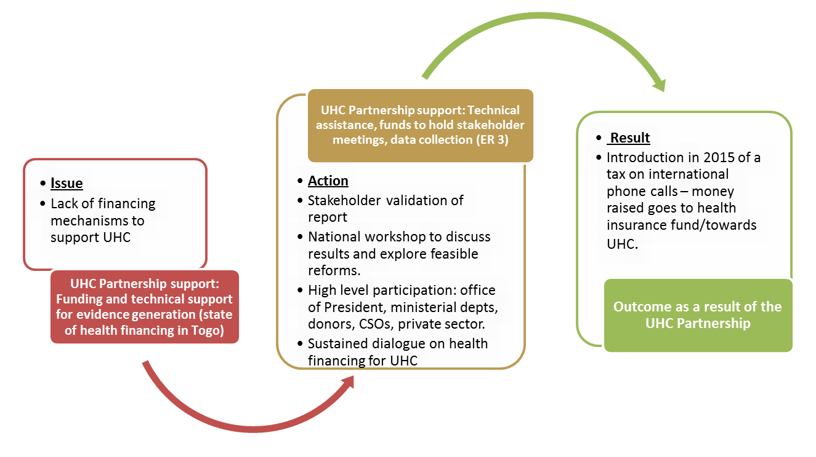
LIBERIA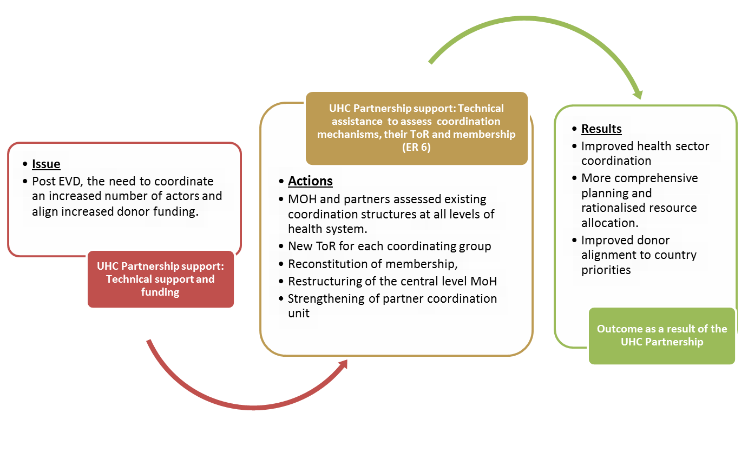
DR CONGO
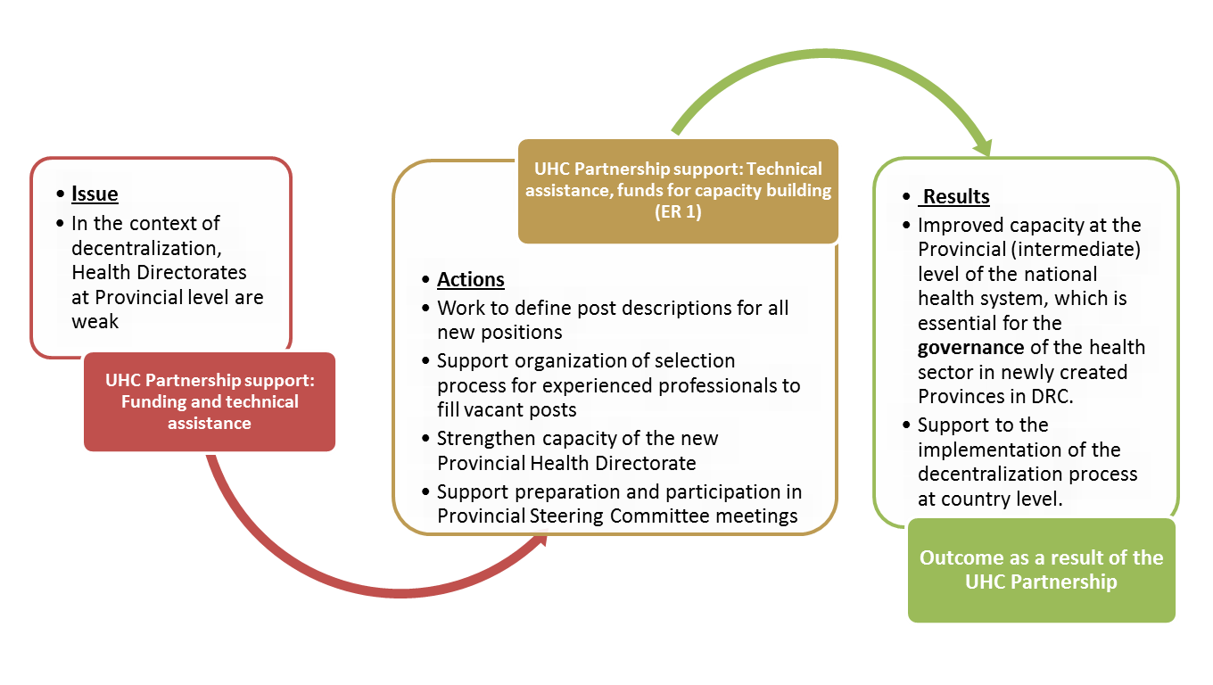

BURKINA FASO
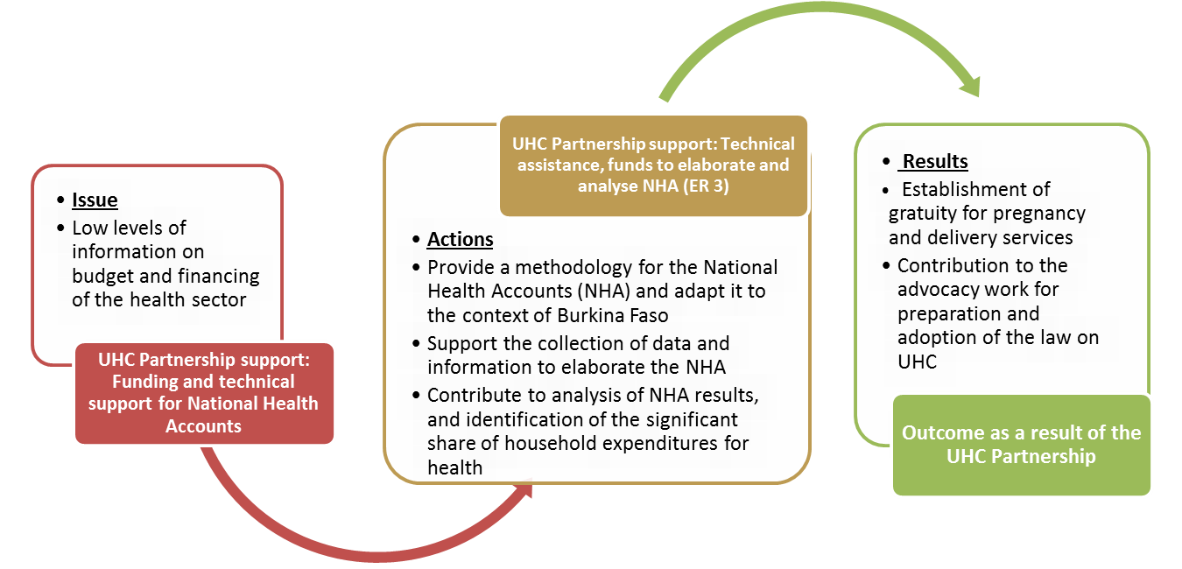

Visibility and Communication
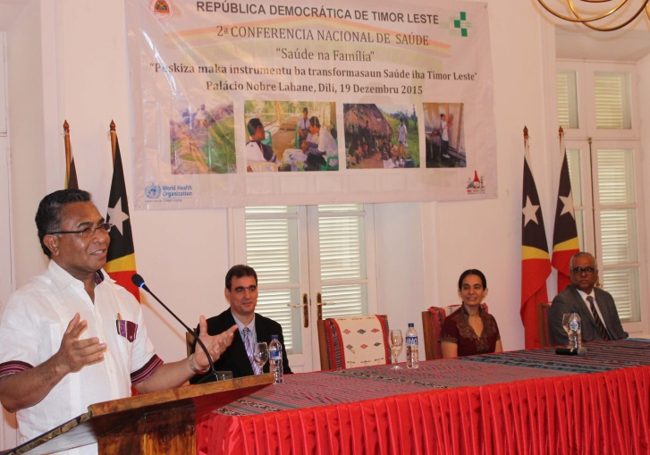
The visibility of the Partnership is an important factor for its funders, the EU and Luxembourg, as well as for WHO. The UHC Partnership website is externally managed by Community Systems Foundation (CSF), and benefits from strong Search Engine Optimization (SEO), coming up as a top result on search engines when looking for UHC. It has gone from strength to strength: in 2015 it recorded over 10,000 users. The website is the principle showcase for the Partnership, and countries are regular contributors of articles, news releases and ‘success stories’.
Many countries make extensive use of social media. Examples include Timor Leste, where a link to the Facebook page of the Cabinet of the Prime Minister of Timor-Leste showed photos of the opening of the Second National Health Conference, chaired by the Prime Minister and co-sponsored and co-organized by WHO, with UHC-P funds, on 19 December 2015: https://web.facebook.com/pm.VIgov.tl/
H.E Prime Minister, Dr Rui Maria de Araujo, Coordinator of the Cuban Medical Brigade, Dr Rolando Montero Diaz, H.E Health Minister Dr Maria do Céu Sarmento Pina da Costa and WHO Representative to Timor-Leste, Dr Rajesh Pandav

Social media posts of handing over of the EU-WHO UHC Partnership in Timor-Leste 2013-2015 (A 3-year Report) to the Health Minister, Timor-Leste, to the EU Ambassador, and presentation of the report to the EU team —were developed and put up on Facebook, a hugely popular medium of communication in the country, including the Government itself: https://mobile.facebook.com/story.php?story_fbid=1669638563293203&id=1487910191466042&_rdr

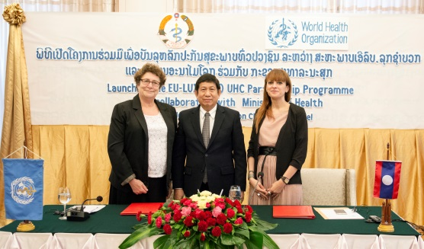
When Lao PDR became the 20th country to join the Universal Health Coverage (UHC) Partnership on 19 November 2015, and the 6th country to be supported by Luxembourg funding, a high-level launch ceremony was held in Vientiane, attended by the Minister of Public Health, HE Professor Dr. Eksavang Vongvichit, Ms Natacha Gomes from the Ministry of Foreign Affairs, Luxembourg, and Dr Juliet Fleischl, the WHO Representative in Lao PDR. The event was also widely reported in the local media.
HE Professor Dr. Eksavang Vongvichit, Minister of Public Health Lao PDR; Ms Natacha Gomes, Luxembourg; Dr Juliet Fleischl, WR Lao PDR

Advocacy
Some countries have made short films highlighting aspects of their health policy development that are supported by the UHC Partnership:
- Vietnam’s Health Partnership Group: https://www.youtube.com/watch?v=VNEFzeceGy8
- Moldova’s UHC Initiative: https://youtu.be/MB4nNVEzRqE
Advocacy documents published in 2015 include: “Policy Dialogue: what it is and how it can contribute to evidence-informed decision-making”

Overall achievements

The UHC Partnership enters its third phase in 2016, with four years’ experience of country-based work behind it. It is a complex intervention, involving multiple actors within many diverse activities in different countries, and the innovative nature of the programme has meant a certain amount of ‘learning on the job’ by those involved in the EU, WHO, Luxembourg, and in the countries. The management of the programme has improved progressively, with extra resources being assigned to grant management, strengthening management of resources allocated to countries, and the creation of a human resources roster of experts to fill the ongoing need for short and long-term technical advisors. When Lao PDR became the 20th country to join the Partnership in 2015, and the 6th country funded by Luxembourg, it took a record three months to complete all the arrangements for the technical advisor to be in place, with funds transferred, and activities prepared which were in line with the country’s priorities.
This section presents overarching key achievements of the UHC Partnership, citing a few examples.
- Enabling a dialogue in the face of health emergencies and crisis (Ebola outbreak and humanitarian crisis context)
The UHC Partnership supported mechanisms which enabled a more coordinated response to the EVD outbreak in Guinea, Liberia and Sierra Leone. In Liberia for example, the overall impact of the programme has been noticeable . While the planned activities in 2015 had to be modified and redirected to address the Ebola crisis, several activities as dictated by the original roadmap were achieved prior to the Ebola outbreak. This led to success during the recovery phase in consolidating county operational plans at the national and county levels, capacity building in data collection and analysis, and strengthening MoH leadership.

In Guinea, WHO along with other partners have used the UHC Partnership-supported mechanisms to convene stakeholders to agree on and align themselves with the country’s health priorities in the face of the Ebola crisis. Noteworthy is the development of the Recovery Plan and Resilient Health System Plan (2015-2017), as well as the establishment of mechanisms to ensure effective implementation of the National Monitoring and Evaluation Plan (PNDS). In South Sudan, improved inclusiveness of stakeholders in health dialogue is being realized despite the crisis. There is better participation of actors principally at the subnational level, which is key to implementation of plans.
- Improved alignment achieved through the UHC Partnership in several countries
Improved participation and inclusiveness through UHC Partnership-supported mechanisms has led to more consensual policy decisions. Commitment has materialized through participation and effective involvement of stakeholders in the development of national health policy and strategic plans.
“It is the development of the compact that allowed all stakeholders to join in the country's national policy. Policy dialogue has enabled the Ministry of Health to ensure good governance and to understand the contribution of partners in improving the living conditions of populations”
Senior MoH official, Togo
Cabo Verde, Chad, Liberia, Senegal and Togo have arguably shown much improved coordination resulting in improved alignment with sector strategies, more streamlined joint work plans, as well as a more collaborative effort in implementation of these plans. In Senegal, the signing of the Health Compact by most technical and financial partners, as well as the Ministry of Finance and Economy, and the consensual NHDP 2009-2018, drawn up in an inclusive manner using a bottom-up approach, are cited as the most illustrative outcomes of UHC Partnership. As a result, increasingly, alignment and harmonisation are being realised.
(iii) Improved evidence-based decision making
“We have the NHDP and its implementation instruments (all strategic plans and other programs) and this serves as a basis for alignment and harmonization. The COMPACT, which is a unique framework for planning and budgeting, is already signed between the state, the ministry of finance and health partners” Head of Regional health directorate, Dakar, Senegal

The UHC Partnership has built a momentum for the development of evidence-informed policies and strategies with potential to improve service delivery and realize better health outcomes. The Partnership has supported strengthening of MoHs’ institutional capacity for M&E as well as strengthening of health information systems. In addition, the Partnership has also supported undertaking surveys providing data on service delivery and health financing. This provides an opportunity for compiling annual performance and evaluation reports using good quality data, and for compiling a more comprehensive picture of health sector performance. The existence of health policy dialogue fora, where the reports and other evidence are discussed, provides a platform for knowledge sharing. An example is how National Health Accounts data has informed development of health financing strategies in Burkina Faso, Chad and Mali and how findings on the status of health financing in Togo informed the decision on the future of health insurance in Togo.
(iv) Strengthened subnational capacity for planning and better alignment of subnational and national plans
In almost all countries, capacity for planning and management has been built at the subnational level, through training, provision of tools and logistics, and the establishment/strengthening of policy dialogue structures resulting in better quality plans. Countries have been able to develop strategic plans in a bottom- up manner also ensuring community input, even in difficult settings like South Sudan. This proved a good opportunity for implementation of agreed strategies, given that service delivery is largely the mandate of subnational levels.
(v) Strengthened leadership role of WHO
WHO made use of the resources provided by the UHC Partnership to strengthen both its technical and leadership role: in all the Partnership countries, WHO is well acknowledged as being central to improved coordination and alignment of all stakeholders.

Lessons learnt
Some fundamental lessons have been learnt following the experiences in the various countries over the past four years of the Partnership, of which a few examples follow :
- Context Specificity: There is consensus amongst the various countries that policy dialogue on health is not a linear concept with a universal approach; rather it is iterative and must be grounded within the national context. For example, South Sudan is a country which has been affected by years of political crisis, where a humanitarian response calls for quick decision making which may not allow enough time for dialogue, and civil society organisations play a very significant role in service delivery; there is clearly a need to be flexible and adapt the programme to the prevailing circumstances in the country.

- Policy dialogue is a process that requires continuous advocacy and building of synergies between stakeholders under a committed leadership. The participation of high level political officers is essential since some decisions can only be made at that level. For example, in Togo, the sustained evidence-based dialogue at the highest political level (office of the Presidency) on health financing for UHC led to putting in place a tax on international telephone communications as a means to raise funds for health insurance. This perhaps would not have happened if the dialogue had been limited to the health sector.

- Policy dialogue needs dedicated champions: Data from the country reports has shown that policy dialogue and national health planning is not a self-driven mechanism, rather, it needs dedicated staff and focal points amongst relevant stakeholders to develop and ensure sustainability. It is also important to identify all stakeholders, both intersectoral and at national as well as provincial levels. In most of the countries, there is agreement that the MoH with support from WHO needs to drive the process.
- Political changes can threaten the continuity of the programme, and lead to reluctance to make significant changes or reforms. In Tunisia, a change of government led to the departure of many of the senior officials who had backed the Partnership. It was only after pressure from groups involved in the ‘dialogue sociétal’ - citizens, unions, politicians, etc - that the Minister of Health re-engaged, thus showing the importance of a wide ownership of the process.
- The role of the Technical Adviser is multi-faceted, and requires not only strong technical skills, but also excellent people skills - communications, coaching, and building trust with counterparts. In Timor-Leste, one take away lesson that emerged is that there is a need for closer collaboration at all levels of WHO for successful implementation.
- Recommendations from studies and assessments are better understood and implemented by countries if they’re followed by specific technical support and expertise provided to staff within relevant national institutions. This also improves stakeholders’ confidence in applying the recommendations and driving changes.

Demonstrating Results
The first 3-4 years of the UHC Partnership saw a strong focus on country-based work: kick-starting the programme in countries, clarifying country needs and translation of global concepts to local realities, and preparing the ground through dialogue with the counterpart Ministry of Health (MoH). The 4th year of the Partnership (2015 – the 3rd year for the Luxembourg component) has seen countries and Policy Advisors more settled in their tasks, with a routine in their relationships with MoH and other stakeholders. This has allowed HQ and Regional Offices to shift their focus slightly from country support to synthesizing multi-country experiences, lessons learnt, and launching a programme of operational research with University of Montreal and McGill University.
From 2016-2018, WHO will put more resources into better understanding the UHC Partnership’s added value in health policy and planning, health financing, and effective development cooperation. More importantly, WHO aims to comprehend how the UHC Partnership contributed to some of the small and large results that have been documented in countries.
The UHC Partnership is a complex intervention involving multiple actors within many diverse activities in different countries. Faced with this complexity, traditional assessment methods are not necessarily adequate and demonstrate several limitations (difficulty in establishing a causal relationship between Partnership activities and end results; difficulty in disentangling WHO’s work from that of the MoH and other health sector stakeholders, given WHO’s mandate to support MoH; difficulty in adequately giving context the importance it deserves, etc). Realist research offers an opportunity to overcome several of these limitations and better document the complex results the Partnership is achieving and aims to achieve in the future.
This work is critical because there is a paucity of information and evidence on health policy dialogue and universal health coverage, and considerable confusion around the concepts themselves. This work will ultimately assist countries in better framing their activities; at HQ and RO level, it will assist the development of guidance documents and tools so that all partners and stakeholders have a similar understanding of what it takes to make policy dialogue and universal health coverage successful.

Principal challenges
While considerable advances have been achieved in the past 4 years of the UHC Partnership, several challenges persist:

- Actors involved in the policy dialogue: The range of actors involved is varied and their capacity to technically contribute to the debate is also varied - for example, civil society organizations are key players in NHPSP development and implementation, but their capacity to engage in policy dialogue can be limited. The UHC Partnership and the MoH do not address this explicitly by, for example, building the capacity of CSOs. Some MoH officers have commented that in some cases what is being realized is just increased presence as opposed to effective engagement. In addition, efforts to ensure inclusiveness have raised another challenge of managing numbers, for example in joint annual reviews where the numbers involved may not allow for adequate discussion. Lastly, the high turnover of staff both within ministries of health and other agencies calls for continuous sensitization and capacity building.

- Sustained funding for policy dialogue activities: The UHC Partnership has provided catalytic funding for key processes with an understanding that partners and MoH will cover the funding gaps. In general this has been realized, although not in all cases, for example the NHA survey in Sierra Leone stalled due to delayed release of funds from another agency. Regular meetings of some coordination structures have not been held due to lack of logistic support.

Conclusion and Way Forward
The UHC Partnership has made a significant contribution in strengthening countries’ capacities in the development and implementation of NHPSP with the potential to improve health outcomes. The focused support on traditionally neglected areas, as well as calling stakeholders’ attention to processes that have not been well appreciated in the past, has been at the core of the UHC Partnership. Figure 1 provides a summary of the UHC Partnership support and results.
Countries are increasingly appreciating what health policy dialogue entails and the benefits it can offer in terms of better development effectiveness, and improved health outcomes. The sustained dialogue, inclusiveness and participation are leading to consensual policies and strategies, commitment to implementation, and improved alignment. There is also a greater focus on mutual accountability between partners. In Phase III new countries will join the Partnership, including Kyrgyz Republic, and several small island states have expressed interest in becoming part of this innovative initiative. Long-term Technical Advisors will be deployed to more countries, including Sudan and Sierra Leone.
Figure 1:
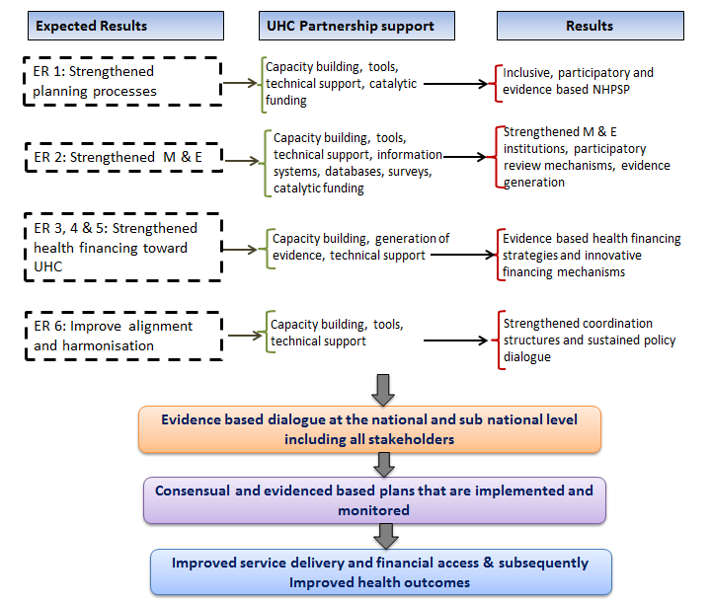
In 2016, an evaluation will be undertaken of the first four years of the UHC Partnership (Phase I and II). The Royal Tropical Institute, The Netherlands (KIT), has been selected as independent external evaluators. The objectives of the evaluation are to assess the Partnership’s results and achievements and of its contribution to strengthen WHO’s capacity to support Ministries of Health in the 20 countries.
As we move forward, the focus should be on consolidating the gains made, expanding the scope of the Partnership in line with the Partnership objectives, as well addressing persistent challenges. In consolidating gains, efforts need to focus on improving the already established coordination structures, and the quality of the dialogue. This will require advocating for continued funding with in-country partners and Ministries. Ensuring effective participation of stakeholders at all levels, as opposed to mere presence, is another area that requires attention, through exploring mechanisms to build actors’ capacities in line with identified gaps.
The Sustainable Development Goals 2030 are entirely consistent with the aims of the UHC Partnership, and expansion of the scope of the partnership will draw from the global agenda: UHC remains an aspiration for most countries, and there needs to be a stronger focus on governance, institutions and regulations, as well as on reproductive, maternal, and child health, and strengthening the health workforce. Furthermore, given the recent experiences of the Ebola outbreak, the global health security agenda and compliance with the International Health Regulations will necessitate concrete actions in all countries. The UHC Partnership is well placed to provide the guidance and support to national governments to achieve these ambitious goals in the coming years.
*************

Burkina Faso, Cabo Verde, Lao PDR, Mali, Niger, Senegal
Chad, DR Congo, Guinea, Liberia, Moldova, Mozambique, Sierra Leone, South Sudan, Sudan, Timor-Leste, Togo, Tunisia, Vietnam, Yemen

