

# TTX 20 Lead Facilitator Guidance Notes for a TTX

***The simulation will be implemented under the leadership of the simulation controller/ lead facilitator.***

As the lead facilitator, you are responsible for the management of the exercise team, including all the facilitators, observers and evaluators. This role starts with briefings on the exercise, includes all aspects of managing the conduct of the exercise, and ends with the post-exercise report.

**The success of an exercise** is often in the lessons identified, and the finding of ways to strengthen the system or plans.

## TOR

This role requires you to be fully prepared in all aspects of the exercise, and to work closely with the exercise management team to ensure that the exercise is conducted in a professional manner.

## Some points to guide your work

**Starting the exercise**

* Ensure that the exercise management team is fully briefed on the exercise objectives; the nature of the participants; the evaluation process; the scenario and inject matrix; the relevant roles and responsibilities; the control room; and the communication arrangements.
* Ensure all technology is tested and ready for the exercise.
* Ensure that the control room is set up and that all facilitators know their roles and responsibilities.
* Ensure that no information is leaked outside the exercise. It is important to avoid creating panic with a fake scenario.

**Conducting the exercise**

* Ensure the exercise starts and engages all participants.
* Have the exercise outline with you at all times to guide your task:
  + Remember to keep the exercise aim and objectives at the forefront of your decision-making.
  + The exercise will take on a life of its own, and you will need to guide it by managing the discussions and sessions.
  + You don’t have to use all the injects you drafted or planned – adapt to the participants.
  + Give participants a reasonable amount of time to complete the tasks requested of them.
  + Major changes or critical failures to the exercise plan will need to be discussed with the exercise director before decisions are made.

**Ending the exercise**

* Do not keep people longer than agreed.

**Post-exercise**

* Review the plan for the participant debrief workshop with the lead evaluator and facilitators.
* Support or lead the participant debrief sessions as required.
* Bring the exercise management team together for a separate hot wash of the exercise.
* Debrief the exercise management team on the exercise conduct (as a group and/or individually).
* Share initial results to key stakeholders as required.
* Support or lead the writing of the post-exercise report.

**Additional advice**

* Know the participant’s code of conduct and ensure it is being respected.
* Have the inject matrix to hand and ensure you are familiar with the injects.
* The plan might change during the exercise, to maximise learning according to the exercise aim and objectives. Remember that the participants do not know what the scenario is, and will only respond to what they are given or have in their plans.
* Ensure constant communication within the exercise management team. Have regular “check-in” meetings to ensure everyone is on track, up-to-date and aware of progress, issues, and changes.
* Work as a team. Support each other delivering the project. Communicate once tasks are completed or if there is a challenge to solve.
* Look for solutions. Find ways through challenges.
* Be flexible. Adapt to the situation. Remember WHY you are there, and keep the project moving forward.

**Debrief introduction**

It is often said that an exercise is only as good as the debrief. In a TTX the debrief workshop is run as part of the exercise day, and is a critical part of the exercise process.

***TIP:*** *The exercise debrief methodology would have been set in the planning phase, and the sessions included in the exercise agenda.*

**The process**

The objective of the debrief process is to review the exercise objectives; capture participant and observer feedback; identify challenges, achievements and recommendations; and build consensus on key actions required in the short, medium and long terms.

*It is critical that participants leave the debrief feeling empowered, engaged and energised for the work ahead.*

**Session 1** – **Identify key achievements, gaps and recommendations**

* Introduce the debrief process, review the exercise purpose and objectives, and look at the key outcomes of each session. Emphasize that this is a review of the exercise and the system, not individual’s performance or decisions.
* Using a flipchart or PowerPoint presentation, capture key achievements (best practices), challenges and recommendations from the exercise.

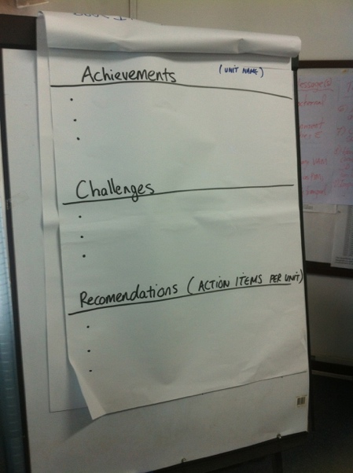

**For bigger groups:**

Discussion in small groups enables all participants to share their experiences.

**Step 1 –** Participants are grouped randomly or according to functions, and are given time to discuss what worked and what did not work in reference to the exercise*.*

*Instruction - In your groups, divide a piece of flipchart paper into three sections. Discuss and write your points in each of the sections to review today’s exercise*.

**Step 2 –** The group is then asked to identify mitigating actions (recommendations) to be put in place both within their function and jointly with other functions. These recommendations need to be specific, measurable and broken down into actionable items.

**Step 3 –** The challenges, achievements and recommendations of each group are shared and discussed with the other groups in plenary. Additional cross-cutting issues are captured during this discussion by the session facilitator.

**Session 2 – Specific actionable recommendations are reviewed and prioritized**

**Action planning:** using the participants’ recommendations from the previous debriefing session, develop an action plan. This plan should build on the achievements (what worked) and addresses all the identified preparedness and response gaps.

This plan should also include a timeline indicating the date by which each action should be completed, and should allocate the person/function/agency responsible for ensuring its completion.



**Session 3 – Ways forward and close the exercise**

At the end of the debrief workshop it is recommended to summarize the exercise and the key outcomes of the debrief workshop. It is important to highlight the process moving forward, and to mention that all comments and recommendations captured during the debrief workshop will be included in the post-exercise report.

The end of the exercise debrief concludes the exercise for the participants, but emphasize that it can be an opportunity to build on the momentum generated by the exercise to make necessary improvements in the short-term.