TTX19 Venue Checklist and Room Layout

Introduction
A TTX should take place in a designated meeting room, such as a large conference room in an office building or in a hotel.

Guidance/checklist
The venue should be a unique location in which exercise participants will sit around a table and discuss during the simulation exercise.

Before the exercise
- Conduct a reconnaissance and review visit to the venue
- Ensure the necessary material and equipment is in place; assess its functionality
- Identify a location for observers, evaluators and facilitators as per the exercise requirements
- Identify a location for the admin support desk (if required)
- Identify possible obstacles to the exercise (e.g. power supplies, air conditioning or lighting).

Material and equipment
A TTX does not require a great deal of material and equipment. The list below is provided as an indication only.

Suggested content:

  - Example material and equipment to be present in the venue

- Enough tables and chairs for all participants, facilitators, evaluators, observers, etc.
- Desks and chairs for admin support staff
- One or two projectors (check requirements with facilitators), depending on the size of the room
- Screen (check quality of the image, find a way to adjust light to ensure proper visibility)
- Flipcharts and markers
- A sound system, if needed
- A location for the live translation booth
- Water supply, toilet and sanitary supplies.

Day before exercise
- Assess the functionality of material and equipment
- Confirm arrangements for food and drink, if applicable
- Confirm arrangements for photography and film, if applicable.

Layout

Different options are possible for the layout of the room. These include gathering everybody in plenary as one big group (U-shaped layout), or dividing the exercise into in separate break-out groups. The lead facilitator should decide on the best option.

It is important to keep in mind that the chosen option should promote and facilitate constructive discussion. Therefore a bigger group might require option 2 (breakout groups), while for a smaller group option 1 (U-shape) is better. Depending on the venue, a combination of the two options may be possible, in which some sessions are held in plenary, and discussions take place in smaller breakout groups.

Always visit the venue well in advance before making final decisions on the best layout.

Option 1: U-shaped
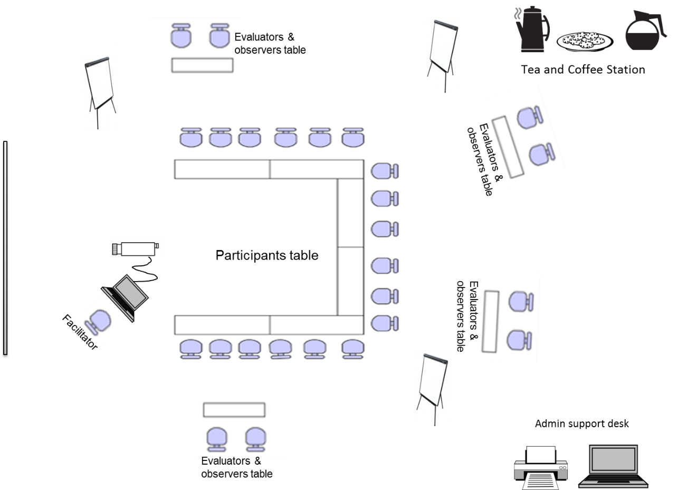

Option 2:
- Participants grouped by functional area
- one evaluator at each table
