**FX19 Venue Checklist and Room Layout**

## 

# **Introduction**

A country or governmental entity should host an FX in its emergency operations centre (EOC) or other operating centre designated responsible for policy decisions, coordination, control, and overall planning in a real emergency.

An agency, NGO or other entity should hold an FX in the central location from which key decision-makers operate in emergency situations.

A frequent objection to exercising at EOCs or other operating centres is that they offer insufficient materiel (e.g. phones), space, etc. If this is the case, it is better to find it out during an exercise then during a real emergency.

# **Guidance/checklist**

The venue should be a unique location in which exercise participants will sit around a table and discuss during the simulation exercise.

## **Before the exercise**

* Conduct a reconnaissance and review visit to the venue
* Ensure the necessary material and equipment is in place; assess its functionality
* Identify a location for observers, evaluators and facilitators as per the exercise requirements
* Identify a location for the admin support desk (if required)
* Identify possible obstacles to the exercise (e.g. power supplies, air conditioning or lighting).
* Map participants, organizations/departments and roles during the exercise, in the room
* Map phone numbers in the room, if applicable
* Identify media room as per exercise requirements
* Identify control room.

For the control room, please refer to the control room guidance (FX20).

### **Material and equipment**

An FX should be carried out using the same material and equipment used during a real emergency. The list below is offered only as an indication for the exercise management team in preparation for the exercise.

A complete list of requirement capacities for an EOC was published by WHO in November 2015: the *Framework for a public health emergency operations centre*. The exercise management team may refer to this document.

*Suggested content:*

|  |  |
| --- | --- |
| *Policies, plans and procedures* | *- Strategic and emergency response plans; staff plans/handbooks including:*   * *Concept of operations (CONOPS)* * *Map of the EOC workstations and rooms, and inventories of equipment* * *Standard operating procedures (SOPs)* * *Forms and templates for data collection, reporting, briefing, etc.* * *Contact information for key officials and PHEOC personnel* * *Notification and communication protocols for host agency, response organizations and partner agencies.* |
| *Infrastructure* | * *Availability of additional rooms for strategic meetings and media briefings* * *Potable water supply* * *Toilet and sanitary facilities* * *Evacuation and control access measures.* |
| *Information and communication technology* | * *Computer workstations, software, servers and technical support* * *Telephone* * *Web or video conferencing equipment* * *Printers, fax machines* * *Power supply, internet access, cell phone coverage.* |

## **Day before exercise**

* Assess the functionality of material and equipment
* Confirm arrangements for food and drink, if applicable
* Confirm arrangements for photography and film, if applicable.

## **During the exercise**

The exercise is meant to test the emergency management system, and in particular the overall adequacy of resources to meet the needs of an emergency situation. Unless the FX is jeopardized, infrastructural or technical difficulties that occur during an exercise must be seen as opportunities to learn and improve the emergency management system.

## **Layout**

An FX should be carried out using the same operational configurations as would be used during a real emergency. Below, the management team will find layouts that can be displayed for specific exercises—for example, those not occurring in the EOC.

**Option 1: Small functional exercise**

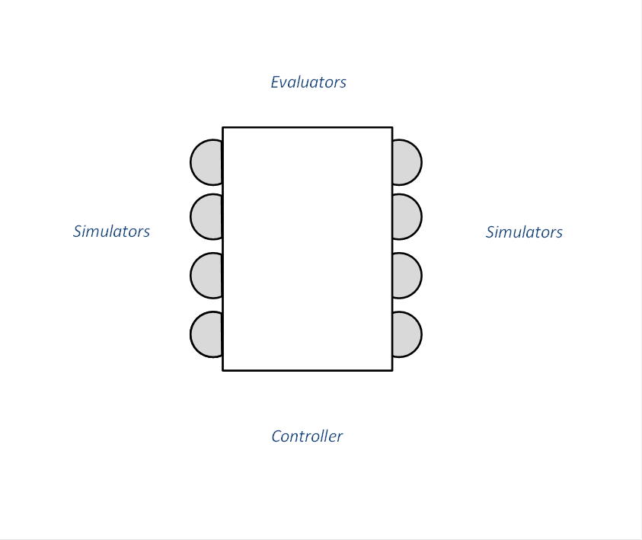

**Option 2: Large functional exercise**



