**FSX22 Debrief Guidance Note**

*The purpose of the debrief workshop guidance note is to provide direction for the exercise debrief.*

*It is often said that an exercise is only as good as the debrief. In a FSX the debrief workshop is run the day after the exercise in order to allow time for the exercise management team to review their debrief plan, setup the debrief venue, and —most importantly—give the participants time to reflect and digest the exercise experience before jumping into a review.*

**Purpose**

The debrief workshop is a participant-focused, facilitated process that allows the participants and the exercise management team to reflect and comment on the success and challenges experienced during the simulation exercise. The process aims to identify specific recommendations and follow-up actions that will enhance the SOPs, plans and response systems (as per the exercise’s specific objectives).

All the information collected must be analysed and presented in the post-exercise report.

***TIP:*** *The exercise debrief methodology would have been set in the planning phase and the sessions included in the exercise agenda. The plan would have been reviewed immediately after the exercise “hot wash,” and the final setup and preparation done then.*

**The process**

The objective of the debrief process is to review the exercise objectives; capture feedback from the participants and observers; identify challenges, achievements and recommendations; and build consensus on the key actions required to move forward.

***TIP:*** *It is critical that participants leave the debrief feeling empowered, engaged and energised for the work ahead.*

**Session 1** – introduce the debrief workshop, including the agenda, the facilitators, and the aims and outline of the process. Emphasize that this is a review of the exercise and the system, not of individual performances or decisions.

***TIP:*** *Suggest that for every constructive criticism offered, there should be a suggestion of how to address the issue.*

**Session 2** - Participants will have different attitudes and perspectives concerning the delivery of the simulation. This session allows participants to express their personal views in an anonymous space, and to build a picture of how participants felt and experienced the simulated emergency.

**Suggested methodologies are outlined below. Any other de-compression session methods can also be used.**

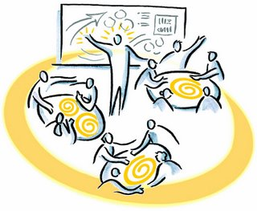**4 Corners (30 min)** – Flipcharts are placed in the 4 corners of the room and a facilitator is assigned to a flipchart. Time is given to each participant to visit all four corners and write one comment on each of the boards. The flipcharts are entitled *What I enjoyed; What I did not enjoy; What I learned;* and *What I will do differently*. At the end of the session, each flipchart is summarized by an assigned facilitator and presented back to the group.

**Session 3– C*hoose an appropriate methodology from the options below.***

**Three positive and three improvements—**Divide participants into groups; identify key topics (e.g. coordination, information sharing, and contingency planning); ask the groups to spend 10-15 minutes discussing their topic and, in relation to each topic, generating three positive aspects & three areas for improvement of their responses during the exercise.

**Focus groups**—Form small groups of 4-8 people. Give each group one topic for discussion. Give the groups 10-20 minutes to discuss the topic and prepare a two-minute presentation in plenary.

***TIP:*** *This is a way to obtain focused input on key challenges that arose in the exercise—e.g. issues with the communication system; information sharing between functions; or specific SOPs or emergency procedures.*

**World Café**—This method is based on the concept of the types of discussion that would take place in a café—only about disaster management. The facilitation team defines the key topics to be discussed. Arrange groups of chairs around the room and allocate a topic to each group (set the number of groups and number of chairs per group according to the number of people and topics).

One chair is allocated in each group to the **host**: this person acts as the facilitator for that group and initiates discussions about the relevant topic, capturing all comments to be reported back at the end of the session.

After 5-10mins, all the people in the group except the host move to another set of chairs and a different topic. People are encouraged to sit with different people and form new groups with each move. The process is repeated until everyone has participated in each group discussion. Finally, the host in each group presents the key discussion points back in plenary.



**Identify key achievements, gaps and recommendations**—This is a three-part process to identify specific and actionable recommendations. Discussion in small groups enables all the participants to share their experiences.

**Step 1—**Participants are grouped according to functions and are given time to discuss what worked and what did not work in reference to the exercise*. It can be useful to go through the functional area-specific injects, looking at the anticipated response, the actual response, and whether the injects achieved their intended output*.

***Instruction:*** *In your groups, divide a piece of flipchart paper into three sections. Discuss and write your points in each of the sections to review today’s workshop*.

**Step 2 –** The group is then asked to identify mitigating actions (recommendations) to be put in place both within their function and jointly with other functions. *These recommendations need to be very specific, measurable and broken down into actionable items.*

**Step 3 –** The challenges, achievements and recommendations of each group are shared and discussed with the other groups in plenary. Cross-cutting issues are captured during this discussion by the session facilitator.

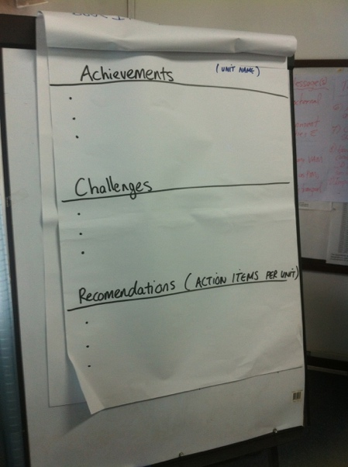

**Session 4—Specific actionable recommendations are reviewed and prioritized.**

**Action planning**—This session uses the participants’ recommendations from the previous debriefing session to develop an action plan. This plan should build on the achievements (what worked) and address all identified gaps in preparedness and response. It should include a timeline indicating the date by which each action should be completed, as well as section assigning the person/function/agency responsible for ensuring its completion.



**Session 5—Exercise survey & tea break**

An exercise survey is a useful tool to capture any feedback on the organization and running of the exercise. An adaptable example of a feedback form can be found in the tools & templates.

**Session 6—Way forward and close the exercise**

At the end of the debrief workshop it is recommended to summarize the exercise and key outcomes of the debrief workshop. It is important to highlight the process of moving forward, including a mention that all comments and recommendations captured during the debrief workshop will be included in the post-exercise report.

The end of the exercise debrief concludes the exercise for the participants, but it can also present an opportunity to build on momentum generated by the exercise and make necessary short-term improvements.

***TIP:*** *As appropriate, senior leadership may be invited to close the exercise, hand out certificates of participation, and/or thank participants and the exercise management team for their hard work and dedication.*

**Guidance notes**

* Ensure key achievements and gaps are linked to the training objectives and outcomes
* There are various ways to conduct a debriefing session. The methodology should be chosen based on the number of people, the resources available, and the local cultural context
* Simulation facilitators are encouraged to use their knowledge of local culture and customs to ensure that the debriefing sessions are not only effective, but also appropriate
* It is important that all participants are included and feel able to contribute. Debriefings are best conducted in large rooms with a minimal number of desks, tables or distractions
* A low-technology approach is recommended (no laptops or phones): the goal is for people to think, communicate, interact, and focus on learning
* Be aware of the space, culture and office dynamics
* Ensure all conversations are captured
* It is strongly recommended that the simulation and debrief are not held at the end of the working week.

**Joining instructions**

This should be covered in the participant invitation and introductory briefing: participants and the exercise management team need to know when and where to meet for this phase of the exercise.

***TIP:*** *All exercise management team members and participants are expected to contribute.*

**Example of a half day workshop agenda**

|  |  |  |
| --- | --- | --- |
| ***Time*** | ***Session*** | ***Facilitated by*** |
| 08:30 | Arrival of participants |  |
| 08:40 – 09:20 | Welcome and introduction:   * Opening remarks * Warm up activity * Agenda and purpose |  |
| 09:20 – 09:50 | Review of exercise   * Pre-exercise preparation * Summary of events and outputs * Summary of exercise feedback |  |
| 09:50 – 10:30 | Participant Reflections:   * 4 corners exercise * Summary of feedback |  |
| ***10:30 – 10:50*** | ***TEA & COFFEE*** | ***All*** |
| 10:50 – 11:40 | Focus group discussions:   * Introduction * Group work |  |
| 11:40 – 12:30 | Group’s feedback and facilitated discussion. |  |
| 12:30 – 12:45 | Exercise follow-up/next steps |  |
| 12:45 | Final remarks and closing:   * WHO Representative * Director General - GHS | WR  DG |
| ***13:00*** | ***LUNCH*** | ***All*** |

**Venue setup**

A collaborative process requires a space that allows for group work, and which facilitates the sharing of ideas and coming together in plenary sessions. The debrief venue should be away from the office or other work distractions, and should allow people to focus on the task at hand.

A round table setup is ideal, with 6-8 chairs per table, a “U” shaped setup, and space for group activities (ice-breakers, energizers and breakout discussions).

**Logistics**

Ensure that the venue is accessible for all, factoring in accommodation arrangements, traffic, wheelchair access, security, and transport.

**Equipment**

Depending on the space used and the methodology chosen, equipment will need to be sourced. This should be planned in the pre-exercise phase and included in the admin & logistics task list.