Slide no. | Title | Slide details | Expected outcome per slide | Notes/timing
1 | Title, country, date | Present the title, to be adapted to each country. | - Title is adapted to each country. | The participants should be defined in the concept note.  The venue should be the EOC, conference room, boardroom or other appropriate meeting venue. If we expect people to be easily distracted, an off-site location is recommended.
2 | Workshop agenda | Set agenda for the day  - 0900 Welcome (WR & MOH)  - 0905 Introductions & scene-setting (WHO facilitator)  - 0910 Overview of the emergency response plan (MOH)  - 0925 TTX Setup (WHO facilitator)  - 0930 TTX session 1 (Activation)  - 1015 Coffee break (15 min)  - 1030 TTX session 2 (Response management)  - 1115 TTX session 3 (Partner coordination)  - 1200 GAP Analysis (WHO facilitator)  - 1300 Way forward (WHO facilitator)  - 1315 ENDEX/Lunch | - Clarity of the day’s timings | 2 min  It is not recommended to run an exercise on a Monday or Friday, or the day before or after a public holiday. Ideally this exercise should be run in the morning when people are fresh.  Serving lunch is highly recommended to ensure people stay until the end. Encourage an informal networking event after the exercise. Relationship building is critical for the success of any plan. Team-building/ice-breaker exercises can be used depending on the audience.
3 | Official welcome | Welcome picture. | - Give high-level support to the activity. | 10 min  Welcome by the most senior government official or WR.  Introduce the context of the TTX.  This may include a prayer, depending on the cultural context.
4 | Introductions | Image | - Everyone is introduced by name and role.  My name is… my role is to… I am responsible for… | 5 mins  - Introduction of the facilitation team  - Introduction of the participants –  each person in the room to introduce themselves and define their role and function at the table.  Recommend nametags/functions & table tags for places around the table.
5 | Why do we run simulation exercises? | Why do we run simulation exercises? | - Draw people into the exercise. | Highlight the benefits of testing plans. Emphasise that this is a safe learning environment.
6 | Overview of simulation types or define the TTX | Defines and explains the different types of exercises and what we can expect today. | - Manages expectations of the TTX. | Define clearly what is a TTX.  “A TTX is a facilitated group discussion of an emergency response, in an informal, low-stress environment. TTXs are designed to elicit constructive participant discussion, to identify and resolve challenges and to refine existing operational procedures and plans.” WHO 2009.
7 | TTX purpose & specific objectives | - Purpose  - Specific objectives | - Everyone is clear on the purpose and specific objectives for the exercise. | 2 mins  Clearly introduce the purpose and specific objectives. Talk about what we aim to achieve today.  To discuss, review and practice the plans – to find the gaps and ensure we are ready for the next emergency.
8 | Overview of the response system  (as required) | E.g. MOH (as required) | - All (re-) familiarized with the response plan and system.  Familiarise participants with their roles and responsibilities in an emergency response. | 10min  The government presents an overview of their response system and plan. Presented by the MOH.  Key elements to cover:  - Activation protocols  - Coordination arrangements (IMS system)  - Partner support  - Timeline of expected actions/ plan milestones  - Tools and resources available.
9 | Overview of the response system  (as required) | E.g. WHO (as required) | - All (re-) familiarized with the response plan and system.  Familiarise participants with their roles and responsibilities in an emergency response. | 10 mins  WHO presents an overview of their response system and plan.  Key elements to cover:  - Activation protocols  - Coordination arrangements (IMS system)  - Partner support  - Timeline of expected actions/ plan milestones  - Tools and resources available.
10 | TTX process | 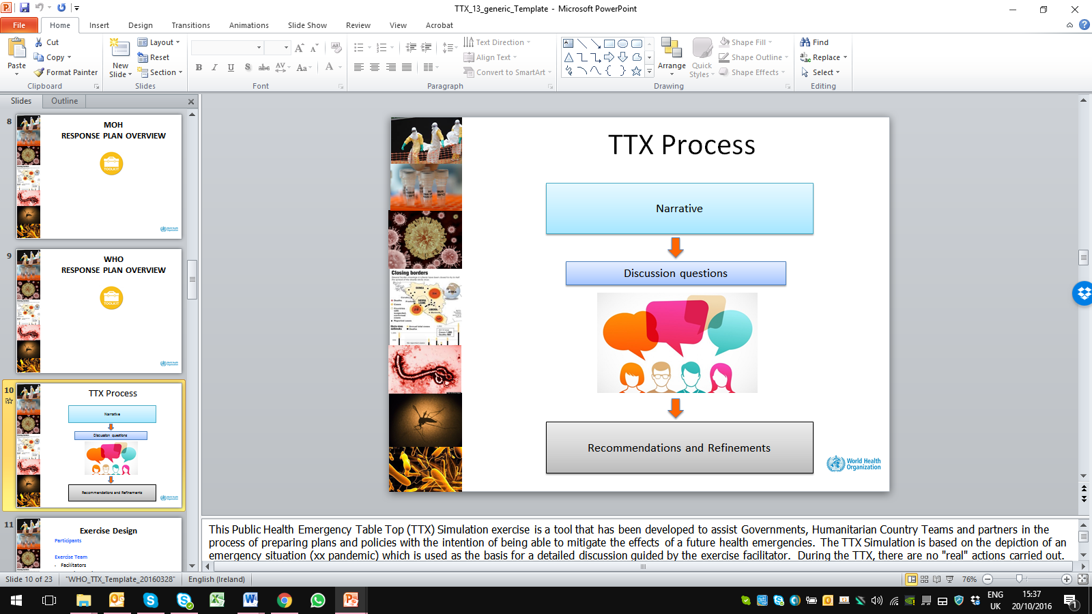 | - All understand the TTX process.  “A tabletop exercise is like a problem-solving or brainstorming session, where problems are tackled one at a time and talked through without stress. “ | 4 mins  Outline the TTX process: “…using a table-top discussion, the facilitators will guide the team through key discussions.  Led by a facilitator, you (participants) will be challenged with simulated emergency situations (scenarios) using pre-defined injects, in order to examine and evaluate your plans, procedures and event-specific responses.  The purpose of tabletop exercises is usually resolving problems or making plans as a group. That means going after real solutions⎯not superficialities.  Identified gaps, challenges and recommendations will be noted. These points will be reviewed and actioned during the debriefing sessions.”
11 | TTX design | Participants  Exercise team  - Facilitators  - Technical advisors  - Support staff  Narrative and problem statements  - 3 sessions with a question to be discussed  - Accept the scenario, do not fight the scenario  Debrief | - Buy-in from the participants. | 5 mins  Outline how this exercise was designed.  Explain how this was custom built for the participants.  The key planning assumptions:  - xx  - xx  The simulation will seek to review xx key components of (insert context):  (Examples)  - Early warning  - Activation  - Response
12 | How to play? | Rules  - Use your plans, guidelines and regulations to inform your responses  - Play yourself  - Work as a team  - Focus on solutions  Remember  The purpose of this tabletop exercise is to familiarize you with the emergency response system. The exercise is not to test or evaluate individual participants. | - Everyone understands how to participate.  Participants understand how valuable their input and reflections are in the process. | Explain how to participate in the exercise. Explain the rules for playing and how the sessions will function.  - Facilitators  - Lead facilitator  - Technical experts for the response plan and hazard  - Scribe to capture comments and give input for the debrief.  - Participants  Role of the facilitators  In addition to ensuring the smooth running of the simulation and debriefing, the task of the facilitator(s) is to assist participants in achieving the stated objectives of the simulation. To this end, the facilitator will not provide direct answers to questions raised or identified by the participants. Instead, he/she will encourage a robust discussion by all participants while at the same time maintaining the overall flow of the simulation.  Participant role  Each participant is required to play themselves based directly on the functions for which they are responsible in their respective organisations. They must respond as they would for any emergency.  Every participant has a vital role to play in identifying problems and strengths within the system, and in particular as they relate to their own roles and functional areas. Participants must therefore feel safe and be encouraged to highlight any strengths, gaps and opportunities, and make recommendations for ways the system can be improved.  The TTX is a safe learning environment, designed as a forum in which to discuss potential future responses and enhance current plans, structures and systems.
13 | Session 1- narrative 1 | Bullet point scenario  Example: details as per the chosen hazard and the required start of the situation, based on the country context. | - Sets the scene. Gives information on the start point of the emergency. | 2mins  Choose the starting point for your public health emergency. Start with the first narrative to set the scene.  Ensure you include the date, time and key information required for the discussion question, so that you can meet your expected outcome for the discussion.
14 | Tasks | Examples of discussion questions/problem statements.  - What is the current situation?  - Should the response plan be activated? Why? What are the triggers? Who is informed and when?  - Who is the designated incident commander (leader)?  - What resources do you have available? (Actual)  - What immediate actions will you take now? | Examples of expected outcomes  - Participants are clear on their roles and responsibilities in an emergency response  - Participants demonstrate situational analysis and decision making with limited information  - Threshold triggers for activation are clear  - Early warning system is in place and operational  - Activation of the response system or contingency plan  - Review of the emergency response structures (IMS, EOC etc.), including lines of communication and accountability  - The plan and tools are used to support the response. | 45mins  Break the ice by beginning with a general question directed at one or two high-ranking officials, or to the group as a whole. Later, other problem statements or messages can be addressed to other individuals or organizations.  - Is the plan used? What tools are there to guide the process?
15 | Tea break | Image | - None | 10 min  Break to get fresh air, and for participants to check in with their office.
16 | Session 2 – narrative 2 | Example: more specific case information  given. Details as per the hazard and the evolution of the situation. Hazard-specific, country context-specific. | - Progression of the first scenario  - Time jump?  - A jump in the situation, requiring a change of strategy. | 2 mins  A jump in the situation, requiring a change of strategy.  Do we want to specify any generic scenario markers… e.g. cross-border movement; rural or urban setting; multiple caseloads; crisis communication; PHEOC?
17 | Tasks | Example  Instructions - You are the WCO IMT  Questions (as a team)  - What is the current situation?  - What further information do you require?  - Establish the priorities, specific objectives and response strategy (strategic response plan)  Extra  - How are decisions being communicated and coordinated?  - What tools are there to guide the process? | Examples of expected outcomes  - Participants are clear on their roles and responsibilities in an emergency response  - Participants demonstrate situational analysis and decision making with limited information  - Humanitarian needs and response actions identified  - Teamwork, full participation  - The team adapts their plan to the emerging situation  - Areas of interdependence between key functions, resources and partners are identified  - The plan and tools are used to support the response. | 40 mins  “The response actions should be directly related to the response strategy (specific objectives)”
18 | Session 3- narrative 3 | Example: Insert updated case example as per your scenario.  Details as per the hazard and the evolution of the situation. Hazard-specific, country context-specific. | - Progression of the scenario as required. | 2 mins  Evolution of the scenario where a time jump could be used. Emphasis on discussing specific partner coordination arrangements and reviewing dependencies.
19 | Tasks | Example:  Instructions - You are the WCO IMT.  Questions  - What is the current situation?  - What resources could partners provide?  - What coordination arrangements are in place for partners?  Extra  - What decision do you need to make at this stage? | Examples of expected outcomes  - Participants are clear on their roles and responsibilities in an emergency response  - Participants demonstrate situational analysis and decision making with limited information  - It is clearly defined how partners (and resources) across the various levels and structures will be coordinated and managed  - Identified areas of interdependence between key functions, resources and partners  - The plan and tools are used to support the response. | 40 mins  Depending on how the group is working, possibly instruct the team to role-play the coordination meeting. How would the room be set up, who would lead the meeting?
20 | Tea break | Image | None | 10-15 mins  Break to get fresh air and check in with the office.  Facilitation team to review the notes on gaps and recommendations.
21 | Session 4 –  debrief | Insert as necessary  - Hot wash  - Summary of the key challenges and discussion points  - Identify recommendations and key gaps  - Action planning | Expected outcomes  - Review the identified session outcomes  - Action plan  Produce or encourage a focused specific action plan, to address the gaps or changes required. | 40 min – x hours  - Review the day’s processes  - Summarise the challenges and recommendations identified by the participants  - Recommendations (clear actions).  Clarify any necessary points and ensure concrete recommendations, solutions or ways forward are agreed.
22 | Way forward  + TTX Feedback | Identify the next steps (ways forward) and collect participant feedback | - Ways forward  - Feedback on the TTX collected.  The success of a tabletop exercise is determined by feedback from participants, and by the impact this feedback has on the evaluation and revision of policies, plans, and procedures. | 5 min  Hand-out – one-page survey questionnaire  YES/NO:  - Did this TTX achieve its objectives?  - Did this TTX help you in your role?  - Did this activity meet your expectations?  Open questions  - What (e.g. training activity, equipment or other) would enable you to be better prepared to respond to emergencies?  - Which TTX session was most useful? Why?  - How can we improve this exercise?
23 | ENDEX | Closing remarks by the WR and most senior government official. | - High-level support given to the TTX and future preparedness activities. | 10 min

