GOVERNMENT OF MONTENEGRO

MINISTRY OF HEALTH LABOR AND SOCIAL WELFARE

Strategy for Prevention and Control of Chronic Noncommunicable Diseases

- Draft -

Podgorica, June

2008

Contents

1. Introduction – need for the Strategy 4

2. Chronic noncommunicable diseases – problems and challenges 6

3. Chronic noncommunicable diseases burden in Montenegro – situation analysis 10

3.1. The key chronic noncommunicable diseases 10

3.1.1. Cardiovascular diseases 11
3.1.2. Malignant neoplasms 16
3.1.3. Diabetes mellitus 21
3.1.4. Musculoskeletal diseases 24
3.1.5. Chronic obstructive respiratory diseases 24
3.1.6. Injuries 25

3.2. Risk factors for the key chronic noncommunicable diseases27

3.2.1. Hypertension (high blood pressure) 27
3.2.2. Tobacco 29
3.2.3. Alcohol 30
3.2.4. Poor nutrition with low fruit and vegetable intake 31
3.2.5. Physical inactivity 31
3.2.6. Overweight/obesity 32
3.2.7. High blood cholesterol 33

  - Demographic, social, economic and environment determinants of health that impact development of chronic noncommunicable diseases 35
3.3.1. Demographic changes 35
3.3.2. Poverty 36
3.3.3. Education 36
3.3.4. Globalization and urbanization 37
3.3.5. Problems in health services orientation 38

3.4. Conclusions of the Analysis 39

- Potentials for health promotion, prevention and treatment of chronic noncommunicable diseases 40

- Legal framework for passing the Strategy and the existing strategic documents 44

6. Guiding principles 45

7. Strategic approach 46

8. Vision, goals and key messages of the strategy 47

9. Action framework 49

9.1. Advocacy 49
9.2. Knowledge and information 50
9.3. Legal regulations and financing 51
9.4. High quality and appropriately oriented health services 53
9.5. Supportive communities 55

10. Institutional framework for implementation of the strategy 57

11. Monitoring and evaluation 58

References 59

Annex 1. Framework of the Action Plan of the Strategy for Prevention and Control of the Key Chronic Noncommunicable Diseases

1. Introduction – need for the Strategy

In response to the request made by WHO Member States at the fifty-fourth session of the WHO Regional Committee for Europe, WHO Regional Office for Europe made in mid 2006 the European Strategy for the Prevention and Control of Chronic Noncommunicable Diseases. The key idea of the Strategy is that gaining better health for the people of Europe is achievable through comprehensive programmes of prevention and control of the key mass chronic noncommunicable diseases: ischemic heart disease, cerebrovascular disease, malignant neoplasms, diabetes mellitus and chronic obstructive pulmonary disease.

The need for development of the Strategy for Prevention and Control of Chronic Noncommunicable Diseases in Montenegro is based on several facts:

- The portion of chronic noncommunicable diseases in the structure of morbidity of Montenegrin population is about 75%.
- The portion of chronic noncommunicable diseases in the overall disease burden of Montenegrin population is on the increase. This is primarily due to the aging population but also due to the features of a society in transition, i.e. social, economic and environmental determinants of health which to a large extent influence inadequate life styles (behavior patterns) in Montenegrin population.
- A significant loss of years of life due to premature death as well as significant figures for disabilities and absentism caused by chronic noncommunicable diseases make a huge economic burden for the state.
- A significant number of risk factors for development of major chronic noncommunicable diseases has been identified and many of them are preventable, primarily through healthy life styles, i.e. changes of inappropriate behavior patterns.
- Practice of developed countries has shown that reduction in morbidity rate and figures for premature deaths from the key chronic noncommunicable diseases is possible to a significant extent through establishment of good functional relations between the measures for health promotion, primary, secondary and tertiary prevention and contemporary treatment methods.

On the basis of these facts and World Health Organization messages Ministry of Health, Labor and Social Welfare in the Government of Montenegro decided to develop the Strategy for Prevention and Control of Chronic Noncommunicable Diseases as the umbrella document which is to offer basic guidelines for a comprehensive and coordinated response to the increasing number of noncommunicable diseases in the national health pathology.

The goal of this strategy is to avoid premature deaths, reduce the disease burden from chronic noncommunicable diseases (coronary heart disease, cerebrovascular diseases, certain malignant neoplasms and diabetes mellitus. The most effective way to achieve this goal is to combine integrated multisector activities aimed at eliminating or reducing risk factors.

2. Chronic Noncommunicable Diseases – Problems and Challenge

In the 20th century, particularly in its second half, the world saw a significant change in the frequency of disease and death causes, particularly in the developed world. A large number of communicable diseases is put under control thanks to the improvements in hygienic conditions at home and work, health education of population, provision of microbiologically wholesome drinking water, safe liquid and solid waste disposal, sanation of environment (drying of swamps etc), implementing disinfection, desinsection and deratisation measures, use of specific immunoprophylaxis (vaccines) and antibiotics. This brought to a significant decrease of their portion in the overall mortality (death). Although reduced to a large extent morbidity (disease) from communicable diseases still has a significant portion of the overall disease. On the other side, mass chronic noncommunicable diseases have become the major death cause and a significant cause of disease, not only in the developed but also in the developing countries. WHO estimates that 35 million people worldwide dies of chronic noncommunicable diseases every year, which is 60% of the overall world mortality. If we exclude Africa, where still a large number of persons dies from communicable diseases, in the largest number of countries it is the chronic noncommunicable diseases that cause on average 75 – 85% of the overall mortality.

Chronic noncommunicable diseases are often characterized by co-morbidity (one person can suffer from two or more noncommunicable diseases/conditions). Comorbidity is frequently found with older persons (at least 35% of persons over 60 years of age have been found to have 2 or more chronic diseases/conditions). For example, depression, as one of the most frequent diseases of the modern world, is more common in people with physical illness than the healthy (depression is identified in up to 35% of people with cancer, 29% of persons with hypertension and 27% of those with diabetes).

NCD have a multifactor etiology and result from complex interactions between individuals and their environment. Individual characteristics (such as sex, genetic predisposition…) and health protective factors (such as emotional resilience), together with social, economic and environmental determinants (such as income, education, living and working conditions), determine differences in vulnerability of individuals to health-compromising conditions. Social, economic and environmental determinants, or “causes of causes”, influence behavior patterns (lifestyle) of population as well as onset, expression and outcome of disease.

A number of persons have genetic predispositions for developing certain diseases, (diabetes mellitus, cardiovascular disease, cerebrovascular diseases, certain malignant neoplasms, schizophrenia, Alzheimer’s disease etc.) while gender can influence overweight, cardiovascular disease and mental diseases. Apart from the above the important thing to emphasize is that the foundations of adult health are laid in early life, even before birth. A “good start” in life is fundamental to later development. Unfortunately, young mothers, poor mothers and those of low educational achievement are more likely to produce a low-birth-weight baby which is associated with increased risk of developing certain diseases. Poor emotional support, exposure to child abuse and other violent and adverse events of childhood, have been associated with an increased development of risk behaviors in later life (smoking, physical inactivity, obesity and alcoholism).

Still, several chronic noncommunicable diseases and conditions which have common risk factors and social, economic and environmental determinants are responsible for a significant portion of the overall disease burden and mortality. These most significant diseases and conditions and factors of risk as well as the determinants causing them are more or less common for almost all European countries. The “killer number one” in all European countries is cardiovascular disease because it is responsible for more than half of the total number of deaths. It is followed by malignant neoplasms responsible for almost 20% of all deaths (Table 1).

Table 1: Disease burden and deaths from noncommunicable diseases in the European Region -WHO estimate for 2005)

Groups of noncommunicable diseases | Deaths (000s) | % of all causes | Disease burden (DALYs) (000s) | % of all causes
Cardiovascular diseases | 5067 | 52% | 34421 | 23%
Malignant neoplasms | 1855 | 19% | 17025 | 11%
Digestive diseases | 391 | 4% | 7117 | 5%
Respiratory diseases | 420 | 4% | 6835 | 5%
Neuropsychicatric conditions | 264 | 3% | 29370 | 20%
Diabetes mellitus | 153 | 2% | 2319 | 2%
Sense organ disorders | 0 | 0% | 6339 | 4%
Musculoskeletal diseases | 26 | 0% | 5745 | 4%
Oral conditions | 0 | 0% | 1018 | 1%
All NCD | 8210 | 84% | 115339 | 77%
All causes | 9564 |  | 150322

Source: World Health Organization. Gaining Health. The European Strategy for the Prevention and Control of
Noncommunicable Diseases. Copenhagen:WHO; 2006

Box 1 presents the connections between key chronic diseases, risk factors and social, economic and environmental health determinants influenced largely by global trends.

Box 1: Connection of social, economic and environmental health determinants, risk factors and certain chronic diseases

Global influences
Trade globalization, particularly food supply, urbanization, technology development, migrations

Social, economic and environmental determinants of health
Social, economic and political circumstances (incomes, life and work conditions, infrastructure, preservation of environment, education, agriculture development, orientation, quality, availability and affordability of health services)

Risk factors related to life styles (behaviour patterns)
Tobacco, poor nutrition, physical inactivity, alcoholism

Biological risk factors
Invariable: genetic predisposition, gender, age
Variable: overweight/obesity, high blood cholesterol, high sugar in the blood, hypertension

Chronic noncommunicable diseases
Ischemic heart diseases, cerebrovascular diseases, malignant neoplasms, diabetes mellitus, chronic obstructive pulmonary diseases, musculoskeletal diseases

WHO experts estimate that almost 60% of the disease burden (as measured by DALYs – the number of the years of healthy life lost due to premature death or disability caused by disease) in Europe is accounted for by seven leading risk factors: high blood pressure (12.8%); tobacco (12.3%); alcohol (10.1%); high blood cholesterol (8.7%); overweight (7.8%); low fruit and vegetable intake (4.4%;) and physical inactivity (3.5%).

The important thing is that these leading risk factors are common to many of the leading NCD and conditions in Europe. Each of these seven leading risk factors, for instance, is associated with at least two of the leading NCD and conditions and, in return and in many individuals, (particularly the socially disadvantaged), risk factors frequently cluster and interact, often multiplicatively. Diagram 1 presents an example of impact of three risk factors (high systolic blood pressure, overweight and high blood cholesterol) on the development of an ischemic (coronary) heart disease.

Diagram 1: Risk of coronary heart disease grows with the increase of exposure to risk factors (high systolic blood pressure, overweight and high blood cholesterol)
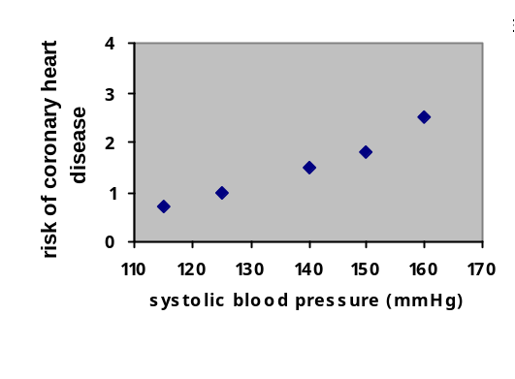
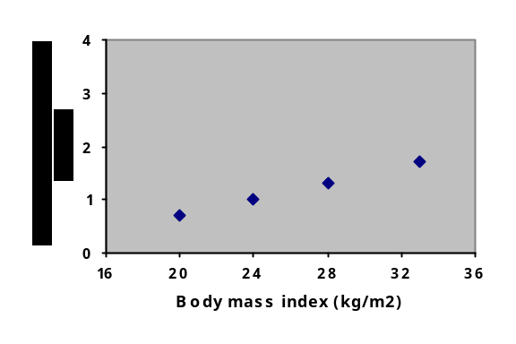

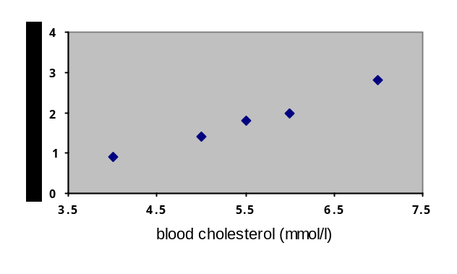

Source: Law MR, Wald NJ. Risk factors thresholds: their existence under scrutiny. BMJ 2002; 324:1570-6

3. NCD burden in Montenegro – Situation Analysis

3.1. Key chronic noncommunicable diseases

Among all health disorders in Montenegro the largest is the burden of chronic noncommunicable diseases. The leading death causes in our country are almost identical to the leading death causes in the developed world, primarily European countries.

Circulatory system diseases and malignant neoplasms made almost three quarter of all death causes in Montenegro in 2006. In the mortality structure circulatory system diseases account for more than half of all deaths (56.8%) while every sixth death (16.3%) was caused by malignant neoplasms (Table 2). Out of the total number of deaths 4.9% were caused by injuries and poisoning, 4.3% by respiratory diseases, 2.0% by complications related to diabetes mellitus, while 9.3% were caused by insufficiently defined conditions leading to cause of death being registered with symptoms, signs and abnormal results of clinical or laboratory findings dominant with the deceased. Due to such high portion of symptoms and insufficiently defined conditions in the overall mortality in Montenegro (in Serbia the share of such diagnoses for 2006 was 4.8%) we have to be rather cautious when analyzing ranks and making conclusions.

Table 2: Leading death causes (clusters of diseases) in Montenegro by gender in 2006

Rank | Groups of diseases  (NCD-10 codes) | Male |  | Female |  | Total
Rank | Groups of diseases  (NCD-10 codes) | Number | % | Number | % | Number | %
1 | Circulatory system diseases  (I00-I99) | 1621 | 47.8 | 1768 | 52.2 | 3389 | 56.8
2 | Malignant neoplasms  (C00-C97) | 573 | 58.8 | 401 | 41.2 | 974 | 16.3
3 | Symptoms, signs and abnormal clinical and laboratory findings (R00-R99) | 274 | 49.1 | 284 | 50.9 | 558 | 9.4
4 | Injuries, poisoning and certain other consequences of external causes  (S00-T98) | 213 | 72.7 | 80 | 27.3 | 293 | 4.9
5 | Respiratory diseases  (J00-J99) | 152 | 59.4 | 104 | 40.6 | 256 | 4.3
6 | Diabetes Mellitus  (E10-E14) | 52 | 43.0 | 69 | 57.0 | 121 | 2.0
7 | Other death causes | 207 | 54.9 | 170 | 45.1 | 377 | 6.3
 | TOTAL | 3092 | 51.8 | 2876 | 48.2 | 5968 | 100.0
Source: Monstat (Statistical Office of Montenegro)
3.1.1. Circulatory system diseases (cardiovascular diseases)

Circulatory system disease is the leading cause of morbidity and mortality in the world. According to the estimates of the World Health Organization, 17.5 million people died of circulatory system diseases in 2006 which is 30% of all death causes. In 2005 5.1 million people died of circulatory system diseases in the countries of the WHO European Region, which is 52% of all death causes. The same year 3389 persons (1621 male and 1768 female) died in Montenegro from circulatory system diseases. This was 56.8% of all death causes, i.e. a bit higher than the European average and almost the same as in the Republic of Serbia (57.3%). Within the cluster of circulatory system diseases, the most frequent cause of death in Montenegro can be found in other forms of heart diseases, cerebrovascular disease and ischemic (coronary) disease (Table 3).

Table 3 Participation of individual cardiovascular diseases in the total deaths in Montenegro by gender in 2006

Rank | Groups of diseases  (ICD-10 codes) | Male |  | Female |  | Total
Rank | Groups of diseases  (ICD-10 codes) | Number | % | Number | % | Number | %
1 | Other forms of heart diseases (I26-I51) | 1056 | 47.8 | 1154 | 52.2 | 2210 | 37.0
2 | Cerebrovascular diseases I60-I69 | 282 | 40.2 | 420 | 59.8 | 702 | 11.8
3 | Ischemic heart diseases (I20-I25) | 260 | 58.7 | 183 | 41.3 | 443 | 7.4
4 | Other disorders of the circulatory system | 23 | 67.6 | 11 | 32.4 | 34 | 0.6
5 | All other diseases | 1471 | 57.0 | 1108 | 43.0 | 2579 | 43.2
 | TOTAL all diseases | 3092 | 51.8 | 2876 | 48.2 | 5968 | 100.0

Source: Monstat (Statistical Office of Montenegro)

Table 3 shows that the portion of females in the total mortality from circulatory system diseases is larger than the one of males (52.2%: 47.8%). However, the differences are more significant if we focus separately on cerebrovascular disease and ischemic (coronary) disease. The portion of females in the total mortality from cerebrovascular disease is significantly larger than the portion of males (59.8% : 40.2%), while the situation is quite the opposite in case of ischemic disease – the portion of males is much larger than the one of females (58.7% : 41.3%).

Observing the trends related to the number of deaths from circulatory system diseases in Montenegro in the last six years we can see the growth in the number of deaths and their potion in the total deaths (Table 4).

Table 4: Participation of circulatory system diseases in the total deaths in Montenegro, 2001-2006

Group of diseases | Number of deaths and participation in the total deaths n Montenegro in %
Group of diseases | 2001 | 2002 | 2003 | 2004 | 2005 | 2006
All diseases  Number of deaths | 5412 | 5513 | 5704 | 5707 | 5839 | 5968
Circulatory system diseases  Number of deaths | 2912 | 2706 | 2873 | 2961 | 3086 | 3389
Circulatory system diseases  Share in % | 53.8 | 49.1 | 50.4 | 51.9 | 52.9 | 56.8
Cerebrovascular diseases  Number of deaths | 669 | 701 | 687 | 699 | 742 | 702
Cerebrovascular diseases  Share in % | 12.4 | 12.7 | 12.0 | 12.2 | 12.7 | 11.8
Ischemic heart diseases  Number of deaths | 446 | 450 | 429 | 481 | 485 | 443
Ischemic heart diseases  Share in % | 8.2 | 8.2 | 7.5 | 8.4 | 8.3 | 7.4

Source: Monstat (Statistical Office of Montenegro)

In 2006 Montenegro had the standardized rate of mortality from circulatory system diseases (heart and blood vessels) of 611.5 for males and 485.5 for females per 100,000 population. In the neighboring Republic of Serbia the standardized rate of mortality amounted in the same year to 632.6 for males and 507.6 for females per 100,000 population. According to the data on mortality from circulatory system diseases contained in the Health for All database of the WHO Regional office for Europe, standardized mortality rate values for both genders amounted to 173.6 (1999) in France, 197.9 (2000) in Spain and 209.5 (2000) in Switzerland. High figures related to the mortality from circulatory system diseases are characteristic for the majority of states in the process of social and economic transition. These are East and South-East European countries (for example, in 2005 the standardized rate of mortality from circulatory system diseases was 837.3 per 100,000 population in Russia, while in Moldova in 2002 it was 855.7). If we compare Montenegro with these countries, as well as with the figures for Europe of 479.4 per 100,000 population and USA of 317/100,000 in 2002, we can say that Montenegro is in the group of countries with the high rate of mortality from circulatory system diseases.

Figures for standardized rate of mortality from ischemic (coronary) heart disease in Montenegro amounted in 2006 to 91.1 for males and 50.6 for females per 100,000 population. These were significantly lower figures than in Serbia (168.9 for males and 103.0 for females). Due to high participation of the other symptoms and insufficiently defined conditions in the overall mortality in Montenegro, we should keep a certain reserve regarding the above figures which currently put Montenegro in the group of countries with the low rate of mortality from ischemic heart disease. In European countries (Health for All database for the period 1999-2002) the lowest rate of mortality from ischemic heart disease per 100,000 population for both genders were registered in France (50.2/100,000) and Spain (65.3), while the highest were registered n Moldova (592.2), Ukraine (517.0) and Belarus (456.9).

Values of the standardized rate of mortality from cerebrovascular diseases amounted in Montenegro in 2006 to 106.1 per 100,000 population for males and 114.6 for females, which is also much lower than in Serbia (168.9 for males and 153.0 for females). In the European countries (Health for All database for the period of 1999-2002.) the lowest rates of mortality from cerebrovascular diseases for both genders were registered in Switzerland (37.5/100,000), France (41.5%) and Norway (54.7), while the highest were registered in Russia (306.6/100,000) and Moldova (228.9). On the basis of these data we can say that Montenegro is currently in the group of countries with medium rate of mortality from cerebrovascular diseases.

Out of the total number of persons who died in 2006 from circulatory system diseases, 1550 or 45.7% were younger than 75 at the moment of death (the approximate life expectancy at birth in Montenegro) and 586 or 17.3% were younger than 65.

If we analyze premature deaths, particularly for cerebrovascular disease and ischemic heart disease (diagram 2) we find the following situation: out of the total number of persons who died from cerebrovascular diseases 45.1% died before the age of 75, and 14.7% before the age of 65, which shows that cerebrovascular disease as a cause of death is more prominent in the older age. This can be noticed when analyzing specific mortality rates: for the age 35 – 44 the mortality rates are low (8.1/100,000) while for the age 45 – 54 a five times increase is registered (42.4/100,000) which is then increased for another two times in the age group of 55 – 64 (94.2/100,000). However, the real “boom” in the mortality rate is recorded only after the age of 65 (for the age group of 65 – 74 it is 428.9/100,000 and for the age of over than 75 it is as much as 1586.3/100,000).

Out of the total number of deaths from ischemic heart disease, as much as 62.3% occur before the age of 75 and 28.4% before the age of 65. This indicates to the fact that deaths from ischemic heart diseases are much more present in the younger population than the deaths from cerebrovascular diseases. It is quite obvious if we make an analysis of the age specific mortality rates for the ischemic heart disease. At the age of 35 – 44 mortality rates are low (9.3/100,000). An increase of five times this figure is registered at the age of 45 – 54, which is similar to the situation of cerebrovascular diseases (43.6/100,000). However the increase in the mortality rates at the age of 55 – 64 is significantly higher (about 3.5 times) than with cerebrovascular diseases and it amounts to 139.6/100,000. At the age of over 65 the figures are still on the increase (age 65 – 74 mortality rate is 300.6/100,000 and at the age of over 75 it is 688.1/100,000) but it is less emphasized than in the case of cerebrovascular diseases.

Diagram 2: Age specific mortality rates for ischemic heart disease and cerebrovascular disease, Montenegro 2006
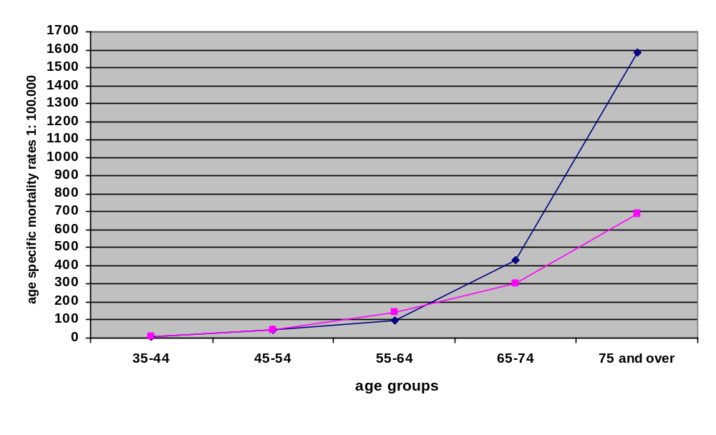Source: (Statistical Office of Montenegro)

The above data clearly show that there is a significant room for deaths from the circulatory system diseases to move “to the right”, i.e. to the older age, which would “save a significant number of years of life” and provide some room for extending the average life duration.

To get more precise data of the burden related to certain disease groups or individual diseases we should have conditions for calculating the new complex indicators like DALY (Disability Adjusted Life Years). This composite indicator indicates to the years of (healthy) life lost due to premature death or due to disability caused by a disease/condition. Apart from the good mortality statistics, calculation of this indicator requires established registers for the key mass noncommunicable diseases, which would provide data on the incidence (the number of diseased per year), prevalence (the number of living persons suffering from a disease) and the age in which the chronic noncommunicable diseases were diagnosed. For now, i.e. before the registers are established and the programme of regular five-year national representative studies of health of Montenegrin population introduced, it is not possible to give any precise data of the number of newly diseased persons suffering from circulatory system diseases or the data for individual entities (for example the number of newly diseased with acute coronary syndrome or cerebrovascular insult – stroke). However, on the basis of the existing health statistics it is possible to identify the disease due to which adults most frequently visit their doctors. According to the available health statistics for 2006, the portion of circulatory system diseases in the total number of diseases that were treated in hospitals is the largest (16.7% of all patients discharged from hospital were discharged with the diagnosis of circulatory system disease). The second place belongs to the digestive system diseases with 11.5%. As for out-patient health services, in 2006 they registered the largest number of respiratory diseases (47.2%) which were followed by urinary-reproductive system diseases (6.8%) leaving the circulatory system diseases on the third place (6.2%).

Montenegro has not yet established any national programme for prevention and control of circulatory system diseases (particularly for the ischemic heart disease and cerebrovascular diseases) which would include the measures of primary prevention and early diagnostics of diseases in general population and among high-risk population (smokers, persons with hypertension, overweight persons, persons with high blood cholesterol and persons suffering from diabetes mellitus), which certainly has a significant impact to the number of newly diseased and premature deaths from circulatory system diseases.

3.1.2. Malignant neoplasms

The estimated 22 million people in the world live with some form of malignant neoplasm. Every year about ten million of newly diseased is registered in the world, 60% in the developing countries.

In Montenegro malignant neoplasms (cancer) are the second frequent death cause immediately after the circulatory system diseases. In 2006 974 persons died from malignant neoplasms in Montenegro. The portion of males in the overall mortality is larger than the portion of females (573 men or 58.8% : 401 women or 41.2%). Standardized mortality rate for 2006 amounted to 209.3 for men and 119.3 for women per 100,000 population (Table 5), while in the same year the standardized mortality rate in Serbia (for both men and women) was much higher – it amounted to 257.8 (men) and 159.0 (women) per 100,000 population. The available data on estimated values of standardized mortality rates per 100,000 population in the selected European states for 2006 are presented in the Diagram 3. On the basis of these data we can say that Montenegro is in the group of countries with medium rate of mortality from malignant neoplasms for men and low mortality rate for women.

Diagram 3 Standardized 1:100.000 mortality rate from malignant neoplasms in the
selected European countries

Source: J Ferlay, P Autier, M Boniol, M Heanue, M Colombet and P Boyle. Estimates of the cancer incidence and mortality in Europe in 2006, Annals of Oncology 2007, Volume 18, No 3: 581-592

In 2006 men in Montenegro died in the largest number from lung cancer, colon and rectum cancer, stomach cancer and prostate cancer, while most frequent death causes for women were breast cancer, lung cancer, colon and rectum cancer, pancreatic cancer, stomach cancer and cervical cancer (Table 5).

Table 5: Most frequent malignant neoplasms causing death with men and women, Montenegro, 2006
M EN |  |  | WOMEN
Localization | Mortality Raw rate per 100,000 | Mortality – standardized rate per 100,000 | Localization | Mortality Raw rate per 100,000 | Mortality Standardized rate –per 100,000
Lungs | 68.0 | 74.9 | Breast | 28.9 | 27.8
Colo-rectum | 13.9 | 15.0 | Lungs | 22.5 | 21.0
Prostate | 12.5 | 15.0 | Colo-rectum | 8.3 | 7.4
Stomach | 9.9 | 11.0 | Uterine cervix | 4.5 | 4.5
 |  |  | Stomach | 2.9 | 2.7

Source: Monstat (Statistical Office of Montenegro)

An interesting thing to mention is that the order of malignant neoplasms was absolutely the same in Serbia for 2006. For men in Montenegro the largest mortality rates are registered for lung cancer (standardized mortality rate for lung cancer was 74.9 per 100,000) while the largest mortality for women was registered for breast cancer (standardized mortality rate amounted to 27.8 per 100.000). However, the problem of mortality from lung cancer has become increasingly emphasized (standardized mortality rate in 2007 was 21.0 per 100,000), which is also the case in other countries where women smoke tobacco in a large extent. Thus in USA the rate of mortality from lung cancer with women is in the last two decades larger than the rate of mortality from breast cancer (Diagram 4.).

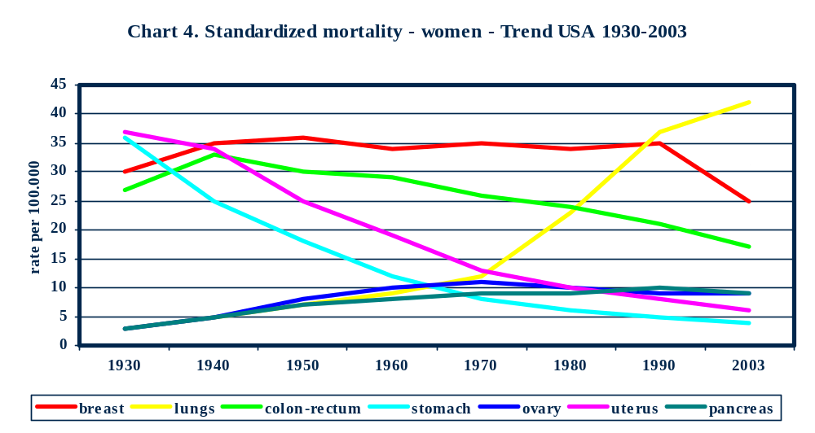 Source: American Cancer Society. Cancer Fact & figures 2007, Atlanta, USA, 2007.

Apart from this, analyzing the number of deaths caused by malignant neoplasms in Montenegro in the last six years shows that the number of deaths caused by malignant neoplasms and their portion in the total number of deaths has not changed to any significant extent (Table 6)

Table 6: Portion of malignant neoplasms in the overall mortality in Montenegro, 2001-2006

 | Number of deaths by disease and their portion in the overall deaths in Montenegro in %
Group of diseases | 2001 | 2002 | 2003 | 2004 | 2005 | 2006
All diseases  Number of deaths | 5412 | 5513 | 5704 | 5707 | 5839 | 5968
Malignant neoplasms  Number of deaths | 881 | 1000 | 967 | 971 | 1026 | 974
Malignant neoplasms  Portion in % | 16,3 | 18,1 | 16,9 | 17,0 | 17,6 | 16,3

Source: Monstat (Statistical Office of Montenegro)

Out of the total number of deaths from malignant neoplasms in 2006, 742 (76.2%) occurred before the age of 75 and 417 (42.8%) before the age of 65. This indicates to the significant problem of premature deaths. This is also confirmed by age specific mortality rates: for the age group 35-44 the mortality rate is 41.9 per 100,000 population; for the age group 45-54 it is about 4.5 times higher (176.6/100,000). For the age group 55-64 there is another increase of two times (385.7/100,000), which continues with the older age groups (65-74 – 651.4/100,000 and over 75 – 751.1/100,000).

Analysis of the age specific mortality rates for the most frequently localized malignant neoplasms (diagram 5) shows that there are significant differences between them in terms of the age in which mortality is the highest. In case of malignant neoplasms of bronchi and lungs and breast the mortality rates are, namely, very high already at the age of 45 – 54, while for the malignant neoplasm of prostate the mortality rate is not emphasized before 65 years of age with the boom in the age of 75 and over 75. For the malignant neoplasms of colon and rectum the age specific mortality rates are more evenly distributed with a significant increase only after the age of 65.

Out of the total number of deaths from malignant neoplasms of bronchi and lung 43.1% occurred before the age of 65, and 80.0% before the age of 75. In case of breast malignant neoplasm this portion is even more emphasized and it amounts to as much as 58.9% before the age of 65 and 81.1% before the age of 75. In case of the malignant neoplasms of colon and rectum, the portion of younger persons in the total number of deaths is slightly lower. Thus, out of the total number of deaths from the malignant neoplasms of colon and rectum 38.2% occurred before the age of 65 and 73.5% before the age of 75.
Diagram 5: Age specific mortality rates for selected malignant neoplasms, Montenegro, 2006
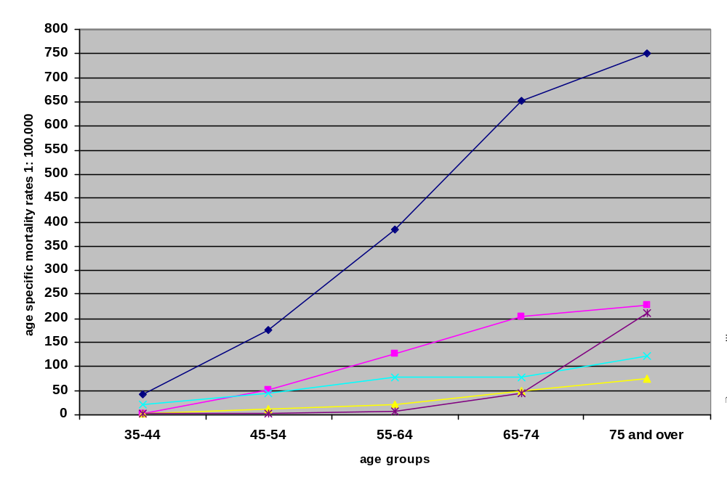
Source: Monstat (Statistical Office of Montenegro)

All the above data indicate clearly to the fact that there is a significant possibility to reduce premature deaths from malignant neoplasms in Montenegro through the implementation of appropriate prevention measures, early diagnosis and adequate treatment.

Given the fact that the combination of avoiding or reducing exposure to risk factors and implementation of protective measures can result in prevention of about 40% of malignant neoplasms and the fact that early detection and appropriate treatment can significantly improve treatment prognosis, the inevitable conclusion is that we must implement all of these measures that are already available.

There are very good and affordable screening methods for early detection of the malignant neoplasms of breast, uterine cervix, colon and rectum and prostate, which significantly influence the number of survivors in USA, for example, where these screening methods are applied. Table 7 presents the impact of early diagnosis and the appropriate therapy to five-year survival within certain groups of malignant neoplasms in USA.

Table 7: Five-year relative survival rate in % in case of malignant neoplasms depending on the stage at diagnosis, USA (1996-2002)

Five-year relative survival rate in %

Site All stages Local Regional Distant
Breast 88.5 98.1 83.1 26.0
Colon and rectum 64.1 90.4 68.1 9.8
Esophagus 15.6 33.6 16.8 2.6
Kidney 65.6 90.4 61.7 9.5
Larynx 64.1 83.5 50.4 13.7
Liver 10.5 21.9 7.2 3.3
Lungs/Bronchus 15.0 49.3 15.5 2.1
Malignant Melanoma 91.5 99.0 64.9 15.3
Oral cavity and pharynx 58.8 81.3 51.7 26.4
Ovary 44.7 93.1 69.0 29.6
Pancreas 5.0 19.6 8.2 1.9
Prostate 99.9 99.9 ---- 33.3

Stomach 23.9 61.9 22.2 3.4

Urinary bladder 80.8 93.7 46.0 6.2
Uterine cervix 71.6 92.0 55.5 14.6
Uterine corpus 83.2 95.7 66.9 23.1

Source: American Cancer Society. Cancer Fact & figures 2007, Atlanta, USA, 2007.

According to the available health statistics for 2006 for Montenegro, the portion of persons with malignant neoplasms in the total number of persons treated in hospitals is very high. Having the share of 8.7% of total discharges from hospital, this was the fourth most frequent reason for hospitalization in 2006 (circulatory system diseases – 16.7%, digestive system diseases – 11.5%, respiratory system diseases – 11.0%).

As for the workload of the outpatient health services, in 2006 in the largest number of cases they were dealing with the health problems belonging to the group of respiratory system diseases (47,2%), while malignant neoplasms with the frequency of 0.53% were at the bottom of the list of reasons for visits to outpatient health services.

So far, Montenegro has not established any national programme for prevention and control of malignant neoplasms which would include measures of primary prevention and early diagnostics of diseases (particularly for malignant neoplasms, with valid and affordable screening tests: malignant neoplasms of breast, uterine cervix, colon and rectum, prostate and skin) in the general population as well as among high-risk populations (smokers, overweight persons, persons with the family history of certain malignant neoplasms). This has a significant impact on the number of newly diseased, total number of diseased and premature deaths from malignant neoplasms.

3.1.3. Diabetes mellitus

Diabetes mellitus is among five leading death causes in most world countries.

Standardized mortality rates per 100,000 population vary in Europe from 5.2 in Greece to 28.6 in Portugal (Diagram 6)

With the standardized mortality rate amounting to 19.1 per 100,000 population both for men and women, Montenegro belongs to the countries with medium rate of mortality from this disease. In the same year the standardized mortality rate in the Republic of Serbia amounted to 23.4 and in Croatia to 17.3 per 100,000 population.

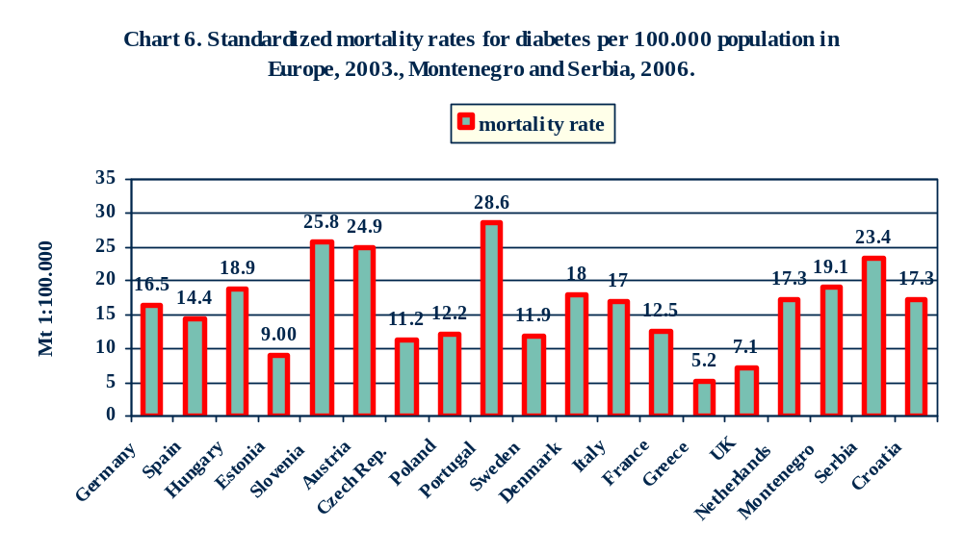
Source: Health for all database, WHO Regional Office for Europe

Out of the total number of deaths from diabetes mellitus in 2006, 58.7% occurred before the age of 75 and 20.7% before the age of 65. The age specific mortality rates for 2006 were as follows: for the age of 45-54 it was very low (4.7 per 100,000 population); for the age 55-64 it grows progressively (about six times) and reaches the value of 27.9/100,000; for the age of over 65 the increase is still significant (for the age group 65-74 the value is 98.2/100,000 and for the age of over 75 it is 206.0/100,000)

The above data indicate to the fact that there is a significant possibility to reduce premature deaths of Montenegrin population caused by diabetes mellitus through the implementation of appropriate prevention measures, early diagnosis and adequate treatment.

The number of deaths caused by diabetes mellitus and its participation in the total mortality has not changed significantly in Montenegro in the last six years (Table 8).

Table 8: Participation of diabetes mellitus in the overall mortality in Montenegro, 2001-2006

 | Number of deaths and participation in the total number of deaths in Montenegro %
Group of diseases | 2001 | 2002 | 2003 | 2004 | 2005 | 2006
All diseases  Number of deaths | 5412 | 5513 | 5704 | 5707 | 5839 | 5968
Diabetes mellitus  Number of deaths | 138 | 121 | 128 | 120 | 122 | 121
Diabetes mellitus  Portion in % | 2,5 | 2,2 | 2,3 | 2,1 | 2,1 | 2,0

Source: Monstat (Statistical Office of Montenegro)

Prevalence of diabetes mellitus on the global level amounted in 2000 to about 2.8%, i.e. about 171 million people in the world lived with diabetes that year. If the current growth trend continues, the projections say that in 2030 the global prevalence will amount to 4.4%, i.e. that about 366 million people in the world will live with diabetes. The current diabetes prevalence in Montenegro has been estimated to about 3%, which put Montenegro into the group of European states with low prevalence (diagram 7).

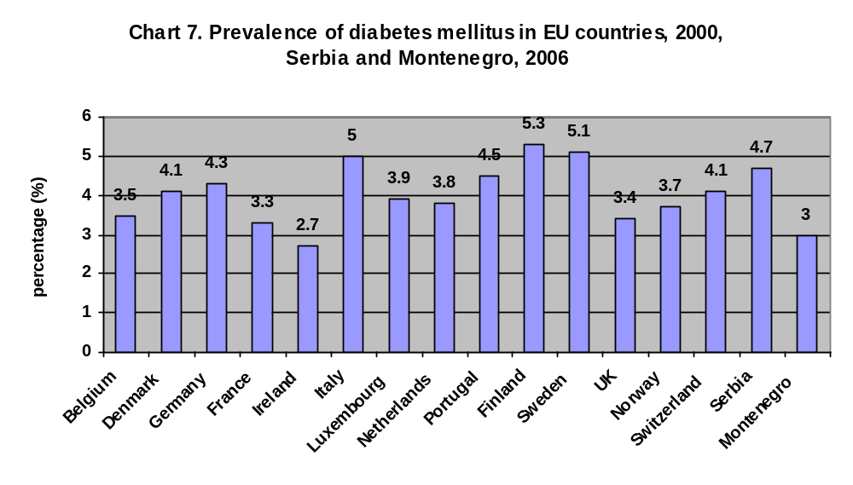Source: Wild S, Roglić G, Green A, Sicree R, King H. Global Prevalence of diabetes: Estimates for the year 2000 and projections for 2030. Diabetic Care 2004, Volume 27: 5:1047-1053.

Diabetes prevalence increases significantly with the age in such a way that age specific prevalence has a sharp increase after the age of 50 reaching the value of as much as 15% in the very old age (Diagram 8).

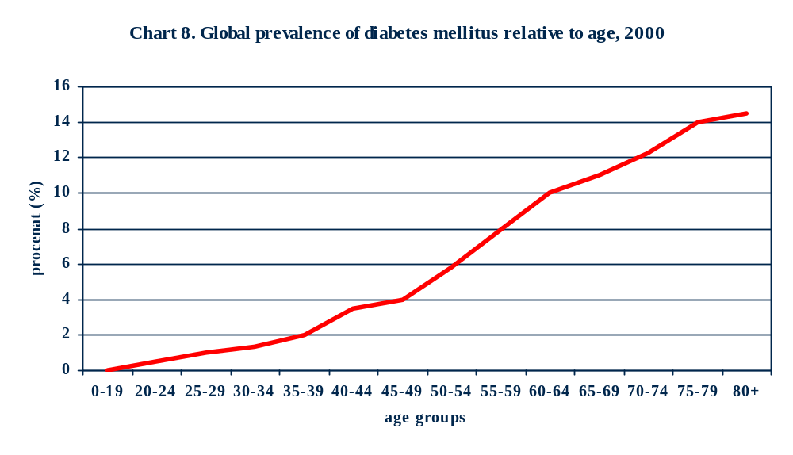
Source: Wild S, Roglić G, Green A, Sicree R, King H. Global Prevalence of diabetes: Estimates for the year 2000 and projections for 2030. Diabetic Care 2004, Volume 27: 5:1047-1053.

Given the fact that prevalence increases with the age, the prevalence of diabetes is frequently presented only for adults, i.e. persons older than 20 (Diagram 9). The diagram shows that further diabetes prevalence growth of 10 to 20% is expected in European countries in the following 20 years
.

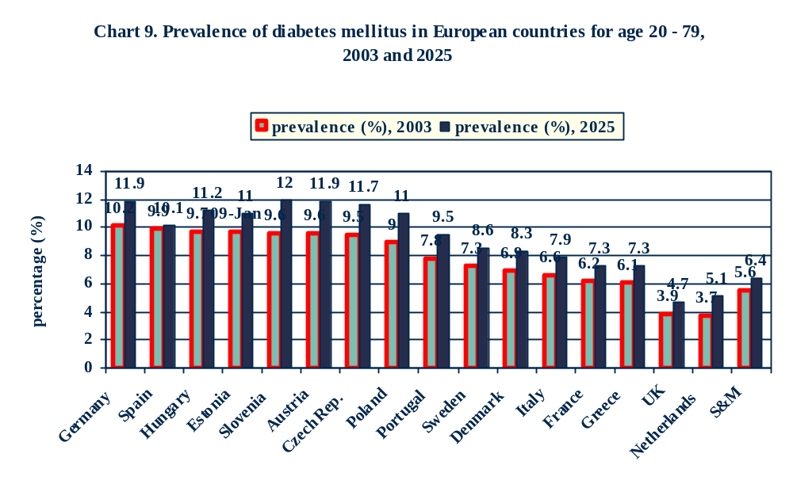
Source: Wild S, Roglić G, Green A, Sicree R, King H. Global Prevalence of diabetes: Estimates for the year 2000 and projections for 2030. Diabetic Care 2004, Volume 27: 5:1047-1053.

According to the available health statistics for 2006, the portion of diabetes mellitus in the number of persons treated in hospitals amounted to 2.9%, while at the same time the portion in first diagnosis in the outpatient services was 1.4%.
So far, Montenegro has not established any national programme for prevention and control of diabetes mellitus which would include measures of primary prevention and early diagnosis of this disease in general population as well as among high-risk populations (overweight persons, persons with the family history of diabetes mellitus). This has a significant impact on the number of newly diseased, total number of diseased and premature deaths from diabetes mellitus.

3.1.4. Musculoskeletal and connective tissue diseases

Musculoskeletal and connective tissue diseases are among significant causes of the loss of years of quality life, but not due to mortality which is very low, but due to morbidity and consequences (disabilities) which are present in many countries. Negative impact of this group of diseases to society stems from their high frequency, long duration and disabilities which come with deterioration of the quality of life, but also with significant costs that result from work incapability of diseased persons and use of health and social protection resources for their treatment and rehabilitation. These health disorders occur in all age groups and are the most frequent disability causes. Still, their frequency increases significantly with age.

In Europe, almost a quarter of adult population has long term musculoskeletal problems and therefore limited daily activities. According to a health research from 2006, 16.8% of adults (older than 20) in Serbia have rheumatic problems; over 40% have or had pains in joints and more than 50% have pains in the back.

In 2006 6.6% of discharges from hospitals in Montenegro were related to this group of diseases. Outpatient services also frequently registered these diseases, so that in 2006 about 27,000 first visits registered in outpatient health services were due to the musculoskeletal and connective tissue diseases (dominantly due to back pains). It was 3.5% of the total number of diagnoses in the outpatient health services that year.

3.1.5. Chronic obstructive respiratory diseases

There are several million people in the world that suffer from chronic respiratory diseases. The estimated 300 million suffer from bronchial asthma and 80 million from other chronic obstructive pulmonary diseases (COPD).

Unfortunately, since Montenegro still does not have any national register of bronchial asthma or any other chronic obstructive pulmonary (respiratory) diseases, it is not possible to identify any incidence or prevalence of bronchial asthma and other obstructive respiratory diseases. It is only possible to say that in 2006 outpatient health services registered a bit over 18,000 first diagnoses related to bronchial asthma and other chronic obstructive respiratory diseases (2.4% of the total number of diagnoses set in the outpatient services) and that the number of these diagnoses has not changed significantly in the last five years.

Mortality caused by these diseases in Montenegro is very low, but they have strong negative effects on the society due to their chronic nature and high costs caused by the work inability of the diseased, absentism and use of health and social services resources for the treatment and rehabilitation of the diseased, as well as indirect costs of sick leaves of parents when their children have such diseases.

So far, Montenegro has not established any national programme for prevention and control of chronic obstructive respiratory diseases which would include measures of primary prevention and early diagnosis of these diseases in general population as well as among high-risk populations (smokers, overweight persons). This has a significant impact on the number of newly diseased and the total number of persons with chronic obstructive respiratory diseases.

Injuries

Although not a proper chronic noncommunicable disease, because many of them are of acute nature, the injuries have a number of risk factors in common with the chronic noncommunicable diseases (alcohol, smoking) and therefore the reduction of these factors can also bring to the reduction in frequency of injuries and mortality caused by injuries. Injuries are among significant death causes in European countries. They can occur in a wide range of situations: at home, during recreation and sports activities, in traffic, at the work place etc.

Intentional and unintentional injuries are among most significant disability causes with the young population, which leads to a huge “loss of years of healthy life”. Currently the rates of mortality caused by injuries vary in European Union Member States from 20 per 100,000 in Baltic states to 129/100,000 in Latvia and 143/100,000 in Estonia. In Montenegro the standardized rate of mortality from injuries and external factors amounted in 2006 to 47.5/100,000. Participation of men in the total mortality from injuries and external factors is much larger than the participation of women (72.7% : 27.3%). Standardized mortality rate for men amounted to 72.0 per 100,000 population, and for women it was 25.3 per 100,000. The largest number of deaths within this group of conditions (50.7%) resulted from of head injuries and chest and abdomen injuries, while the so called other injuries account for 47.6%.

Out of the total number of persons that in 2006 died of consequences of injuries and other external factors, about 90% died before the age of 75, while 77% died before the age of 65. A particularly important data is that out of the total number of deaths caused by injuries and external factors, 26.5% are the deaths of people under 35. These data show that there is a large room for a reduction in the number of premature deaths in Montenegro which can be achieved through implementation of appropriate measures for prevention of injuries.

The number of deaths caused by injuries and external factors in Montenegro in the last six years shows that the number of deaths and their participation in the total number of deaths has not changed significantly, except for the leap in 2006 (Table 9)

Table 9: Participation of injuries as death cause in the total mortality in Montenegro, 2001-2006

 | Number of deaths caused by injuries and their participation in the total number of deaths in Montenegro in %
Group of diseases | 2001 | 2002 | 2003 | 2004 | 2005 | 2006
All diseases  Number of diseases | 5412 | 5513 | 5704 | 5707 | 5839 | 5968
Injuries  Number of deaths | 294 | 236 | 225 | 211 | 225 | 290
Injuries  Portion in % | 4.5 | 4.3 | 4.1 | 3.8 | 4.0 | 4.9

Source: Monstat (Statistical Office of Montenegro)

About 9.0% of all diagnoses at discharge from hospitals in Montenegro were related to injuries and consequences of external factors. Outpatient health services also registered a significant number of patients coming due to injuries and impact of external factors. In 2006 outpatient services registered over 20,500 first visits due to injuries and consequences external factors impact. It was 2.7% of the total number of diagnoses set in the outpatient health services. Within this group the most frequent reason for visiting doctors was the so called “Other specific, non-specific and multiple injuries” with 78.1%. Unfortunately, since there are no specific registers for injuries, it is not possible to get more detailed information about how the injuries occur, i.e. whether they occur as a consequence of traffic accidents, during recreation or sports activities, at work or at home and whether they brought to a certain degree of disability i.e. chronic condition.

A special Strategy for prevention and control of injuries is required because of the importance injuries have in national pathology, their complex nature and the fact that they do not belong to chronic noncommunicable diseases in the proper sense of that term, since they are acute.

3.2. Risk factors

3.2.1. High systolic blood pressure

High systolic blood pressure is one of the most important risk factors for the development of chronic noncommunicable diseases. It is, namely, most consistently linked with deaths both of men and of women and therefore it is taken as a parameter to be monitored in international studies of comparing estimated exposure to risk factors. Age-specific values for systolic blood pressure are similar in all world populations and there are no significant differences between men and women (Diagram 10)

Diagram 10: Standard templates of age-specific values of systolic blood pressure with men and women
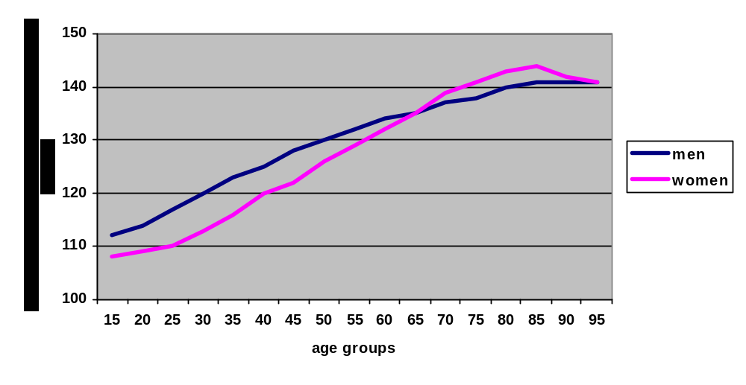Source: World Health Organization. The SuRF Report 2: Surveillance of Chronic Disease Risk Factors. Geneva:
WHO, 2005
Ezzati M at al., eds. Comparative quantification of health risk: global and regional burden of
disease attributable to select major risk factors. Geneva, World Health Organization, 2004.

The largest number of world studies show that the average values of systolic blood pressure increase with age. This correlation can be noticed in the national reports used by the WHO project for surveillance of risk factors on the national level. However, there are also the records (WHO) showing that in several isolated populations systolic blood pressure does not have any growth trend with age. These populations prove that the increase of systolic blood pressure with age is not a physiological phenomenon but that it is connected with the changes in life style which come with age in urban populations and which are connected with the increase of body mass and reduction in physical activity. In principle, the most developed countries, except for USA, saw recently a reduction in the average values of systolic blood pressure, which cannot be explained only by the use of antihypertension drugs, because they are not used by the overall population. It can be explained by significant behavior changes. Unfortunately, East European countries constantly have an increase in the average values of the systolic blood pressure (MONICA project WHO), which is connected with the behavior patterns characteristic for societies in transition.

High blood pressure in the beginning almost always comes without any secondary symptoms, but it brings to structural damages of arteries which supply large parts of human body with blood. These damages can bring to cerebrovascular insults (ischemia or bleeding), ischemic heart disease, kidney damages and other diseases. According to the WHO estimates, high systolic blood pressure is globally responsible for 7.1 million deaths a year.

According to WHO data, 15 – 37% of adult population in the world suffer from high blood pressure, while the prevalence of hypertension with the persons older than 60 is about 50%. On the basis of the data from the research on health condition of Montenegrin population which was in 2000 conducted on the nationally representative sample, the estimated prevalence of high blood pressure in the adult population (over 20) was 37.5% (35.5% in female population and 39.8% in male population). Frequency of high blood pressure increased with the age and thus the lowest prevalence was registered in the age group of 20-34 (15.2%), which was followed by the age group of 35-44 with 29.9% after which the prevalence significantly increased in the age of 45 – 54 (51.0%). The highest prevalence figures were registered in the age group 55-64 (67.9%) and with persons over 65 (67.7%).

Average values of systolic blood pressure amounted to 132.6 mmHg (131.3 for women and 134.1 for men), and of diastolic blood pressure to 81.4mmHg (80.1 for women and 82.8 for men). The values of systolic and diastolic blood pressure recorded the growth trend with the age. Thus, the average values of systolic and diastolic blood pressure amounted for the various age groups to:

Age groups Average values of systolic Average values of diastolic
(years) blood pressure (mmHg) blood pressure (mmHg)

20-34 122.8 76.4 35-44 128.8 80.6
45-54 137.1 84.7
55-64 145.9 87.4
65 and older 148.7 86.8

Apart from the persons established in the research as suffering from high blood pressure, we have also registered a number of persons with normal blood pressure which was the result of the fact that they were taking antihypertension therapy. Since by definition the persons with normal blood pressure but taking antihypertension medicines also belong to the group of persons with high blood pressure, the total figure for the prevalence of hypertension and potential hypertension in Montenegro in 2000 is 43.4%
The study of health condition of Montenegrin population, which is being done on the nationally representative sample and the results of which are expected for December 2008, will offer an updated estimate of high blood pressure prevalence among Montenegrin population. The data on the number of first high blood pressure diagnoses registered in outpatient health services is of key importance for understanding of the dimensions of this problem. 31,518 diagnoses were registered in 2006. It was 4.1% of the total number of conditions established in outpatient health services in 2006. After the acute tonsillopharyngitis (221,518 or 29%), other acute infections of upper respiratory tract (44,723 or 5.8%) and acute bronchitis (42,953 or 5.6%) this is the most frequent diagnosis in outpatient health protection services and it shows the significance of high blood pressure problem in Montenegrin population.

3.2.2. Smoking tobacco

Use of tobacco, including smoking as the most widespread form of tobacco use, is in causal relation with numerous chronic noncommunicable diseases, including the most significant ones like malignant neoplasms, cardio- and cerebrovascular diseases and chronic obstructive pulmonary diseases (COPD). WHO estimates that in 2000 tobacco use caused 4.8 million deaths globally, the most numerous of which were cardiovascular diseases (1.7 million deaths), chronic obstructive pulmonary diseases (1 million deaths) and malignant neoplasms of lungs (0.85 million deaths). According to WHO estimates, tobacco accounts for 4.1% of the total number of years of healthy life lost, this harm being even more significant in the developing countries where people die of these diseases at a much younger age than in the developed world. Smoking tobacco is the most important risk factor for development of malignant neoplasms (risk factor for 15-30% of all malignant neoplasms). The interesting thing is that tobacco is the only product purchased legally which when used in the manner recommended by the producer kills at least a half of its users.

Estimates made on the basis of data collected in the research of health condition of Montenegrin population done in 2000 show that in the adult population (persons over 20) the prevalence of regular smokers (persons smoking every day) was 37.4% (28.5% in the population of women and 47.7 in the population of men). On top of that there were another 6.1% of occasional smokers. A significant data is the data on frequency of tobacco use among school population. The research done in 1999 on the school population of the age 11 – 18 and the Global Youth Tobacco Survey show that smoking is quite strongly present among school children and the young. About 20% of secondary (high) school population regularly smokes tobacco (every day), as well as 4% of children in the age group 11-14 in primary schools. Every third primary school student and every second secondary (high) school student experimented with smoking tobacco. Since it is proven that passive smoking of tobacco has serious impacts on health (according to WHO estimates, in 15 European Union countries as a consequence of passive smoking about 20,000 non-smokers die of cardiovascular diseases and another 1,000 of malignant neoplasm of lungs), the important data from the above research is that more than 90% of children say that they are exposed to tobacco smoke every day in their homes or in public places. The study of health condition of Montenegrin population, which is being done on the nationally representative sample and the results of which are expected for December 2008, will provide an updated estimate of the tobacco use prevalence among Montenegrin population.

Public Health Institute estimates show that every year about 800 – 1000 persons die from the consequences of smoking tobacco.

3.2.3. Excessive alcohol use

Excessive alcohol use causes many health problems which are translated in various consequences like traffic accidents, domestic violence, chronic diseases and numerous other social problems coming with alcoholism. Problem with alcohol, unlike tobacco, is in the fact that moderate alcohol consumption is beneficial in case of cardiovascular and cerebrovascular diseases and diabetes mellitus (in France there is a convenient pattern for using alcohol, mostly wine, with food, i.e. wine is considered a food product). Still, excessive alcohol use and se of alcohol in form of intoxicants (characteristic for some states, particularly Scandinavian, where spirits are used without any food, frequently just for the purpose of intoxication) causes diseases like liver cirrhosis, cardiovascular diseases and certain malignant neoplasms. According to the WHO estimates, the excessive alcohol use participates in the total number of deaths globally with 3.2%, while in the European Region (with the largest alcohol use per capita – about 7.3 liters of pure alcohol per capita) alcohol use as a death cause in the total number of deaths is about three times bigger than on the global level.

In Montenegro there are no precise data on prevalence, i.e. on the total number of persons with excessive alcohol use, but on the basis of the data from the research on health condition of Montenegrin population from 2000 it can be estimated that in 2000 in the adult population (persons over 20) the prevalence of persons that use alcohol every day was 2.7% (0.4% women and 5.6% of men). Prevalence of persons that use alcohol every day was the highest in the age group 45-54 and it amounted to 5.2%.

Prevalence of persons that use alcohol occasionally amounted to 26.7% (8.6% women and 47.5% men). The percentage of persons claiming that they used to drink alcohol but do not use it any more was 5.7% (0.8% of women and 11.4% of men). The study of health condition of Montenegrin population, which is being done on the nationally representative sample and the results of which are expected for December 2008, will provide an updated estimate of alcohol use among Montenegrin population.

3.2.4. Poor nutrition

Epidemiological studies have for a long time now been indicating to the fact that diet characterized by high intake of fruit and vegetables significantly reduces the probability of development of certain malignant neoplasms and cardiovascular diseases. Insufficient fruit and vegetable intake is namely an independent risk factor for malignant neoplasms of stomach, colon and rectum, esophagus and lungs, as well as for cardiovascular diseases. On the basis of comparative international studies, WHO has estimated that the minimum fruit and vegetable quantity to be taken daily by an adult is about 600 grams. For children at the age of 5 to 14 it is about 480 grams, while it is 330 grams for children of the age of 1 to 4. One should take five meals a day which include fruit and vegetable, one meal containing about 80 grams of fruit and vegetable. According to the WHO estimates, the total mortality related to the insufficient fruit and vegetable intake on the global level is 2.7 million deaths.

A particular problem is poor nutrition which means the increased intake of salt, concentrated sugar and saturated fats which increase the risk of high blood pressure and diabetes, which in turn are the risk factors for development of various diseases, primarily cardio and cerebrovascular diseases. For now, there are no national representative data in Montenegro on quality and quantity of intake of various food products and their components. This gap is to be bridged very soon by a specialized nutrition research.

3.2.5. Insufficient physical activity

Regular moderate physical activity brings to numerous health benefits, including the body mass regulation and strengthening of cardiovascular and respiratory system. Measuring the level of physical activity or inactivity in population is rather difficult but the WHO project on monitoring and comparing risk factors estimates that physical inactivity significantly contributes to development of certain diseases:

- 21.5% ischemic heart diseases,
- 11% cerebrovascular insults
- 14% diabetes mellitus
- 16% malignant neoplasms of colon and rectum
- 10% malignant neoplasms of breast

On the basis of the knowledge we have had so far, WHO recommends that every day at least 30 minutes of moderate physical activity are necessary (for example walking or cycling).

Estimates made on the basis of data from the research on health condition of Montenegrin population for 2000 show that among the adult population (persons over 20) the prevalence of persons that do physical exercises every day to such an extent that they sweat or briefly loose breath was 9.1% (6.9% women and 11.5% men). The frequency of regular daily physical exercises was the highest in the age group 20-34 – 13.1% and the lowest in the age group of over 65 – 60%). Prevalence of persons doing physical exercises 4 – 6 times a week was 4.2% (2.5% of women and 6.0% of men) and prevalence of persons who were exercising 2 – 3 times a week was 10.1% (7.9% women and 12.6 men). 14.9% of persons were exercising once a week (13.6% women and 16.4% men). Thus, about 61.8% i.e. 76.5% persons (excluding those that exercise only once a week) were insufficiently active in 2000 (13.8% of them were not capable of exercising due to illness or disability). The study of health condition of Montenegrin population, which is being done on the nationally representative sample and the results of which are expected for December 2008, will provide an updated estimate of physical activity prevalence among Montenegrin population.

3.2.6. Overweight/obesity

There are various indicators to be used in estimating of whether a person is overweight or not. One of the simplest is Body Mass Index – BMI defined as the weight in kilograms divided by the square of the height in meters (kg/m2 ). A BMI over 25 kg/m2 is defined as overweight, and a BMI of over 30 kg/m2 as obese.
Diseases that are more frequent with people who are overweight or obese are:

- diabetes mellitus type 2
- hypertension
- ischemic heart disease
- cerebrovascular insult
- osteoarthritis
- malign neoplasms of colon, kidney, uterine cervix and post-menopause malignant breast neoplasm
Results of national research collected by WHO show that in the world there are currently 300 million obese persons and that over 750 million people are overweight. Number of persons who are overweight is on the increase in every country in the world (Table 10). According to the WHO estimates obesity and overweight are responsible for about 2.5 million deaths globally.

Table 10: Portion of overweight for men and women in selected countries with the estimates for 2010

Country | Overweight %  Male |  |  | Overweight %  Female
Country | 2002 | 2005 | 2010 | 2002 | 2005 | 2010
Brazil | 43.4 | 47.4 | 54.0 | 49.2 | 53.5 | 60.3
Austria | 59.0 | 61.0 | 62.9 | 53.4 | 53.2 | 55.2
Algeria | 32.1 | 34.1 | 37.4 | 43.2 | 45.6 | 49.4
Germany | 63.7 | 65.1 | 67.2 | 53.6 | 55.1 | 57.1
Croatia | 60.0 | 61.3 | 63.5 | 45.3 | 46.4 | 48.3
Norway | 53.3 | 54.8 | 57.2 | 42.0 | 43.4 | 45.8
Sweden | 51.7 | 54.5 | 57.0 | 43.3 | 44.9 | 47.2
France | 44.1 | 45.6 | 48.0 | 33.4 | 34.7 | 36.9
Greece | 74.6 | 75.7 | 77.5 | 60.1 | 61.3 | 63.2
China | 27.5 | 33.1 | 45.0 | 22.7 | 24.7 | 32.0
USA | 72.2 | 75.6 | 80.5 | 69.8 | 72.6 | 76.7

Source: World Health Organization. The SuRF Report 2: Surveillance of Chronic Disease Risk Factors. Geneva: WHO, 2005

Estimates made on the basis of data from the research on health condition of Montenegrin population for 2000 show that among the adult population (persons over 20) the prevalence of overweight persons was 34.8% (27.2% women and 41.9 men), while the prevalence of obese persons was 12.8% (12.1% women and 13.3 % men). The data that in 2000 47.6% of adult population (39.3% women and 55.2% men) in Montenegro were overweight to a certain extent, shows that the problem of overweight among adults is strongly present in Montenegro. In the recent research of the bodyweight of school children of the age 6 – 11 done by the Public Health Institute, 29.5% of school pupils belonging to this age group were overweight. The problem of overweight is more strongly emphasized with boys (36.6%) than with girls (22.4%).

The study of health condition of Montenegrin population, which is being done on the nationally representative sample and the results of which are expected for December 2008, will provide an updated estimate of overweight prevalence among Montenegrin population.

3.2.7. High blood cholesterol

High blood cholesterol is related to hereditary disorders, diabetes mellitus and diet rich with saturated fats. High blood cholesterol increases the risk of cerebrovascular insults, ischemic heart disease and other vascular diseases.

According to the WHO estimates, high blood cholesterol is responsible for 4.4 million of deaths in the world every year. The distribution is the following:

- 40% for developed countries
- 20% for developing countries characterized by low mortality rates
- 20% for developing countries characterized by high mortality rates

For now, Montenegro does not have any precise data on prevalence, i.e. the total number of persons with high blood cholesterol, because no prevalence study has been done on the nationally representative sample.
The study of health condition of Montenegrin population, which is being done on the nationally representative sample and the results of which are expected for December 2008, should provide a valid estimate of high blood cholesterol prevalence among Montenegrin population.

  - Demographic and social and economic determinants that have an impact on development of chronic noncommunicable diseases

3.3.1. Demographic changes

Demographic changes in European countries, manifested in the process of population aging, represent an additional challenge in economic, budgetary and social sense. In Western Europe the number of people over 65 has more than doubled since the 1950s, while the number of those over 80 has quadrupled. Although this can be considered a triumph of public health systems it also poses a particular challenge for the health and social sector. Predictions are that the ratio of elderly, economically inactive people (over 65) to people of working age could become extremely unfavorable in Europe. It is therefore extremely important that people remain healthy and independent to as late in life as possible so that premature deaths among the middle-aged working population are avoided and morbidity is “compressed” towards the end of life.

According to the last census from 2003 portion of Montenegrin population older than 65 in the total population was about 12% (10.5% among men and 13.4% among women) and it shows the constant growth trend, similar to other European countries: Austria (16.7%), Croatia 17.3%), France (16.3%), Germany (18.3%), Greece (18.5%). According to the census from 2002, the portion of persons older than 65 in the overall population amounted in the neighboring Serbia to 14.4% among men and 18.6% among women.

The last available data (Monstat) on life expectancy of live born in Montenegro were in 2004 73.3 years (69.8 for men and 76.1 for women). These values are much lower than the average in developed European countries (for men 76 to 79 and for women 80 – 84, which is a bit under 80 for both genders), but they are on the same level as in the Balkan states and surrounding (Diagram 11).
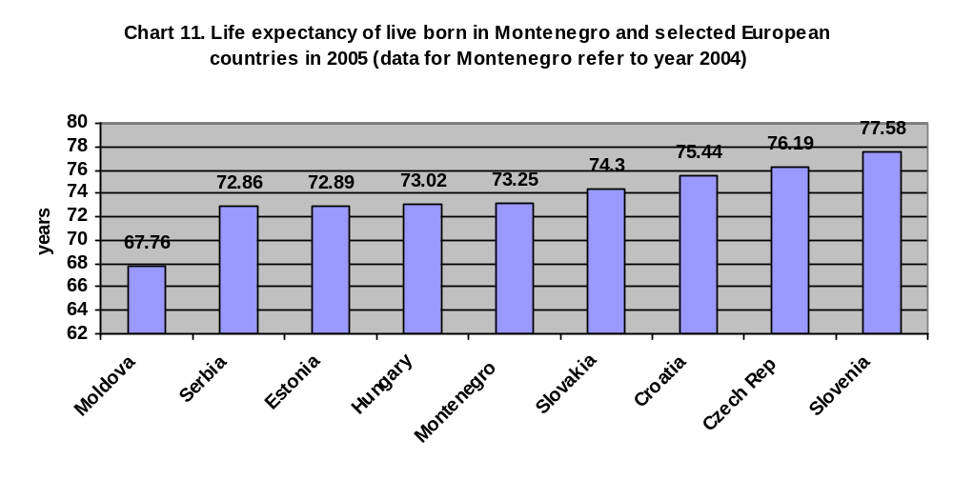Source: Health for all database, WHO Regional Office for Europe

3.3.2. Poverty

Poverty, usually defined as insufficiency of means for satisfying substantial needs, is a very complex phenomenon which is more or less reflected in the impossibility of employment, dissatisfactory housing, inadequate health and social protection, education and communal services, rights to healthy environment not exercised etc, which put an individual or a family into a dissatisfactory social and economic position. Due to everything stated above, poverty is an important determinant for development of chronic noncommunicable diseases. Long time ago people observed that majority of poor individuals and families have inadequate diet, that they are more susceptible to numerous bad habits (for example tobacco and alcohol use), living in inadequate conditions etc, which brings to the fact that poor people more frequently suffer from chronic noncommunicable diseases. The increased blood pressure, for example, according to the latest data from a research done in Serbia, was more frequent with people who had lower education levels (62.7%) as well as with the poorest (53.1%). According to the latest research of poverty in Montenegro (Monstat) the estimated 11.3% of population is poor, the largest percentage of the poor living in the North of Montenegro (18.3%).

All the societies undergoing the process of social and economic transition face the phenomenon of poverty. Montenegro is no exception to that rule. Therefore, the activities undertaken in Montenegro in the field of poverty reduction, which are to be intensified, are at the same time the activities aimed at reduction of morbidity and mortality from chronic noncommunicable diseases. Growth of Gross Domestic Product, reduction of unemployment rate and growth of personal incomes are very important indicators of undertaken activities. In Montenegro they show a positive trend. According to the data of Montenegrin Employment Office, in 2000 Montenegro had 86,163 unemployed persons, unemployment rate being 32.7%, while in June 2008 it had 29,876 registered unemployed persons and unemployment rate of 11.34%.

3.3.3. Education

According to the last census data from 2003, Montenegro had 12,617 registered illiterate persons, which was 2.3% of the total population. On the level of Europe, the percentage of illiterate persons is about 1.5%. Out of the total number of illiterate persons 8,714 or 69% are older than 65. 7,882 or 90.4% of them are women. Literacy is very high among young population and it is equally distributed on both genders. Currently, the largest portion of population in Montenegro has high (secondary) school diplomas (48.4%), followed by primary school education (22.9%), college (9.6%) and university degree (7.5%) The important thing to mention is that census after census we can see the trend of growth in the number of young people with college and university diplomas.

Apart from the positive literacy trend in Montenegro, an important thing to mention is that a significant progress has been made in the reform of education system. To a large extent the basic principles of the reform are in compliance with the programmes of prevention and control of chronic noncommunicable diseases (adoption of the inclusive education strategy with a particular focus on children with special needs – the implementation of which is in progress in some schools; curriculum “Healthy Life Styles”; full-day stay in school etc.). However, there are still some problems that are directly connected to prevention and control of chronic noncommunicable diseases. These problems are to be solved in the near future:

- Insufficient number of schools (network of schools does not follow demographic changes), which causes that some schools have too large number of students and therefore have to organize their work in shifts, which in its turn makes impossible to carry out all the programmes planned in the reform
- Inadequate equipment, no modern teaching tools and materials necessary for organizing modern forms of teaching;
- Still not fully achieved integration of marginalized groups, primarily Roma and children with special needs into the education system;
- Insufficient number of appropriate activities for high school and student population with a special focus on health education and acquiring social knowledge and skills that will help future generations in the daily challenges they have to face

3.3.4. Globalization and urbanization
Among other things, globalization is associated with the trend for populations in low- and middle-income countries to consume unhealthy diets high in energy, saturated fats, salt and sugar. Slowly, people in many countries are becoming dependent on only a few retailers for their daily purchases of food, and local markets are disappearing; this trend started in Western Europe and is now seen in parts of Eastern Europe. The growth of trade agreements, common markets and transnational marketing of tobacco and alcohol undermines the efforts of government to exert effective controls on their supply and availability.

Urbanization has been increasingly present in all countries. Urban populations are becoming increasingly sedentary, for example from rapidly increasing levels of motorized transport, urban sprawl and reduced opportunities for daily physical activity in housing, occupational and school settings. Our modern “obesogenic” environments, with the combination of unhealthy diet, usually high in energy, physical inactivity and stress, have serious implications for the growth of numerous risk factors (obesity, high blood cholesterol and sugar in the blood, high blood pressure) which in their turn increase the possibility of development of cardiovascular disease, diabetes mellitus and malignant neoplasms.

According to the last Census from 2003, urban population is 62% of the total Montenegrin population while 38% is rural population. Urban population shows a trend of growth.

3.3.5. Problems in health services orientation

Health promotion and prevention of NCD have a relatively small share of the health system budget in most countries of the world. According to the Organization for Economic Co-operation and Development (OECD), on average only 3% of total health expenditure in OECD countries goes toward population-wide prevention and public health programmes, while most of the spending is focused on “sick care.” National programmes of early diagnosis of diseases are insufficiently wide-spread. Up to 50% of people suffering from diabetes mellitus are considered not to have the diagnosis in the early stage, which increases the possibility of numerous complications this disease causes. About 30,000 women die each year from uterine cervical cancer in Europe, most frequently due to the fact that the disease was not identified in time because there are no screening programmes for this disease. This problem is particularly present in the countries of Central and Eastern Europe where death rates are between two and four times higher than in the Western European countries.

One of the reasons for insufficiently developed and financed programmes of prevention and control of NCD is the lack of capacities for the adequate system of monitoring and evaluation of the NCD problems. Just like many other countries, Montenegro does not have a satisfactory health-information system which would provide high-quality information to institutions that are to set priorities on the basis of these information, pass decisions for development of individual programmes and allocate funds for their implementation. Apart from collecting data on health condition of population, health-information systems should analyze data on diseases by age, gender or ethnic affiliation in order to facilitate detection of potential health inequalities between certain population groups. Given the multi-factor etiology of chronic noncommunicable diseases, it is important to collect data about the most important social, economic and environmental health determinants as well as about the most important risk factors. Since it is possible to get certain data just through complex research methods on nationally representative samples, we need to ensure funds for strengthening capacities of health institutions to do such research and we need to ensure implementation of the research.

Apart from the above, the availability of health protection in form of continuous provision of health protection in all forms and on all levels (prevention, treatment and rehabilitation) and in line with the needs of the community is of huge importance for the implementation of all planned programmes in the field of public health. For the implementation of the Strategy and specialized programmes of prevention and control of certain NCD that are yet to be developed, we will need to strengthen health service capacities and ensure their appropriate geographic distribution with the view of better availability of health services, which is a precondition for the full implementation of the programme of primary, secondary and tertiary prevention and appropriate treatment of certain NCD in the whole territory of Montenegro.

3.4. Conclusions of the analysis

- Montenegro is in the period of social and economic transition which is convenient for inadequate life styles i.e. exposure to certain risk factors that contribute to the increase of chronic noncommunicable diseases;

- The portion of NCD in the total number of deaths in Montenegrin population is about 75%. NCD are currently the most significant cause for incapability for work, disability and premature deaths.

- Significant loss of years of life due to premature deaths, as well as significant disabilities and absentism caused by NCD, make a heavy economic burden for Montenegro

- Portion of population over 65 is relatively high in Montenegro and it has the trend of growth which will inevitably impact the growth of morbidity and mortality caused by NCD;

- Although having many positive characteristics, globalization processes, the effects of which are increasingly visible in Montenegro, as well as the increasingly present urbanization, will also have the effect of increase in NCD;

- Risk factors listed by WHO as important for development of major NCD which can be prevented are largely present among Montenegrin population;

- System for monitoring chronic noncommunicable diseases is insufficiently developed (there are no registers for the key NCD) and therefore there are no precise data on incidence and prevalence of the major NCD;

- Apart from a few exceptions, multisectoral programmes for health promotion and prevention of diseases, particularly NCD, are not sufficiently developed and organized;

- National programmes for health education of citizens through electronic and printed media are insufficiently developed and therefore citizens are insufficiently informed about the health determinants and risk factors for development of NCD;

- National screening programmes for early diagnosis of the key NCD recommended by WHO and EU are not developed and established;

- National recommendations and national clinical guidelines for treatment of the key NCD are not established and implemented.
4. Potentials for health promotion, prevention and treatment of chronic noncommunicable diseases

Experiences of certain countries prove that there are effective interventions for the prevention and control of NCD. It is possible to reduce or modify numerous risk factors; prevent the onset or significantly slow down or even prevent progression of disease by early detection, appropriate treatment and increasingly effective rehabilitation. Experiences of the countries like Finland, Austria, Canada, Poland and Great Britain show that from the moment of the full implementation of the programme of prevention and control of chronic noncommunicable diseases the rate of mortality caused by the key noncommunicable diseases is expected to fall by about 2% a year. This means that at least 5 or 10 years should pass before there are any significant changes in the mortality rates.

In its Strategy for Prevention and Control of Noncommunicable Diseases for the countries of the European region the World Health Organization lists the following possibilities for promotion of health and prevention of disease, disability and premature deaths:

- It has been proven that there are effective interventions for prevention and control of NCD, prevention having the greatest potential for reduction of NCD. It is not always necessary to wait for decades to achieve the effects of the preventive programmes. Reduced exposure to risk factors can bring to improvements in health relatively quickly. This can be illustrated by national trends for certain health disorders. Finland and Ireland are excellent examples. Thanks to significant reduction in the major risk factors (smoking, cholesterol and high blood pressure), the mortality from ischemic (coronary) heart disease was reduced for almost 60% during 1972–1992. In Ireland the reduction amounted to 48.1% during 1985–2000. The examples of countries like Finland and Ireland show that there are great potentials in the programmes of health promotion and primary prevention. Preventive programmes have to be present simultaneously on population and individual level. The reasons for such good results Finland achieved in the reduction of the rate of mortality from coronary heart disease (Diagram 12) lie in the comprehensive multisectoral activities Finland undertook on the level of health promotion, primary, secondary and tertiary prevention and appropriate treatment measures. About 75% of the total reduction in the rate of mortality from coronary heart disease result from the well planned and undertaken measures of prevention aimed at elimination or reduction of exposure to the major risk factors. 25% of the mortality rate reduction results from the modern therapy. Good examples of reduction in diabetes can be found in several states: Incidence of the type 2 diabetes was reduced for 60% in Finland and USA and for over 30% in China. Prevention in general population is a sustainable long term strategy and it simultaneously affects risk factors common to several noncommunicable diseases. In several countries simultaneous interventions on smoking, nutrition and physical activity have resulted in effects on reduction in NCD morbidity and mortality. The example of the neighboring Serbia is encouraging – thanks to the comprehensive action of the state which made tobacco control its priority, prevalence of smoking among adults during 2000 – 2006 was reduced for 6.9%. In the same period smoking was also reduced among the young of the age group 15 - 19 from 22.9% to 15.5%.
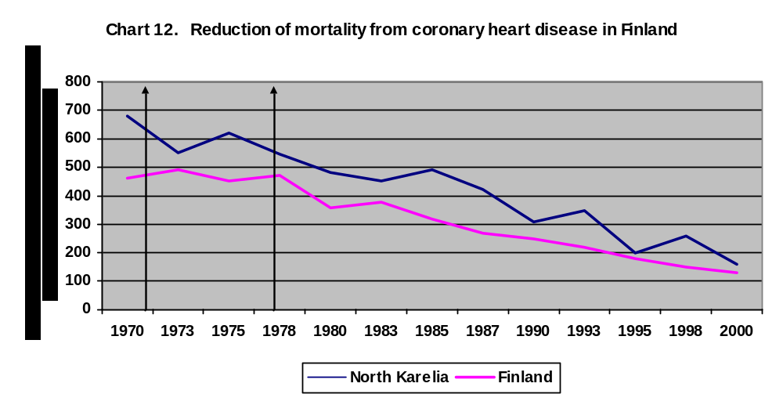
- Attention should be focused on reducing health inequalities. Interventions tackling the wider health determinants like economic growth, income inequalities and poverty, as well as education, the working environment, unemployment and access to health care, represent the main options for substantial health gains. These broad range of population wide measures require broad societal efforts, with both health and non-health sectors working together. The health sector needs to reach out to different sectors of society to make them more aware of the role they play in determining certain conditions and the responsibility they bear for their improvement. By their nature, efforts to reduce social inequalities in health should mainly be regarded as integral to social and economic policies, rather than separate activities targeted at health inequalities.

- Prevention needs to take place simultaneously at the population level and at the individual level. Unless people at high risk are treated, there will only be limited impact on morbidity and mortality from NCD in the short to medium term, i.e. significant results can be expected only in the long run. In individuals with impaired glucose tolerance, who are at high risk of developing diabetes, an intensive lifestyle modification programme can reduce the risk of diabetes by 58%, and pharmacological intervention (application of appropriate medications) can reduce the risk of diabetes by 31%. Thus, combining preventive measures at the population level (for example developing healthy life styles with the young or modification of inadequate life styles with the young and adults) with the same measures applied in the high risk population and using the modern and effective therapies will produce much better results much sooner

- Medical screening can prevent disability, reduce mortality and improve quality of life, if it is effectively implemented and if effective, affordable and acceptable treatment is available to those who require it, according to the screening results. Screening, and then treating individuals for elevated risk of cardiovascular disease using an overall or total risk approach, which takes into account several risk factors at once, is more cost-effective than focusing just on individual risk factors. In countries with sufficient resources to provide appropriate treatment, it is also effective to introduce mass screening of individuals for early detection of breast and uterine cervical cancer. In the countries in our region development of national screening programmes for certain malignant neoplasms has already started. Thus Croatia made the national programme for screening of uterine cervical cancer and introduction of mass screening for detection of breast cancer and colon and rectum cancer is planned for the near future. In Serbia a programme for screening uterine cervical cancer has been prepared and all preconditions for its implementation created. There is a plan to introduce mass screening for detection of breast cancer very soon. There are plans for introducing screening for detection of the cancer of colon and rectum as well. Although the reduction and control of risk factors and health determinants are in the foundations of prevention and control of NCD, the tests for detecting disorders on the level of genes are envisaged only in 5 – 10 years. They will provide us with the possibility to identify persons with the genetic predisposition for certain diseases and to apply interventions before the symptoms appear.
- Preventive interventions need to be combined with efforts to strengthen health protective factors that can improve people’s resistance to risk factors and disease. Some of very successful examples are promoting a good start in life programme (Programme of baby-friendly and mother-friendly birth centers, Programme of exclusive breast-feeding; Programme of improvement of social environment in schools (“Healthy Schools”); Programme of improvement of social environment and conditions of work at the work place (“Healthy work places”). Programmes of improvement of social environment in the community (“Healthy Towns”). A particular attention also should be paid to development and enhancement of the programmes for social support to elderly people. In schools and companies that educate and employ young people and adults focus should be put on the techniques and social skills aimed at adequate problem solving, prevention of disease, stress management etc. There are several strategies and action plans recently adopted in Montenegro that have their bases in the combined effects of preventive activities and strengthening of health protection factors, for example: National Plan of Action for Children, National Plan of Action for the Young, Mental Health Development Strategy; Violence Prevention Strategy, Action Plan for Prevention of Drug Addition, Tobacco Control Strategy.
- Focusing on evidence-based and cost-effective interventions, and improving the quality of interventions. In disease management, effective interventions exist for reducing morbidity, disability and premature mortality. Treatment of stroke, for example, through stroke unit care, has been shown to reduce the proportion of those dying or dependent on others by 25%. The challenge lies in the ability of health systems to adopt effective interventions on a large scale – although the quality of care can be improved even in low-resource settings.
- In improving the management of chronic diseases, programmes need to take account of both common approaches to chronic care and disease-specific approaches for greatest benefit. Using the models of many European countries, our neighbors, Serbia and Croatia, made guidelines of good practice for treatment of certain NCD. More attention is paid to the active participation of patients in treatment, which can improve health outcomes. Due to extension of life duration an increasingly large number of people have one or several NCD, the development of which is contributed to by urbanization, adoption of unhealthy life styles as well as media advertising the life styles that bear health risks. Given the high degree of co-morbidity, priority should be given to care that is oriented to overall patient needs. In this, the primary care physician plays an important role in providing integrated care. All of these require a reorganization of the health systems world-wide so that they can cope with the increased NCD burden. Reform of the health system in Montenegro is in progress. Among other things the reform is an attempt to deal with the above challenges.

In summary, overall the greatest potential for health gain lies in a comprehensive strategy that simultaneously promotes population-level health promotion and primary, secondary and tertiary prevention of NCD which actively targets groups and individuals at high risk, while maximizing population coverage with effective treatment and care.

5. Legislation framework for the adoption of the Strategy and the existing strategic documents

The Strategy is based on the basic principles and values emphasized in the international documents:

- WHO Gaining Health. The European Strategy for the Prevention and Control of Noncommunicable Diseases. Copenhagen, WHO 2006.;
- Health for All in the 21st Century – “21 Targets for the 21st Century”, 1999;
- Helsinki Mental Health Declaration and Mental Health Action Plan, 2005 ;
- European Strategy for Tobacco Control, 2002 ;
- European Action Plan for Food and Nutrition Policy, 2000 ;
- European Framework for Alcohol Policy, 2005;
- European Strategy on Health of Children and Adolescents, 2005 ;
- Children’s Environment and Health Action Plan for Europe, 2004 ;
- Global Strategy for Infant and Young Children Feeding, 2002 ;
- Global Strategy on Diet, Physical Activity and Health, 2004

And national legislation and other strategic documents:

- Law on Health Protection – Official Gazette of the Republic of Montenegro 39/04, Article 10;
- Law on Health Insurance – Official Gazette of the Republic of Montenegro 39/04, Article 17;
- Health Policy in the Republic of Montenegro by 2020, 2001.
- Law on Restriction of Tobacco Use, 2004
- Law on Food Safety, 2007
- Health Care Development Strategy, 2003
- Poverty and Social Exclusion Reduction Strategy, 2007
- National Strategy of Sustainable Development of Montenegro, 2007
- National Strategy for Tobacco Smoking Control, 2005;
- Strategy for Health Food Safety, 2006;
- National Action Plan for Children, 2006;
- National Action Plan for the Young
- Mental Health Improvement Strategy in the Republic of Montenegro, 2006;
- Strategy for Prevention of Violence, 2005;
- National Strategic Response to Drugs, 2008

6. Strategy guiding principles

The principles of the Strategy have been harmonized with the European Strategy for the Prevention and Control of Chronic Non-communicable Diseases and with the “Health for All” policy framework for the WHO European Region. As such, it shares the vision of health as a fundamental right, which can be exercised through five key principles that should guide policy development at all levels in a country:

- The ultimate goal of the health policy is to achieve the full health potential of everyone.

- Closing the health gap (reducing inequality in health) contributes to better public health.

- Participation of an individual and the community as a whole, are crucial for health development of an individual and the nation.

- Visible health development on the national level can be achieved only through multisectoral strategies that address health determinants.

- Every sector of society is accountable for the health impact of its own activities.

The policy implementation in line with these five principles can lead to the achievement of the Health for All vision and the WHO definition of health reading “Health is a state of complete physical, mental and social well-being and not merely the absence of disease or infirmity”. In this way, health policy is much more than just patient care.

The Government has been recognized as responsible to act on social, economic and environmental determinants of health, i.e. to provide the enabling conditions that make health opportunities, and ultimately lead to the preservation and improvement of the national health since this is not only one of the most important objectives and responsibilities of the state, but also the most significant prerequisite for development of an effective and efficient economy.

7. Strategic approach

- The Strategy unifies the principles of prevention and control of chronic non-communicable diseases. It aims to balance action on the avoidable causes of disease, disability and premature death with action to improve the health outcomes and quality of life of those already suffering from disease. The strategy seeks to prevent or modify risk factors; prevent onset or progression of disease; prevent disability; and prevent painful or premature death.

- The Strategy covers all those chronic non-communicable diseases (cardio- and cerebrovascular diseases, malignant neoplasm, diabetes mellitus, chronic obstructive respiratory diseases) linked by common risk factors and their social, economic and environmental determinants and opportunities for prevention. This approach (prioritization and focusing on the most important chronic non-communicable diseases and common risk factors for their development) is considered today to be the most effective and most efficient since by acting on risk factors that can be modified or avoided, concurrently the problem is resolved of a larger number of chronic non-communicable diseases.

The Strategy promotes population-level health promotion and disease prevention programmes, actively targeting groups and individuals at high risk, and maximizes coverage of Montenegrin population with effective treatment and care.

8. Vision, goals, objectives and key messages of the Strategy

Vision:

Montenegro free of preventable chronic non-communicable disease, premature death and avoidable disability.

Goal:

To reduce the number of premature deaths and significantly reduce the disease burden from NCD (incidence and disability) by taking integrated action, improving the quality of life and extend healthy life expectancy for all Montenegrin citizens. By the year 2020, reduce mortality with the population under the age of 65 from the most significant NCD (cardio- and cerebro-vascular diseases, malignant neoplasms and diabetes mellitus) by 20% and extend life expectancy 3-5%.

Objectives:

- Create social, economic and environmental setting convenient for the elimination or reduction of the exposure of Montenegrin population to risk factors for the key NCD through the application of healthy lifestyles (behaviour patterns).

- Improve and strengthen health system in Montenegro for improved prevention and treatment of NCD.

Strategy key messages

Key messages are harmonized with the messages of the European Strategy for the Prevention and Control of NCD.

- Prevention through life is effective and must be regarded as an investment in health and development. It needs to be started as early as possible, even in pre-conception and prenatal period.

- Society should create health-supporting environment, making healthy choices more easily accepted as appropriate ones.

- Health and medical services should be fit for purpose, responding to the present disease burden and increasing opportunities for health promotion.

- People should be empowered to promote their own health, throughout their entire lives, interact effectively with healthcare services and be active partners in managing disease.

- Universal access to health promotion, disease prevention and health services is central to achieving equity in health.

- Governments at all levels have the responsibility to build healthy public policies and ensure synchronous action across all sectors.

9. Framework for action

The Strategy for the Prevention and Control of NCD is based on a comprehensive approach and inter-sectoral cooperation as the prerequisites for the success of the proposed activities, recognizing the priority areas for action:

Advocacy for health

Knowledge and information (improvement of knowledge on chronic non-communicable diseases and risk factors for their development and dissemination to the population),

Regulation and financing

Capacities - High quality and appropriately oriented health protection

Community support.

9.1. Advocacy for health

Advocacy for health is a combination of individual and social actions designed to gain political and social commitment, support to policy and programmes which have got positive impact on shaping of healthy lifestyles, i.e. good health of individuals and of the nation. With the purpose of prevention and control of NCD, advocacy for health comprises the following activities:

- Positioning of prevention and control of NCD, as the priority areas of importance for all sectors of the society aimed at strengthening the productivity, social cohesion and economic progress of the entire society;
- The adoption of regulations by the Government of Montenegro which will establish the responsibility of all bodies the activities of which are connected with health and their role in the achievement of objectives and measures of health policy. This will create the obligation with all bodies and organizations to pay attention to health effects of these measures on the occasion of proposing legislation, regulations, certain programmes and measure. This would secure the principle “health in all policies” i.e. representation of health component in all political documents;
- Creation and implementation of multi-sectoral strategies (programmes) aimed at the reduction of risk for health and the improvement of the citizens’ quality of life;
- Joining international actions and programmes which have the effect on the elimination or reduction of certain risk factors
- Through media, continuous emphasizing of the relations between health and social, economic and environmental determinants and the need for the problem of prevention and control of NCD to be approached through various sectors (media support is exceptionally important not only in informing the public, but also in the procedure of individual observations of being exposed to health risk, as well as of the wilful acceptance of the need to preserve and improve health through practicing healthy lifestyle);

9.2 Knowledge and information

When creating policy, strategies and programmes, with the purpose of defining priorities and adequate resource allocation, it is necessary to adopt numerous decisions which must be based on the knowledge resulting from reliable information and evidence. With the view of prevention and control of NCD, the strengthening of knowledge and information comprises the following activities:

- Development of national health information system which will ensure collection of appropriate information and indicators necessary for the monitoring of health of Montenegrin population, as well as the monitoring and evaluation of health programmes;
- Implementation of legal obligation of performing autopsies for all persons whose cause of death is unknown, with the improvement of the work of coroners with view of reducing the number of diagnoses with insufficiently defined conditions;
- Development and maintenance of population registers for the key NCD with the greatest social and medical significance;
- Strengthening the cooperation between scientific-research institutions and decision makers in the area of health policy;
- Strengthening capacities of the institutions responsible for carrying out research in the area of health, creation of policies and decision making;
- Periodically, (every five years) carrying out of nationally representative population research on the condition of health of Montenegrin population, on the degree of their exposure to risk factors and social, economic and environmental health determinants;
- Periodically (every six years) carrying out of nationally representative population research on the state of nutrition of the population of Montenegro, by qualitative and quantitative ingredients of the food being consumed and the degree of physical activity of the population of Montenegro;
- Drafting recommendations for regular and “healthy” nutrition for various population groups with the purpose of the improvement of nutrition of the population of Montenegro;
- Education of food technologists aimed at the reduction of the content of salt, sugar, saturated fats and additives in industrially manufactured food, as well as further improvement of food safety;
- Improvement of the level of health information of the entire population of Montenegro by means of better accessibility of all relevant health information, especially those on risk factors for development of NCD or protective factors (this must be explained in a very understandable and plastic way so that the population understands how, for instance, the increased concentrations of salt impact the occurrence of high blood pressure or how physical activity acts protectively on human health – for this activity, top education professionals must be engaged, or appropriate foreign education programmes must be taken over which should then be adjusted to our social and cultural features, i.e. it is necessary to allocate considerable financial means). In this way we will secure strengthening of the population capacity for making informed and responsible decisions based on tested and scientifically proven facts (for instance, the decision to change lifestyle, which might comprise more adequate nutrition or more regular physical activity, or giving up smoking, or perhaps all of these together, and so on);
- Inform the population with all international actions on elimination or reduction of risk factors or practicing healthy lifestyles, which represent protective factors for health;
- Organization of health-education campaigns on TV media, like the courses for breaking of smoking habit, courses for choosing “healthy” food products and their appropriate preparation and storage; courses for practicing appropriate relax and remedial exercises; courses for non-pharmacological treatments of the increased level of sugar and cholesterol in blood and so on.

9.3. Regulation and financing

Regulation and financing are fundamental elements of public health policy. The regulatory framework is related to the role of all Government sectors, especially to the role of the Ministry of Health, Labour and Social Welfare in making and implementing the decisions significant for the preservation and improvement of the health of the population. Appropriate financing of healthcare system ensures the possibility for the practical implementation of strategic determinations and principles, i.e. healthcare programmes.

Regulation and financing in the prevention and control of NCD means the following:

- Improvement of regulation in relation to restricting the possibilities of advertising and sponsoring the products such as tobacco, alcohol and certain industrially manufactured food products, particularly those intended for children and the young which increase the risk of the development of NCD (for instance, high energy sweet/salty industrial products rich in saturated fats);
- Improvement of regulations for regular and rigorous quality control of food products and general consumption products with mandatory introduction of labels containing clear information on the characteristics and composition of products as well as on potential health risks, in order for consumers to be able to make responsible and reasonable decisions when choosing certain products (for instance, what is the content of salt or cholesterol in a given product);
- Securing, through voluntary or enforced agreements (regulations), for food industry to reduce the level of added salt, sugar, fats (especially saturated ones), various additives in industrially manufactured food products being sold in the market;
- Securing financial and expert support to development of agricultural sector, especially organic agriculture with the substitution of certain cultures being grown (for instance, grow useful industrial plants, as well as fruits and vegetables, instead of tobacco) with the creation of the appropriate living standards for agricultural producers and their families in villages, in order to make sure for young workforce to stay in villages;
- Securing, through agricultural and economic-commercial sector, greater accessibility of fresh fruit, vegetables, and other “healthy” (organic) food products (for instance, skimmed milk) at favourable prices. Use subsidies for the provision of these food products in pre-school institutions and schools and at work places, in order to help create proper habits in food consumption through the provision of “healthy meals”;
- Securing conditions for the effective Law on Restriction of Tobacco Use (primarily the ban on smoking in closed public areas) to be fully implemented;
- Development of adequate tax policy for health risky products (raising fees on tobacco, alcohol and other products the use of which can be harmful to health, like sweetened beverages, for instance) and directing the collected funds to the activities which support healthy lifestyles;
- Improvement of regulations which promote contemporary architectural and ecological principles in construction of residential and manufacture/business premises and buildings, which should secure sufficient space for rest, walking and recreation (parks, walking areas, sport and leisure fields), protection from natural radiations (radon) etc;
- Improvement of regulations regulating the construction and maintenance of roads in a contemporary and ecological way, with the view of increasing road safety. Also, the regulations with impact on other elements which contribute to road safety should be modernized (establishing rigorous and clear standards for vehicle technical safety, obligation for vehicles to have contemporary systems of active and passive safety – safety belts, airbags, automatic light switch connected with ignition system, ABS, mandatory protective clothing and helmets for motorcyclists, cyclists, mandatory use of special seats for small children, etc). On top of this, it is necessary to ensure strict implementation of the effective traffic legislation (severe fines for speeding, negative points leading to re-taking of driving exam, fines for pedestrians and cyclists who do not observe traffic rules, etc.), as well as ensuring of more contemporary approach towards the education of future motorists, control of the conditions of persons who steer vehicles (alcohol, narcotics) or control of the use of mobile phones and other devices which disrupt driver’s attention;
- Improvement of the regulations which make sure that in settlements there are adequate conditions for safe movement of pedestrians and cyclists in order to ensure the use of physical body energy for coming to work, which would mean the increase in the number of people who regularly practice moderate physical activities;
- Improvement of the regulations which promote air-pollution control in working and living areas, through the obligation of using contemporary manufacturing technologies, but also the obligation of using motor vehicles with internal combustion engines which meet the most recent European standards for the protection from air-pollution. Also, where it could be economically justified, the possibility should be considered of using trams or trolley cars for public transport;
- Improvement of regulations which ensure better working conditions (“healthy working places” – introducing greater number of breaks during working hours for relax exercises and walks to be practiced; providing premises at work for short-term exercises during such breaks; creating conditions for “healthy meals” at work, pre-school institutions and schools; raising the level of safety at work; organizing control check-ups; organizing health education at work dedicated to the most important risk factors for the occurrence of NCD; education dedicated to leadership and team work, with the view of improving the organization of work, stress control and level of satisfaction of employees which leads to the increased efficiency; providing favourable conditions for the rest and recreation of the employees and so on);
- Adoption of a regulation which improves accessibility and affordability of social services aimed at assisting elderly people, and especially those with NCD, to leave their daily lives and satisfy their needs;

9.4. High quality and appropriately oriented health protection

Healthcare system in Montenegro is currently undergoing a process of reform the objective of which is for each citizen to be provided with efficient and accessible best possible combination of necessary services with adequate and sustainable financing system. The investment in basic resources in the system (personnel, premises, equipment, drugs and medical devices) is a prerequisite for the improvement of the quality of health protection. Aimed at control of NCD, health protection services include:

- Creating conditions for comprehensive, affordable, continuous and accessible health protection services while respecting the principle of equality and fairness and the elimination of barriers in the area of health protection;
- Improving the accessibility and affordability of healthcare services for the elderly or for the members of the marginalized populations, particularly persons with already diagnosed NCD;
- Strengthening primary healthcare as a priority level in the healthcare system, which along with treatment, should increasingly work on preventive healthcare programmes the aim of which is the prevention of serious chronic diseases and their early diagnosis with the purpose of preventing the progression of diseases and premature deaths. Special emphasis should be put on preventive-screening check-ups for early diagnosis of certain risk factors (overweight, high cholesterol and sugar in blood) in order to identify persons at a higher risk of developing the most frequent NCD (cardiovascular diseases, certain malignant neoplasms, diabetes mellitus);
- Education of the existing and future healthcare workers and associates (through regular graduate/postgraduate and permanent education) with the purpose of improving the knowledge and skills for the prevention and control of NCD (programmes of giving up smoking, excessive use of alcohol, use of “unhealthy” food and excessive quantities of food in general);
- Development of programmes with the organization of counselling offices for breaking of smoking habit, excessive use of alcohol, use of “unhealthy” food and consumption of excessive quantities of food (within the centres for prevention in Day Clinics);
- Strengthening the Public Health Institute (PHI) and local hygienic-epidemiological services (HES) in the field of knowledge and skills necessary for development of national programmes for health promotion and prevention of NCD and coordination of their implementation on the level of local communities. In cooperation with the media, the PHI and the local HES should be educated to coordinate and use health information, to educate and motivate Montenegrin citizens in order to have healthy lifestyles widely practiced with the purpose of reducing the burden of key diseases, and especially of NCD;
- Establishing working groups for drafting detailed programmes of prevention and control of the key NCD with common risk factors (ischemic heart disease; cerebrovascular insults; malignant neoplasms of breast, uterine cervix, colon and rectum and prostate; diabetes mellitus; musculoskeletal diseases; chronic obstructive lung diseases). These programmes should also contain the specification of human resources in healthcare who should be engaged in the implementation of certain programmes, as well as the necessary diagnostic and therapeutic equipment;
- Development and implementation of a national plan for investments in the reconstruction, rehabilitation and construction of new infrastructure in healthcare institutions, as well as the acquisition of appropriate equipment for diagnostics, treatment and rehabilitation of the key NCD at all levels and in line with the priorities laid down in appropriate plans and programmes for prevention of certain NCD. Special attention should be dedicated to the acquisition of equipment for preventive and screening check-ups – arterial blood pressure measuring devices, body mass measuring scales, peak-flow meters and spirometers), meters measuring the level of sugar and cholesterol in blood, tests for detecting blood in stool – “hemmoccult”, mammographs, equipment and diagnosticum for colposcopy and Papa Nikolaou tests and other, as well as the equipment for the adequate treatment of persons suffering from NCD;
- Promotion of therapeutically justified and rational use of medicines through drafting of national recommendations and clinical guidebooks for treatment of key NCD which should be regularly updated in line with new achievements in science;
- Creating conditions for securing accessibility of high quality, safe and effective essential drugs and medical devices for treatment of NCD in line with national recommendations and clinical guidebooks;

9.5. Community support

The activity of communities related to health promotion and protection means that each state, local self-government and individuals act jointly with the view of establishing higher control over social, economic and environmental health determinants. Strengthening of community capacities, through strengthening and mobilization of individuals with the view of taking over the responsibility for their own health and development of social networks and partnerships for health, lead to the strengthening of social cohesion and creation of conditions for the improvement of the quality of life and well-being of all its members. Aimed at prevention and control of NCD, the strengthening of community support includes:

- Strengthening of individual capacities with the view of taking over the responsibility for health and developing healthy lifestyles through the improved health information, knowledge and skill development.
- Promotion of social responsibility for health, tolerance, equity and solidarity with the development of mechanisms for stronger participation of beneficiaries in making decisions related to their own treatment and channelling funds towards healthcare;
- Social integration of marginalized groups (the poor, refugees, victims of accidents and others).
- Within the new subject “Healthy lifestyles”, the implementation of which should start in primary schools in the academic 2008/2009 and which should be extended to secondary schools as well, practical training for preparation of “healthy meals” should be introduced. In this way, young generations would learn how properly to choose and prepare food, as well as how to store them properly. Introduction of “healthy meal” in pre-school institutions and schools will also develop with younger generations a critical relationship towards choosing and preparing of food at home. This in its turn will impact parents and eventually lead to the necessary changes in bad life habits.
- Creating conditions for development and strengthening of partnerships for health between governmental and non-governmental, state and private sector (for instance, establishing patient clubs or support groups for the chronically ill and their families in changing lifestyles. These clubs/associations should be supported by the Government, local self-governments, state and private companies);
- Establishing NGOs for the assistance to the elderly, and especially those suffering from NCD, in their everyday life and needs;
- Creating conditions and settings which promote health and support healthy lifestyles (programmes like “Healthy Towns”, “Healthy Schools”, “Healthy Work Places”, “Baby-friendly and mother-friendly hospitals, etc).
- Organization of national and local actions like a day or a weekend a month dedicated to physical recreation, a day or weekend a month dedicated to the preparation of healthy food, a day/weekend without TV/DVD and similar. All these actions should be followed by strong media support which should create a climate that such a behaviour is not only acceptable but also desirable, which would also encourage and facilitate the efforts to all the individuals wishing to change their risky behaviour.

10. Institutional framework for the implementation of the Strategy

Institutional framework for the implementation of the Strategy includes:

- Adoption of the Strategy (Government of the Republic of Montenegro);
- Establishing National Office for Prevention and Control of NCD within the Ministry of Health, Labour and Social Welfare (monitoring of the implementation of the Strategy and evaluation of effects);
- Establishing an intra-sectoral commission at the government level for support in the implementation of the Strategy;
- Establishing specific expert commissions for the areas covered by the Strategy (making detailed programmes with action plans for the key NCD)

11. Monitoring and evaluation

Monitoring and evaluation of activities aimed at prevention and control of the key NCD should be organized through continuous and annual monitoring of procedural indicators related to the implementation of the planned activities. With the view of evaluating the results of the Strategy and specific programmes of prevention and control for certain NCD we need to make the analysis of performance indicators in certain intervals related to the changes of behaviour (lifestyles) of Montenegrin population that eliminate or reduce the most important risk factors (increased blood pressure, tobacco smoking, excessive alcohol use, overweight, high cholesterol and sugar in blood), as well as the analysis of impact indicators related to the changes in age specific rates of morbidity and mortality from certain NCD, as well as the expected life expectancy at birth.

On the basis of the experiences of the states like Finland, Australia, Canada, Poland and Great Britain, the World Health Organization estimates that with the population under 65, reduction of the rate of mortality from the key NCD at the annual rate of about 2% could be expected from the moment of the full implementation of the comprehensive programmes for prevention and control of chronic non-communicable diseases. This means that at least five to ten years should pass before we can achieve any visible change in mortality caused by NCD. The shift in the mortality rate of the older age groups is also expected, as well as the increase of life expectancy at birth.

On top of annual monitoring of indicators it would therefore be reasonable to evaluate impact of indicators every five years using nationally representative studies on the health condition of population and their lifestyles (behaviour), as well as through the system of health monitoring (incidence and deaths), which will be strengthened with the introduction of registers for the most important NCD covered in the Strategy.

Reference books and sources

World Health Organization. Gaining Health. The European Strategy for the Prevention and Control of Non-communicable Diseases. Copenhagen: WHO; 2006

World Health Organization. Preventing Chronic Diseases: a vital investment: WHO global report. Geneva: WHO; 2005.

Ahmad OB, Boschi-Pinto C, Lopez AD, Murray CVL, Loano R, Inoue M. Age Standardization of Rates: A New WHO Standard. GPE Discussion Paper Series: No. 31, EIP/GPE/EBD, World Health Organization; 2003

World Health Organization. The SuRF Report 2: Surveillance of Chronic Disease Risk Factors. Geneva: WHO, 2005

Ezzati M at al., eds. Comparative quantification of health risk: global and regional burden of disease attributable to select major risk factors. Geneva, World Health Organization, 2004.

World Health Organization. World Health Report – 2002 Reducing Risk: Promoting Healthy Lifestyles. Geneva: WHO; 2002.

World Health Organization. The European Health Report 2002. Copenhagen, WHO Regional Office for Europe,2002. (WHO Regional Publications, European Series, No 97).

World Health Organization. Innovative Care for Chronic Conditions: Building Blocks for Action. Geneva: WHO; 2002.

Klerk M, Veer P, Kok FJ. Vegetables and fruits in chronic disease prevention. Wageningen, The Nederlands, Wageningen University, 1998.

Physical activity and health. A report of the Surgeon General: executive summary. Atlanta, GA, US Department of Health and Human Services, Centres for Diseases Control and Prevention, 1996.

Stahl T, Wismar M, Ollila E, Lahtinen E, Leppo K. Health in All Policies: Prospects and potentials. Ministry of Social Affairs and Health, Finland, 2006.

Puska P. Successful prevention of non-communicable diseases: 25-year experiences with North Karelia Project in Finland. Public Health Medicine, 2002, 4:5-7.

Law MR, Wald NJ. Risk factors thresholds: their existence under scrutiny. BMJ 2002; 324:1570-6

Peterson S, PetoV, Rayner M. European cardiovascular disease statistics. University of Oxford, UK, 2005.

Boyle P and Ferlay J. Cancer incidence and mortality in Europe, 2004. Europe. Annals of Oncology, 2005, 16:481-488.

J Ferlay, P Autier, M Boniol, M Heanue, M Colombet and P Boyle. Estimates of the cancer incidence and mortality in Europe in 2006, Annals of Oncology 2007, Volume 18, No 3: 581-592

American Cancer Society. Cancer Fact & Figures 2007, Atlanta, USA, 2007.

Osborne M, Boyle P, Lipkin M. Cancer prevention. The Lancet 1997, 349 Suppl 2:SII27-30: 27-30.

Wild S, Roglić G, Green A, Sicree R, King H. Global Prevalence of diabetes: Estimates for the year 2000 and projections for 2030. Diabetic Care 2004, Volume 27: 5:1047-1053.

Amos A, McCarty D, Zimmet P. The Rising global burden of diabetes and its complications: estimates and projections to the year 2010. Diabetic Medicine. 1997; 14 Suppl 5.S1-85.

European Bone and Joint Health Strategies Group. European Action Towards better Musculoskeletal Health – A Bone and Joint Decade Report, 2005. Available at: http/www.Boneandjointdecade.org.

World Health Organization. Poverty and Health: evidence and action in WHO′s European Region, Copenhagen, WHO Regional Office for Europe, 2001 (document EUR/Rc51/8)

Institut za javno zdravlje Podgorica. Statistički godišnjak 2006 - o zdravlju stanovništva i zdravstvenoj zaštiti u Crnoj Gori, Podgorica, 2007.

Zavod za statistiku Crne Gore - Monstat. Statistički godišnjak 2007, Podgorica, 2007.

Žižić Lj, Đorđević Z. Uhranjenost djece školskog uzrasta 6-11 godina u Crnoj Gori, Zbornik radova X Kongres preventivne medicine Srbije sa međunarodnim učešćem, Vrnjačka Banja 2008.

European Commission. Eurostat. Key data on health 2002 – Data 1970-2001.

HZJZ. Kardiovaskularne bolesti u Hrvatskoj. HZJZ Zagreb, 2004.

