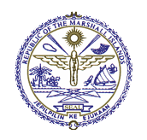

***'RMI NCD CRISIS RESPONSE PLAN’***

***NCD EMERGENCY RESPONSE TOWARDS A HEALTHY RMI***

**Action Plan 2013-2018**

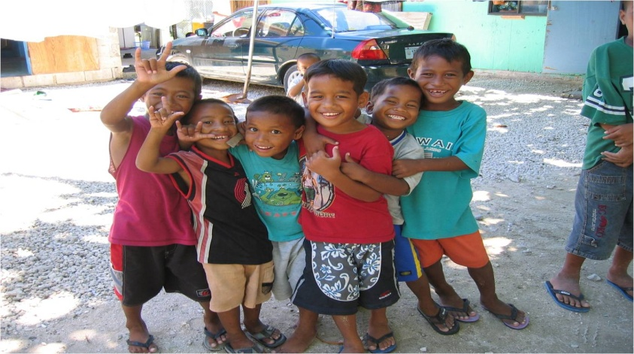

**Forward by the Minister of Health**

**

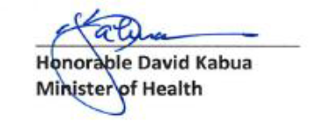

The Republic of the Marshall Isalnds is one of the few countries with highest prevalence of NCD in the Pacific Region and in the World. However, the Marshall Islands is committed to reduce the prevalence and strong effect of NCD among Marhallese people. In furtherance, the RMI has formulated a strong mission statement as such:

"*To provide high quality, effective, affordable and efficient health services to all the people of the Marshall Islands through a primary health care program to improve the health status and build the capacity of the community and indivuduals to care for their own health and to the maximum extent possible, the Ministry of Health pursues these goals using the natinal resources of the Republic of the Marshall Islands*. "

In October 29, 2012, His Excellency Christoper Loeak, President of the Republic of the Marshall Islands declared a state of health emergency due to the epidemic of non-communicable diseases (NCD) in the Republic of the Marshall Islands.

The Ministry of Health does realizes the double burdens of NCD must be reduced to a manageable level. However, to be able to do that, a joint collaboration of all relevant government sectors and non-government organization; and full partnership are necessary to implement such plan.

Other risk factos such as negative effects of tobacco and medical complications of alcoholism must also be eliminated through changes in lifestyles and behaviors. Currently, the prevalence rate of

tobacco use amongst the youth is 25.9% and 19.8% amongst the adult population. That is quite high comparetively and that must be brought down to a lower stratum.

The Crisis Response Plan is geared to address the attributable risk factors and suggest reputale public health measures as avenues to tackle all these complication of non-communicable diseases.

There fore, the Ministry of Health is calling all relevant partners to collaborate with the Ministry of Health to change the lifestyles and behavior which are causes of all these NCD problems. After all, these are preventable by lifestyles changing and simple but robust programs of exercise. Again, the Ministry of Health appreciates the continued supports and partnership with our stakeholders.

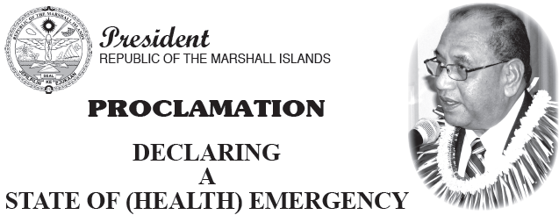

*Declaring a state of health emergency due to the epidemic of noncommunicable diseases (NCD) in the Republic of the Marshall Islands.*

**WHEREAS**, a political commitment has been made by our leaders at the special United Nations High Level Meeting on NCD in September 2011, the Pacific Island Forum Leaders in New Zealand in August 2011 declared NCD being a health and economic crisis,

**WHEREAS**, a State of Medical Emergency on Noncommunicable Diseases (NCDs) has been declared by the Pacific Island Health Officers Association (PIHOA) in May 2010 by its Board Resolution #48-01 and endorsed by the Micronesian Chief Executive, Micronesian Presidents, Association of the Pacific Island Legislatures, Micronesian Traditional Leaders Council and Micronesian Chief Justices;

**WHEREAS**, the Nadi Statement on the NCD crisis in Pacific Island Countries and Areas is being adopted as a pan-Pacific statement on NCDs and has been addressed at the High Level Meeting in the United Nations General Assembly;

**WHEREAS**, the Republic of the Marshall Islands is home to more than 53,000 people living on 70 square miles of land spanning an area of over 750,000 square miles of ocean in the Western Pacific;

**WHEREAS**, the leading causes of morbidity and mortality for adults in the Republic of the Marshall Islands are from noncommunicable diseases including cardiovascular disease including hypertension and stroke, cancer, obesity, diabetes, depression, and injury;

**WHEREAS**, the rates of noncommunicable diseases risk factors in the Republic of the Marshall Islands are high and rapidly increasing, and include high tobacco use, high alcohol consumption, unhealthy diet high in salt and lacking consumption of fruits and vegetables, and lack of physical activity;

**WHEREAS**, noncommunicable diseases rates of diabetes and high blood pressure are some of the highest in the pacific causing significant loss in longevity, quality of life, and loss to workforce productivity in the Republic of the Marshall Islands;

**WHEREAS**, the NCD burden can be expected to worsen significantly over the next generation, and will adversely affect the youth of the Republic of the Marshall Islands, shortening their lives and preventing them from achieving their full potential;

**WHEREAS**, NCDs are largely preventable with reduction of risk factors and early intervention;

**WHEREAS**, the current health care system response is insufficient to address the noncommunicable disease crisis as the health system lacks the necessary infrastructure and resources to manage noncommunicable diseases and is unable to bear the high costs of their health complications;

**WHEREAS**, strengthening primary health care, investing in the healthcare workforce, creating enabling environments for health, and increasing community engagement and empowerment is urgently needed at this time in order to prevent and effectively treat noncommunicable diseases to reduce their prevalence and the morbidity and mortality they cause;

**WHEREAS**, to mitigate the crisis there is a need not only for a whole of government but also a whole of society approach ensuring every organization is building a healthier Marshal Islands building an environment that enables and empowers individual to make healthy choices; emergency due to noncommunicable diseases;

2. The Ministry of Health to develop a noncommunicable disease strategy that builds on the current KUMIT plan detailing programmes, services, and activities that the Ministry of Health and its partners will implement to respond to the emergency and reduce the burden of noncommunicable diseases;

3. A NCD Task Force be established and charged with providing strategic direction and expert advice on the response of the Republic of the Marshall Islands to the noncommunicable disease crisis.

4. Sufficient investment to scale be made into combating NCDs.

5. All heads of government sectors, nongovernmental agencies,

statutory bodies and civil society proactively assist the efforts of the Ministry of Health technically and with resources to tackle the noncommunicable disease crisis;

Given under my hand this 29th day of October 2012.



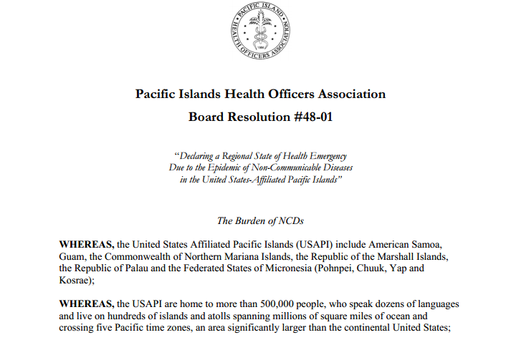

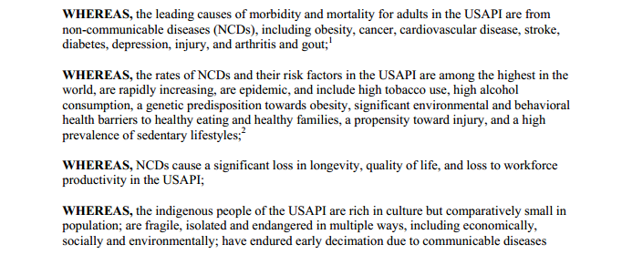

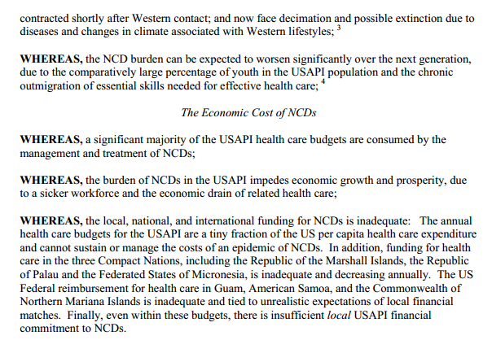

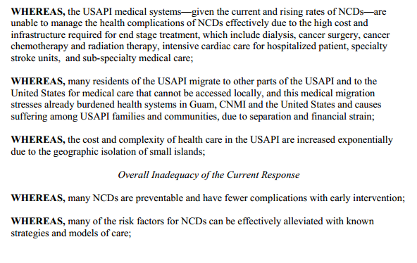

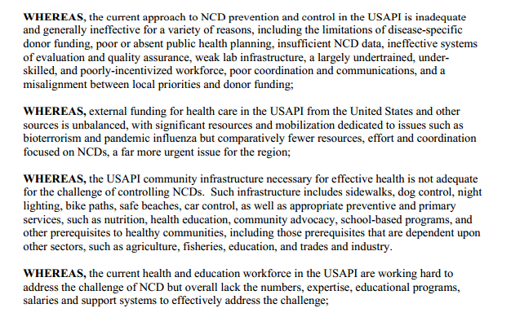

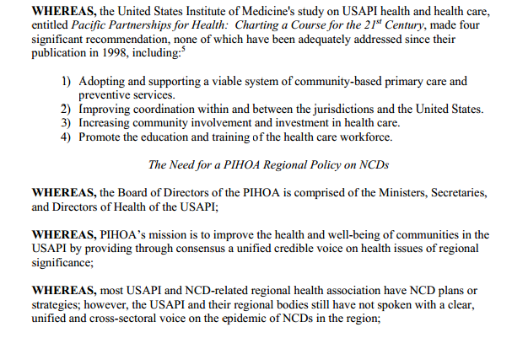

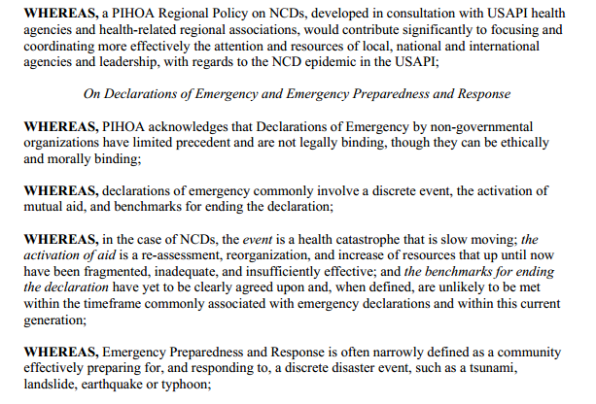

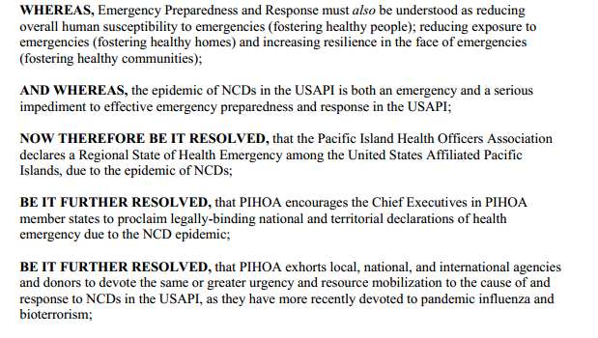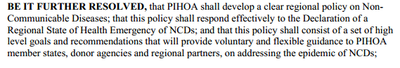

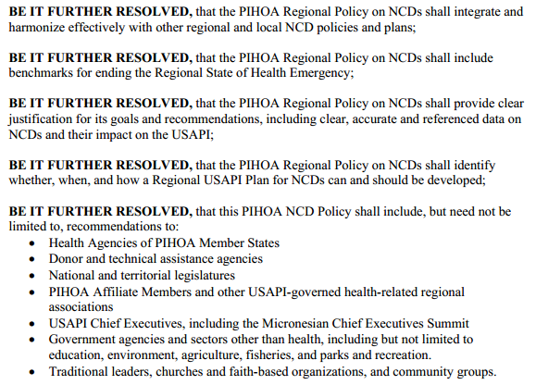

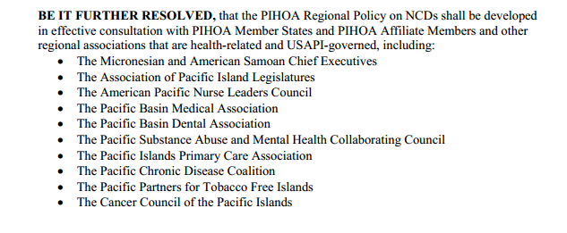

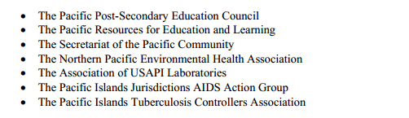

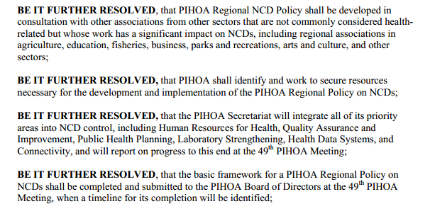

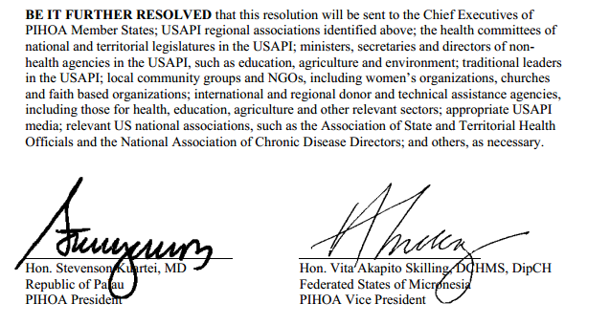

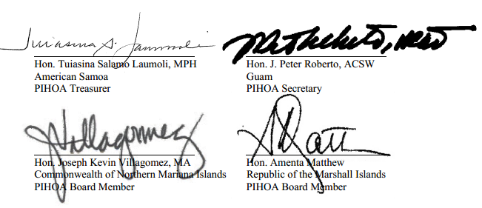

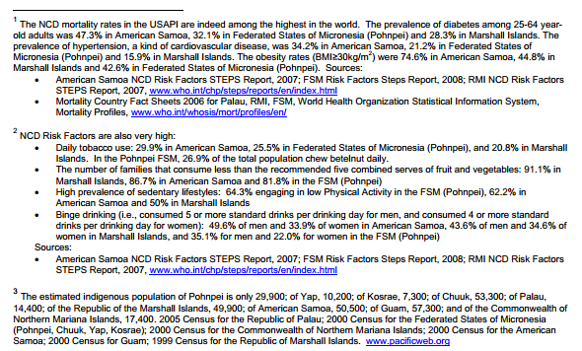

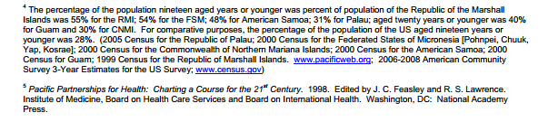

**SIX COMPONENTS OF ACTION**

The six components of the action plan that align with the Pacific NCD and Food Security Framework are:

**I Advocacy and Coordination of NCD**

* Government and public sectors
* Hospital and Outer Islands

**II Tobacco Free RMI**

* Policy, legislation, taxation
* Strengthening Community Action in School, Workplace, Church & Villages
* Cessation initiatives

**III Nutrition**

* Food Safety & Salt Reduction

1. Strengthen Food Control System

Policy & Legislation Enforcement

1. Strengthening Community Action

(School, Workplace, Church & Villages)

**IV. Physical Activity**

* Apply to AusAid for Sports and Healthy grant
* Work with government workplaces, schools, and churches to increase physical activity in these settings.

**V. Primary Health Care and NCD**

* Implementation of Package of Essential NCD (PEN) Services
* Community Mobilization
* Chronic Care Model (CCM)

**VI. Surveillance of NCD**

* NCD STEPS and Mini-STEPS
* Behavior Survey
* Global Youth Tobacco Survey
* Vital Registration (For Cause Specific Morbidity & Mortality)
* Chronic Disease Electronic Management System (CDEMS)
* Cancer Registry

## 1. Background

The Republic of the Marshall Islands is a collection of 1,225 low-lying coral islands grouped into 29 atolls and 5 single islands spreading across an ocean area of over 750,000 square miles. RMI is approximately 2000 miles southwest of Hawaii, 8º north of the equator and is part of the Micronesian group. The total land area is about 70 square miles (181 square kilometers). The main height of land is about 7 feet above sea level (2 meters). The total population in 2011 was 53,158 (EPPSO) with the majority residing on the two major atolls of Majuro and Ebeye. 55% of the total population comprise the working age population (15-64 years) with 42.9% under 15 years and population 65 years and older of 2% (EPSO- need to confirm). **Marshallese is the official language but English is taught in the schools and is widely spoken. The t**otal fertility rate is 4.5 (World Bank) and the annual population growth is 1.4% (World Bank). With growing populations and very limited land areas, population density continues to be a concern with 300.2 persons/km2 (World Bank) and greatly contributes to poor living conditions.

The Government of the Marshall Islands, is politically and economically linked to the United States of America as a “freely associated state”. Under the terms of the Compact of Free Association between the Republic of the Marshall Islands (RMI) and the United States, the RMI is eligible for many of the Public Health Service programs and funds from the Department of Health and Human Services. However, the RMI is not eligible for Medicaid, Medicare, WIC, EPSDT, and federal funds for education (including development disabilities). These constraints limit the referral and resource options for health care providers striving to provide comprehensive services for their clients.

The Constitution of the Marshall Islands has designated the Ministry of Health (MOH) as the “state” health agency. The health care system consists of two hospitals, in Majuro and Ebeye, and 54 community health centers in the outer atolls. The main hospital in Majuro is a 100-bed facility, and the hospital on Ebeye has 30 beds. The Bureau of Primary Health Care (PHC) within the MOH also offers a full range of preventive and primary care programs in the main hospitals and is responsible for all preventive and primary care programs throughout the country.

The MOH has six major bureaus: 1) Bureau of Primary Health Care (PHC), 2) Bureau of Majuro Hospital Services, 3) Bureau of Health Planning and Statistics (HP&S), 4) Bureau of Kwajalein Atoll

Health Care Services (KAHCS), 5) Bureau of Administration, Personnel and Finance, and 6) Bureau of Medical Referral Services. An Assistant Secretary heads each bureau and all Assistant Secretaries report directly to the Secretary of Health who is the head of the institution governed and represented politically by the Minister of Health.

## NCD CRISIS in RMI

Like the other Micronesian countries in the pacific, RMI is facing the double burden of disease having not satisfactorily controlled communicable disease and facing rising rates of NCD or chronic diseases such as diabetes, heart disease including hypertension and stroke, cancers and respiratory disorders. In nutritional disorders there is probable coexistence of obesity and under-nutrition (micronutrient deficiency) within individuals, families and communities. Compounding this situation, RMI faces a large population increase with decreasing funds.

According to the National NCD STEPS survey in 2002, the prevalence of hypertension was 10.5% and Diabetes was 19.6% which is one of the highest in the Pacific. In recent years, diabetes has overtaken tuberculosis as the most common disease with the longest hospital stay in the Marshall Islands. Diabetic complications such as cataracts and gangrene or gangrene-related amputations have also been on the increase through the years. From 2000 to 2001, amputations increased by 28% (MOH, Planning and Statistics) Furthermore, the trend of diabetes is affecting the younger population with a gradual increase of cases in the 20-35 years of age. The increase in the number of diabetic patients and people at risk for diabetes is mainly due to the changes in the lifestyles of the Marshallese population. With the increase number of the population being screened found to be diabetic, the Ministry has placed more emphasis on screening for early detection and managing people with diabetes and hypertension, and overweight and obesity as preventive measures.

**Table 1. Diabetes Prevalence Rate in the RMI**

|  |  |  |  |  |  |  |
| --- | --- | --- | --- | --- | --- | --- |
| **Description** | **FY 2007** | **FY 2008** | **FY 2009** | **FY2010** | **FY2011** | **FY2012** |
| Population | 52,701 | 53,236 | 54,065 | 54,439 | 53,158 | 53,158 |
| Majuro | 1694 | 1570 | 1369 | 1385 | 1357 | 1,009 |
| Ebeye | 600 | 600 | 600 | 623 | 623 | 785 |
| Majuro and Ebeye | 2,294 | 2,170 | 1,969 | 2,008 | 1,980 | 1,794 |
| Prevalence Rate* | 435 | 408 | 364 | 369 | 372 | 337 |
| Increase/Decrease |  | 6.2% | 10.8% | 1.4% | 0.81% |  |
| * Per 10,000 Population | | | | | | |

On the other hand, Cancer is the 2nd leading cause of death in RMI. It affects the female population more than the male. The death is attributed to breast cancer, cancer of the cervix, liver cancer, and of course, lung cancer.

**Table 2. Death due to type of Cancer,FY 2012**

|  |  |  |  |
| --- | --- | --- | --- |
| **Cancer Site** | **Male** | **Female** | **Total** |
| Cervical | 0 | 4 | 4 |
| Lung | 3 | 1 | 4 |
| Breast | 1 | 3 | 4 |
| Nasopharyngeal | 3 | 1 | 4 |
| Laryngeal | 2 | 0 | 2 |
| Ovary | 0 | 2 | 2 |
| Kidney | 1 | 1 | 2 |
| Leukemia | 0 | 1 | 1 |
| Submandibular | 1 | 0 | 1 |
| Pancreas | 1 | 0 | 1 |
| Colon | 1 | 0 | 1 |
| Neck | 1 | 0 | 1 |
| Liver | 0 | 1 | 1 |
| Stomach | 1 | 0 | 1 |
| Urinary Bladder | 1 | 0 | 1 |
| Brain Tumor | 1 | 0 | 1 |
| Lumber | 1 | 0 | 1 |
| Uterus | 0 | 1 | 1 |
| **Total** | **18** | **15** | **33** |
| Source: MOH Vital Statistics Information System (VRIS). | | | |

There is a continuing need to look at risk factors in the general population and put in place ‘primary prevention strategies’ to prevent or halt progression of individuals to NCDs like Diabetes. There are four risk factors on NCDs. Among them, tobacco use and smoking is the main risk factor contributing to NCDs. According to the 2011 census, add the data here and any other data among the youth, ect.

The WHO Framework Convention on Tobacco Control (WHO FCTC) is the first international public health treaty under the auspice of the WHO. RMI ratified the WHO FCTC on 8 December 2004 and the WHO FCTC entered into force for RMI on 8 March 2005. As a Party of the Convention, RMI as a whole needs to implement effective measures to meet all its obligations. The WHO FCTC serves as an important legal instrument and tool to contribute to the prevention of non communicable diseases. The Political Declaration of the UN High Level Meeting on NCDs , 2011 calls upon countries to implement the WHO FCTC. The Government of the RMI together with the Convention Secretariat, WHO FCTC conducted a joint needs assessment on implementation of the WHO FCTC. The needs assessment report serves as a good reference document to better implement the Convention and prevent the NCDs in RMI. The 2002 STEPS results revealed startling figures which have been the thrust of the NCD/Nutrition planning. The government has realized the full implications of the figures as NCDs are not only the highest cause of morbidity and mortality now but will cause devastation in the future if nothing is done to intervene.

**3. Management of the NCD Crisis**



* **Comprehensive**: incorporating both policies and action on major NCDs and their risk factors together
* **Multi-sectoral:** involving the widest of consultation incorporating all sectors of society to ensure legitimacy and sustainability
* **Multidisciplinary and participatory**: consistent with principles contained in the Ottawa Charter for Health Promotion and standard guidelines for clinical management
* **Evidence Based**: targeted strategies and actions based on STEPS and other evidence. The employment of both population wide and individual based interventions termed best buys.
* **Prioritized**: consideration of strata of socioeconomic status, ethnicity and gender
* **Life Course Perspective**: beginning with maternal health and all through life in a ‘womb to tomb’ approach
* **Simple**: setting some strategic direction but also simple enough for any stakeholder to be able to quickly identify activities that could help drive its implementation.

The plan is intended to be a workable and realistic approach which can be achieved. As the plan will be monitored and reviewed over the next 5 years and beyond, new activities can be added based on emerging issues and also changing priorities.

With the realization that the current NCD services are quite fragmented, there is a need for coordination of the services currently in place for NCD and advocacy for awareness and commitment by government to address what has become the largest health burden in RMI.

With these considerations, and by a combination of the Pacific Framework for NCD and Food Security and the Ottawa Charter of Health Promotion, 5 components for action were prioritized under which formulation of strategies and activities for NCD and Nutrition in RMI will be carried out. These are intended to meet the targets set by RMI at the NCD Forum 2013 (see below), which are inspired by the Global and Pacific Targets for NCDs.

|  |  |
| --- | --- |
| **Area of Action** | **RMI TARGETS** |
| ***NCD Mortality*** | *Reduce mortality between ages 30-70 due to Cardio Vascular Disease (CVD), diabetes, cancer or Chronic Renal Disease (CRD by 25%* |
| **Tobacco** | TOBACCO FREE RMI by 2020/2025  Tobacco reduction to 10% on current users |
| **Physical Activity** | Increase physical activity by 75% (2018) |
| **Salt and Hypertension** | 50% relative reduction in salt consumption  25% relative reduction in raised blood pressure (TIMEFRAME) |
| **Cardiovascular disease and diabetes** | CVD multidrug treatment and counselling  25% relative reduction in prevalence of diabetes.(TIIMEFRAME) |
| **Cancer** | 25 % of women (21-65 yrs) screened for cervical cancer  10% of women (40- up) screened for breast cancer |

**4.0 NCD Commitments**