Content sheet 10-7: Organizing a Proficiency Testing Program

Design | In some settings, there is no local proficiency testing (PT) provider who can supply a functioning scheme for the laboratory tests being performed. Because of the value of EQA as a quality tool, some countries or regions may undertake the establishment of a program. In designing or organizing a PT scheme, there are many things to consider:  - A program can be developed at a national level, with a single site for preparation of samples, distribution, and data analysis.  - Another option is to organize at the provincial level.  - The necessary resources must be assembled, including PT program expertise, technical support, laboratory space, a distribution system, and the financial resources that will be needed.  - Provide clinically relevant challenges that mimic patient samples as much as possible to check the entire examination process, including pre- and postexamination procedures.
Participation and success in a PT scheme | All PT providers must have demonstrated success in an EQA scheme on a regular basis before establishing their own program. Continuing successful participation is essential.  If the provider is a national reference laboratory, it may need to subscribe to a foreign scheme in order to be independently evaluated.
Involve those with authority | When starting a new PT program, it is essential to involve those with authority at the appropriate level (national, provincial, or other). In this way, the process is appropriately authorized, and sustainability is assured.  It is essential to have buy-in from those with decision-making authority, in order to ensure adequate funding for the EQA process. In addition, commitment from these authorities will:  - ensure a means of communication with all concerned parties;  - make it easy to establish the appropriate relationships with any licensing, certification, and accreditation bodies;  - allow for compliance with national regulations;  - make it easier to secure participation of the laboratories.  To assure that all laboratories participate in PT, it may be necessary to mandate participation by legislation.
If new, start simple and small | If a PT provider is new, it is preferable to start with something simple, then expand the program as experience is gained.  As an example, begin a PT program providing slides to evaluate:    - Gram staining techniques;  - acid-fast bacilli staining techniques;  - ability to identify parasites.  Another possibility is to begin a microbiology bacterial identification program using only enteric microorganisms (for example, Escherichia coli and Salmonella).  It is best not to try to provide proficiency testing to too many laboratories in the first year or two. Consider doing a pilot first, using a small number of laboratories (four to five laboratories outside the program) and targeting a specific region of the country for the pilot, keeping in mind the need for adequacy of transportation for samples.  Start with no more than 15 laboratories for the first year, to distribute at least two challenges for the first year, and to include at least three samples in each challenge.  Each time samples are sent out for a PT event, it is a good idea to also send to a reference laboratory to verify the quality of the samples.  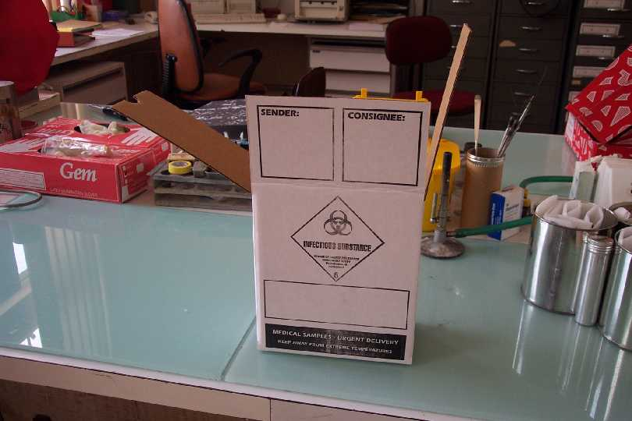  For microbiology PT, it may useful at the beginning to use reference material to assure the quality of the challenge. In the early days of a new proficiency testing program, consider using only materials that do not pose a significant hazard to those who will handle them. Do not distribute pathogens that could be considered dangerous (for example, cultures of Vibrio cholerae, Shigella dysenteriae type 1, Yersinia pestis). It is preferable not to use sera containing hepatitis or HIV, until mechanisms are in place for handling and transporting biohazardous materials.  All national transport of sample laws must be followed.
Needs | The needs for establishing a small PT program are not great. Requirements for beginning a small PT program include:  - workspace and equipment: small laboratory space with essential equipment and sufficient bench place for preparing and packaging samples;  - qualified staff;  - supplies and materials : access to materials for the challenges must be in place on a continuous basis;  - transport: even public transport can be used to send samples;  - tools for data management and analysis: personal desk, a computer and printer, and a space to store the results of participating laboratories;  - communication means: telephone, facsimile, Internet access, postal services.
Marketing | When establishing a new program, it is important to communicate with laboratories, authorities, scientific societies, professional associations, and others who will have an interest in EQA, to create interest and promote participation.  In the communications, be clear about the objectives and rules for confidentiality. Be sure to acknowledge all appropriate persons and organizations. Contact information should be sent to everyone along with the projected timetable.
Monitoring | Starting the program and distributing samples will require monitoring all aspects of the process. Use the participants’ results and their comments and feed-back to improve the program. Seek the best ways of solving any problems incurred, and also the best ways of communicating with the participants to help guide them to better techniques.  Remember the program is serving a reference role, and will need to be able to help participants in their quality improvement efforts.  It is not asking too much of the program to be perfect in its management and performance.

