Activity 7-3: Interpretation of Control Data Using Westgard Rules

Purpose | To review control charts using Westgard Rules (also called multirule QC).
Suggested  Time | 15 minutes
Instructional Method | Individual assignment
Instructions | Show Levey-Jennings charts with 2 levels of control by either projecting a slide (Presentation 7, optional slide 10) or giving as a paper and pencil exercise.  Ask the participants to:  - Examine the Levey-Jennings charts shown.  - For each day, write down how the control results for that day would be interpreted.  - Indicate if the system is in control or not, and, if not, indicate which of Westgard Rules are violated.  Shown below are examples of two glucose controls run over 23 days.  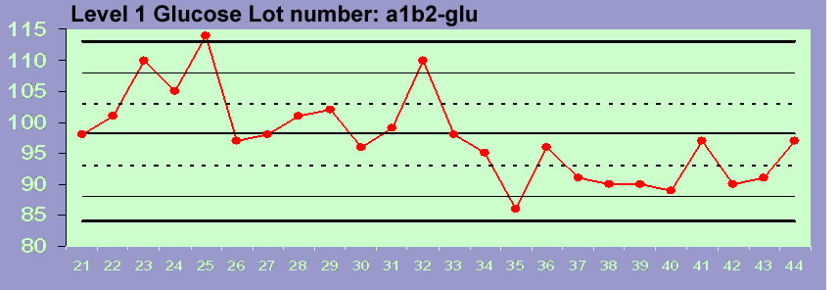  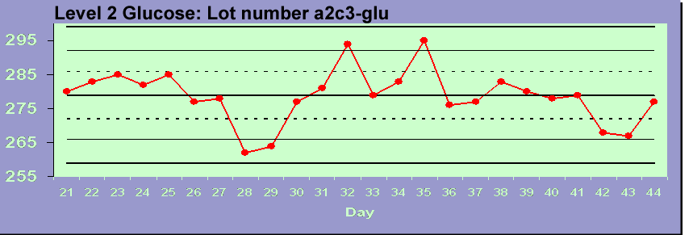
Expected results | - Day 21, 22, 24, 26, 27, 30, 31, 33, 34, 36-44 – in control  - Day 23, 28, 29 – 1_{2s}  - Day 25 - 1_{2s} and 1_{3s}  - Day 32 – 1_{2s} and 2_{2s}  - Day 35 - R_{4s}

