Activity 2-1: Scenario — Need for Biosafety Management

Purpose | To identify the need for biosafety management.
Suggested  Time | 10 minutes
Scenario | “Your laboratory specializes in virology. There is an epidemic of avian flu virus H5N1 in your country and the Ministry of Health names your laboratory as the reference laboratory for processing all samples.”
 | What are the elements to consider ensuring biosafety in your laboratory?

Activity 2-2: Critical Analysis of a Simple Laboratory Plan

Purpose | To analyse a laboratory plan.
Suggested  Time | 5 minutes
Instructions | 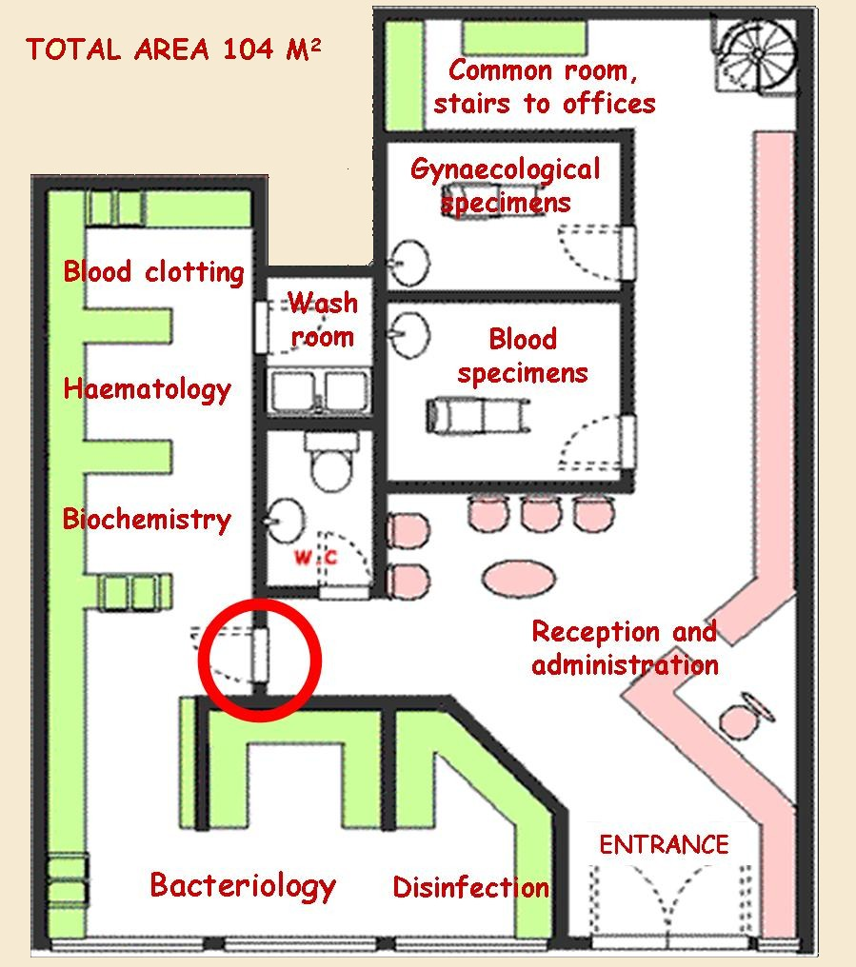
Do you have any comments about this laboratory plan?
How are the pathways organized for patients, biological samples, clean and dirty glassware, contaminated waste, and other areas?

Activity 2-3: Critical Issues on Biosafety during Sample Manipulation

Purpose | To involve participants in a discussion about basic safety measures and personal protective equipment (PPE) used in laboratories.
Suggested  Time | 10 minutes
Instructions | 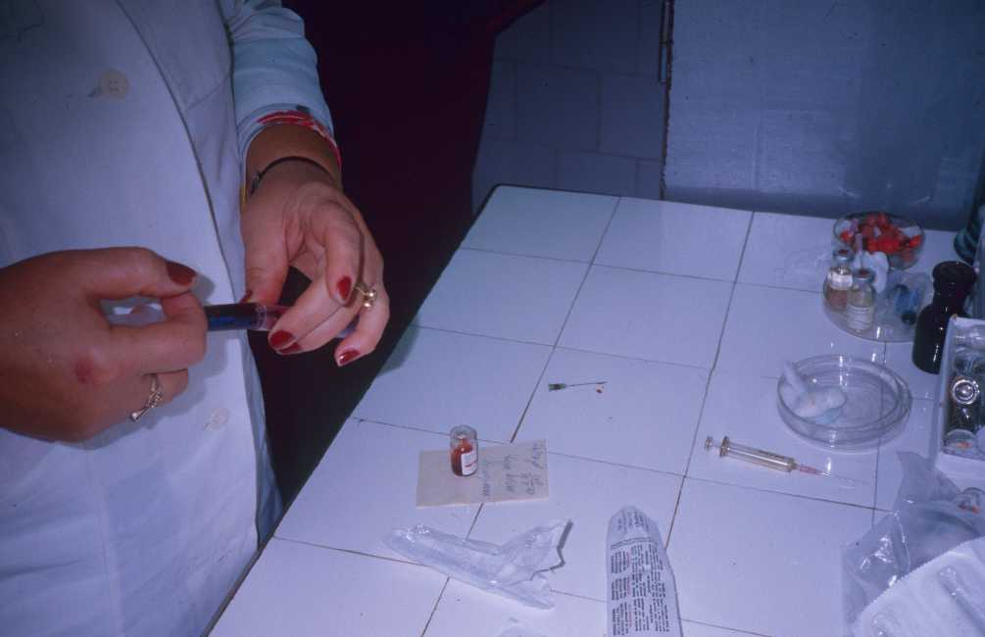
 | Point out the errors. Which PPE should be used?

