Annex 14-A: Occurrence Management Form Example

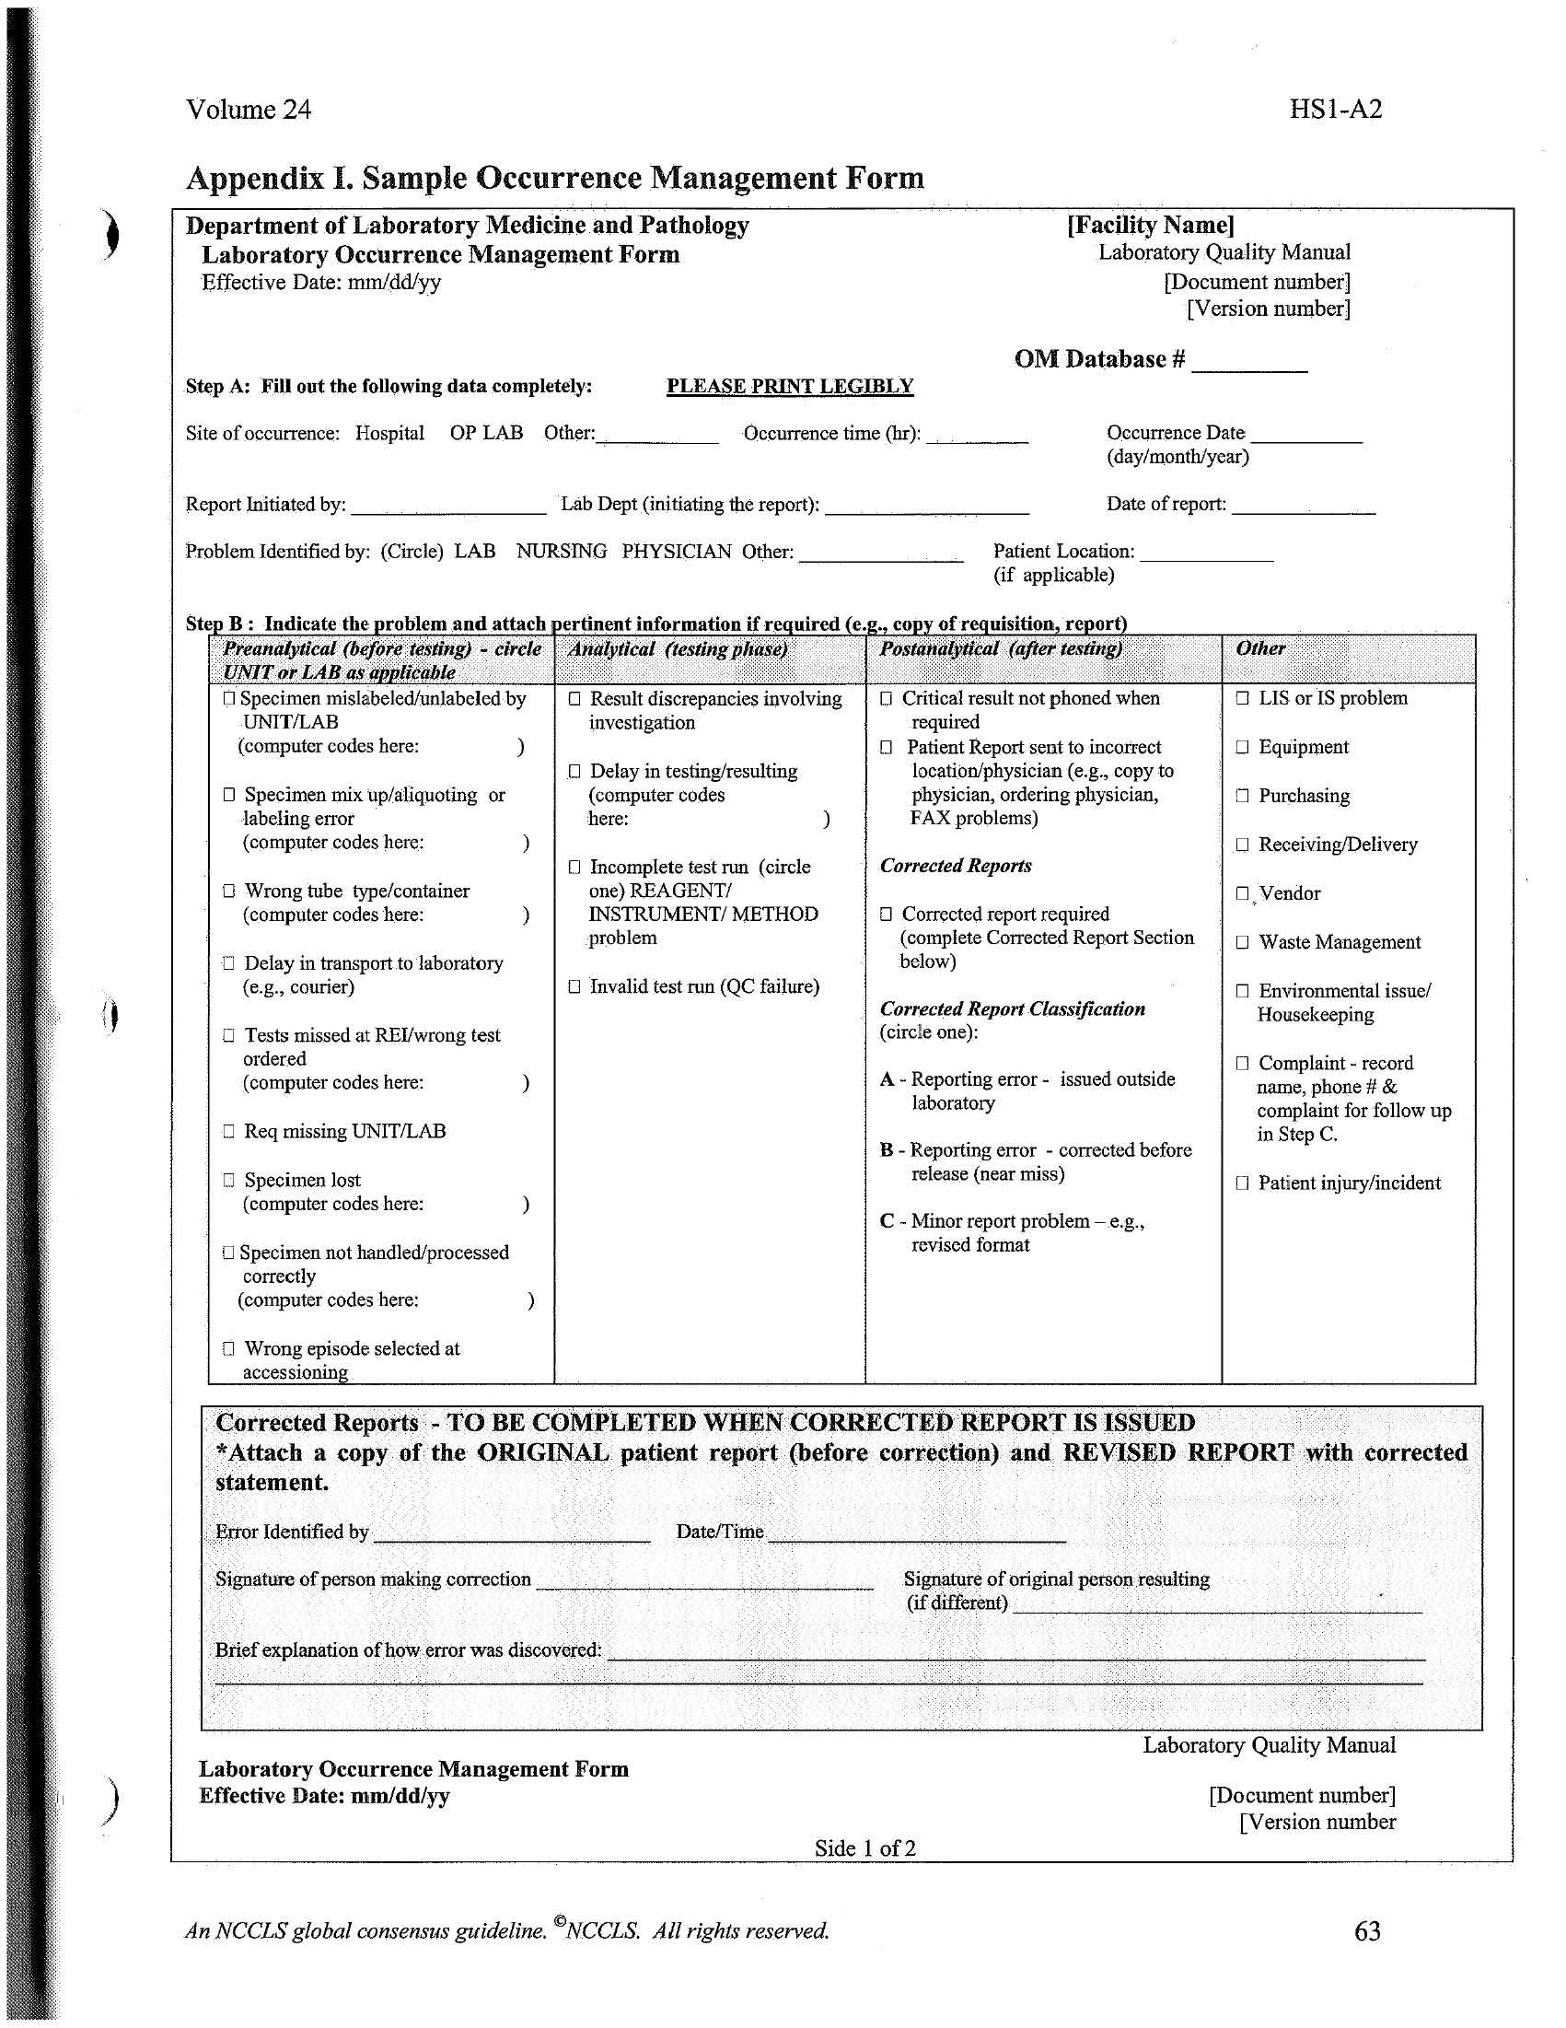

Step C. Immediate Action (describe what happened and what was done)

Name of person providing immediate action…………………………………………
(Investigation on reverse side)
Step D. Supervisor/Manager investigation and Comments (optional); (How did this happen? Why did this happen? If appropriate, what changes have been made to prevent recurrence? Note: Have the necessary staff member review and sign.)

Supervisor Name:……………………………………………………...Date:………………………...

Staff member reviewed (signature):……………………………………Date:……………………..…
Annex 14-B: Opportunity for Improvement Form Example

