Activity 12-1: Scenario — Overview of Personnel

Purpose | Discuss the main elements of personnel management.
Suggested  Time | 10 minutes
Instructional Method | Problem solving: use as an individual, or group activity, or as a class discussion.
Instructions | Give the participants a copy of the following scenario and/or show it as a slide (Presentation 12, Slide 3). Allow 2 minutes for them to read.  “You are a laboratory manager. One of your two senior technologists has been temporarily re-assigned to another laboratory. Your other senior technologist is sick and the remaining two have not read malaria smears since their initial training several years ago. This morning you received 20 malaria smear requests. As you are unable to ensure accurate testing, you must notify test requestors that the testing will be delayed. As you are unable to ensure accurate testing, you must notify test requestors that the testing will be delayed.”  Ask the question (Presentation 12, slide 4):  As a manager, what should you have done to prevent this situation?  Tell the participants to take three minutes to think about possible answers then write them on the whiteboard arranged in order under the headings as shown below (Presentation 12, Slide 7) and referring to Contents 12-1.  The answer could include:  - made sure staff are hired with sufficient qualifications;  - provided appropriate training and continuing education, including cross-training;  - conducted competency assessment to ensure that staff are competent;  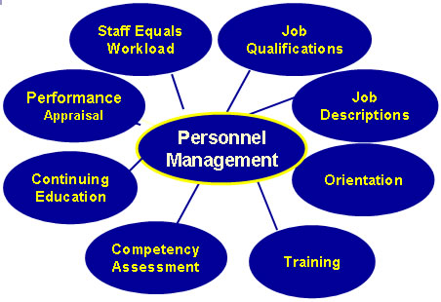  - made sure that people have an appropriate job description covering multiple disciplines (could include regular rotations in the laboratory).

