Activity 2-1: Scenario—Need for Biosafety Management

Purpose | To allow participants to identify the need for biosafety management.
Suggested  Time | 10 minutes
Instructional Method | Problem solving: use as an individual or group activity, or as a class discussion.
Instructions | Give the participants a copy of the following scenario and/or show it as a slide (Presentation 2, slide 3). Allow 2 minutes for them to read.  “Your laboratory specializes in virology. There is an epidemic of avian flu virus H5N1 in your country and the Ministry of Health names your laboratory as the reference laboratory for processing all samples.”  Ask the question:  What are the elements to consider ensuring biosafety in your laboratory?
Expected Results | Try to direct the discussion so that participants list the main elements of protection that are described in the contents sheets for this module.

Activity 2-2: Critical Analysis of a Simple Laboratory Plan

Purpose | To analyze a laboratory plan.
Suggested  Time | 5 minutes
Instructional Method | Brainstorming (entire group).
Instructions | Give the participants a copy of the laboratory plan.  Ask the questions:  Do you have any comments about this laboratory plan?  How are the pathways organized for patients, biological samples, clean and dirty glassware, contaminated waste, and other areas?  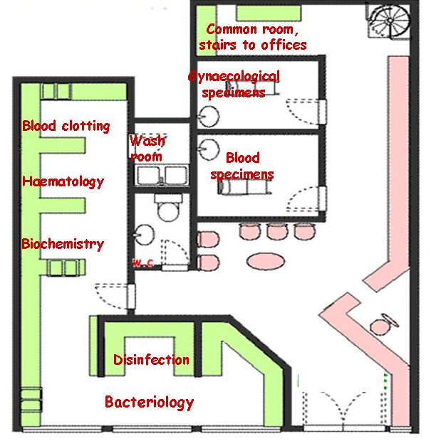
Expected Results | In this plan, patients have access to the reception and the sampling rooms, but not to the laboratory where the examinations take place. Stress the fact that if possible, samples and patients should have separate paths.  Inside the laboratory, samples should have separate paths, or paths organized in a way to minimize risks of cross-contamination between samples and/or working places. For this reason the bacteriology section is separated from the other types of analysis to avoid contamination with waste.  However one can identify one problem in this plan, all samples and materials will go through the bacteriology section prior to go to disinfection.  Ask participants the following question. Can you see similar problems in your own laboratories?  Refer to Presentation 2, Slides 9, 13, 14, 15, 18, and 19.

Activity 2-3: Critical Issues on Biosafety during Sample Manipulation

Purpose | To involve participants in a discussion about basic safety measures and personal protective equipment (PPE) used in laboratories.
Suggested  Time | 10 minutes
Instructional Method | Brainstorming (entire group).
Instructions | Show the participants this picture or view it using Presentation 2, Slide 36.  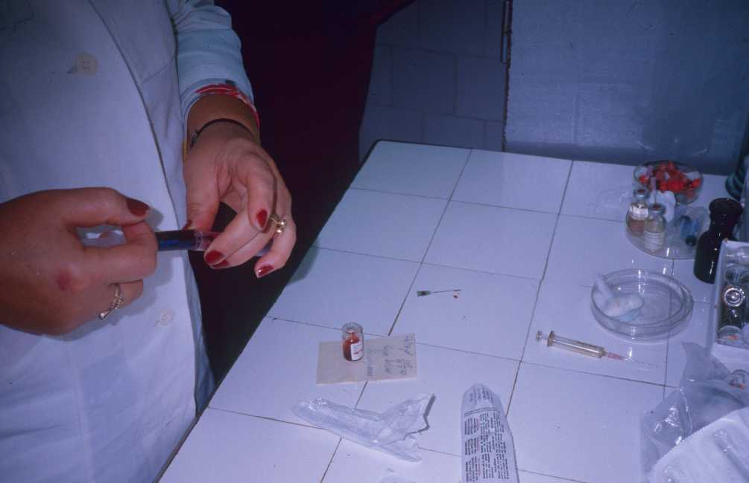  Ask the participants to point out the errors and which PPE should be used.
Expected Results | Answers should include:  - manipulation without gloves;  - uncapped needle on the bench;  - uncapped syringe on the bench;  - needle in the flask upper right corner of picture, ready for reuse.  Are PPE available in the participant’s laboratories?  Are PPE used as a general procedure, or only for specific manipulations?  Are PPE reused in the participant’s laboratories?

