Fellowship Application
Innovative Financing for Health Promotion
March - December 2023

Organized by the Southeast Asia Tobacco Control Alliance and the Thai Health Promotion Foundation

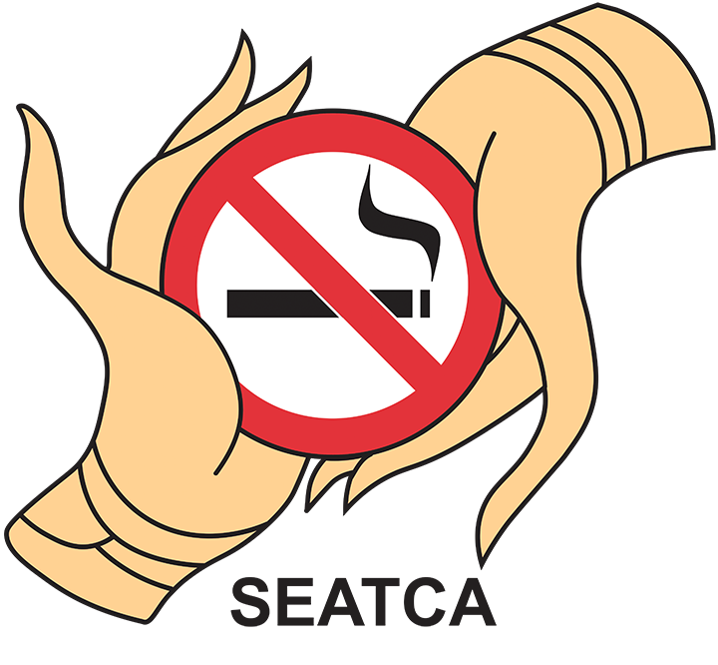
______________________________________________________________________

Interested governments are invited to apply for the fellowship by completing the assessment and nominating up to two fellows using this application form. Complete applications must be emailed by Wednesday, 30th November 2022 to both email addresses below:

anisa@seatca.org
info@seatca.org

Please contact Ms. Anisa Ismail at anisa@seatca.org if you have any questions.
______________________________________________________________________

Part 1: Assessment
Fellowship: Innovative Financing for Health Promotion

Please complete this form in English.

1. Country:

2. Date:

3. Name of individual completing the assessment:
4. Organization:

5. Position within the organization:

6. Email address:

Questions

- Describe how the taxation system your country has evolved for products such as tobacco, alcohol, and sugar-sweetened beverages. Include details about surcharge taxes if applicable (maximum 250 words).

- Describe the status of non-communicable disease (NCD) control, in particular tobacco control, in your country. Include details about the annual budget, existing programs, funding mechanisms, and policy gains in these areas (maximum 250 words).

- Describe the legislation (if any) that your country has in place to promote sustainable financing mechanisms for NCDs or health promotion. Please attach a copy or translation of this legislation in English. If your country does not have relevant legislation, describe efforts that have been made (if any) to pass this type of legislation in your country (maximum 250 words).

- Describe the position of your country’s Ministry of Health on NCDs and the taxation of tobacco/alcohol/sugar-sweetened beverage products to fund health promotion programs (maximum 250 words).

- Describe the position of your country’s Ministries of Finance, Trade & Industry, and other relevant ministries on the taxation of tobacco/alcohol/sugar-sweetened beverage products to fund health promotion programs (maximum 250 words).

- Provide the names and website links of civil society organizations (CSOs) in your country that have supported tax increases on harmful products like tobacco, and/or supported NCD prevention. Briefly describe the work these CSOs have done in these areas.

- Provide the names of individuals (government officials, CSO workers, advocates) who have been champions for sustainable health promotion (including tobacco control and NCD control) in your country.

______________________________________________________________________

Part 2: Fellow Nomination Form
Fellowship: Innovative Financing for Health Promotion

Nominations must be submitted by a government representative.
Please complete this form in English.

Nominator details

1. Country:

2. Date:

3. Name of individual completing the nomination form:

4. Government department:

5. Position within the department:

6. Email address:

______________________________________________________________________

Fellow Criteria

Successful applicants:

- Have been working for at least one year in an organization (government, academic, or NGO) that is actively working on or otherwise engaged with tobacco control policy in their country.
- Have experience with conducting research, particularly policy research, in any field.
- Are able to read, write and speak in both the local language and English.
- Are able and willing to honor the time commitment and activities/tasks required for the duration of fellowship, including participating in an orientation workshop and study visit in Bangkok, Thailand during the week of 27-31 March 2023.
______________________________________________________________________

Nomination (Fellow 1)

1. First and Middle Names:

2. Surname:

3. Title (e.g. Prof/Dr/Ms):

4. Email address:

5. Organization:

6. Position within the organization:

7. Nominee’s start date at the organization:

8. English language proficiency:
(0 – No Proficiency, 1 – Elementary Proficiency, 2 – Limited Working Proficiency, 3 – Professional Working Proficiency, 4 – Full Professional Proficiency, 5 – Native / Bilingual Proficiency)

9. Nominee’s main speaking/working languages:

10. State the reasons why this individual will be suitable for this program. Include their responsibilities in their current role; relevant work on NCD control, tobacco control and health promotion; relevant work on the development, implementation and/or enforcement of tobacco control law/regulations; research experience; and the expected benefits of the individual’s participation in this fellowship program for their country (maximum 300 words):

______________________________________________________________________

Nomination (Fellow 2)

1. First and Middle Names:

2. Surname:

3. Title (e.g. Prof/Dr/Ms):

4. Email address:

5. Organization:

6. Position within the organization:

7. Nominee’s start date at the organization:

8. English language proficiency:
(0 – No Proficiency, 1 – Elementary Proficiency, 2 – Limited Working Proficiency, 3 – Professional Working Proficiency, 4 – Full Professional Proficiency, 5 – Native / Bilingual Proficiency)

9. Nominee’s main speaking/working languages:

10. State the reasons why this individual will be suitable for this program. Include their responsibilities in their current role; relevant work on NCD control, tobacco control and health promotion; relevant work on the development, implementation and/or enforcement of tobacco control law/regulations; research experience; and the expected benefits of the individual’s participation in this fellowship program for their country (maximum 300 words):

