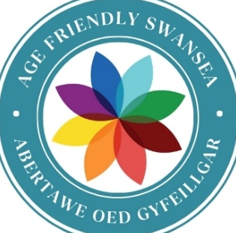

Age Friendly Swansea

Baseline Assessment
2025

Contents

- Introduction
- About Swansea
- Population – Current Situation and Predictions
* Health
* Dementia
* Daily Tasks
* Loneliness and Isolation
- Age-Friendly Roles
- Collaboration
* Ageing Well Steering Group
*Swansea Council Ageing Well
*Collaboration Stations
- Information and Activities for People aged 50+
- Grants for Activities for People aged 50+
- Summary

Introduction
This document sets out the foundation for Swansea’s age-friendly journey and includes our application for membership of the WHO Global Network of Age-Friendly Cities and Communities (GNAFCC). Joining the GNAFCC will enable us to learn from other age-friendly communities, share best practice and build on opportunities that support people to live longer, healthier lives. Achieving this will require strong partnership working.
The baseline provides an overview of the starting point for Swansea’s age-friendly journey. It draws on data and insights from the 2021 Census, the local Population Needs Assessment and community consultations.
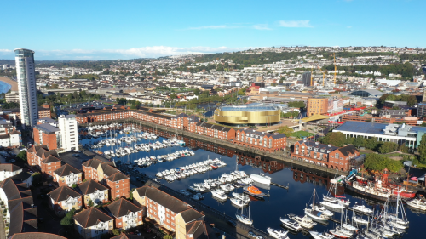
About Swansea

Swansea is the second largest city in Wales, known for its vibrant coastal setting in the south-west of the country and is defined by its sweeping sandy bay, marina and proximity to the Gower Peninsula - Britain’s first Area of Outstanding Natural Beauty. Its waterfront setting shapes daily life, offering a blend of natural beauty, outdoor living and a strong maritime identity.
The city balances urban energy with rural character. Approximately 69.5% of the land in Swansea is rural and 30.5% is urban. While central Swansea serves as the region’s commercial and cultural hub, much of the wider county is rural, creating varied experiences around access to transport, services, and amenities. Regional planning acknowledges these differences, with major investment underway to improve bus and rail networks, enhance connections between transport modes and support future residents in both urban and rural areas.
Historically known as “Copperopolis,” Swansea’s industrial heritage is still celebrated across its cultural institutions and regenerated districts. Today, the city is undergoing one of the UK’s largest urban transformation programmes, including a £1 billion regeneration of the city centre and waterfront. New office spaces, cultural venues, public squares, homes and leisure developments are reshaping Swansea as a modern, forward-looking destination.
With two universities, strong digital infrastructure and a reputation for quality of life, Swansea blends heritage, landscape, innovation and community into a distinctive and welcoming city.

Population - Current Situation and Predictions
The 2021 Census showed that Wales has an ageing population. This is reflected in the data for Swansea.

Almost 40% of residents were aged over 50 in 2021 (95,086 people). This equates to almost a 10% increase in the 10 years, since the 2011 Census.
The latest mid-year population estimate (2024) shows this increasing again. The
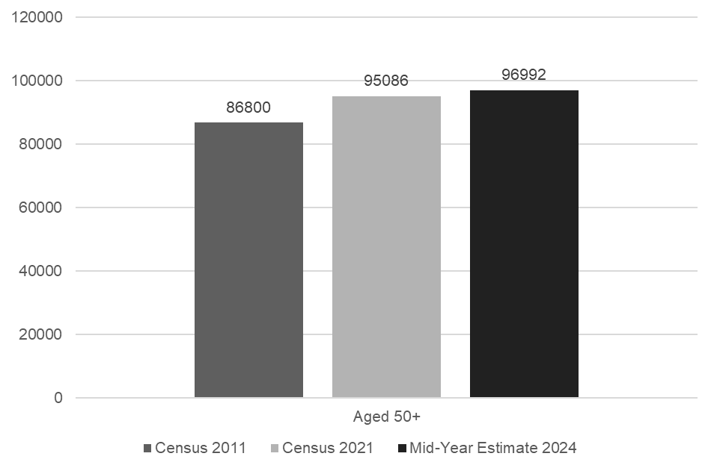
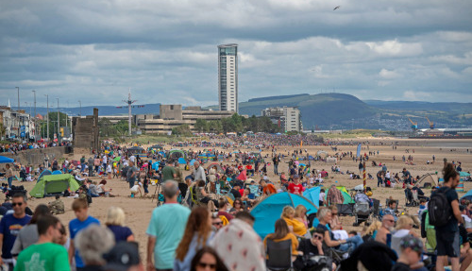
In August 2021, the Welsh Government (WG) published population projections for the 22 local authority areas in Wales, covering the 25-year period from 2018 to 2043.

They predict that by 2028 the number of people aged 65 and over in Swansea will increase by around 9% from the 2021 Census figure to 53,103.
By 2043, they predict it to be 20% higher than in 2021.

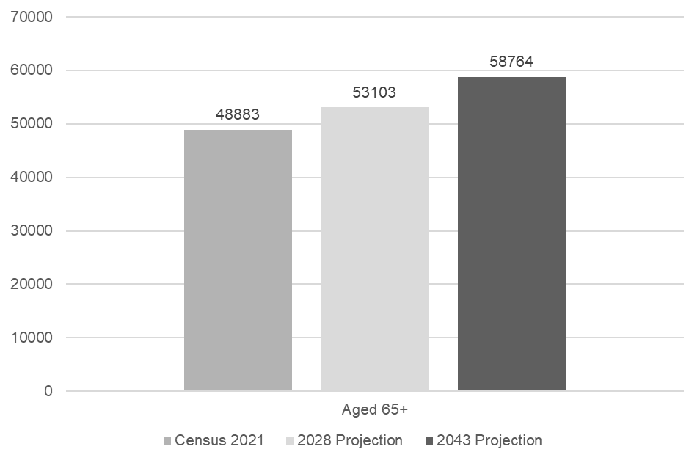

From 2038 the population rise is predicted to slow for those aged 65+, but it is expected to continue to rise for those aged over 75. 20
d that Wales has an ageing population. This was reflected in the data for Swansea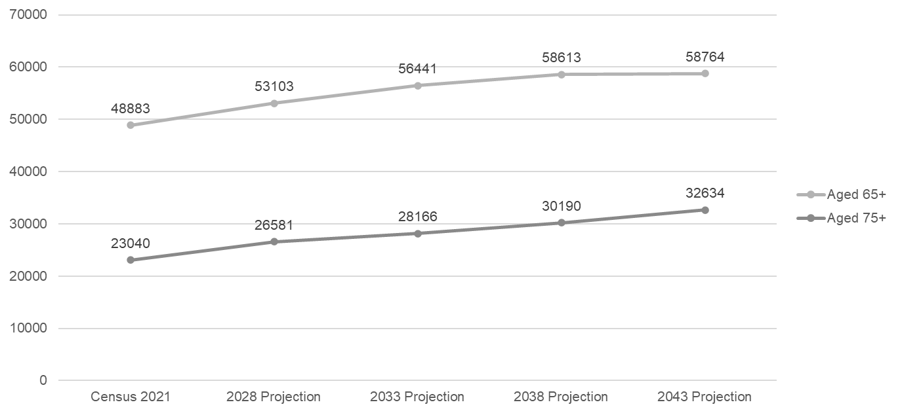
Source: Census 2021, Office for National Statistics
2018-based projections for local authorities in Wales, Welsh Government
In the 2021 Census, in Swansea:




n.

Health
There was a small positive increase overall in how people in Swansea felt about their health in the 2021 Census.

Dementia

Dementia is a growing concern in Wales, and Swansea.
Social Care Wales predicted that in Swansea in 2024 a total of 3,794 people aged over 65 would have dementia.
By 2040, they predict this number will rise by almost 40% to 5,295 people.

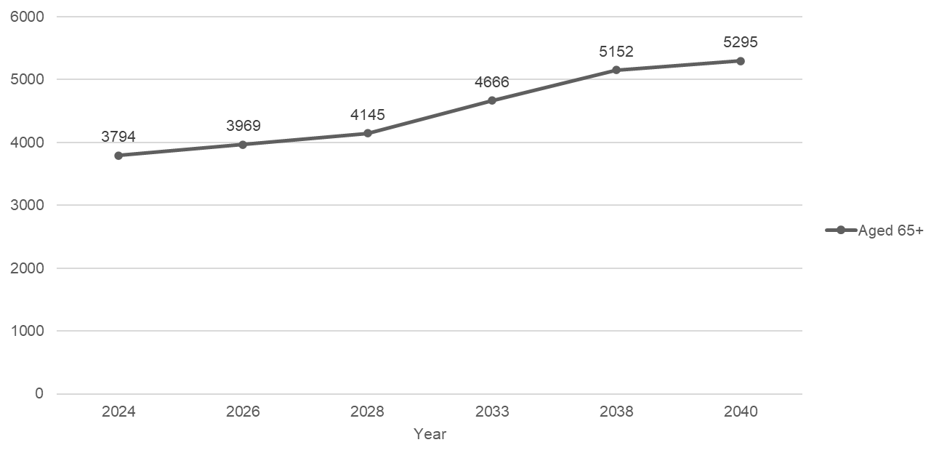
Source: Social Care Wales

Daily Tasks
Social Care Wales predict that the number of people aged over 65 in West Glamorgan (Swansea and Neath Port Talbot) who will struggle with daily tasks will increase from 22,116 in 2025 to 28,311 by 2040.
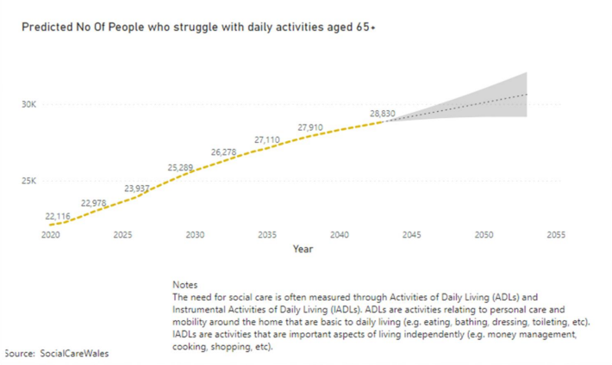
Loneliness and isolation

Tackling loneliness and social isolation are priorities identified by the Welsh Government.

The Wales Centre for Public Policy found in 2021 that although social loneliness and emotional loneliness reduced with age, 54% of over 65s in Wales were sometimes lonely and 12% felt lonely.

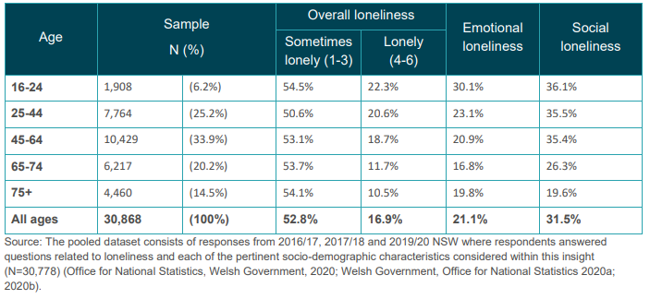
Levels of loneliness, by age group
Source: Wales Centre for Public Policy, Age and loneliness in Wales Data Insight, October 2021

The National Survey for Wales 2022-23, found that 49% of residents surveyed in Swansea were sometimes lonely and 11% were lonely.
https://www.gov.wales/national-survey-wales-results-viewer
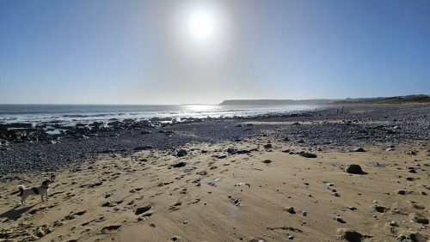

Age-Friendly Roles

Swansea has appointed an Age-Friendly Co-ordinator/Lead and an Age-Friendly Involvement Officer within the local authority. Their role is to work closely with partners and older residents to support Swansea’s journey toward becoming an age-friendly city. As a recognised Human Rights City and City of Sanctuary, Swansea is committed to safeguarding everyone and ensuring that all people feel valued, included and able to participate fully in our community.
The Age-Friendly Officers are responsible for ensuring that all decisions and changes affecting older people align with age-friendly principles and priorities. Throughout this process, they will keep older people informed and actively involved.

The Leader of the Council has also appointed an Older People Champion. The current champion, Councillor Hayley Gwilliam, was appointed in May 2022 to compliment her portfolio as Community Support cabinet member.
Councillor Gwilliam has a strong focus on people, communities and the value of early intervention and prevention services. She is a committed supporter of Swansea’s age-friendly work, regularly attending engagement sessions and events to connect directly with community members. Councillor Gwilliam is dedicated to listening to the voices of older people, recognising that they are the experts in their own lives. She understands the real challenges faced by our older population and is committed to finding practical solutions that involve and empower them wherever possible.

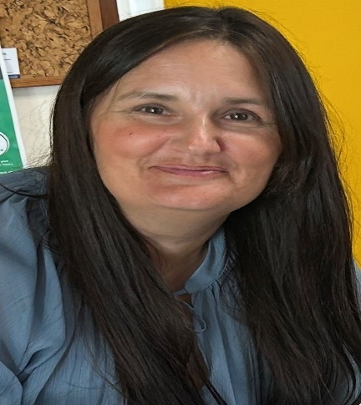
Collaboration

We want older people to be healthy, to be safe inside and outside the home, to enjoy life, to have a voice and to make a positive contribution to help improve Swansea.
Collaboration has been a key word with regards to how we have set about achieving this. Back in 2021 we created the Swansea Ageing Well Steering Group, designed to bring together individuals and organisations who work with or support older people. The aim was to create a space for networking and the development of new working relationships. The Steering Group now includes organisations and charities from the private, community and public sectors, as well as many older community members. We meet bi-monthly to shape our collective efforts in the community and support Swansea’s ambition to become a member of the WHO Global Network of Age-Friendly Cities and Communities.
As with any collaborative group, levels of involvement naturally vary. Since its formation, however, the Ageing Well Steering Group has engaged with representatives from every organisation listed below. Many have contributed valuable insight into their community activity and how their work supports older people across Swansea. The Steering Group has already fostered strong working relationships and delivered meaningful outcomes, with the ability to put names to faces arguably being one of the most significant benefits. In Swansea, we’ve learned that collaboration is far more likely when it involves people you know - those with whom you’ve built genuine relationships.

Organisation | Organisation | Organisation
Action For Elders | Adferiad Swansea | African Community Centre
Age Cymru | Ageing Well Community Group | BMHS Swansea
Bowel Cancer UK | British Heart Foundation | British Red Cross
Caredig | Chinese In Wales Association | Citizens Advice
COPA | Copper Jack | Dementia Hwb Swansea
First Bus | Freedom Leisure | Goleudy
Grand Ambition | Grand Theatre | Gower College
Home Instead | Living At Home | Llais Wales
Matt’s House Swansea | MAWW Fire Service | National Waterfront Museum
NPC Wales | Odeon | Ospreys
Parkwood Leisure | PAVO Heart of Wales Line | Retirement Excellence
Sadie’s Butterflies | SCVS | South Wales Police
Swansea Area | Swansea Bay UHB | Swansea Carers Centre
Swansea City AFC Foundation | Swansea Councillors & Heads of Service | Swansea Environment Centre
Swansea EYST | Swansea University | Tenovus Cancer Care
TFW Rail | U3A | Various Swansea Council Colleagues
Versus Arthritis | Victim Support | Wallich
Warm Wales | Welsh Ambulance Service | —

Creating safe and inclusive spaces for community members and organisations has fostered open, honest and relaxed conversations. These informal discussions often spark ideas for new projects and initiatives, which in turn lead to meaningful action.

Swansea Council Ageing Well Activities
As a result of this collaborative approach, Swansea Council’s Ageing Well team have established ongoing partnerships between a wide range of local businesses, organisations and charities. These relationships have enabled us to deliver a diverse weekly engagement programme across Swansea, offering activities that span physical fitness, mental stimulation, creative expression and opportunities for social interaction. These sessions help individuals build confidence, form new connections and engage more with community life, services and projects.
Some of the engagement sessions available on either a weekly or fortnightly basis to our older community members include:
- Tai Chi
- Movie & Soup Social
- LGBTQ+ Coffee Morning
- Marina Social Walk
- Tea & Chat
- Reminiscing & Ancestry Group – Local History
- Cuppa with a Copper
- Tech Tuesday – Combating Digital Exclusion
- Dance to Health
- Ageing Well Choir @ Swansea Arena
- Aches & Lanes Bowling
- Disability Social
- Purls of Wisdom Knitting Group
- 60+ Dance
- Upcycling Clothes Group
- Boules on the Beach
Swansea Council’s Sport and Health team then co-ordinate the 60+ Active Leisure Scheme. Some of the activities available to older people through this scheme include:

- Nordic Walking
- Trampoline Exercise
- Aerobics
- Paddle Boarding
- Mountain Biking
- Rock Climbing
- Pickleball
- Canoeing/Kayaking

All these sessions are fully booked on a regular basis and there is a huge demand for more! Walking opportunities are also offered: https://www.swansea.gov.uk/healthywalking
A key factor in the long-term success of this programme is that a team member is always present at our engagement sessions. This consistent presence helps build trust, familiarity and strong relationships with community members. As a result, conversations are more meaningful and we’re often approached for advice or support on other issues. Thanks to our collaborative approach, even when we can’t help directly, we’re usually able to connect individuals with organisations that can.

Collaboration Stations

To enhance our visibility, approachability and accessibility further, in August 2023 we opened a small office space inside the National Waterfront Museum. Located in a high-footfall area of this beautiful and accessible venue, the space offers a welcoming environment where community members can drop in for advice, or as often happens, simply for a cup of tea and a chat. The space was named by members of the Ageing Well Community, and so, The Collaboration Station was born.
Building on the success of our space at the Waterfront Museum, we opened a second, significantly larger venue in the city centre in November 2024 - The Collaboration Station @ St David’s. This new space gives us the opportunity to host engagement sessions in our own dedicated venue, marking an exciting step forward. Designed with the entire community in mind, it aims to provide a safe, welcoming, and relaxing environment for people of all ages.
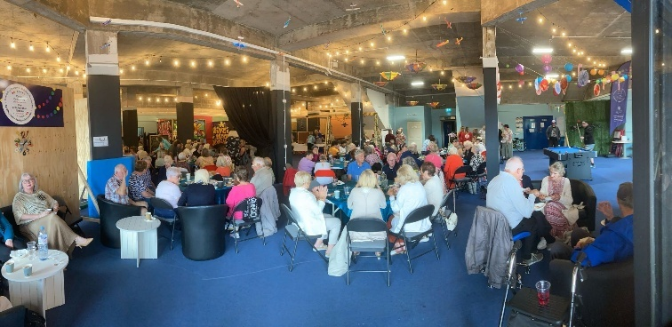
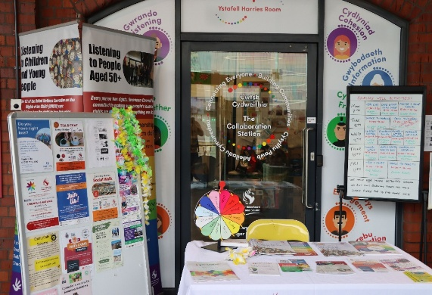

Since opening, the space has hosted over 50 events, delivered by both internal Council teams and external partners. Several of these have been dedicated to the Ageing Well initiative, all of which have been warmly received.
The Collaboration Station @ St David’s has also gained national recognition, with its intergenerational projects, delivered in partnership with a wide range of organisations, winning awards for Early Intervention, Crime Prevention and Partnership Working at the 2024 Wales Safer Communities Awards. Another intergenerational event hosted at the space, City Chill, was also named the overall winner.
2024 Safer Communities Awards - Wales Safer Communities

Information and activities for ages 50+

Ageing Well Information Network
Swansea Council sends a weekly newsletter to individuals who have signed up to our Ageing Well Information Network. The newsletter serves as a key tool for sharing information with the community. It highlights not only Swansea Council’s Ageing Well engagement sessions but also a wide range of activities for older people taking place across the city. Many of these opportunities are submitted by partners from the Ageing Well Steering Group. With nearly 3,000 subscribers, the newsletter consistently generates strong community interest and uptake in the events and initiatives it promotes.
One Stop Information Shop
A bi-monthly One Stop Info Shop in partnership with the National Waterfront Museum. This event provides a space for networking, advice and information, offering attendees the opportunity to speak directly with a wide range of organisations.
Although led by the Council, each One Stop event brings together between 45–60 organisations—all members of Swansea’s Ageing Well Steering Group, who share a common goal: supporting older people in our community to live well and age well.
https://www.swansea.gov.uk/onestopinfoshop
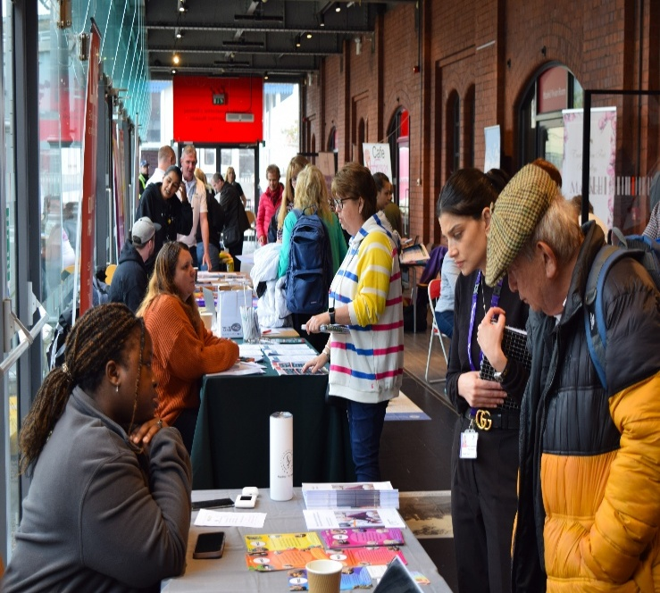
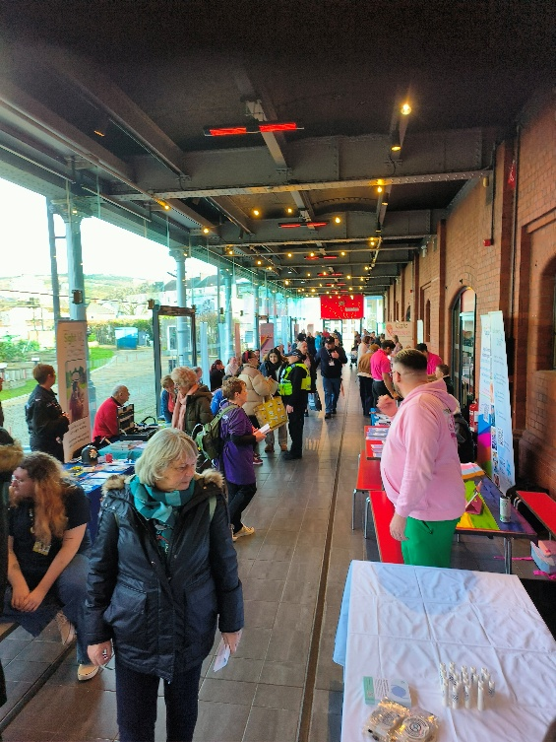

Grants for activities for people aged 50+
In 2021, as part of the pandemic recovery, Swansea Council funded 54 organisations to provide activities for people aged 50 plus, alongside Welsh Government funded ‘Winter of Wellbeing’ activities for children and young people.
Following the success of that pilot, since 2023 Swansea Council has provided over £250,000 of funding for COAST activities through Summer Grants, Enabling Communities Grants, and Winter Wellbeing Grants.
121 projects have been run, benefitting over 13,400 participants.
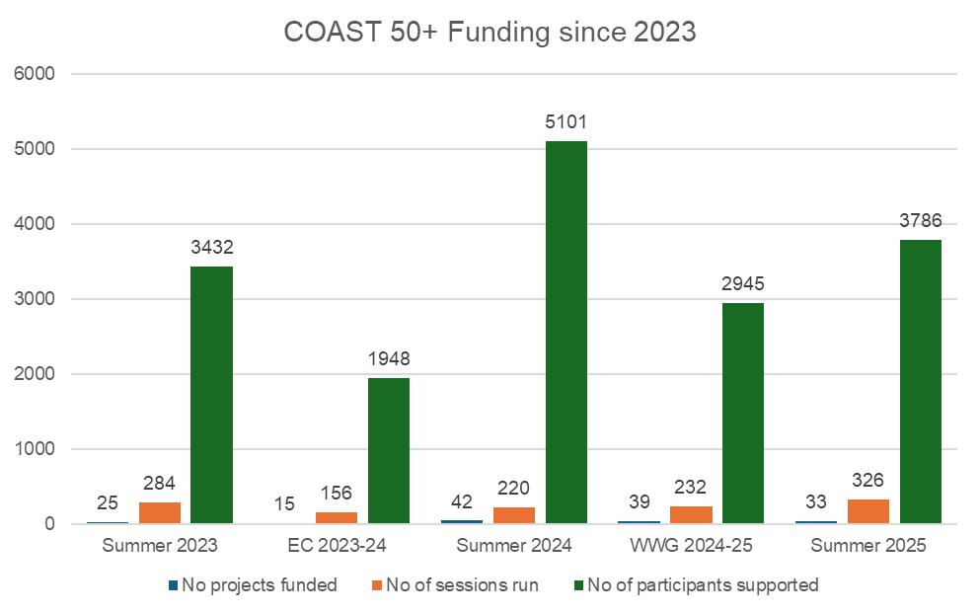
COAST 50+ Winter Wellbeing Grant 2025
The number of applications for COAST 50+ funding for this Winter was much higher than anticipated.
98 projects applied for funding
56 projects were awarded funding.

Now that COAST funding has become a regular and established opportunity in Swansea, we are seeing a growing number of organisations submitting joint applications. By working collaboratively, partners can stretch available funding further and deliver more meaningful outcomes.
We are also noticing that many individuals and organisations who receive funding are engaging more closely with community members to discuss their plans. This approach is helping to ensure that projects are community-led, reducing duplication and increasing the range of opportunities available.
Importantly, many of these partnerships and working relationships have been formed through the Ageing Well Steering Group and events such as the One Stop Information Shop. These spaces have played a key role in bringing organisations together, encouraging shared learning, and strengthening our collective approach to supporting older people across Swansea.
Summary
Although we are only now submitting our application to join the WHO Global Network of Age-Friendly Communities, Swansea has been steadily strengthening its age-friendly approach and raising awareness across the city since 2021. Our work has been regularly highlighted by the Older People’s Commissioner’s Office, which has shared our examples of good practice with other local authorities across Wales.
Age-friendly work in Swansea has also been consistently recognised at a national level. The Ageing Well Programme has been named a finalist on three separate occasions in the Best Health & Well-being Initiative (including Social Care) category at the APSE Service Awards. Although we have yet to secure the overall award, this repeated recognition reflects the quality and impact of our work.
While this section has focused primarily on Swansea Council’s Ageing Well work within the community, this reflects the nature of the Ageing Well Co-ordinator’s role, where broad involvement in age-friendly initiatives is inevitable. However, it is important to emphasise that none of this work has been achieved in isolation. Partnership and collaboration remain central to everything we do, and much of what has been accomplished in Swansea would not have been possible without the commitment and contributions of our many partners.
Swansea’s ability to offer such a rich and varied range of opportunities for older community members is a direct result of the long-term commitment of groups such as, but not limited to, the Ageing Well Community Group, the Chinese in Wales Association, Sadie’s Butterflies and Action for Elders.
It is also important to acknowledge the invaluable support of local businesses, venues and organisations, including the National Waterfront Museum, The Swigg, The Welsh House, Coast Café, Secret Bar & Kitchen, Tenpin Swansea, LC2 Swansea, Swansea Arena, Glynn Vivian Art Gallery, South Wales Police, Gower College and many others, who have all generously provided free venue space, reduced rates on refreshments, and staff time to support or even deliver engagement sessions.
There is undoubtedly a wealth of excellent age-friendly activity taking place across Swansea that we have yet to fully discover. While strong partnership working already exists, there remains significant potential to broaden and deepen this collaboration. As we move forward, our intention is to continue expanding the Ageing Well Steering Group and to actively reach out to organisations and individuals who are delivering valuable age-friendly work across the city. Strengthening these connections will help ensure we have a clearer and more comprehensive understanding of the initiatives already underway.
Once Swansea has secured membership of the WHO Global Network of Age-Friendly Cities and Communities, we hope to further enhance these relationships and be able to better recognise, promote and celebrate local age-friendly practice that may currently be under the radar. This will include identifying examples of good practice, aligning them to the relevant WHO domains and then mapping them against our action plan to demonstrate progress and highlight opportunities for continued improvement.
rants were awarded to these projects.

