Engaging and Understanding Ceredigion
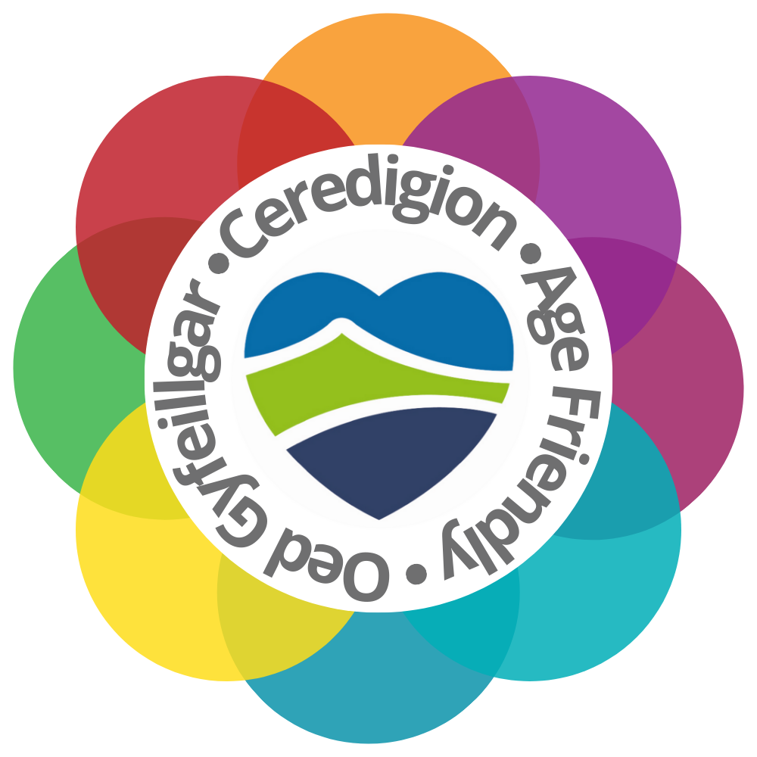

An Age Friendly Self-Assessment

Table of Contents

1. Introduction 3
2. The approach 6
3. Feedback from Engagement across the eight domains of Age Friendly Communities 7
4. Conclusion and Next Steps 25

Introduction
This report is the culmination of extensive collaboration with older persons in Ceredigion and organizations that support older persons throughout the county. The voice of our older residents can be heard throughout this report and their feedback is captured in each of the eight domains. Views were captured at: small, localised engagement events across the county; with existing social and support groups and during our event in October 2023 to celebrate International Older Persons Day. The initial round of engagement commenced in October 2022 and culminated in the event in October 2023. The International Older Persons Day event brought together key stakeholders, with: over forty information stalls; a series of workshops focussing on support for older persons and a demonstration by participants of the National Exercise Referral Scheme. Attendees were given the opportunity to provide feedback against the 8 domains and to vote for their choice of Age Friendly Ceredigion Logo (as seen on the cover page of this document). The event was jointly opened by Sion Wyn Evans from the office of the Older Persons Commissioner for Wales and Councillor Alun Williams, Cabinet Member for Early Intervention, Wellbeing and Culture.

We recognise that this is merely the start of Ceredigion’s process to become an age-friendly county, however, it demonstrates a strong commitment to bringing stakeholders together. We recognise that the process needs to take the form of a collective journey to engage, understand, evaluate and plan to make Ceredigion an Age Friendly Community “A place in which older people, communities, policies, services, settings and structures work together in partnership to support and enable us all to age well”.

Commenting at a National Level, Deputy Minister for Social Services Julie Morgan has stated:-

“Population projections suggest that we will see a very sizeable increase in those over 80 in the next few decades. It is therefore vital that we plan for the future we all want, today.”

The Welsh Government is “helping Local Authorities to work towards membership of the World Health Organisation’s Global Network of Age-friendly Cities and Communities and create great places to grow old”.

Older People’s Champions helping to create an Age Friendly Wales (gov.wales)

In practical terms, according to WHO an Age-Friendly Ceredigion would be free from physical and social barriers and supported by policies, systems, services, products and technologies that:
- promote health and build and maintain physical and mental capacity across the life course; and
- enable people, even when experiencing capacity loss, to continue to do the things they value.

Age-friendly practices help build older people’s abilities to:
- meet their basic needs
- learn, grow and make decisions
- be mobile
- build and maintain relationships; and contribute

In doing so, age-friendly practices:
- recognise the wide range of capacities and resources among older people
- anticipate and respond flexibly to ageing-related needs and preferences
- respect older people's decisions and lifestyle choices
- reduce inequities
- protect those who are most vulnerable; and
- promote older people's inclusion in and contribute to all areas of community life.

Age-Friendly in Practice - Age-Friendly World (who.int)

There are 8 areas or domains that that WHO acknowledges as being key they are:
- Outdoor spaces and buildings
- Transport
- Housing
- Social participation
- Respect and social inclusion
- Civic participation and employment
- Communication and information
- Community support and health services

These are all interconnecting for example, if we don’t have accessible transport then it’s hard for people to access health services, it can limit their housing options, and social participation choices. They can feel isolated and unable to participate in their communities and struggle maintaining employment etc.

Ceredigion
Ceredigion covers an area of 1,900km² and is mostly made -up of agricultural land, moorland and forestry, and forms a significant portion of the Cambrian Mountains. The county to the west borders over 90k of coastline. The attractive landscapes and remote locations in Ceredigion form the basis of ‘rural well-being’ tourism, which draws in many visitors to the area. Overall, there are almost 3 million visitors to Ceredigion each year. The economy of Ceredigion is typical of that of many rural and coastal areas. A high proportion of jobs are in the tourism industry (12.9%), wholesale and retail (12.9%) and human health and social care activities (12.3%). Education is the largest sector in the county, unlike many rural areas, the County has two universities at Aberystwyth and the University of Wales Trinity St. David ’s Campus at Lampeter. It is also home to national institutions such as the National Library of Wales.
(Corporate Strategy Plan 2022-27)

An Older Ceredigion
The 2021 census shows that the population of Ceredigion decreased by around 5.9%
Since the previous census in 2011.

Between the last two censuses, the average (median) age of Ceredigion increased by five years, from 42 to 47 years of age.

This area had a higher than average (median) age than Wales as a whole (42 years).

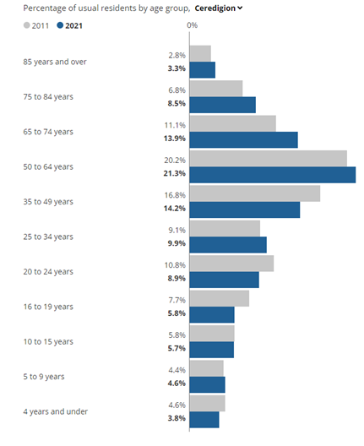

The median age is the age of the person in the middle of the group, meaning that one half of the group is younger than that person and the other half is older.

The number of people aged 65 to 74 years rose by just over 1,500 (an increase of 18.1%), while the number of residents between 35 and 49 years fell by around 2,600 (20.2% decrease).

The share of residents aged between 65 and 74 years increased by 2.8 percentage points between 2011 and 2021. (Information from 2021 Census)

Percentage of 65+ population by community area
Statistics Wales data for 2019 to 2020 shows that for ages 45-64, 852 people migrated inwardly into Ceredigion while 490 people of this age group migrated from Ceredigion.
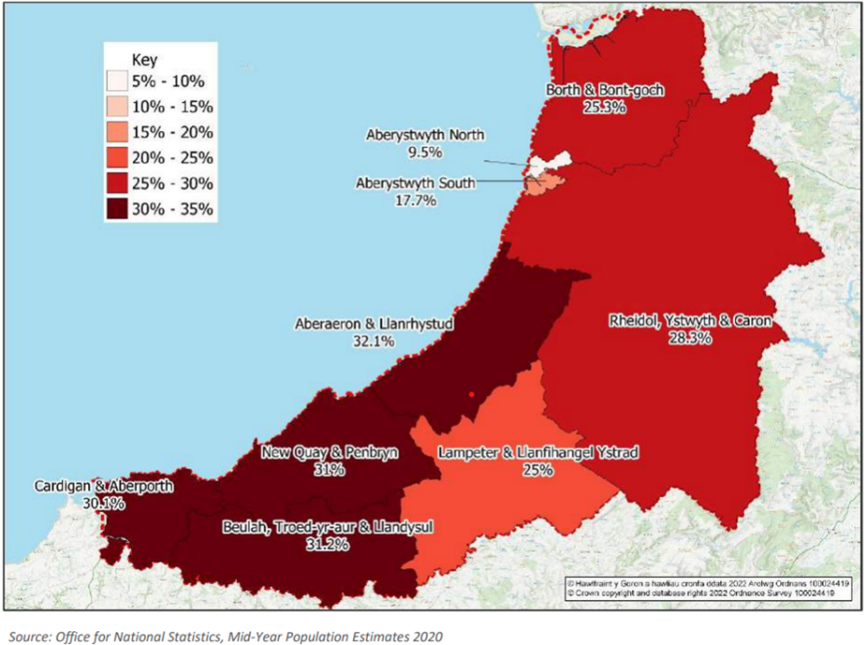

The Approach

Over the last few years Ceredigion Local Authority has been undergoing a transformation of the way it delivers its services aiming to adopt a Through-age and Wellbeing Model of delivery. Through-age Wellbeing Strategy - Ceredigion County Council

In 2021/22 a new team structure was implemented that brought together Carers Development Officers and Community Connectors to form the Carers and Community Support Team.

An Ageing-Well post sits within this team alongside other newly added posts including Digital Connectors and Carers, Community Support Development Coordinators and Community Group Support Facilitator. The team is responsible for ensuring we engage with and work alongside residents in their communities to explore options and solutions to the challenges they face.

We started Age Friendly work by exploring the following questions with Ceredigion residents:
- What’s good about growing older in Ceredigion?
- What’s not so good about growing Older in Ceredigion?
- What could be better about growing Older in Ceredigion?

Alongside our extensive programme of engagement activities, the Ceredigion Public Services Board’s Assessment of Local Wellbeing Plan 2022 has been a valuable resource in establishing our base line assessment. Residents have also contributed to this assessment and provided critical insight into the lives of people living in the County.

In Autumn 2023 we engaged again with residents of Ceredigion asking “what one thing would make a difference to their lives” under each of the eight domains.

- Feedback from Engagement across the eight domains of Age Friendly Communities

(a) Civic Participation & Employment
“Older people have diverse interests, and many want to be involved with a broad range of activities such as working, volunteering, being politically active or taking part in local groups or clubs.”

(What are Age-friendly communities? - Older People’s Commissioner for Wales)

Our residents told us…

What’s good about growing older in Ceredigion?
“The community - A good network of volunteers, great stuff, love it!”

What’s not so good about growing Older in Ceredigion?
“There is a shortage of volunteers, nobody is retiring, volunteers are like gold dust.
Health and Safety makes volunteering off-putting, there is too much detail, it should be more straight forward”.

“Lack of volunteers to drive the transport vehicle – difficult for older people with mobility issues.”
“There is potential to encourage people to volunteer but there are less volunteers as the retirement age creeps up”.

What could be better about growing Older in Ceredigion?
“There was an event in Bont Pavilion about 20 years ago held by the Council, an intergenerational project involving schools, young people and older people. There was a huge contribution from volunteers whose experience and knowledge benefitted everyone. I know there have been individual schools’ projects since, but I think we need to revisit this as a county and build something more cohesive.”

According to the 2021 Census, regarding the workforce in Ceredigion:
- People in employment make up 49% of the population aged 16 to 64
- The working age population is projected to decrease by 12.8%
- The percentage of retired Ceredigion residents increased from 24.9% to 27.7% and this growth is expected to continue in this age group.
(Census 2011-2021)

“Nearly 25% of the population of Ceredigion is 65 years old or over. Many of these people will possess very useful skills which can be shared with the community in an intergenerational way but need an organised way to do this. This could be on a mentoring basis and could cover anything from business support to passing on agricultural skills to the next generation of entrepreneurs. By harnessing the expertise and a lifetime of skills, of the over 65s to pass on to younger generations, you are enhancing the community, where everyone is valued.”

(Example of a written response to The Well-being Survey - The Ceredigion Assessment of Local Wellbeing Plan (2022))

The lack of digital skills could be a barrier to continuing to work post 65, although across the county there are training opportunities available to the general population to help older people to improve their digital skills, such as through Dysgu Bro, and Cwmpas Digital Communities Wales project, which offer a range of courses for adults to improve their skills.

Volunteering rates tend to be higher in rural areas such as Ceredigion and older age groups are also more likely to volunteer.

In the Well-being Survey 38% of the 65+ respondents stated that they volunteer in Ceredigion, with 33% saying that they would consider joining a community/volunteer group to help achieve good community cohesion in their neighbourhood.

Concerns were raised in the Well-being Survey by 22% of the 65+ respondents, that in the future employers/education providers would not be prepared to make reasonable adjustments for employees of different ages, sexes, genders, races, backgrounds, beliefs and/or who are disabled.

Concern was not so much about the lack of volunteering opportunities in Ceredigion but the lack of volunteers being able to take up this opportunity due to the increases in retirement age. This is a commonly raised issue at our county wide engagement activity.

The increased retirement age came up as a big concern for some women in work They felt they had suddenly an extra 7- 8 years of working when they always thought they would be able to retire at 60. The Institute for Fiscal Studies report – Labour market effects of the increase in the state pension age from 65 to 66 (Jan 2022), found that the increase in state pension age from 65 to 66 between December 2018 and October 2020 increased the employment rate of 65 year old men by 7.4% and women by 8.5%.

(b) Communication and Information
“In order to be involved with community life, you need to know what is happening in your community. Information about events, services and facilities should be available in accessible formats, and in places where people know to look for them. Special care should be taken in ensuring that information is accessible for people with sensory impairments and made available in their language of choice. It’s also important to remember that not all older people are online, and may not want to be”.
(What are Age-friendly communities? - Older People’s Commissioner for Wales)

Our residents told us…

What’s good about growing older in Ceredigion?
“The cost of living leaflet had useful information in it.”
“Dysgu Bro helpful. They held 4 digital working lessons in the Village Hall Bow Street.
‘Library and their services in Aberystwyth’”
“Have welcomed the digital age into our lives think technology is wonderful”.
“Able to use mobile phone uses What’s App and FB messenger to talk to family”
“Carers magazine bright, informative, easy to read nice to pick up with a mug of tea and have a read through – like the fact that is bilingual.”

What’s not so good about growing Older in Ceredigion?
“The place I live and the fresh air, but the services aren’t as good anymore.”
“Older people are not so aware of what services and support are available to them.”
“People come to live here from away without family nearby and they battle on alone. Do we look out for them enough in Ceredigion? That is where the local authority should step in.”
“I’m not able to access internet.”
“If I choose fibre for my broadband and I lose my landline if I have a power cut there is no way of communicating to anyone that I am ok what do I do?”
“I have problems using apps on phone with sight problems.”
“Difficulty finding time to do things for myself”
“Where do we find out about things that are going on in our area?”
“There’s no mobile signal – Bwlch y Groes and Ponterwyd”

What could be better about growing Older in Ceredigion?
“More information should be sent out to older people similar to the cost of living leaflet which was very informative.”
“Fibre, broadband mobile signal needs improving very poor around the area.
The need to better publicise events difficulty finding things.”
“Digital Courses needed in Lampeter for older persons to become familiar with mobile phones and the internet.”
“Welsh speaking classes for older learners”
“Leisure centre could advertise events better – unsure what’s going on around the area.”
“Infrastructure for Ceredigion is a massive issue that needs addressing now! - digital connectivity.”

Ceredigion is one of the heartlands of the Welsh language. However, the 2021 census shows us the percentage of Welsh speakers in Ceredigion fell from 47.3% in 2011 to 45.3% in 2021. There were around 3,300 fewer Welsh-speaking Ceredigion residents (over the age of three years) compared with 2011.

This can be broken down into age groups able to speak Welsh as follows:
- 3-15 years 71.8%
- 16-64 years 42.4%
- 65+ years 39.9%

The Local Authority is currently developing a new Language Strategy for the next 5 year period. All information is available bilingually and the Local Authority is in the process of improving its website.

Ceredigion has an established and well-received Carers magazine which is published 3 times a year, available to Carers on the Carers Information Service and hard copies are distributed throughout the county.

The Ceredigion Carers and Community Support Team has its own page which shares information about events, consultation, activities, the community connectors drop-in sessions, warm welcome hubs etc.

Dewis Cymru is the national citizen portal for wellbeing information in Wales and is available to all residents and professionals in the county. There are currently 617 live Ceredigion resources on Dewis.

Ceredigion Association of Voluntary Organisations (CAVO) have an information platform https://connectceredigion.org.uk/networks. This community platform is for anyone who lives in Ceredigion and contains information in relation to:-
- Wellbeing
- local activities
- community projects

There are six Libraries in Ceredigion including four that are contact points for the Local Authority. The Library Service operates Mobile Libraries, that visit villages and farms in Ceredigion every four weeks. Residents can also ask for the Mobile Library to call at their homes. Housebound residents and registered carers can apply to have books and other resources brought to their homes. There is also a list of e resources including books, comics and magazines that can be accessed via the Library Service online.

Information with regard to the cost of living has been distributed to homes in Ceredigion and is also available online.

(C) Community & Health Services
“Accessible and affordable health and care services are vital for older people to stay healthy, independent and active. These services need to be conveniently located to where people live and public transport routes.”
(What are Age-friendly communities? - Older People’s Commissioner for Wales)

Our residents told us…
What’s good about growing older in Ceredigion?
“I had to visit the Minor Injuries Department here. A fantastic experience. Everybody, from reception to the medical staff were excellent. Nothing was too much trouble”
“Porth Gofal services very good”
“Carers assessment – booked and arrived within 3 weeks.”
“Care and repair will look to use in the future.”
“Health Service is good, appointments have come through very quick.”
"Treated well in Bronglais General Hospital when i broke my foot, I don’t mind waiting for appointments, physio have been great.”
“It’s also reassuring that Bronglais is nearby (Aberystwyth resident)”
“Support from Tregaron pharmacy with medication Tregaron surgery very helpful”
“Flu jab and Covid jab widely available really good service.”
“Parkinson group very good in Plas Antaron, Aberystwyth”
“Parkinson’s Nurse brilliant service for husband.”
“Vaccinations the way Ceredigion managed the situation and how quickly they got people jabbed.”
“Local Dentist services are good – Lampeter My Dentist very good service really look after you and care.”
“A and E brilliant – when I have had an appointment Bronglais has already got an appointment ready for next time 6 months – at least you know where you are with them.”
“I see my wife 3 days a week says the Coach House is a beautiful care home very pleasant with fantastic views.”

What’s not so good about growing Older in Ceredigion?
“Elderly get no help, shortage of carers/home help. GP service is hopeless”
“I live in Carmarthenshire but registered with Lampeter GP, get pushed from pillar to post because of being across the county border.”
“No day care for elderly or those living with dementia.”

One lady told us her story:
“I was diagnosed with Breast cancer in 2020, the drugs had bad side effects, chest pains and difficulty breathing, I spent 10 hours waiting for a bed in A&E. I finally got a bed at 1.30am. I was diagnosed with unstable angina and given a spray ; the consultant advised me to take it with me at all times. I took the dog out for a walk and had to use it. I fainted and broke a hip. I was then told that the spray is only to be used at home or when sitting down as it could cause me to faint, had I been told this I wouldn't have a broken hip. I now have a blue badge and walk with a stick. I complained to the consultant’s secretary but it didn't go any further.

When you’re old everything tends to get passed off as old age, patients have to speak up for themselves, I have an interest in medical things and know what I'm talking about, there’s a thing called an expert patient which GPs should know about. patients have to run the gauntlet with the receptionists first before even speaking to a GP.

Your balance thing in your inner ear goes as you get older, so walking gets more risky. I used to do a lot of walking but now my balance has gone I'm too afraid.”

“Seeing a dentist is difficult, you cant get an NHS dentist, I only get to see mine once a year.”
“Problems with Cardigan Dentist – Had to go to Fishguard for appointment”
“Borth surgery has been going for over 100 years, its not just about Borth, they cover furnace, Penparcau and Ponterwyd, closing would place a greater burden on Aberystwyth surgeries, seeing a GP in Aberystwyth is difficult enough. a GP surgery is one of the most valuable commodities in Ceredigion.”
“This is not just an issue for GP recruitment, it also applies to dentists and dental hygienists.”
“The dermatology clinic has already closed and i have to travel down south”
“Where can older people get their feet seen to?”
“Ear wax Cleaning - Specsavers £50 only place offering the service”
“Referral to the optician took too long.”
“Labels on medication pots from pharmacy difficult to read instructions”

What could be better about growing Older in Ceredigion?
“Need a hospital in Aberaeron or Felinfach.”
“Keeping Borth surgery going is so important.”
“Previous GP. closures have been on financial grounds, the greater problem here is staffing. the health board needs to be doing something to attract employees.”
“We need dynamic exercise equipment along the prom, like mumbles promenade, it would help people to meet others and socialise.”
“Health communication could be better”
“Holistic wellbeing day – reduce the risk of falls”
“The need for a NHS dentist is critical.”
“Possible fast track service on the phone from the doctors surgery for older persons reduce waiting on phone to listen to all the automated messages and having to press different numbers to get through.”
“We could set ourselves apart in Ceredigion by making preventative healthcare a priority. There are people who make life choices to remain healthy, we need to acknowledge our own responsibility for health as we age. Good choices need to be embedded in us to become a healthier population”
“Buckinghamshire has an Ageing Well project, they have started thinking of building resilience at a younger age, 40. this can be done a lot better here too. Good exercise classes, NICE recommend everyone should be on vit D -builds density but isn't advertised anywhere, there's been a Welsh Government consultation on the benefits of exercising with resistance bands to prevent osteoporosis, we need to put policy into practise and disseminate this information as widely as possible, announcements on local radio for example. This could include advice on prevention of stroke/heart disease/hydration/sepsis recognition. the council needs to work with the health board re prevention and focus on resilience from a younger age, including mental health resilience.”

This domain was a popular topic at engagement sessions; for some it was fears for their own health failing and for others it was concern about services closing.

There is one general hospital in Ceredigion, Ysbyty Bronglais in Aberystwyth and 3 other hospitals in the Hywel Dda region that provide services to Ceredigion (2 in Carmarthenshire and 1 in Pembrokeshire). There have been two new joint integrated care centres opened in Ceredigion in recent years, Aberaeron and Cardigan with plans to open a 3rd in Tregaron.

A new Extra Care Scheme in Aberystwyth, Maes y Môr was developed by Wales and West Housing Association in partnership with Ceredigion County Council and opened in October 2021. There is another Extra Care Scheme, Maes Mwldan in Cardigan in partnership with Caredig Housing Association.

On 04 July 2023, Ceredigion Cabinet Members approved a decision to transfer Hafan y Waun Care Home to Council ownership, transfer was completed on the 1st November 2023. Hafan y Waun, in Aberystwyth has 90 en-suite bedrooms and four wings, which can be self-contained, as well as a large ‘dementia friendly’ garden. This also includes a community hub which acts as a resource for the care home as well as the community.

Ceredigion Assessment of Local Wellbeing Plan 2022 states:
“Dementia and Alzheimer’s was the third most common cause of death in Ceredigion between 2013 and 2020. Approximately 65 people died per year from dementia and Alzheimer’s disease in the county, equating to around 8.2% of deaths each year during this period.”

According to the West Wales Care Partnership, in 2020 there were 1,322 people aged 65+ living with dementia in Ceredigion. By 2035, this number is projected to increase significantly to 1,993.

The total number of people living with dementia in Ceredigion is expected to increase by 51%
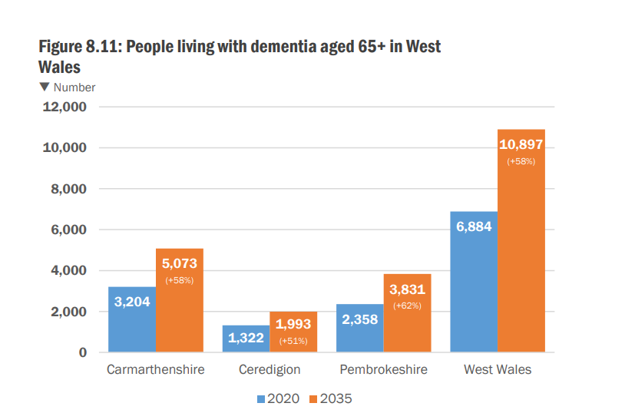

In November 2023, Age Cymru Dyfed successfully tendered for the contract to run the Dementia Wellbeing Connector service in the Hywel Dda area. This will lead to the provision of 1.8FTE dementia wellbeing connector posts to work in Ceredigion.

Ceredigion County Council is to develop a local dementia Implementation Plan to support the Regional Dementia Strategy. The report and local implementation plan will support Ceredigion County Council and Hywel Dda University Health Board to address some of the challenges and gaps identified. An integrated Health, Social Care and 3rd Sector Development Group has been created to oversee the implementation of the plan

The Ceredigion Assessment of Local Wellbeing 2022 asked the following question of residents:
‘Thinking ahead, over the next ten years, what concerns you the most about being able to stay physically and/or mentally well?’ (Aged 65+ responses)

Not having access to healthcare or other support that I need, as close to home as
possible or available through technology 72%
Not being able to stay living in my own home 63%
Not being able to spend time outdoors or in nature and green spaces 54%
Not being able to get support when I’m not well and can’t look after myself 43%
Not being able to take regular exercise 36%
Ceredigion Assessment of Local Well-being 2022

Below is a summary of main themes when survey respondents were asked – “what needed to be put in place to improve their physical and/or mental health”

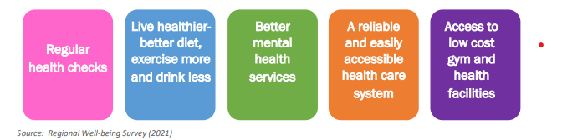

In addition to traditional Health and Social Care the Local Authority operates health and wellbeing services in its wellbeing/leisure centres which enable older adults to remain healthy independent and active.

Older persons in Ceredigion can access the National Exercise Referral Scheme which is a national initiative to encourage adults who have been diagnosed or are at risk of being diagnosed with a particular illness or disease to exercise. Once a referral is received, an Active Lifestyle Mentor will look at key aspects of their health and wellbeing and discuss the 16 week exercise programme.

There is a full timetable of classes available for Ceredigion residents at Plascrug, Aberaeron and Cardigan Leisure Centres as well as Lampeter Wellbeing Centre. We also have weekly classes in Llandysul and Tregaron. After the clients complete the 16 weeks NERS programme, they are offered the opportunity to continue health and wellbeing classes through the Fit for Life programme. This is a continuous offer of low impact classes and activities that suit the older residents. On average, 1000 persons attend the Fit for Life classes in Ceredigion every month. This equates to approximately 500 individuals attending the classes on two occasions per week.

Additionally, residents are offered Wellbeing Walks to help them keep active. We offer walks every week at Cardigan, Aberporth, Lampeter, Aberystwyth and Borth. Approximately 300 attendees attend the walks every month.

(d) Housing
“Everyone has a right to adequate housing, regardless of age or ability. For many, having a place to call home is at the heart of what it means to age well. Simple modifications and adaptations can enable people to continue to live independently in their own homes. An age-friendly community supports people to make decisions about where they live, whether to stay in their existing homes, or find a new home suitable to their needs near to the people and places that are important to them.”
(What are Age-friendly communities? - Older People’s Commissioner for Wales)

Our residents told us…
What’s good about growing older in Ceredigion?
“Care in the Community/Care and Repair is a great service for small home adaptations’.”
“The Council home assessment of needs is good.”
“Care and repair very good but system don’t seem to advertise it enough.”
“I live in sheltered accommodation in Bow Street, the decor is a bit old and tatty but they've just replaced the leaky roof and it’s much better, there’s a shop right opposite and I have somewhere to park my car.”

What’s not so good about growing Older in Ceredigion?
The cost of living was raised frequently for example:
One resident stated that they were “Worried about heating or eating.”
We heard about one person struggling to get help to have their boiler upgrades and others weren’t sure of their eligibility.
Residents reported difficulty in getting information on some support schemes.

What could be better about growing Older in Ceredigion?
“Improve information about what help is available to improve homes especially support with rising energy costs.”
“Provide more support to Dementia sufferers and their carers to live a longer independent life within the home.”
“We all love living in our own homes, but we need to explore what could communal living be like, a review is needed looking at shared community arrangements to reduce isolation and consider new developments that make it easier for people as they grow older.”

Ceredigion Local Authority is not a major housing stockholder, having transferred its stock over to Barcud in 2009. Ceredigion operates a Common Housing register, those who need accessible housing can apply to the accessible housing register, people who need accessible housing can also apply to:

- the Affordable Housing Register
- the Designated Older Persons Register, if they are aged 55 or older

The Ceredigion Assessment of Local Well-being 2022 tells us:

“Much of the housing stock in Ceredigion is inadequate due to its old age which makes it difficult to heat and adapt to improve the safety and energy efficiency, as a result, Ceredigion residents have higher energy costs. In 2019, the median estimated energy cost per year in Ceredigion for existing flats was £651 and £1,158 for existing houses, both of which are significantly above the national average (£525 for existing flats and £907 for existing houses). It is very likely that these figures will have increased due to the current UK energy crisis. This will have an adverse impact on older people, particularly those already living in fuel poverty, as heating usually needs to be at a higher temperature and left on for longer hours.

Furthermore, a high proportion of Ceredigion’s households are located off the main gas network, which leaves residents reliant on more expensive fuels such as oil, electricity or LPG and dual fuel tariffs.”

In October 2022 Ceredigion County Council was awarded third prize for the ‘National Council or Local Authority of the Year’ as recognition for delivering energy efficiency projects for the local community between January 2021 and March 2022. Special emphasis was placed on the successful integration of the ECO Flex and Cozy Ceredigion schemes. In 2023 Ceredigion County Council received a Special Commendation in the National Energy Efficiency Award under the category of National Council or Local Authority of the Year.

Ceredigion Local Authority operate:-
- Disabled Facilities Grant –
Up to £36,000 of grant aid (means tested) to cover disability adaptations and equipment to enable persons to maintain independence in their home.
- Safe Warm and Secure – Fast Track Adaptation Grant
- Grant of up to £800 (non means tested) or £5,000 plus vat and fees, for adaptations or equipment for disabled or elderly person to maintain independence.
www.ceredigion.gov.uk/resident/housing/financial-assistance/energy-efficiency-schemes/
- Welsh Government’s National Empty Homes Grant Scheme.
We are committed to supporting individuals to bring empty homes back into use to help re-generate communities and provide much-needed housing for individuals across Wales.

Grants of up to £25,000 are available for homeowners or prospective homeowners to renovate empty houses to make them safe to live in and improve their energy efficiency.
www.ceredigion.gov.uk/resident/housing/financial-assistance/national-empty-homes-grants/Ceredigion

The Social Housing Grant development programme has delivered a number of new schemes across Ceredigion. Several wheelchair accessible homes have also been provided for applicants from the Housing Registers.

(e) Outdoor Spaces and Buildings
“Accessible communities enable people to stay connected, participate in social activities and access local services and facilities. Well-maintained and well-lit streets, clear signposting, green spaces and public toilets all support older people to stay active and lead independent lives.”
What are Age-friendly communities? - Older People’s Commissioner for Wales)

Our residents told us…
What’s good about growing older in Ceredigion?
“Happy with the environment enough open spaces to walk.”
“A Beautiful place to live.”
“Wild swimming and Walking – Aberystwyth is pretty flat and easy for a stroll.”
“We are fortunate to have a lovely well-maintained prom which is on the flat, I go for long walks.”
“Streets around Cardigan are good for mobility scooter.”
“Pathways around Longwood Walk very well maintained good for people with mobility issues who may need a scooter, chair.”
“Aberystwyth is peaceful with plenty of fresh air and a low crime rate.”
“Ceredigion has good sized towns with multiple arts, music, and theatre connections. there are good intergenerational links at the Aberystwyth Arts Centre.”
“I love where I live. we moved here because it was a family home and by the sea. I’m a cold sea swimmer and I’m looking forward to getting back out there, people are friendly.”
“The access into larger public buildings for people with mobility issues is good”
“Happy with the refuse collection of clears and food every week then domestic and glass every 3 weeks.”
“Enjoy this walk being out and about – socialising – good for mental health and loneliness (Aber ramblers) lovely scenery.”
“Wide pavements for people with mobility issues on this walk. Enough benches along the route if needing to stop for a rest (Aber ramblers).”

What’s not so good about growing Older in Ceredigion?
“Access to the beach particularly for those living with disabilities.”
“Parking is difficult in towns.”
“Too many steps into older buildings in Ceredigion.”
“Steps into shops are too high.”
“Potholes in the road require immediate attention.”
“Collection of bins – seagulls/ birds destroying the bags.”
“Lack of pavements for mobility scooters and mobility issues.”
“No access to beach (Borth).”
“Pavement outside Doctors surgery is difficult to walk on. (Borth)”
“Buildings without level access and lack of disabled parking.”
“Public toilets – massive issue –still not open in cardigan – Cenarth Falls and New Quay only open when the tourists are in town.”
“Lack of police presence in certain areas.”

What could be better about growing Older in Ceredigion?
“Increase public toilets – women, men, neutral.”
“Install bird deterrents and bins that the birds find difficult to get into.”
“Paths need widening.”
“Boardwalks or something on beach so people could get to the sea and paddle, feel the sea on their toes.”
“The council needs to grit more, I have a petrifying fear of slipping and breaking a hip, there’s no gritting in rural areas.”
“If I stay in this area I’d like to see the libraries where people could meet up socially.”
"The extent to which voluntary services and the 3rd sector rose to the challenge during covid is to be commended, from all this work came the notion of community hubs, could this be a model for use right across the county, good intergenerational work, using the family centres, to be recognised as the fabric of Ceredigion. They are successful because local people are using them.”
“The council would do well to open the day centres, a review of the system is needed, we should look at a model which follows the Scandinavian approach, free health and wellbeing classes, ticks all the boxes of Ageing well and connectedness.”
“When Canolfan Padarn’s refurb is done will it then release the other day centre? lots of people want to use that service and there is nothing else in its place.”
“Improve the access to smaller buildings in Ceredigion for people with mobility issues.”
“Continence management is a big worry, there should be adult and child changing facilities.
“Why haven’t we got wheelie bins in Ceredigion?”

“Ceredigion covers an area of 1,900km² and is mostly made-up of agricultural land, moorland and forestry, with the upland areas to the east forming a significant portion of the Cambrian Mountains. There are six main towns in Ceredigion that are located on the coast or in river valley locations. Ceredigion has a variety of natural landscapes and habitats including being bordered by over 90km of coastline According to the local well-being assessment. The County’s landscapes and natural environment are highly valued by local people, with 68% stating that ‘nature and green spaces’ was what they value the most in their local environment.”
(Corporate Strategy 2022-27; Ceredigion County Council)

Residents of Ceredigion provided the following information in response to questions posed in the Regional Wellbeing Survey (2021)

Aged 65 and over - thinking ahead over the next ten years, what concerns you the most about being able to stay physically and/or mentally well?
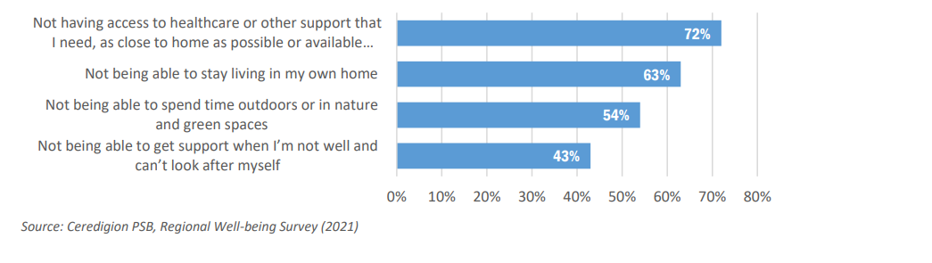

Which three things do you value the most about your local environment?
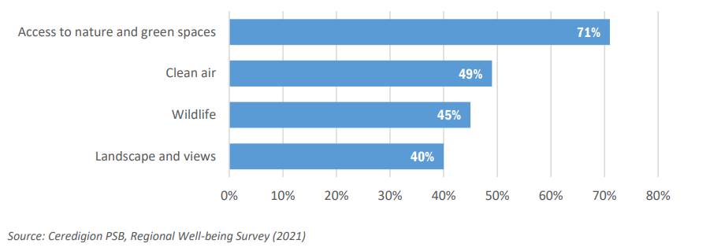

There are 36 public toilets across Ceredigion some of which are open 24 hours a day.
https://www.ceredigion.gov.uk/media/5750/toilet-strategy-publication-english.pdf

As part of the equalities plan it has been agreed that the Local Authority will review the Toilet Strategy so that it reflects the needs of our changing population where reasonably and practicably possible. The review is scheduled to take place this year and it would be beneficial to include older people in the review.

The Ceredigion Green Infrastructure Assessment (2020), details that in the 6 key towns in Ceredigion (i.e. Aberystwyth, Aberaeron, Cardigan, Lampeter, Llandyssul and Tregaron), there are 57 ha of greenspace playing fields; 6.2 ha of Public Parks or Gardens; 9ha of village greens; 13ha of open access land and 104ha of other sports grounds/ facilities.

In 2023, Ceredigion Local Authority published “Ceredigion: A Strategy for Greening 6 Towns, which built upon the findings of the 2020 Ceredigion Green Infrastructure Assessment and focusses on developing Ceredigion’s Blue and Green Infrastructure in the County’s largest towns. One of the key principles guiding the strategy is : “Creating happy and healthy communities, where specific reference is made to the needs of Ceredigion’s ageing population. Stakeholders contributing to the development of the strategy emphasised the need for walking and cycling routes to be accessible to all, including for the use of e bikes and improving links from outlying villages to the towns to promote active travel.

(f) Respect and Social Inclusion
“Ageism underpins many of the issues currently faced by older people, resulting in older people being treated unfairly, feeling socially excluded and their rights not being respected. Age-friendly communities challenge ageism by bringing people of different ages together and fostering positive images of ageing.”
(What are Age-friendly communities? - Older People’s Commissioner for Wales)

Our residents told us…
What’s good about growing older in Ceredigion?
“People tend to mind their own business and let you get on with it but help each other when its needed.”
“People tend to show a lot of consideration to older people in this area.”
“The MP has been very helpful with benefit queries.”
“Having family close is wonderful.”
“Caring community.”

What’s not so good about growing Older in Ceredigion?
“All Banks in Newcastle Emlyn are closed.”
“All banks in the area now closed and the post offices – need to drive to get money and post letters.”

What could be better about growing Older in Ceredigion?

“Daytime Groups – please could we have more of them.”
“More organised walks.”
“Drop curbs in Aber town, particularly near disabled parking spaces.”
Comments hung on the Hopes and Wishes tree at Aberystwyth Pride (22/04/23)
“Wider promotion of events. Some are still unaware of the fantastic community that there is accessibility, information, events, public consultation.”
“Safe spaces for LGBTQ+ people and other minorities.”
“More inclusivity in gender identity by doctors, stores etc so trans can be seen and feel valid.”
“Better mental health services in Ceredigion for people with identity crisis and mental health crisis.”
“Fast and accessible mental health care.”
“Develop your Community Connectors model to include a Disability Awareness expert and a LGBT person.”

Composition of Ceredigion’s population

Population of Ceredigion in 2021 Census 71,500
Age | % of population |  | Religion | % of population |  | Ethnic group identity
85 plus | 3.3% |  | No religion | 43.0% |  | Asian, Asian British or Asian Welsh | 1.5%
Age 75 -84 | 8.5 % |  | Christian | 46.7 % |  | Black, Black British, Black Welsh, Caribbean or African | 0.5%
65 – 74 | 13.9% |  | No answer | 7.7% |  | Mixed or Multiple ethnic groups | 1.2%
50 - 64 | 21.3 |  | Buddhist | 0.5% |  | White | 96.2%
35 - 49 | 14.% |  | Hindu | 0.2% |  | Other ethnic groups | 0.5%
25 -34 | 9.9% |  | Jewish | 0.15%
Under 25 | 28.8% |  | Muslim | 0.7%
 |  |  | Sikh | 0%

Source: Office for National Statistics – 2011 Census and Census 2021
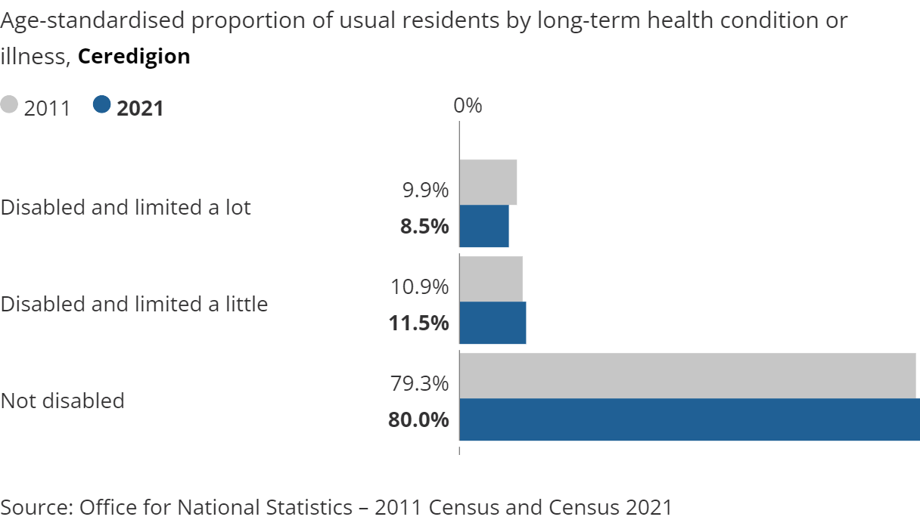

The Local Authority and the Community Sponsorship schemes run by community groups - Croeso Teifi and Aberaid, have enabled 74 refugees from war-torn Syria to settle in Ceredigion under the Home Office Vulnerable Persons Resettlement Scheme. As at the 18/12/2023, there were 104 individuals from Ukraine residing in Ceredigion. Of the 104 individuals 17 were aged 50+.

Some of these individuals have now moved on to other areas within the UK and 66 are currently living in the county.

(g) Social Participation
“Being able to stay connected with friends and family is essential for ageing well. Age-friendly communities enable older people to take part in a range of social activities, bringing people of all ages together around shared interests.”
(What are Age-friendly communities? - Older People’s Commissioner for Wales)

Our residents told us…
What’s good about growing older in Ceredigion
“Ceredigion has good sized towns with multiple arts, music and theatre connections. There are good intergenerational links at the Aberystwyth Arts Centre.”
“Warm spaces much needed with the cost of living crisis.”
“The extent to which voluntary services and the 3rd sector rose to the challenge during covid is to be commended, from all this work came the notion of community hubs, could this be a model for use right across the county… They are successful because local people are using them.”

What’s not so good about growing older in Ceredigion?
“No day care for elderly or those living with dementia.”
“Lots of the groups I went to stopped because of Covid and didn’t start back up.”
“Now I'm older and especially after covid I feel more isolated.”
“Less inclined to go out in the dark, I used to work in drugs and alcohol rehabilitation for 20 years and I know what the drug situation is in Aberystwyth. There are drug users in town, county lines are expanding, and the police need to do more.”
“No community centre or hall for people to meet up and use in Aberystwyth Town. villages have a Hall, Kings Hall has gone, Drill Hall and Parish Hall too, day centre has gone.”
“Difficulty finding support groups.”
“Feeling of isolation – recluse.”

What could be better about growing Older in Ceredigion?
“We need more events and they need to be more inclusive.”
“We need more events for older people.”
“Those living in Tre’r Ddol are keen to access Borth Hub but there is no transport. Staff are not insured; people are unable to get there. a system of Hubs is needed supported by a transport system.”.
“One to one home visits to build confidence to join groups could be an idea.”
“Daytime Groups – please could we have more of them.”
“More organised walks.”
“Aqua Aerobics – start a class in Leisure centres.”

Social participation is different for different people, for many people in 2023 staying connected involves using the internet. For some, digital inclusion is difficult due to lack of skills, knowledge, equipment or a lack of connectivity and others may not wish to be digitally connected. However, for instance, some unpaid carers told us that being able to join activities online meant they didn’t need to leave their cared for.

The graph below, produced by The National Survey for Wales in 20/21, demonstrates that the 65+age range has the lowest percentage of persons who use the internet several times a day. However, it does also demonstrate that from 2014 the percentage has increased from just under 40 % to over 60% in 2021, though it remains lower than for other age groups.
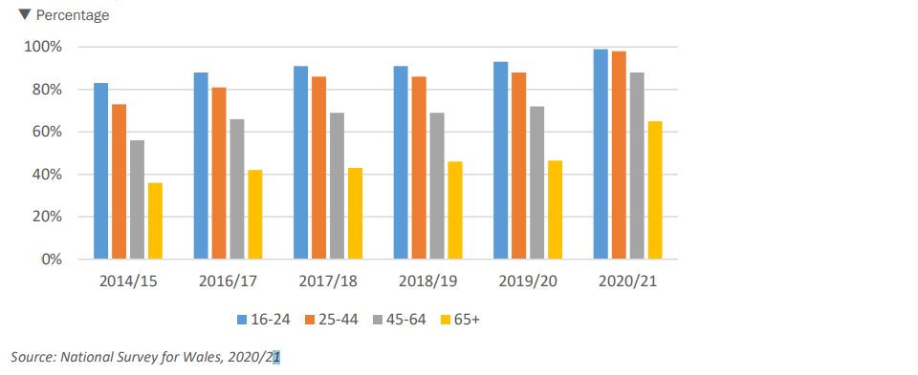

Day Centres closed during Covid and the Local Authority commissioned a consultation and engagement exercise, focussing on respite and day opportunities in the line with the through age model. The final report has now had cabinet approval and work will commence in the new year on implementing the agreed action plan.

Approximately 2000 people received a warm welcome in Community venues across the county in Winter 22/23. The aim of these centres is to encourage communities to get together for a chat and a cuppa. Some offer a hot meal and activities as well. This year 41 warm welcome spaces are open to all for free or for a small donation.

(h) Transportation
“Affordable, reliable and convenient transport options enable people to get out and about and continue to do things that matter to them. Whether going shopping, visiting the cinema, meeting friends or attending a GP appointment, good transport is essential to everyone, particularly in rural areas and for people who do not drive.”
What are Age-friendly communities? - Older People’s Commissioner for Wales

Our residents told us…
What’s good about growing older in Ceredigion?
“Taxi services, Train service, Hospital transport.”
“Green dragon transport Free bus passes for older residents.”
“No Motorways in Ceredigion.”
“Bus routes in town good.”

What’s not so good about growing older in Ceredigion?
“Lack of train service south of the county.”
“Some of the bus routes don’t fully support rurality and finish too early.”
“The Bwcabus service needs improving.”
“Some bus routes have closed.”
“Some bus routes have no weekend service or evening services.”
“Very limited spaces for disabled passengers on buses and limited number of accessible taxis.”
“Older people rely on buses which have been cut and communication is terrible about changes.”
“They only use one taxi firm for the whole of mid and north Wales.”

What could be better about growing Older in Ceredigion?
“We need a train station in Lampeter.”
“Recruit volunteer drivers for community transport.”
“Improve bus routes.”
“Transport to exercise/wellbeing classes.”
“Improve weekend bus provision.”
“Could we utilise the councils' minibuses, if there is any spare capacity?”
“Improve travel information so that it is more accessible for older people who may be not able to access it online.”
“Can Green Dragon in South Ceredigion offer more?”
“I would like the option of being able to donate my bus pass to families who are struggling as the bus is too expensive. I rarely use the bus.”

Due to its rurality, Mid Wales has a high dependence on the private car for transport and less than 1% of road miles are driven by buses. The region also has below average take up of electric vehicles with limited charging points compared to the UK average.

Ceredigion County Council has partnered with Silverstone Green Energy Limited as its Charge-point Operator and have begun to install EV charge-points in public Pay and Display off-street car parks in the county. A network of charging points will be installed across the county.

Rail links in Mid Wales are characterised by low service frequency, slow line speeds and limited direct services to major UK cities with the only regular principal service being the two-hourly Aberystwyth to Birmingham International through services.
Vision_for_Growing_Mid_Wales_FINAL_ENGpdf.pdf

Affordable, reliable and convenient transport options enable people to get out and about and continue to do things that matter to them. Whether going shopping, visiting the cinema, meeting friends or attending a GP appointment, good transport options is essential to everyone, particularly in rural areas and for people who do not drive.

There is a rail link from Aberystwyth to Shrewsbury and Birmingham via north Powys and it is possible to access the Cambrian cost northwards as far as Pwllheli. Many residents stated that they would like to see the reopening of the Aberystwyth to Carmarthen line.

Concerns were raised via the equality’s consultation that rail replacement buses often have steps and are therefore not always accessible.

The Ceredigion Assessment of Local Wellbeing Plan (2022) informs us that 62% of respondents aged 65+ identified “a good transport network that meets the needs of rural and non-rural areas” as the thing they valued the most in a prosperous community. When asked to look ahead at the challenges in relation to a prosperous community, over slightly more than half (50.2%) identified “a good transport network” as being a concern. The Ceredigion Disabled Persons Forum also highlighted public transport as not being adequate to meet the needs of many people, and was a major barrier to travelling, accessing services or attending recreational events.

Bus travel is the only remaining option for many people living in south Ceredigion and the Traws Cymru bus company provides essential links to other towns with local routes operated by other providers. The Traws Cymru buses are accessible and equipped with free Wi-Fi and air conditioning.

A well as the national transport links there are a few local transport options:-
- The Aberystwyth and Cardigan town riders
- Bws y Bryniau is a pre bookable service that runs from Cwmystwyth and Aberystwyth and return every Thursday.
- Dolen Teifi Community Transport manage 6 mini buses as well as 2 cars which are used to carry wheelchairs as well as 4 passengers, the service extends to both Ceredigion and Carmarthenshire.
- Bws Draig Werdd Green Dragon Bus have 3 buses that provide services across Pembrokeshire and Southwest Ceredigion.
- Country Cars is a voluntary transport scheme co-ordinated by the Royal Voluntary Service (RVS) and funded by Ceredigion County Council, which provides transport for residents of Ceredigion, regardless of age, who do not have transport available for essential journeys.

When public transport is not an option the alternative for those who are unable to drive is a taxi. There are 36 licensed taxi firms in Ceredigion of which 8 are registered as accessible some parts of the county struggle to book an accessible taxi. The current taxi fare is £3.50 per mile daytime £4.00 after 9pm before 6:00am.

- Conclusion and Next Steps
We were fortunate to have an overwhelming response to our engagement with Older Persons throughout the county which has formed the basis of our self-assessment.

The self-assessment will form the foundation of our approach in the coming years as we continue to engage with older persons and establish an age friendly and inclusive Ceredigion. The self-assessment will be submitted to the World Health Organization with a view to Ceredigion becoming a member of the Age Friendly network and represents the first stage of our journey and ambition for Ceredigion to be a county which supports people of all ages to live and age well.

