
Age Friendly Communities Newport
Base Line Assessment
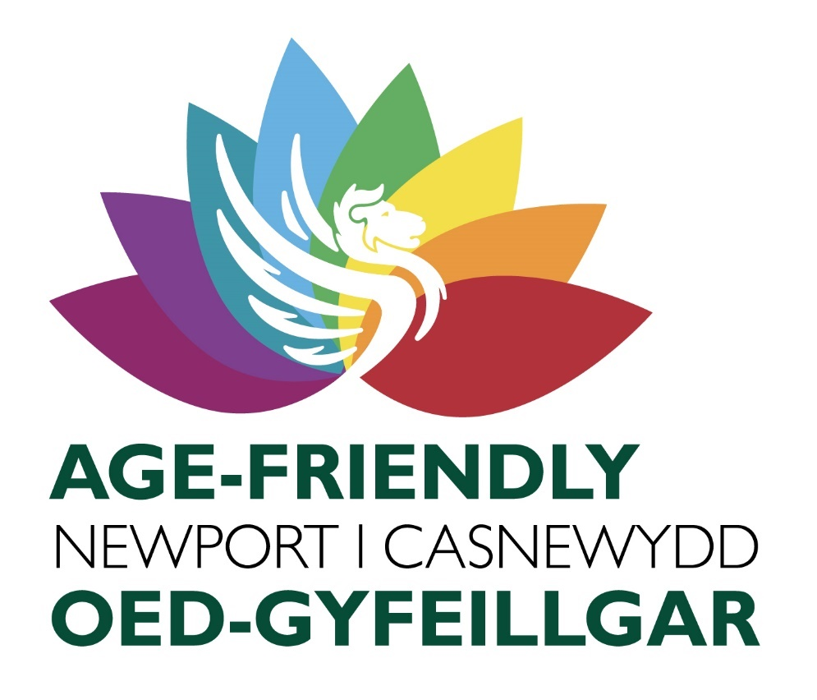


Contents Page
Contents | Page
Age Friendly Communities and Cities | 3
Newport’s population | 4
Newport Gwent Regional Area Plan | 5
Place Based Models of Care | 5
Gwent Marmot Region | 7
One Newport Local Action Plan | 8
Working towards becoming age friendly | 10
Engagement feedback on the 8 domains of age friendliness  - Outdoor spaces and buildings  - Transportation  - Housing  - Social Participation  - Respect & Social Inclusion  - Civic Participation & Employment  - Communication and information  - Community support and health services | 11  12  12  13  14  15  15  16
Ageing Well in Wales | 18
Dementia Specific Community Engagament | 20
Feedback Conclusion | 21
Newport’s Age Friendly Practice  - Diversity and Inclusion  - Outdoor spaces and buildings  - Transport  - Housing  - Social participation – Communication and Information  - Respect and Social Inclusion  - Community Support and Health services  - Civic Participation | 22  23  23  23  23  25  25  25  26
Appendix and further information | 27


Age Friendly Cities and Communities
Newport City Council, its Age Friendly steering and subgroup members, partners and stakeholders have been working together to make an application for Newport to join the World Health Organisation’s Global Network of Age-Friendly Communities. The World Health Organisation established the approach of Age Friendly Cities and Communities in 2010, with the aim to connect cities, communities, and organizations worldwide with the common vision of making their community a great place to grow old in.
According to Age UK, Age Friendly Cities and Communities are places where older people -
- have opportunities to enjoy life and feel well.
- participate in society and be valued for their contribution.
- have enough money to live well.
- feel safe, comfortable, and secure at home.
- Have access to quality health and care.

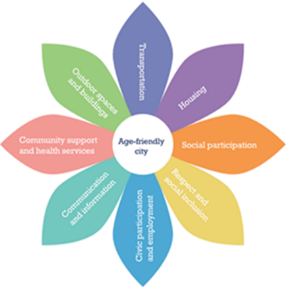
To achieve the objectives of Age Friendliness, The World Health Organisation has a number of steps that cities and communities should undertake. One of these steps is to complete a base line assessment using the below eight domains that when acted on can help to address barriers to ageing well.
- Outdoor spaces and buildings
- Transportation
- Housing
- Social participation
- Respect and social inclusion.
- Civic participation and employment
- Communication and information
- Community support and health services

The domains do not have a clear-cut distinction between them and can often interact and overlap with one another. For example, respect and social inclusion can be reflected within outdoor spaces and the accessibility of buildings, location of services and transport. If older people do not have access to good public transport this can create social isolation, affect their ability to attend health appointments and participate in their community. With access to good, adapted transport, older adults can partake in the things they enjoy, enhancing mobility, facilitating social participation and a sense of belonging in one’s community.
Newport’s baseline assessment is the starting point when measuring how age friendly we are as a city, while supporting us to map current activities, services, and identify gaps in provision when creating an age friendly Newport.
For those wishing to join the World Health Organisation’s global network of age friendly cities and communities a base line assessment is a requirement. Newport’s base line assessment focuses on the views of older adults in relation to the eight domains of age friendliness. The views gathered include responses from engagement sessions carried out by Aneurin Bevan University Health Board (ABUHB) when looking at people’s experiences with dementia and engagement sessions carried out during facilitator lead discussions with older adults in 2017 during an Ageing Well in Wales event.
Newport’s Population
According to the 2021 population census Newport’s population stands at 159,600, showing an increase by 9.5% where the population was 145.700 in 2011. This is higher than the overall increase for Wales (1.4%) (ONS Census 2021). Newport has some of the most and least deprived neighbourhoods in Wales. Geographical patterns of poverty are also reflected in health inequalities and significant differences in healthy life expectancy across the city. Certain neighbourhoods are disproportionately affected by unemployment, low incomes, poor skill levels, crime, and antisocial behaviour. Wales has seen an increase of 17.7% in people aged 65 years and over with Newport’s increase of 14.5% in people aged 65 years and over.

Age Categories | Toal | % of Newport population
Aged 64 and under | 132532 | 83.0%
Aged 65 to 84 years | 23634 | 14.8%
Aged 85 and over | 3426 | 2.1%
Grand total | 159592 | 100%

With a growing ageing population, it is hard to know if these years will be lived in good health and social integration. This could result in an increased demand for support and services, thus providing evidence for the need to develop Age Friendly Communities.
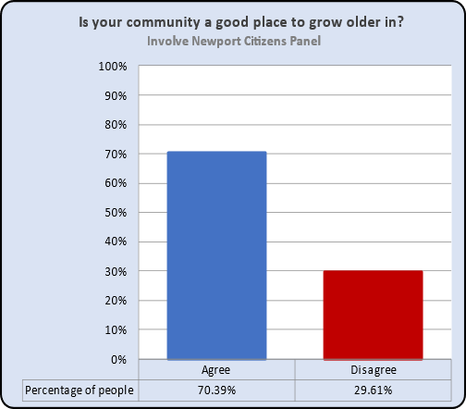
With this increase comes the need to enable older people to be able to have access to information and services that can empower them to make decisions on how to live well. Through adopting the approach of Age Friendly Cities and Communities, we can support older people to have the tools to become active members of the community, promote wellbeing and for Newport to be a great place to grow old. Newport has a GP practice population of 144.841. 78.184 in the East and 66,657 in the West. 27 community centres all offering a range of social activities with 4 of those being community hubs offering a range of information and services. Linc housing offers 4 extra care schemes for older adults offering an alternative to residential care. Newport City Homes, Pobl and Melin Homes provide accommodation for those aged 55 years and over.

In a recent age friendly community survey completed by citizens from the Involve Newport Citizens panel 70% felt their community was a good place to grow older in.

Newport Gwent Regional Area Plan
The Integrated Service Partnership Board (ISPB) developed a population needs assessment within each of the Gwent Regions. The last assessment for Newport was published for 2023 to 2024. The document provides an overview of the demographic, economic, social and environmental trends and challenges in Newport Gwent. It is part of the Well-being Assessment for the Gwent region, which aims to inform the development of a Well-being Plan to improve the quality of life and well-being of the local population.
The document covers topics such as population growth, diversity, health, education, employment, income, deprivation, housing, transport, environment, culture, and community. It also identifies the strengths, weaknesses, opportunities, and threats for Newport based on the available data and stakeholder feedback. The assessment aims to support the collaboration and engagement of public service providers, community groups, businesses, and citizens in shaping the Well-being Plan for the region.
Place Based Models of Care
Within the Social Care and Wellbeing Act (Wales) and Wellbeing and Future Generations Act (Wales) there is a strong emphasis on the wider determinant of health, highlighting important sources of community support that are not solely about clinical responses. These sources are social services, housing, transport, community activities, voluntary services, natural resources, finances, and benefits which can be found within the 8 domains of age friendly communities all contributing in a positive way to both health and wellbeing when connections are made amongst them all.
Newport City along with its two neighbourhood networks East and West identified 6 areas throughout the city when creating Place Based models of care. These areas will be equipped to design, develop, and implement services to improve communities within the defined place resulting in better outcomes for individuals.
- NEWPORT EAST - Newport East covers the electoral wards of Alway, Beechwood, Caerleon, Ringland, St Julians, Victoria, Langstone and Llanwern and Graig. The three “Place Based” areas as outlined in the plan are Ringland/Llanwern, Caerleon/St Julians and Beechwood/Lliswerry.
Advantages and disadvantages of Newport East as outlined within the regional plan– Transport links are good with easy access to the M4 bringing opportunities for work and social links. However, it has varying states of deprivation and affluency with the highest areas being Ringland and Alway, Somerton and Corporation Road. The total demand into Urgent Primary Care (per 10,000 GP registered population) is 1366, above the Gwent total of 1238. The main opportunity is the development of a Health and Wellbeing Centre 19 Hills in Ringland, which will enable integrated working and provide access to a range of services. Ongoing work to redevelop this area is taking place to create a Ringland “campus” in association with Newport City Council and Newport City Homes, with the creation of a Health and Wellbeing Centre for Newport East.
Deprivation levels in Ringland are high with parts ranking in the top 7% deprived areas in Wales. This would indicate that life expectancy and healthy life expectancy in these areas will be lower than the Newport and Wales averages. Areas of Alway rank in the top 4% of most deprived in Wales. In comparison, the Llanwern ward is not considered to be an area of deprivation, however it does rank in the top 10% most deprived in terms of access to services predominantly due to its relatively isolated location on the rural fringe of Newport. Similarly, Langstone is among the least deprived areas of Newport and Wales, however, there remains a risk of social isolation for those experiencing long term ill-health or disabilities who may struggle to access essential services.
The Newport East Health and Wellbeing Centre (NEHWBC) development in Ringland is being supported through Welsh Government Pipeline funding enabling integrated working between Aneurin Bevan University Health Board, Newport City Homes and Newport City Council to deliver collaborative health and wellbeing services to the population in Newport East.
NEWPORT WEST: Newport West has a practice population of 66,657 and consists of the electoral wards of Allt-yr-yn, Bettws, Gaer, Malpas, Rogerstone North, East and West, Tredegar Park and Marshfield, Shaftesbury, Stow Hill, and Pillgwenlly (Pill). The three “Place Based” areas are City Centre/Pillgwennly, Rogerstone/Duffryn and Malpas/Bettws. There are good road and rail transport links with some areas having easy access to the M4. There are varying areas of deprivation within Newport West. The areas within Newport West indicated as having lower levels of deprivation include areas of Bassaleg, Rogerstone and areas north of the Civic Centre within the city centre. The areas of highest deprivation are some of the highest in Wales, including Pillgwennly and parts of the city centre.
The main challenges and opportunities for Newport West: Consists of varying areas of deprivation and affluency, with Lliswerry having a high unemployment rate. The main challenges are the lack of suitable estate for expanding service provision, and the high levels of deprivation and health inequalities in some areas. The main opportunity is the potential for collaborative working with partners and the community. There is a well-established wellbeing collaborative for Pillgwennly working to support residents and improve overall wellbeing.
To support its residents Newport aims to provide a more integrated system of primary care with community care and wellbeing services. To sustain and improve current services there is a need to evolve, with a necessity to change historical ways and patterns of working that no longer meet the needs of today’s society and the needs of the future population, notwithstanding the changes of service delivery and communication brought about by the recent pandemic.
Newport’s aim is to provide a more integrated system of primary care with community care and wellbeing services, based around each Neighbourhood Care Network footprint.
To enable the plan to succeed the following is required:
Partnership and Collaboration, Estates, Workforce and Culture, Communication and Engagement, Funding, Quality, Value and Patient Safety and Digital, Data and Technology.

The regional Gwent Adult Strategic Partnership will develop, co-ordinate and monitor delivery of this plan on behalf of the Regional Partnership Board. A market position summary was undertaken as part of the Population Needs Assessment, the agreed actions are:
1. Increase early intervention support and inclusion opportunities, to reduce loneliness and isolation. 2. Reduce Delayed Transfers of Care, through improved integrated working.
3. Increase wellbeing through access to the right support at the right time to reduce crisis referrals

All these actions feature within the World Health Organisation’s 8 domains of Age Friendly Communities. Age Friendly Communities will work in collaboration, building an action plan identifying the needs of older people and the tasks to be undertaken to meet these needs.

The first ISPB plan for Newport provided the template to embed and enhance existing collaborative working to address these challenges and take every opportunity to provide a more co-ordinated approach to planning and operational service delivery across the city. To address these challenges Gwent became a Marmot Region.
Gwent Marmot Region
A Marmot Region is a network of local stakeholders committed to tackling inequity through action on the social determinants and economic conditions that shape our health.
Through becoming a Marmot Region, it signifies a collective intent to work together to improve equity across Gwent and improve the lives of all our communities as a result. Lead by public health work is being undertaken via the integrated health networks Ringland and Pill Collaborative. The intention is to put into practice the report’s recommendations by working collaboratively across all public services in Newport to ensure that improved health and reduced inequalities is at the centre of our policies, approaches, and resources to early years, education and skills, transport, housing, communities, and businesses.
According to the findings within the Marmot inequalities data, a high percentage of Newport’s older adults reported a good level of life satisfaction. With Langstone and St Julians area’s having higher life expectancy, while Maindee having the highest recorded health conditions. The findings within the Marmot report and working collaboratively with partners will identity the gaps in services, where services are needed and inform measurement of our age friendliness.
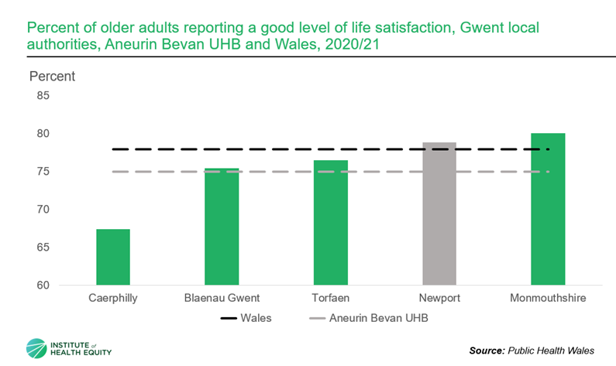
The Marmot data graph shows the percentage of older adults who have reported a good level of life satisfaction.

The ABUHB Director of Public Health Annual Report 2022 outlines how we can work to address inequalities in our region by setting out a framework under two policy goals:
To create an enabling society that maximizes individual and community potential.
To ensure social justice, health and sustainability are at the heart of all policies. Central to the review is the recognition that disadvantage starts before birth and accumulates throughout life.

To address these inequalities, it is believed that public engagement is paramount, so that people are continuously co-designing their own model of care and truly own and feel responsible for not only their community, place-based care, but for their own health and well-being. All feedback gathered from engagement sessions will be fed back to services via the Age Friendly steering and subgroups.
One Newport Local Action Plan
To improve the economic, social, environmental, and cultural wellbeing of Gwent, The Gwent Public Services Board (PSB) has merged with the former Public Services Board (PSB), working in partnership through bringing public bodies together. Under the Well-being of Future Generations (Wales) Act 2015, they are responsible for overseeing the development of the new Local Well- Being Plan.
Since the merger of the former five regional partnership boards the subgroup One Newport has developed its own Local Action Plan for 2023 – 2028 and is made up of the following membership.
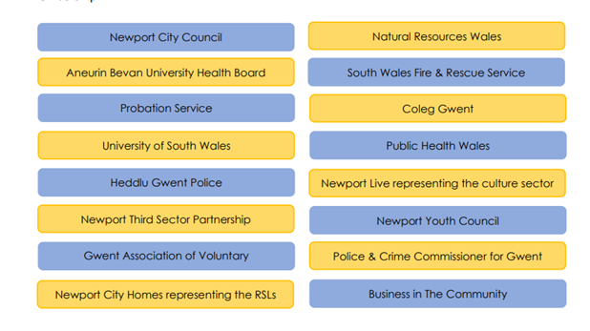
The following actions have been identified:
• Deliver local priorities within the Gwent Well-Being Plan and contribute to regional projects.
• Develop and deliver activity in Newport that would benefit from a strong partnership approach.
The tasks will be carried out through the local action plan while supporting the delivery of Gwent’s PSB Wellbeing Plan, this makes sure that Newport’s unique issues get the attention they deserve.
The plan will focus on what Newport needs to be become a better place not just for today’s generation but also for those to come. To make a real difference this work might take up to five years through placing an emphasis on preventing health and social problems, or making sure people have the skills employers will need in coming years.
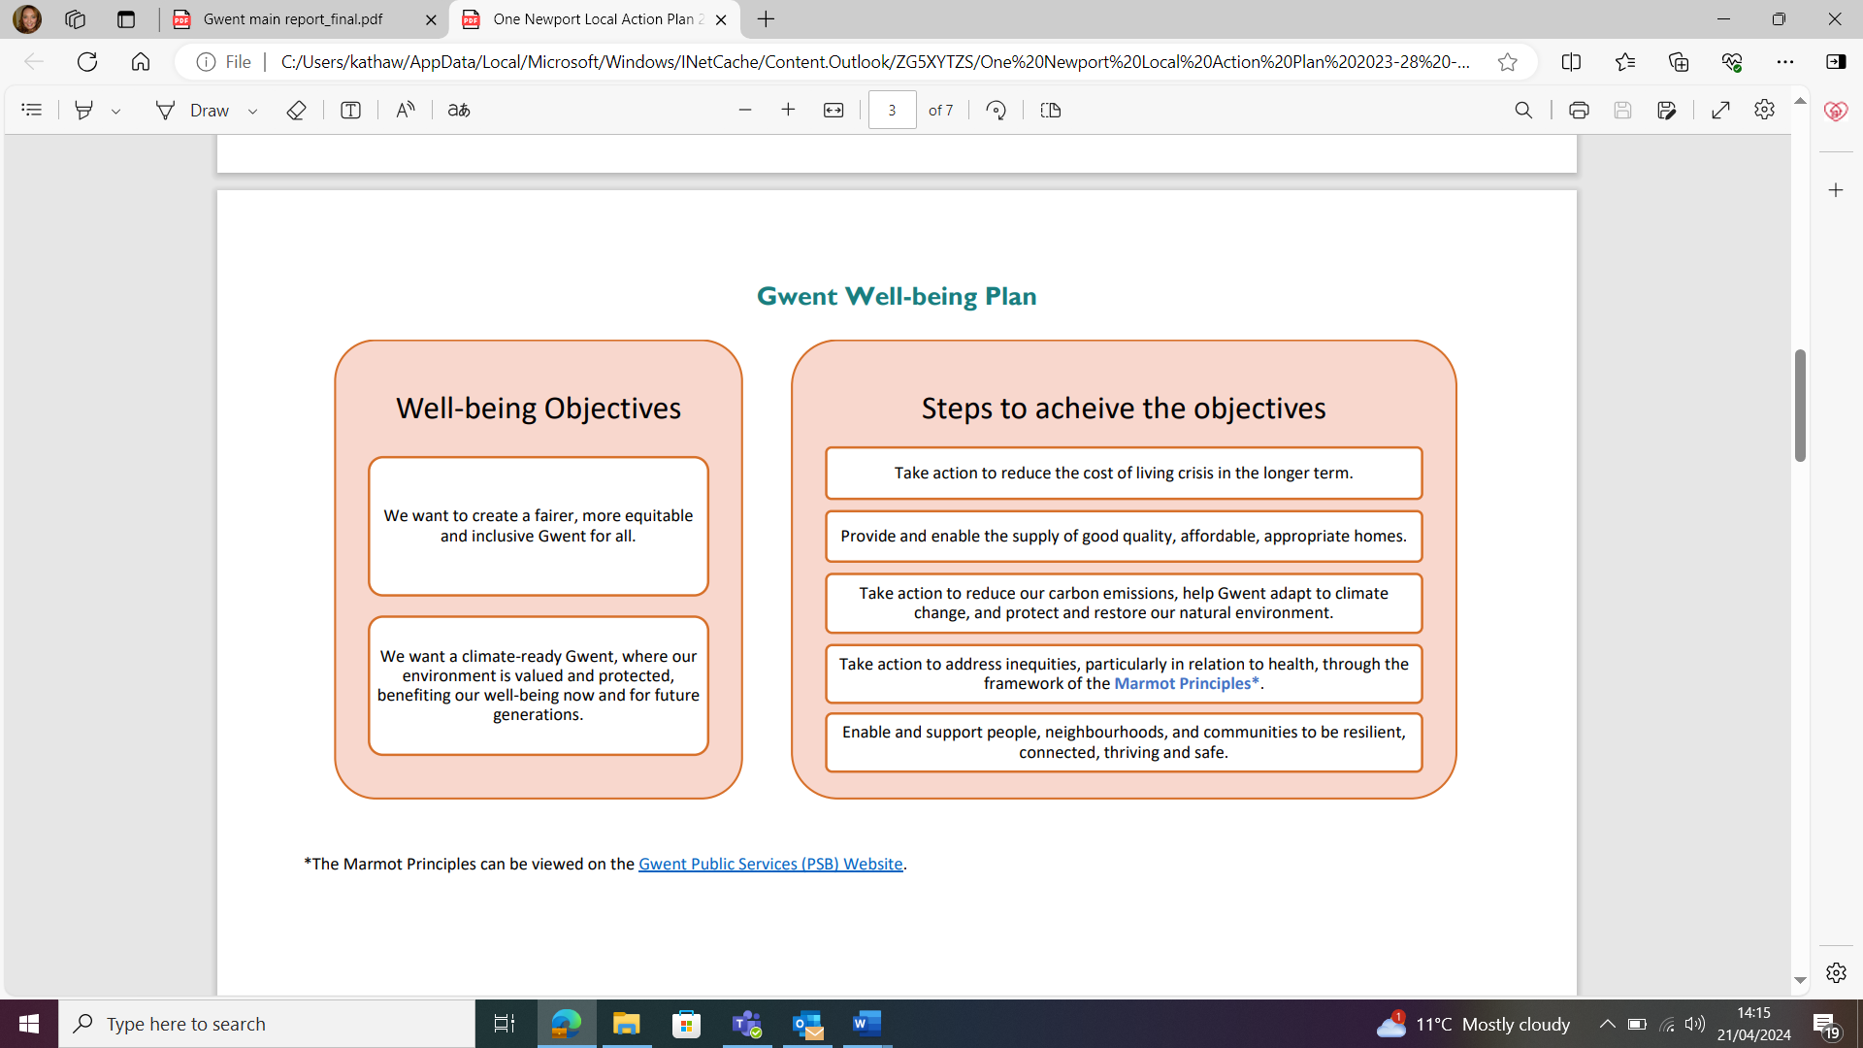

The themes of the local wellbeing plan
The local action plan has three themed areas of work:
- Economy and Culture
- Communities
- Environment

Through providing people with the best outcomes at a young age this will help them to live longer with a good and healthy wellbeing. Many of the actions and themes within the Marmot report, Gwent Regional Area Plan, and One Newport Plan include areas within the domains of Age Friendly communities. Action from the reports will align within the delivery plan for Newport Age Friendly communities with a focus on promotion of services and collaborative working.

Working towards becoming age friendly
Newport’s journey to create an age friendly city dates’ back to 2013 when Newport signed the Dublin Declaration to commit to creating an Age Friendly City. From that, services were put in place such as the Newport City Council Community Connector service with the aim of tackling loneliness and isolation. Since the Community Connector service launch in 2014 it has grown to support the needs of unpaid carers and those within ethnic communities.
In 2015 Newport pledged to work in partnership to become a Dementia Friendly City. In 2017 Ageing Well in Wales consultation and enquiry into loneliness was created. Following the COVID pandemic Newport 50+ forum was re-established and in 2023 a Policy Officer was appointed to support the work of age friendly communities and shape Newport City Council’s application to the World Health Organisation for Newport to be recognised as an Age Friendly City.
In October of that year Newport cabinet agreed to make a commitment to Newport citizens to create an age friendly city.
One of the key principles of age friendly cities is to consult with older people and their organizations on their needs, preferences, and opinions. Newport’s Age Friendly policy officer and members of the subgroup have done this through various methods, such as:
- Surveys and engagement sessions. Surveys used a mixed-methods approach, combining quantitative and qualitative data collection and analysis. The quantitative data was obtained from a survey of people from different backgrounds, communities, and groups, such as ethnic minorities, unpaid carers, those with health conditions and people with disabilities. Surveys were distributed online via the One Newport Citizens panel, with 82% of respondents being over the age of 55. Paper copies of the surveys were also distributed at community groups, during events and at round table discussions where they were all completed by adults 50 years and over.
The qualitative data was gathered from community engagement, round table discussions with older adults, unpaid carers and community groups. Discussions at community groups explored respondents' experiences, challenges, and suggestions for improvement regarding everyday life as an older adult.
Members of the age friendly subgroup share feedback from their surveys and engagement sessions during subgroups meetings or through digital means. A special event was held to celebrate International Older Persons Day which celebrated Newport’s older adults and their contribution to society. Again, attendees at the event were asked their views on how to shape an age friendly community.
- Age Friendly steering and subgroup – Is the mechanism for engaging, codesigning services, consulting and providing feedback to commissioners and strategic bodies. The steering group involves Newport City Council members representing all the eight domains. The subgroup consists of stakeholder and partners with representatives from the regional partnership board, Aneurin Beven University health board, care and repair, Age Cymru, Housing schemes for older people, Newport live, the third sector unpaid carers services, Gwent association Voluntary Organisations, Older persons representative from Gwent Drug and Alcohol Services Alzheimer’s Society, Place based care, Warm Wales, department of work and pensions, wider partners and representatives from community groups and over 50 forums.
The subgroups will be creating an Age Friendly distribution list with the aim to reach as many people as possible. Policy Officer for Age Friendly Communities attends the 50+ forum committee and public meetings where they are kept up to date of the work of the subgroup and share their views on how to create an Age Friendly Community. The subgroup also has representatives from ethnic communities community connector service who support with sharing information to those whose first language is not English.

Gathering information on the local issues has enabled Newport City Council and our partners and members of the subgroup to identify gaps and make improvements via the stakeholder group. It is also a mechanism of sharing practice across the domains, such as digital inclusion, intergenerational practice, informal carers support and dementia friendly programs.
Engagement feedback on the 8 domains of age friendliness
This section of the base line assessment discusses the eight domain areas of the built and social environment which can help to address barriers of ageing well when they are acted upon. It also contains feedback received from participants of surveys, engagement sessions and case studies of age friendly practice.
Through engaging and involving older people in the process of becoming a more age friendly city, we are establishing relationships with older residents, discovering what the needs of older people are, respecting their rights and benefiting from their wisdom.
The assessment will be used when measuring our current age friendliness and the areas which need to be improved upon.
The below explanations of each one of the domains is taken from The Centre for Ageing Better web page: https://ageing-better.org.uk/

Outdoor spaces and buildings
The outside environment and public buildings have a major impact on our mobility, independence, and quality of life as we age. Outdoor spaces and buildings in an Age-friendly Community will strive to be safe, accessible, and comfortable for people of all ages.

Feedback
Most older adults in Newport agreed that the city is a good place to grow old and welcomed the idea of becoming age friendly. They also suggested that an age-friendly community should be inclusive to all ages.
Issues with accessibility and safety: Many participants felt Newport has many parks and green spaces but not all are easily accessible. Lack of public toilets was raised and a need for outdoor seating. They also raised concerns about parking problems, cars on pavements, and the use of apps for paying for parking. Some raised concerns regarding feeling unsafe in the main city centre at night.
Criticism of the town centre: The town centre was criticized for having a lack of attractions and shops for older people. Some participants also expressed not feeling safe walking through the town centre, with some saying that they avoid traveling into town and prefer to use retail parks for shopping.
Request for a community space: Some participants suggested that an empty shop unit could be used as a venue for community groups and a space for information sharing. They felt that this would help them to find out what is happening in their community and to connect with others.

Transportation
Affordable, reliable, and convenient transport options enable older people to get out and about and continue to do things that matter to them. Whether it’s going shopping, meeting friends, or attending an appointment, good transport is essential to everyone.

Feedback
Problems with public transport: Many older people in Newport faced difficulties with public transport, such as the lack of evening services, shelters, and accessible bus stops. Newport transport reported a decline in the uptake of concessionary bus passes.
Bus Passes: Those with bus passes felt this was a lifeline for them and kept them independent as it enables them to access services, medical appointments and remain active.
Issues with proximity to services: Newport 50+ forum raised concerns regarding the NERS (National Exercise Referral Scheme) programme taking place in a venue that is not accessible via public transport. Further concerns were raised by those attending engagement sessions with one person reporting that they have not attended any of the sessions as they cannot access the premises unless attending by taxi. This has been fed back to members of the age friendly sub group and to the local health board.
Housing
The right housing and support can allow people to age comfortably and safely, in their community. Poor housing can have a huge impact on health, but when housing is considered as part of the age-friendly approach, it can help to maintain or improve physical and mental wellbeing, as well as social connections.

Feedback
Safety and security: 100% of participants value safety and security in their homes and would consider adaptations to stay in them.
Older person housing: Newport has a range of housing schemes and extra care facilities, feedback from residents was positive with many members creating their own communities within the extra care complexes. One scheme has been working in partnership with Newport Dragons, Reality Theatre and Duffryn link to hold social activities to help those who are unable to leave their home and support with social participation.
Issues with proximity to services: Many older people live in isolated areas or have limited mobility, which restricts their social participation and access to services.
Lack of awareness of older person housing: Many older people do not know how to apply for housing schemes or find them difficult to access online. Over half of those engaged with were unaware of the benefits and availability of housing adaptations and assisted technology.
Good news story
Y Sied, Cartref Yn Y Coed, Treberth, is an older person’s housing complex, including 50 older persons bungalows owned by Pobl. One resident said that prior to moving into Y Sied they were lonely and isolated following the death of their spouse. Since moving in they have joined the breakfast club, met others and travel to the shops with another resident. “I feel I have a family and am part of the community”. Pobl’s residents have worked together to create a safe and welcoming space for everyone, building strong relationships and a community for themselves. Residents meet for a social breakfast and have recently welcomed Action for Elders who hold weekly exercise sessions. They have also recently worked with Pobl, Public health and Newport City Council to hold two community events. They have also produced a short video about what Y Sied means to them.
- Welsh square: https://vimeo.com/819570022?share=copy
- English landscape: https://vimeo.com/819429514?share=copy

Social participation
Participating in leisure, cultural and spiritual activities in the community is important for health and wellbeing, a sense of belonging and good relationships. Without social participation, people can experience loneliness and isolation. An Age-friendly Community will work to make sure activities available in their place are as financially, culturally, and physically accessible as possible.

Feedback –
Many older people in Newport said they would like to be more social, some wanted to join in activities and community groups, while others felt reluctant to join groups due to lack of confidence. Many expressed that groups are not well advertised, and faced some barriers to accessing them, such as transportation, parking, poor signage, and advertisement issues. When sharing information on what groups are available for older people many were shocked as to how much Newport has to offer its residents and expressed a need for better promotion of groups.
Loneliness and isolation among older people: Loneliness and isolation were common concerns for older people, especially those who had lost their loved ones, taken on care responsibilities or no longer caring for loved ones. They expressed the need for more opportunities to socialize, learn new skills, and stay active, but also worried about the availability, affordability, and accessibility of such activities.
Challenges and barriers for community groups: Since the pandemic, community groups have noticed a decline in numbers. Unpaid carers requested groups and activities specifically for carers, which would allow them time out from their caring role.
Respect and social inclusion.
An Age-friendly Community enables people of all backgrounds to actively participate, and it treats everyone with respect, regardless of age. Despite “age” being a protected characteristic, ageism is still prevalent nationally, and Age-friendly Communities seek to challenge this.

Feedback
Many older people in Newport wanted to feel valued in their community and disliked the negative portrayal of older people in the media. There was a difference in responses from those who are active in the community feeling that they are not treated differently due to their age to those who participated in few community activities feeling less valued. Responses were also different depending on the area they lived. Those who lived in areas with socioeconomic deprivation felt that there was little for older people in their community, but community mapping and public engagement has shown in the slightly more affluent areas of Newport there is less in the way of community groups for older people. There was strong interest in intergenerational activities and inclusive policies.
Loneliness and invisibility among older women: Many older women reported feeling lonely and invisible as they aged. One said “as soon as my hair became grey, I became invisible”.
Intergenerational activities – During engagement sessions many wanted to participate in intergenerational activities and did not feel that they are discriminated by younger people but did say that people’s views differ greatly and did not feel devalued. Members of the youth forum agreed and said they did not feel that older people discriminated against them because of their age, with some members saying they enjoy spending time with their grandparents and would like to become involved in any activities that promote intergeneration.
Images of older people: Participants were not happy with the way older people are portrayed in the media and carer material often showing an older person as frail with a younger person being the care giver. They would like to see positive images of ageing. They expressed the need for more social opportunities, learning new skills, and staying active.

Civic participation and employment
Age-friendly Communities look to provide good-quality options for people in later life to continue to contribute to their communities. Those options can include paid employment or voluntary work as well as being engaged in democracy.
Good-quality volunteering has a measurable positive impact on mental health. And paid work can benefit wellbeing as well as finances. Yet often, the opportunities for these diminish with age.

Being able to contribute to their communities was important to many with half of those spoken with being part of an action group, forum, or social group. Being able to share their views and have their voices heard on issues that affect them is important to them. Some were concerned about the changes taking place regarding voting and expressed concern about not being able to vote in the next elections. Many felt that there were a lot of opportunities to volunteer but did not know about support with employment or how to find employment following the ending of their caring role or being out of employment for some time.
Older person forums: Newport is a diverse community and has several older person forums, prior to the pandemic Newport 50+ forum held public meetings and an annual information day. Following the pandemic the forum is beginning to reestablish and has several cooperative members who are supporting with relaunching the annual information day. Age alive for ethnic communities recently took part in the Older Persons Commissioners paper Access denied: Older people’s experiences of digital exclusion in Wales and hold a range of activities for older adults from ethnic communities.

Communication and information
Staying connected with events and people, and getting timely, practical information is important for all of us, especially as we get older.
Age-friendly Communities seek to ensure information is accessible for those with varying resources and abilities – for example people who don't have English as a first language, are digitally excluded or have a sensory impairment.

Information was one of the main issues that was raised with over half of older adults not knowing how to access information and where to go to speak to someone. One person shared their experience of trying to find support services as having a negative effect on her mental health and feeling devalued. For those with access to the internet some reported to being concerned about scams or web sites being out of date. Feedback from group discussions included being told to go online or download an app which they were unable to do as they did not have or did not want access to the internet. Not having access to information also led to isolation and low wellbeing. A popular opinion was that there is not enough information in paper form especially following the pandemic. Suggestions were to utilise notice boards, and public venues such as community centres and GP surgeries. Advertise in the local papers, newsletters and for Newport to create one place that everyone can go to for information.
Internet access and trust issues: Some expressed concerns when using the internet fearing being scammed, some expressed frustration with outdated websites. Others felt uninterested in using the internet or frightened by the thought of it. Following one community event attendees both young and old expressed their frustration about the nearest car parks only taking payments over apps.
Need for more paper-based information: A popular opinion among older adults is that there is not enough information in paper form, especially after the pandemic. They suggest using notice boards, public venues, local papers, and newsletters to provide information. They also want Newport to create a place where they can go to for information, in paper form but also to be able to speak to someone.
Community Directory – One community group said that the community directory of groups and services was excellent, and they were pleased to see their group advertised. People said that they liked to have a paper copy of information that they can refer to as and when needed. One community group said they knew about the directory but had not seen it. They also said that they had received telephone calls from people wanting to attend the group after seeing the group in the directory.
Community support and health services
As the older population grows, the need for community support and health services grows too. Alongside accessible and affordable health care services, community support and physical activity opportunities are strongly connected to good health and wellbeing throughout life.
Some Age-friendly Communities incorporate their financial inclusion work in this domain, acknowledging the huge impact that financial instability has on quality of life and health.

Everyone agreed with the above statement, some shared good experiences of community support and health services while others expressed negative experiences and long waiting lists for home support. One person shared how attending a community health group has had a positive impact on their life and improved their wellbeing.
Importance of community and health services: Participants said they value having good community support and health services, but they face difficulties in securing GP appointments and finding NHS dentists. They also expressed enjoying physical activities and going to the gym to stay fit and healthy.
Concerns about future care and support: Younger older adults expressed worrying about the possibility of having to go into nursing homes or having support within the home as they age. They do not know where to find support and some had negative experiences with seeking help.
Loss of independence- A common concern that was identified by people of all ages was loss of physical independence and mental capacity and a fear of talking about these issues. “Having a leaflet that you can pick up would be ideal for those not wanting to have to talk about their fears”.
Loss of sense of community and service integration: Some people compared the past and the present and feel that the sense of community has diminished over time. They also prefer health services to be in one place rather than scattered over the community.
Unpaid carer support: Unpaid carers felt that more support was needed with respite care. Everyone felt that having good access to health care was important to them but stressed that for those with no transport attending hospital appointments can become expensive. Carers of teenagers with autism expressed frustration over lack of communication from services and issues with transition from children services to adult services.

The below graph shows results from the age friendly communities survey regarding what matters to them.
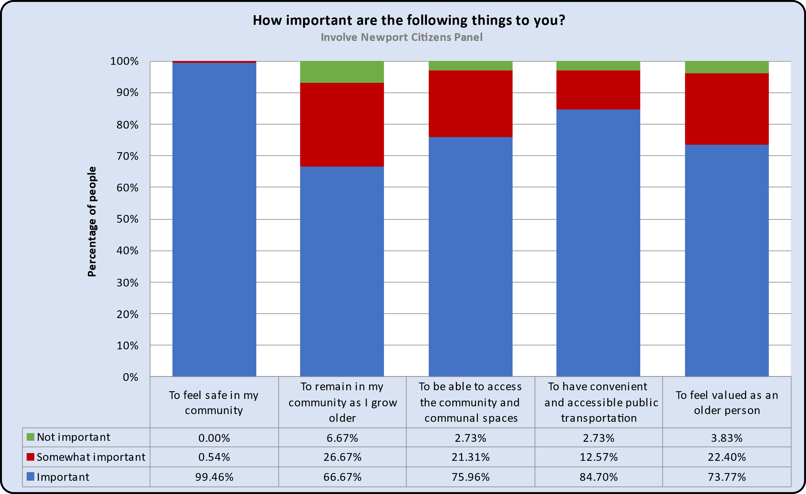

Ageing Well in Wales
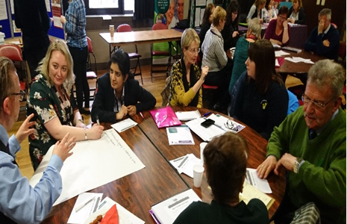
In February 2017 Newport City Council hosted their first Age Friendly City Information Event & Engagement Workshops, it focused on social isolation, dementia, and Age Friendly Environments. Several facilitator workshops were held by COPA (Cymru Older People Alliance) and the Older Persons Commission. The event included a wide range of stall holders and presentations from Older People's Commissioner for Wales Policy Drivers, Ageing Well in Wales, FFrind I Mi, Aneurin Bevan University Health Board, Community Connector team talking about Social Isolation, COPA, the Strategy for Older People Engagement, falls prevention and role of housing associations, the importance of working in partnership and dementia friendly cities.

Feedback from the event has been used and compared to recent feedback when looking at the opinions of older adults and if their needs have changed and what actions have been taken since the first Age Friendly event. Comparisons have been made and it appears that many of the views gathered have remained the same or are very similar.
Transport: Concerns regarding lack of public and community transport. Bus shelters need to be positioned in accessible areas and rural areas with good lighting, seating, and a covering. There was a high interest in applying for the concessionary bus pass to support those with no access to transport. Since COVID 19 Newport transport has reported a decline in the uptake of concessionary bus passes. Newport age friendly communities will work to promote the concessionary bus passes and have met with Newport transport to share the views of older adults. Comparing feedback then to now people’s views have remained the same.
Location of older person complexes and community centres - Concerns raised with the placement of older persons housing complexes and centres. When developing new builds, they should be built on a flat area, centres should also include lifts, wide doorways for wheelchairs and disabled toilets or toilets with handrails. Since the event Newport Access Group have been involved in the planning of the town centre and the train station flyover, and the viewpoints of residents have been included in the development of the new 19s Hills health centre.
Dementia – They felt there was a need for dementia specific groups along with a better understanding of how to support someone with dementia. Newport has a wide range of groups for those with dementia and their carers. At the time there were groups for those with dementia, but they were not widely advertised. Community groups pledged to become dementia friends and sessions were arranged. COVID 19 impacted on groups which saw some cease. Age Friendly Communities subgroup have worked to gather information on all the services for those with dementia into an easy read document which is used for signposting. One subgroup member from Homeinstead who is a community engagement officer has created a number of memory groups throughout Gwent.
Since 2023 engagement is taking place via the dementia standards patient experience and involvement team and they have recently joined the engagement sub group into the dementia friendly Gwent network to reach a wider audience. Learning and development sessions are taking place to enhance workers understanding and awareness along with several community sessions to educate older and younger adults about the risk factors and brain health.
Environment – Concerns were raised about a lack of public toilets, the state of the pavements and a need for increased community safety. Recent views are that Newport has lost some of its public toilets having them turned into community venues but have not seen them be replaced. Public toilets remain on the agenda of the 50+ forum and are important to older adults.
Partnerships – Participants called for improved communication amongst partnerships, as many agencies are duplicating their services – “Why can’t we have one service where the public can go to obtain information and then be signposted to the relevant services”. The work of the age friendly subgroup, integrated wellbeing network, dementia friendly network, and Multi agency stake holder steering group will help to strengthen communication amongst partners.
Care & Support- Unpaid carers requested respite services to allow care givers to have a break, and activities specifically for carers. Following feedback received Newport carers team have set up a carers network and café for unpaid carers. These are still operating and expanding, and respite support has been put in place to support the needs of unpaid carers.
Attendees wanted awareness raising of future care planning so people can plan for their future. Many felt there was a need for the older generation to discuss their wishes for the future, they should be letting people know what they want/don’t want and share information.
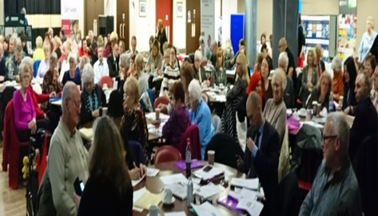

Dementia Specific Community Engagament
There are nearly 2,000 people living with dementia in Newport and it is important that those living with the condition can live as normally as possible with dignity and respect. Age Friendly Communities has been partnering with Aneurin Bevan University Health Board and the Regional Partnership Board, finding out about people’s experiences with services for those with lived experiences of dementia as part of the dementia standards work. As part of the dementia workstream several surveys and engagement sessions have been undertaken that coincide with the work carried out when creating an age friendly community. Feedback from the sessions will be collated to help shape Newport becoming Age Friendly.

The results of the project revealed that people living with dementia and their carers in Newport faced multiple barriers and difficulties in accessing and receiving adequate services and support. Some of the main themes that emerged from the data were:
- Lack of awareness and information about dementia and the available resources
- Stigma and discrimination associated with dementia.
- Isolation and loneliness experienced by people living with dementia and their carers.
- Financial and emotional burden of caring for someone with dementia.
- Inadequate and inconsistent quality of care and support from health and social care professionals
- Limited opportunities for social and recreational activities for people living with dementia and their carers.
- Unmet needs for respite, counselling, and peer support for carers

Dementia standards workstream - Collaboration work has commenced. Steering groups have been created, led by the Dementia board and Aneurin Bevan University Health Board to commence the work over all five Gwent regions, continuing the work of Dementia Friendly Communities and the All-Wales Dementia Care Pathway of Standards. To support the work of the dementia standards and Age Friendly Communities a visit was held for those living with dementia and their carers to attend Newport’s digital technology hub. Joined up working has taken place when carrying out community engagement with members of the public and delivering information to community groups supporting age friendly communities and dementia standards to identify the needs of older people with lived experience of dementia. Dementia engagement has now merged with the Dementia Friendly Gwent network which includes community listeners as part of the network. Future work includes linking with minority ethnic communities, those with sensory loss and Gypsy and Traveller communities.

Feedback Conclusion
The word community has so many meanings and means something different to everyone, it could be the road they live on, the town they live in. Some might say their community is the people around them, family, friends’ neighbours, social circle or a shared set of values, beliefs, and experiences. However described, a community has an impact on everyone’s wellbeing especially as we grow older. As we grow older, we start to think about what matters to us and what we want to achieve, such as personal goals, keeping healthy and feeling part of our community. To feel valued and have opportunities and to spend time with family and friends. People are aware that ageing can come with some physical, mental, emotional, and financial challenges that might affect their independence, mobility, and quality of life.
Many shared their fears for their future, - what if I must leave my home, where will I go, who will look after me. I have people around me, but I still feel lonely. I have no family and my only source of interaction is when I collect my newspaper from the local shop and when I attend my social group. I fear that my pension will not be enough to pay for the things I need. I am concerned that as an older person with a child who requires 24 hours care I will no longer be able to care for them and who will care for them when I am gone. People worry that they will lose capacity to make their own decisions and lose their independence. They don’t want to feel they are a burden. I want to feel wanted, welcome and be part of the community, I fear I will become invisible. I want to learn how to use computers and access the internet but don’t know where to start. I want to be able to have the information required to make decisions about my health, wellbeing and make decisions about what matters to me.
However, despite the fears of ageing and what might happen when we age, ageing is a privilege that is denied to many. Becoming older brings experience, wisdom, resilience, and a perspective that can enhance creativity, productivity, and contribution. Age Friendly Newport aims to provide people with the tools to make decisions about how they live, how they can live a good later life and continue to enjoy the things that matter to them.
What people want in an Age Friendly World
According to those we spoke to, an age friendly world is something that they want to feel part of, somewhere that includes people of all ages and has an equality of opportunity. That has good transport links, access to food and health care, is a place to grow old without fear, provides opportunities to take part in social activities and provides the information needed to live a good life. They also expressed a desire to support their community and other younger generations to learn from, appreciate, and collaborate with everyone.
- To feel safe in their home and enhance community safety and cohesion.
- Have access to information in all formats in one place.
- Good transport links
- Increased consultation, intergenerational activities
- Reduce loneliness and isolation by supporting existing social and community groups and making sure that social activities are accessible and affordable.
- Planning for the future
- Reduce the stigma of dementia expand and diversify the range of social and recreational activities and services for people living with dementia and their carers.
- To be involved in the design, delivery, and evaluation of the support and services put in place for older people.
Newport’s Age Friendly Practice
To support the work of Age Friendly Communities it is vital to work collaboratively with partners and members of the public especially when identifying and supporting the needs of older adults. To create an age friendly community, Newport’s policy officer has established an age friendly steering and sub group and has joined several steering and subgroups to help address the needs of older adults living in Newport. Policy officer has also attended Cymru Older Person’s alliance (COPA) annual meetings and has plans to work with Action for Elders.
Integrated wellbeing network, Pillgwenlly (Pill) and Ringland collaborative – Led by public health with over 20 partner agencies and community members. Age Friendly Communities features on the quarterly meeting agendas. Information is shared on good practice and areas for improvement. Current plans for the collaborative are to create a newsletter for residents and identify training to support the wellbeing of those living in Ringland and Pill.
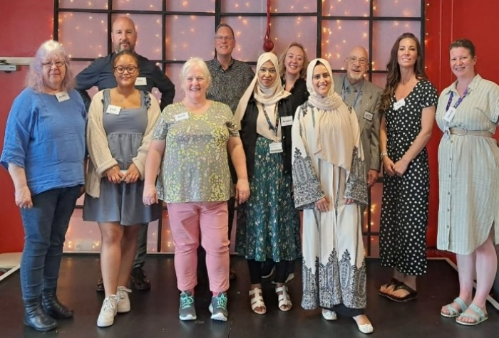
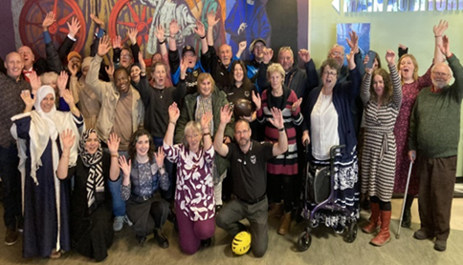
Participatory Budget – Working in partnership with Mutual Gain, Aneurin Bevan University Health Board, Newport access group, 50+ forum and members of the community a steering group was formed to hold an event through participatory budgeting. Aiming to empower citizens and communities to have their say on what matters for their local area and choose what projects to fund. The Raising Hope Dementia fund encouraged a variety of groups to present their ideas when improving wellbeing and support for those with dementia and their carers. 80 people attended the 1-day event, with 15 projects applying for funding, presenting their ideas to voters. 11 groups secured funding to the value of £100k. Following its success the participatory budget steering group was asked to hold a second event which will include the themes identified within the Marmot health inequalities report, young people, loneliness and isolation and women’s wellbeing.

Photo: Winners of the participatory budget who will be creating projects to support those with dementia. Members of the participatory budget steering group.
The steering group have created a video about Participatory Budgeting and the Raising Hope Dementia event.
English: https://youtu.be/2Blb-bTP21s Welsh: https://youtu.be/c9Fbp94kEjw
Web page www.yournewport.co.uk/participatory-budgeting-2/

Diversity and Inclusion
Newport is a diverse community with many people whose first language is not English or Welsh. Newport City Council’s community connector team has a specific team to support the needs of those from ethnic communities, with workers speaking multiple languages. Members of the Age Friendly Subgroup, Community Cnnectors for ethnic communities and elders from the ethnic communities have shared the need for information to be available in a range of languages. The team are members of the age friendly subgroup and have supported with undertaking community engagement so that the voices of our ethnic communities are represented in the development of creating an age friendly newport.
Outdoor Spaces, Housing and Community Health
- Pill Masterplan - The Masterplan is a new physical plan for Pill prepared by the local community that live and work there along with anchor agencies that operate there. Aim to improve the physical state of Pill and to improve coordination and collaboration among the community and the anchor agencies. It provides an opportunity to bring everyone together and deliver change, create green spaces, and create a safer environment. Updates are given at the Pill collaborative meeting.
- Ringland regeneration - Housing association Newport City Homes is leading a five-year redevelopment of Ringland, including 158 properties for social rent and new community facilities. The neighbourhood will also be the home of a new health and wellbeing centre for eastern Newport, which is expected to open in early 2025.

Transportation

- Adapted transport - Newport transport hosted a community event where residents could come and view their adapted transport vehicles.
- Printable timetables – Bus timetables have been republished in leaflet format and are available in the market and main office.

Housing
- Social participation Housing association schemes have been opening their doors to outside residents to take part in actives.
- Engagement – Housing schemes have completed several surveys to identify the needs of their older residents. The Reality Theatre who work in partnership with Newport City Council have produced a video Their Future, Our future https://www.youtube.com/watch?v=QpozRdBBfTY
Social Participation, Communication, and Information:
- Chatty Café: Working alongside Newport City Council’s Community Connector team a chatty café has been established to provide monthly drop-in sessions for information and advice alongside a social activity to help with tackling loneliness and isolation. Christmas 2023 saw 30 attendees coming together to create Christmas wreaths, build social networks, share their views with ABUHB engagement team on health care services and hear from newport live about their new momentwm project that looks at active travel through walking and cycling.
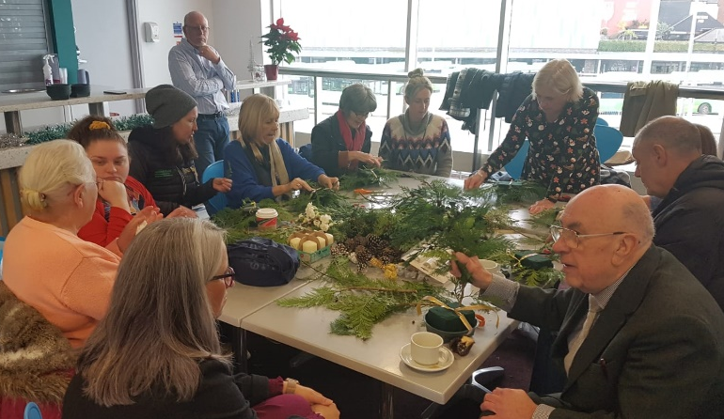
- Case study A male in his 80s attended the Chatty Café looking to attend fitness groups in the community. While at the group it was identified that he and his wife care for each other, he was referred to the Community Connectors for support where a ‘what matters conversation’ was undertaken. He expressed wanting to join groups but due to being hard of hearing he was unable to make contact himself. A connector sat with him to identify support services and which groups he wanted to attend, completed the referral forms, and supported him to speak directly to the group to make an appointment to attend a session. As he was a carer, he was able to access the unpaid carers support fund, which granted membership to Newport live. The man is now accessing Re Engage via Newport Dragons, County in the Community and Newport Live sessions. Since attending the exercise group’s, he has reported an improvement in his mental and physical wellbeing and feels more connected to his local community.

- Community Directory - A community directory has been created focusing on tackling loneliness and isolation with a dedicated age friendly section containing specific information aimed at those 50 years and over. The directory is in paper format and can be sent via post. The directory is shared with partners and found in central library. Future Plans: Due to the public feedback copies of the directory will be held at community centres, hubs and GP surgeries.

- Digital Information Newport City Council are also working with health and integrated wellbeing partners to populate and promote Your Newport Your Wellbeing interactive map alongside Welsh Governments’ information resource DEWIS.

Link : Your Newport, Your Wellbeing https://www.yournewport.co.uk/
Link: DEWIS https://www.dewis.wales/

- Dementia Information Offer – Part of information, assistance and advice, services for those with dementia and their carers has been compiled, gathered into a document that has been shared with partners, groups, and services to support the wellbeing of those with dementia.
Case study signposting –Referral for an elderly person whose spouse passed looking for support with paperwork. The connector signposted them to services and made referrals on their behalf. During the conversations the daughter was identified as an unpaid carer, carers assessment was offered, and referral made to the carers support fund to assist with financial pressures. Appointments were made with citizens advice where the carer reported they were helpful, and they were given a direct line to an advisor for further support with the paperwork that would be arriving over the next few weeks. In a follow up telephone call from the connectors the carer said
Thank you for referring me and mam for help, I really appreciate what you did. It was so lovely to receive a follow up call. Without them calling me to talk things through, getting us an appointment with CAB I don't know what would have happened, they really do go above and beyond.
Respect and Social Inclusion
- Intergenerational Activities – A steering group has been established to hold intergeneration activities. For the Kings coronation the community engagement team hosted an afternoon tea where school children took part in craft activities with the older persons Gaer group.
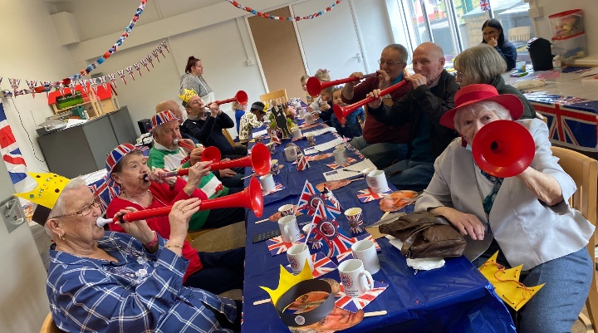

Community support and health services:
- As part of the Integrated Wellbeing Network’s ongoing work across Newport with a focus on health inequalities, preventative health and community support, women’s health has been highlighted as key priority. This has been identified through health inequalities data and partner and community insights. In collaboration with the networks many partners including a close alignment with Newport City Council, a women’s health survey has been developed and distributed in order to hear the voices of our female citizens across Newport. The survey ascertains how women access information and support in the community and what topics are important to them. As part of their work under the Heritage and Health work with community groups and partners, the survey has been translated into 18 different languages in order to engage well with residents across the wealth and depth of diverse communities we have in Newport.
Through links created with the Age Friendly Communities Network, wider organisations and groups, there is an emphasis on capturing the views of older residents across Newport. An offline offer for the survey exists and will be conducted by staff visiting a range of sheltered accommodation/ independent living accommodation and community groups.

- Unpaid Carers Services - Monthly carers café and network, provides support to unpaid carers with time away from their caring role, meet other carers and be provided with information on carer related support. The network provides a monthly bulletin to network members and holds quarterly face to face meetings where speakers are invited to share information about their services.

- Respite services: Regional Bridging the Gap short breaks service with NEWCIS in operation where carers can choose what respite they need and the provider from a list of providers.

- Feedback from carer – Thank you for arranging the trip to the Botanical Gardens, Mum and I had a wonderful time, we don’t usually get to go out and partake in activities due to mums’ health conditions, but we had a wonderful time and even made friends with another carer and their daughter. Trips like this are a rarity and its either for the carer or cared for but being together has really helped both of us, having a positive effect on mum. I can see her wellbeing has improved and she slept all through the night.

- Cost of living carers: To support carers with the cost-of-living age friendly communities has linked in with the carers support fund (CFS) to promote the scheme to the older population. The promotion of the CSF has resulted in 112 older carers receiving the grant.

Civic Participation and employment
- Support for voting with photographic ID: The council's electoral services have been working with Age Friendly Communities to help Newport residents get the photographic ID they need for voting in the upcoming elections. So far, 120 older adults have attended the sessions to seek support with obtaining their ID.

Good news story - An attendee of the 50+ forum public meeting was concerned that he would not be able to vote as he did not have a passport or driving licence. Through support from the electoral team, he was able to obtain his ID.

- Age Friendly Employer Pledge – Through the work of the Steering group, Newport City Council’s Human Resources has led on the development of an age inclusive booklet to support our pledge on becoming an age inclusive council through becoming recognised as an age friendly employer, listening to, and supporting the needs of older employees and welcoming applications from older people. The council aim to educate business on the value of older workers and hope that they too will join us in pledging to became age friendly employers.

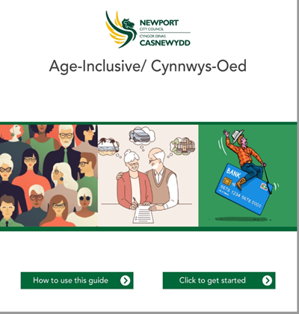

Although work has commenced there is still a lot more to be done to fulfil our commitment to the people of Newport to create an Age Friendly City. To help build an age friendly community we have developed a delivery plan that contains several actions which will enable collaboration when working towards becoming age friendly. The actions within the delivery plan are reviewed regularly to monitor progress and impact of the actions, as well as identify any gaps or challenges that may arise.

Appendix and further information

- One Newport plan One Newport PSBNewport Age Friendly Communities Delivery Plan October 2023.docx
- Marmot Region, Health inequalities - Building a Fairer Gwent - Aneurin Bevan University Health Board (nhs.wales)
Gwent Joint Strategic Assessment - Aneurin Bevan University Health Board (nhs.wales)
- Population needs assesment and Regional area plan Home - Gwentrpb
- Pill Masterplan PillConnects.com - Masterplan
- The Integrated Service Partnership Board (ISPB) Download.aspx (gwentrpb.wales)

Contacts: Katherine Hawkins Age Friendly Policy Officer, Newport City Council
Sandra Trimarco, Community Strategy Manager, Prevention & Inclusion, Newport City Council.
