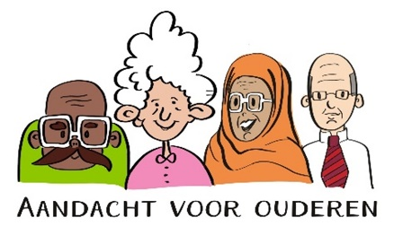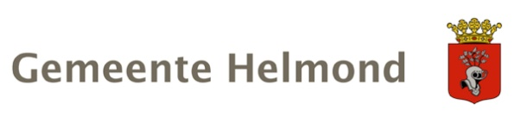

Social Domain Framework Helmond 2024-2028 (Kadernota Sociaal Domein Helmond 2024-2028)
The Social Domain Framework is a vision document – required by the national government - in which Dutch municipalities determine their course in the social field every four years.
The central ambition of municipal social policy is to enable all residents to participate, make ends meet and get ahead, if necessary with care and support from the local government and the organizations they subsidize. Working on this ambition requires continuous coordination and perseverance. The social challenges in our city are substantial and complex. Our approach in this domain is intertwined with our efforts in the spatial, security and economic domains.
In addition, the municipality depends on many healthcare and welfare providers and partners for implementation in the social domain, for example in the areas of housing, work, education and safety.
Our focus is on a strong social basis for everyone, on Social Teams providing broad basic support in the neighborhoods, in time and nearby, and organize appropriate specialist care and support if necessary. But it takes a while before effects are visible.

Growing old in vitality and happness
We want our residents to be able to grow old in vitalityy and happiness, in an environment that meets their needs and where they control their own lives for as long as possible. However, we also note that the current level of facilities is under pressure and that the time when care from cradle to grave was arranged by the government, is over.
Self-reliance and timely anticipation of changing living conditions are becoming more important. Caring for each other (co-reliance) must become self-evident again. And for those who need it, accessible facilities must be available, close to home. In addition, there must be a suitable place for everyone to live and residents must feel safe, both indoors and outdoors.

There are significant challenges
The number of elderly people will grow significantly in the coming decades. In 2040, a quarter of the Helmond population will be 65 years or older. The 2021 GGD monitor shows that approximately 20% of this target group is vulnerable and/or (very) lonely, experience lack a purpose in life and little control over their own life. Moreover; they find it difficult to ask for help. The demand for care - and therefore the costs of care - of this group is therefore increasing sharply. In combination with the tightness on the labor market, the decrease in the number of informal caregivers, and the stagnant flow of the housing market, a different approach is necessary to achieve future-proof support and care for the elderly. Prevention by strengthening the social basis is important.

We already do a lot for our elderly
Our social department subsidizes a wide range of social basic facilities. Consider (professional) facilities aimed at meeting, increasing mobility and fitness, strengthening skills and independent client support. This offer can be found on www.socialekaarthelmond.nl. We also facilitate approximately 200 associations in the field of sports, culture and leisure activities. Many of the activities can be found in the Activities Guide 55+, which is distributed every 2 years through elderly organizations, community centers and healthcare institutions. Prevention and strengthening the social basis are the starting points for all these basic services.
Naturally, indicated support from the Wmo is available for those who need it. Consider household support, day care aids, home adjustments, lifestyle monitoring and income support.
From a housing perspective, we are working on the enormous challenge of creating sufficient, suitable housing for our older residents. In addition, we try to encourage them to move from a large family home to a suitable, smaller home in order to stimulate the flow on the housing market.
Various policy programs – what is the common denominator?
The attached infographic provides a good insight into the interventions we already have available and the various policy programs that focus on the elderly target group (in Dutch). At a local level, this includes the Vision on Housing, Welfare and Care and at a national level the Healthy and Active Living Agreement (GALA, VWS), the Integrated Care Agreement (IZA, VWS) and two programs on Housing and Care for the Elderly (VWS, BZK). The task from the Integrated Care Agreement (IZA) will be translated into a regional plan this year and, based on the GALA, a local action plan will be drawn up to invest in a healthy and active society.
All programs refer to challenges mentioned above and note that things 'must change' in order to achieve a future-proof system of support and care. In addition to the shift towards prevention (self-reliance and co-reliance), integrality and cooperation are also part of our approach.

Integrity and cooperation deliver benefits for everyone
The task ahead of us is complex. We will only realize the required changes if we tackle this together: municipality, welfare organizations, healthcare providers, housing associations, health insurers, partnerships such as the Working Group Attention to the Elderly and Residents. It is also important to work more integrally, to create coherence, and to connect developments and organizations. We will investigate in the near future how we will shape this integrality in the field of the elderly.

This is our promiss to our elderly in the coming years
A selection of the activities with which we work towards the goals as stated in the infographic:
- working on an implementation a program on the 7 themes from the Vision for Housing, Welfare&Care;
- subsidize the Elderly Network with the aim of strengthening this partnership and ensuring the continuity of activities;
- work together with a wide range of partners to provide adequate informal care support. Based on the ambition to work together to ensure that informal caregivers can be in balance, that all overloaded informal caregivers are identified by 2025 and, if they wish, receive tailor-made support.
- investigate the possible expansion of e-health applications;
- translate the needs of residents on a physical and social level into the neighborhood development plans;
- encourage and facilitate resident initiatives that contribute to accessible encounters, meaningful daytime activities and strengthening co-reliance in a district/neighborhood;
- strengthening regional chain cooperation around dementia;
- implementation of the UN Convention on Disability Action Plan 2024-2025; many elderly people fall into this target group;
- implement the Action Plan for Fall Prevention for elderly people;
- policy- and implementation plans in response to the various policy assignments from the Government (see links under appendices).

Attachments
It is not possible to include this in the application. If desired, we can provide these documents outside the procedure for placement on the website.
- Kadernota Sociaal Domein (2024-2028)
- Visie op Wonen Welzijn Zorg Helmond (2023-2026)
- Infographic ‘Wat wij doen voor onze ouderen’ (2023)
- links to recent government policies (Dutch Ministry of Health, wellbeing and sports):
- Integraal Zorgakkoord: 'Samen werken aan gezonde zorg' | Rapport | Rijksoverheid.nl
- (goal: to keep healthcare good, accessible and affordable for the future)
- GALA -Gezond en Actief Leven Akkoord | Rapport | Rijksoverheid.nl (Dutch Ministry of Health, wellbeing and sports):
- (goal: citizens who grow older with dignity and health and who live independently for longer and 'the healthiest generation of youth' who grow up with opportunities in a living environment with a strong social basis)
- Programma Wonen en zorg voor ouderen | Rapport | Rijksoverheid.nl (Ministry of Internal Affairs)
- (goal: that elderly people can live happily in a suitable home and living environment and can move if they want to

Figures for the municipality of Helmond
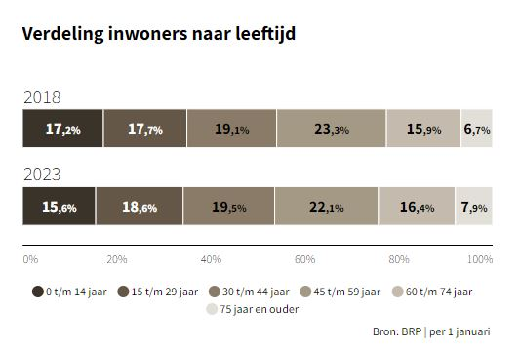

Figures from the province of North Brabant

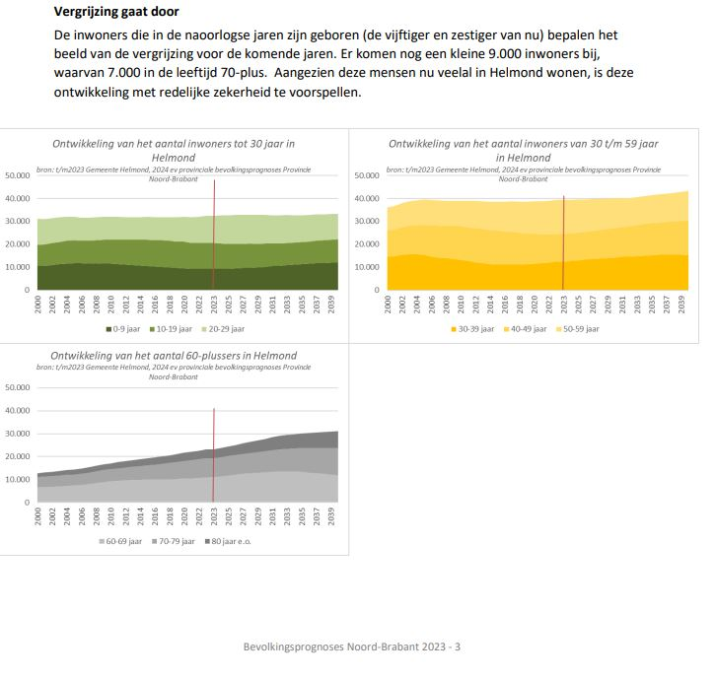

See for more information: 2023-11 samenvatting provinciale prognoses NB.pdf (incijfers.nl)

