D-4. Age-Friendly City Survey Results

1) Survey Overview

Purpose
- The purpose of this survey is to provide fundamental data for establishment of an Age-Friendly City development plan in Geochang County. This includes diagnosing perception of citizens regarding Age-Friendly City in order to assess current state of senior-friendliness and to anticipate future demands.

Survey Scope
- Geographical Scope: Geochang County
- Content Scope: WHO AGE-Friendly City Survey

Survey Content
- General information of Geochang County and eight items related to Age-Friendly City
- Includes expert opinions on eight areas of Age-Friendly City guideline proposed by WHO as well as perspectives on roles and performances of various institutions in the journey of Geochang County to become an Age-Friendly City

Sample Size Determination
- Size of the sample was determined based on proportional representation of the population by region, age, and gender. Considering that the number of elderly population (65 years and older) which is relatively small, and the possibility of probabilistic extraction in the general target survey, differentiated approach was taken to each sample groups.
- The maximum tolerance limit is 3.8%, and the sample size was determined to survey over 300 elderly individuals (65 years and older) and over 300 general citizens.

Sample Distribution
- The sample size was proportionally allocated based on the population of elderly individuals (65 years and older) in each administrative district.

Survey Method
Sortation | Details
Survey method | - 1:1 individual interviews and distribution surveys
Data collection tools | - TAPI(Tablet PC Assisted Personal Interview)
Period of survey | - August 9, 2023 to September 19, 2023
Sampling method | - Allocation table considering the number of people in each eup, myeon, and dong based on administrative districts
Recovery rate | - A survey sample of 850 copies (450 copies of the elderly and 350 copies of the non-senior) was distributed and 408 copies (90.67%) of the elderly and 334 copies (95.43%) of the non-senior were confirmed, excluding data that were not recovered and processed.

Data Processing
- Computerized collected raw data with SPSS ver. 21.0 through Editing, Coding and Punching

2) Respondent Analysis Results

Gender status of respondents
- Based on age groups of respondents in Geochang County, males aged 65 or below account for 84 individuals (24.8%), and females aged 65 or below account for 255 individuals (75.2%). For respondents aged 65 and above, males account for 99 individuals (24.3%) while females represent 309 individuals (75.7%).
- Gender status of this survey coincides with proportion of elderly females among the general population statistics in Geochang County. Therefore, it is necessary to consider customized policies for the elderly female population in the future development of Geochang County's Age-Friendly City.

[Table 1] Analysis of respondent’s gender status
Sortation |  | under the age of 65 |  | aged 65 and over
 |  | Number of respondents | Percentage (%) | Number of respondents | Percentage (%)
the entire |  | 334 | 100.0% | 408 | 100.0%
Gender | men | 84 | 24.8% | 99 | 24.3%
 | women | 255 | 75.2% | 309 | 75.7%

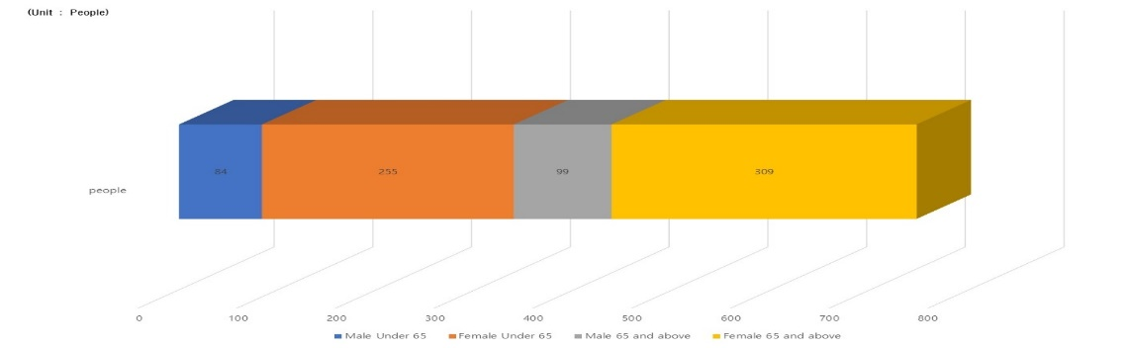
[Fig 1] Analysis of respondent’s gender status

Status of the respondent by age group
- The distribution of survey respondents appears to be relatively even across different age groups. - For those aged 65 or below, the data was compiled into five stages based on a 10-year interval. The lowest response came from those under 20, with only 2 individuals (0.6%), while the highest portion was in the age group of 40 to 49, with 108 respondents (31.9%).
- For respondents aged 65 and above, the data was compiled into five stages based on a 5-year interval, considering the characteristics of the elderly. The result showed the lowest response of 5 individuals (1.2%) in the age group of 91 and above, and the highest distribution was observed in the age group of 75 to 79, with 95 respondents (23.0%).

[Table 2] Analysis of respondents’’ status by age group
Sortation |  | Aged 65 or below |  | Aged 65 and over
 |  | Number of  respondents | Percentage  (%) | Number of  respondents | Percentage  (%)
the entire |  | 339 | 100.0 | 408 | 100.0
the age group | 20 or below | 2 | 0.6 | - | -
 | 20 to 29 | 35 | 10.3 | - | -
 | 30 to 39 | 81 | 23.9 | - | -
 | 40 to 49 | 108 | 31.9 | - | -
 | 50 to 59 | 82 | 24.2 | - | -
 | 60 to 65 | 31 | 9.1 | - | -
 | 65 to 69 | - | - | 71 | 17.4
 | 70 to 74 | - | - | 89 | 21.8
 | 75 to 79 | - | - | 95 | 23.3
 | 80 to 84 | - | - | 94 | 23.0
 | 85 to 90 | - | - | 54 | 13.2
 | 91 and above | - | - | 5 | 1.2
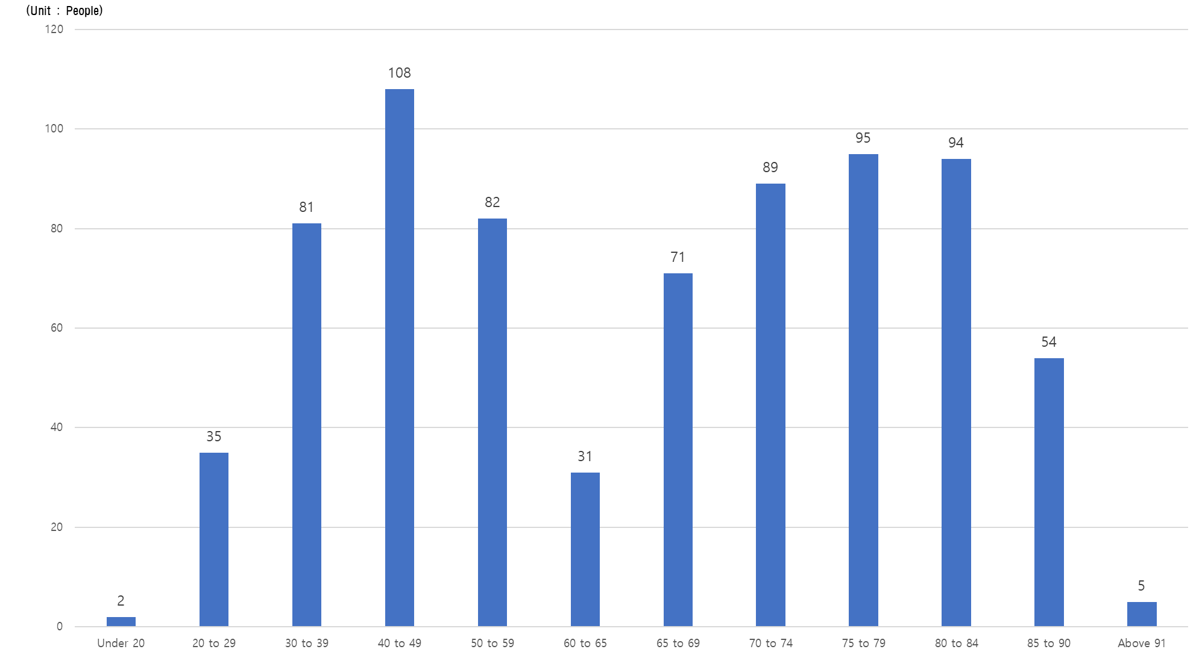
[Fig 2] Analysis of respondents’ status by age group

Status of the respondents’ academic background
- The academic background of survey subjects shows an overwhelmingly high portion from over college graduate for those under the aged 65 or below (271 individuals, 79.9%), while among those aged 65 and above, the majority had completed elementary school (266 individuals, 65.2%), while graduation from middle school and high school showed a relatively even distribution.
- Only 12 respondents of aged 65 and above (2.9%) graduated college. Most of this age group has completed elementary school or middle school.
- As highly educated individuals are increasing among pre-elderly population, it seems necessary to provide specific plans to utilize their careers and experiences which could possibly serve as foundation to the creation of an age-friendly city.

[Table 3] Analysis of respondents' academic status
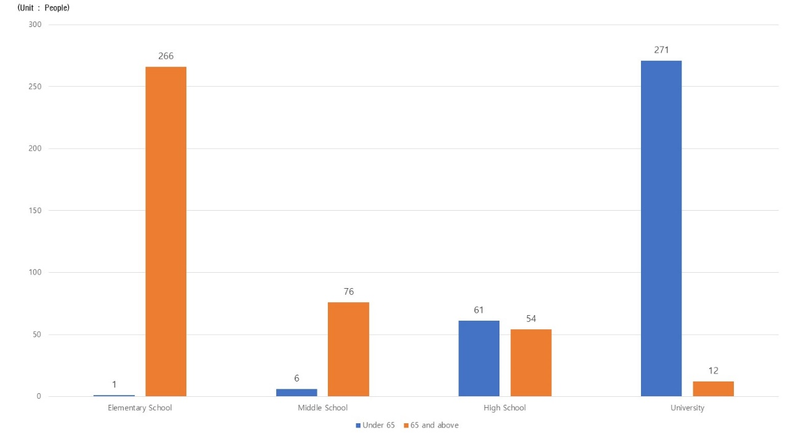
Sortation |  | Aged 65 or below |  | Aged 65 and over
 |  | Number of respondents | Percentage (%) | Number of respondents | Percentage (%)
the entire |  | 339 | 100.0 | 408 | 100.0
educational background | Elementary  school | 1 | 0.3 | 266 | 65.2
 | Middle school | 6 | 1.8 | 76 | 18.6
 | High school | 61 | 18.0 | 54 | 13.2
 | Over college  graduate | 271 | 79.9 | 12 | 2.9
[Fig 3] Analysis of the respondents’ academic background status

Status of respondents’ health
- In the health-related questions of this survey, majority of the aged 65 or below answered ‘normal’ or ‘good’, while the aged 65 and above mostly answered ‘normal’ and ‘bad’ in a similar portion.
- In aged 65 and above, responses of ‘very good’ and ‘good’ were higher than ‘bad’ and ‘very bad’, suggesting that the health status of this age group in Geochang county is generally good.
- To enhance the quality of life for the elderly population aged 65 and above, it is necessary to explore measures in health and welfare services, focusing on maintaining or improving current health conditions through physical fitness promotion and regular check-ups.

[Table 4] Analysis of the respondents’ health status
Sortation |  | Aged 65 and over
 |  | Number of respondents | Percentage(%)
the entire |  | 408 | 100.0
Physical condition | very good. | 45 | 11.0
 | good | 109 | 26.7
 | normal | 155 | 38.0
 | bad | 83 | 20.3
 | very bad | 16 | 3.9

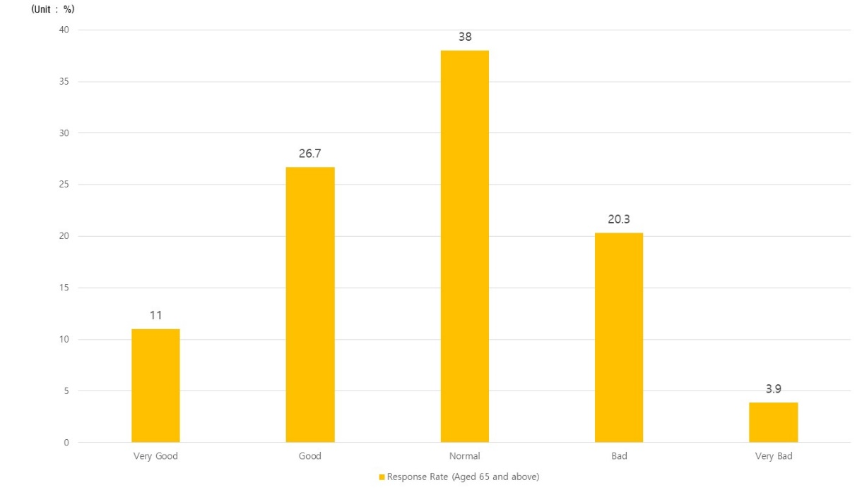

[Fig 4] Analysis of the respondents’ health status

Status of residential types of respondents
- 78.7% of respondents answered that they reside in single-family houses in the question regarding the housing type
- Other types of residential types were reported as follows: 13.2% in apartments, 7.31% in townhouses/multi-family houses, and 0.2% in other forms of housing.

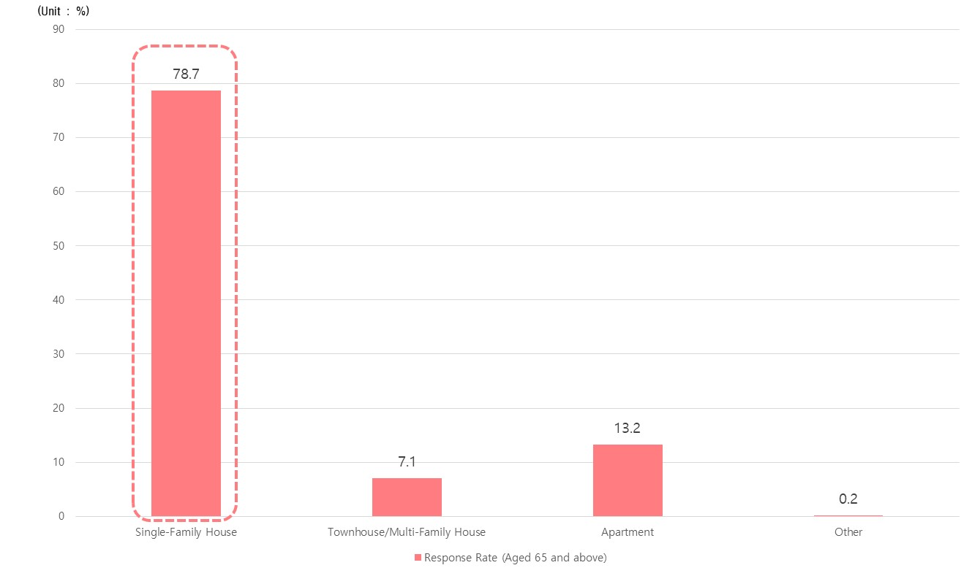
[Table 5] Analysis of Status of residential types of respondents
Sortation |  | Aged 65 and over
 |  | Number of respondents | Percentage (%)
the entire |  | 408 | 100.0
Residential type of residence | Single-family house | 321 | 78.7
 | Townhouses/Multi-family house | 29 | 7.1
 | apartment | 54 | 13.2
 | etc. | 1 | 0.2

[Fig 5] Analysis of Status of residential types of respondents

- The rate of elderly individuals residing in single-family houses remains high despite the increasing trend in the supply of apartments in nationwide. This suggests that additional survey of housing environments is needed to provide projects regarding enhancement of decrepit housing and general enhancement of residential conditions.

Status of respondents by administrative districts
- The result of the survey, conducted by considering the proportional distribution of sample size and the number of elderly (65 years and older) in each district of Geochang county based on the population of each district, is as follows:

[Table 6] Analysis of respondents by administrative districts
Sortation |  | under the age of 65 |  | aged 65 and over
 |  | Number of  respondents | Percentage  (%) | Number of  respondents | Percentage  (%)
the entire |  | 339 | 100.0 | 408 | 100.0
Eup, Myeon | Geochang-eup | 280 | 82.6 | 114 | 27.9
 | Jusang-myeon | 5 | 1.5 | 34 | 8.3
 | Ungyang-myeon | 5 | 1.5 | 24 | 5.9
 | Goje-myeon | 6 | 1.8 | 12 | 2.9
 | Bugsang-myeon | 6 | 1.8 | 31 | 7.6
 | Wicheon-myeon | 5 | 1.5 | 31 | 7.6
 | Mari-myeon | 7 | 2.1 | 22 | 5.4
 | Namsang-myeon | 5 | 1.5 | 31 | 7.6
 | Namha-myeon | 1 | 0.3 | 36 | 8.8
 | Sinwon-myeon | 5 | 1.5 | 30 | 7.4
 | Gajo-myeon | 11 | 3.2 | 32 | 7.8
 | Gabuk-myeon | 3 | 0.9 | 11 | 2.7
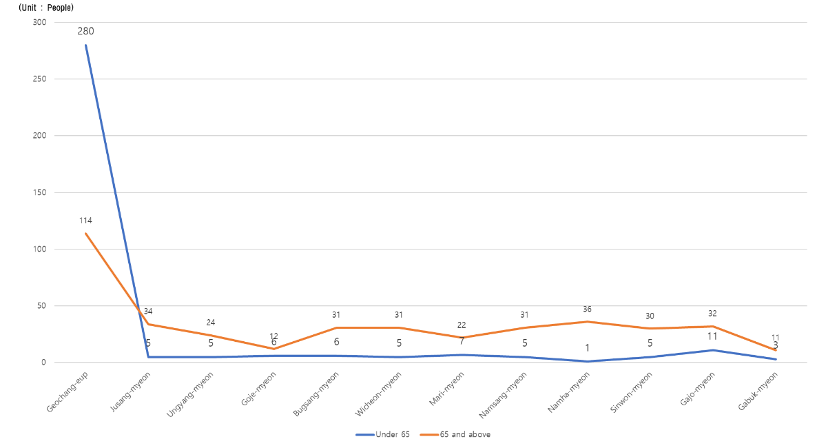

[Fig 6] Analysis of respondents by administrative districts

- Geochang-eup accounts for 27.9% of the total, followed by Jusang-myeon, Bugsang-myeon, Wicheon-myeon, Namsang-myeon, and Namha-myeon, showing a relatively even distribution.
- The lowest proportions were observed in Goje-myeon and Gabuk-myeon, each with 2.9% and 2.7%, respectively.
- Overall, the results indicate a very satisfactory outcome in terms of sample distribution.

3) Results of Age-Friendly City Establishment Analysis by Eight Areas

Analysis of the current status of eight areas on the Establishment of Aging-friendly Cities
- Average scores for each of the 8 areas of age-friendly city establishment came up with 4.26 out of 7 points for those under 65, while the score of aged 65 and above was slightly lower as it showed 4.43 out of 7 points.
- For aged 65 or below, the lowest scores among the 8 areas were the convenience of transportation and the stability of residential environments. On the other hand, respondents aged 65 and above gave the lowest scores to leisure and social activities, and communication and information.
- In contrast, the highest scored area for respondents aged 65 or below were local care and medical service, while that of aged 65 and above were social participation and employment.
- The result suggests that respondents aged 65 or below may reflect the increased burden of supporting the elderly population, therefore highlighted the need for local welfare and medical services. The survey result of aged 65 and above indicates their needs for economic and social activities after their retirement.
- Overall analysis indicates citizens of Geochang county needs more intensive efforts in the software domain, rather than hardware development among eight areas for the establishment of Age-Friendly City

[Table 7] Analysis of the status of the eight key areas for the establishment of an age-friendly city

Sortation |  | Aged 65 or below |  | Aged 65 and over
 |  | Average value | Ranking | Average value | Ranking
the entire |  | 4.26 | - | 4.43 | -
the eight key areas | 1. External environment and facilities | 4.13 | 5 | 4.51 | 3
 | 2. Convenience of transportation means | 4.08 | 7 | 4.78 | 2
 | 3. Stability of residential environment | 3.99 | 8 | 4.36 | 5
 | 4. Leisure and social activities | 4.42 | 3 | 4.28 | 7
 | 5. Social Participation and Jobs | 4.43 | 2 | 4.93 | 1
 | 6. Respect and Social Integration | 4.39 | 4 | 4.43 | 4
 | 7. Communication and Information | 4.09 | 6 | 3.84 | 8
 | 8. Community Care and Medical Services | 4.51 | 1 | 4.31 | 6

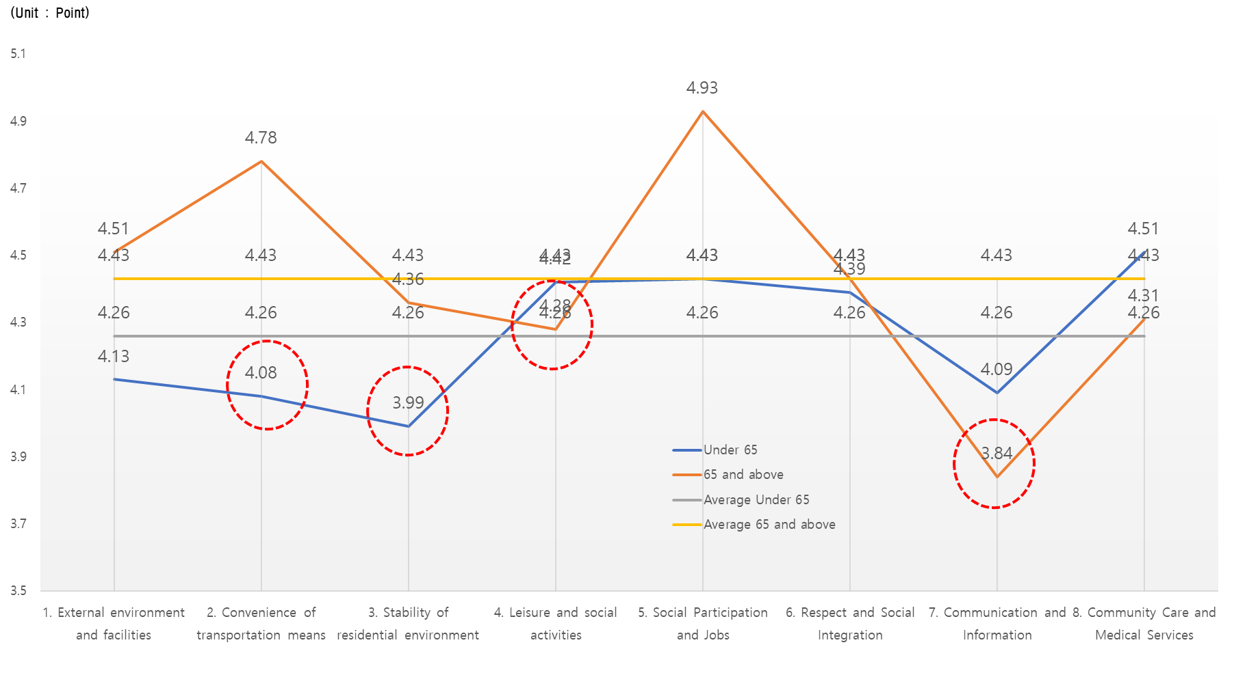
[Fig 7] Analysis of the current status of eight areas for the establishment of an age-friendly city

- Particularly, respondents aged 65 and above tend to express a greater need for activities such as social participation, employment, convenient transportation, and external environment and facilities in the 8 areas. This suggests the necessity of establishing social infrastructure that allows the elderly population to play a role as an integral part of society in the construction of an age-friendly city.
- Furthermore, for those under 65, the higher scores in areas related to support for the quality of life of the elderly, such as care, employment, and leisure, are predicted to reflect the burdens and needs as caregivers. Therefore, it is considered crucial to formulate policies that can alleviate the burden of caregivers.

External environment and facilities
- Both age groups prioritized outdoor resting places when asked about their ideal features in the surrounding environment and facilities. While younger respondents emphasized accessibility facilities within public buildings, older adults identified safe and well-maintained pathways and sidewalks as key priorities.
- However, both groups rated external safety features like safety handles, sloped walkways, emergency call buttons, and age-friendly crosswalk design relatively low.
- These findings suggest several priorities for building an age-friendly city: 1) Regular driver safety education. 2) Expanded safety infrastructure like handrails, ramps, and emergency buttons. 3) Prioritizing age-friendly design in constructing new pedestrian facilities and crosswalks.
- Additionally, improving accessibility by ensuring convenient movement facilities within walkways and public buildings is crucial for an inclusive urban environment.

[Table 8] Analysis of the status of external environment and facilities
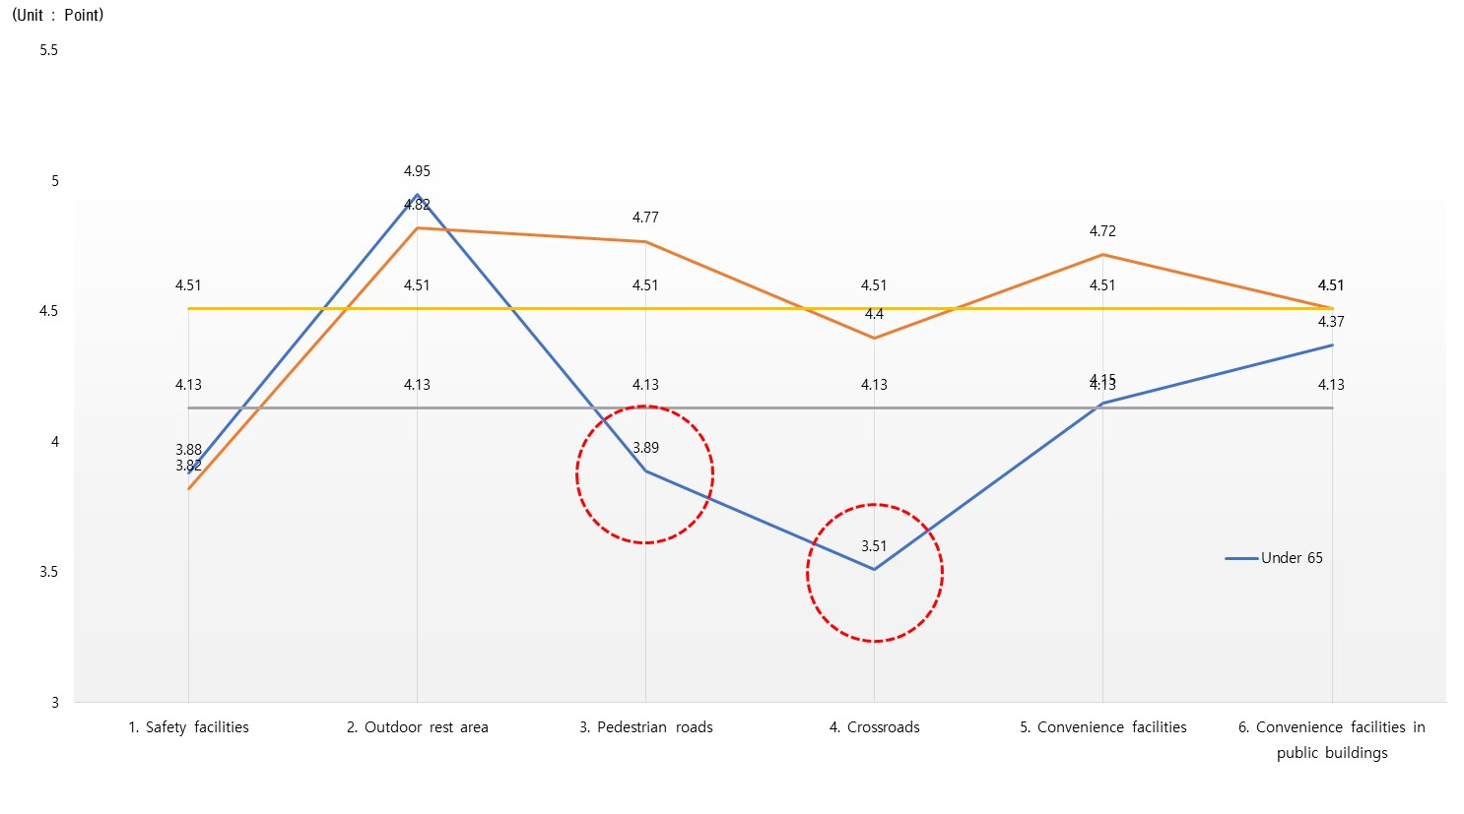
Sortation |  |  | Aged 65 or below |  | Aged 65 and over
 |  |  | Average value | Ranking | Average value | Ranking
the entire |  |  | 4.13 | - | 4.51 | -
- External environment and facilities | 1-1 | Safety facilities | 3.88 | 5 | 3.82 | 6
 | 1-2 | Outdoor rest area | 4.95 | 1 | 4.82 | 1
 | 1-3 | Pedestrian roads | 3.89 | 4 | 4.77 | 2
 | 1-4 | Crossroads | 3.51 | 6 | 4.40 | 5
 | 1-5 | Convenience facilities | 4.15 | 3 | 4.72 | 3
 | 1-6 | Convenience facilities in public buildings | 4.37 | 2 | 4.51 | 4

[Fig 8] Analysis of the status of external environment and facilities

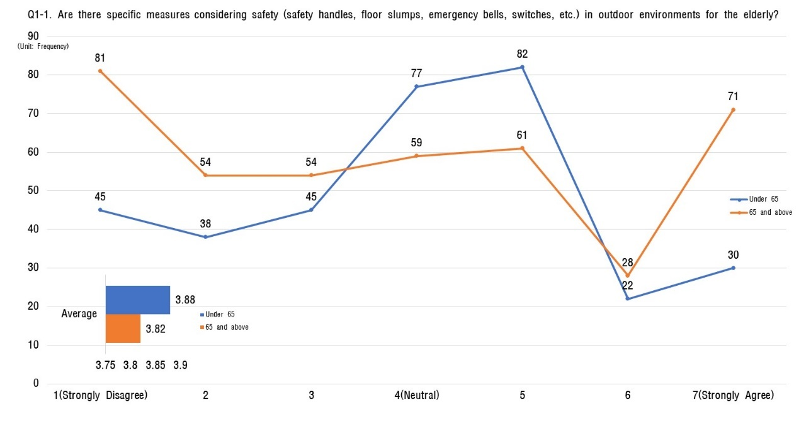
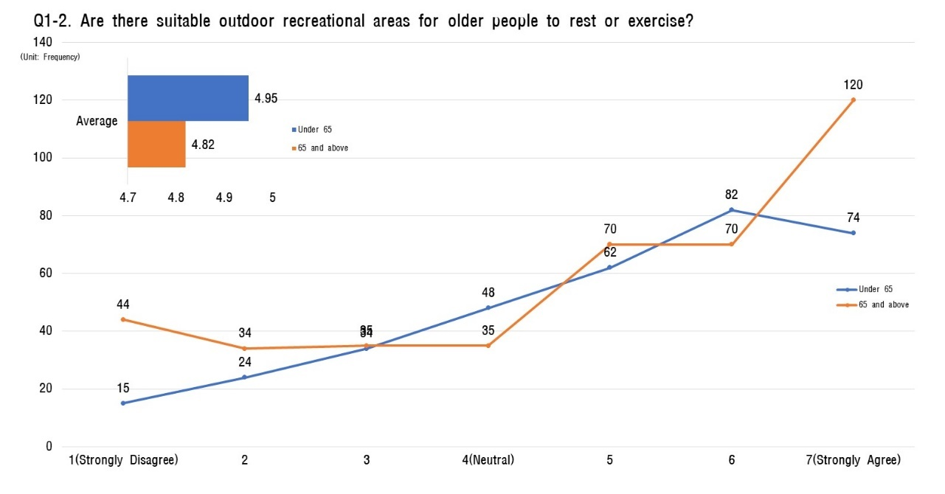
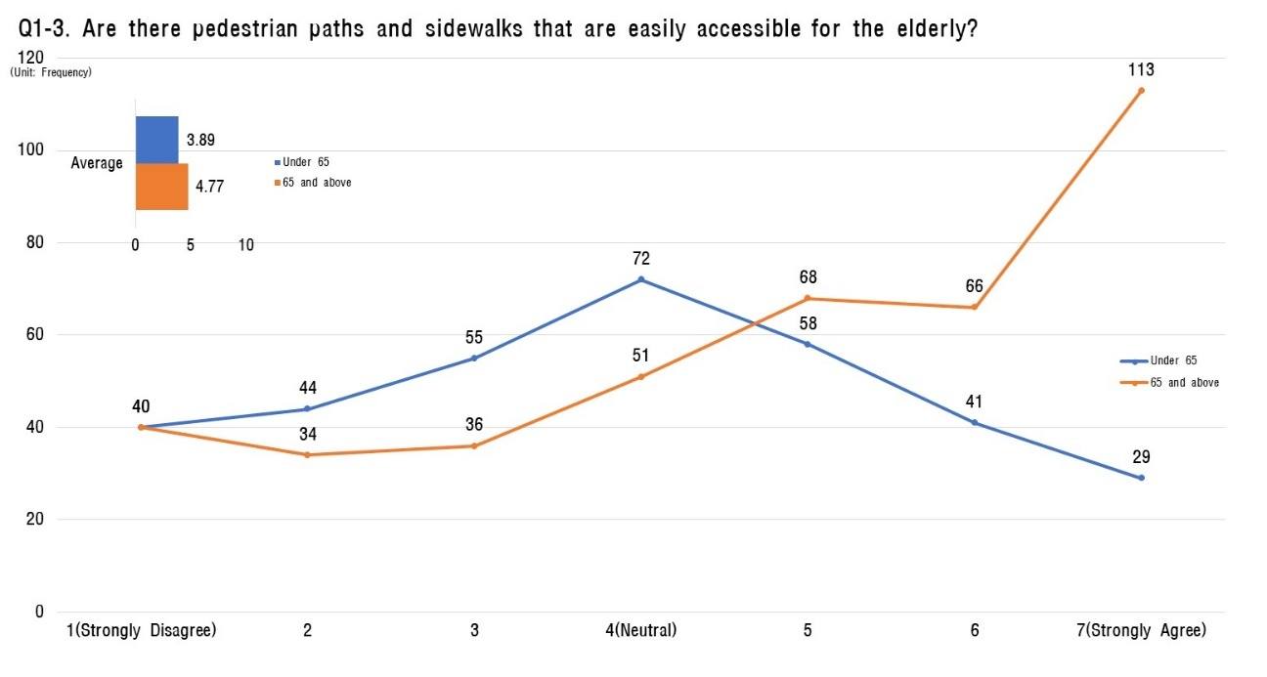
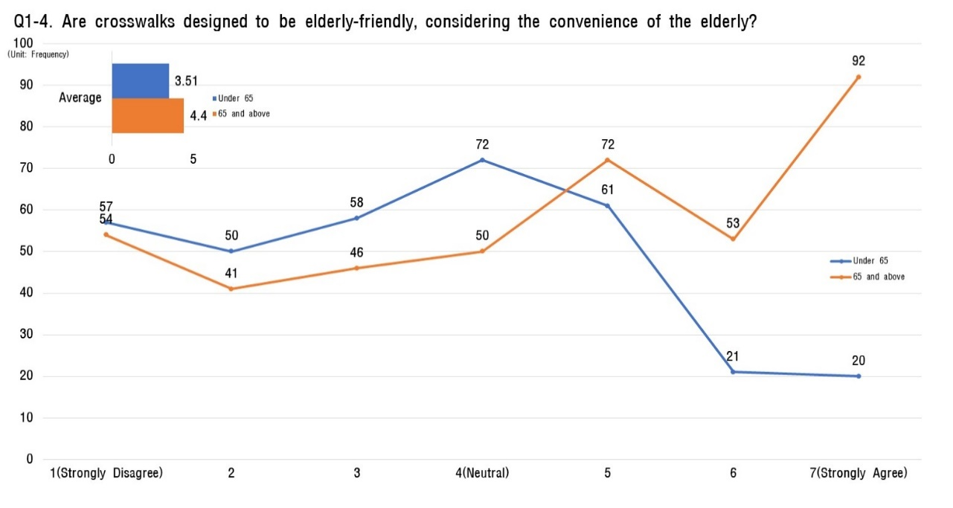
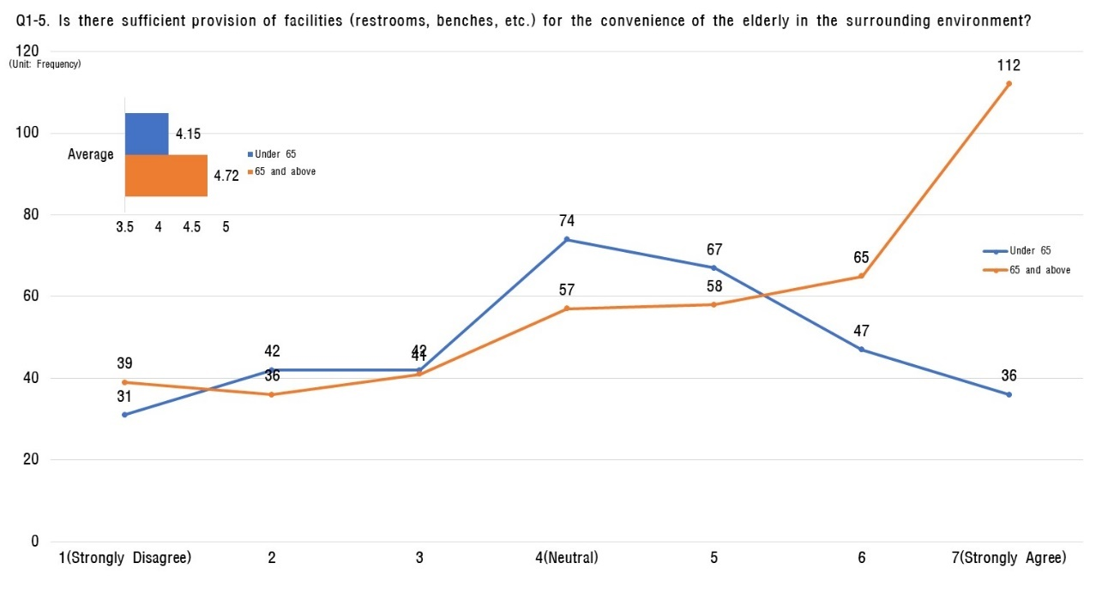
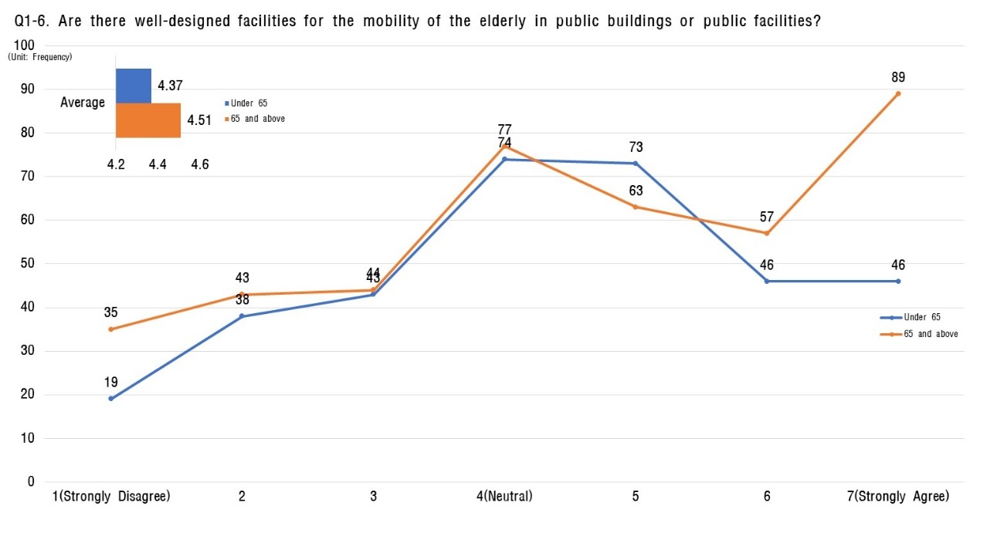

Convenience of transfortation
- Regarding transportation convenience, all survey participants voiced frustration with the inadequate support systems for elderly passengers. Their complaints focused on the lack of features like low-floor buses, readily accessible elevators, and guidance systems for individuals with visual or hearing impairments.

[Table 9] Analysis of the current status of transportation convenience
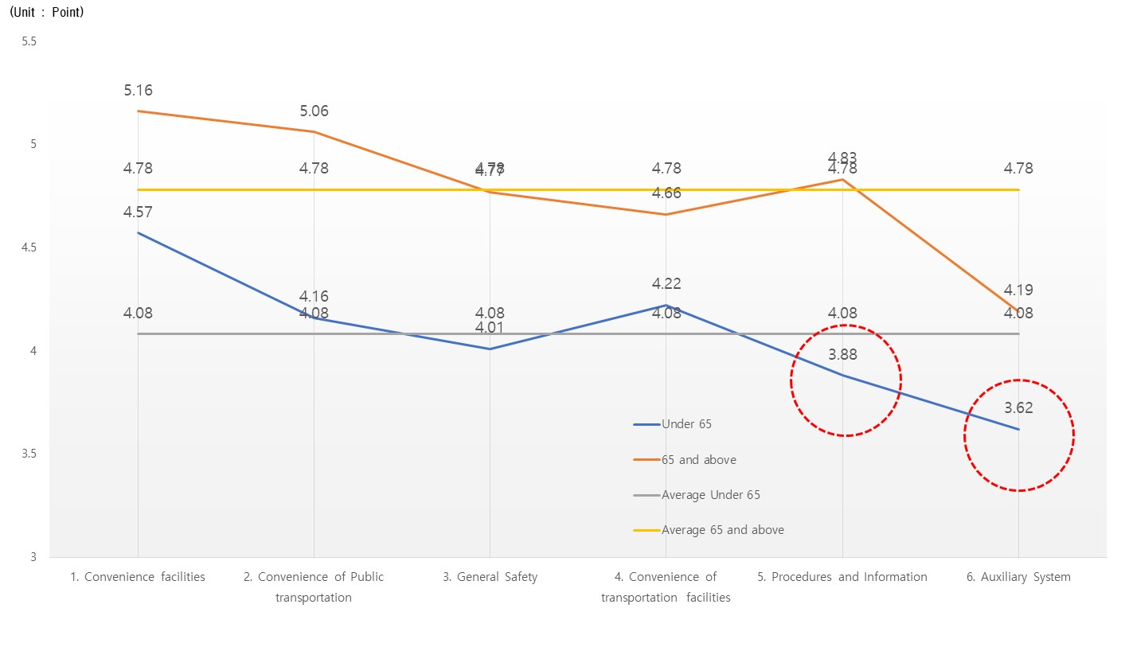
Sortation |  | Aged 65 or below |  | Aged 65 and over
 |  | Average value | Ranking | Average value | Ranking
the entire |  | 4.08 | - | 4.78 | -
2. Convenience of transportation means | 2-1 Convenience facilities | 4.57 | 1 | 5.16 | 1
 | 2-2 Convenience of Public transportation | 4.16 | 3 | 5.06 | 2
 | 2-3 General Safety | 4.01 | 4 | 4.77 | 4
 | 2-4 Convenience of transportation facilities | 4.22 | 2 | 4.66 | 5
 | 2-5 Procedures and Information | 3.88 | 5 | 4.83 | 3
 | 2-6 Auxiliary System | 3.62 | 6 | 4.19 | 6
[Fig 9] Analysis of the current status of transportation convenience
- Conversely, participants positively rated the presence of convenience facilities specifically designed for the elderly, such as designated seating and comfortable waiting areas. They also found the overall ease of use of public transportation and its facilities satisfactory.
- These findings suggest that improving the satisfaction of older individuals with public transportation hinges on prioritizing accessibility-focused measures. This includes implementing comprehensive auxiliary systems and clear guidance specifically for elderly passengers. By catering to their unique needs, we can not only enhance their comfort and independence but also optimize the existing infrastructure for broader usability.

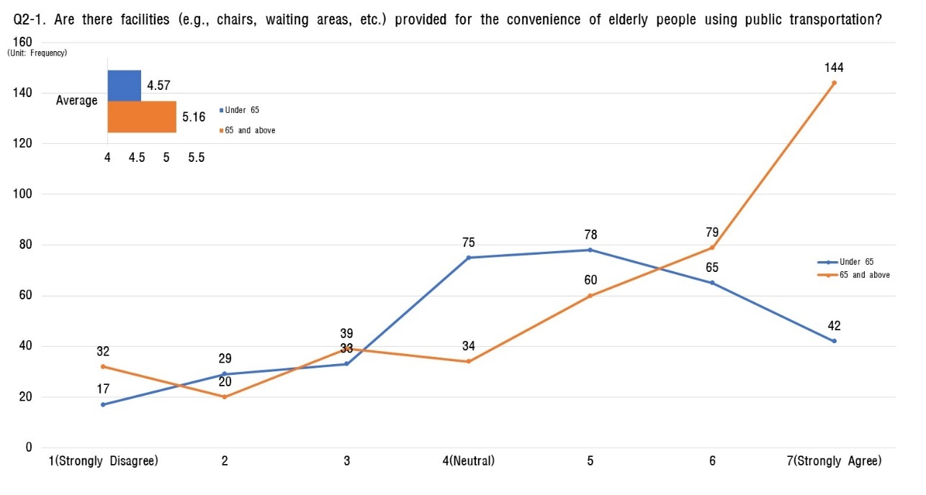
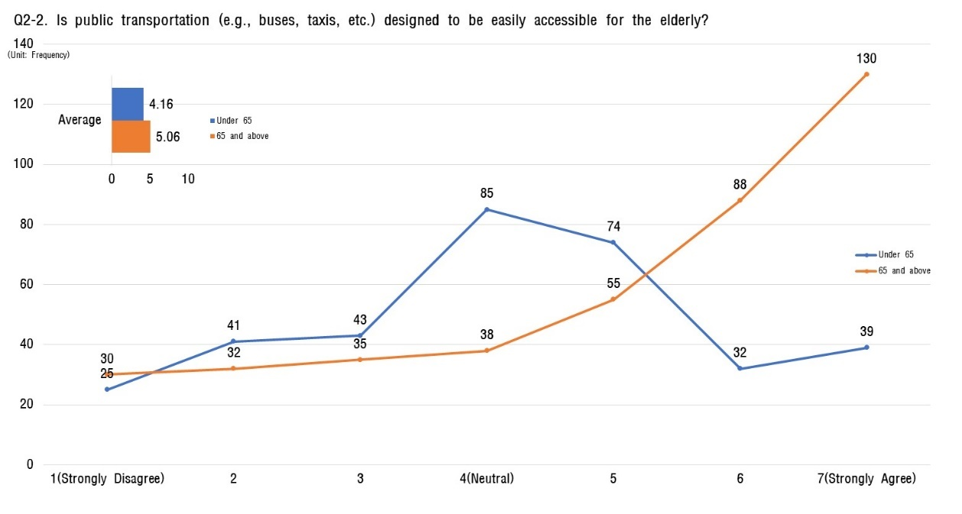
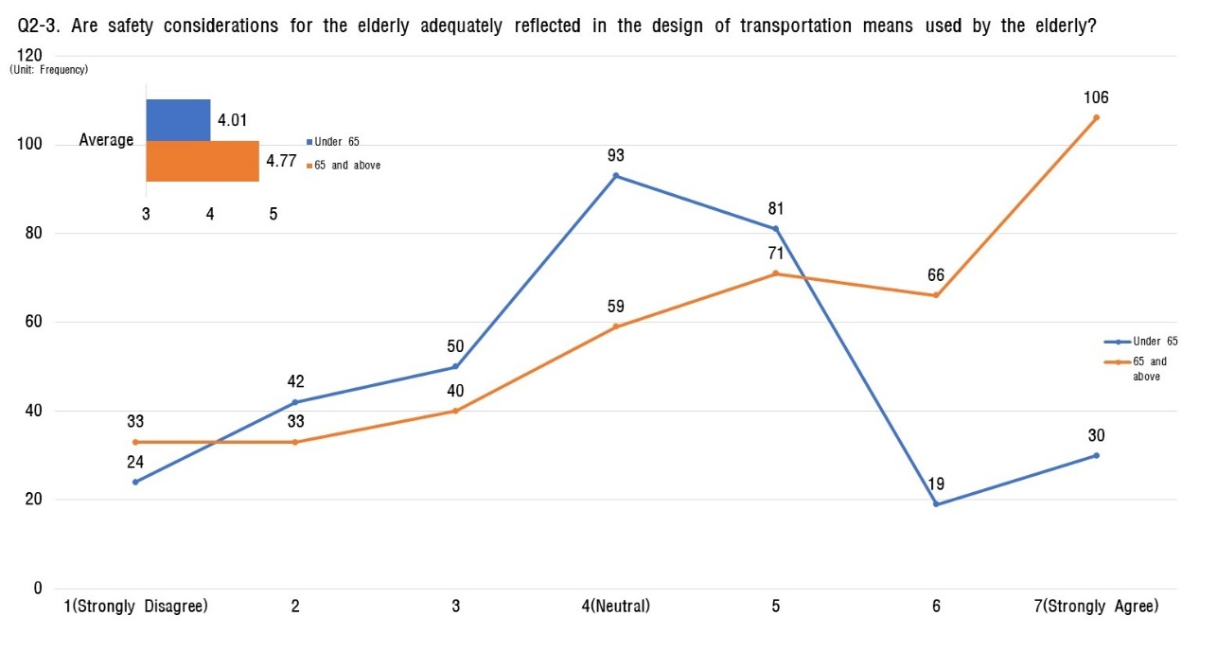
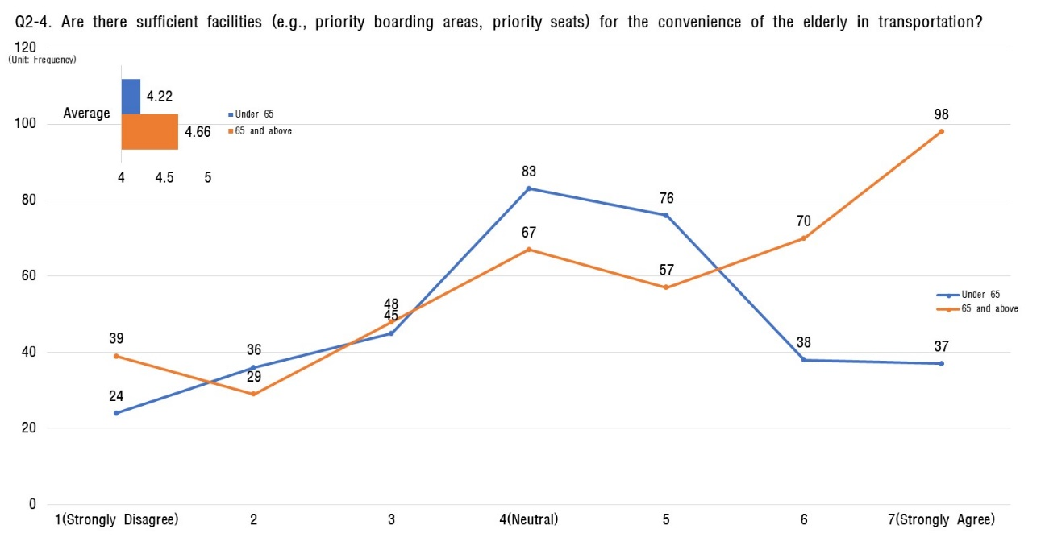
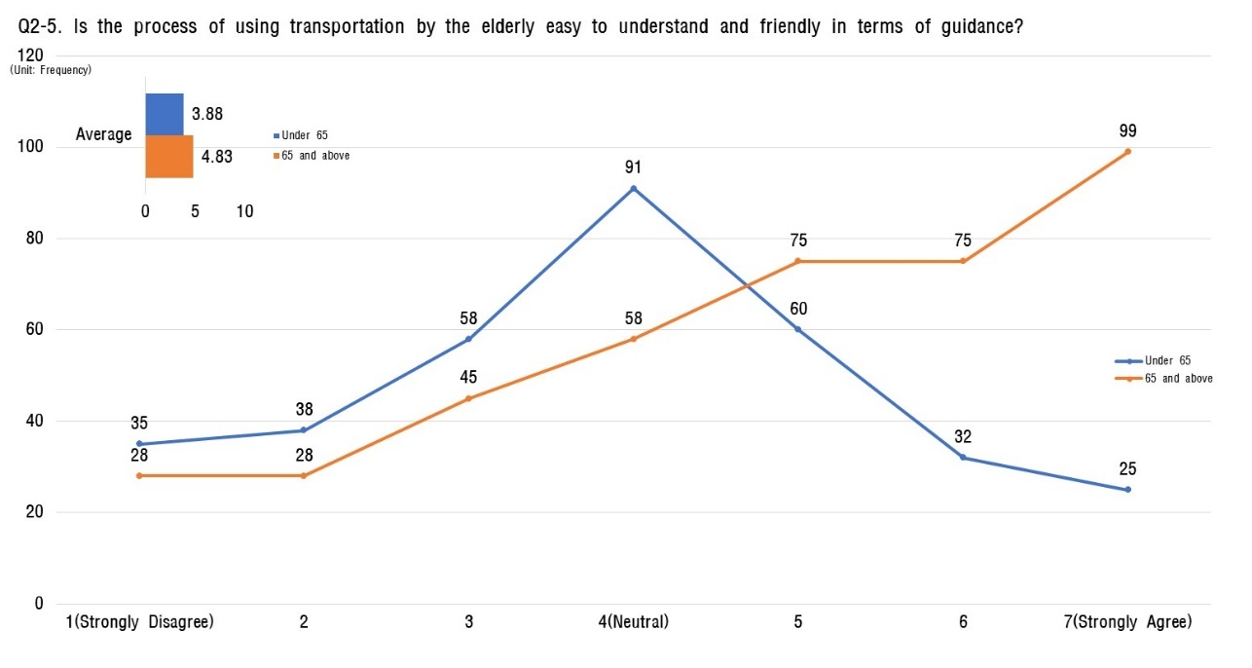
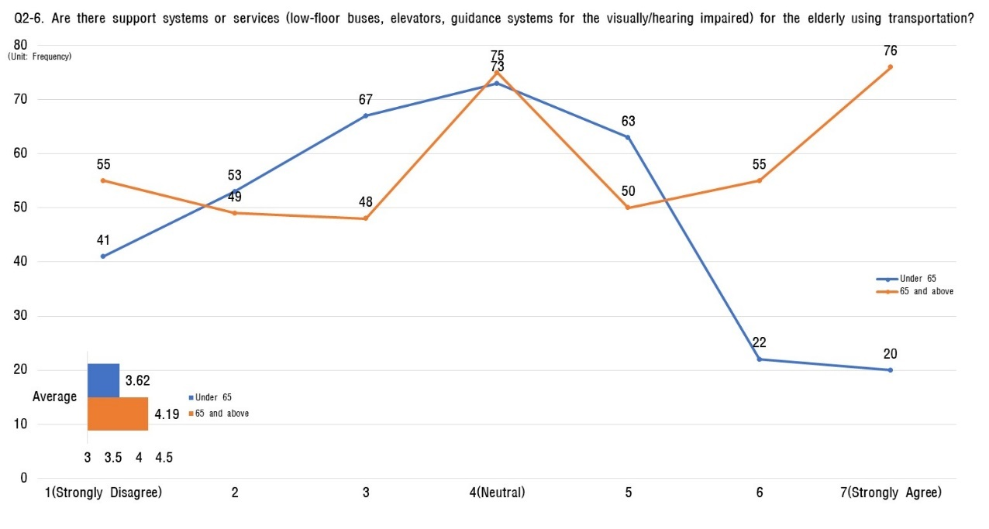

Stability of residential environment
- Regarding questions about the residential environment, young respondents (aged 65 or below) rated it slightly less convenient than their older counterparts (aged 65 and above), with average scores of 3.99 and 4.36 out of 7, respectively.
- For respondents under 65, the item with the lowest average score was 'How is the convenience inside the house (safety bars in the bathroom, slip prevention, sloped thresholds, etc.)?' The next lowest was related to residential safety: 'Is your residence equipped to safely escape disasters such as fires or earthquakes?'
- Similarly, for those 65 and older, the lowest average score was also for 'convenience inside the house,' followed by an item related to the convenience of the surrounding residential area: 'Are there sufficient facilities available for the elderly in the vicinity, such as shops, medical facilities, parks, etc.?'
- To address these low evaluations for interior convenience, initiatives such as surveying actual residential conditions and implementing projects for improving elderly housing and providing home repair support are necessary.

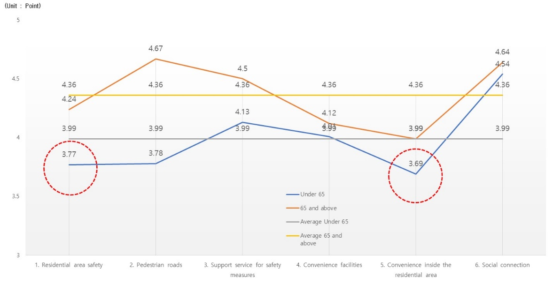
[Table 10] Analysis of status of residential environment stability
Sortation |  | Aged 65 or below |  | Aged 65 and over
 |  | Average value | Ranking | Average value | Ranking
the entire |  | 3.99 | - | 4.36 | -
3. Stability of residential environment | 3-1. Residential area safety | 3.77 | 5 | 4.24 | 4
 | 3-2. Pedestrian roads | 3.78 | 4 | 4.67 | 1
 | 3-3. Support service for safety measures | 4.13 | 2 | 4.50 | 3
 | 3-4. Convenience facilities | 4.01 | 3 | 4.12 | 5
 | 3-5. Convenience inside the residential area | 3.69 | 6 | 3.99 | 6
 | 3-6. Social connection | 4.54 | 1 | 4.64 | 2

[Fig 10] Analysis of status of residential environment stability

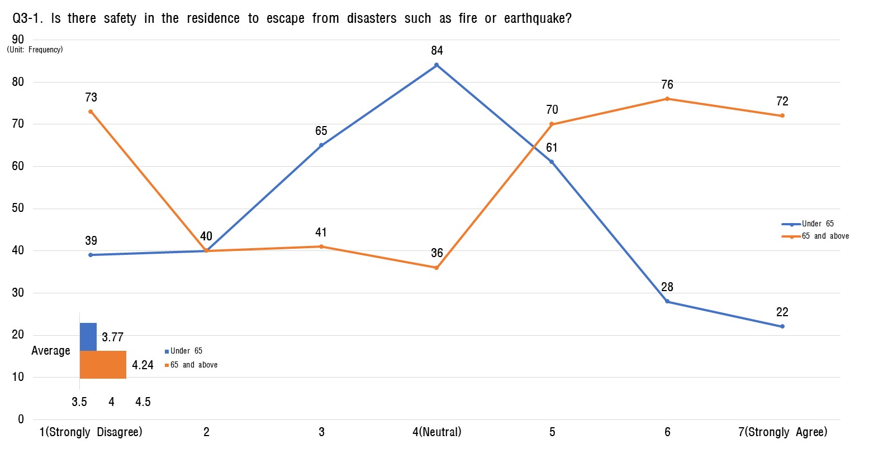
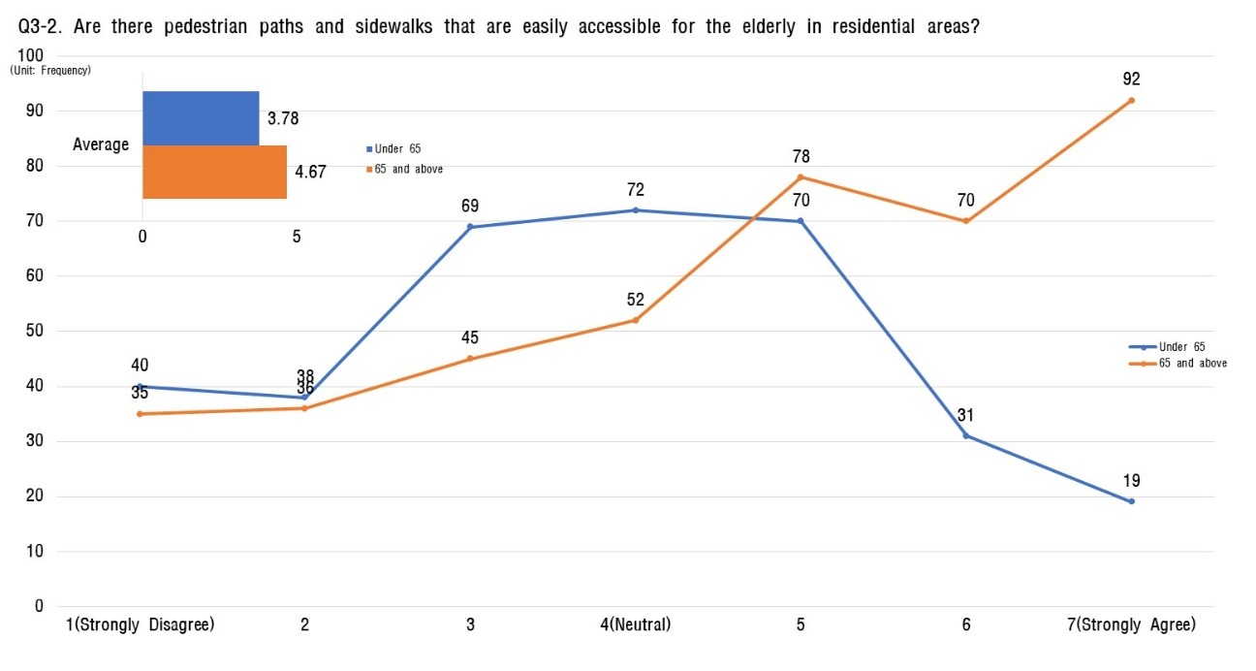
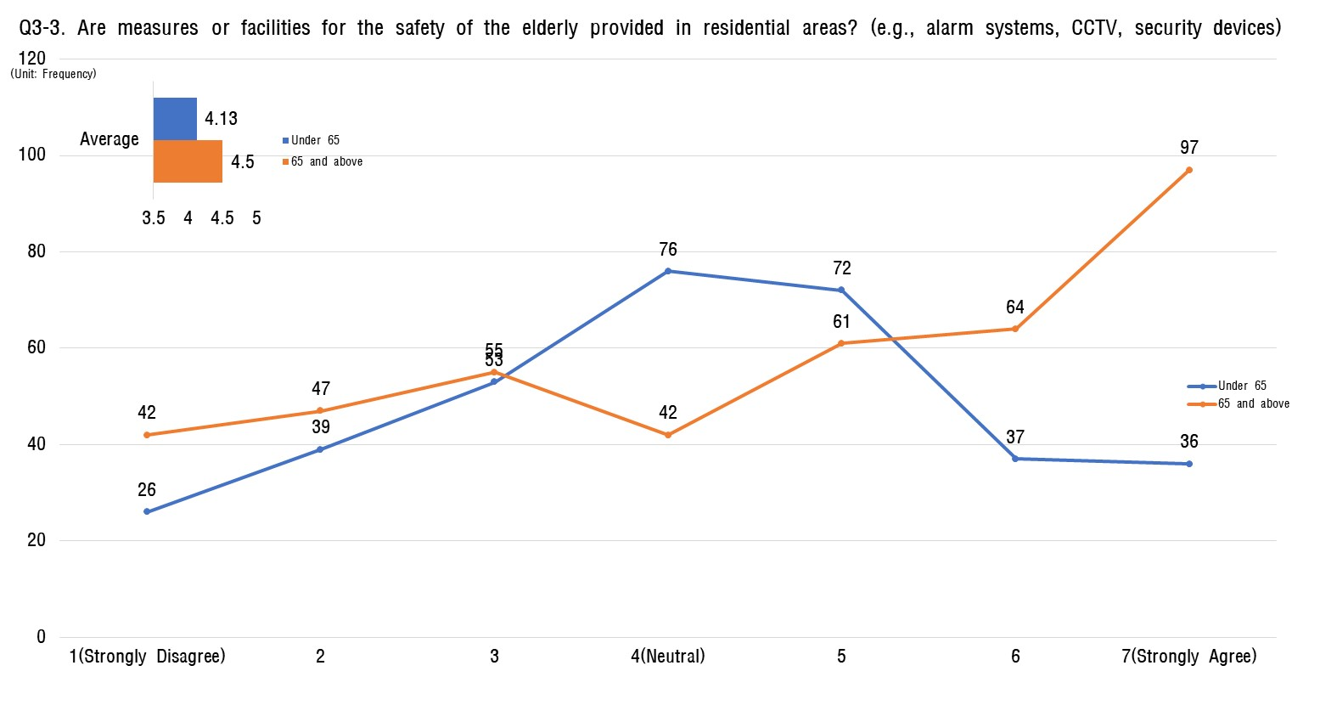
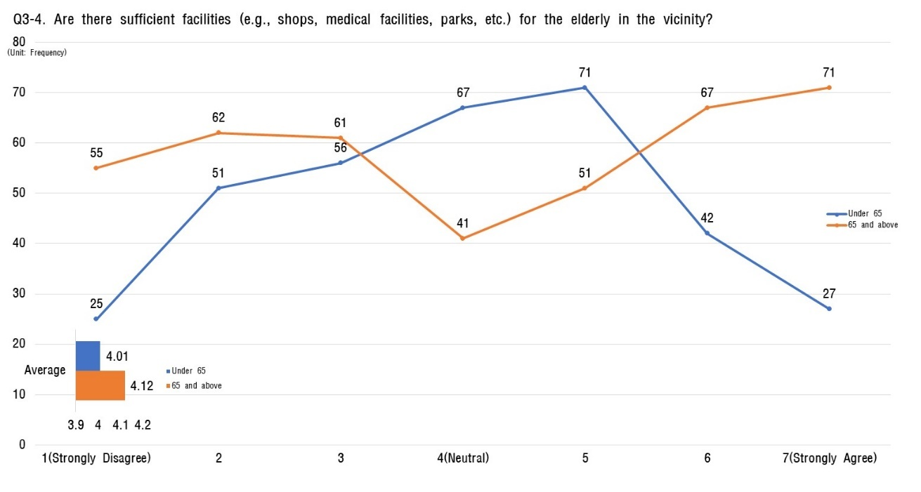
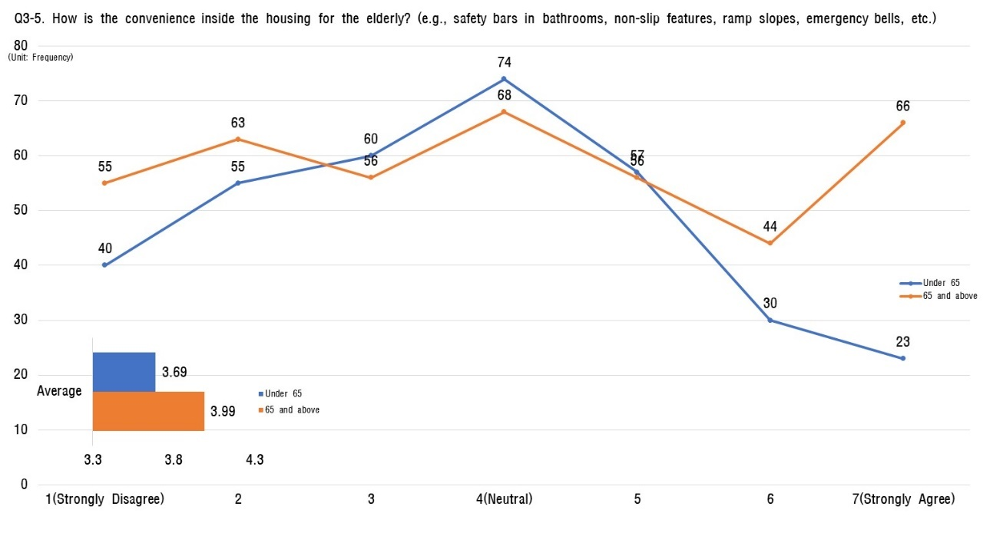
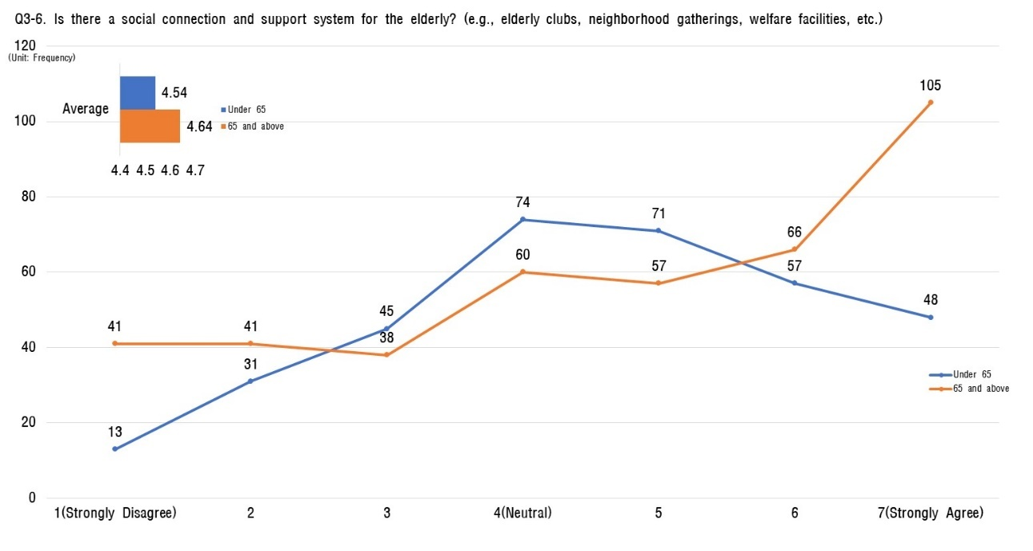

Leisure and social activities
- In questions related to leisure and social activities for the elderly, the average score for those under 65 is higher than the average score for those 65 and older.
- For those 65 and older, the item perceived as being the best in terms of leisure and social activities is 'Various programs (e.g., cultural and artistic activities, exercise, hobby activities) are well-operated.'
- For those under 65, the item 'Are there policies or programs encouraging social activity participation for the elderly?' has the highest score.

[Table 11] Analysis of the status of leisure and social activities.
Sortation |  | Aged 65 or below |  | Aged 65 and over
 |  | Average value | Ranking | Average value | Ranking
the entire |  | 4.42 | - | 4.28 | -
4. Leisure and social activities | 4-1 Various leisure activities | 4.63 | 2 | 4.50 | 1
 | 4-2 Initiative policies | 4.68 | 1 | 4.38 | 2
 | 4-3 Certain place or facility | 4.56 | 3 | 4.22 | 3
 | 4-4 Transport accessibility | 4.01 | 6 | 4.21 | 5
 | 4-5 Support programs for social activities | 4.35 | 4 | 4.14 | 6
 | 4-6 events and gathering | 4.28 | 5 | 4.22 | 4
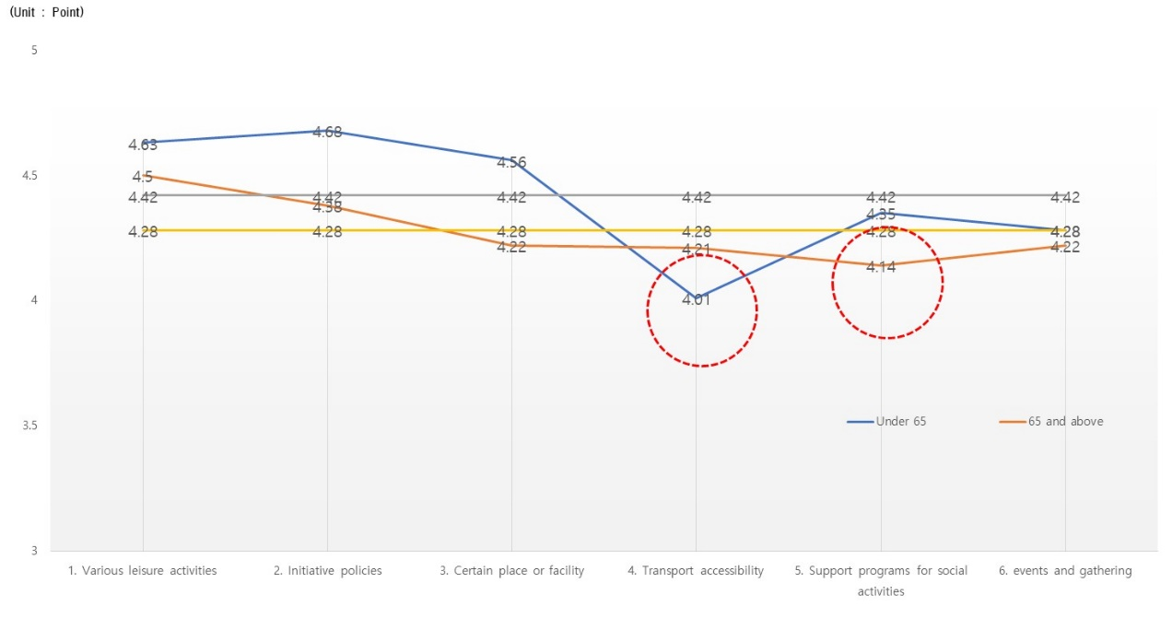
[Fig 11] Analysis of the status of leisure and social activities.
- On the other hand, for those under 65, the lowest score is found in the item 'Is transportation accessibility guaranteed for elderly participants in social activities?' with an average score of 4.21 out of 7.
- Consequently, those 65 and older express satisfaction with various leisure activity programs but have concerns about accessibility to these programs. In contrast, there is a perception among those under 65 that, unlike leisure activity programs, social activity support programs are not well-established.

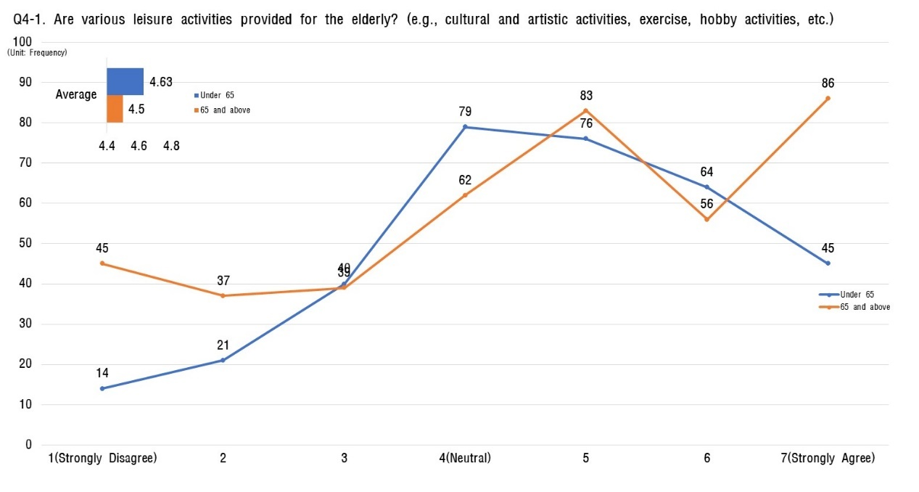
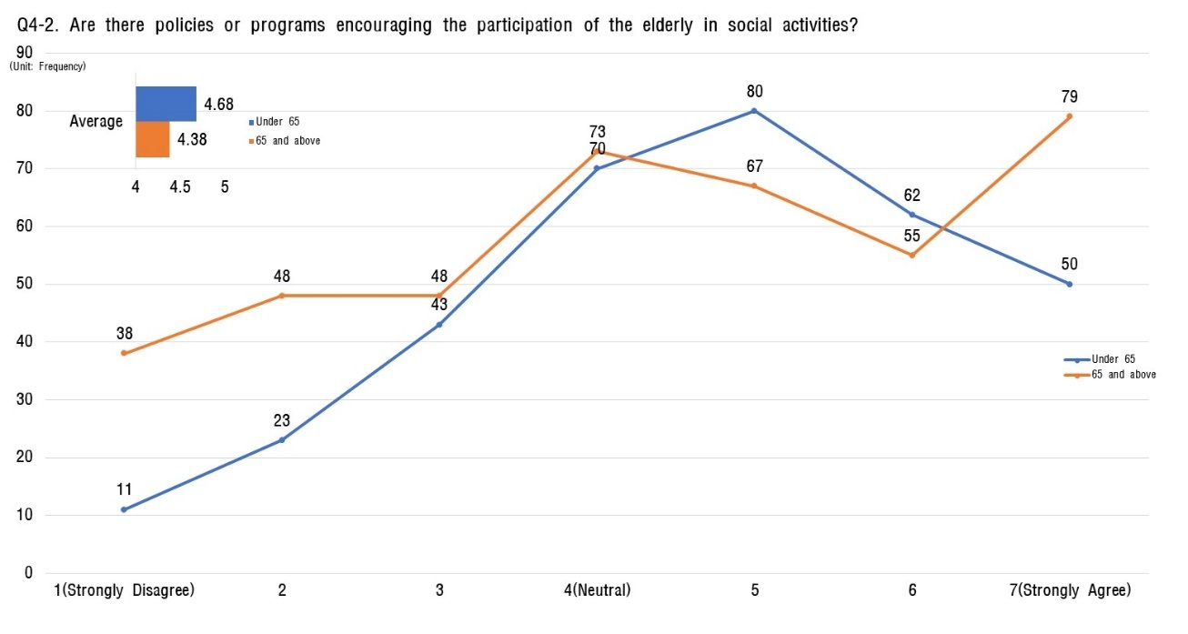
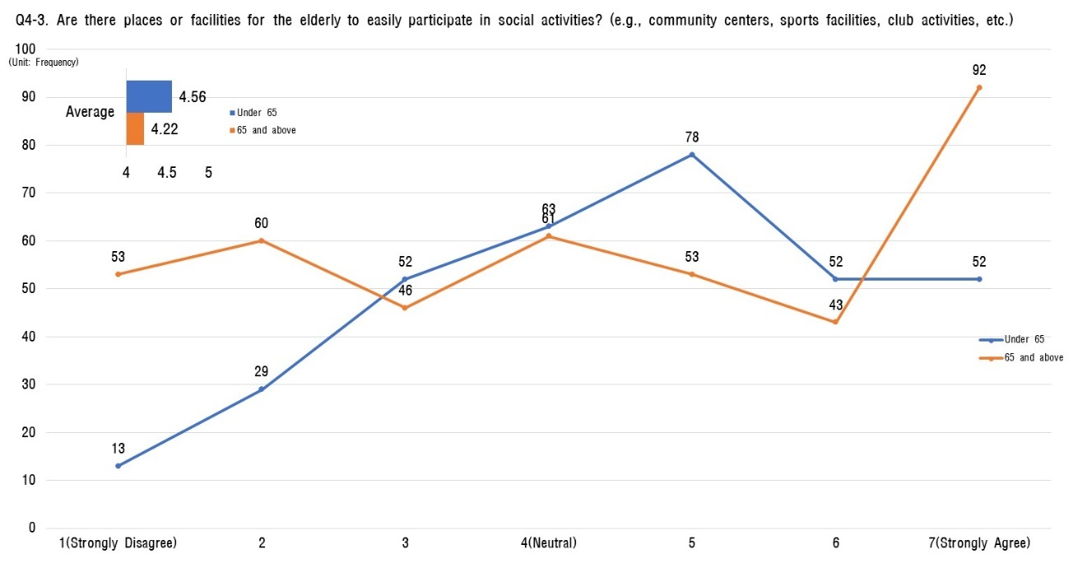
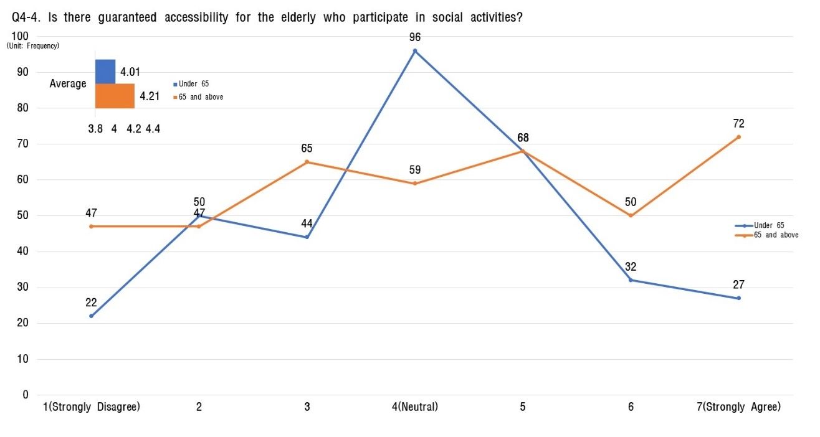
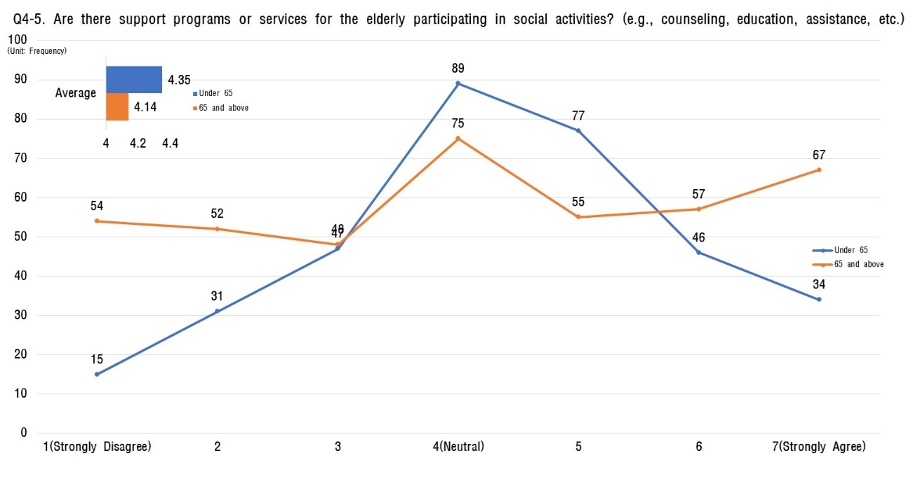
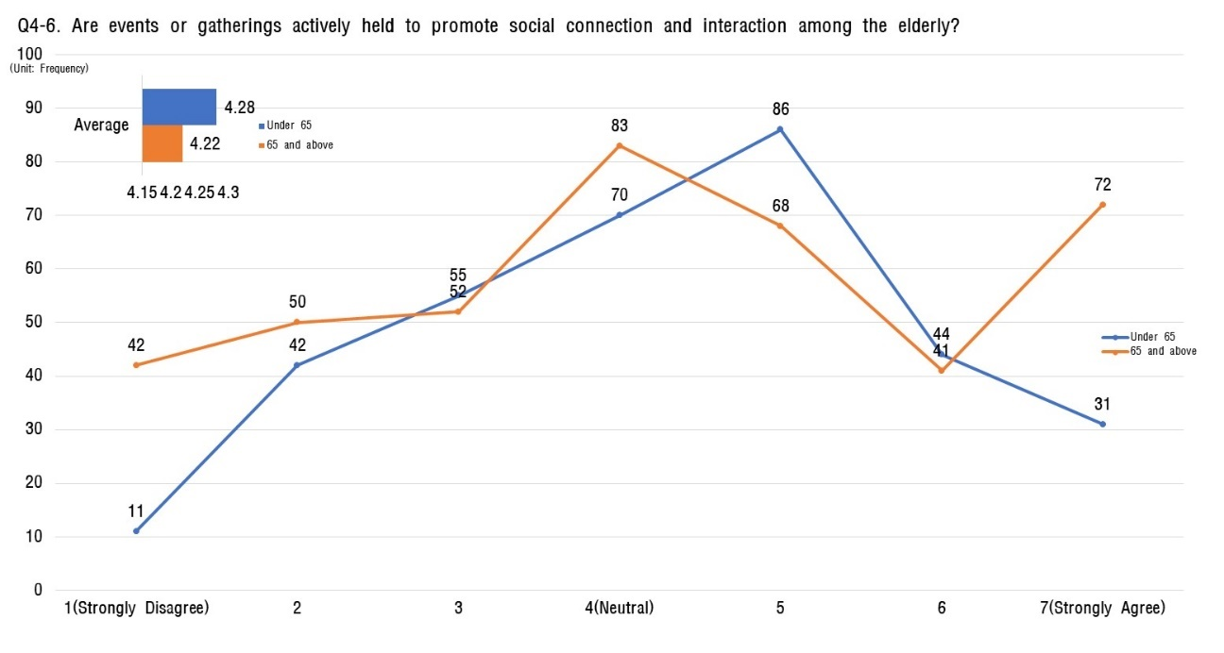

Social participation and employment
- Across all age groups, survey respondents overwhelmingly feel that a lack of opportunities exists for older adults to engage meaningfully in society or secure employment that leverages their skills and experience.
- Moreover, respondents consistently indicated that information and educational resources regarding social participation and employment options for the elderly are inadequate.
- A strong consensus emerged across all demographics that efforts should prioritize enhancing expertise after retirement, creating specialized job categories tailored to older adults, and enabling them to utilize their wealth of experience in diverse fields.
- Furthermore, respondents emphasized the need for targeted programs that actively promote employment and social participation policies, specialize in outreach and promotional activities, and develop specialized curricula to provide diverse job information and educational resources for the elderly.

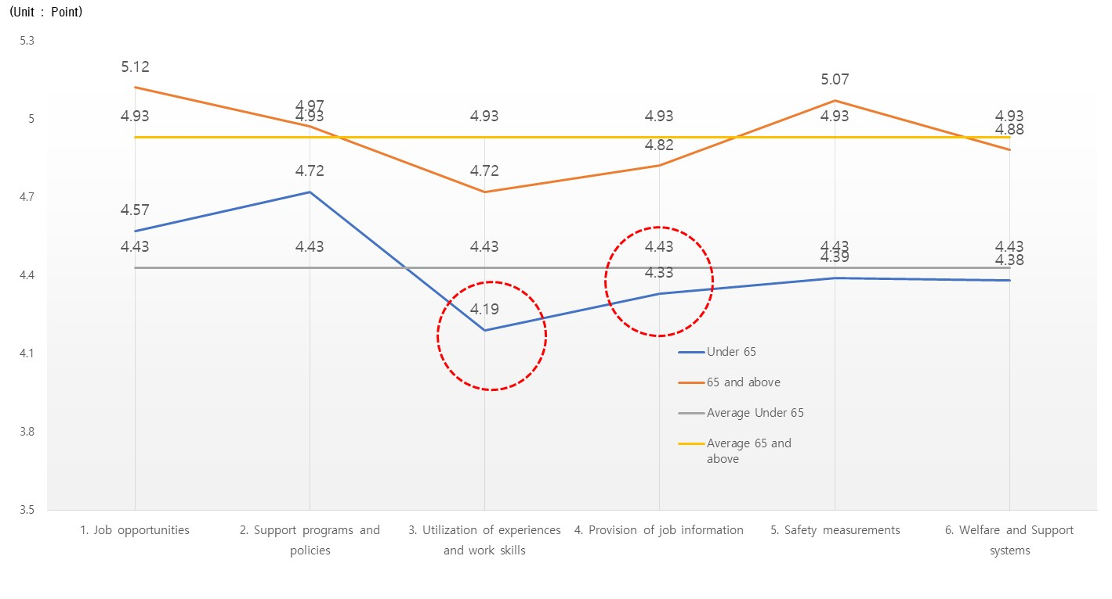
[Table 12] Analysis of the status of social participation and jobs
Sortation |  | Aged 65 or below |  | Aged 65 and over
 |  | Average value | Ranking | Average value | Ranking
the entire |  | 4.43 | - | 4.93 | -
5. Social participation and Jobs | 5-1 Job opportunities | 4.57 | 2 | 5.12 | 1
 | 5-2 Support programs and policies | 4.72 | 1 | 4.97 | 3
 | 5-3 Utilization of experiences and work skills | 4.19 | 6 | 4.72 | 6
 | 5-4 Provision of job information | 4.33 | 5 | 4.82 | 5
 | 5-5 Safety measurements | 4.39 | 3 | 5.07 | 2
 | 5-6 Welfare and Support systems | 4.38 | 4 | 4.88 | 4

[Fig 12] Analysis of the status of social participation and jobs

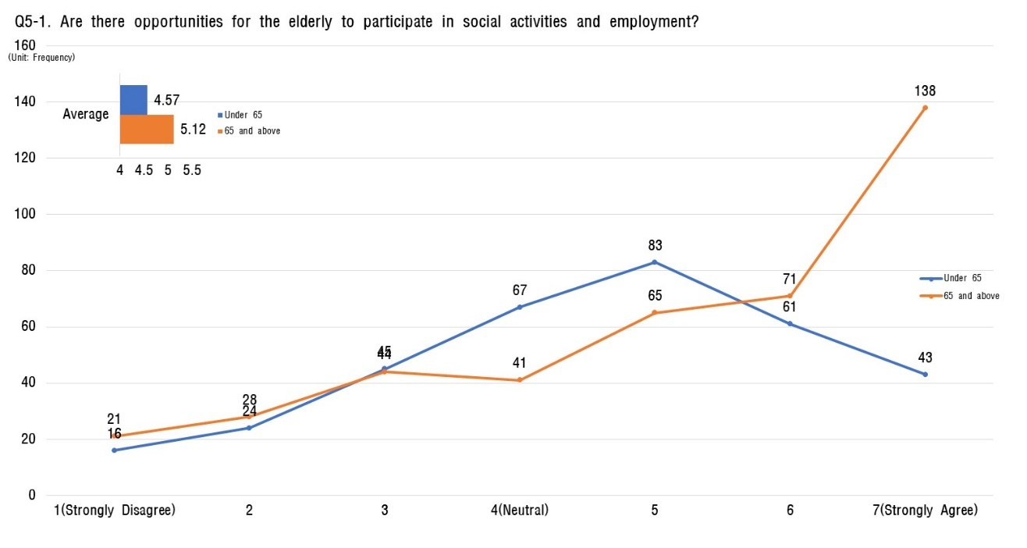
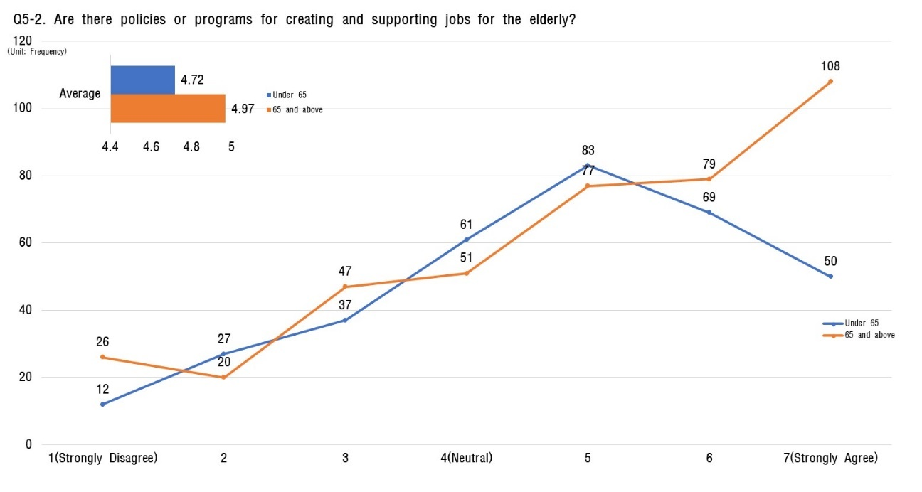
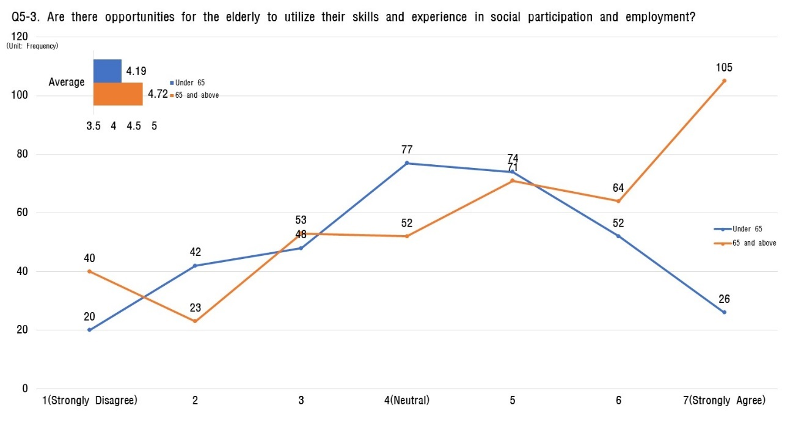
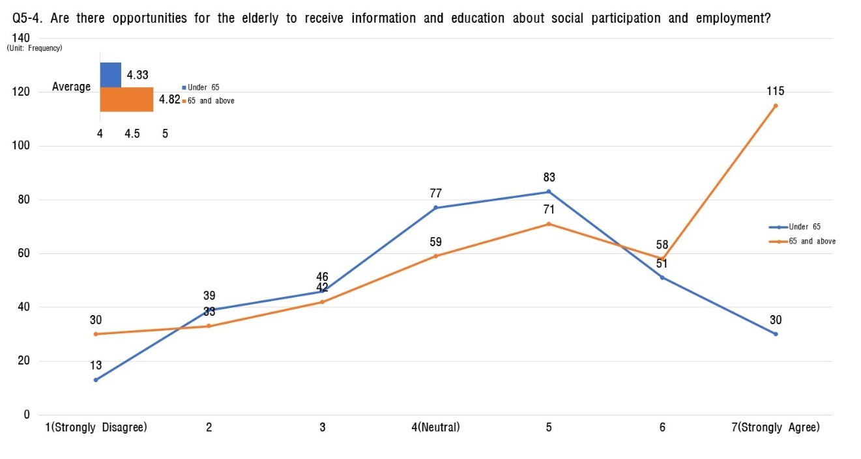
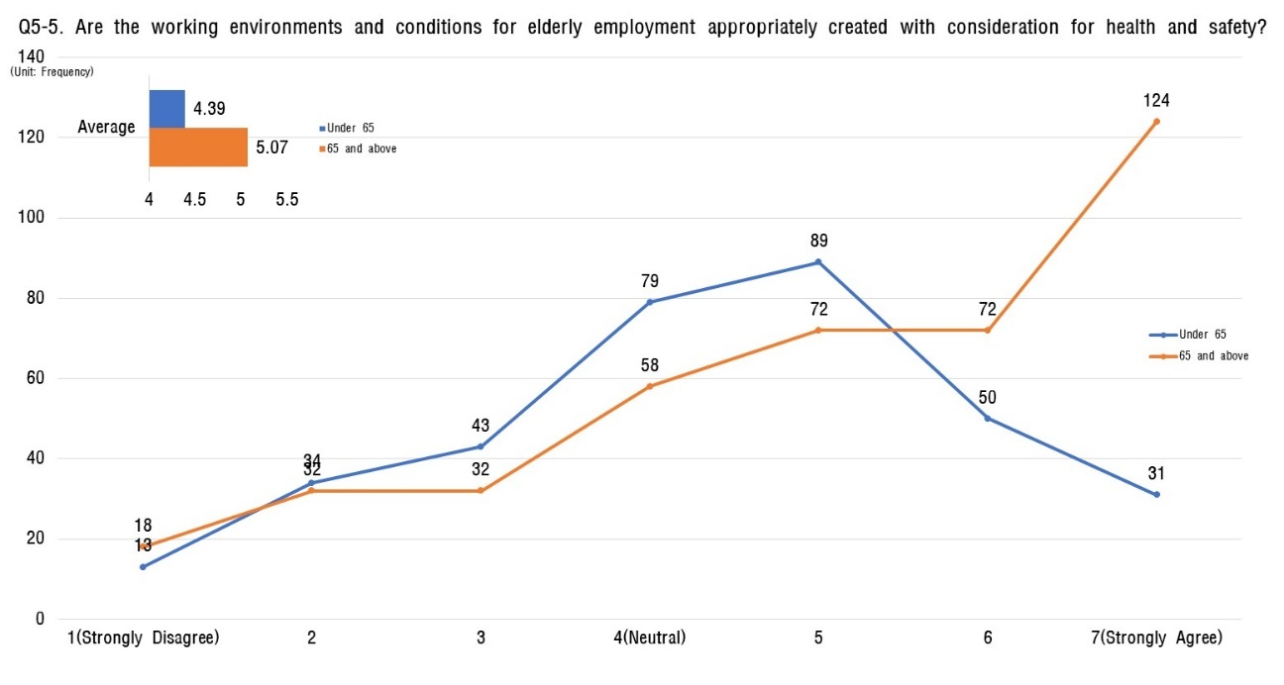
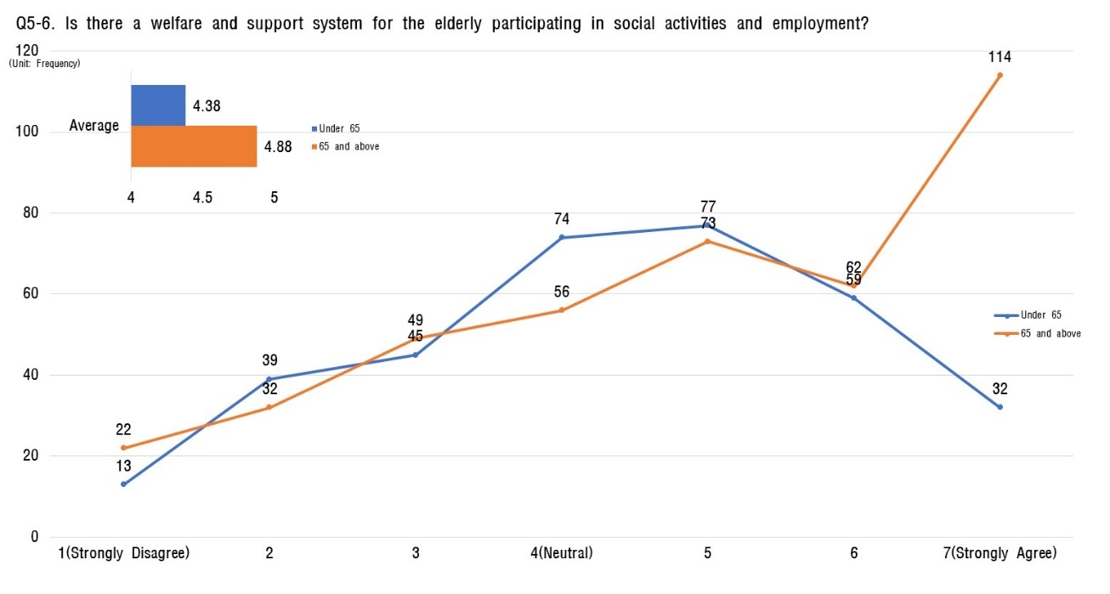

Respect and Social Integration
- Regarding respect and social integration, younger respondents (under 65) believe a societal culture that respects the dignity and autonomy of the elderly exists, but they don't see this reflected in how decisions are made. Meanwhile, older respondents (65 and above) perceive that their own opinions and needs are not adequately considered in the same decision-making processes.
- Improvements are needed in societal decision-making processes to strengthen respect for elderly autonomy. This requires expanding their presence and voice in social decision-making, enhancing their sense of agency and belonging.

[Table 13] Analysis of the status of respect and social integration
Sortation |  | Aged 65 or below |  | Aged 65 and over
 |  | Average value | Ranking | Average value | Ranking
the entire |  | 4.39 | - | 4.43 | -
6. Respect and Social Integration | 6-1 Social Culture | 4.34 | 6 | 4.31 | 5
 | 6-2 Reflecting Social Decision-Making Processes | 4.44 | 2 | 4.28 | 6
 | 6-3 Equal Opportunities | 4.37 | 4 | 4.68 | 1
 | 6-4 Support Programs | 4.39 | 3 | 4.38 | 4
 | 6-5 Social Support Network | 4.45 | 1 | 4.49 | 2
 | 6-6 Understanding and Empathy | 4.36 | 5 | 4.44 | 3
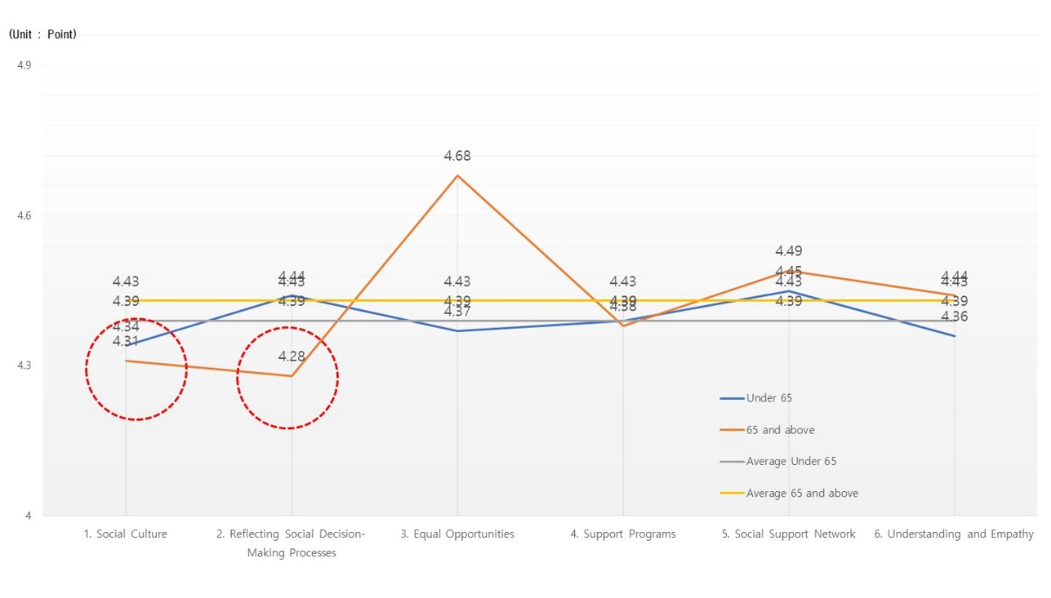
[Fig 13] Analysis of the status of respect and social integration

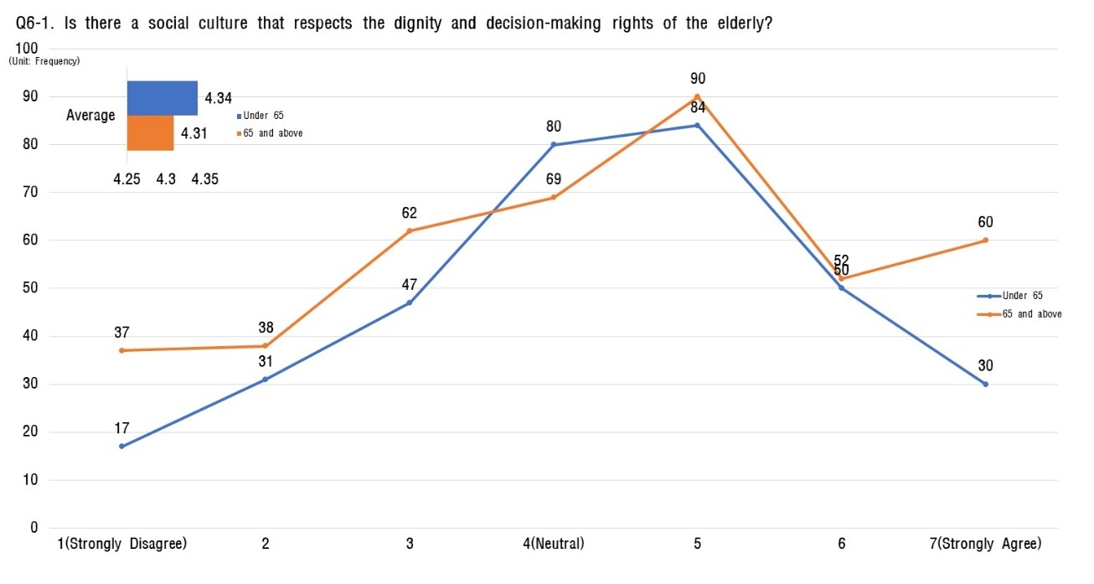
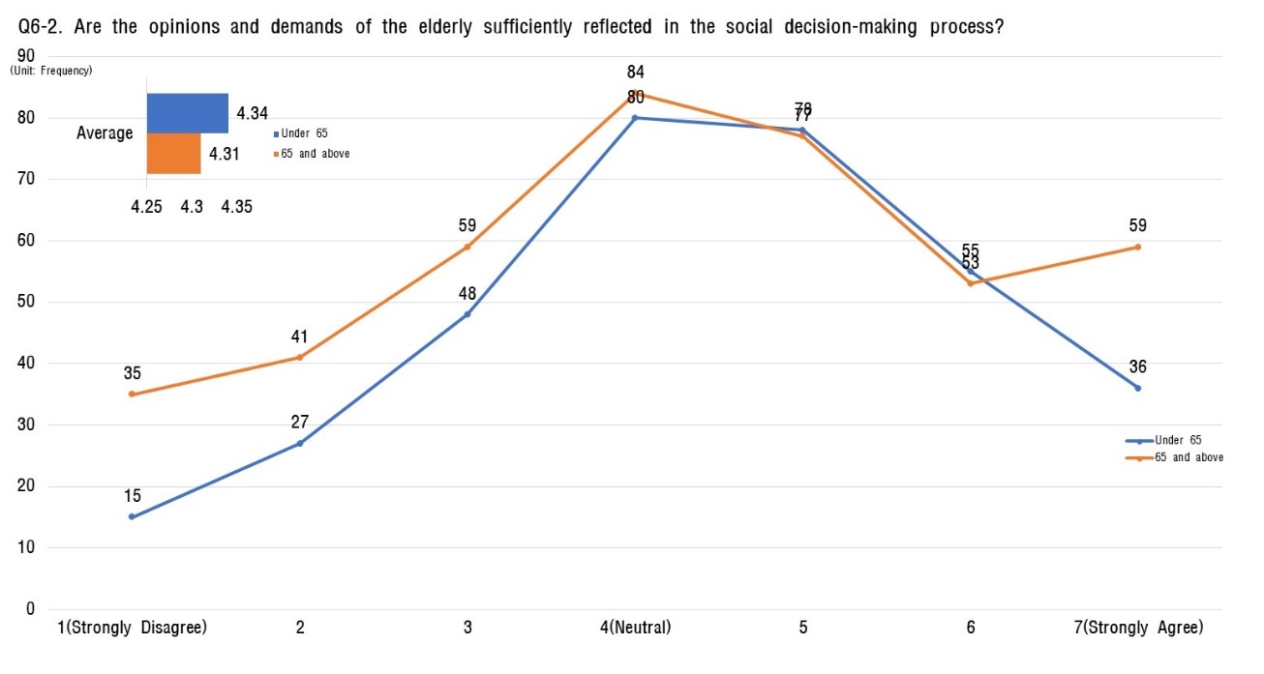
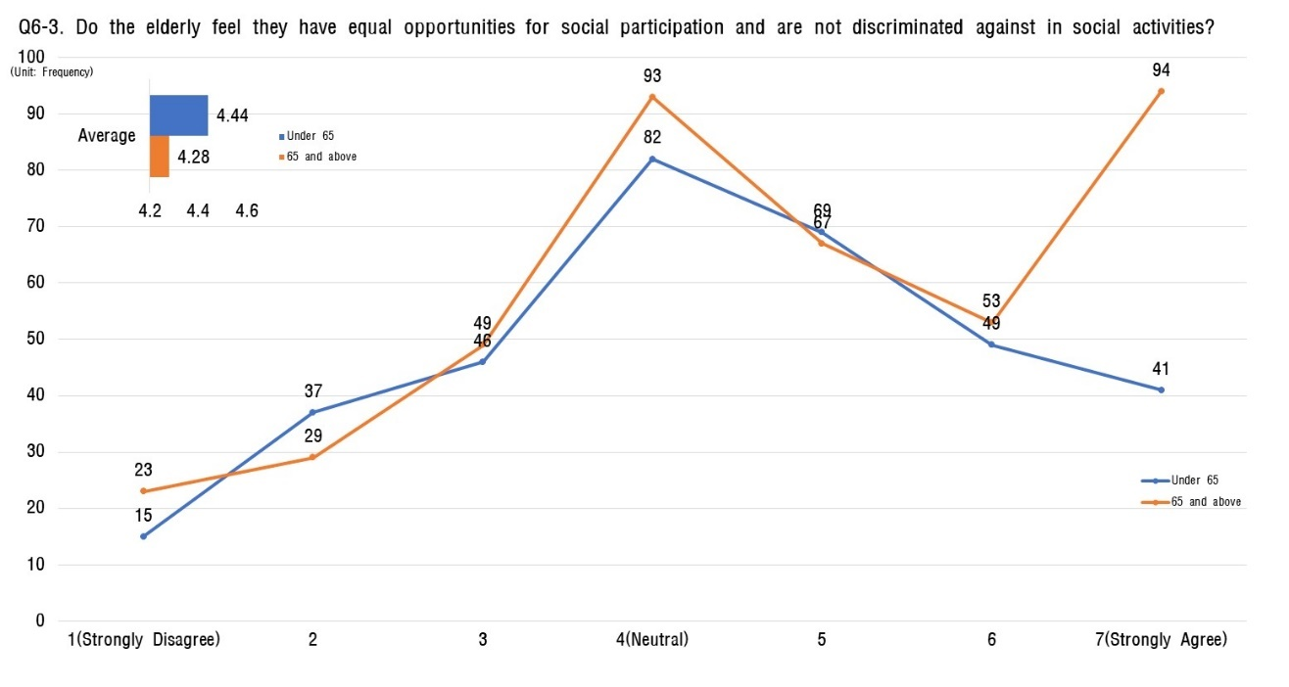
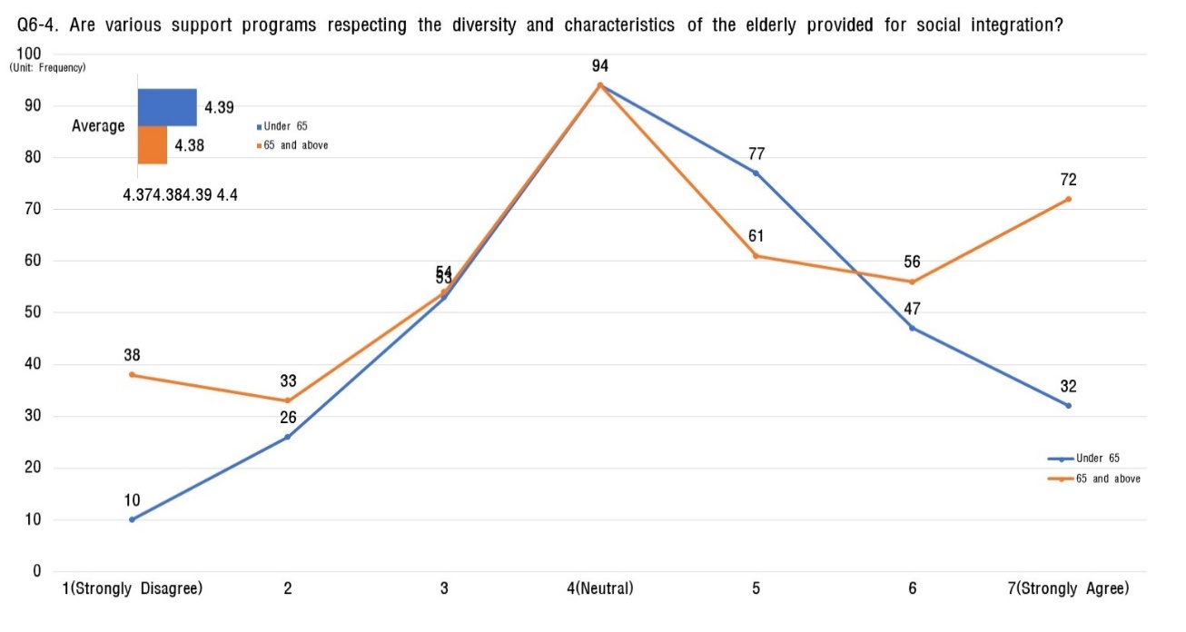
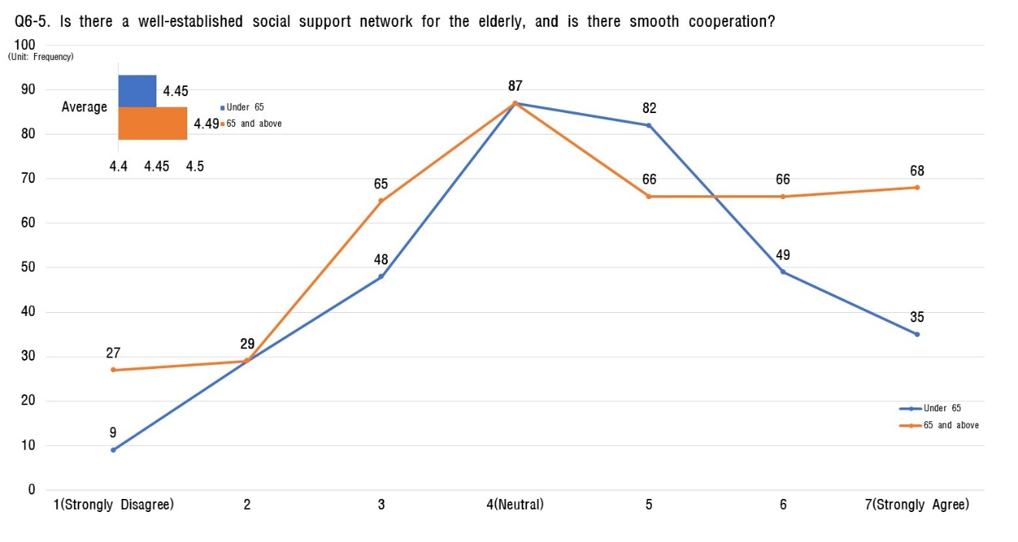
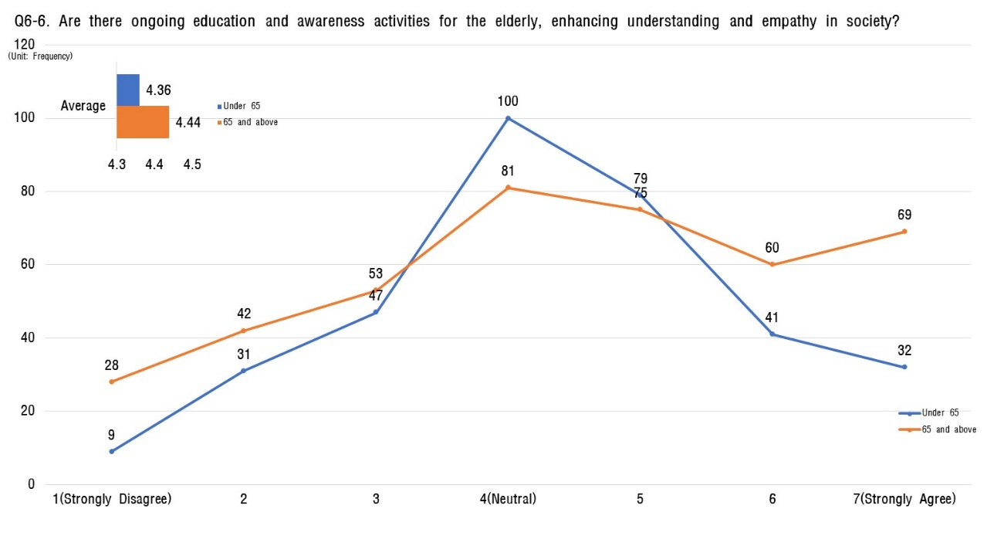

Communication and information
- In the category of communication and information, younger respondents (under 65) scored slightly higher (4.09 out of 7) compared to their older counterparts (65+, 3.84 out of 7).
- Both younger and older adults share the perception that existing efforts to provide digital literacy and information accessibility programs for the elderly are inadequate.
- To address these concerns and promote digital inclusion, designing comprehensive education programs and initiatives is deemed necessary. These efforts should aim to equip the elderly with the essential digital skills needed for daily life and empower them to fully participate in a digital world.

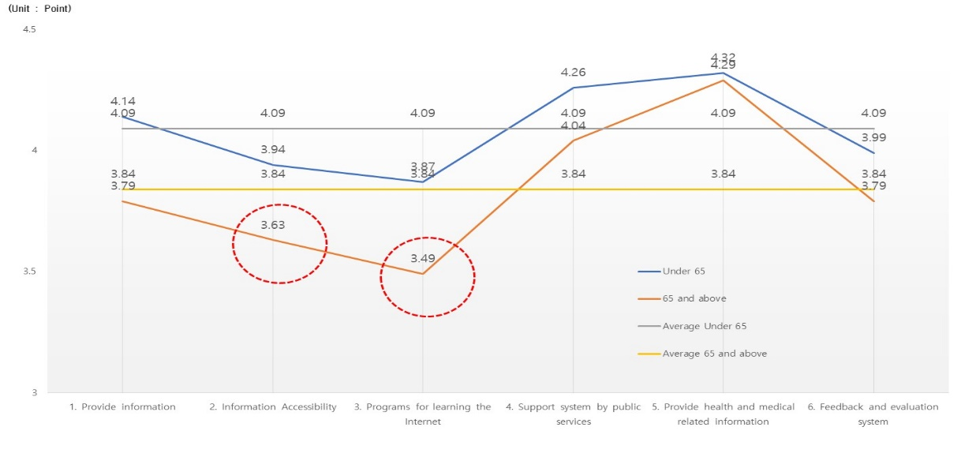
[Table 14] Status analysis of communication and information
Sortation |  | Aged 65 or below |  | Aged 65 and over
 |  | Average value | Ranking | Average value | Ranking
the entire |  | 4.09 | - | 3.84 | -
7. Communication and information | 7-1 Provide information | 4.14 | 3 | 3.79 | 4
 | 7-2 Information Accessibility | 3.94 | 5 | 3.63 | 5
 | 7-3 Programs for learning the Internet | 3.87 | 6 | 3.49 | 6
 | 7-4 Support system by public services | 4.26 | 2 | 4.04 | 2
 | 7-5 Provide health and medical related information | 4.32 | 1 | 4.29 | 1
 | 7-6 Feedback and evaluation system | 3.99 | 4 | 3.79 | 3

[Fig 14] Status analysis of communication and information
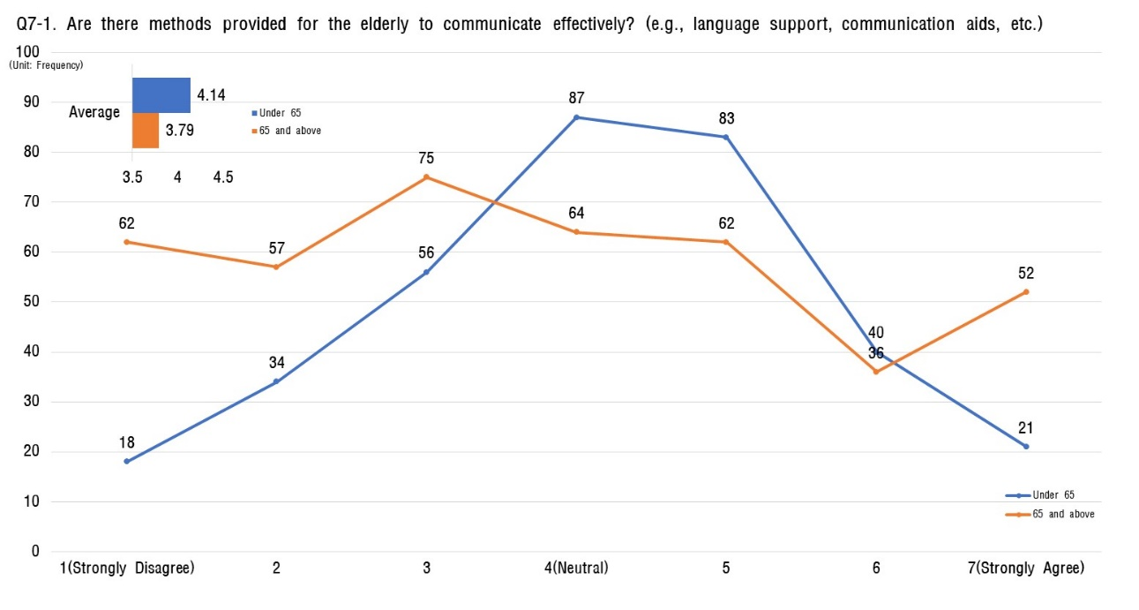
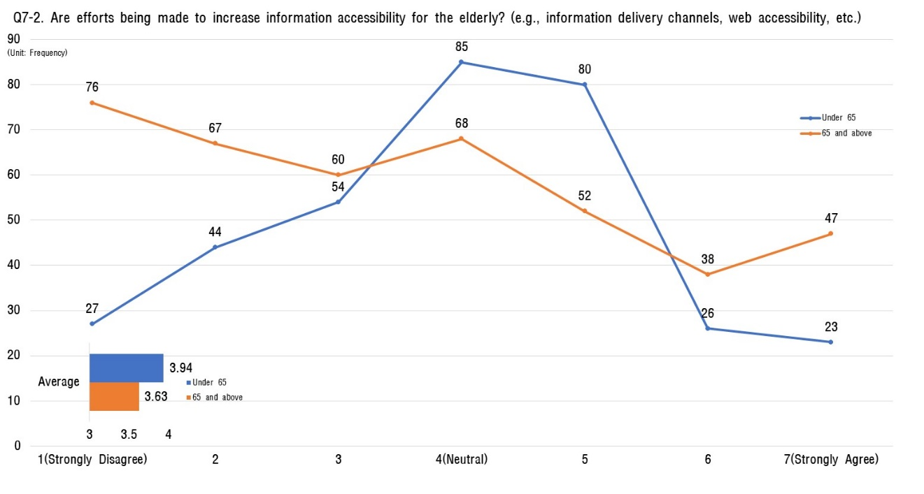
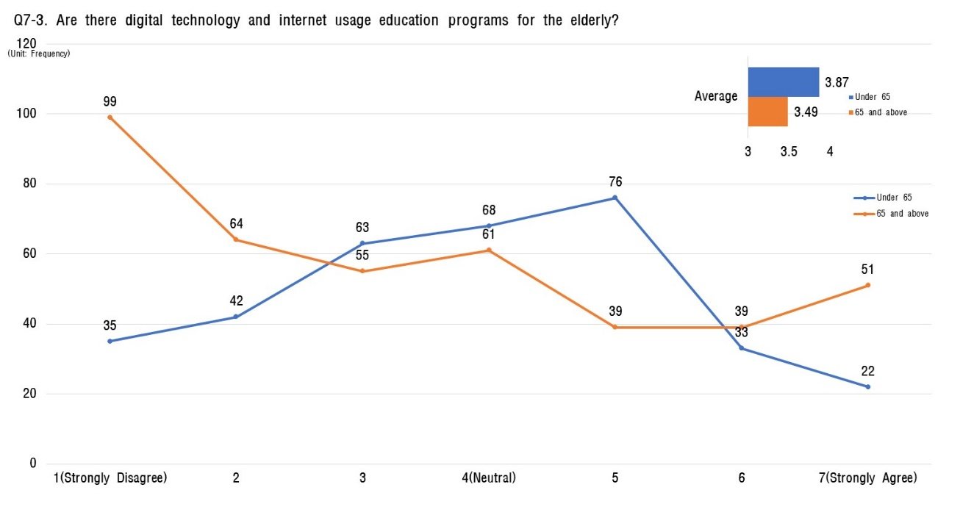
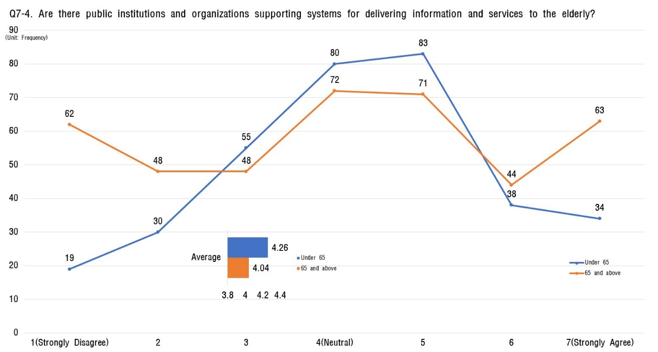
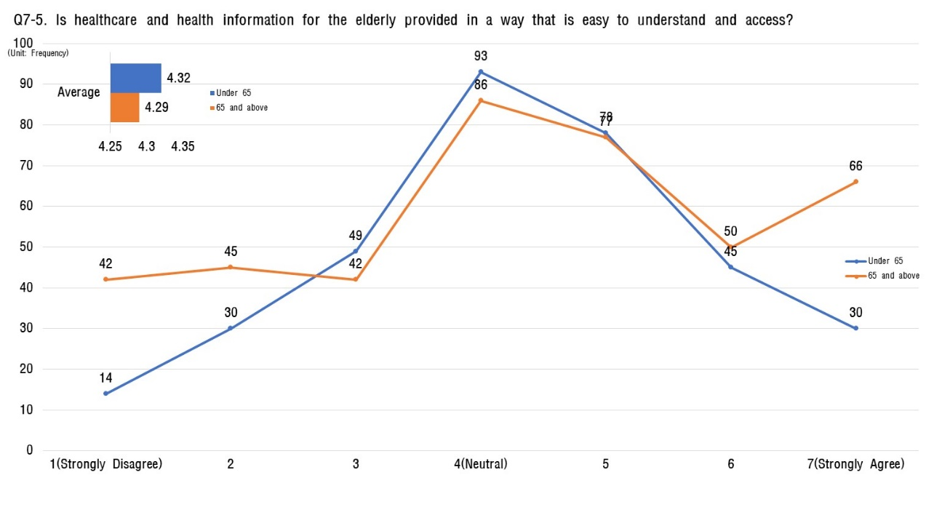
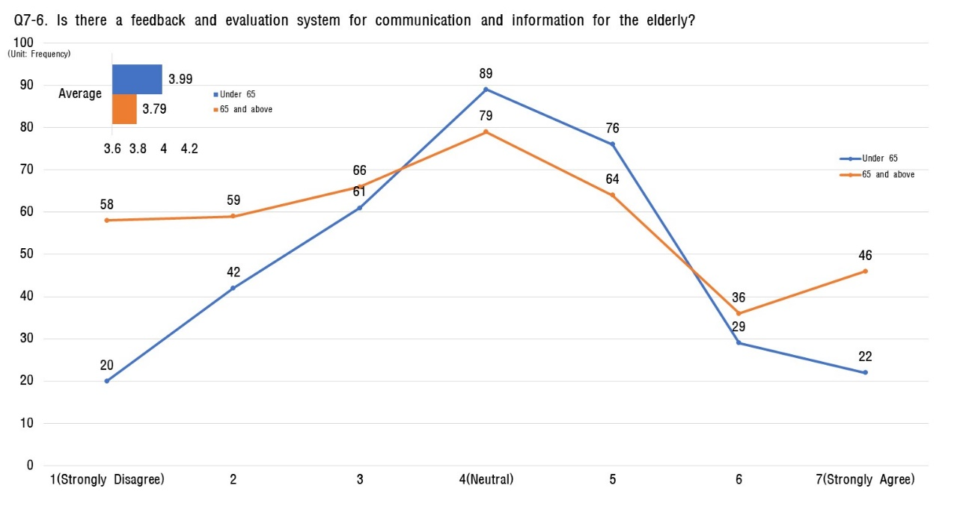

Community Care and Medical Service
- Across all age groups surveyed, local care services received the highest scores. Respondents believe community care services, including home care and senior welfare facilities, are adequately provided.
- However, the area with the lowest scores is the monitoring and evaluation of the health status and utilization of medical services for the elderly. This indicates a perceived lack of effective monitoring and follow-up care within the health and welfare system.

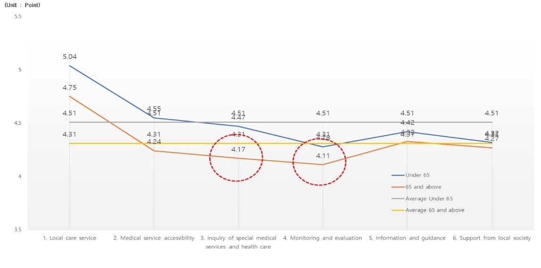
[Table 14] Analysis of the status of local care and medical services
Sortation |  | Aged 65 or below |  | Aged 65 and over
 |  | Average value | Ranking | Average value | Ranking
the entire |  | 4.51 | - | 4.31 | -
8. Local care and medical services | 8-1 Local care service | 5.04 | 1 | 4.75 | 1
 | 8-2 Medical service accessibility | 4.55 | 2 | 4.24 | 4
 | 8-3 Inquiry of special medical services and health care | 4.47 | 3 | 4.17 | 5
 | 8-4 Monitoring and evaluation | 4.28 | 6 | 4.11 | 6
 | 8-5 Information and guidance | 4.42 | 4 | 4.33 | 2
 | 8-6 Support from local society | 4.32 | 5 | 4.27 | 3

[Fig 14] Analysis of the status of local care and medical services

- Therefore, to enhance the effectiveness of services, it is crucial to focus on improving this area through regular surveys and data analysis to optimize health monitoring and medical service utilization for the elderly.

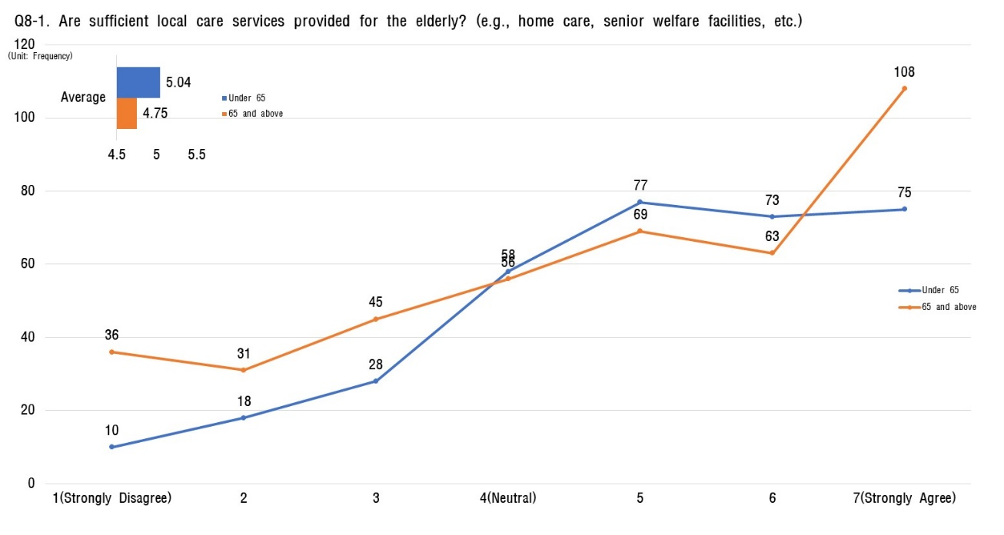
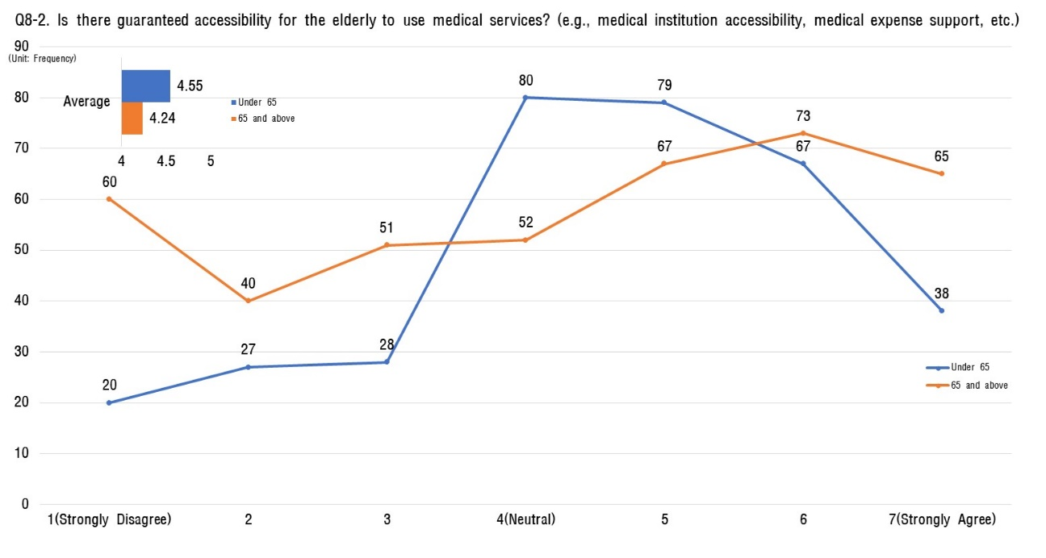
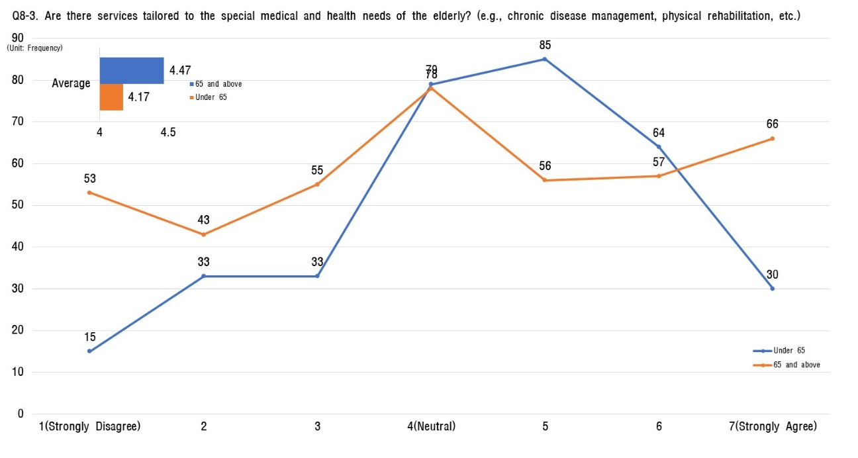
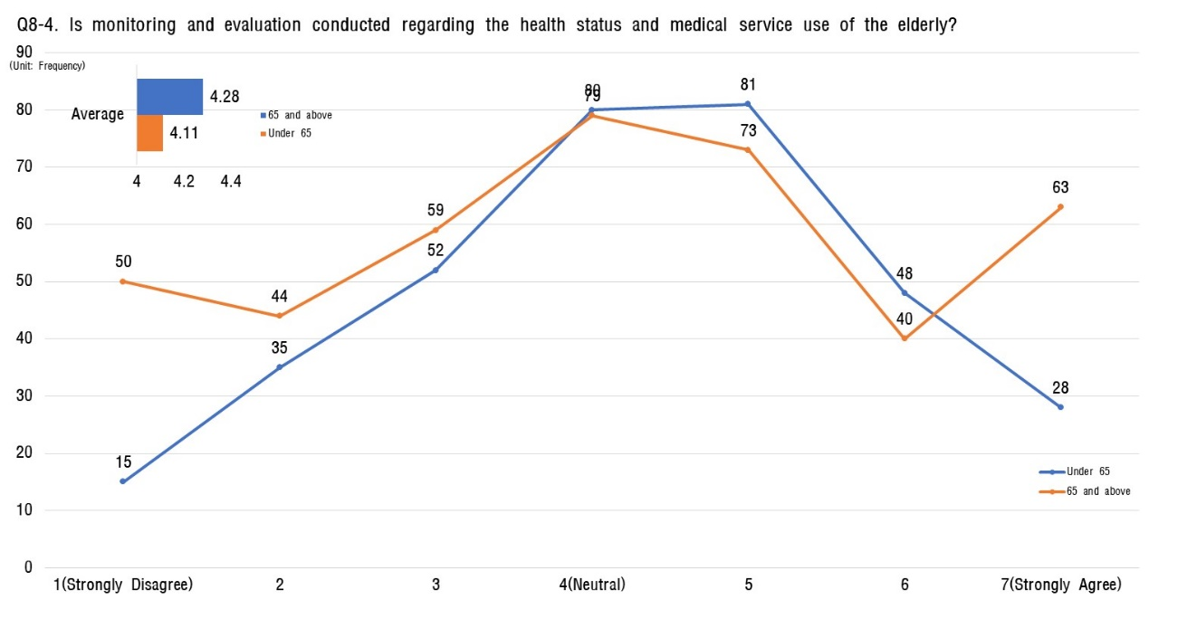
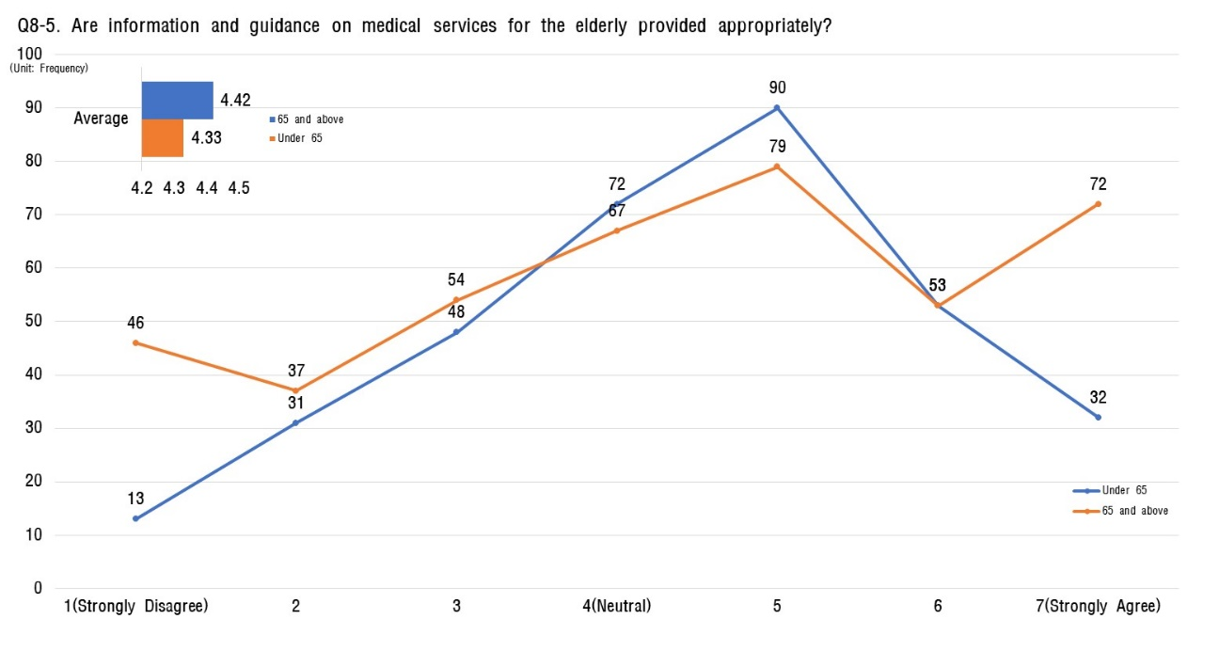
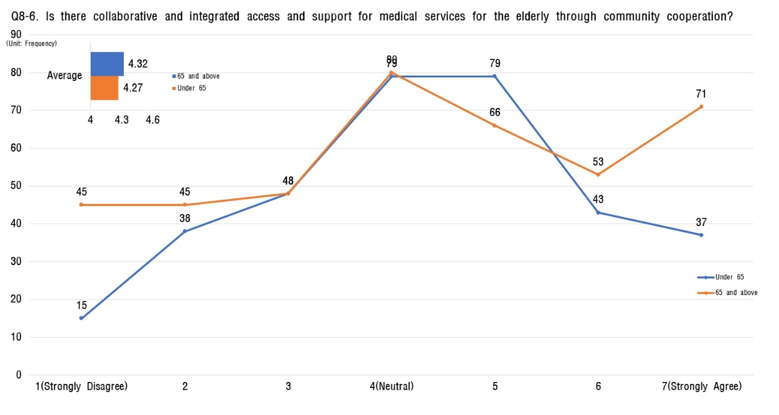

4) Detailed analysis results of eight key areas

It the overall assessment of age-friendliness (out of 7), individuals aged 65 and above tend to assign slightly higher scores (General Citizens: 4.26, Seniors: 4.43) compared to those under 65.

Younger respondents (under 65) prioritize areas of highest satisfaction in descending order, with local care and medical services (1st), social participation and employment (2nd), and leisure and social activities (3rd).

In contrast, older respondents (65+) prioritize areas of highest satisfaction in the order of social participation and employment (1st), followed by transportation convenience (2nd) and external environment and facilities (3rd).

❚ Overview of analysis

Upon analyzing the results, it appears that individuals aged 65 and above tend to provide a relatively more positive assessment of age-friendly measures in the city compared to those under 65. This could be attributed to their greater awareness of their own needs and demands, perceiving greater value in services and infrastructure tailored for them.

Younger respondents (under 65) generally prioritize and positively evaluate local care and medical services, reflecting the importance they place on long-term health management and accessibility to medical services for unforeseen circumstances. Moreover, they seem to recognize the significance of expanding opportunities for social participation, job creation, and leisure activities.

In contrast, individuals aged 65 and above prioritize highest social participation and employment. This highlights their desire to maintain an active lifestyle even after retirement. The high priority placed on transportation convenience reflects its essential role for seniors to independently move around and participate in social activities. Accessibility and safety in external environments and facilities are also crucial factors, addressing challenges related to physical movement and safety concerns for seniors themselves.

These insights provide valuable guidance for policymakers involved in age-friendly city planning to understand the specific needs and expectations of each age group. It is crucial to develop tailored age-friendly policies that reflect these insights and reinforce the importance of supporting seniors in maintaining an active role in society for sustainable social development and intergenerational solidarity.

Therefore, these evaluation results underscore the significance of age-friendly city planning for society at large. They highlight the need for continuous interest and investment in improving relevant policies and programs to support seniors and promote sustainable societal development.

[Table 15] Analysis result of major eight areas of age-friendly city development
Sortation |  | Analysis Result
The eight major areas | 1. External Environment and facilities | To prioritize the creation of an age-friendly city, addressing the low safety ratings is crucial. Initiatives such as regular safety education for drivers and expanding safety facilities (e.g., safety handles, ground slopes, emergency call buttons) are urgently needed.
 | 2. Convenience of transportation means | Ensuring meticulous consideration and measures for assistive systems and guidance for the elderly can enhance the convenience of using existing facilities. This, in turn, is expected to increase satisfaction with the convenience of transportation for the elderly.
 | 3. Residential environment safety | Despite over 78% of respondents aged 65 and above residing in single-family homes, the average score for convenience within homes and residential area safety appears low. Initiating housing environment improvements through surveys, projects for enhancing aging-in-place residences, and support programs for home repairs is deemed necessary to address the perceived deficits in housing convenience.
 | 4. Leisure and social activities | Although satisfaction with various leisure activity programs is high among respondents aged 65 and above, there is a notable sense of dissatisfaction with program accessibility. This analysis suggests the need to explore ways to enhance accessibility for both leisure activity and social support programs targeting this demographic.
 | 5. Social participation and job | Across all age groups, there is a perceived lack of opportunities for older adults to utilize their skills and experience in social participation and job placement. Therefore, policies should be developed to create employment opportunities that leverage the skills and experience of older individuals, while also diversifying pathways for social participation.
 | 6. Respect and social integration | Respecting the autonomy of older adults and expanding their participation in the social decision-making process are essential for fostering a sense of belonging and efficacy among the elderly. Therefore, it is necessary to regulate and refine decision-making processes and procedures to ensure that older individuals can participate as active members of society.
 | 7. Communication and Information | To facilitate the adaptation of older adults to the rapidly changing digital technology and foster a society where they can coexist with technological advancements, it is crucial to design educational programs and activities that enhance accessibility to digital skills in their daily lives.
 | 8. Local Care and Medical services | To enhance local care and medical services, it is necessary to focus on improving effectiveness based on the analysis of health conditions and the usage of medical services through surveys. Adequate allocation of personnel and procedural improvements in relevant institutions are deemed essential to meet these needs.

5) Analysis of Experts' Opinions on the Establishment of an Age-Friendly City

Gender status
- In-depth interviews with Geochang County experts involved 3 males (60%) and 2 females (40%), ensuring a balanced gender representation at a 6:4 ratio.

[Table 16] Analysis of the gender status of experts

Sortation |  | in-depth expert interviews
 |  | Number of respondents | Percentage (%)
the entire |  | 5 | 100.0%
Gender | men | 3 | 60.0%
 | women | 2 | 40.0%

Status by age group
- The in-depth interview survey data revealed a balanced spread across age groups,
- 40% of respondents born in 1969 or later (8 respondents), another 40% born between 1970 and 1975 (8 respondents), and the remaining 20% born in 1976 or later (4 respondents).
- Occupations were also diverse, with social workers representing 20% (4 respondents), university professors 40% (8 respondents), and citizen monitors forming the remaining 40% (8 respondents). (Total number of respondents: 20)

[Table 17] Analysis of professional age groups and job status.
Sortation |  | In-depth expert interviews |  | Sortation |  | In-depth expert interviews
 |  | Number of respondents | Percentage |  |  | Number of respondents | Percentage
The entire |  | 5 | 100.0 | The entire |  | 5 | 100.0
The age group | 1963 ~ 1969 | 3 | 60.0 | Educational background | Social worker | 2 | 40.0
 | 1970 ~ 1975 | 1 | 20.0 |  | Professor | 1 | 20.0
 | 1976 ~ 1980 | 1 | 20.0 |  | Citizen monitoring | 2 | 40.0

WHO, Expert Opinion on Eight key Areas of Aging-Friendly Cities
Sortation | Expert 1 | Expert 2 | Expert 3 | Expert 4 | Expert 5
External Environment and Facilities  (1) | Utilize idle spaces to provide opportunities for the elderly to plant flowers and participate in gardening. | Well-maintained and easily accessible resting areas that are safe and secure. | Utilize visual elements to enhance readability and directionality. | Install emergency bells at various locations to prepare for incidents such as falls or accidents. | Install safety facilities (handrails, handles) at the entrance, walls, interior of partitions, and washbasins in public crematoriums.
Convenience of transportation  (2) | Expand low-floor and slow buses to enhance public transportation accessibility.  Address the high risk of accidents on alleys, crosswalks, and similar locations. | Pedestrian signals at crosswalks that are visually clear and have audible cues. | Insufficient public transportation at the town and village levels. | Promote transportation convenience through the creation of barrier-free spaces and facilities. | Ensure that sidewalks are flat and obstacle-free for easy walking.
Residential Environment safety  (3) | Strengthen neighborhood improvements on an administrative district basis for residential environments. | Application of electronic technology to support health and independence. | Lack of streetlights in residential areas. | Support readability, clarity, and appropriate design for product and service use. | Apply ICT-based lighting systems for crime prevention and loneliness prevention for elderly individuals living alone.
Leisure and social activities  (4) | Expand mobility rights for program participation. | Discovery and application of functional gaming content for the elderly. | Standardization of surrounding exercise facilities. | Ensure that services and environments facilitate active aging. | Organize various events that can unite all generations to secure a platform for communication.
Social participation and jobs  (5) | Ensure information and education on job opportunities post-retirement for utilizing their skills and experience. | Clear and informative explanations and guidance are necessary. | Strengthening service features to obtain local job information. | Encourage participation tailored to physical conditions. | Create an inclusive service environment in social participation and public employment where no one faces discrimination.
Respect and Social Integration  (6) | Implement measures to prevent frequent slipping accidents on entrance stairs caused by rain or snow. | Exploration of ways for the elderly to participate in elementary school activities, fostering respect from younger generations. | Mandatory installation of easily readable and visible signage. | Conduct education to improve awareness of caregiving for the elderly. | Round off the corners of wall surfaces.
communication and information  (7) | Promote social interaction among the elderly with friends, neighbors, and acquaintances to overcome loneliness and solitude. | Expansion of mobile phone education opportunities. | Diversify social networks in old age around family, relatives, friends, and the community. | Expand education programs for the use of electronic devices. | Install smart tactile blocks on crosswalks that provide vibration feedback to indicate signal status when stepped on.
Community Care and Medical Services  (8) | Enhance support services, such as region-specific side dishes and lunch boxes, through increased collaboration with private businesses. | Addressing welfare blind spots, such as providing side dishes for economically disadvantaged elderly individuals. | Reduce the financial burden of healthcare expenses for the elderly and ensure access to specialized medical services. | Strengthen efforts to identify and support marginalized groups beyond existing beneficiaries. | Utilize a smart home exercise program for health management tailored to obese elderly individuals.

Sortation | Analysis Results of Expert Opinion | Remark
External Environment and Facilities | Improve accessibility to nearby facilities for the elderly, providing information for convenient use of services such as shopping, medical services, and cultural activities.  Create an elderly-friendly environment by installing handrails, shaded rest areas, benches, etc. | Creating a Barrier-free Sharing Path
Convenience of transportation | Expand transportation services to ensure convenient and safe travel to destinations frequently used by the elderly.  Enhance the mobility convenience for vulnerable groups such as the elderly and people with disabilities.  Provide education on using public transportation more easily for the elderly, including utilizing smartphones for information acquisition. | Ensuring the Mobility Rights of Transportation Vulnerable Individuals.
Residential Environment safety | Integrate senior housing and welfare facilities to proactively address the challenges of an aging society.  Develop or support the creation of specialized residential complexes or communities for the elderly. | Establishment of Shared Living Facilities.
Leisure and Social Activities | Provide various opportunities for social participation, such as cultural activities, art programs, and sports, through information sharing and education from relevant institutions.  Diversify support for cultural and artistic education for seniors. | Support for Elderly Social Activities and Promotion of Local Cultural Activities.
Social Participation and jobs | Expand opportunities for diverse activities within the local community.  Improve information and educational programs for the elderly, ensuring continuous learning opportunities. | Offering Diverse Volunteer Activities and Learning Opportunities.
Respect and Social Integration | Provide intergenerational meeting opportunities to minimize feelings of social exclusion.  Expand education for self-esteem restoration.  Emphasize social connectivity and self-esteem through volunteer activities that contribute to society. | Expanding Opportunities for Intergenerational Meetings and Enhancing Self-Esteem.
Communication and Information | Offer information portals and counseling services for the elderly to provide necessary information and support.  Regularly provide senior news, including local and government senior policies and services, through platforms like YouTube and text messages. | Establishing a Systematic Information Delivery System for Regular Participation.
Community Care and Medical Services | Ensure a healthy and safe living environment through the establishment of an integrated local care system, preventing duplication and social exclusion through a comprehensive management system linking local community resources.  Promote the health of the elderly through preventive programs, strengthen education on medical information, and provide financial support for medical services. | Establishing an Integrated Local Care System and Emergency Safety Assurance Service.

