# ****Seniors Festival 2023 – It’s a wrap!****

## 30/11/2023

## Write up

**Seniors Festival 2023 – It’s a wrap!**

Seniors Festival 2023 on the Mornington Peninsula was the biggest yet. Over the month of October community groups and services hosted 84 events and around 2867 community members attended a diverse range of free or low-cost events and activities put on by local clubs, groups and organisations as well as Shire services.

From nature walk to comedy show, exercise classes and social games, open days, movie nights, singing workshops and more. Community came together to share in the joy of collective experience, try new things, meet new people and have a great time.

Seniors Festival is a State Government initiative, with its beginnings dating back to 1982. As part of the festival Seniors Card Holders can access **8 days of free public transport** and state and local government provide a range of community activities and events. This year Mornington Peninsula Shire provided community clubs and groups subsidy’s as an incentive for events, increasing the range of activities and allowing more community members to take part in Seniors Festival.

Now let’s explore a few highlights and personal accounts from Seniors Festival events.

The **Archibald Prize exhibition** at Mornington Peninsula Regional Gallery attracted a whooping 12,390 concession attendees over the month of October and of this number 149 utilised the *OctoberSeniors* discount offer, a special for the festival.

A happy exhibition goer expressed their gratitude saying “From the moment I stepped through the doors, I was captivated by the curated selection of artwork that adorned the walls. The atmosphere you've created is truly remarkable – a perfect blend of sophistication and warmth.” (Anonymous)

Another shared joy and feeling of inspiration “[MPRG] is a haven for art lovers like myself. I left feeling inspired, uplifted, and with a newfound appreciation for the power of visual expression.” (Louisa). Some attendees were painters themselves and one left so inspired to endeavour to enter the Archibald Prize herself and has started planning to do so for the first time next year. Many commented on the ease of access to the exhibition and the benefit of the additional facilities as well as the extra steps staff took to welcome and accommodate community’s needs.

**The comedy and show ‘*Get in the swing of it’*** at George Jenkins Theatre gathered 325 community members. Featuring Dave O’Neil who had the room in stitches as he shared stories of his childhood, reflected on how parenting has changed over the decades and poked fun at a few audience members. The Wild Tonics with support from the glitzy Gatsby dancers performed songs and dance from the 1920’s through to today. Overall it was an evening to delight the senses, warm the bellies and uplift the hearts. An outcome of collaboration between Mornington Peninsula Shire and Frankston City Council teams.

Lorelle provided some heartfelt community feedback saying “Wow!  It was incredible! These things have a profound ripple effect. My Dad is in palliative care so these accessible events enable a lift to wellbeing for our whole family!  Wonderful and thank you to you and the team.  We look forward to the next events! Dave O'Neil was hysterical.  We recounted his jokes for days.  Awesome!”

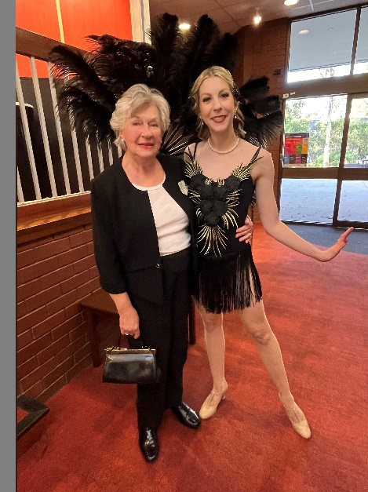

Pic: Lorelle’s mum Marlene and Gatsby Girl

Cr Lisa Dixon reflected that it was ‘great to see so many attend and enjoying the evening’ and Cr Antonella Celi commended event organisers on providing transport for the event emphasising that it “really helped our community get to the event”.

Pic (left to right): Deputy Mayor Cr. Antonella Celi, Gatsby Girl, Cr Lisa Dixon

Pic: Event Organisers from Mornington Peninsula Shire and Frankston City Council with the Gatsby Girls

There were numerous physical activity events including the annual **Get Active Expo** at Camp Manyung. It was a glorious day with 100 attendees taking part in pickle ball and golf ‘come and try sessions’ and many braving the giant swing as well as tree top challenge and archery. The event also provided an opportunity for community to learn about local clubs, groups and services.

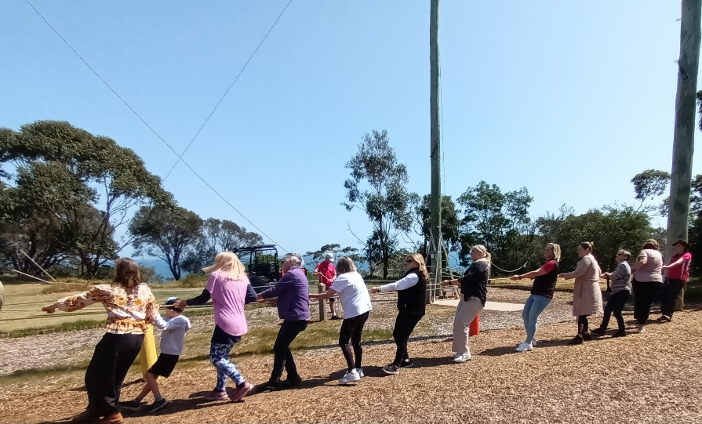

Pic: Giant swing towing participant up to the top

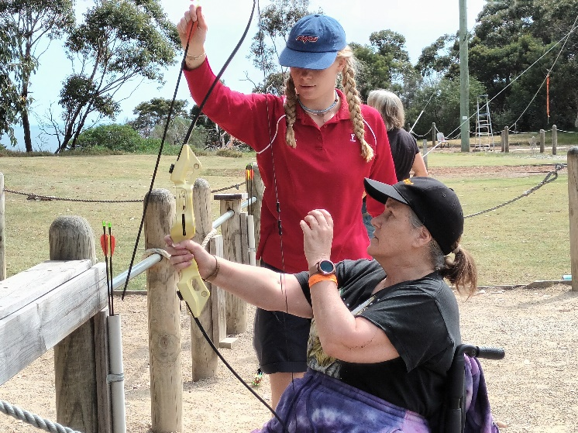

Pic: Archery participant

**Croquet and high tea** encouraged community from Mornington to take a drive to Sorrento where they had a go at a new game. Some had previously played golf and they felt that “you need an activity after golf as golf is hard on the body and croquet was a good fit”.

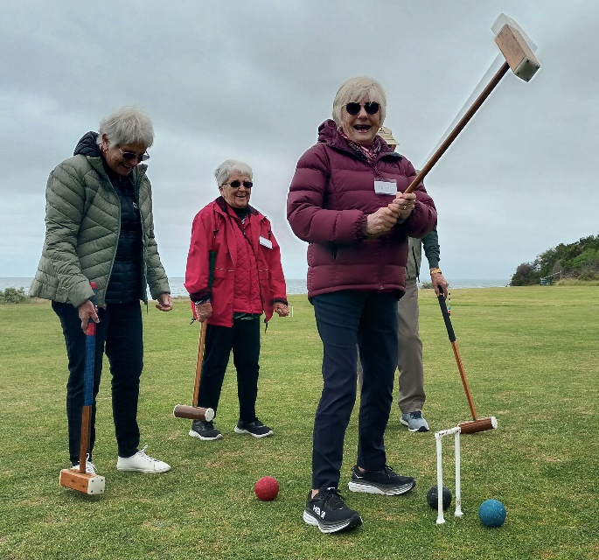

Pic: Croquet in action at Sorrento Crochet Club

Local multicultural clubs hosted community days, including the **Australian Croatian Social Club**, that shared in conversation, connecting with one another, and telling community stories over some traditional Croatian treats for morning tea. Before getting out on the bocce green for some healthy competition and lots of laughs.

Pic: Participants at the Australian Croatian Social Club Open Day

A number of environmental groups shared nature walks and regeneration initiatives. Charles who attended the **Tanti Creek walk, talk and morning tea** was “Most impressed with the way that the volunteer group, *Tanti Creek Friends*,have improved the amenity of this section of the Tanti Creek”.

Fun and Zen opportunities were abundant at the libraries with **Lego for Seniors** and **Virtual Reality Meditation** as well as stepping back in time with a lovely slide show event. Libraries also delivered the reportedly informative sessions on the **Vic Emergency app**, which enabled participants to confidently navigate through the Vic Emergency App and create their own ‘watch zone’ as well as set up emergency alerts. At Community Houses CFA provided **Fire planning workshops**, participants came away able to talk about localised fire risks and had learnt about the importance of having an individualised fire plan.

An intergenerational activity called **Friendship Through the Ages** broughtresidents from Corowa Court Aged Care and students from Paint Your World Art School came together to connect, communicate, collaborate and create in a celebration of Seniors Festival and also World Mental Health Day. The participants included young people ranging from 5-14 and seniors, the oldest was 91. Participants learnt about portrait painting and explored different drawing and painting techniques. The portrait painting brought participants joy, encouraged thoughtful conversation, harnessed a sense of value and fostered connections, which broke down the barriers between the generations. The resulting portraits are not just beautiful artworks, they also highlight the rich tapestry of life uncovered by connecting younger and older people.

Betty (91 years) who took part shared the joy felt from the experience “I loved being with the children and the whole experience, it was so different and I‘ve never painted before; painting with the children was great it would be lovely to do it again.”

It’s safe to say that Mornington Peninsula’s Seniors Festival brought people together and was a huge success. Mornington Peninsula Shire would like to thank all community members that joined in the celebration of Seniors Festival 2023 by taking part in events and activities, your time and participation in the events is what makes it! A special thank you to all community groups and organisations that held events and hosted community at your local clubs. We’d also like to extend our gratitude to Peninsula Transport Assist who provided local shuttle buses to key events enabling transport connection for community.

*Article contributed by Cass Boyle, Community Multicultural Officer at Mornington Peninsula Shire*