EVALUATION OF PERCEPTION OF
THE "AGE-FRIENDLY COMMUNITY" CONCEPT
in Sărata Veche commune,
Falesti district

Product made within
the "Aging and Health" project,
funded by the Swiss Red Cross,
implementation period 2020 – 2023

Balti 2021

content
List of abbreviations 3
List of figures 4
List of tables................................................... ................................................ ....................5
General information about the study ………………………………………………………..…… 6
Chapter I. Study methodology ……………………………………… ………………………. 7
Chapter II. Presentation of study results 10
Conclusions and recommendations 30
Appendices 32

LIST OF ABBREVIATIONS

WHO - World Health Organization
AO "CASMED" - Public Association "CASMED " Socio-Medical Assistance Center at Home
SRC - Swiss Red Cross

LIST OF FIGURES

Figure 1. Profile of respondents (women, men), N=272, respondents, %.
Figure 2. Age of respondents, N=272, respondents
Figure 3. Analysis of needs regarding public spaces and buildings, N= 272 , respondents, %
Figure 4. Analysis of needs regarding Public Transport, N= 272 respondents, %
Figure 5. Analysis of housing needs, N= 272 respondents, %
Figure 6. Analysis regarding the coverage of needs regarding the Social Participation aspect, N= 272 respondents, %
Figure 7. The level of coverage of the needs of the elderly in the Respect and social inclusion aspect, N= 272 , %.
Figure 8. The level of coverage of the needs of the elderly in terms of civic participation and employment opportunities, N= 272 , %.
Figure 9. The level of coverage of the needs of the elderly in the Communication and information aspect, N= 272 , %.
Figure 10. The level of coverage of the needs of the elderly in terms of community and health services, N= 272 , %.
Figure 11. Analysis of the level of coverage of the needs of the elderly on each aspect, N= 272 , %.
Figure 12. Broad analysis of the situation of the level of coverage of the needs of the elderly on each aspect, N=272, %.

LIST OF TABLES

Table 1. Analysis of needs regarding public spaces and buildings in Sărata Veche commune, N= 272 respondents
Table 2. Analysis of needs regarding Public Transport, N= 272 respondents
Table 3. Analysis of housing needs, N= 272 respondents
Table 4. Analysis of needs regarding Social Participation, N= 272 respondents
Table 5. Needs analysis regarding Respect and social inclusion, N= 272 respondents
Table 6. Analysis of needs regarding Civic participation and employment opportunities, N= 272 respondents
Table 7. Analysis of needs regarding Communication and information, N= 272 respondents
Table 8. Analysis of needs regarding community and health services, N= 272 respondents

GENERAL INFORMATION
The population aging rate is increasing all over the world and the Republic of Moldova is no exception. This phenomenon involves important changes in all social spheres, causing the need to adopt measures aimed at responding to the needs related to aging and making life easier for the elderly.
The World Health Organization (WHO), for more than a decade, has guided the integration of age-friendly actions into the development plans of the largest cities and communities around the world, developing the concept of the Age-Friendly Community, which includes 8 aspects important: transport, housing, public spaces and buildings, social participation, respect and social inclusion, civic participation and employment, communication and information, community and health services.
Since 2017, this concept has also been piloted in the Republic of Moldova, within the "Aging and Health" project, by AO "CASMED" with the support of the Swiss Red Cross (SRC).
Starting from 2020, the "Age-friendly community" concept is also implemented in Sărata Veche commune, Fălești district. For the successful piloting of the concept, a sociological study was carried out regarding the evaluation of citizens' perception of an age-friendly Community.

CHAPTER I. STUDY METHODOLOGY
The basic objectives of the study are :
- Evaluation of the level of perception of the elderly on the current situation in accordance with the concept of an age-friendly Community;
- Identifying the needs of the elderly in the 8 areas: public spaces and buildings, transport, housing, social participation, respect and social inclusion, civic participation and employment opportunities, communication and information, community and health services.
Range:
The Sărata Veche commune, Edineț district was selected as a result of the competition announced for the town halls of the Edineț district and will implement the concept of "Age-friendly community" in the period 2020 - 2023, part of the "Aging and health" project, financed by the Swiss Red Cross . The survey on residents' perception of how friendly their community is for the elderly was conducted in Sărata Veche commune between June 8 and June 29, 2020.
Selection of respondents
People over the age of 50+ were selected as respondents. The total number of people in the community was calculated for the following age categories: 50-56 years, 57-65 years, 66-70 years, 71-80 years, 81+. 20% of the total number of people participated from each age category. The total number of respondents was 272.
Profile of respondents
Of all respondents, 61% (166) are women and 39% (106) - men. This can be explained by the age structure of the sample, where the share of people over 56 is very high, and after this age, the share of women is much higher than that of men.
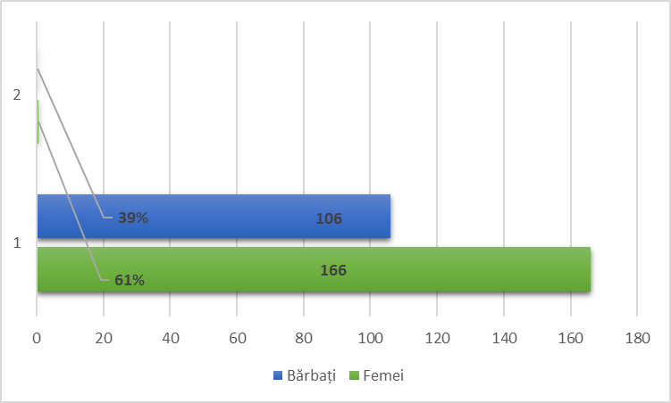
Figure 1. Profile of respondents (women, men), N=272 respondents, %.
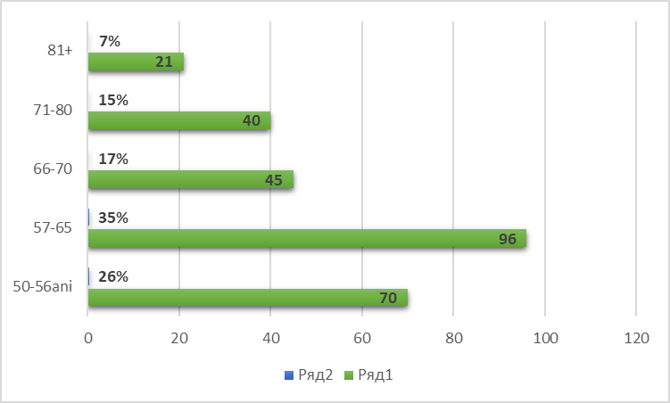
Figure 2. Age of respondents, N=272 respondents,%
Thus, the age group with the largest weight that participated in the survey were people aged 57-65 years -96 (35%) respondents and 50-56 years -70 (26%) respondents, the smallest group of respondents were those aged 81+ with a number of 21 (7%) people.
Research Tool and Field Operators
The survey was conducted face-to-face using the questionnaire for "Assessing the level of perception of the elderly regarding the concept of 'Age-Friendly Community'" which can be found in Appendix 1. The questionnaire contains a set of statements and questions on the 8 domains of a friendly community age, with five answer options for each question. The time to complete a questionnaire is 20 - 30 min. The questionnaire was applied by 9 operators: the members of the Local Coordinating Committee from Sărata Veche commune. All 9 operators benefited from 4 hours of training, being familiar with:
- Tools used to identify the needs of the elderly: survey, focus group;
- The perception questionnaire regarding the concept of "Age Friendly Community";
- Application of the questionnaire;
- Communication methods and techniques in applying the questionnaire.

The quantitative data collection and interpretation tool
The data collected through the questionnaires were processed through the KoboCollect online application, which allows content storage, submission verification, online data visualization and analysis, data download, which will facilitate the reassessment of the situation in 4 years. The laptop and other mobile devices connected to the Internet were used to access the application.

CHAPTER II. PRESENTATION OF THE RESULTS OF THE STUDY
The evaluation of the level of perception of the elderly regarding the concept of "Age-Friendly Community" in Sărata Veche commune, Fălești district demonstrated that the level of coverage of the problems of the elderly in the locality up to the time of project implementation is around 40.70% .
The study shows that in the locality, in terms of community and health services, the level of coverage of the needs of the elderly does not reach 25%.
The highest level of coverage of needs is found in the Social Participation aspect, which reaches 60.72%.
The results of the survey will be presented to the local authorities and discussed with the members of the Local Coordinating Committees.

1. Public spaces and buildings
Table 1. Analysis of needs regarding public spaces and buildings in Sărata Veche commune, N=272 respondents
Public spaces |  | No. of accumulated responses
No.  d/r | question | I definitely do not agree | I disagree | I do not know | I Agree | I totally agree | ConCluSIonS
1. | All public institution buildings have railings and access ramps | 16 | 108 | 29 | 115 | 4 | 45.5% consider the lack of railings and ramps at public institutions a problem;  43.7%-do not consider this as a problem;  10.6%-don't know about these issues.
2. | There are enough rest and leisure spaces for the elderly adapted to each season | 20 | 141 | 52 | 55 | 4 | 59.1%-consider that there are no rest and leisure spaces for the elderly;  21.6%-do not consider this as a problem;  19.1% - do not know about these problems.
3. | There are sufficient benches/chairs in the park, near public places and along the main street | 10 | 144 | 33 | 75 | 10 | 56.6%-consider the lack of chairs in public places and along the main street to be a problem;  31.25% - do not consider this a problem;  12.13%- I don't know about these issues.
4. | The steps / thresholds at all public institutions are comfortable and accessible even in winter | 16 | 143 | 24 | 77 | 12 | 58.4%-consider that the steps / thresholds of public institutions are not comfortable and accessible, especially in winter;  32.7% - do not consider this a problem;  8.8%- I don't know about these issues.
5. | The roads / streets in the locality are illuminated at night | 16 | 111 | 12 | 115 | 18 | 46.7%-consider that not all streets are lit at night .  48.8% - of respondents live on streets lit at night;  4.4%- I don't know about these issues.
6. | do you think should be improved in buildings and public places to meet the needs of the elderly? | To light the adjacent streets;  To install chairs and ballot boxes on the central street;  To set up a rest and recreation area;  To install ramps and railings at public institutions.  Public spaces and buildings – 35.61% the level of coverage of the needs of the elderly in this aspect
As a result of the analysis of the answers given in the survey, we notice that the great majority, about 59.1% of respondents, believe that there are no rest and leisure spaces for the elderly.
58.4%-consider that the steps / thresholds of public institutions are not comfortable and accessible, especially in winter.
35.61% of the respondents believe that all the needs of the elderly regarding the adaptation of public buildings and rest and relaxation spaces are covered, and 53.26% believe that the needs of the elderly in this aspect are not covered. While 11.13% do not know what the situation is at the moment.
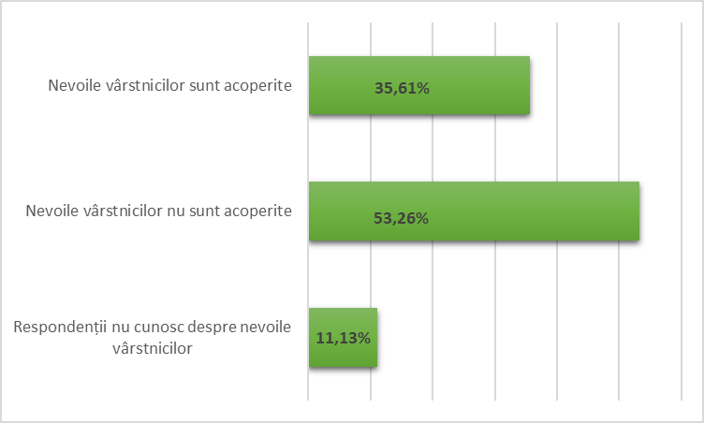

Figure 3. Analysis of needs regarding public spaces and buildings, N=272 respondents, %

2. Public transport
Analyzing the results of the survey recorded in Table 2. in this aspect we notice that the elderly encounter many problems that need to be solved.
Table 2. Analysis of needs regarding Public Transport, N=272 respondents
Public transport | The number of accumulated responses
question | I definitely do not agree | I disagree | I do not know | I Agree | I totally agree | ConCluSIonS
Public transport is available for the elderly | 54 | 36 | 18 | 138 | 26 | 33.1% believe that public transport is not available for all seniors, but 60.3% - believe that it is available  6.6%-don't know about these issues.
The public transport timetable is convenient for the elderly | 53 | 30 | 21 | 143 | 24 | 30.51 % consider that the transport schedule is not convenient, and 61.4% consider it convenient;  7.7%- do not know about these problems.
All public transport waiting stations are conveniently arranged and display the traffic schedule | 22 | 153 | 25 | 67 | 4 | 64.33% consider that the waiting stations are not set up and do not have a traffic schedule, while 26.1% consider that everything is fine;  9.2%- do not know about these problems.
Elderly people and those with reduced mobility can travel to public institutions in the community with local public transport | 37 | 94 | 38 | 87 | 13 | 48.16%- consider the impossibility of the elderly with a reduced degree of mobility to travel by local public transport as a serious problem and only 36.7% do not consider this a problem;  13.97%- do not know about these problems.
What do you think should be done to improve the quality of the public transport service? | To set up a transport waiting station in Hitrești and to place the public transport circulation schedule;  To repair the roads; To build sidewalks.  Public transport - 46.12% the level of coverage of the needs of the elderly in this aspect
On this aspect 64.33% of respondents considers that the waiting stations are not arranged and do not have the traffic schedule . Also, 48.16% consider the impossibility of the elderly with a reduced degree of mobility to travel by local public transport as a serious problem .
With regard to the Public Transport aspect, the severity of the problems presented is on average 44.3%.
46.12% believes that the needs of the elderly in this aspect are covered and only 9.58% are undecided.
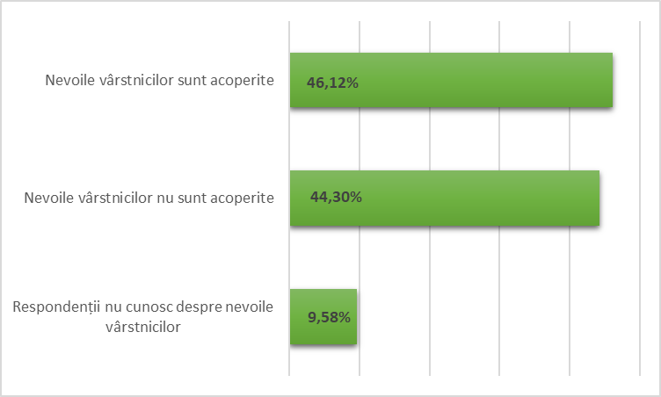
Figure 4. Analysis of needs regarding Public Transport, N=272 respondents, %

3. Housing
Table 3. Analysis of housing needs, N=272 respondents
House | The number of accumulated responses
question | I definitely do not agree | I disagree | I do not know | I Agree | I totally agree | ConCluSIonS
Homes for the elderly do not present an increased risk of falls or accidents | 9 | 50 | 75 | 132 | 6 | 21.7% believe that the homes of the elderly present an increased risk of falls or accidents  50.73% believe that the situation in Housing for the elderly does not present an increased risk of falls or accidents  27.6% - do not know about these problems.
Homes for the elderly are equipped with smoke detectors | 22 | 110 | 72 | 63 | 4 | 47.52% believe that the homes of the elderly need to be equipped with smoke detectors  25.36 % do not consider this as a problem;  26.47%-don't know about these issues.
Elderly people are helped by the authorities and/or people from the locality/neighbors in clearing snow, heating the room during the cold season, cutting wood | 10 | 79 | 39 | 133 | 10 | 32.72% believe that it is necessary for local authorities/neighbors to help the elderly in solving problems during the winter  52.8 state that the authorities help the elderly during the cold season;  14.13%-don't know about these issues.
The elderly and the disabled are given wood and coal for the cold period of the year by the local authorities | 15 | 66 | 64 | 105 | 20 | 29.8% state that the elderly are not provided by the authorities with wood and coal during the winter;  45.95% believe that the elderly receive wood and coal;  23.5% - do not know about these problems.
How could the living conditions in the homes of the elderly be improved? | Equipping homes with smoke detectors.  Housing - 43.71% the level of coverage of the needs of the elderly in this aspect
Within this aspect, the most important problems faced by the elderly as well as the disabled are: not equipping the homes of the elderly with smoke detectors - 47.52%
32.72% believe that it is necessary for the local authorities/neighbors to help the elderly in solving problems during the winter, while 23.36% do not know much about the problems of the elderly in this aspect.
43.71% is the level of coverage of the needs of the elderly in this aspect , 32.93% of respondents believe that the elderly are not safe in their homes.
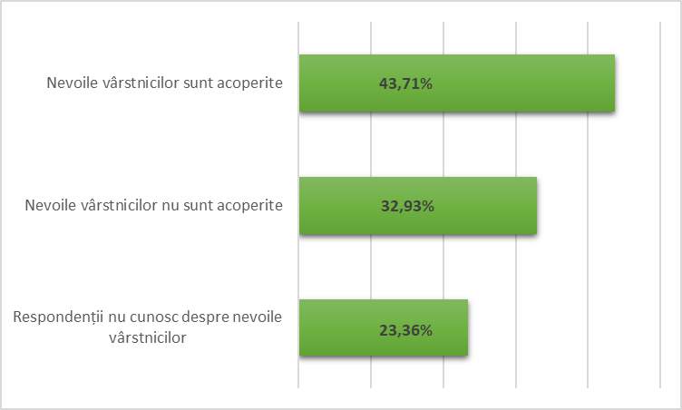

Figure 5. Analysis of housing needs, N=272 respondents, %

4. Social participation
Table 4. Analysis of needs regarding Social Participation, N=272 respondents
Social participation | The number of accumulated responses
question | I definitely do not agree | I disagree | I do not know | I Agree | I totally agree | ConCluSIonS
The events and activities organized in the community are intergenerational, being designed to involve people of different ages | 6 | 29 | 59 | 137 | 40 | 12.8 %- believe that the activities carried out in the community are not intergenerational and do not involve people of different ages. 65.1% mentioned that people of different ages participate in the activities.  21.7% - do not know about these problems.
Elderly people participate in the socio-cultural activities organized in the locality and outside it | 4 | 69 | 44 | 134 | 21 | 26.8 % mentioned that the elderly do not participate in socio-cultural activities, while 56.9% of respondents agree that the elderly participate in socio-cultural activities.  16.2% - do not know about these problems.
Elderly people are involved in organizing different public events in the community | 8 | 40 | 75 | 126 | 16 | 17.6 %- mention that the elderly are not involved in the organization of various public events in the community; 52.2% agree with this statement;  27.6% - do not know about these problems.
There are enough opportunities to stimulate and facilitate meetings between older people | 6 | 55 | 58 | 140 | 12 | 22.4 % - do not agree that there are opportunities to facilitate meetings between elderly people; 55.88% believe that such an opportunity exists.  21.32%-don't know about these issues.
Elderly people with reduced mobility or immobilized are visited at home | 2 | 33 | 36 | 187 | 13 | 12.86 % believe that people with reduced mobility or immobilized are not visited at home;  73.5 % agree that they are visited;  13.2%-don't know about these issues.
What types of activities should be organized in the community to stimulate the participation of the elderly? | To organize interest groups for the elderly and adults, concerts, sessions, meetings, fitness. To set up a socialization center for the elderly.  Social participation - 60.72 % the level of coverage of the needs of the elderly in this aspect
Within this aspect there are fewer issues that need to be resolved. Only 26.8 % of the respondents mentioned that the elderly do not participate in socio-cultural activities.
Within the Social Participation aspect, the needs of the elderly are covered by 60.72%. A large percentage of respondents, about 20.78%, are not aware of the problems of the elderly in this aspect. While 18.5% of respondents believe that the needs of the elderly in this aspect are not covered.
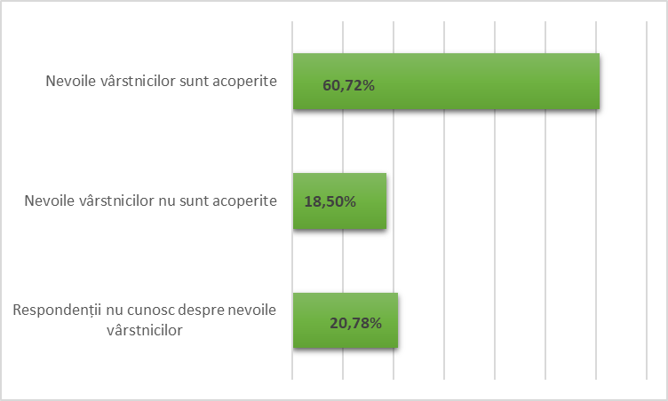
Figure 6. Analysis regarding the coverage of needs regarding the aspect of Social Participation, N=272 respondents, %

5. Respect and social inclusion
Table 5. Analysis of needs regarding Respect and social inclusion, N=272 respondents
Respect and social inclusion | The number of accumulated responses
question | I definitely do not agree | I disagree | I do not know | I Agree | I totally agree | ConCluSIonS
Local authorities and local people are concerned about older people and their needs | 2 | 80 | 32 | 145 | 13 | 30.14 %- believe that the local authorities and local people are not concerned about the elderly and their needs, but 58.1% believe that they care;  11.8%-don't know about these issues.
Older people are asked to attend local council meetings and similar activities and their input is valued. | 11 | 101 | 98 | 59 | 3 | 41.2 % believe that the elderly are not invited to CL meetings and the contribution of the elderly at the community level is not appreciated.  22.8% mentioned that elderly people are asked to participate in local council meetings, and their input is appreciated.  36.02%-don't know about these issues.
More and more young people show a respectful attitude towards the elderly | 11 | 123 | 43 | 85 | 10 | 49.26% believe that young people do not show a respectful attitude towards the elderly, but 34.92% stated the opposite.  15.8% - do not know about these problems.
Older people are sometimes treated with less respect and/or discrimination | 4 | 105 | 32 | 112 | 17 | 40.07 % mentioned that elderly people are sometimes treated with less respect, and 47.42% disagree with this statement;  11.76%-don't know about these issues.
What needs to be done to increase respect for the elderly? | To organize more joint activities of young people and the elderly (thematic meetings, different workshops);  Respect and social inclusion – 40.81% the level of coverage of the needs of the elderly in this aspect
The problems related to Respect and social inclusion of the elderly in the municipality of Sărata Veche are not covered well enough.
49.26% believe that young people do not show a respectful attitude towards the elderly. 41.2 % believe that the elderly are not invited to CL meetings and the contribution of the elderly at the community level is not appreciated.
19.02% of respondents do not know about these issues.
40.81% is the level of coverage of the needs of the elderly in this aspect . But 40.17% believe that the elderly encounter problems in this aspect.
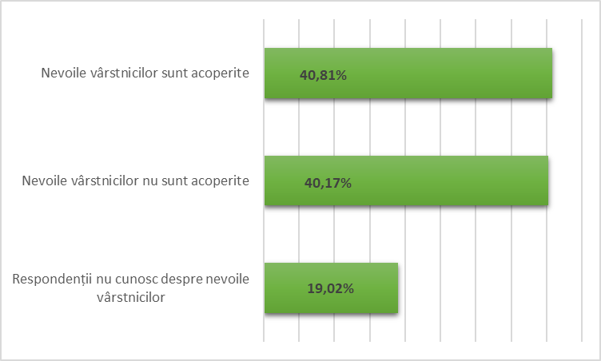

Figure 7. The level of coverage of the needs of the elderly in the Respect and social inclusion aspect, N=272, %.

6. Civic participation and employment opportunities
Table 6. Needs analysis regarding Civic participation and employment opportunities, N=115 respondents
employment opportunities | The number of accumulated responses
question | I definitely do not agree | I disagree | I do not know | I Agree | I totally agree | ConCluSIonS
Local authorities support initiatives and volunteering activities carried out by older people | 9 | 2. 3 | 95 | 133 | 11 | 6.9 % mention that Local Authorities do not support the initiatives and volunteering activities carried out by the elderly, while 54.7% believe that they support the initiatives and volunteering activities carried out by the elderly  38.2% - do not know about these problems.
Older people are well represented in committees and participate in the decision-making process | 8 | 108 | 88 | 65 | 2 | 31.3 % believe that the elderly do not participate in the decision-making process, while 32.1% believe that the elderly get involved in this process.  36.5% - do not know about these problems.
Older people have opportunities to learn new things, to be socially active | 6 | 85 | 67 | 103 | 10 | 33.9% believe that elderly people do not have opportunities to learn new things and be socially active, while 34.7% believe that such opportunities exist.  31.3%-don't know about these problems.
Elderly people with special needs/disabilities have access to volunteer activities | 10 | 58 | 100 | 96 | 6 | 38.2 % believe that elderly people with special needs/ disabilities do not have access to volunteer activities and only 25.2% have a different opinion.  36.5% do not know about these problems.
There are employment opportunities for the elderly | 33 | 111 | 69 | 51 | 5 | 53.9% believe that there are no employment opportunities for the elderly and only 20.0% state that there are.  26.0% - do not know about these issues.
What needs to be done for the elderly to participate more actively in community life? | To create jobs for the elderly. To inform the citizens in the villages.  Civic participation and employment opportunities - 33.34% the level of coverage of the needs of the elderly in this aspect
Within this aspect, we identified that 32.84% of the needs of the elderly are not covered. The coverage level of problems in this aspect is 33.34%. One of the problems lies in the fact that citizens do not know about these needs of the elderly, as shown by the 33.82% of respondents who mentioned this fact.
While 53.9% believe that elderly people do not have employment opportunities in the field of work.
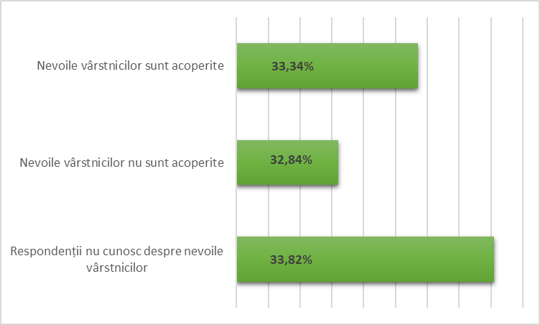
Figure 8. The level of coverage of the needs of the elderly in the aspect Civic participation and employment opportunities, N=272, %.

7. Communication and information
Table 6. Analysis of needs regarding Communication and information, N=272 respondents
Communication and information | The number of accumulated responses
question | I definitely do not agree | I disagree | I do not know | I Agree | I totally agree | ConCluSIonS
The elderly are informed about the activities that are organized in the locality | 4 | 28 | 18 | 62 | 3 | 27.8 % do not agree that the elderly are informed about the activities organized in the locality.  While 56.5% consider that they are informed.  15.6% - do not know about these problems.
The information placed on the information boards is displayed for the understanding of the elderly | 8 | 40 | 2. 3 | 40 | 4 | 41.7% believe that the information placed on the information boards is not exposed in the sense of the elderly, while 38.2% believe that the information is exposed in the sense of the elderly.  20.0% do not know about these issues.
Older people voluntarily involved as experts, information disseminators and trainers/trainers | 9 | 21 | 61 | 2. 3 | 1 | 26.0 % believe that elderly people are not voluntarily involved as experts, information disseminators and trainers/trainers.  20.8% believe that the statement is true.  53.0% do not know about these issues.
Elderly people have access to computers and the Internet in public spaces or institutions (community center, library, etc.) | 5 | 30 | 26 | 46 | 8 | 30.4 % do not agree that elderly people have access to computers and the Internet in public spaces or institutions. While 46.9% say that the elderly have access.  22.6% do not know about these problems.
What suggestions do you have for improving communication between citizens and local authorities? | More informative panels to be installed; To send letters to home; To develop an informative bulletin; to hold meetings with the citizens in the villages by councilors .  Communication and information – 40.6% the level of coverage of the needs of the elderly in this aspect
On this aspect , 31.48 % of the respondents believe that the elderly are not informed about the activities that are organized in the locality, and 41.7% believe that the information placed on the information boards is not presented in a way that elderly people can understand.
The percentage of those who do not know about these problems is high - 27.92%.

The level of coverage of the needs of the elderly in this aspect is 40.6%.

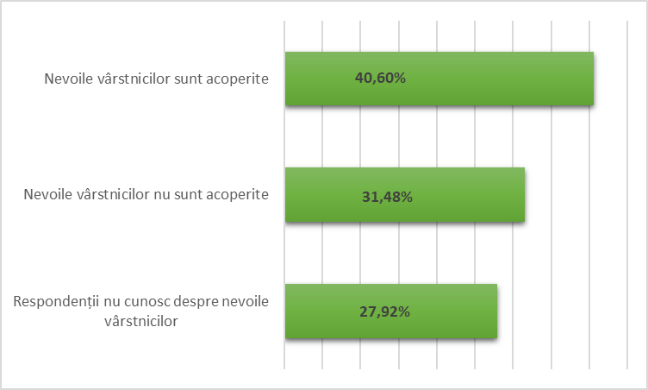
Figure 9. The level of coverage of the needs of the elderly in the Communication and information aspect, N=272, %.

8. Community and health services
Table 8. Analysis of needs regarding community and health services, N=272 respondents
Community services  and health | The number of accumulated responses
question | I definitely do not agree | I disagree | I do not know | I Agree | I totally agree | ConCluSIonS
There is a family doctor in the community | 19 | 62 | 3 | 27 | 4 | 70.4 % do not agree that there is a family doctor in the community.  While 26.9% say that there is.  2.6% do not know about these issues.
There are enough nurses in the community | 22 | 65 | 7 | 18 | 3 | 73.0 % disagree that there are enough nurses in the community.  18.2% consider that they are sufficient  6.0% do not know about these issues.
Elderly people have access to social and medical care services when such a need arises | 5 | 51 | 11 | 44 | 4 | 48.6 % do not agree that the elderly have access to social and medical care services when such a need arises.  41.7% believe they have access.  9.5% do not know about these issues.
There are educational programs for elderly care in the locality and a number of communicators who provide information to the elderly on health topics | 10 | 52 | 39 | 13 | 1 | 53.9 % do not agree that there are educational programs for the care of elderly people in the locality; 1 2.1% believe that there is.  33.9% do not know about these problems.
The elderly have access to solid waste collection services | 31 | 69 | 11 | 4 | 0 | 86.9% do not agree that elderly people have access to waste collection services,  3.4% consider that they have access.  9.5% do not know about these issues.
Elderly people have access to water supply services | 5 | 2. 3 | 24 | 60 | 3 | 24.3% do not agree that the elderly have access to water supply services; 54.7% believe they have access.  20.8% do not know about these issues.
Elderly people have access to pharmaceutical services | 31 | 61 | 4 | 17 | 2 | 80.0 % do not agree that the elderly have access to pharmaceutical services; 16.5% believe they have access.  3.4% do not know about these issues.
What services would still be needed in the community for the elderly? | To create the waste collection service. Dentistry and veterinary pharmacy services are needed. Socio-medical services are requested in Sărata Noua .  Community and health services – 24.79% the level of coverage of the needs of the elderly in this aspect

In the Community and health services aspect, respondents mentioned that 86.9% of elderly people do not have access to waste collection services.
80.0% of the elderly do not have access to pharmaceutical services. 73.0 % disagree that there are enough nurses in the community.

12.77% do not know about the needs of the elderly .
24.79% is the level of coverage of the needs of the elderly in this aspect, while 62.44% are not covered.

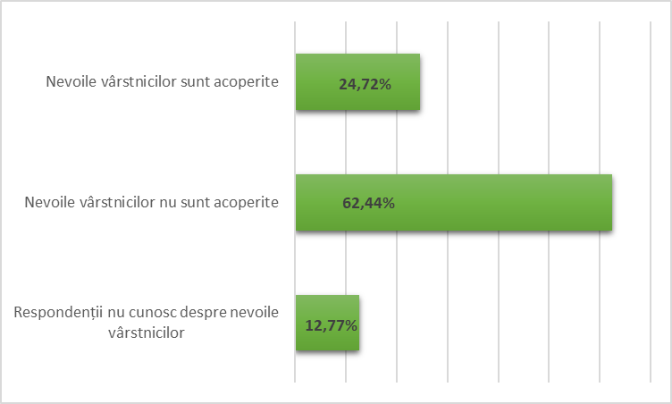
Figure 10. The level of coverage of the needs of the elderly in the Community and health services aspect, N=272, %.

CONCLUSIONS AND RECOMMENDATIONS
The period in which the survey was conducted was marked by the pandemic situation caused by the COVID-19 virus. However, the 9 operators did not encounter any problems when conducting the survey. The operators used measures to prevent infection with Covid-19 by wearing protective masks and gloves, respecting social distance. The survey process itself was an interesting one for the operators, people showed themselves available to give their opinion. Difficulties were encountered by the respondents, because they did not know many concepts and the operators had to explain the meaning of many words to them. Few respondents filled in the space with proposals and recommendations for solving the problems, but all welcomed the fact that they were asked for their opinion and agree with the initiative to make a change in the community.
Following the study, we identified the following levels regarding the coverage of needs on each aspect:
- Public spaces and buildings – 35.61% the level of coverage of the needs of the elderly in this aspect;
- Housing – 43.71% the level of coverage of the needs of the elderly in this aspect;
- Public transport – 46.12% the level of coverage of the needs of the elderly in this aspect;
- Respect and social inclusion – 40.81% the level of coverage of the needs of the elderly in this aspect;
- Civic participation and employment opportunities – 33.34% the level of coverage of the needs of the elderly in this aspect;
- Communication and information – 40.60% the level of coverage of the needs of the elderly in this aspect;
- Community and health services - 24.72% the level of coverage of the needs of the elderly in this aspect.
- Social participation - 60.72% the level of coverage of the needs of the elderly in this aspect;
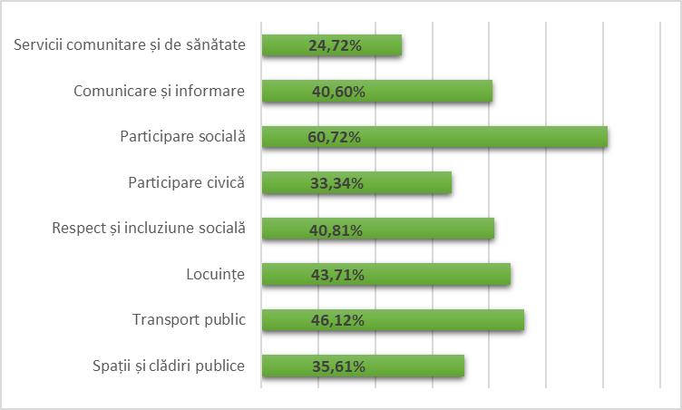
Figure 11. Classification of aspects according to the level of coverage of needs, N=272,%

The needs of the elderly are least covered in the aspects Community and health services – 24.72% and Civic participation and employment in the labor field – 33.34%. While in Social Participation the coverage of needs is 60.72%.
The average coverage of the needs of the elderly is 40.70%.
The proposals and solutions received from the respondents were included in the tables of the report and it is necessary to take them into account when developing the Strategic Plan for the "Age Friendly Community" component and the Action Plan for the realization of this strategy.

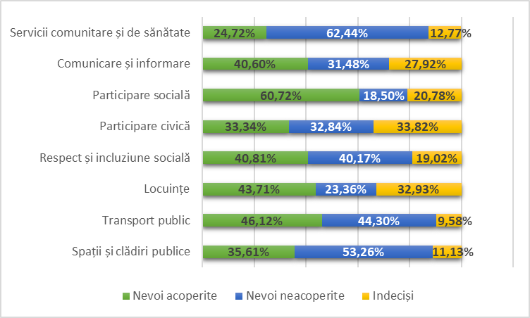
Figure 12. Broad analysis of the situation of the level of coverage of the needs of the elderly on each aspect, N=272, %.

Appendix 1
Questionnaire for conducting the survey (CPV)
Please answer a few questions to rate how senior-friendly your community is. There are no right or wrong answers;
An honest statement of your opinion is very important. Completing a questionnaire will take a maximum of 20-30 minutes.

City ______________________
Age : 50-56 57-65 66-70 71-80 81+
Genre : female male

1. Public spaces and buildings
- All public institution buildings have railings and access ramps
I definitely do not agree I disagree I do not know I Agree I totally agree
- There are enough rest and leisure spaces for the elderly adapted to each season
Strongly disagree Disagree Don't know I Agree I totally agree
- There are enough benches/chairs in the park, close to public places and along the main street.
Strongly disagree Disagree Don't know I Agree I totally agree
- The steps/thresholds at all public institutions are comfortable and accessible even in winter
I definitely do not agree I do not agree I do not know I Agree I totally agree
- The roads/streets in the locality are illuminated at night
I definitely do not agree I do not agree I do not know I Agree I totally agree
- What should be improved in buildings and public places to meet the needs of the elderly?
______________________________________________________________________________________________________________________________________________________________
_______________________________________________________________________________

2. Transport
- Public transport is available for the elderly
I definitely do not agree I disagree I don't know I Agree I totally agree
- The public transport timetable is convenient for the elderly
I definitely do not agree I disagree I do not know I Agree I totally agree
- All public transport waiting stations are conveniently laid out and have posted timetables
of transport
I definitely do not agree I disagree I do not know I Agree I totally agree
- Elderly people and those with reduced mobility can travel to public institutions in the community with local public transport
I definitely do not agree I do not agree I don't know I Agree I totally agree
- What do you think should be done to improve the quality of the public transport service?
_____________________________________________________________________________________________________________________________________________________________________________________________________________________________________________

3. Housing
- Homes for the elderly do not present an increased risk of falling or injury
I definitely do not agree I disagree I do not know I Agree I totally agree
- Homes for the elderly are equipped with smoke detectors
I definitely do not agree I do not agree I do not know I Agree I totally agree
- Elderly people are helped by the authorities and/or local people/neighbors in clearing snow, heating the room during the cold season, cutting wood
I definitely do not agree I do not agree I do not know I Agree I totally agree
- The elderly and the disabled are given wood and coal for the cold period of the year by the local authorities
I definitely do not agree I don't agree I don't know I Agree I totally agree
- How could the living conditions in the homes of the elderly be improved?
_____________________________________________________________________________________________________________________________________________________________________________________________________________________________________________

- Social participation
- The events and activities organized in the community are intergenerational, being designed to involve people of different ages
I definitely do not agree I disagree I do not know I Agree I totally agree
- Elderly people participate in the socio-cultural activities organized in the locality and outside it
I definitely do not agree I disagree I do not know I Agree I totally agree
- Elderly people are involved in organizing different public events in the community
I definitely do not agree I disagree I don't know I Agree I totally agree
- There are enough opportunities to stimulate and facilitate meetings between older people
I definitely do not agree I disagree I do not know I Agree I totally agree
- Elderly persons with reduced mobility or who are immobilized are visited at home
I definitely do not agree I don't agree I don't know I Agree I totally agree
6. What types of activities should be organized in the community to stimulate participation
the elderly?
______________________________________________________________________________________________________________________________________________________________
_______________________________________________________________________________

- Respect and social inclusion
- Local authorities and local people are concerned about older people and their needs
I definitely do not agree I disagree I do not know I Agree I totally agree
- Older people are asked to attend local council meetings and similar activities and their input is valued.
I definitely do not agree I don't agree I don't know I Agree I totally agree
- More and more young people show a respectful attitude towards the elderly
I definitely do not agree I disagree I do not know I Agree I totally agree
- Older people are sometimes treated with less respect and / or discriminated against
I definitely do not agree I disagree I do not know I Agree I totally agree
- What needs to be done to increase respect for the elderly?
_____________________________________________________________________________________________________________________________________________________________________________________________________________________________________________

- Civic participation and employment opportunities
- Local authorities support initiatives and volunteering activities carried out by older people
I definitely do not agree I disagree I don't know I Agree I totally agree
- Older people are well represented in councils, commissions and participate in the decision-making process
I definitely do not agree I disagree I do not know I Agree I totally agree
- Older people have opportunities to learn new things, to be socially active
I definitely do not agree I disagree I do not know I Agree I totally agree
- Elderly people with special needs/disabilities have access to volunteer activities
I definitely disagree I do n't agree I don't know I Agree I totally agree
- There are employment opportunities for the elderly
I definitely do not agree I disagree I do not know I Agree I totally agree
- What needs to be done for the elderly to participate more actively in community life?
_____________________________________________________________________________________________________________________________________________________________________________________________________________________________________________

- Communication and information
- The elderly are informed about the activities that are organized in the locality
I definitely do not agree I disagree I do not know I Agree I totally agree
- The information placed on the information boards is displayed for the understanding of the elderly
I definitely do not agree I don't agree I don't know I Agree I totally agree
- Older people voluntarily involved as experts, information disseminators and trainers/trainers
I definitely do not agree I disagree I do not know I Agree I totally agree
- Elderly people have access to computers and the Internet in public spaces and or institutions (community center, library, etc.)
I definitely do not agree I don't agree I don't know I Agree I totally agree
- What suggestions do you have for improving communication between citizens and local authorities?
_____________________________________________________________________________________________________________________________________________________________________________________________________________________________________________

- Community and health services
- There is a family doctor in the community
I definitely do not agree I disagree I do not know I Agree I totally agree
- There are enough nurses in the community
I definitely do not agree I disagree I do not know I Agree I totally agree
- Elderly people have access to social and medical care services when such a need arises
I definitely do not agree I disagree I do not know I Agree I totally agree
- There are educational programs for elderly care in the township and a number of communicators who provide information to the elderly on health topics
I definitely do not agree I disagree I do not know I Agree I totally agree
- The elderly have access to solid waste collection services
I definitely do not agree I disagree I do not know I Agree I totally agree
- Elderly people have access to water supply services
I definitely do not agree I disagree I do not know I Agree I totally agree
- Elderly people have access to pharmaceutical services
I definitely do not agree I disagree I do not know I Agree I totally agree
- What services would still be needed in the community for the elderly?
_____________________________________________________________________________________________________________________________________________________________________________________________________________________________________________

Thanks for your time!

