D-4.

Overview of the survey

Purpose
    - The purpose of the survey is to provide basic data necessary for establishing an aging-friendly city development plan through the diagnosis of the aging-friendly status and demand outlook as a survey on public perception for the establishment of an aging-friendly city in Jinju.

Scope of survey
    - Spatial range: Jinju city
    - Content range: WHO Survey on Aging-Friendly City

Details of Jinju city’s survey
    - General status, consisted of 8 items related to aging-friendly city.
    - Collecting opinions on the eight areas of the guidelines for aging-friendly city suggested by the WHO as an expert opinion survey and opinions on the role of each institution in Jinju City's move to an aging-friendly city.

Determination of sample size
    - The decision was made up based on the proportional size of the population by region, age, and gender. In particular, the sample size was determined in consideration of the facts that in case of aged 65 and order the overall size was not large and that it could be extracted probabilistically in a general survey.
    - The maximum tolerance limit is 4.9%, and depending on the size, 400 or more elderly (aged 65 and over) and 400 or more ordinary citizens were surveyed.

Distribution of samples
    - Based on the number of people by by each administrative districts; each eup, myeon, and dong the number of samples and the size of the elderly (aged and over) by each eup, myeon, and dong in Jinju city is proportionally distributed

Survey Method

Sortation | Details
Survey method | - 1:1 individual interviews and distribution surveys
Data collection tools | - TAPI(Tablet PC Assisted Personal Interview)
Period of survey | - July 27, 2022 to October 11, 2022
Sampling method | - Allocation table considering the number of people in each eup,  myeon, and dong based on administrative districts
Recovery rate | - A survey sample of 1,000 copies (500 copies of the elderly and  500 copies of the non-senior) was distributed and 467 copies (93.4%) of the elderly and 489 copies (97.8%) of the non-senior were confirmed, excluding data that were not recovered and  processed.

  - Data Processing
    - Computerized collected Data with SPSS ver. 21.0 through Editing, Coding and punching

Respondent Analysis Results

Gender status of respondents
    - Based on the 65-year-old age of respondents in Jinju city, 197 men (40.3%) and 292 women (59.7%) were under the age of 65 of 65, while 149 men (31.9%) and 318 women (68.1%) were aged 65 and over.
    - In other words, the gender ratio of respondents under the age of 65 of 65 was 4:6, which was higher for women, and the gender ratio of respondents aged 65 and over was more different than that of respondents under the age of 65 of 65
    - As a result, this survey shows the gender ratio phenomenon of the elderly in Jinju city well, and it seems that consideration for the elderly women should be given priority in creating an aging-friendly city in the future.

[Table 1] Analysis of respondents' gender status

Sortation |  | under the age of 65 |  | aged 65 and over
 |  | Number of respondents | Percentage (%) | Number of respondents | Percentage (%)
the entire |  | 489 | 100.0 | 467 | 100.0
Gender | men | 197 | 40.3 | 149 | 31.9
 | women | 292 | 59.7 | 318 | 68.1
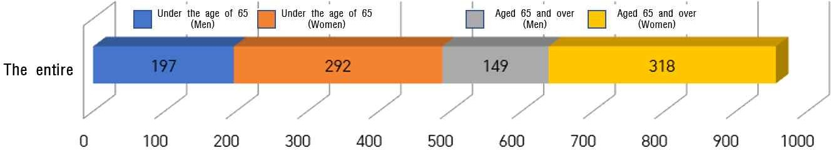
[FIG. 1] Analysis of respondents' gender status

Status of respondents by age group
    - Looking at the status of survey respondents by age group, it is analyzed that they are generally evenly distributed.
    - Those born in 1958 to in 1967 responded the lowest with 55 persons(11.2%), while those born in 1990 to in 1999 did the highest with 160 persons(32.7%)
    - For those aged 65 and over according to the characteristics of the elderly statistics were compiled in five stages based on 5 years. As a result, 211 persons(45.2%) born since 1950 answered the most, followed by 107 persons(22.9%) born in 1945 to in

[Table 2] Analysis of respondents' status by age group

Sortation |  | under the age of 65 |  | aged 65 and over
 |  | Number of  respondents | Percentage  (%) | Number of  respondents | Percentage  (%)
the entire |  | 489 | 100.0 | 467 | 100.0
the age group | before in 1935 | - | - | 18 | 3.9
 | 1935～1939 | - | - | 50 | 10.7
 | 1940～1944 | - | - | 81 | 17.3
 | 1945～1949 | - | - | 107 | 22.9
 | 1950～1957 | - | - | 211 | 45.2
 | 1958～1969 | 55 | 11.2 | - | -
 | 1970～1979 | 101 | 20.7 | - | -
 | 1980～1989 | 95 | 19.4 | - | -
 | 1990～1999 | 160 | 32.7 | - | -
 | since 2000 | 78 | 16.0 | - | -
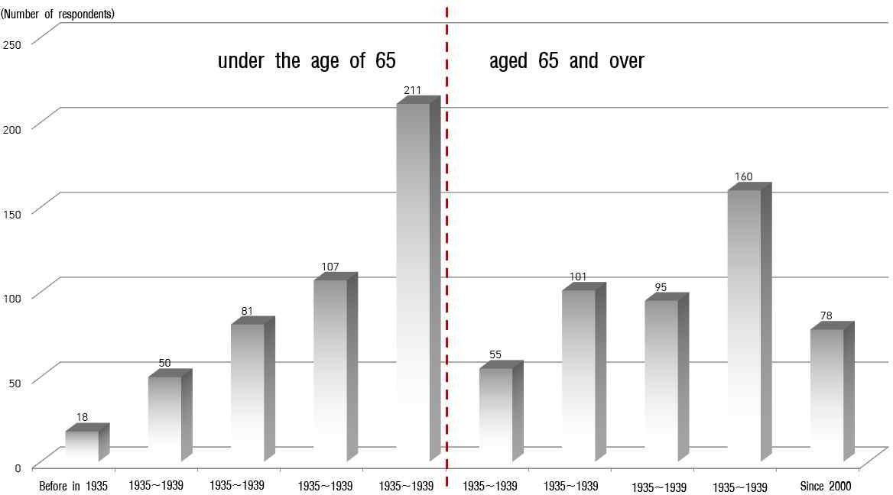
[FIG. 2] Analysis of respondents' status by age group

Status of the respondents' academic background
    - The academic background of survey subjects was overwhelmingly high from over college graduate for those under the age of 65 of 65, followed by high school graduate and it was analyzed that it was evenly distributed among the subjects for aged 65 and over from elementary school, middle school, high school, and college graduate because of the characteristics of the elderly.

    - In particular, 59 persons (12.6%) respondents in aged 65 and over of the survey subjects, indicate that they generally had good academic background.
    - In the future, it seems necessary to devise an alternative that can utilize the career and experiences of highly educated people, marked in the 10% or more of the elderly, so that it can be the foundation for creating an aging-friendly city.

[Table 3] Analysis of respondents' academic status

Sortation |  | under the age of 65 |  | aged 65 and over
 |  | Number of respondents | Percentage (%) | Number of respondents | Percentage (%)
the entire |  | 489 | 100.0 | 467 | 100.0
educational background | Elementary  school | 2 | 0.4 | 142 | 30.4
 | Middle school | 21 | 4.3 | 122 | 26.2
 | High school | 76 | 15.5 | 144 | 30.8
 | Over college  graduate | 390 | 79.8 | 59 | 12.6
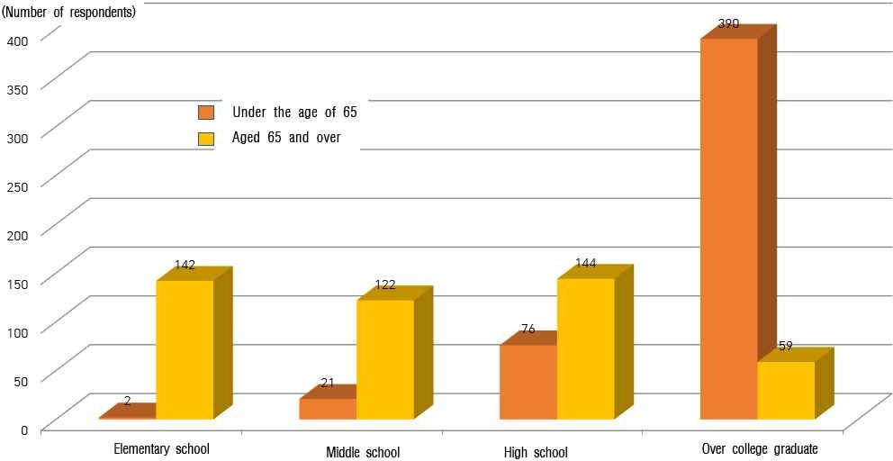

[FIG. 3] Analysis of the respondents' academic background status

Status of respondents' health.
    - When asked about the health status of the respondents in this survey, it was analyzed that those under the age of 65 perceived themselves to be very healthy, and those over the age of 65 perceived to have less than normal health status.
    - Regular health care for the elderly should be practically carried out, and continuous education programs should be developed and provided to improve health awareness. Besides both improved awareness and health leading to live a healthy life can be carried out simultaneously.

[표 4] 응답자의 건강상태 현황 분석

Sortation |  | under the age of 65 |  | aged 65 and over
 |  | Number of  respondents | Percentage  (%) | Number of  respondents | Percentage  (%)
the entire |  | 489 | 100.0 | 467 | 100.0
Physical condition | very good. | 86 | 17.6 | 17 | 3.6
 | good | 231 | 47.2 | 106 | 22.7
 | normal | 150 | 30.7 | 215 | 46.0
 | bad | 19 | 3.9 | 112 | 24.0
 | very bad | 3 | 0.6 | 17 | 3.6
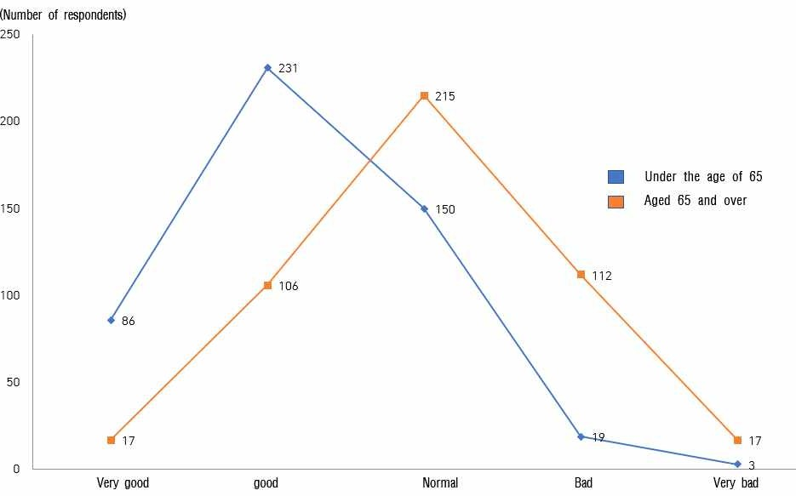
[FIG. 4] Analysis of respondents' health status

Status of residential types of respondents
    - When asked about the residential type of the survey subjects, they answered more than 65% of those under the age of 65 of 65 mainly lived in apartments, followed by detached houses and row houses and multi-household houses.

[Table 5] Analysis of Status of residential types of respondents

Sortation |  | under the age of 65 |  | aged 65 and over
 |  | Number of respondents | Percentage (%) | Number of respondents | Percentage (%)
the entire |  | 489 | 100.0 | 467 | 100.0
Residential type of residence | a detached  house | 82 | 16.8 | 172 | 36.8
 | row and household  house | 66 | 13.5 | 61 | 13.1
 | apartment | 324 | 66.3 | 230 | 49.3
 | etc. | 17 | 3.5 | 4 | 0.8
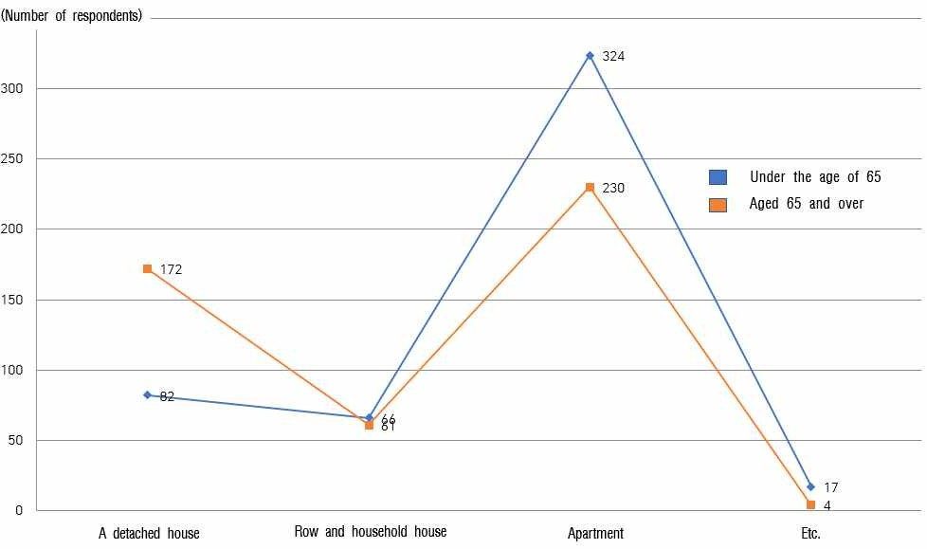
[FIG. 5] Analysis of residential types of respondents

    - About 50% of those aged 65 and over responded that they also lived in apartments, followed by 36.8% of detached houses, 13.1% row houses and multi-household houses.
    - In other words, considering the domestic apartment penetration rate, the elderly's occupancy rate of detached houses is relatively high, so efforts to improve the residential environment seem to be very necessary.

Status residential types of respondents.
    - Based on the number of people by each eup, myeon, and dong in Jinju city, the number of samples and the sample sizes of the elderly (aged 65 and over) by each eup, myeon, and dong in Jinju city, in consideration of proportional distribution, the results show as follows.
    - In general, it is judged that the sample distribution shows very good results.

[Table 6] Analysis of respondents by each eup, myeon, and dong

Sortation |  | under the age of 65 |  | aged 65 and over
 |  | Number of  respondents | Percentage  (%) | Number of  respondents | Percentage  (%)
the entire |  | 489 | 100.0 | 467 | 100.0
Eup, Myeon, Dong | Munsan-eup | 4 | 0.8 | 17 | 3.6
 | Mae dong-myeon | 10 | 2.0 | 10 | 2.1
 | Jeongchon-myeon | 5 | 1.0 | 6 | 1.3
 | Geumgok-myeon | 4 | 0.8 | 3 | 0.6
 | Jinsung noodles | 8 | 1.6 | 8 | 1.7
 | Bansug 1-myeon | 3 | 0.6 | 3 | 0.6
 | Bansug 2-myeon | 2 | 0.4 | 2 | 0.4
 | Sabong-myeon | 6 | 1.2 | 4 | 0.9
 | Jisoo-myeon | 3 | 0.6 | 2 | 0.4
 | Daegok-myeon | 5 | 1.0 | 4 | 0.9
 | Geumsan-myeon | 14 | 2.9 | 14 | 3.0
 | Jiphyeon-myeon | 11 | 2.2 | 13 | 2.8

 | Micheon-myeon | 4 | 0.8 | 3 | 0.6
 | Myeongseokmyeon | 15 | 3.1 | 20 | 4.3
 | Dae pyeong-myeon | 7 | 1.4 | 7 | 1.5
 | Sugok-myeon | 5 | 1.0 | 4 | 0.9
 | Cheonjeon-dong | 29 | 5.9 | 29 | 6.2
 | Seongbuk-dong | 25 | 5.1 | 20 | 4.3
 | Jungang-dong | 26 | 5.3 | 35 | 7.5
 | Sangbong-dong | 22 | 4.5 | 25 | 5.4
 | Sangdae-Dong | 26 | 5.3 | 30 | 6.4
 | Hadae-dong | 33 | 6.7 | 24 | 5.1
 | Sangpyeong-dong | 19 | 3.9 | 11 | 2.4
 | Chajang-dong | 41 | 8.4 | 25 | 5.4
 | Pyeongeo-dong | 39 | 8.0 | 47 | 10.1
 | Sinan-dong | 20 | 4.1 | 24 | 5.1
 | Yihyun-dong. | 25 | 5.1 | 22 | 4.7
 | Panmun-dong | 21 | 4.3 | 21 | 4.5
 | Gaho-dong | 29 | 5.9 | 26 | 5.6
 | Chungmugong-dong | 28 | 5.7 | 8 | 1.7

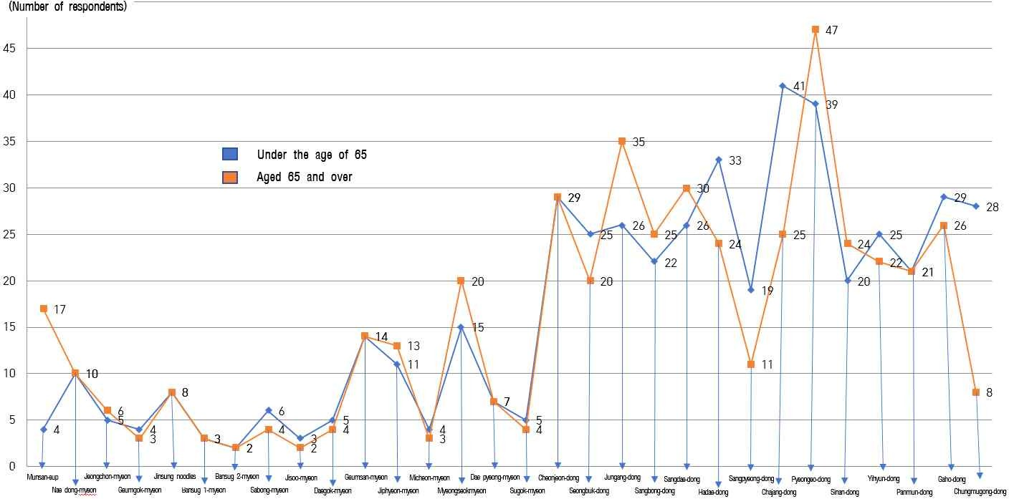

[FIG. 6] Analysis of respondents' status by each eup, myeon and dong

Results of Analysis by Eight Areas on the Establishment of Aging-friendly Cities

Analysis of the current status of eight areas on the Establishment of Aging-friendly Cities
    - As a result of calculating the average value of under 65 years of age and aged 65 and over by each of the eight major areas to establish an aging-friendly city, the average value is generally good.
    - Though the overall average value of creating an aging-friendly city was 6.2 (out of 9)points for those under the age of 65 and a bit lower 6.00 (out of 9)points for those aged 65, it can be seen as positive.
    - The area with the highest score in the eight areas was transportation convenience, which is the hardware field, followed by residential environment stability, external environment and facilities, which are high in both groups.
    - On the other hand, under the age of 65 of 65, it was below the average in terms of leisure and social activities, social participation and jobs, respect and social integration, communication and information, community care and medical services, which is software one.
    - Even aged 65 and over showed also above average in the hardware field while they showed below average in the software field.
    - As a result, it is believed that they hope that more intensive projects can be carried out in the software field rather than hardware construction in eight areas to create an aging-friendly city.
    - In particular, elderly respondents show the lowest average in the communication and information sectors in the eight major areas, so a special strategy for communication and information provision seems to be needed in discovering the businesses first in the future.
    - It can be confirmed through the analysis results that the above results are recognized even under the age of 65 of 65.

[Table 7] Analysis of the status of the eight key areas for the creation of an aging-friendly city
Sortation |  | under the age of 65 |  | aged 65 and over
 |  | Average  value | Ranking | Average  value | Ranking
the entire |  | 6.20 | - | 6.00 | -
the eight key areas | 1. External environment and facilities | 6.32 | 3 | 6.12 | 3
 | 2. Convenience of transportation  means | 6.52 | 1 | 6.48 | 1
 | 3. Stability of residential environment | 6.37 | 2 | 6.30 | 2
 | 4. Leisure and social activities | 6.18 | 5 | 5.83 | 5
 | 5. Social Participation and Jobs | 6.19 | 4 | 5.95 | 4
 | 6. Respect and Social Integration | 6.15 | 6 | 5.82 | 6
 | 7. Communication and Information | 5.94 | 7 | 5.67 | 8
 | 8. Community Care and Medical  Services | 5.92 | 8 | 5.79 | 7

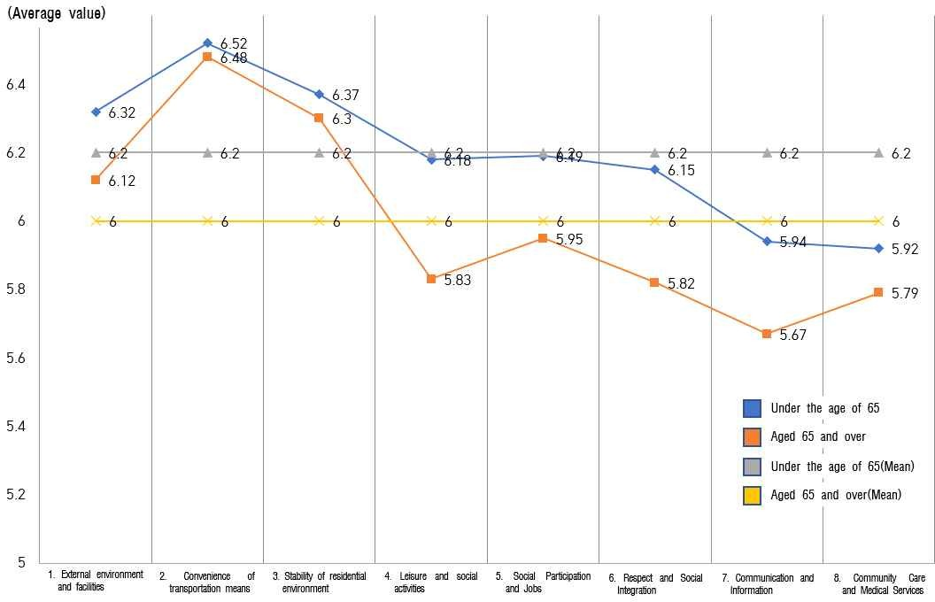
[FIG. 7] Analysis of the current status of eight areas for the creation of an aging-friendly city

External environment and facilities
    - It was investigated that all age groups evenly recognize the external environment and facilities for the creation of aging-friendly city.
    - In terms of the perception of the living external environment and facilities, it was considered that park management, green space creation, and outdoor rest areas were above average well equipped.
    - On the other hand, both groups give very lower scores than average in 'Drivers drive safely and prioritize pedestrians', 'Safety facilities (safety handles, floor slumps, emergency bells, etc.), and Mobile amenities are well equipped in public buildings'.
    - In particular, it shows the results indicating that improvement in 'Drivers' safe driving and pedestrian priority' should be promoted first.
    - Though safety awareness should be a top priority, it is very low to create an aging-friendly city. So regular safety education for drivers and expansion of safety facilities (safety handles, floor slumps, emergency bells, etc.) are required first of all.

[Table 8] Analysis of the status of external environment and facilities

Sortation |  |  | under the | age of 65 | aged 65 | and over
 |  |  | Average value | Ranking | Average value | Ranking
the entire |  |  | 6.37 | - | 6.30 | -
1. External environment and facilities | 1-Ⓒ. | Park management | 7.03 | 1 | 6.70 | 2
 | 1-Ⓒ. | Greening projects | 6.90 | 2 | 6.67 | 3
 | 1-Ⓒ. | Outdoor rest area | 6.72 | 3 | 6.74 | 1
 | 1-④. | Floor Obstacles | 6.37 | 6 | 6.25 | 5
 | 1-Ⓒ. | Crossing time | 6.38 | 4 | 6.21 | 7
 | 1-⑥. Convenience facilities |  | 6.27 | 7 | 6.21 | 7
 | 1-Ⓒ. | Outdoor rest area | 6.37 | 6 | 6.39 | 4
 | 1-⑧. | Safe driving | 5.56 | 10 | 5.93 | 9
 | 1-⑨. | Safety facilities | 5.93 | 9 | 5.92 | 10
 | 1-⑩Convenience facilities in  public buildings |  | 6.16 | 8 | 5.98 | 8

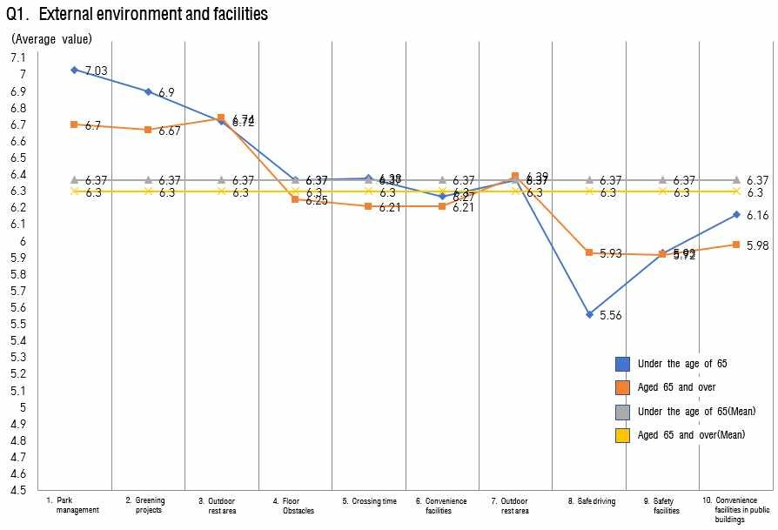

[FIG. 8] Analysis of the status of external environment and facilities

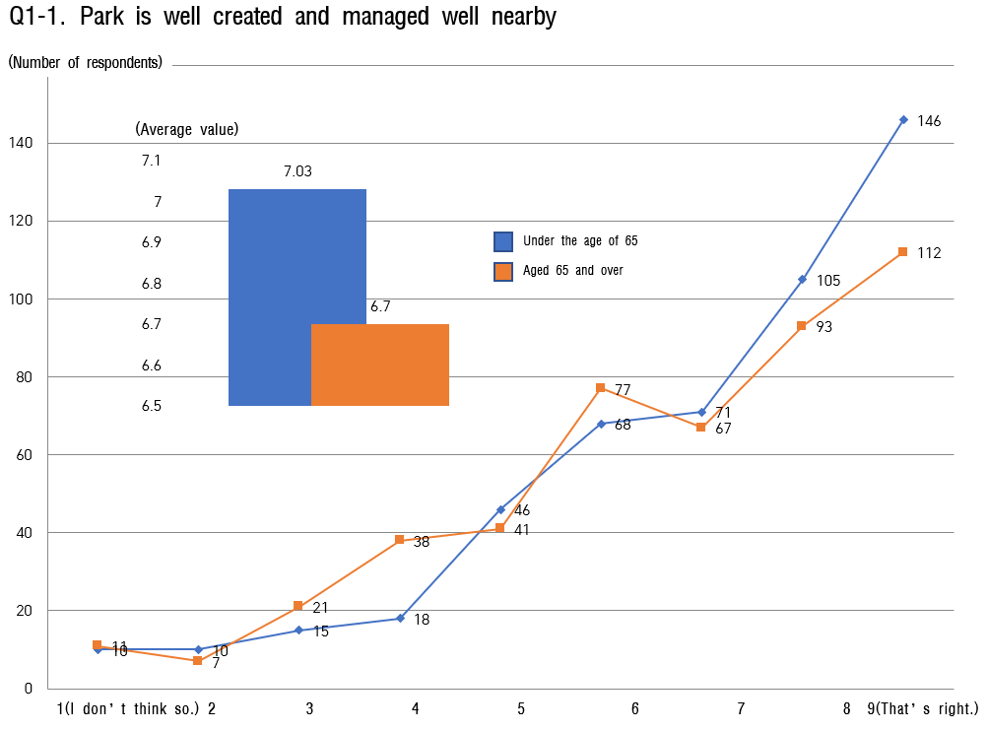

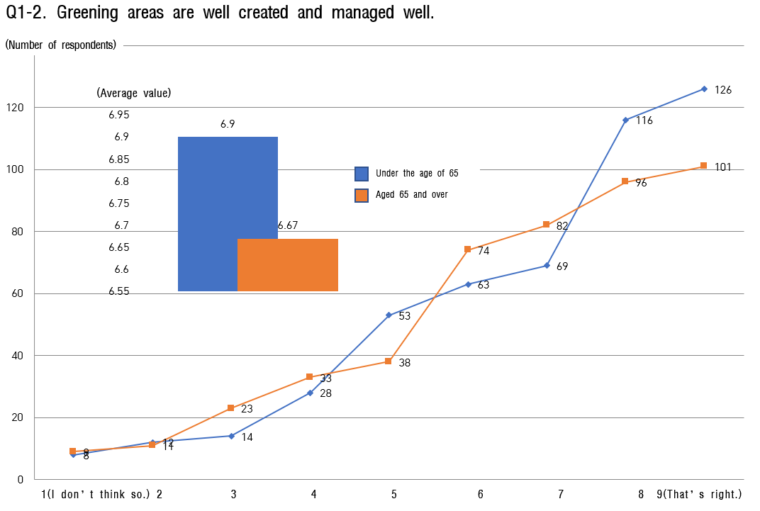

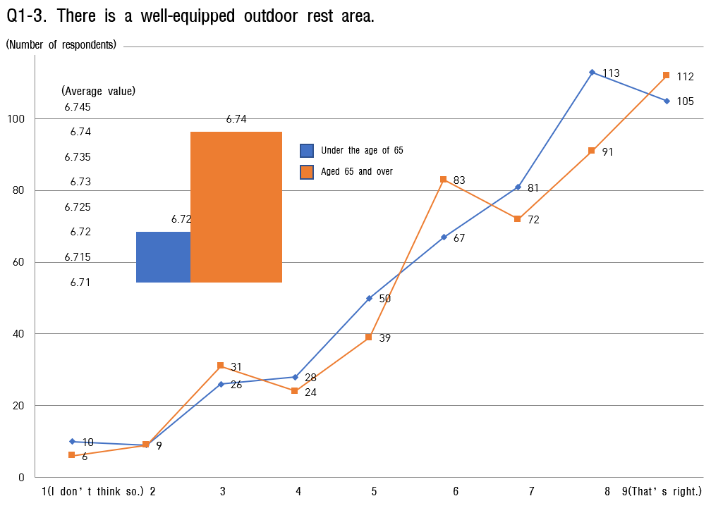

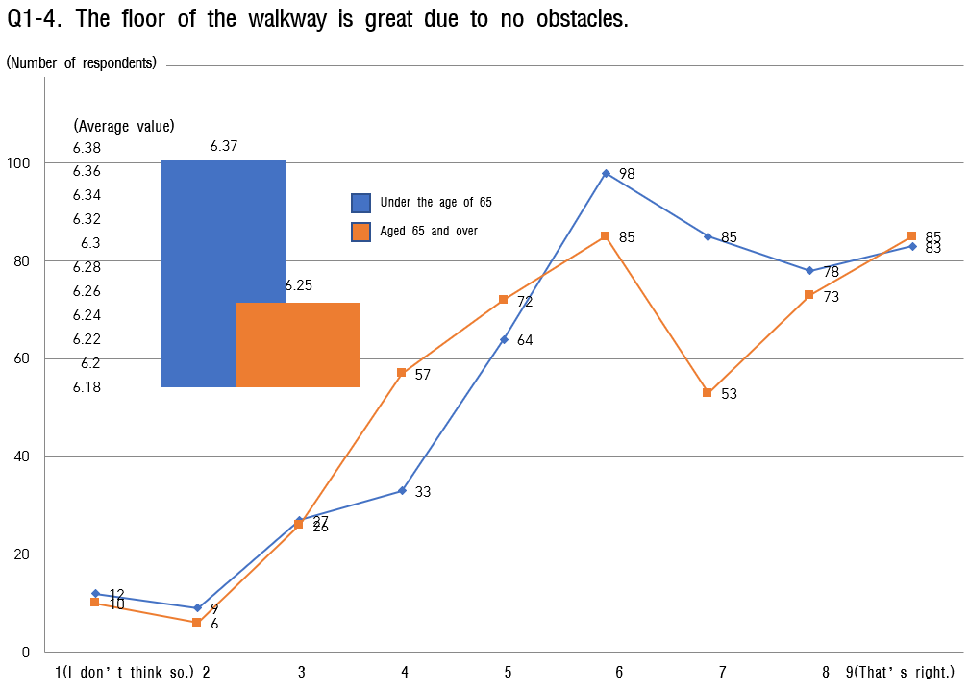

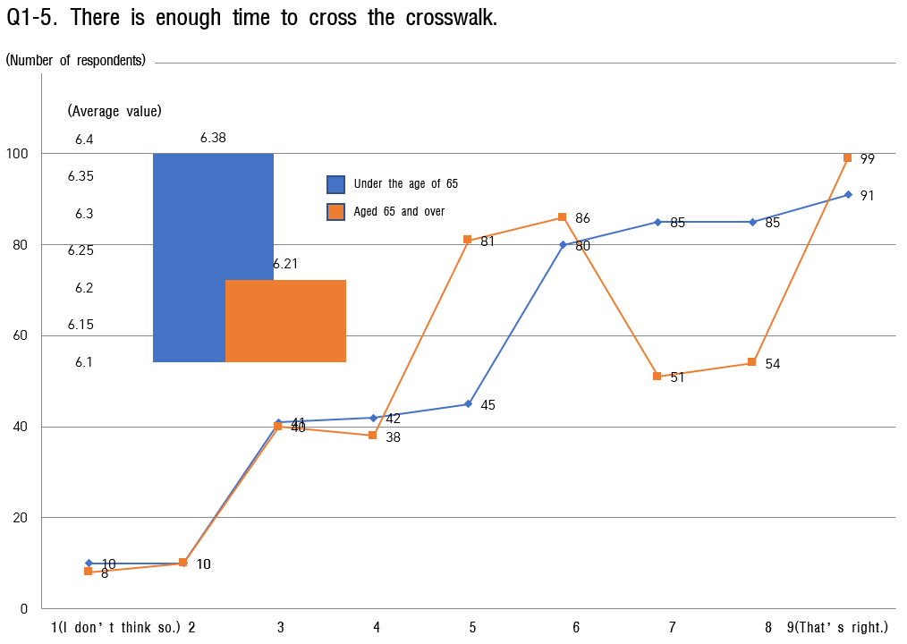
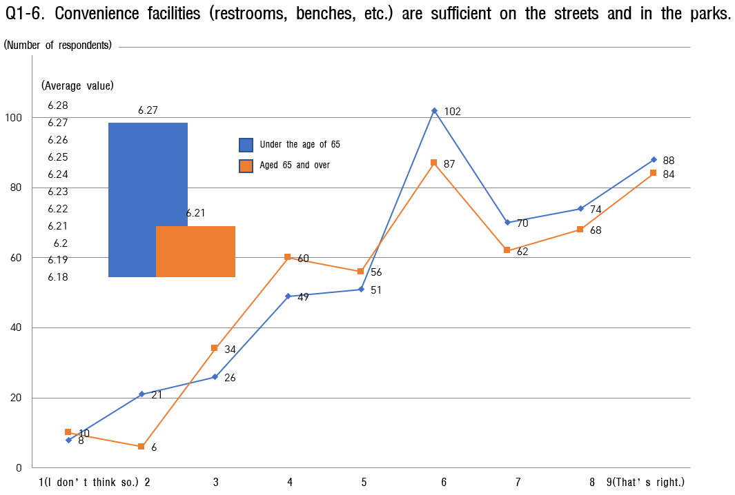

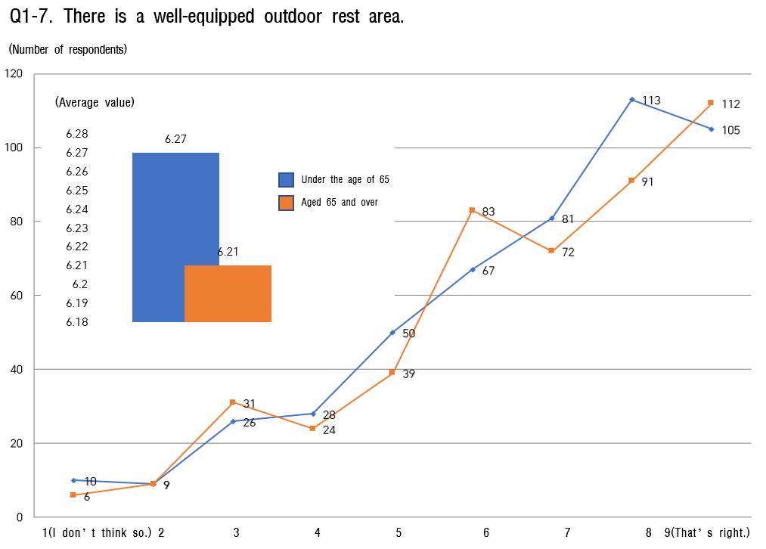
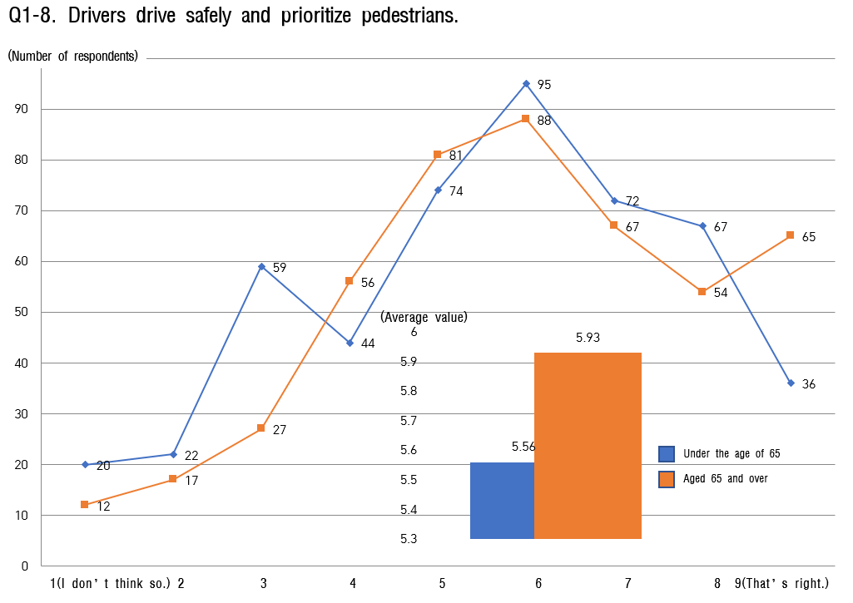

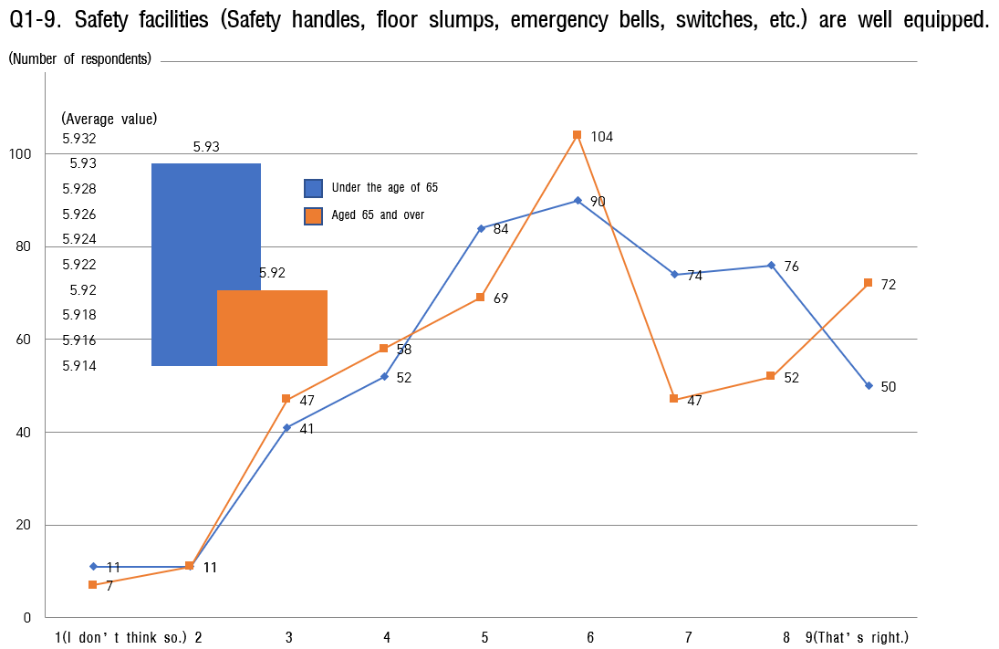

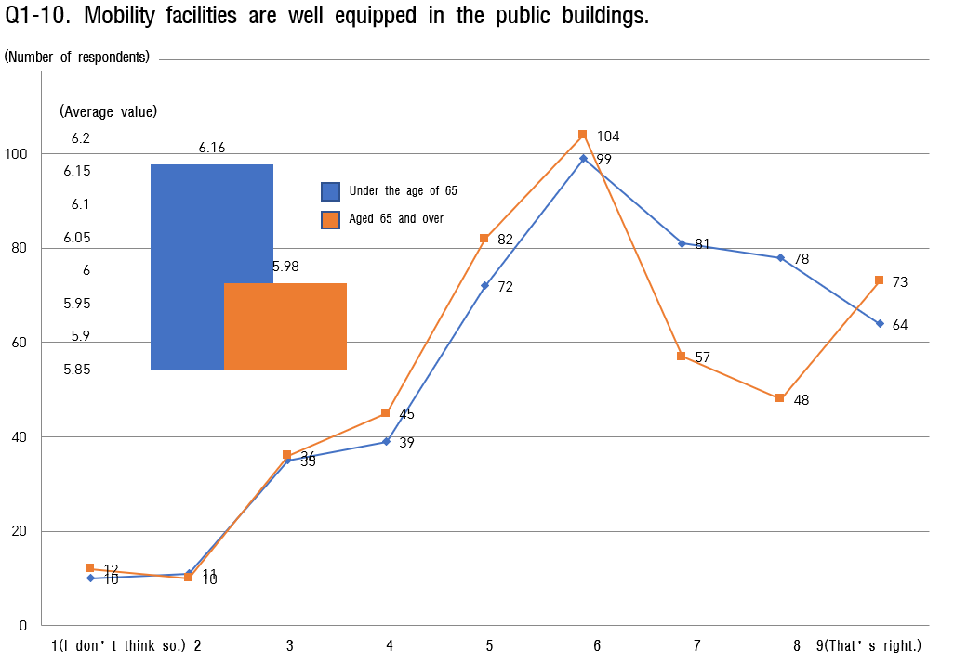

Convenience of transportation
    - In the question of transportation convenience, the overall average value is low.
    - The fact that the average value under the age of 65 of 65 is higher than that aged 65 and over can be seen as a phenomenon caused by the difference in convenience for mobility, and it can be seen that the mobility of the elderly is relatively lower.
    - For those under the age of 65 to show above the average value is that “Bus stop managed well” is by for the top response. And next is “Vehicles managed well”, “convenience of using taxi” and “Convenience of public transportation”. There are two 4-point ranges, one is "free shuttle buses or volunteer vehicles are available in places where using public transportation is difficult. "The other is "Installation of stickers or information boards to notify the elderly of their own driving."

    - Items which answered below the average value from those aged 65 are that ‘they can use free shuttle buses or volunteer vehicles in places where public transportation is difficult’, such as those under the age of 65 of 65." These two items show the lowest score. And next, it is thought that they hope that "many low-floor buses that are convenient for the elderly with physical disabilities will be operated. more often"
    - As a result, it seems necessary produce and support more stickers for the elderly’s own driving and to resolve blind spots in public transportation.

[Table 9] Analysis of the current status of transportation convenience

Sortation |  | under the | age of 65 | aged 65 | and over
 |  | Average  value | Ranking | Average  value | Ranking
the entire |  | 6.18 | - | 5.83 | -
 | 2-Ⓒ. Convenience of | 6.27 | 4 | 6.43 | 4
 | public transportation
 | 2-Ⓒ. Vehicles | 6.72 | 2 | 6.55 | 2
 | managed well
 | 2-Ⓒ. Fee Satisfaction | 6.04 | 5 | 6.47 | 3
 | 2-④. Priority parking | 5.64 | 7 | 5.83 | 6
 | for the elderly
 | 2-Ⓒ. Convenience of | 6.50 | 3 | 6.07 | 5
2. Convenience of transportation  means | using taxi
 | 2-⑥. Bus stop  managed well | 6.85 | 1 | 6.63 | 1
 | 2-Ⓒ. Driving stickers | 4.68 | 10 | 4.95 | 9
 | for the elderly
 | 2-⑧. Low-floor bus | 5.37 | 8 | 5.21 | 8
 | service
 | 2-⑨. Convenience of
 | A l t e r n a t i v e | 4.79 | 9 | 4.52 | 10
 | transportation
 | 2-⑩. Signboard | 5.94 | 6 | 5.63 | 7
 | Readability

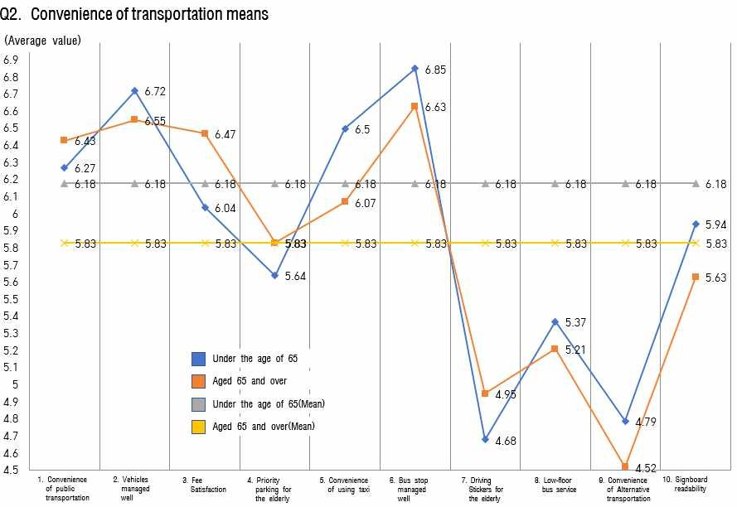
[FIG. 9] Analysis of the status of transportation convenience

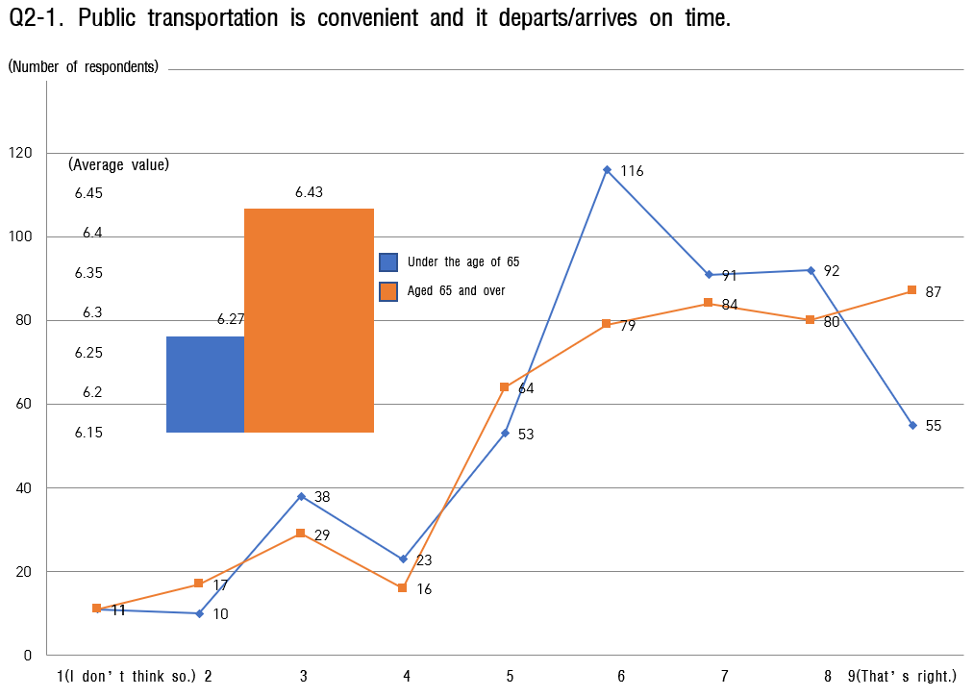

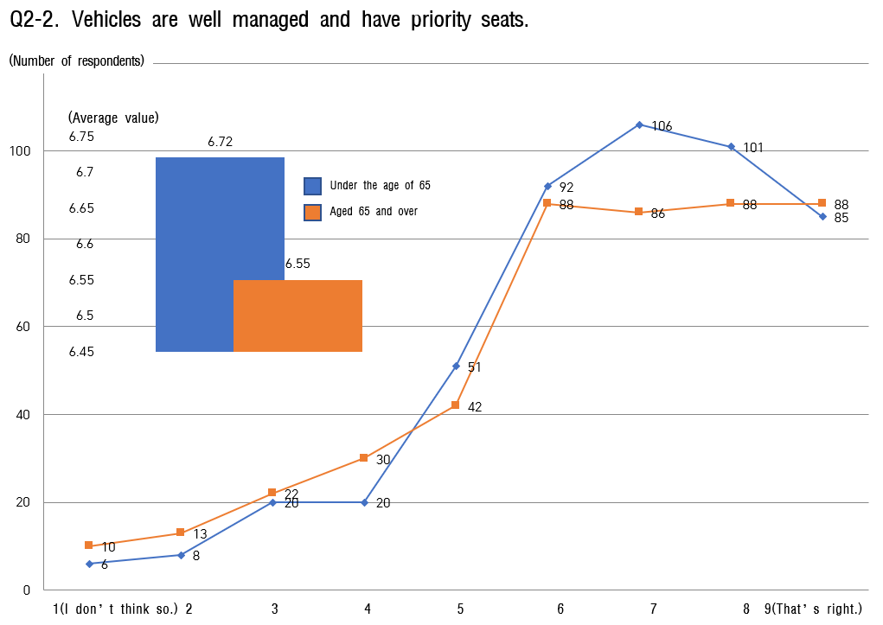

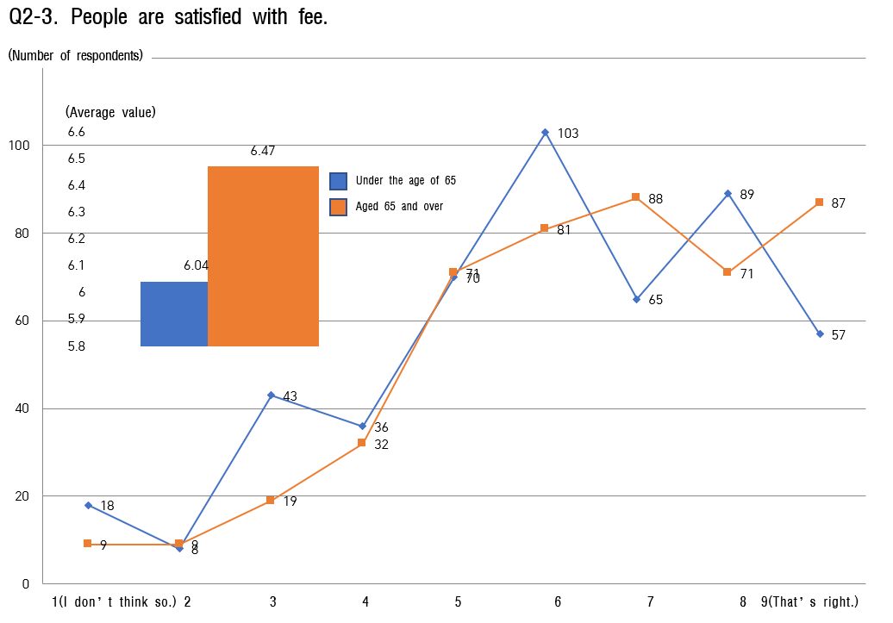

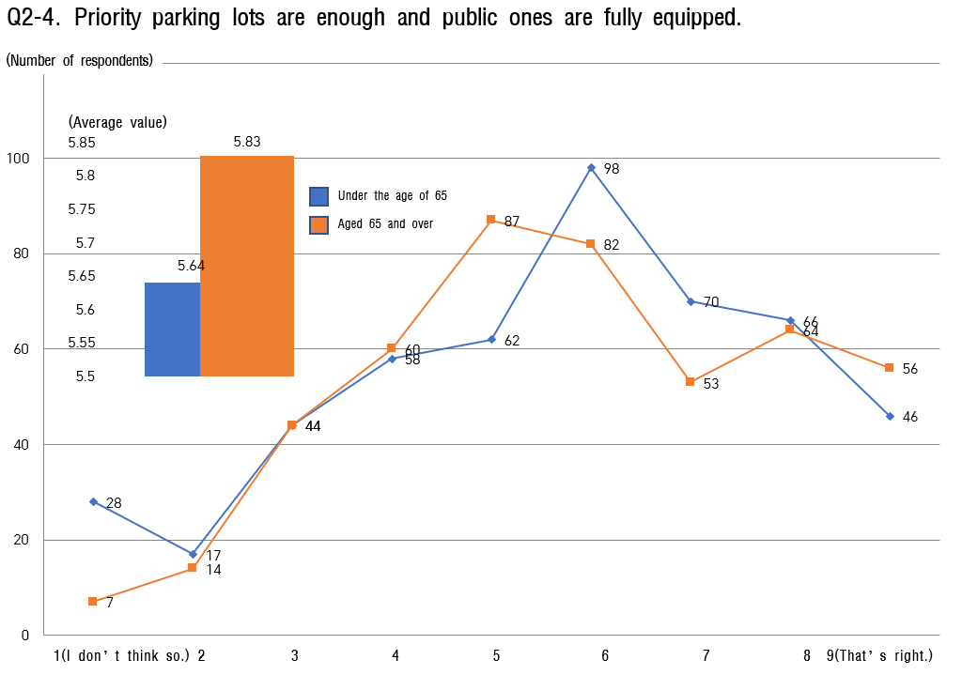

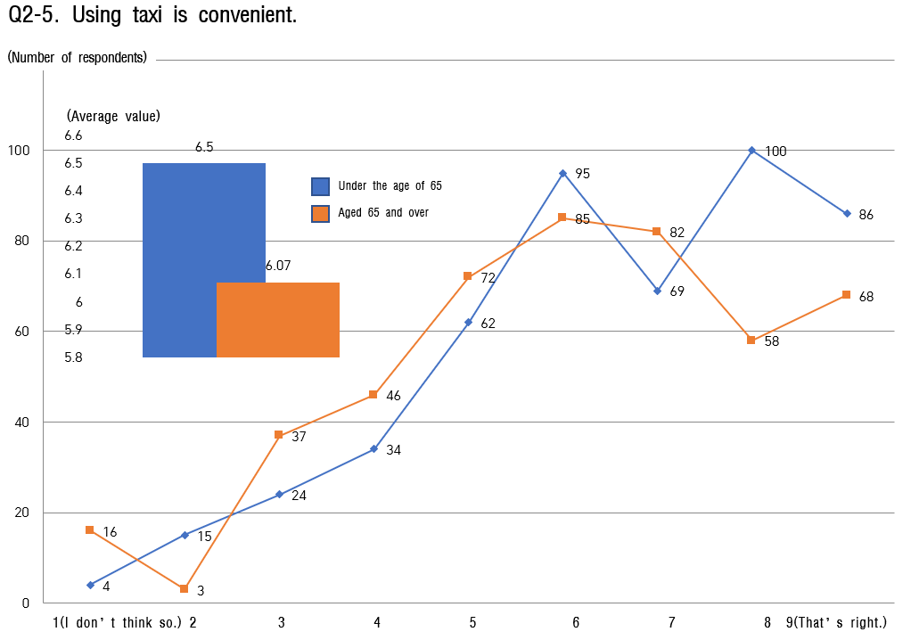

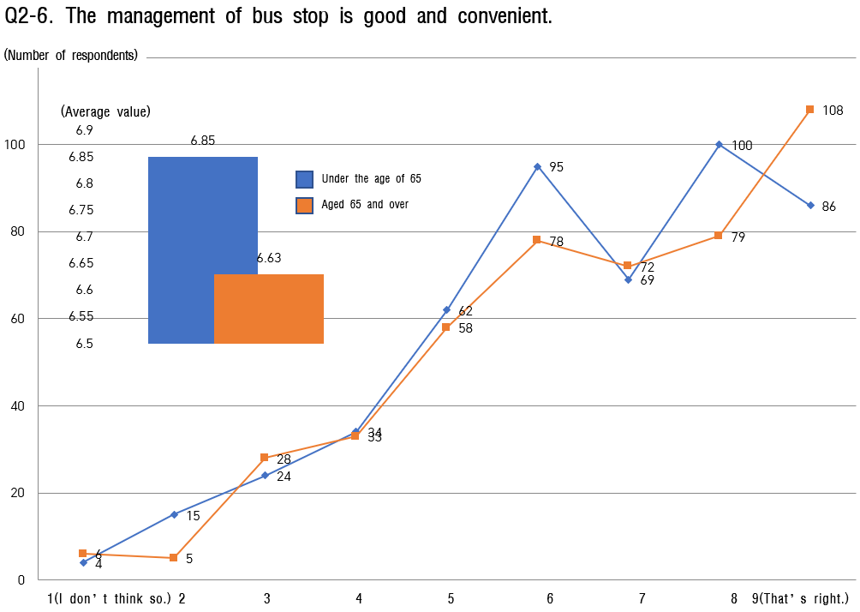

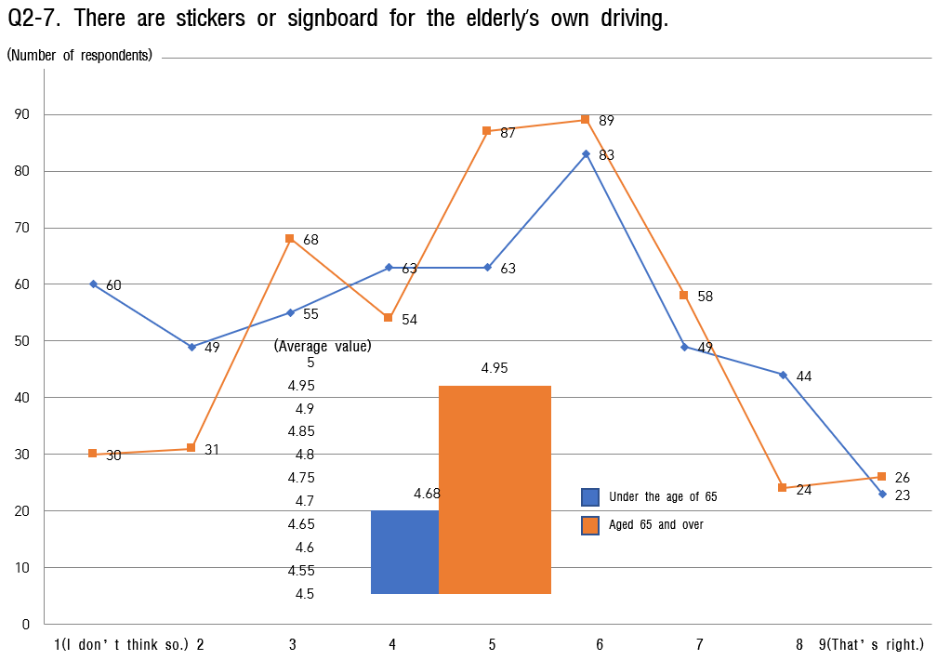
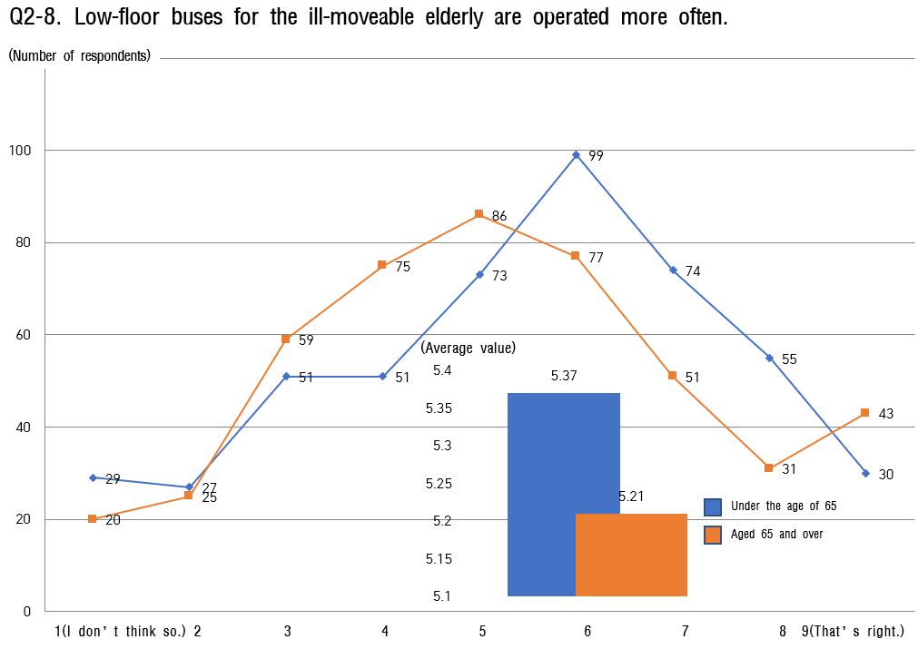

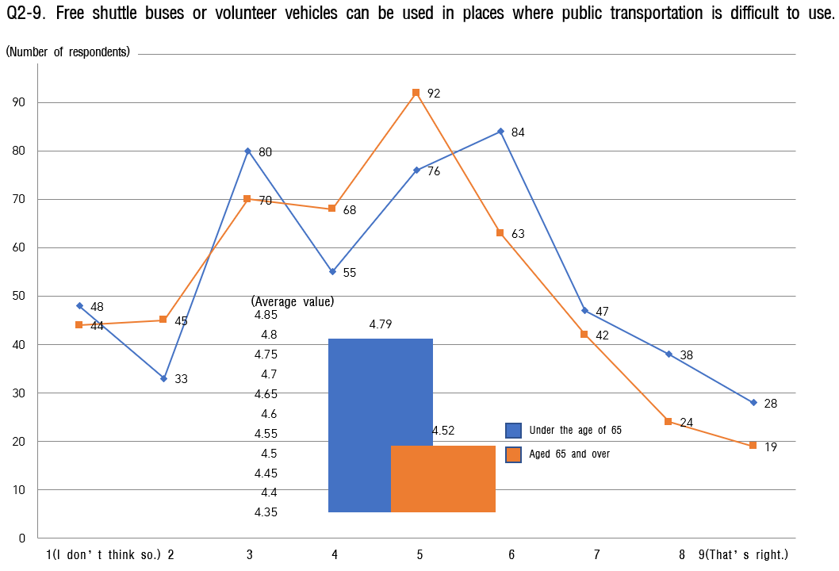

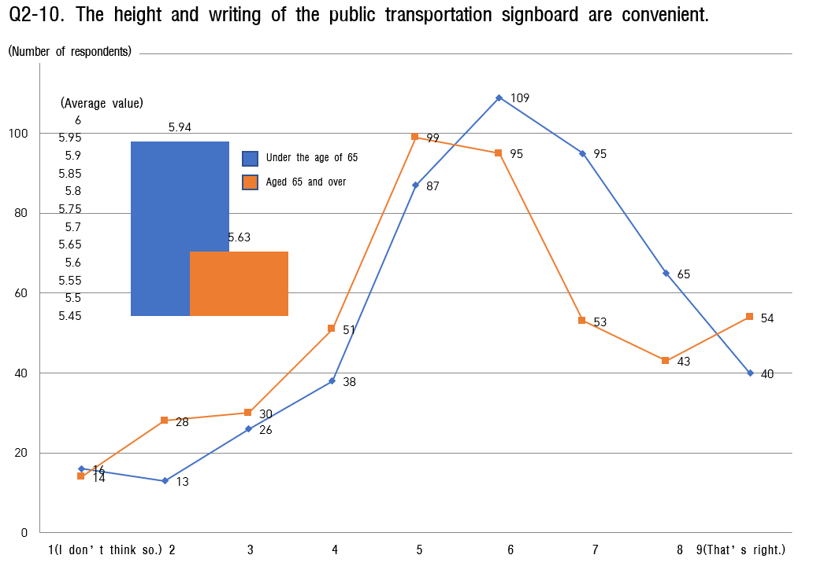

Stability of residential environment
    - In the question of the residential environment, the average value under the age of 65 was 6.19 points (out of 9), and the average value over the age of 65 was 5.96 points (out of 9 points); the average value of the former was analyzed to be 0.24 points higher than that of the latter.
    - The lowest average value for those under the age of 65 is 'Housing management support service (house repair support, etc.)', and the second lower ranking is ‘old age friendly facilities’(toilet safety bar, anti-slip, threshold ramp, emergency bell, etc.) It means that house repair support and installation of safety facilities in housing are needed first
    - The response of those under the age 65 is similar to that of those aged 65 or older, and the awareness of the stability of the residential environment is very low for those aged 65 and over 89, so detailed projects to improve the residential environment seem to be needed.

    - In particular, it can be inferred that housing management support services for the elderly (house repair support, toilet safety bar, anti-slip, threshold ramp, emergency emergency bell, etc.) are recognized as the most urgent projects.

[Table 10] Analysis of status of residential environment stability

Sortation |  | under the age of 65 |  | aged 65 and over
 |  | Average value | Ranking | Average value | Rankin g
the entire |  | 6.19 | - | 5.95 | -
3. Stability of residential environment | 3-Ⓒ. Residential area safety | 6.48 | 5 | 6.48 | 2
 | 3-Ⓒ. Convenience of transportation | 6.61 | 2 | 6.38 | 3
 | 3-Ⓒ. Convenient movement of convenience facilities | 6.58 | 3 | 6.31 | 4
 | 3-④. Excellent welfare service | 6.53 | 4 | 6.61 | 1
 | 3-Ⓒ. Support for elderly residential welfare | 5.90 | 7 | 5.59 | 8
 | 3-⑥. Counseling, support, and services | 5.97 | 6 | 5.58 | 9
 | 3-Ⓒ. Disaster safety | 5.79 | 8 | 5.62 | 6
 | 3-⑧. Old age-friendly facilities | 5.71 | 9 | 5.61 | 7
 | 3-⑨. Difficulty to find affordable housing | 6.81 | 1 | 6.11 | 5
 | 3-⑩. Support service for Housing management | 5.55 | 10 | 5.25 | 10

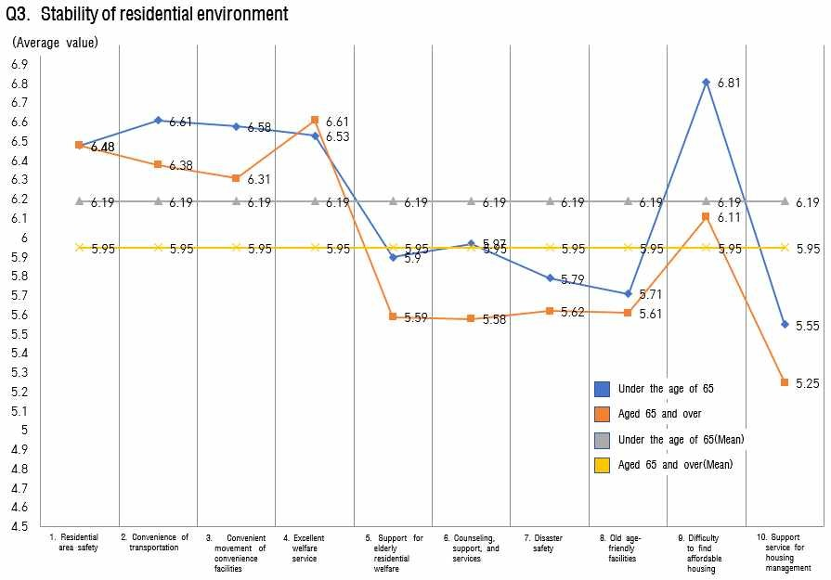

[Fig. 2-10] Analysis of the status of residential environment stability

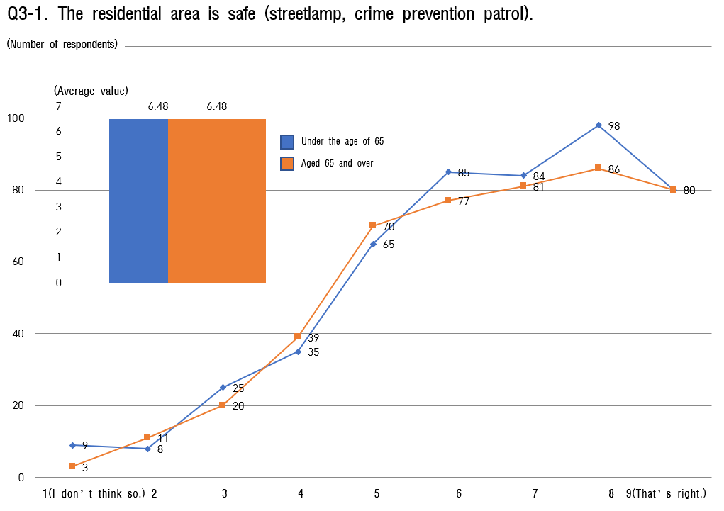
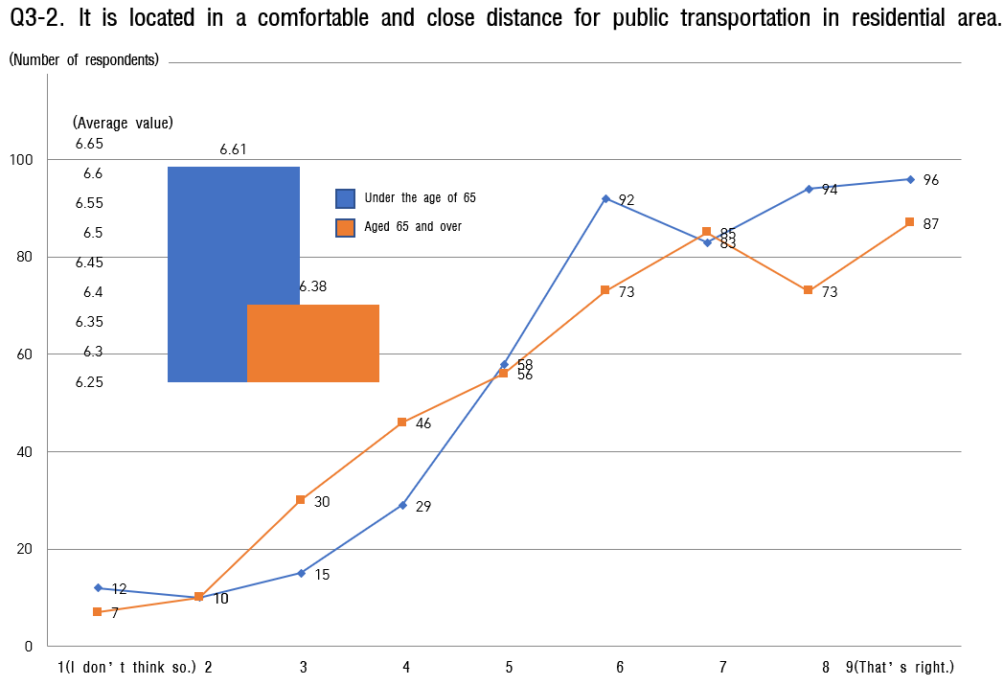

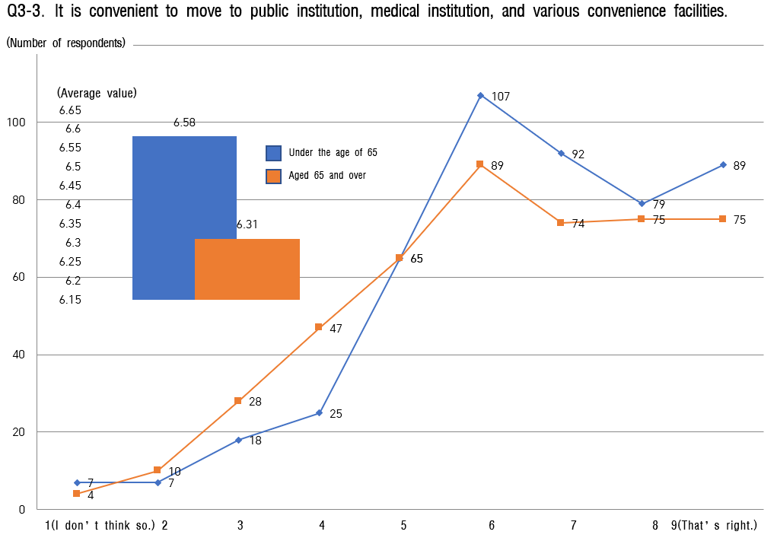

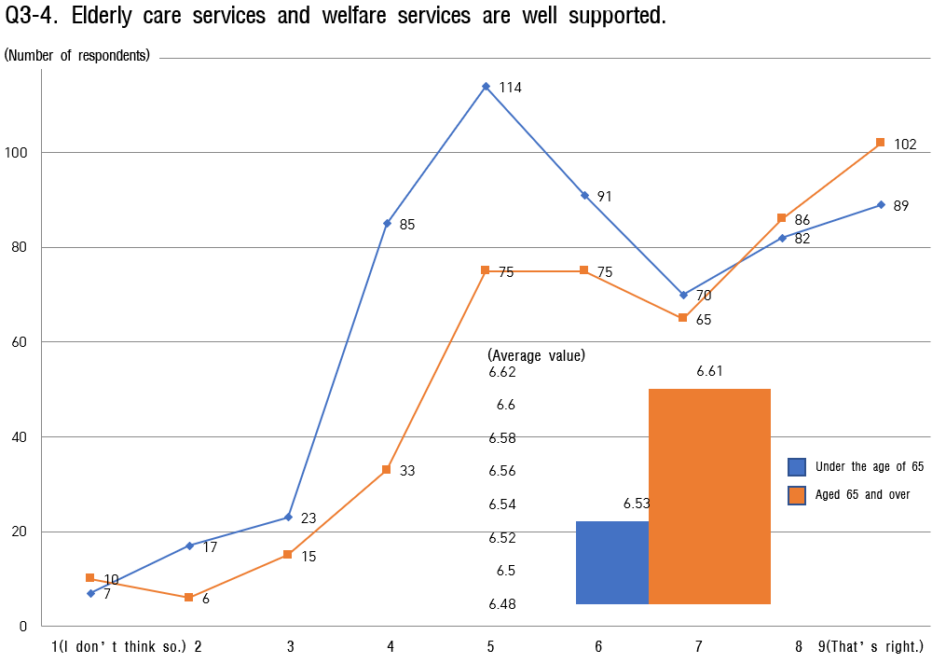

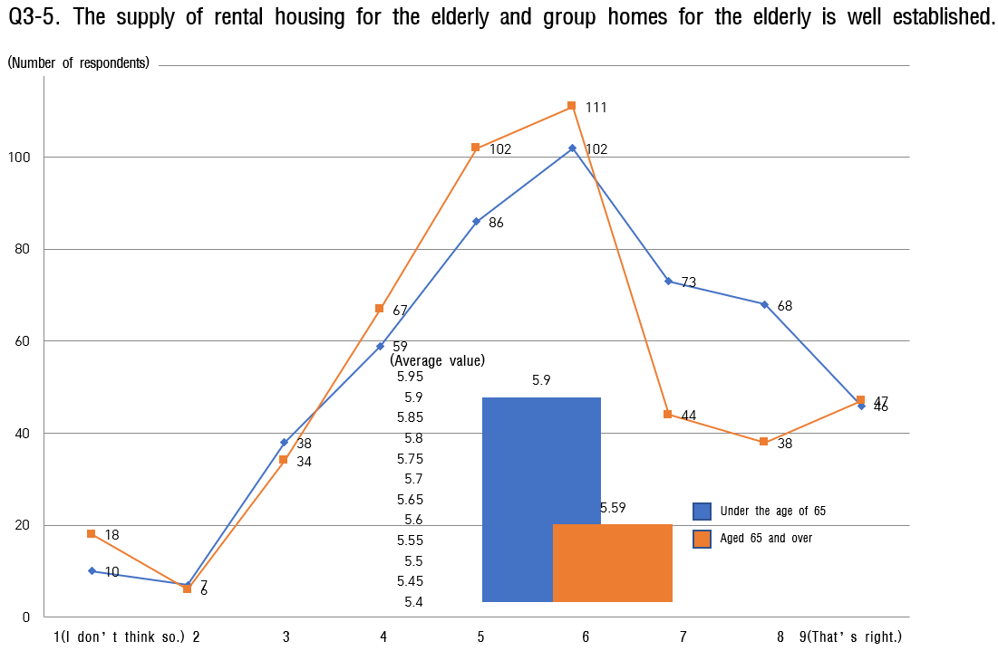

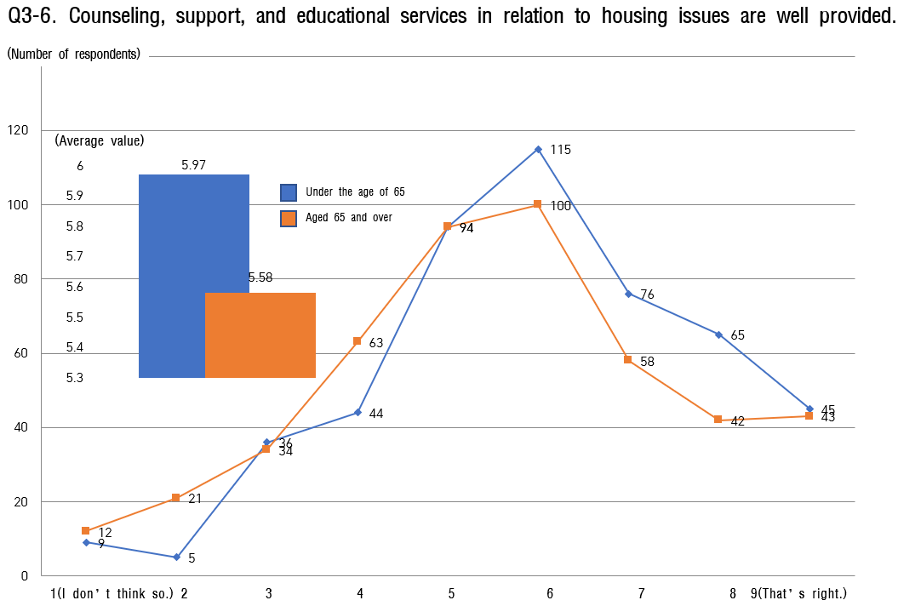

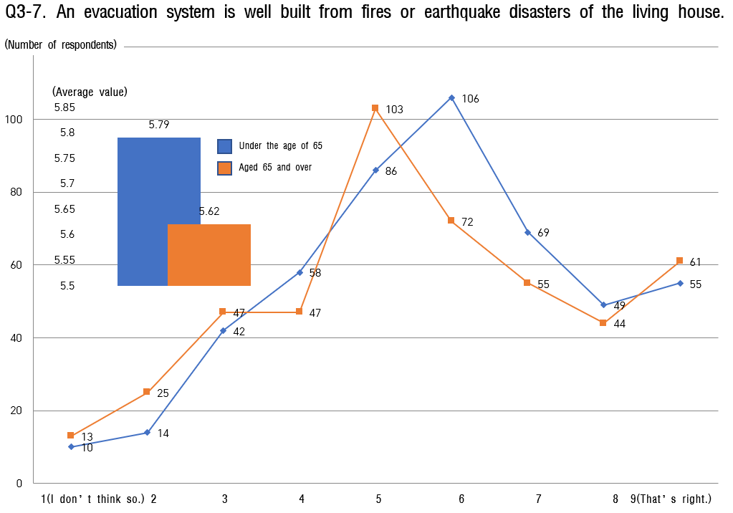

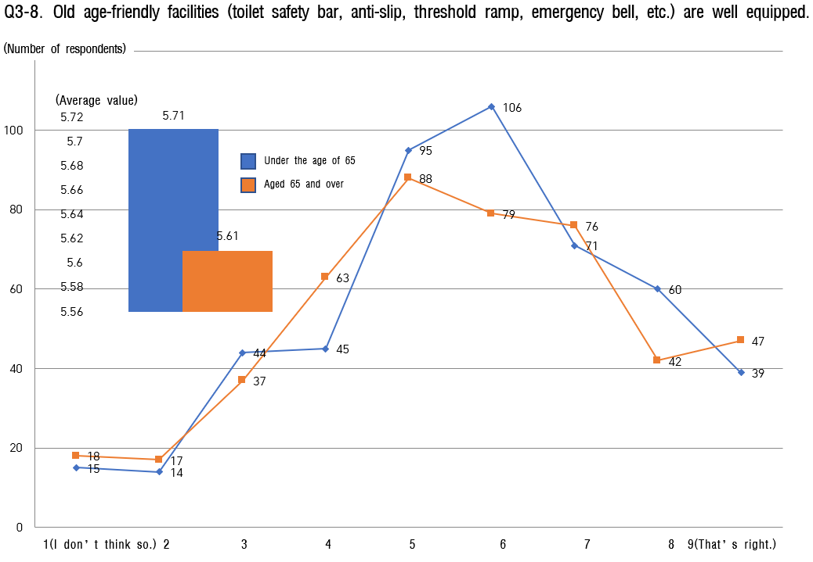

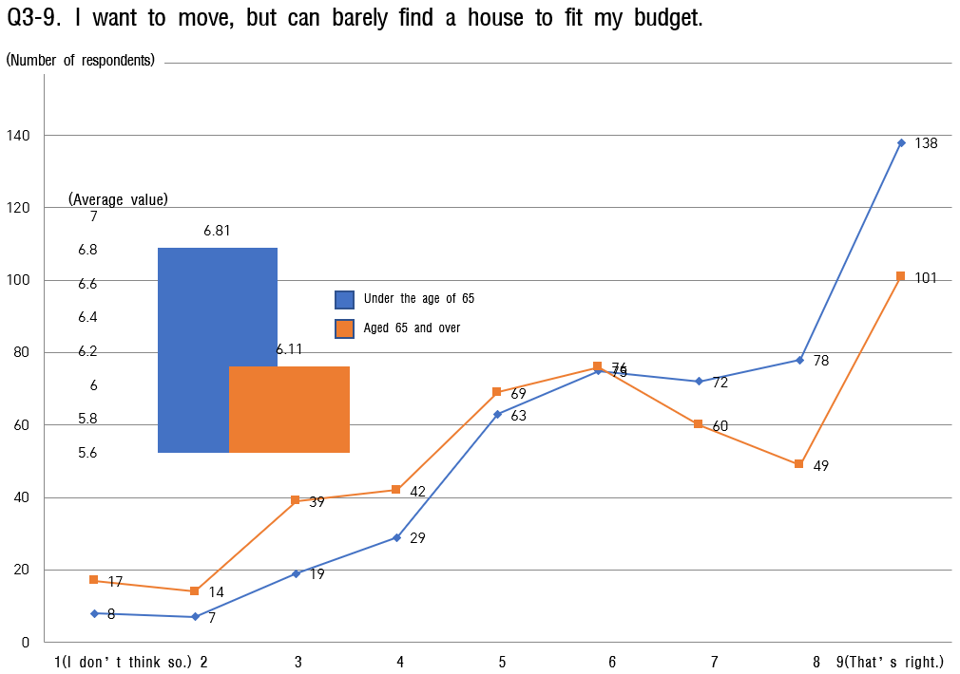

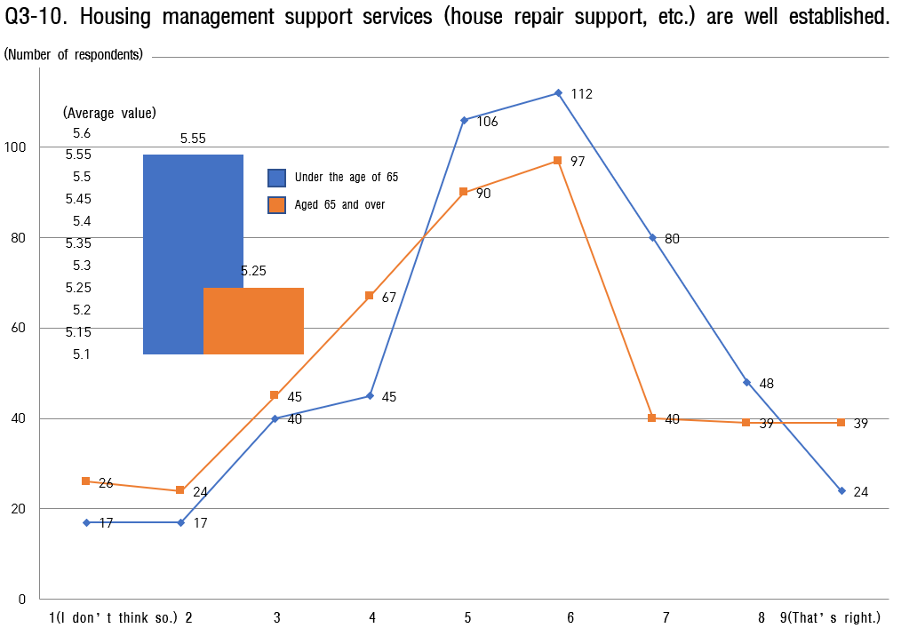

Leisure and social activities
    - In the question of leisure and social activities of the elderly, the average value under the age of 65 of 65 was higher than the average value aged 65 and over.
    - It is a variety of programs(Yoga, music, cooking, physical education, etc.) that people under the age of 65 regard leisure and social activities as doing best.
    - The overall average value is low for those aged 65 and over, but it shows the highest score in "There are various social activities (religion, culture, hobbies, leisure, volunteer activities, etc.) that can participate."
    - On the other hand, the lowest score for those under the age of 65 of 65 was 5.31 points (out of 9), saying, "There are many spaces such as meeting places and facilities for inter-generational harmony." Next, with the score of 5.45 points (out of 9), is “Generation integration events” participating in all generations are conducting well.
    - As a result, it can be seen that it is very necessary to develop a space and program for harmony between generations as a strategy for the elderly's participation in leisure and social activities.

[Table 11] Analysis of the status of leisure and social activities.

Sortation |  | under the age of 65 |  | aged 65 | and over
 |  | Average  value | Ranking | Average  value | Ranking
the entire |  | 6.15 | - | 5.82 | -
 | 4-Ⓒ. Various social activities | 6.39 | 4 | 6.12 | 4
 | 4-Ⓒ. Space available for participation | 6.52 | 3 | 6.24 | 1
 | 4-Ⓒ. Systematic collection of | 6.55 | 2 | 6.12 | 4
 | information
 | 4-④. Easy and convenient | 5.97 | 8 | 5.78 | 7
 | participation
4. Leisure and social | 4-Ⓒ. Finding a place for social  activities easily | 6.17 | 6 | 5.87 | 6
 | 4-⑥. Operation of various programs | 6.70 | 1 | 6.22 | 2
activities
 | 4-Ⓒ. Convenient participation in | 6.34 | 5 | 5.92 | 5
 | social activities
 | 4-⑧. Generation integration events | 5.45 | 9 | 5.05 | 10
 | 4-⑨. Providing a space for | 5.31 | 10 | 5.12 | 9
 | intergenerational harmony
 | 4-⑩. Opportunities for Low cost | 6.06 | 7 | 5.74 | 8
 | participation
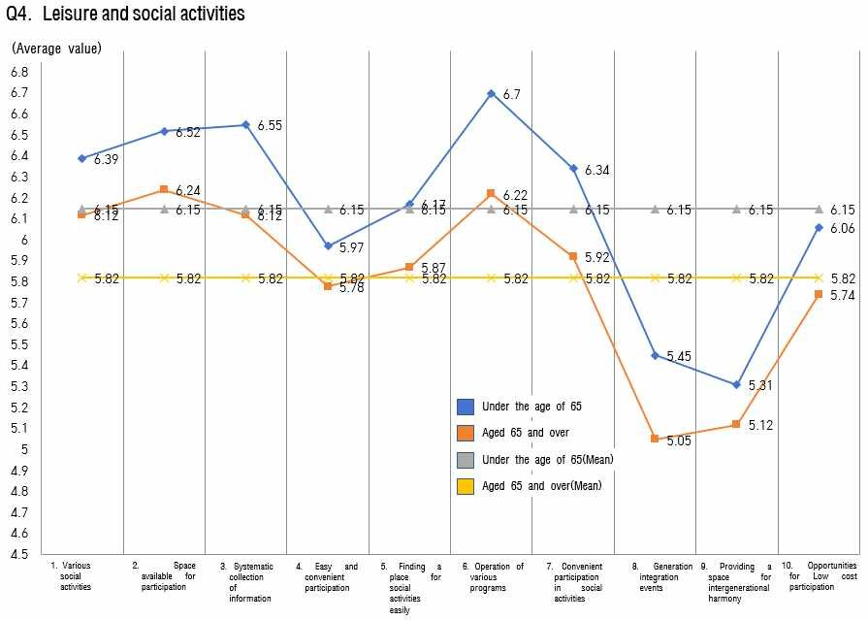
[FIG. 11] Analysis of the status of leisure and social activities
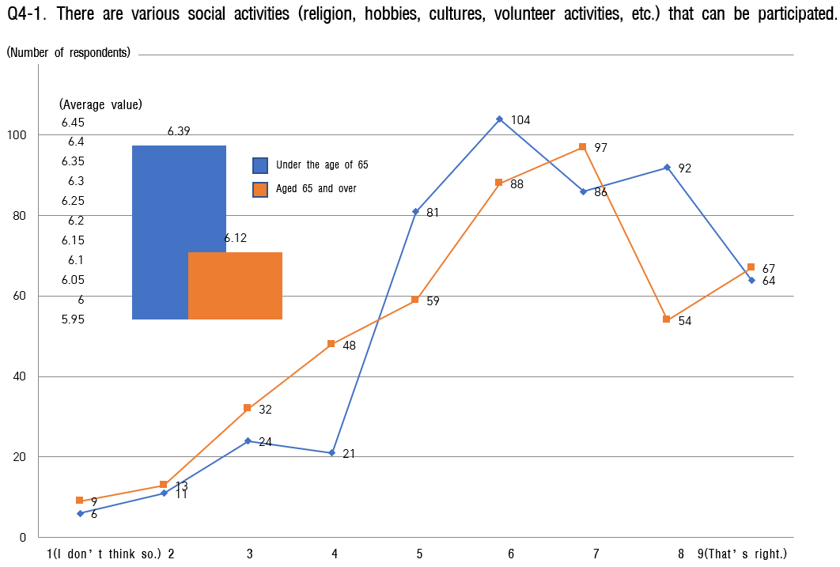

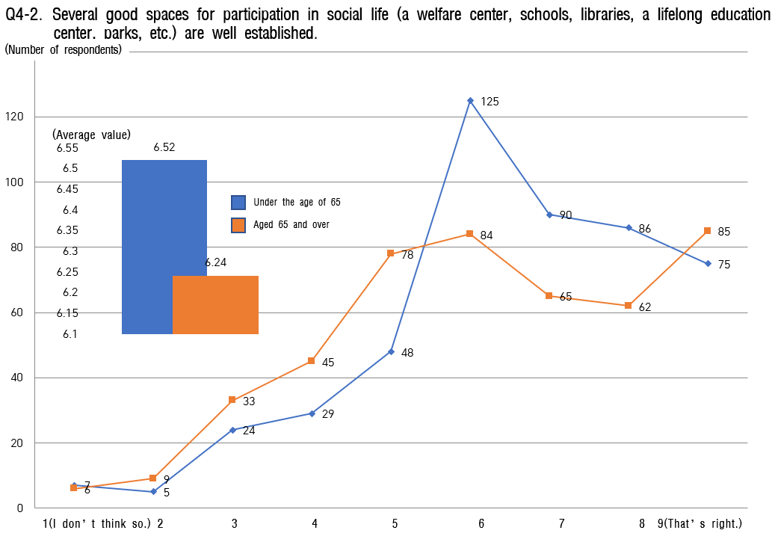

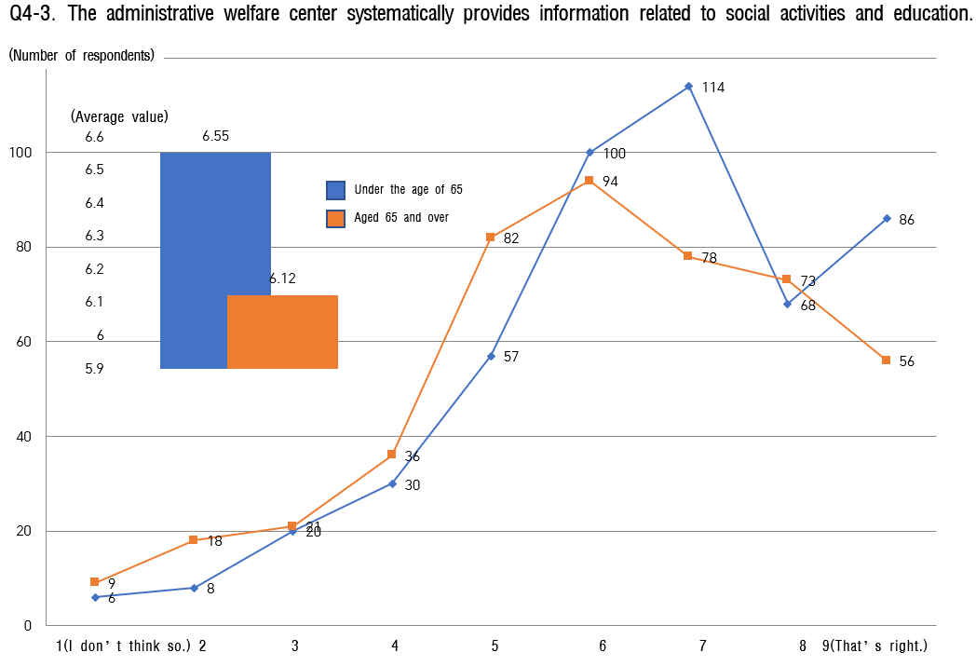

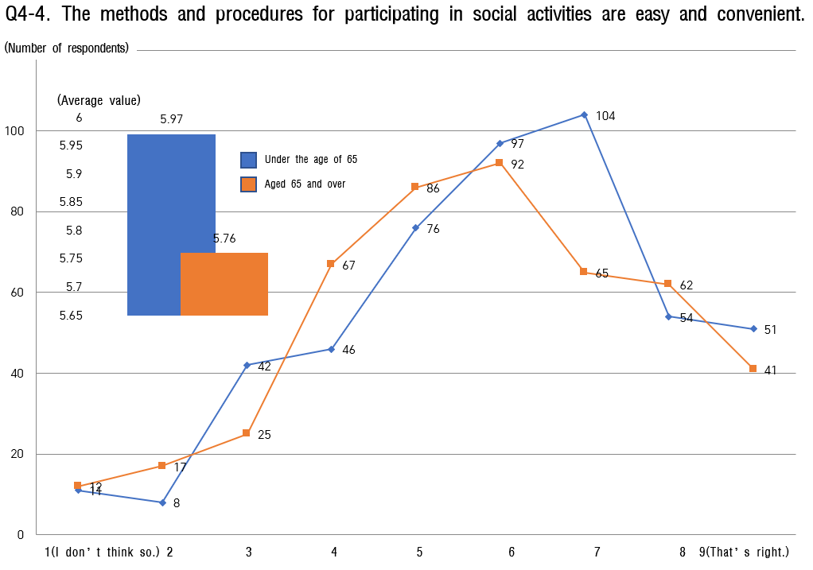

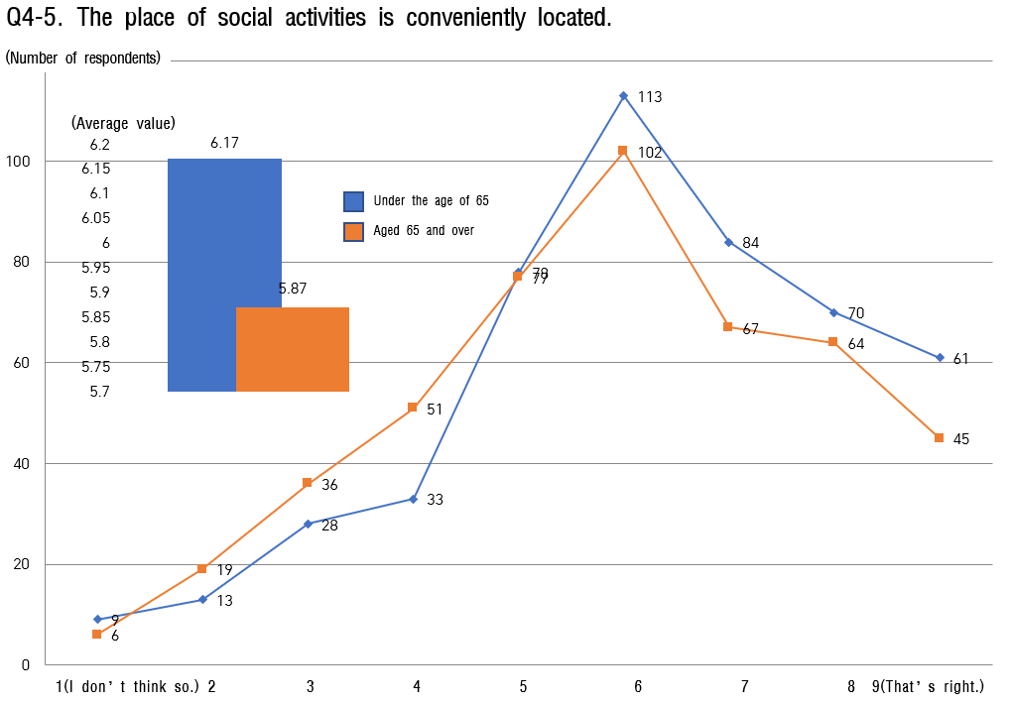

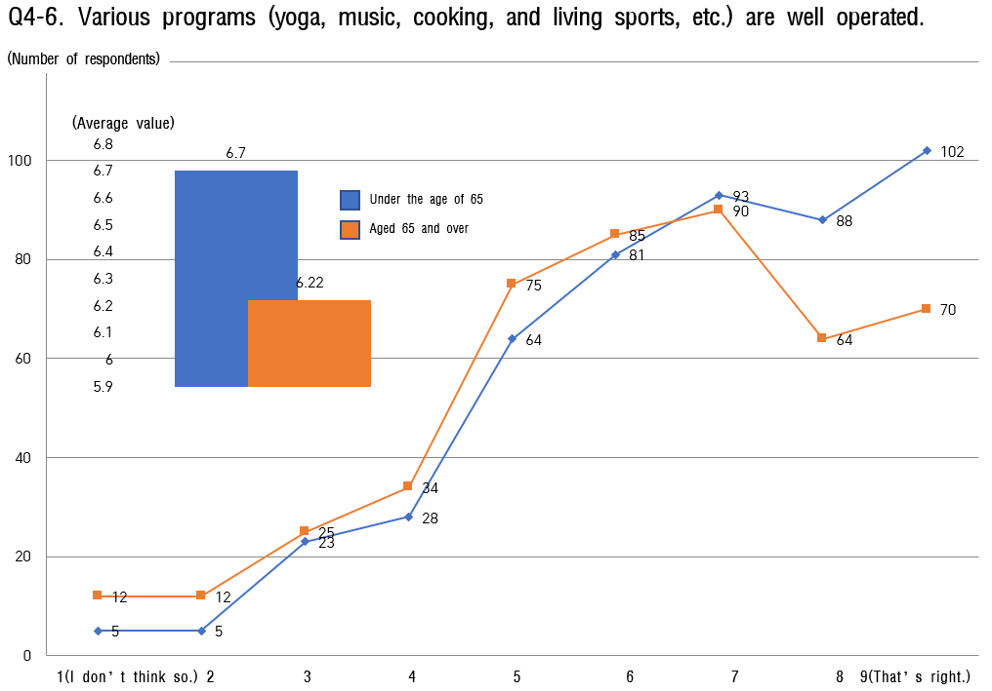

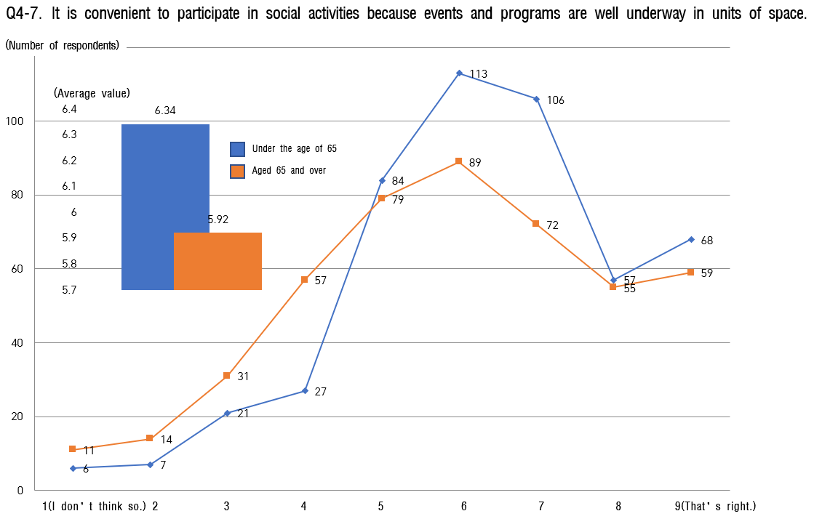

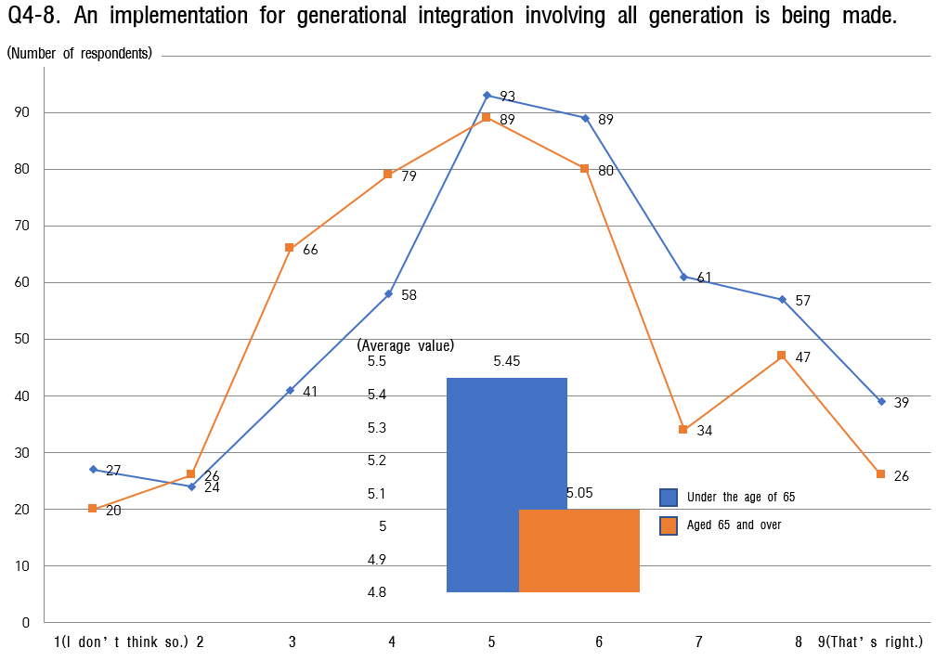

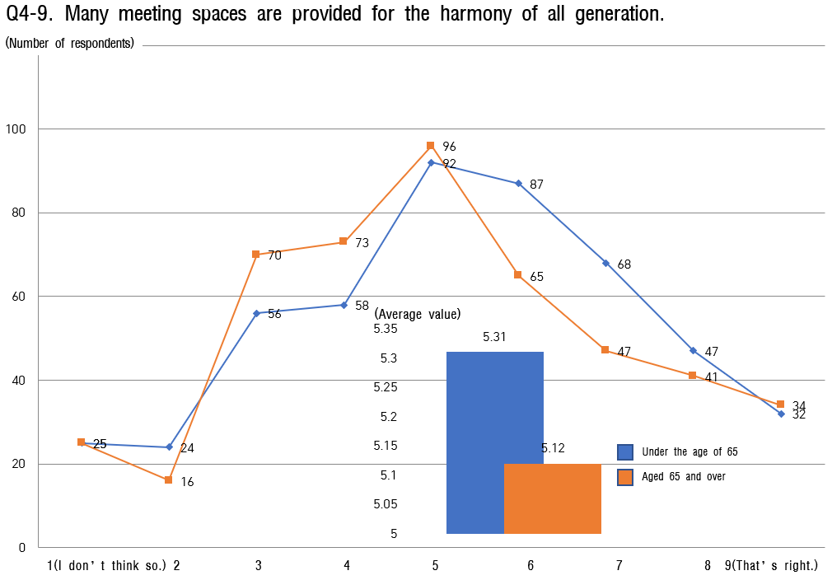

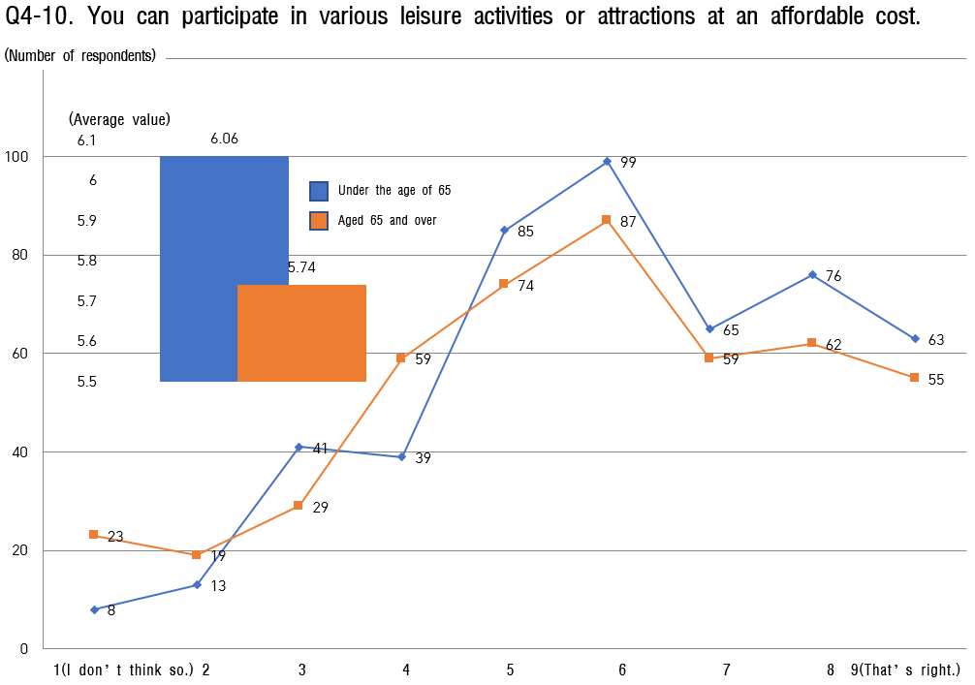

Social participation and employment
    - In questions about social participation and jobs, the average value of all age groups is in the 5-point range.
    - In particular, it was confirmed that respondents aged 65 and over had lower social participation and awareness of jobs than respondents under the age of 65 of 65.
    - The lowest score for those under the age of 65 of 65 is 'a job training program suitable for me is in operation’ and 'You can consult with experts on reemployment.' was surveyed as 5.62 points (out of 9) and 5.66 points (out of 9), respectively, and even those aged 65 and over showed also far lower scores with 5.17 points and 4.93 points in the same category.
    - It seems necessary to establish a strategy so that vocational training programs can be operated based on the expansion of reemployment counseling by experts in all age groups and the contents of counseling obtained in this way.

[Table 12] Analysis of the status of social participation and jobs

Sortation |  | under the age of 65 |  | aged 65 | and over
 |  | Average  value | Ranking | Average  value | Ranking
the entire |  | 5.94 | - | 5.67 | -
 | 5-Ⓒ. Guidance on volunteer | 5.66 | 9 | 5.53 | 6
 | activities
 | 5-Ⓒ. Encouragement and support | 5.85 | 5 | 5.80 | 5
 | for volunteer work
 | 5-Ⓒ. Volunteer support for the | 6.08 | 3 | 6.01 | 2
 | elderly with financial difficulties
5. Social Participation | 5-④. Volunteer Support for the  ill-moveable elderly | 6.05 | 4 | 5.99 | 3
 | 5-Ⓒ. Public work | 6.83 | 1 | 6.52 | 1
and Jobs
 | 5-⑥. Support for elderly start-ups | 5.82 | 6 | 5.41 | 8
 | 5-Ⓒ. Provision of job information | 6.10 | 2 | 5.81 | 4
 | 5-⑧. Discrimination against jobs | 5.75 | 7 | 5.48 | 7
 | 5-⑨. Operation of vocational | 5.62 | 10 | 5.17 | 9
 | training program
 | 5-⑩. Reemployment counseling by | 5.66 | 9 | 4.93 | 10
 | experts

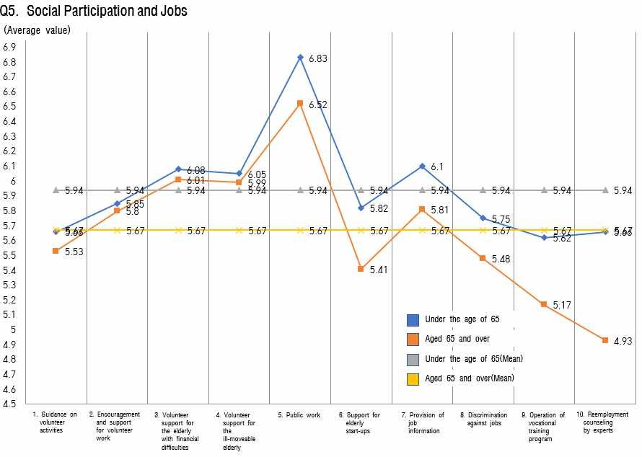
[FIG. 12] Analysis of the status of social participation and jobs

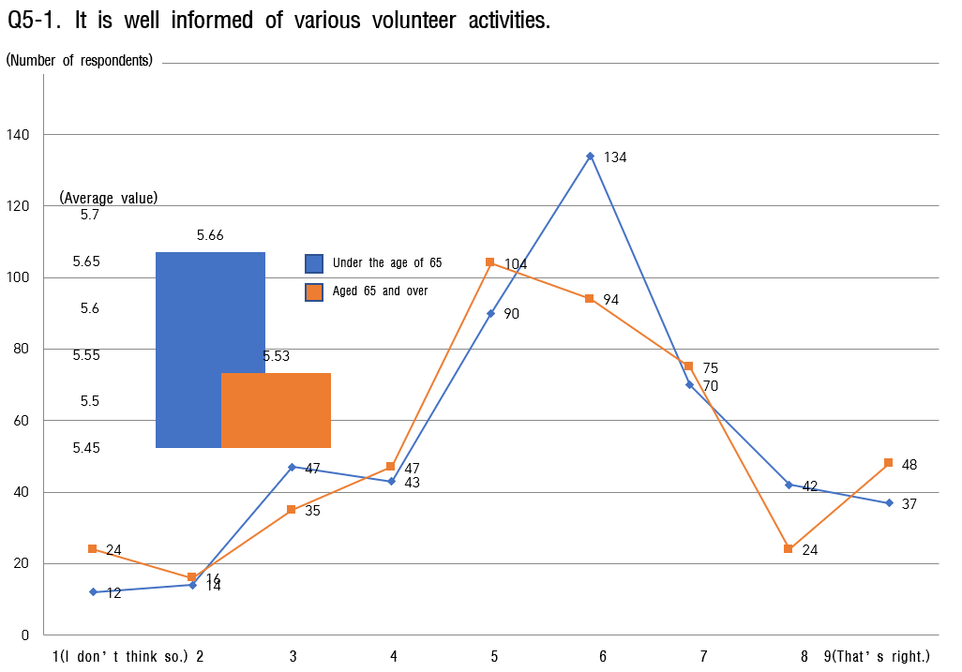
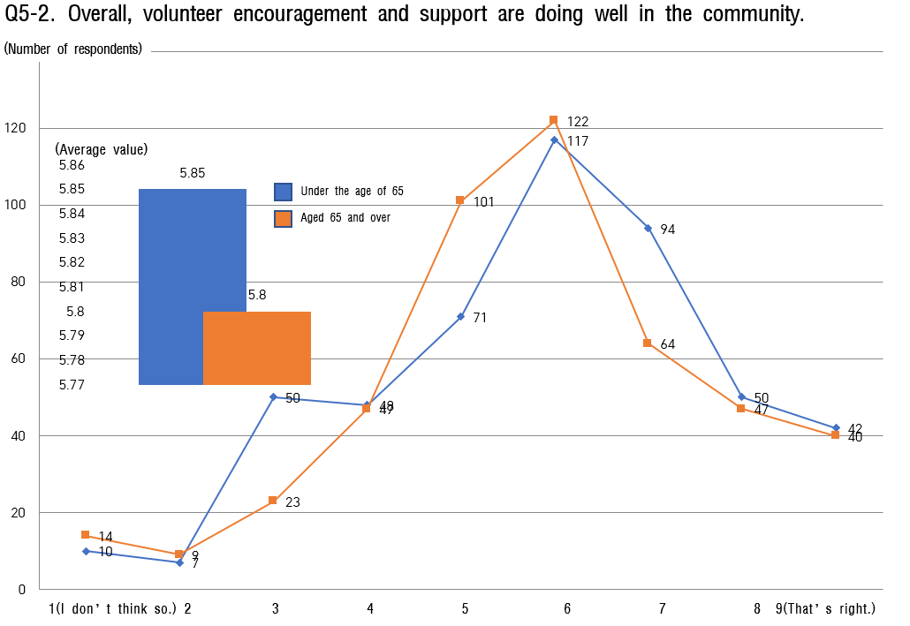

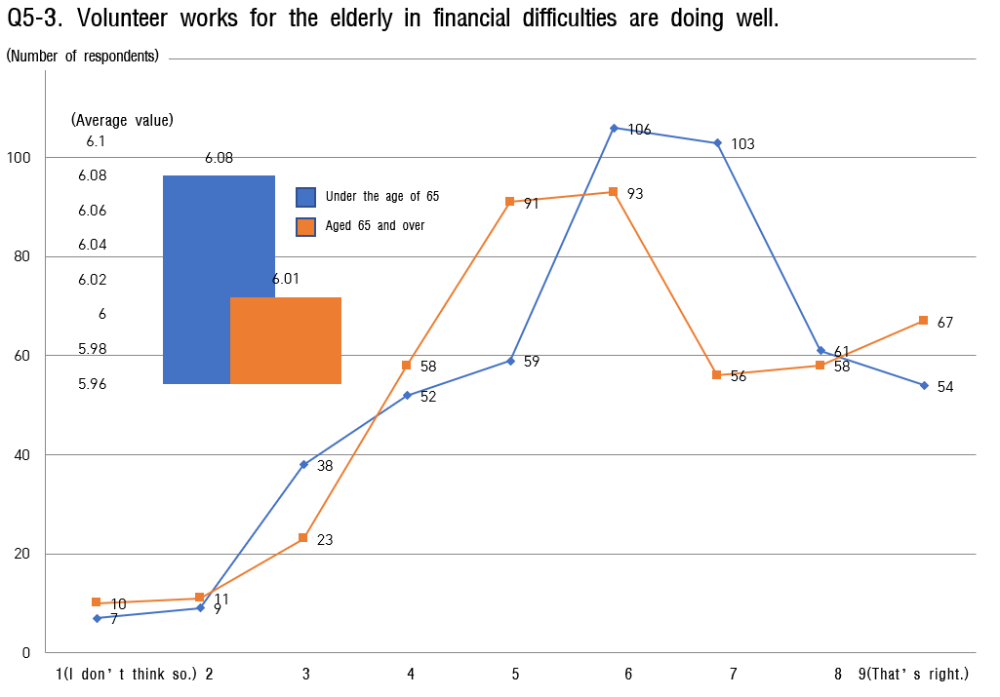

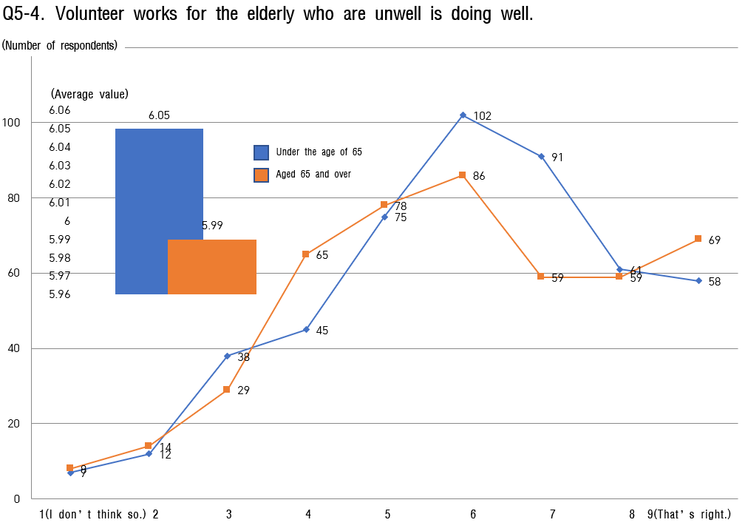

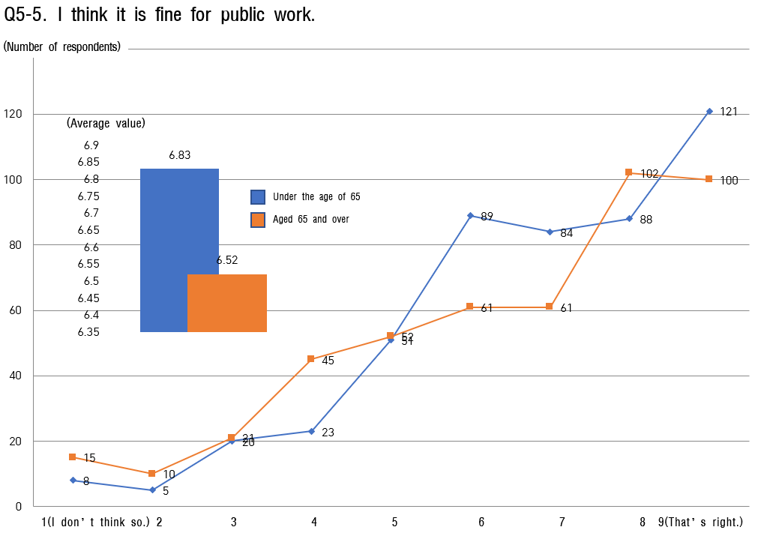

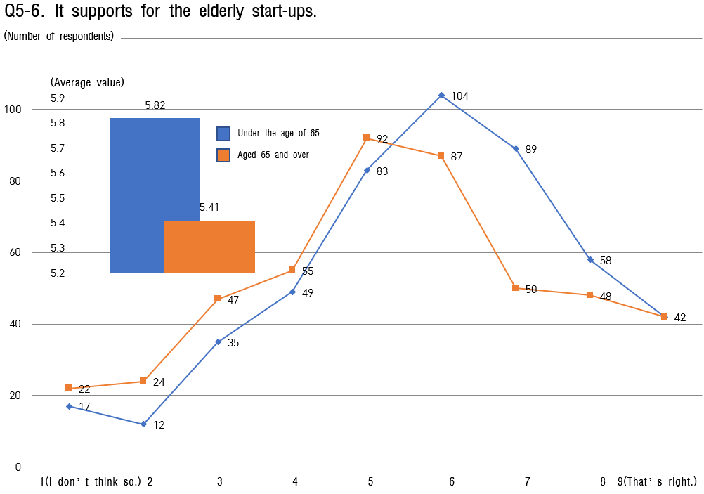

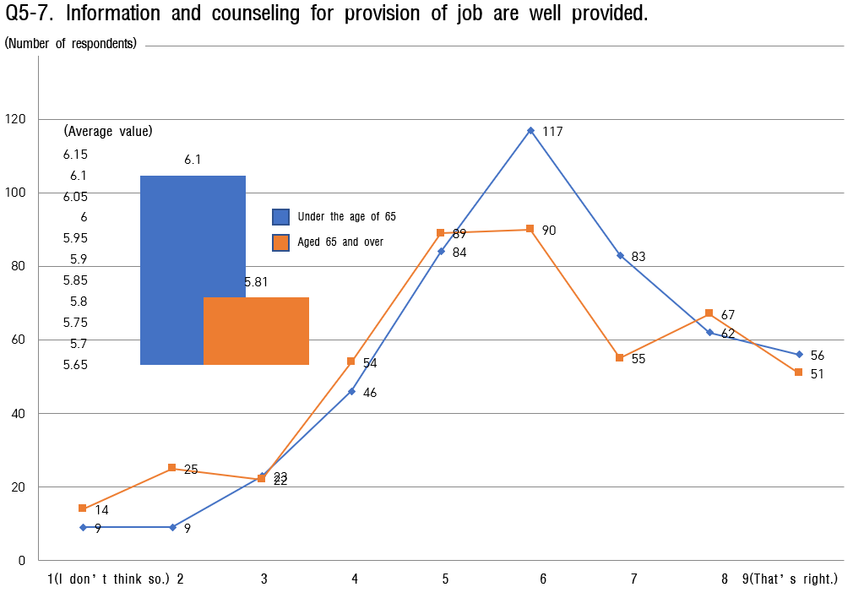
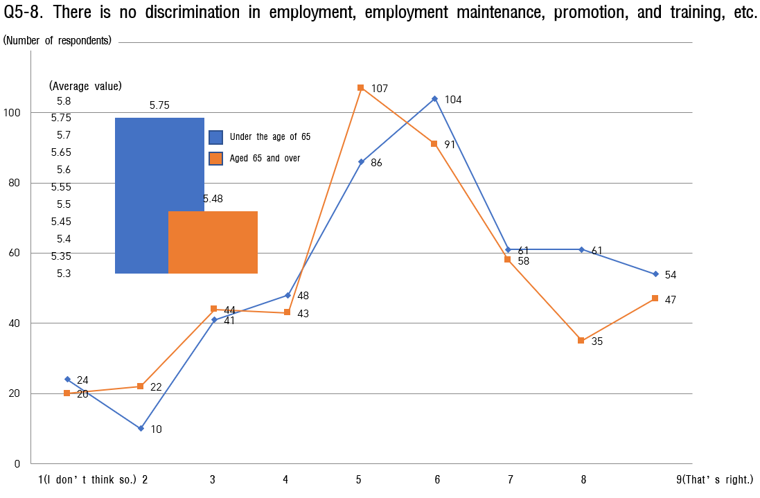

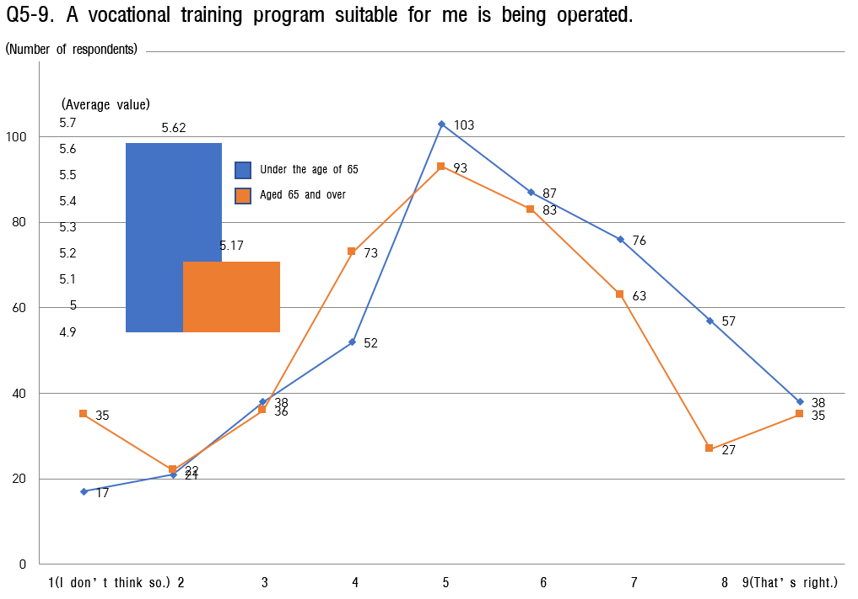

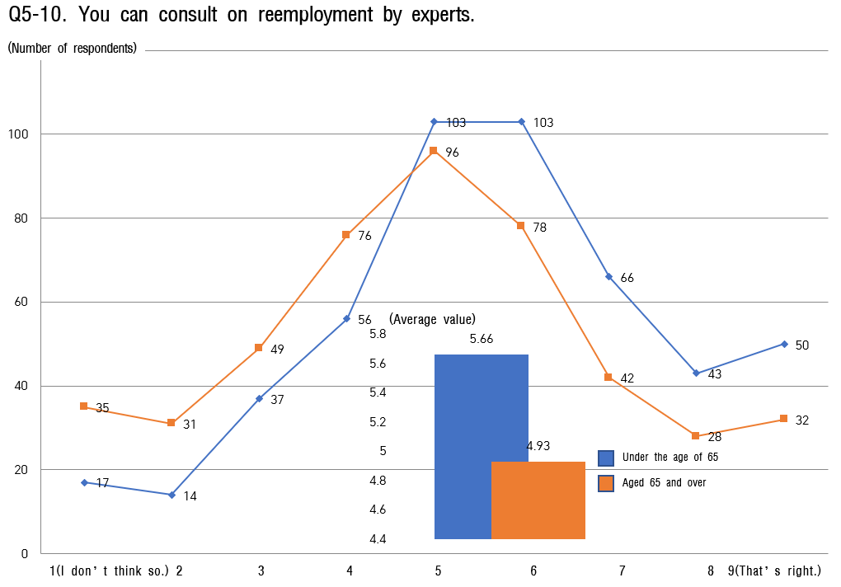

Respect and Social Integration
    - In the question of respect and social integration, the average value under the age of
65 is 5.92 points, and that of over the age of 65 is 5.79 points, showing a lower average score in here.
    - The reason for this is attributed to the characteristics of the 06-8 and 06-10 questions, and the lower the score, the better as two saying, "I think the elderly are socioeconomic burdens and conflicts." and "I think elder abuse occurs frequently around."
    - In all age groups I continue to listen to opinions to provide appropriate services. and 'education institutions are providing education for the elderly.' show a low score.
    - Therefore, it seems necessary to expand the means of listening to opinions for the elderly and the right to learn lifelong education more than now.

[Table 13] Analysis of the status of respect and social integration

Sortation |  | under the | age of 65 | aged 65 | and over
 |  | Average value | Ranking | Average value | Ranking
the entire |  | 5.92 | - | 5.79 | -
 | 6-Ⓒ. Proceeding with listening to opinions | 5.95 | 8 | 5.76 | 5
 | 6-Ⓒ. Respect and consideration | 6.24 | 3 | 6.07 | 3
 | 6-Ⓒ. Feeling rewarded | 6.27 | 2 | 6.28 | 2
 | 6-④. Kindness without prejudice | 6.35 | 1 | 6.44 | 1
 | 6-Ⓒ. Implementation of education for the elderly | 5.99 | 7 | 5.74 | 7
6. Respect and | 6-⑥. Opportunities for the
Social | elderly to participate in | 6.19 | 5 | 5.75 | 6
Integration | educational institutions
 | 6-Ⓒ. Opportunities for the
 | elderly to participate in | 6.21 | 4 | 5.57 | 8
 | understanding
 | 6-⑧. Existence of
 | socioeconomic burden and | 5.09 | 9 | 5.38 | 9
 | conflict
 | 6-⑨. Appropriate Support Services | 6.08 | 6 | 5.92 | 4
 | 6-⑩. Elderly abuse | 4.81 | 10 | 4.96 | 10

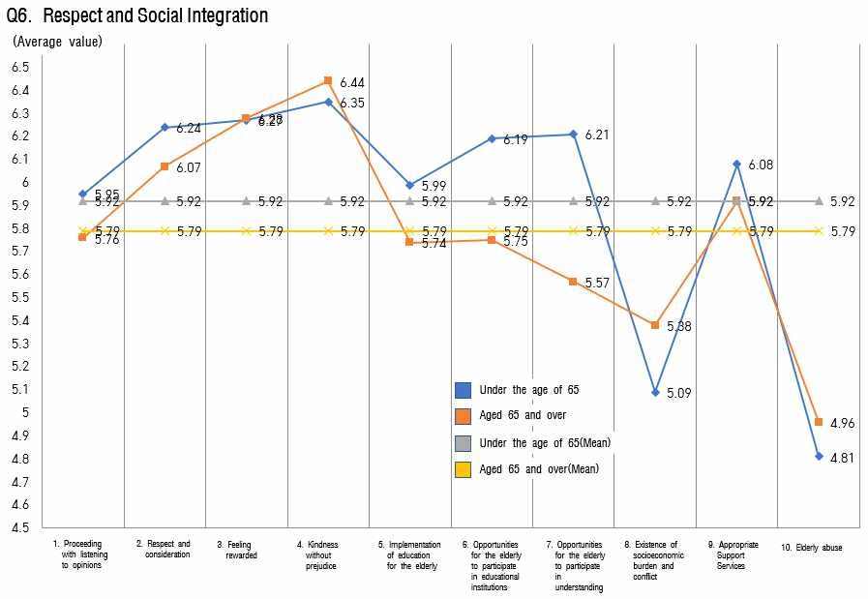

[FIG. 13] Analysis of the status of respect and social integration

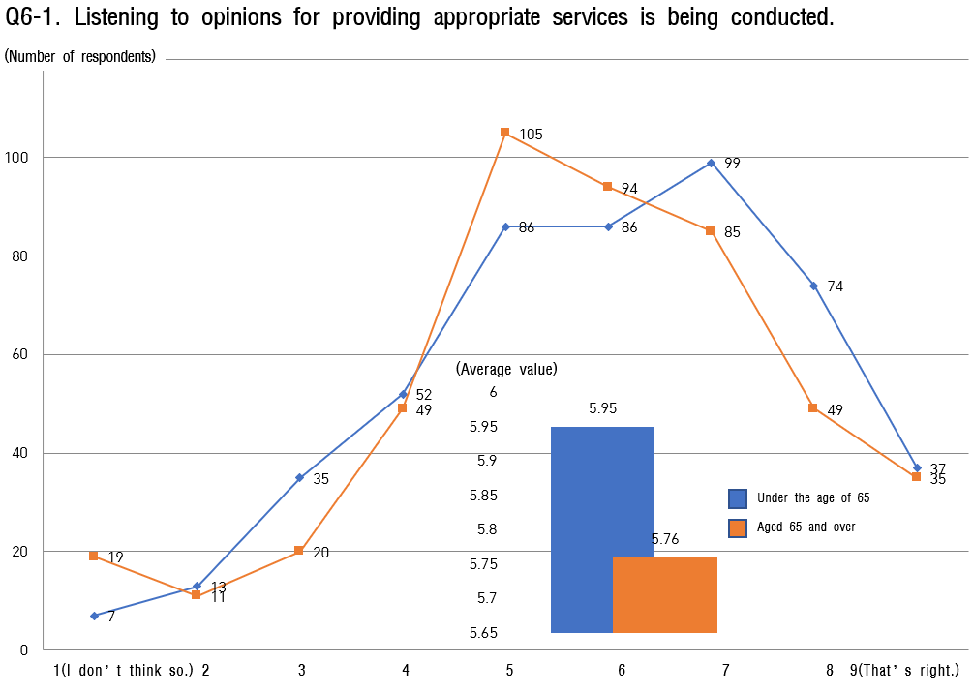

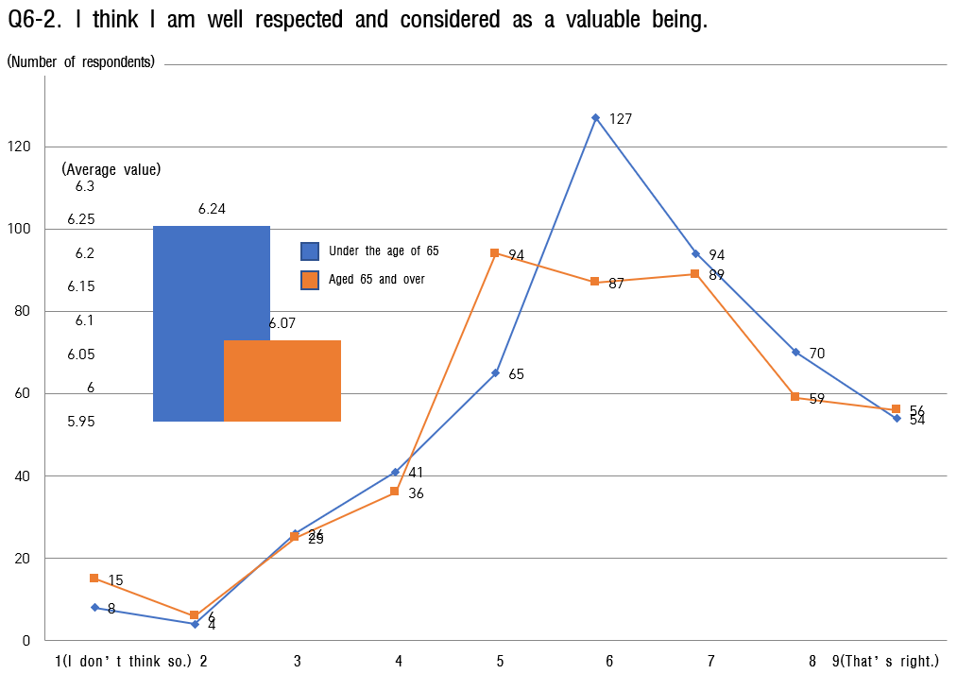

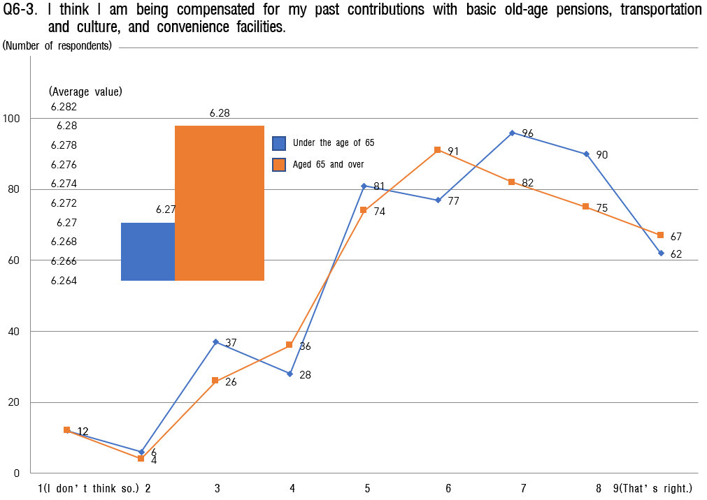

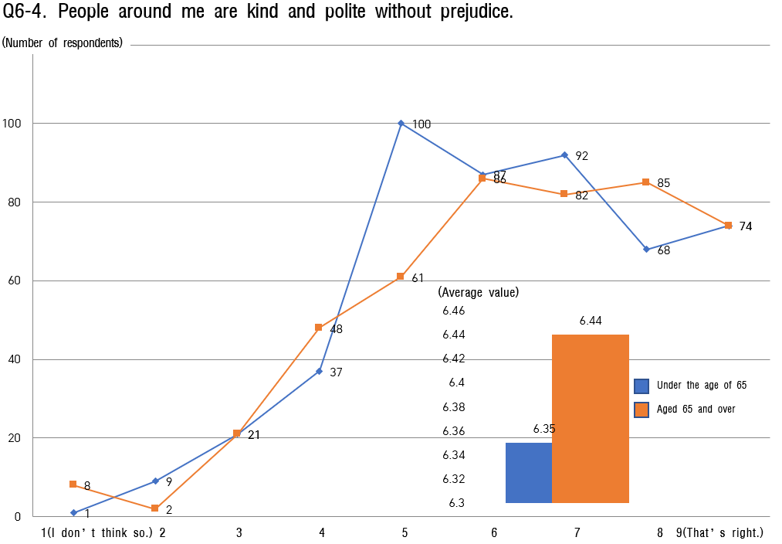

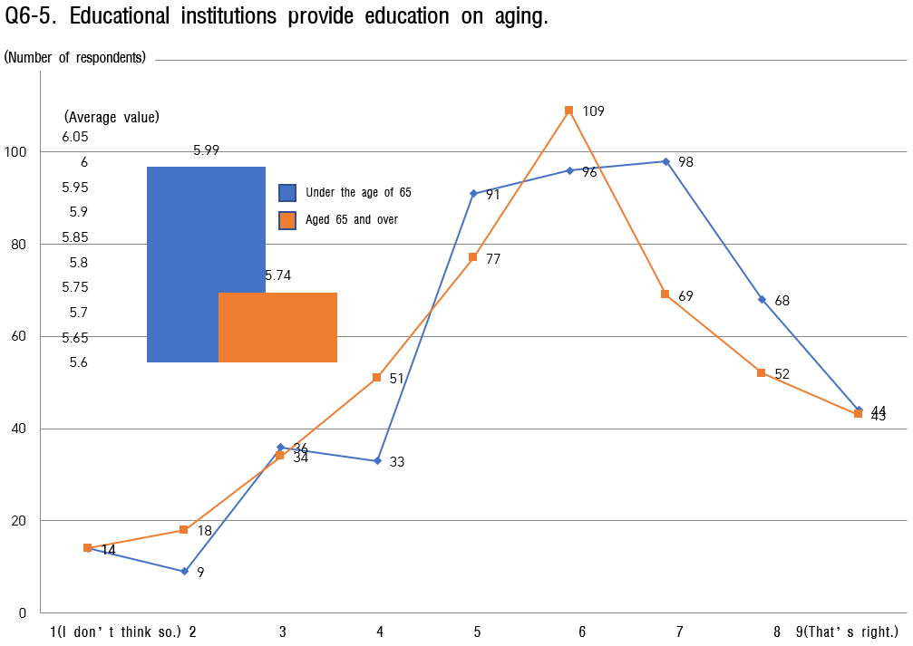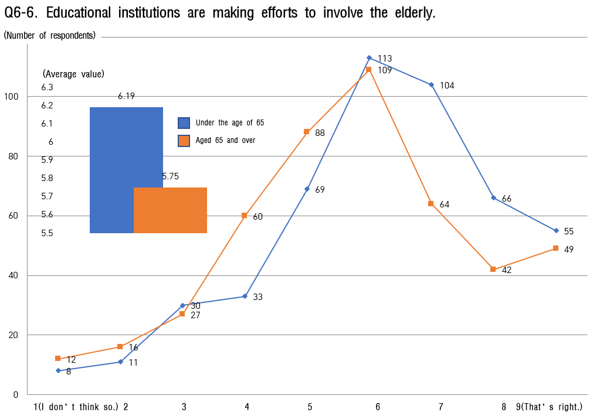

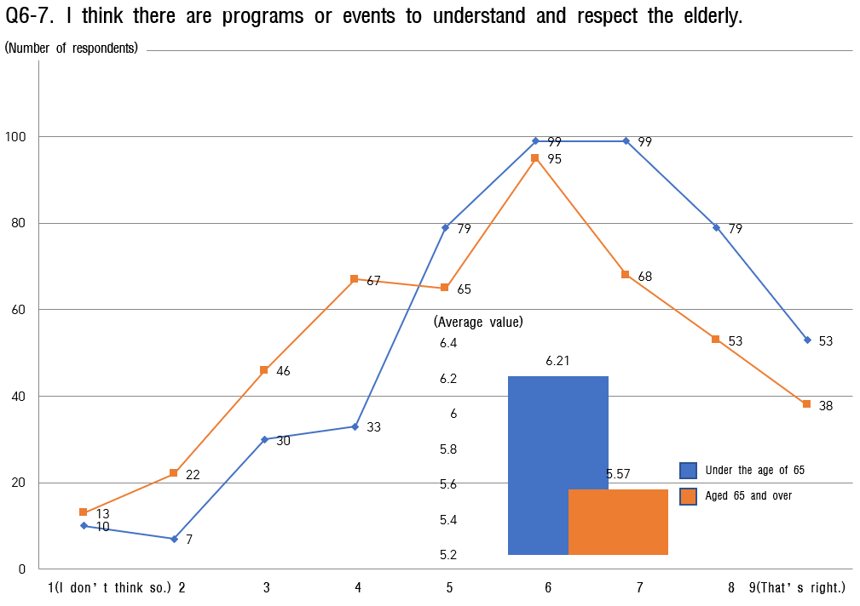

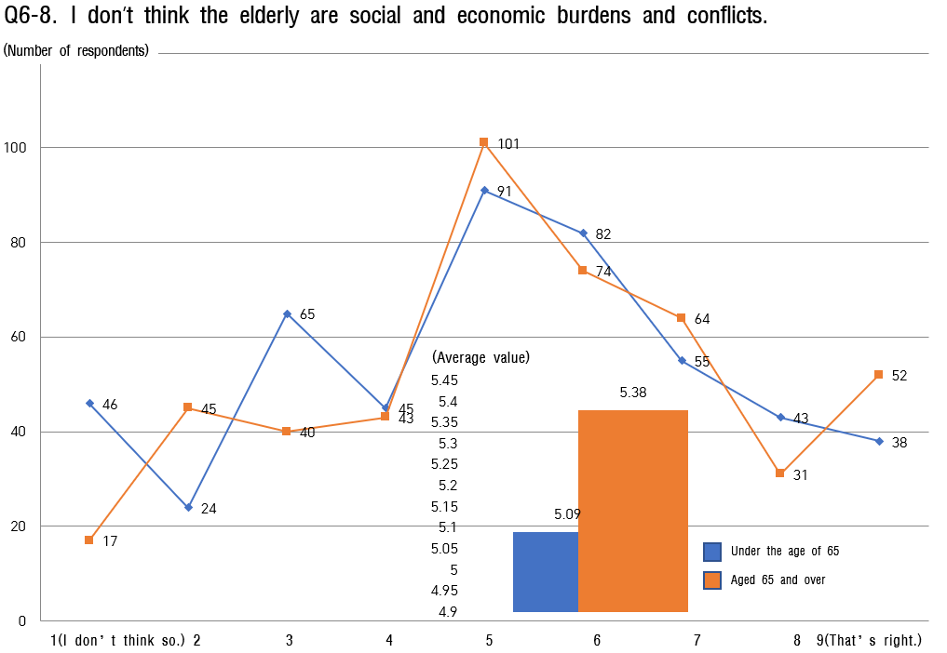

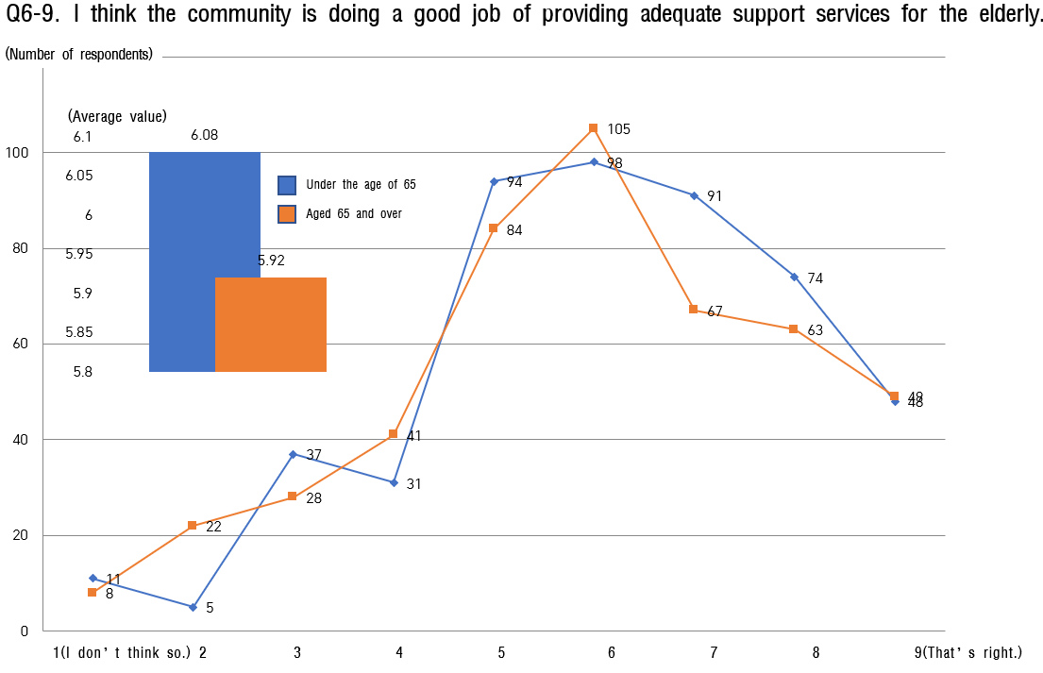

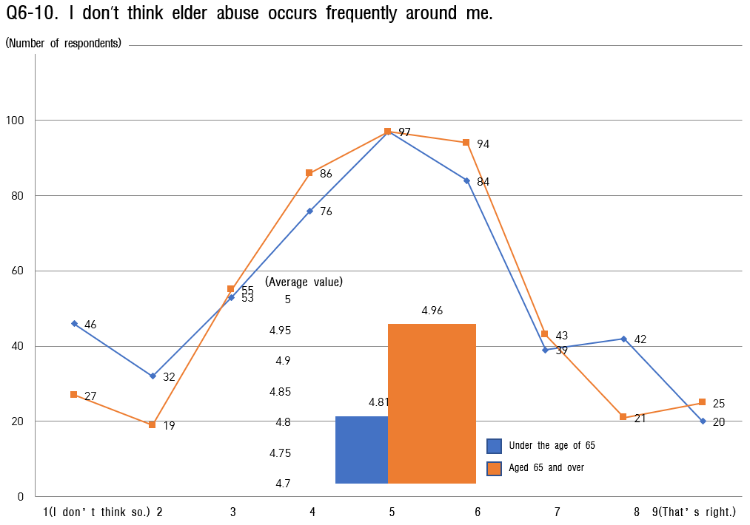

Communication and information
    - In the question of communication and information, the average value under the age of 65 was slightly higher at 6.32 points, that of age over the age of 65 was 6.12 points.
    - The lowest score in all age groups is 'a customized information provision system for the elderly is well established,' followed by 'computer, mobile phone, and information delivery education can be learned at a free or low price in public places.'
    - All age groups believe that above all, in awareness of communication and information the existing customized projects for the elderly are less reliable, so through listening to opinions more active reflection is needed than now. Therefore various support benefits should be found and supported to facilitate access to information and communication.

[Table 14] Status analysis of communication and information

Sortation |  | under the | age of 65 | aged 65 | and over
 |  | Average  value | Ranking | Average  value | Ranking
the entire |  | 6.32 | - | 6.12 | -
 | 7-Ⓒ. Public facilities | 6.36 | 6 | 6.09 | 4
 | information
 | 7-Ⓒ. Public services | 6.39 | 5 | 6.05 | 6
 | information
 | 7-Ⓒ. Use familiar words with | 6.44 | 4 | 5.96 | 7
 | standard language
 | 7-④. Communication service | 6.03 | 8 | 5.55 | 10
7. | 7-Ⓒ. Provision of customized | 5.76 | 10 | 5.71 | 9
Communication | information
and Information | 7-⑥. Provide visiting | 6.51 | 3 | 6.78 | 2
 | information visit information
 | 7-Ⓒ. Cell phone education | 6.79 | 1 | 6.28 | 3
 | 7-⑧. Provide information | 5.99 | 9 | 5.89 | 8
 | related to the elderly
 | 7-⑨. Policy comprehension | 6.31 | 7 | 6.05 | 6
 | 7-⑩. Need for someone to | 6.65 | 2 | 6.83 | 1
 | talk to

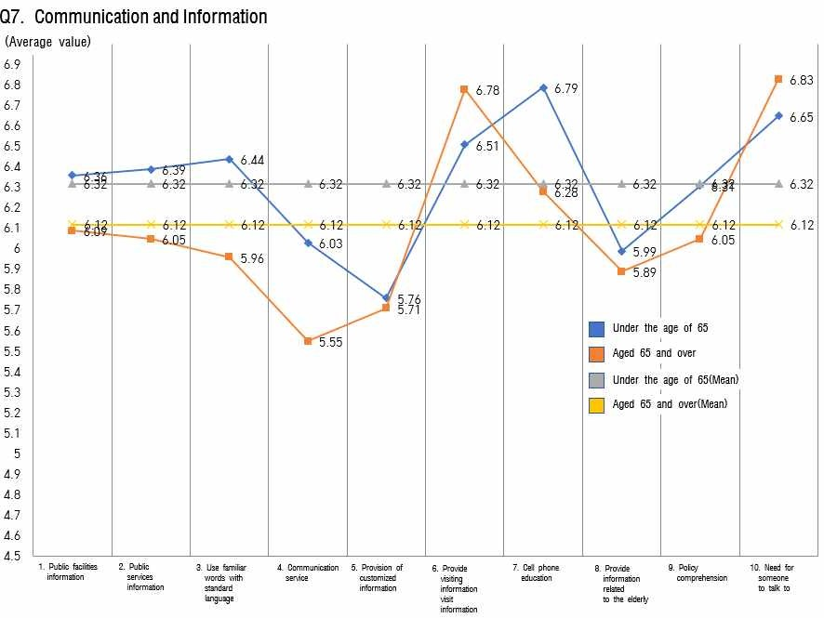
[FIG. 14] Analysis of the status of communication and information
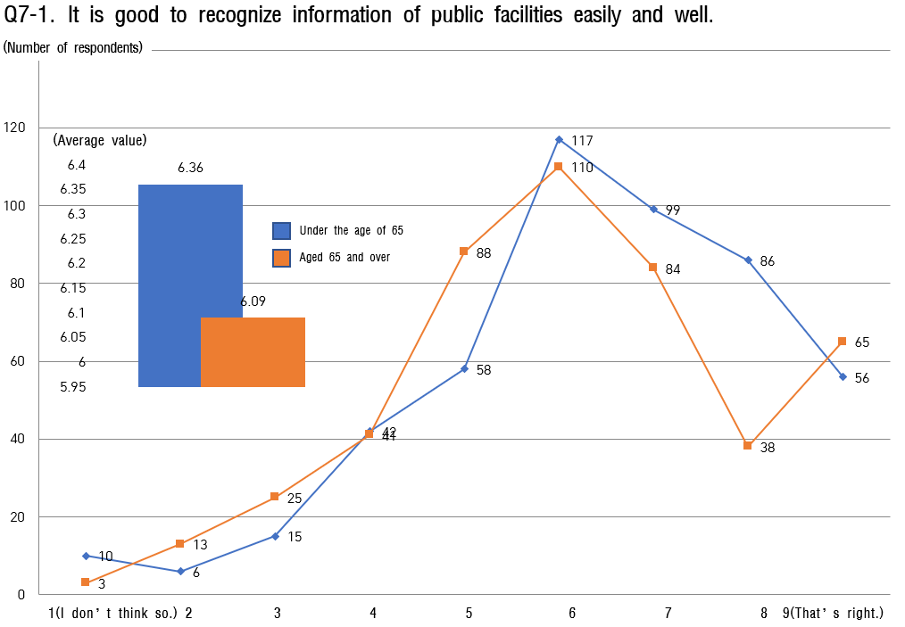

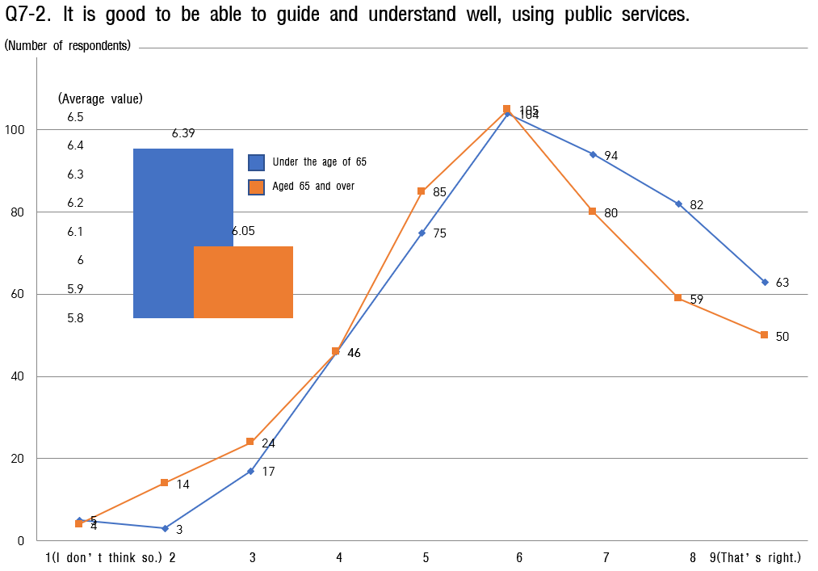

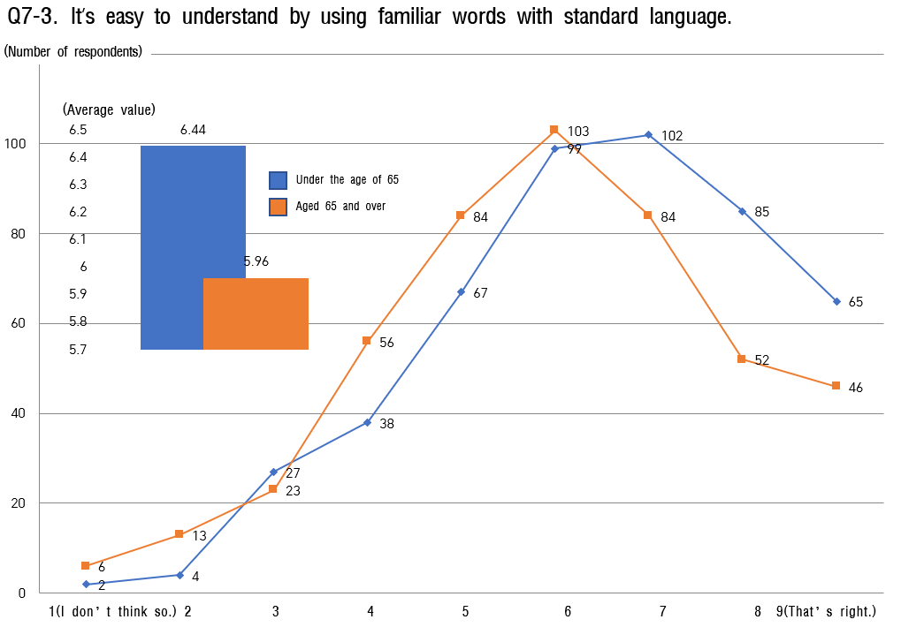

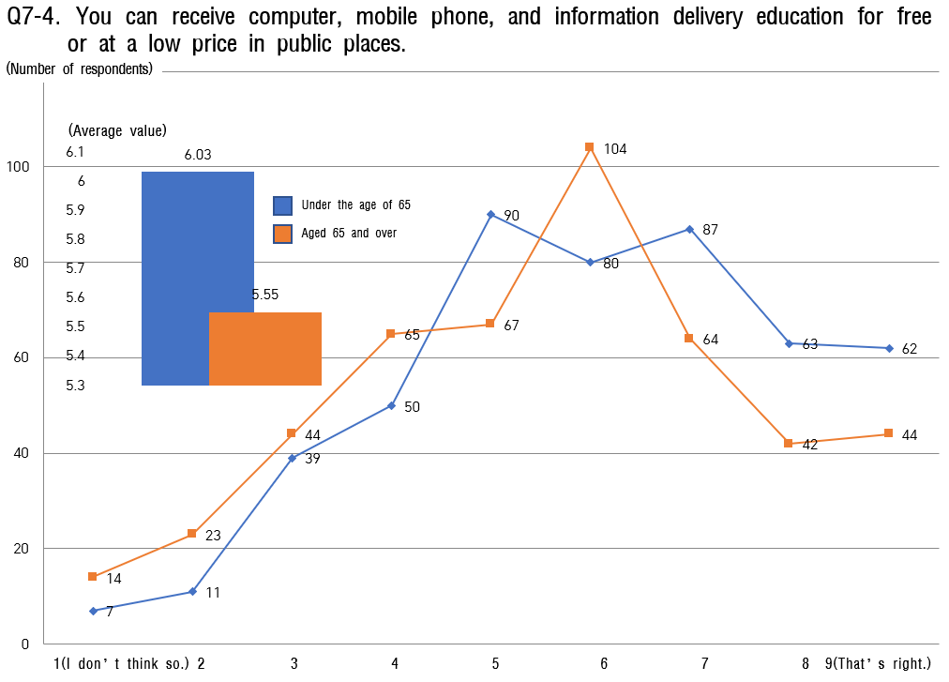
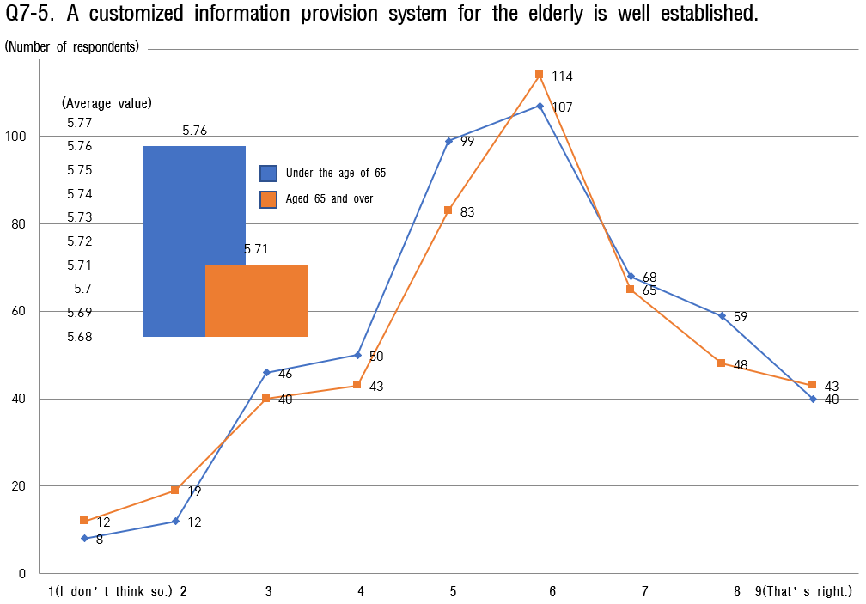

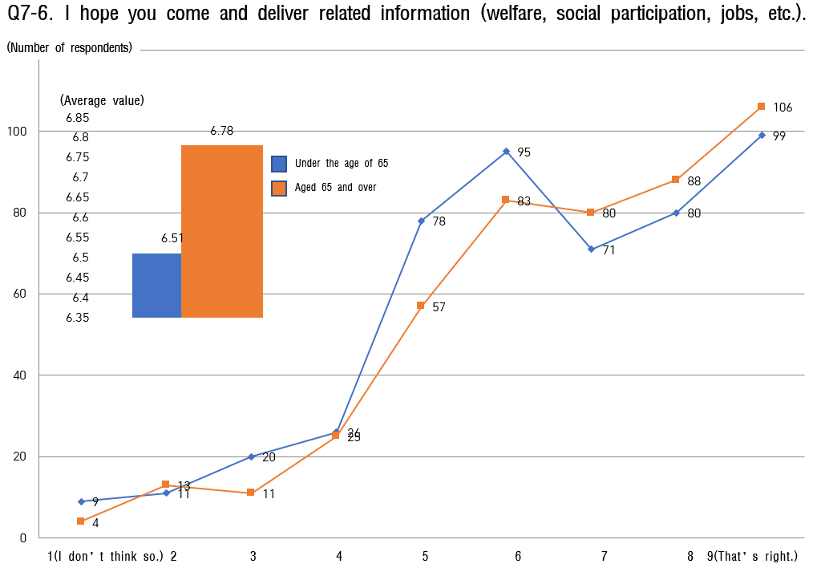

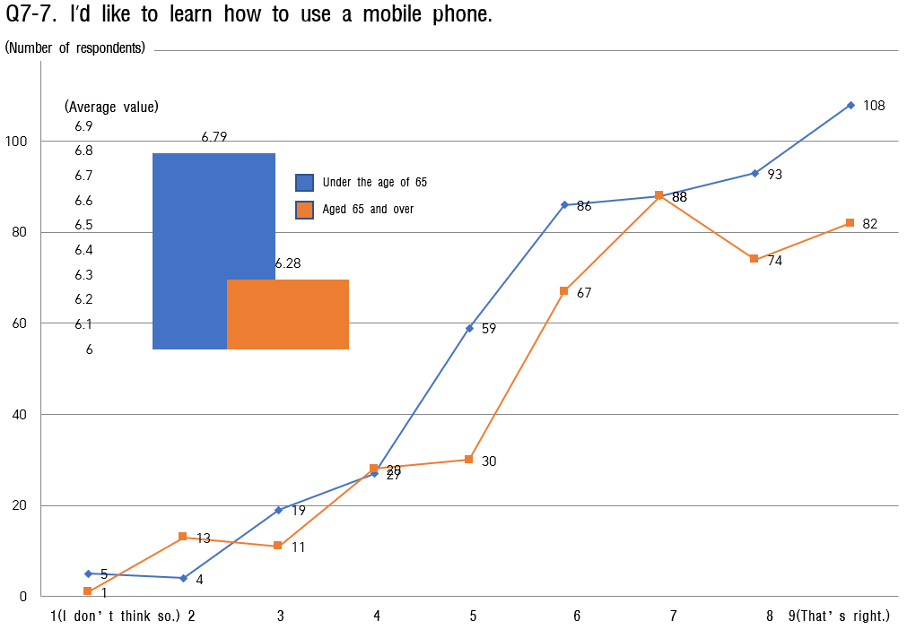

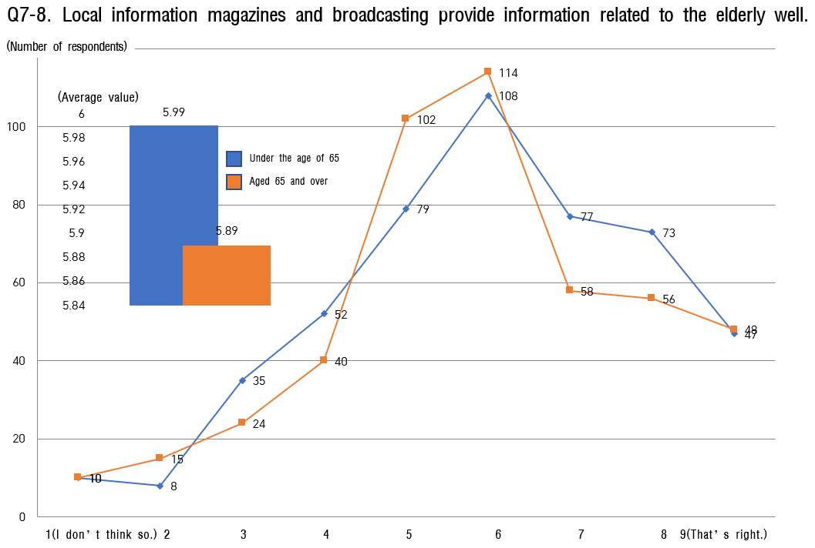

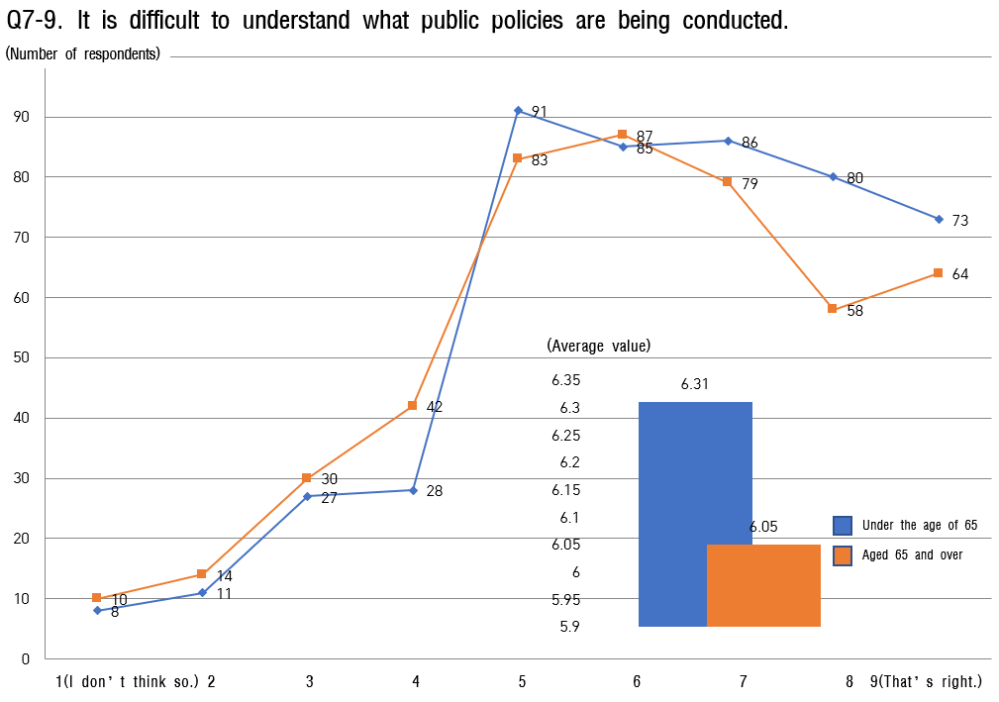

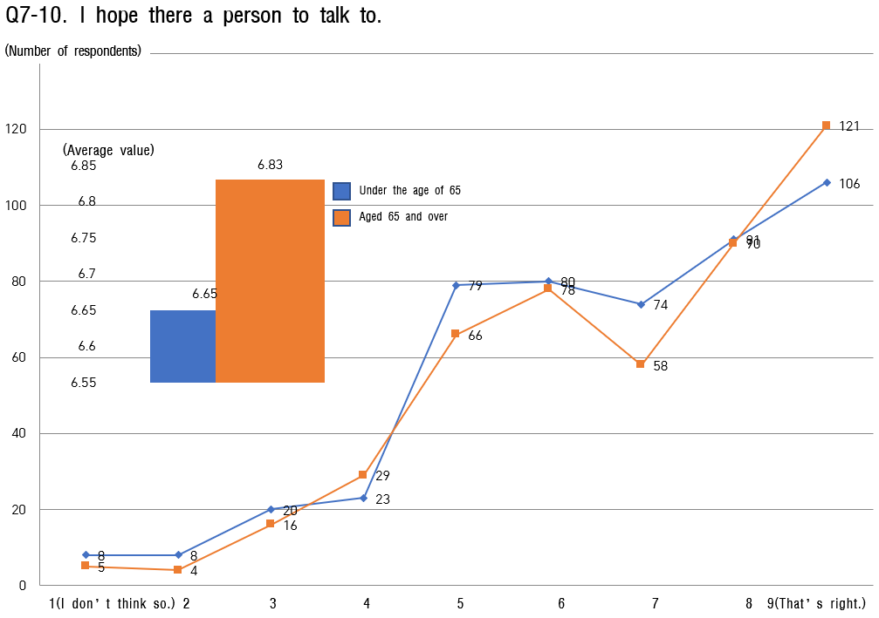

Community Care and Medical Services
    - It was found that all age groups showed high satisfaction in questions about care and medical services.
    - The highest score in all age groups is 7.01 points, saying, "I want to participate in programs to promote health." Next, with 6.76 points, "Health services (health care, health insurance premium support, etc.) are doing well."
    - On the other hand, the lowest score is 'supporting measures are excellent in case of natural disasters (such as severe cold, heat waves, heavy rain, etc.). and 'services suitable for the region (sharing side dishes, lunch box delivery, etc.) are in operation.'
    - As a result, regional care and medical services need to be supplemented by expanding health promotion programs, support measures in the event of natural disasters, and regional customized services (side dish sharing, lunch box delivery, etc.).

[Table 15] Analysis of the status of local care and medical services.

Sortation |  | under the | age of 65 | aged 65 | and over
 |  | Average  value | Ranking | Average  value | Ranking
the entire |  | 6.52 | - | 6.48 | -
 | 8-Ⓒ. Good health service | 6.76 | 2 | 6.76 | 2
 | 8-Ⓒ. Convenient use of medical | 6.69 | 3 | 6.47 | 6
 | and welfare facilities
 | 8-Ⓒ. Convenient procedures for | 6.34 | 8 | 6.36 | 7
 | medical and welfare facilities
 | 8-④. Provision of visiting | 6.38 | 7 | 6.33 | 8
 | services
8. Local Care | 8-Ⓒ. Provision of regional | 6.32 | 9 | 6.08 | 9
and medical | customized services
services | 8-⑥. Regular medical checkups | 6.66 | 4 | 6.68 | 4
 | 8-Ⓒ. Social support | 6.48 | 6 | 6.54 | 5
 | 8-⑧. Natural disaster support | 5.99 | 10 | 5.88 | 10
 | measures
 | 8-⑨. Dementia management and | 6.55 | 5 | 6.68 | 4
 | prevention services
 | 8-⑩. Participation in health | 7.01 | 1 | 7.01 | 1
 | promotion programs

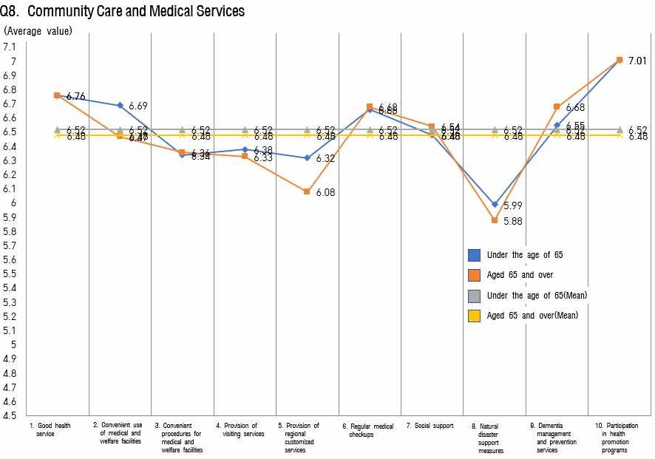

[FIG. 15] Analysis of the status of local care and medical services

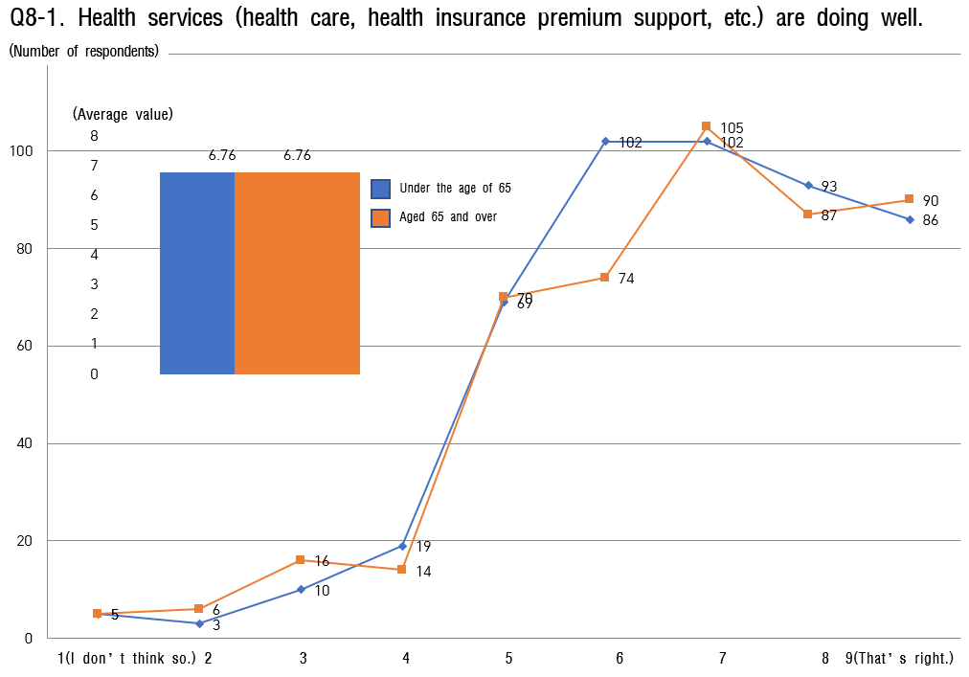

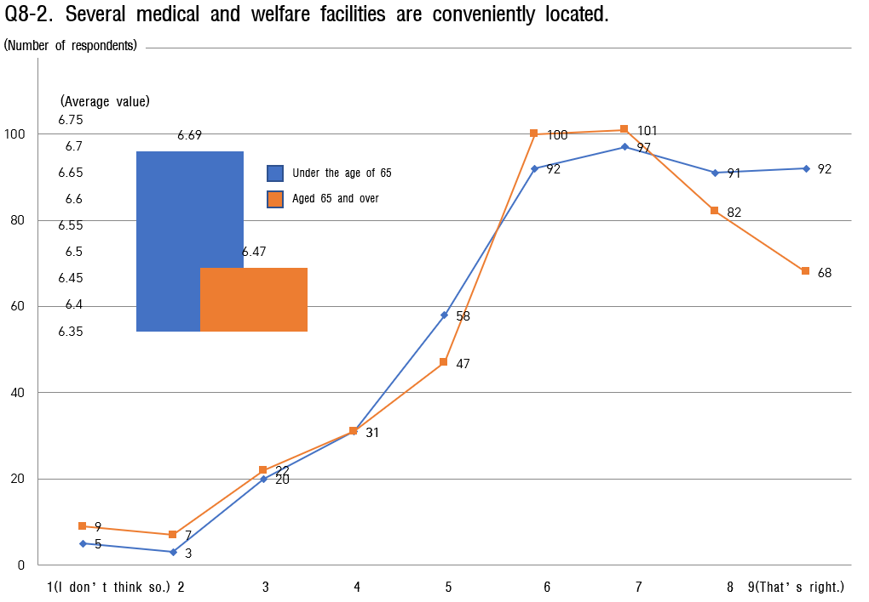

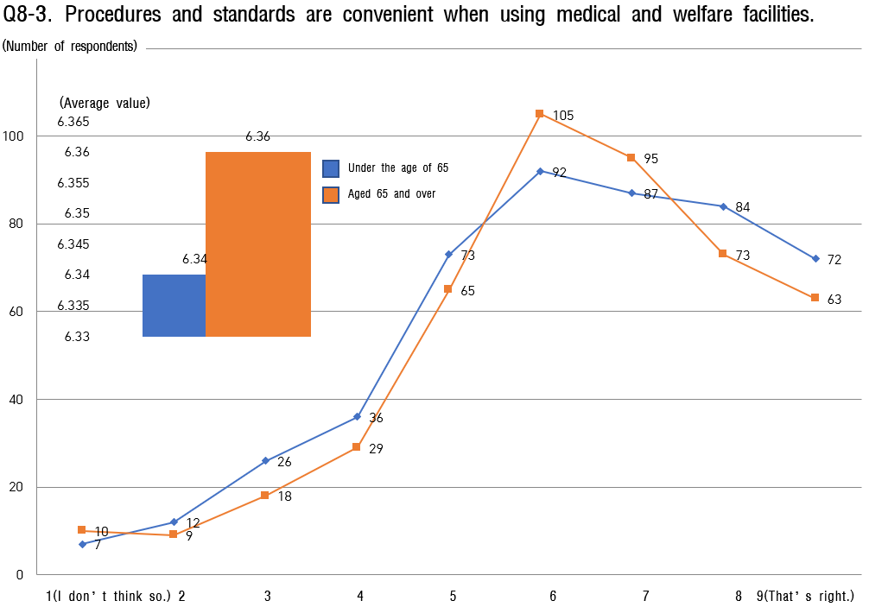
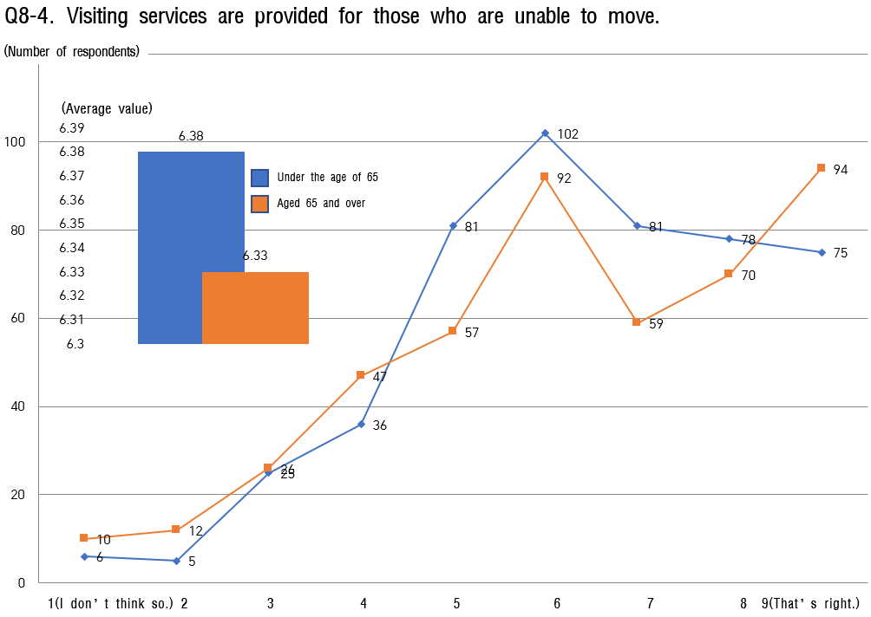

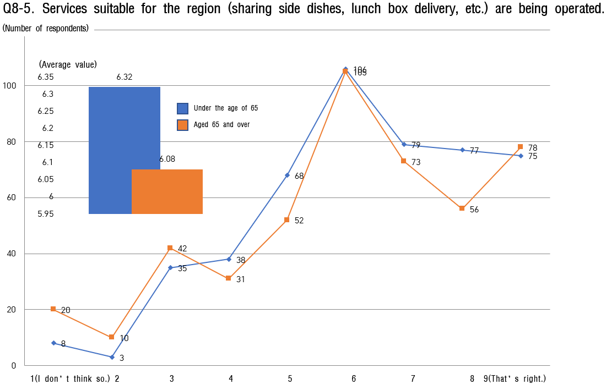

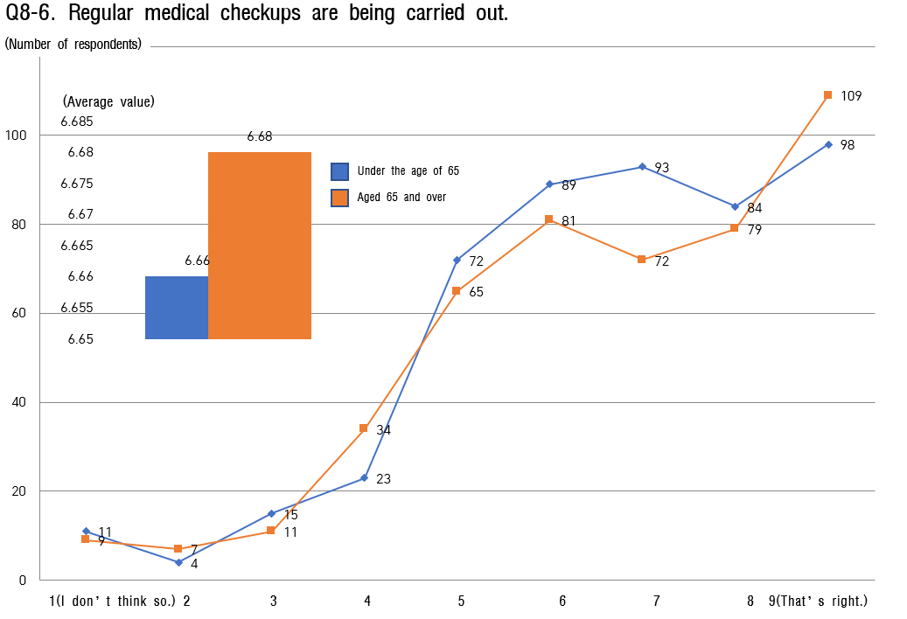

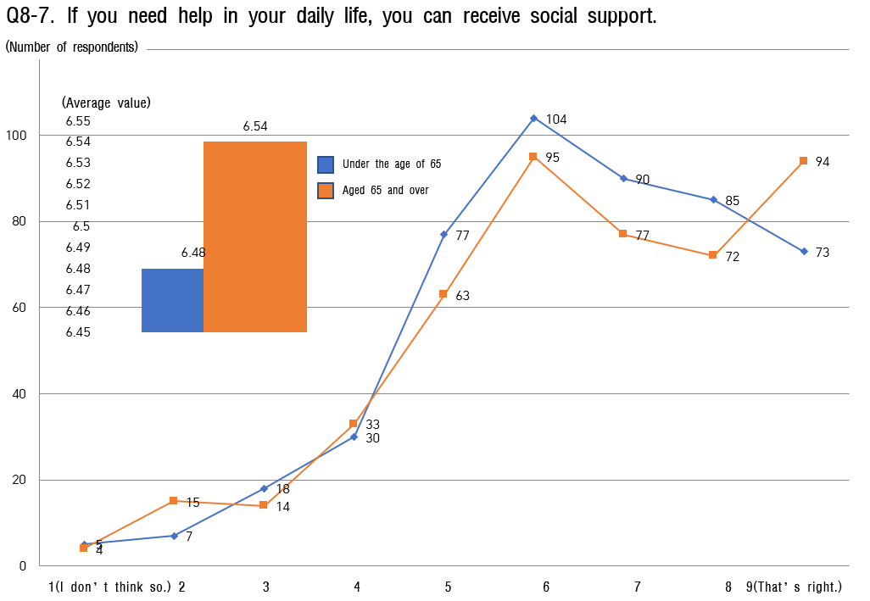

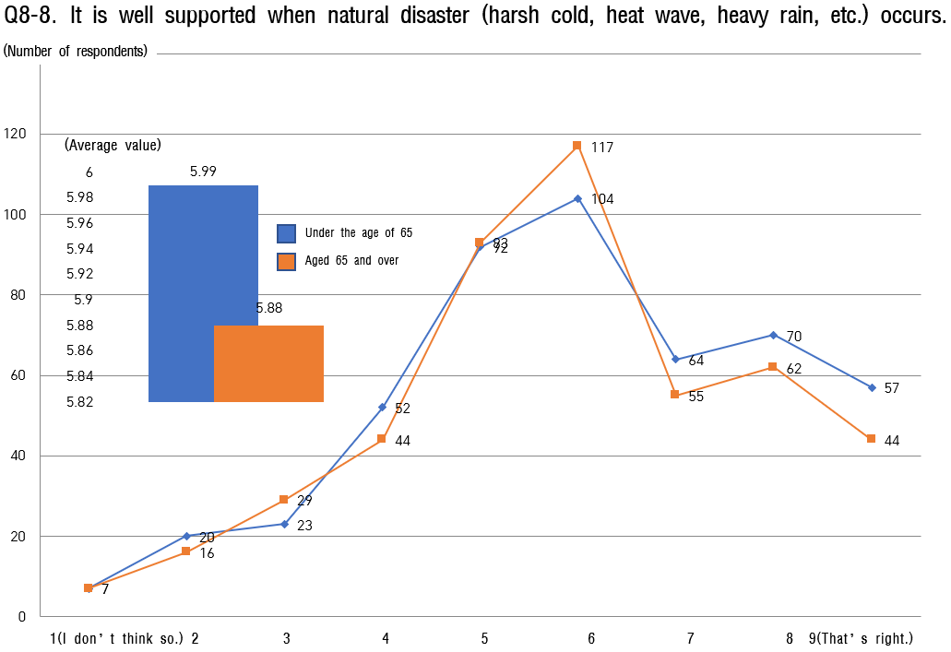

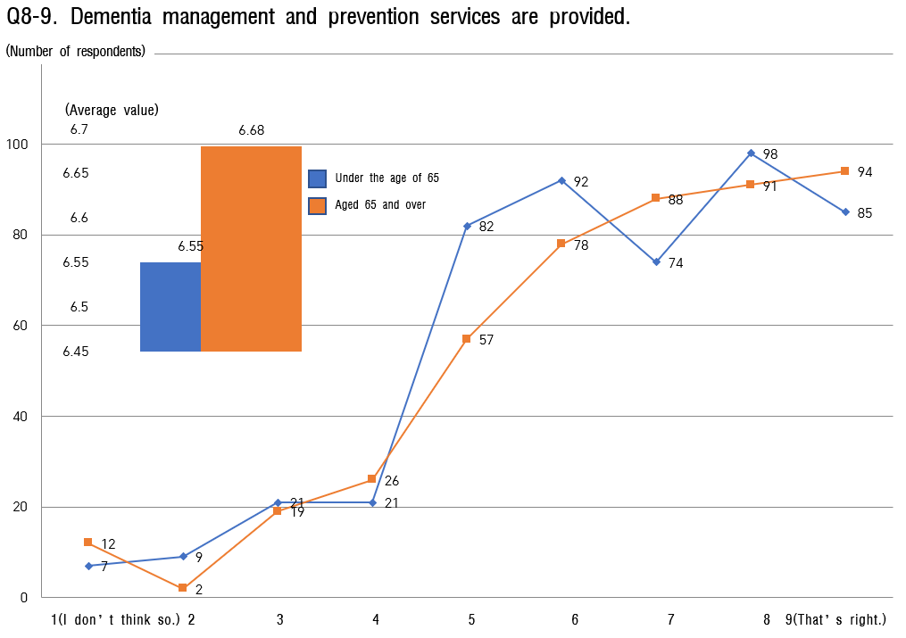

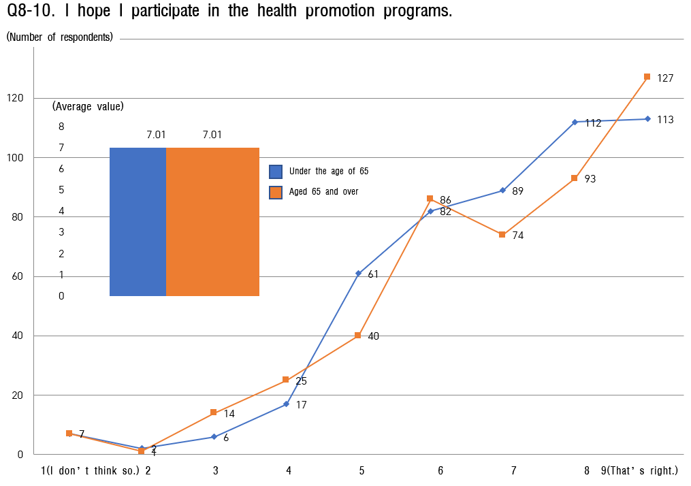

Analysis results of details by 8 areas

Overall, it was found that those under 65 years of age gave relatively more positive scores (general citizens: 6.20, senior citizens: 6.00) compared to those over 65 years of age, and the difference was found to be statistically significant (t=-16.397, p<.05)
  - The areas of transportation convenience (first priority), residential environment stability (second priority), and external environment and facilities (third priority) are evaluated relatively positively in all age groups compared to the other five areas.

Sortation

1. External
the eight
Environment and
major areas
facilities
Analysis Results

- As safety awareness which is regarded as the first priority is very low for the creation of an aging-friendly city, a plan to create a safe environment through intelligence and use natural space is required first.

 | 2. Convenience of transportation means | - It is necessary to pursue the convenience of using public transportation by expanding support for sticker production for elderly own driving, continuous distribution of eco-friendly low-floor buses, and strengthening bus information systems linked to this.
 | 3. Residential environment safety | - Urban regeneration and improvement of living and residential environment are required because it seems to be very necessary to improve the poor residential environment. It is also expected to have a synergy effect if housing management support services for the elderly (house repair support, toilet safety bar, anti-slip, threshold ramp, emergency bell, etc.) are combined.
 | 4. Leisure and social activities | - As all age groups recognize the need for generational integration and intergenerational harmony, it is necessary to facilitate accessibility through welfare center operation by base. It is required to create an open space for all generations by recycling the existing idle space.
 | 5. Social  participation and job | - A dedicated support organization such as the Senior Job Support Center is needed to operate vocational training programs based on the expansion of professional reemployment counseling and the contents of such counseling. It seems that customized vocational training should be conducted here.
 | 6. Respect and social integration | - Expansion of infrastructure to express gratitude for the hard work of the elderly, expansion of means of listening to opinions for the elderly, and support projects to relieve the economic burden to ensure lifelong education learning rights are required.
 | 7 .  Communication and  Information | - It is necessary to strengthen the operation of the call center so that it can be more actively reflected through listening to opinions, and to support various participation programs to facilitate access to information and communication.

 | 8. Local Care and  Medical services | - It is necessary to expand health promotion program, to build infrastructure that can maintain regional care using high-tech skills, and to supply the expansion of regional customized services (sharing side dishes, lunch box delivery, etc.).

Analysis of Experts' Opinions on the Establishment of an Aging-Friendly City

Gender status
    - The gender of experts who responded to the in-depth interview survey of experts in Jinju city was 10 men (50.0%) and 10 women (50.0%).
    - In other words, the gender ratio of expert respondents is 5:5, showing an appropriate ratio.

[Table 16] Analysis of the gender status of experts

Sortation |  | in-depth expert interviews
 |  | Number of respondents | Percentage (%)
the entire |  | 20 | 100.0
Gender | men | 10 | 50.0
 | women | 10 | 50.0

Status by age group
    - Looking at the current status of respondents in the in-depth interview survey by age group, it is analyzed that they are generally evenly distributed.
    - Eight (40.0%) were born under 1969, eight (40.0%) were born from 1970 to 1975, and four showed the year of birth since 1976.
    - The number of jobs is 20 percent with four social workers, 40 percent with eight university professors, and 40 percent with eight citizen monitors.

[Table 17] Analysis of professional age groups and job status.

Sortation |  | in-depth expert interviews
 |  | Number of respondents | Percentage (%)
the entire |  | 20 | 100.0
the age group | 1963～1969 | 8 | 40.0
 | 1970～1975 | 8 | 40.0
 | 1976～1980 | 2 | 10.0
 | since 1981 | 2 | 10.0
Sortation |  | under the age of 65
 |  | Number of respondents | Percentage (%)
the entire |  | 20 | 100.0
educational background | social worker | 4 | 20.0
 | Professor | 8 | 40.0
 | Citizen monitoring | 8 | 40.0

WHO, Expert Opinion on Eight key Areas of Aging-Friendly Cities

Sortation | External Environment and Facilities (1) |  |  |  |  |  |  | Convenience of transportation (2)
1 | Development of green environment to serve road as buffer |  |  |  |  |  |  | Install lamps to access wheelchair
2 | Maintenance and in public spaces patrol at regular intervals |  |  |  |  |  |  | Considering high readability and visibility, font size, color, etc.
3 | Lack of awareness surroundings | of | the | need | to | improve | the | Heavy burden with transportation costs, lack of awareness of usage time zone
4 | Strengthen the management of pedestrian obstacles on the sidewalk |  |  |  |  |  |  | Introduction of free transportation at fixed time
5 | Establishment of a cluster of services that are easy to access to the elderlys’ residential areas |  |  |  |  |  |  | Adjust the signal waiting time of a crosswalk to suit the elderly.
6 | Providing opportunities for the elderly to plant flowers and participate in gardening by utilizing idle spaces |  |  |  |  |  |  | Expansion of low-floor and low-speed buses  Exposure to many accident risks in alleys,  crosswalks, etc.
7 | A road bump, a lack of space for elevators, etc. |  |  |  |  |  |  | Strengthening the Measures to Consider the Transportation Weakness  Training on the prevention of reckless driving is  required.
8 | Restricting noise and unpleasant behavior in public places |  |  |  |  |  |  | pedestrian safety crosswalk sufficient for the elderly to cross
9 | a well-maintained, safe and accessible shelter |  |  |  |  |  |  | Visually distinct and well-heard crosswalks
10 | Many public silver houses, and customized care facilities, etc. are needed a lot |  |  |  |  |  |  | Provision of traffic lights a way to travel through vehicles and public transportation to move places
11 | Constructing smooth road surface without obstacles |  |  |  |  |  |  | Securing the safety of the physical environment such as roads and pedestrian paths
12 | Increase readability and direction by utilizing visual elements |  |  |  |  |  |  | Lack of public transportation by township units
13 | Intstall emergency bells everywhere in case of falls, accidents, or outbreaks. |  |  |  |  |  |  | Convenience of transportation convenience by creating barrier-free spaces and facilities
14 | Convenient access for the elderly using wheelchairs or walkers to public restrooms |  |  |  |  |  |  | Supplying more low-floor buses
15 | Maintenance for wheelchairs |  |  |  |  |  |  | Installation of visual and auditory signals on crosswalks
16 | perceived lack of facilities |  |  |  |  |  |  | Accessibility Convenience Needed
17 | Safety facilities (handrails, handles) are installed at the entrance to public restrooms, walls, interior of  partitions and washbasins, etc. |  |  |  |  |  |  | The road surface of the sidewalk is flat and it’s easy to walk around without obstacles
18 | Provide green space with toilets and sitting areas |  |  |  |  |  |  | Separation of bike lanes for cyclists
19 | Make it possible to communicate with L-shaped or circular benches even if the benches are installed. |  |  |  |  |  |  | Expansion of low-floor buses  Expansion of distribution in dense areas
20 | Designing the surrounding environment based on the behavior and needs of the elderly |  |  |  |  |  |  | Expansion of convenience facilities by weather (sunscreen, perpagora, etc.) when walking

Sortation | Residential Environment Safety (3) | Leisure and social activities (4)
1 | Intuitive use as learning terms for use, with easy access and easy of use | Aging-friendly sports facilities have a high effect of reducing the elderly suicide rate.
2 | Support to perform daily works independently and securely | I hope it will be held at a time when the elderly can participate.
3 | Inconvenience in using public facilities | Convenience in using welfare center
4 | Need help removing obstacles in the house | Strengthening the visiting senior citizen center support program
5 | Restroom with different levels of floor support for installation of ramps | Expanding the space and programs for all generations to hang out
6 | Strengthening the Improvement of the Residential Environment by Myeon Unit | Expanding the guarantee of mobility rights to participate in the program
7 | Need to improve the residential environment in urban hollowing out | Lack of leisure facilities (kind of aging-friendly leisure sports)
8 | The great accessibility of residential space and park | Need alternatives to facilitate access to major facilities (medical, welfare centers, childcare facilities, etc.)
9 | Application of healthy and independent electronic technology | Application of developing functional game contents for the silver generation
10 | Induce living alone into a common residence | Expansion of public leisure and welfare facilities
11 | Support for smart homes and fall prevention technologies to enhance convenience at home | It seems that an alternative to increase the participation rate of lifelong education should be devised.
12 | a shortage of residential streetlights | the unification of nearby sports facilities
13 | Readability and clarity for product and service use and support things in proper form | Services and environment must be in place to enable active aging
14 | Residential environment is good | Lack of events involving all generations
15 | Support for safety systems such as heat, lighting, door lock notifications, security alarms, fall detection, etc. | Strengthening mobility services for the elderly with mobility difficulties
16 | Expansion of support for convenient facilities for old age | Public-Private Cooperation System for the Provision of Open Space for Intergenerational Harmony
17 | Application of ICT-based lighting system for crime prevention and solitary death prevention for the elderly living alone | Securing a venue for communication by holding various events that can integrate all generations
18 | Take advantage of comfortable technology that can overcome physical boundaries and barriers | Ensure that the community is well equipped with sports and medical facilities
19 | Measures to Support Aging Housing  Balanced Development through Redevelopment | Need for measures to Support Participation in Rural Vulnerable Areas
20 | Recommended use of wallpaper, floorboards, paint, etc. with eco-friendly materials in residential spaces for the elderly | The provision of information for participation in social activities should be customized.

Sortation | Social Participation and Jobs5) | Respect and Social Integration (6)
1 | It is necessary to comprehensively examine the informal social support network of the elderly. | Need for Physical Consideration made by Universal Design
2 | The elderly discount system is applied to participate in events or attractions. | It should be considered in an easy location for the elderly to expand or access facilities
3 | Need for relieving participation conditions | Measures to Prevent Elder Abuse
4 | job expansion | Generation needs to advertise together for public interest
5 | Expanding opportunities for counseling with experts | Use large letters, colors, pictograms, etc. for the elderly to easily recognize them
6 | Securing Safety for Public Jobs | the need for education in which generations live together
7 | Need to establish a job center tailored to the elderly | Looking for ways to continue listening to the elderly
8 | To enable familiar work in a familiar place for social activities. | Support for physical, cognitive, and emotional functions and strengthen independence
9 | Induce employment retention, education, and participation in creative recreational activities | Installing a stand for the elderly or placing movable chairs in case of waiting
10 | Improvement of counseling and information support methods to provide jobs | Strengthening the participation as a mentor to the youth or reading books to them
11 | Support for metaverse platforms (family gatherings, social participation, etc.) for non-face-to-face social  participation. | Mainly, the movement guidance sign is applied to the floor for easy identification.
12 | Need for explanation and guidance to easily understand | Elementary schools need measures to participate in the elderly for respect for adults.
13 | Social relationships are the biggest influencing factor on the elderly's life satisfaction, and the second is  family relationships. | The elderly are exposed to many accidents in alleys, etc., so 112 dispatch emergency bells are  recommended.
14 | generally good | Good respect and consideration
15 | Strengthening the service function to get job information in our neighborhood | Mandatory installation of information facilities with good readability and visibility
16 | Induce participation appropriate to physical conditions | Implementation of education to improve the awareness of support for the elderly
17 | Need to be able to get job information and education to demonstrate your career after retirement | Falling accidents frequently occur on the stairs of the entrance due to rain or snow
18 | Creating a service environment that is not discriminated against in social participation and public  jobs | Round treatment of wall corners
19 | Create jobs that make you feel pride | Use your experience to create an atmosphere to participate
20 | Support for jobs and educational programs tailored to the elderly | In the event of facilities frequently used by the elderly, they are suitable for places with gentle terrain and slopes.

Sortation | Communication and Information(7) |  |  | Community Care and Medical Services(8)
1 | Prevent safety by recognizing pedestrians through thermal imaging sensors and giving warning light signals on the floor. |  |  | Promotion of environmental disease management and prevention projects for the elderly, such as environmental atopy and asthma.
2 | Provision of fine dust information through ICT-based fine dust measurement system |  |  | Measures to reduce the depression of the elderly should be actively applied.
3 | Conduct regularly mobile phone training |  |  | Strengthening Support for Daily Life
4 | Strengthening the Transmission through Public Radio | of | Information | Through phone counseling Medical Support Service
5 | Providing sufficient information attractions to the elderly in advance | on | events and | It seems necessary to take measures to protect against natural disasters.
6 | Digital bus time is difficult to access |  |  | Take preventive measures against excessive surveys
7 | Reorganization of the delivery system for the elderly |  |  | A Plan to bridge the Medical Service Gap by each Eup, Myeon and Dong
8 | Application of welfare technologies such as real-time audio-visual contact technology and monitoring  physical activity of the elderly |  |  | Support for facilities capable of connecting to others and remote health monitoring.
9 | Robot Conversation Support for Depression in the Elderly | the | Recovery of | By smart TV-based, smart healthcare support for medical services
10 | Development of a program communication between generations | to | strengthen | The establishment of a medical linkage system
11 | Provides screen design according to user needs, usage functions, information types, etc. |  |  | Development of customized Jinju City Health App Service for the Elderly
12 | Expansion of mobile phone training opportunities |  |  | Eliminating welfare blind spots dishes for the next-highest elderly. | by | sharing | side
13 | The font size is appropriate so that the elderly can easily recognize it from a distance. |  |  | Providing Smart Remote Health Examination Services
14 | Expanding opportunities for computer and mobile phone training |  |  | Relatively good
15 | Categorize the social network of old age around family, relatives, friends, and the community to which they belong. |  |  | Need to reduce the burden of medical expenses for the elderly and provide professional medical services
16 | Expand training programs for using electronic devices |  |  | Strengthening the discovery of underprivileged people other than existing recipients
17 | Older people can overcome loneliness and solitude by interacting with friends, neighbors, and  acquaintances. |  |  | It is necessary to expand support services such as locally customized side dishes and lunch boxes with  private companies.
18 | Installation of smart braille block that informs signal status by vibration when stepped on crosswalk |  |  | Utilization of Health Care Smart Home Exercise Program for the Obese Elderly
19 | Expanding educational and volunteer opportunities for informatization |  |  | Expansion of public medical institutions
20 | Expending support benefits related to information and communication |  |  | It seems that programs need to be expanded rather than health promotion facilities.

Sortation | Analysis Results of Expert Opinion | Remark
External Environment and Facilities | - It is designed to serve as a buffer through gardening, etc. in order to  minimize mutual interference between residential and external spaces.  - It shall be used as a wheelchair or walker in public restrooms, and various safety facilities shall be installed.  - Installing benches to communicate (ㄱ-shaped, ㄷ-shaped, ㅁ-shaped  benches). | Development of forest and green park
Convenience of transportation | - Installation of audio-visual signals to enhance the readability and listening  ability in the crosswalks  - Expansion of low-floor buses  - Facilities for walking (sunscreen, pergola, folding chair under pergola, etc.) | Expansion of  BIT and low-floor  buses
Residential Environment safety | - Installation of safety facilities (ICT-based) in the house where the elderly  can live alone.  - How to resolve the floor level difference between the bathroom and the living room  - Measures to Support old houses and the installation of Safety Streetlamps  (Solar Streetlamps) in the vicinity | Improvement  of Living Conditions and Residential  Environment
Leisure and social activities | - Alternatives that can guarantee the right to move for leisure and social activities  - Development of various programs (customized games/leports for the elderly, etc.)  - Expanding events for all generations | Establishment of a base for leisure activities
social participation and jobs | - Strengthening awareness by expanding opportunities for expert counseling  - Establishment of a job support center tailored to the elderly (active use of elderly volunteers)  - Measures to Support jobs from close distance | Help create customized jobs
Respect and Social Integration | - Promoting Universal Design of Public Facilities  - Measures to Prevent Elder Abuse  - Mandatory installation of information facilities with good readability and  visibility | Support for a Happy Life
communication and information | - Construction of Recognition Floor Light Signal System for pedestrian through Thermal Image Sensor  - Strengthen adaptability to the digital age by expanding participation in information and communication-related education  - Robot Conversation Support Project for the Recovery from Depression in  the Elderly | Strengthenin g the Interactive Communicati on System
Community Care and Medical Services | - Promotion of the management & prevention projects for environmental disease in the elderly  - Support facilities capable of remote health monitoring by connecting with others.  - Support for private-sector linkage to resolve welfare blind spots (support  with side dishes, lunch boxes) | Integrated care using ICT

