Baseline Assessment
& Guide-line of the Age-Friendly City of Hwasun-county
2020

Table of Contents

Ⅰ. Hwasun County Status and Analysis of Its Current Situation 4
1. Status on the Demography, Society and Economy 4
1.1 Social Environment 4
1.2 Demographic Status 4
1.3 Economic Status 5
1.4 Sanitation/Welfare Status 6

Ⅱ. Hwasun County Planning to be a member of the GNAFCC 6
1. Current Mayor’s Public Commitment 6
1.1 To get the approval of the GNAFCC 6
1.2 Establishment of the Complex Center to combine generations 7

Ⅲ. Deriving Key Issues from the Baseline Assessment by Using Questionnaire of the Age-friendly City 8
1. Survey Introduction 8
2. Results and Interpretation of the Survey on the Age-friendliness in
Hwasun-county 9
2.1 Summary of the Survey Result 9
2.2 Core issues derived from the diagnostic research 10

Ⅳ. Guidelines for the Hwasun-county, Making Age-Friendly Community with Core issues and Strategic Tasks 22
1. Visions and Objectives of the Hwasun-county Age-Friendliness Community 22
2. Implementation Strategy for the Hwasun-county to be a member of the Age-Friendly City 24
2.1 Process Flow 24
2.2 Implementation Structure 25
3. Issues and Strategic Tasks of the AFC in Hwasun-county, derived by the WHO 8 Domains 26

Ⅴ. Action Plan for the Age-Friendly City, Hwasun-county 30
1. Basic Direction of the Action Plan 30
1.1 Targets of Establishing AFC Action Plan for Phase#1 30
1.2 Action Plan Establishment Flow 31
2. Summary of the Action Plan for the AFC Hwasun-county 32

Ⅰ. Hwasun County Status and Analysis of Its Current Situation

- Status on the Demography, Society and Economy

1.1. Social Environment
○ Administrative Area
- Composed of 1 Eup (sub-county) and 12 Myeon (small county)
○ Population Status
- As of 2019, the total population of Hwasun County is 62,737 and its density records 83 persons per ㎢.
○ Population
- Hwasun County is located at the heart of Jeollanamdo (local provincial government)
and adjacent to Gwangju Metropolitan City, having 8 different borders with adjacent cities and counties.
- Various old age cultural heritages are widespread within the Old-age Cultural Zone
around Yeongsan-River
- We have Dolmen Sites designated by the UNESCO World Cultural Heritage, which
are only one UNESCO relics in Jeollanamdo local province.
○ Traffic Network
- It is very convenient to access everywhere with various traffic networks as in National
Road #15,22, and 29, Local Road #817 and its 7 sub-county roads, and 2 Railroads (Gyeongjeon-line, Bokam-line) with Y-shape.

1.2. Demographic Status
○ According to the statistics on the senior from Commissioner of Statistics Korea (KOSTAT) in 2018, the total population of aged over 65 reached 14.3% and will be increasing to 41% in 2060.
○ Reflecting on the population trend of the senior aged over 65 between 2013~ 2017, the population of the senior increased from 14,960 persons in 2013 to 15,828 persons in 2017 by 5.8%, showing continuous rising to 16,263 persons in 2019.
○ The ratio of the aged over 65 has been increased continuously at the ratio of 21,8% in 2013, 24.1% in 2016, and 26.0%.
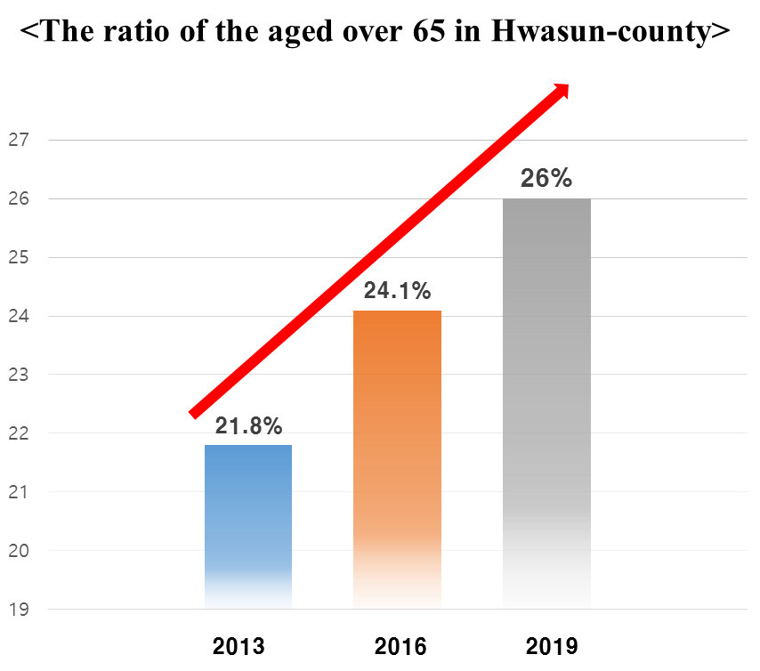
○ Based on the statistics of the aged over 65 in 2017 with 3 sub and small counties, Hwasun-eup (sub-county) records sharp increase from 5,479 persons to 6,212 persons at 12.4%, Neungju-myeon (small county) at 10.0%, and Dogok-myeon at 6.3% by showing continuous increase.

1.3. Economic Status
○ As of 2017, the whole business in Hwasun-county records 5,143 companies with 23,721
employees.
○ From 2017 statistics, the majority of each business is as follows: 1,154 companies in the
wholesale and retail shop, 818 in the lodgings/restaurants business, and 768 in the transportation.
○ With regard to the employees, 4,204 persons in health and social welfare service shows
the majority, next 3,460 in the manufacturing.
○ As of 2017, the increasing ratio of employees for recent 5 years, the health and social
welfare service increased from 4,005 to 4,204 at 4.9%, the manufacturing from 3,269 to 3,460 at 5.8%, the construction from 2,366 to 2,941 at 24.3%.
○ Regarding the housing in Hwasun-county, the housing supply rate hits 120% with the
increase of apartment(flat) housing.
○ Self-reliance ratio of finance of Hwasun-County in 2017 is 28.42%, which is slightly
low compared to national average at 55.23% and Jeollanamdo Province at 32.04%, but it is a lit bit higher than the County average at 22.59%.

  - Sanitation/Welfare Status
○ One nursing house as a senior welfare housing was set up in Hwasun-County.
○ As senior medical welfare facilities, 15 senior nursing facilities and 4 cohabitation
nursing facilities among seniors were set up.
○ As senior welfare facilities targeting for seniors living alone, 61 facilities were
established as in 29 visiting nursing services, 9 all-time nursing/protection services, and
visiting shower services.
○ There is no job supporting institution for the senior, thus it is required to set up this facility.
○ Regarding medical facilities, there are total 135 as in one general hospital, 3 hospitals,
30 clinic centers, 17 dental clinics, and one oriental medical clinic.
○ With regard to the public health center, there are 26 as in one community health center,
12 branches of community health center, and 13 clinic centers for the remote area.

Ⅱ. Hwasun County Planning to be a member of the GNAFCC

- Current Mayor’s Public Commitment

  - To get the approval of the GNAFCC
○ Future Policy
- To be a member of WHO global network for Age-friendly cities and communities,
we have strived to make city convenient without age discrimination and the most wanted dwelling society to live forever.
- To set up the Age-friendly city, we have focused on the safety, traffic convenience,
housing, social engagement by targeting all ages.
○ Expectations
- We could get new dynamics by adopting strategies for advanced aging society and international guideline.
- We could expect a synergy effect of Hwasun-county image by establishing
governance system and promoting high quality local community.
- We could apply an international guideline to the senior welfare policy.
- We could initiate the integration efforts on the construction of policy infra-structure
among generations.

  - Establishment of the Complex Center to combine generations
○ To build citizen’s community platform as a base for the women plaza, senior hall, and mother’s school to make harmony.
○ Hwasun-county participated in a public offering project to connect life SOC, receiving government fund which amounts to 6.1 billion Korean Won.
○ To improve the quality of citizen’s welfare and to activate local community, we have tried to consolidate facilities based on the citizen’s requirement.
Ⅲ. Deriving Key Issues from the Baseline Assessment by Using Questionnaire of the Age-friendly City

- Survey Introduction
○ To formulate age-friendly environment, we have conducted a baseline assessment focused on how citizens evaluate and what they recognize in various area by including various factors as in the economy, society, health/social services, physical urban environment and so on.
○ This survey was conducted to construct future fundamental data by deriving core issues of the age-friendly city and setting up strategic tasks.
○ We have set up basic direction by choosing various and inclusive samples to motivate active participation in this survey
- Elderly aged over 55 and over in each of the 13 sub and small counties of Hwasun-county to guarantee objectivity. Within the sample regions, the respondents were selected randomly.
○ We have collected various opinions from action officers in the welfare institution, seniors in the welfare facilities, and its related experts by reflecting active ageing concept to promote quality of life in Hwasun-county with a focus on the end-users.
○ The scope of survey comprises of 8 domains recommended by WHO to examine the level of the Age-friendly city as in 1) Outdoor Spaces & Buildings), 2) Transportation, 3) Housing, 4) Social Participation, 5) Civic Participation & Employment, 6) Respect & Social Inclusion), 7) Communication & Information), and Community Support & Health Services.

- Results and Interpretation of the Survey on the Age-friendliness in Hwasun-county

2.1. Summary of the Survey Result
○ We have conducted a survey to examine the level of Age-friendliness on 8 domains recommended by WHO to make diagnosis frame with inclusiveness and sufficiency as in 1) Outdoor Spaces & Buildings, 2) Transportation, 3) Housing, 4) Social Participation, 5) Civic Participation & Employment, 6) Respect & Social Inclusion, 7) Communication & Information, and Community Support & Health Services.
○ We use a” Likert-scaled response option” (e.g. 5-point scale ranging from ‘1 = strongly disagree’ to ‘5 = strongly agree’ to measure the level of agreement with a statement, or from ‘1 = never’ to ‘5 = always’ to measure the level of frequency) by separating the indicator data by population subgroup (e.g. gender, age groups, income level) or administrative area to obtain a more detailed assessment that would be sensitive to inequalities.
○ The result shows that the highest point was given to ‘Outdoor Spaces & Buildings (3.27), followed by ’Social Participation (2.97)’, Community Support and Health Services (2.95) in order. While, the domain of ‘Civic Participation and Employment (2.45) received the lowest score.
○ Hwasun-county earned the total score of 2.88 points for its Age-friendliness, a bit lower than the ordinary level of 3 points.

<Total Score for the Age-friendliness of Hwasun-county>
Domain | Outcome | Domain | Outcome
Outdoor spaces  & Buildings | 3.27 | Respect & Social Inclusion | 2.97
Transportation | 2.8 | Civic Participation & Employment | 2.45
Housing | 2.88 | Communication \  & Information | 2.89
Social Participation | 2.8 | Community support & Health services | 2.95
5 points scale |  | Average | 2.88

2.2. Core issues derived from the diagnostic research
○ Followed by diagnostic research as stated above. we analyzed each domain based on the good and bad issues expressed with percentages.
○ If an average rate is higher, we compared the rate of yes and no responses as a reference for classifying the positive and negative response.

- Outdoor Spaces & Buildings

○ Respondents show a positive reply on Outdoor Spaces and Buildings, evaluating outdoor spaces are clean and comfortable and in terms of the neighborhood walkability, locally accepted standards as in path wide enough, no step to road, obstacle free including for those who use wheelchairs and mobility aids were fully applied.
○ When it comes to the waiting time on the traffic signal, most respondents showed positive response but minor group (11.4%) replied negatively that signal waiting time is not enough. Thus it is considered as the core issue to be rectified for safety and connectivity of pedestrian facilities.
- Considering those who have limitations in mobility, vision or hearing, it is required to have an elaborate check for waiting time on traffic signal, voice-recording guide, and visual signs.
- The respondents show that drivers were very cautious to protect pedestrians on the crosswalk in terms of minimizing hazards and accidental or unintended actions.
○ Regarding safety from crime, violence and hazardous events in the community, respondents show that they can be protected from the physical health and mental wellbeing of residents. Thus it is necessary to set up safety facilities around parks and the Age-Friendly facilities to prevent senior accident.
○ With regard to the question on ‘Do the building and spaces enable access for everyone?’, they show affirmative response. Thus it is recommended that universal design or inclusive design, which can be used efficiently and comfortably with a minimum of physical effort should be applied.
○ With regard to the proper public toilet, they respond that it is suitable in number and clean to use.

- Transportation

○ Regarding the convenience of transportation, there are negative responses on poor scheduling in dispatch interval and accessibility to reach their destination. Thus locally accepted standards should be applied to counter lack of accessibility.
○ Concerning the availability of handicapped seating for public transportation and special transportation method for the handicapped, the elderly, and pregnant women, they showed negative response. Thus it is recommended that local government should prepare for extra seats for the seniors. Lack of information about transportation options must be rectified.
○ Concerning the bus transportation, respondents showed positive response to bus drivers who tried to observe safety regulation whenever bus stops and departs and passengers get in/out of bus, also responding that bus stops are safe and convenient.
○ It is hard to get the information on the public transportation route and timetable and another transportation service is not easy to use.
- It is required for the senior to access public transportation information easily by building easily accessible information system.
- It is recommended to provide 100won taxi (won= KRW: Korean Money Unit) that operates on a specific route by considering to subsidize such a service to make it economically feasible and accessible to older people. Availability of taxi service is seen as important by seniors.
○ With regard to the well-regulated transportation flow and traffic signs, they responded averagely but the negative response exceeds over positive one, pinpointing that it is not easy environment for seniors to drive. Thus it is required that local government should set up the convenient driving plan for people of all ages.
○ When it comes to the senior driver’s driving capability, they responded that the official certificate education has not been done successfully to approve driving capability, showing that safety problem in senior’s driving is not taking seriously. It is recommended to make driver refresher courses available to people over age 60.
○ Regarding a parking lot for the transportation vulnerable, it is necessary to make measures to meet that requirement. As a rule, the issue of transportation came up as a dominant issue in most other domains.

- Housing

○ Questions about the preparation for the future housing for ageing, most of them answered negatively. This is directly related to respondent’s disposition to continuing to live in the homes they have inhabited for years or decades.
○ Even though they want to retrofit their house to prevent negligent accident and solve out physical inconvenience, they did not receive proper information on the housing management services and its support services. While some seniors recognize that their older homes are not functional for an aging person, they may not be able to afford the upgrades and adaptations that would improve living conditions. Thus it is required that local government should take active promotion plan.
○ Regarding daily essential facilities as in water supply, toilets, heating, etc., 21% of them responded that they don’t have satisfying facilities. The biggest financial barriers facing seniors who want to remain in their homes appear to be related to heating and home maintenance costs. Lack or shortage of long-term care options was also cited as a significant barrier for older persons in rural and remote communities. Thus it is recommended that local government take actions to rectify this imbalance to increase the quality of life.

- Social Participation

○ Since 50% of the respondents live alone, active social participation is crucial factor to make the Age-friendly city.
○ It is not easy to get information on the various events, meetings, and attractions. Thus it is necessary to enhance the accessibility to those event places by inducing active social participation.
○ Since most respondents participated in various activities held in senior town and senior welfare center, it is required to have continuous public relations by leading active participation to those facilities.
○ Questions about bosom friends, family, and relatives in need, most of them replied positively, while 20% did negatively. thus it is necessary to vitalize local autonomy to make harmony by providing necessary local information to induce their active participation. It is also suggested from respondents to provide a continuum of care in the community—from home care to assisted living to facility care that is well-coordinated.
○ Other common barriers identified include a lack of information about planned events (information not getting out to people in a timely or efficient manner), and problems of affordability and accessibility that prevent some seniors from being able to participate in social activities and programs.

- Respect and Social Inclusion

○ It is analyzed that local government and communities do their utmost efforts to verity senior’s current needs periodically. Regarding this matter, respondents gave positive response. Thus active and involved seniors are less likely to experience social isolation and more likely to feel connected to their communities.
○ It is identified that older persons were treated and included in community life by providing public/private services and volunteer
○ Question about the courtesy and kindness to the senior, it is analyzed that they are well treated with a great deal of respect, kindness and courtesy by all generations.
○ It is analyzed that seniors in local communities are treated by their respect and appreciation as core members through mass-media and local communities.
○ As for the local community events participation, they responded passively. It is also suggested from respondents to provide opportunities for intergenerational activities and events—don’t isolate older people.

- Civic Participation and Employment

○ With regard to the senior’s opportunities in volunteer, job-seeking, and job education, a number of respondent felt that opportunities to contribute in their communities are limited.
- It is recommended to provide systematic start-up education and re-entry education for the seniors to seek jobs with paid employment based on their aptitude.
○ Respondents show negative response on the recruit, employment consistency, promotion, and training/education based on the age.
○ Volunteer activities were identified as an important factor in keeping older people active, included and involved. Thus it is required to find feasible options to provide jobs based on their career and to maintain jobs continuously, introducing information exchange and strengthening core capabilities.

- Communication and Information

○ Newsletters or directory-type publications appear to be another important source
of information for older adults as a useful publication. While seniors are embracing new technologies, these technologies often cause concern and frustration as in using the internet and computer in public facilities.
○ With regard to the kindness of the public facilities as in hospitals and welfare centers, respondents show positive response that workers/staffs are very kind to provide necessary information.
○ Caused by the farsightedness due to old age, the senior has difficulties in identifying colors and reading. Question about the elder-friendly mass-media publication, they show average response. But it is necessary to provide enlarged font and clearly contrasted color lay-out etc., when publicizing mass-media materials.
- For those who have difficulty in hearing, it is necessary to provide user-friendly contents which must be pronounced clear and loud with normal speed and core contents must be spoken first with brief information, giving them to repeat provided script as needed in terms of consideration.

- Community Support and health Services

○ Whether or not older people are able to age in place depends upon a number of
factors, including the availability of support and services that meet the varying needs of seniors. These include professional services, such as medical and personal care.
○ Respondents positively reply that they have an enough opportunity to receive health management with diverse health services and facilities in the community.
- It is recommended that health business as in the health education, counseling and preventive diagnosis should be extended to increase senior’s quality of life through the Senior Welfare Law to be amended.
○ With regard to the accessibility of local health services to provide an opportunity of health management, they are not well-informed through a variety of media, of the services that they may be entitled to and how they are accessed. Thus it is required for local health care facilities to provide information to seniors on a range of health and wellness topics positively.
○ When seniors have dementia and a stroke, they reply that they will not be treated properly from family and local community, replying that they could get proper assistance from local government, community center, and welfare center by receiving home-care service for daily life.
○ Regarding the accessibility to medical facilities, they show negative response, which is directly related to providing transportation services as required.
○ Caused by economical problem, there are cases that they could not get proper treatment and buy medicines.
○ With regard to the emergency plan suited for seniors as in natural disaster, they reply to it averagely.

- Comprehensive Analysis

○ This survey was designed to provide a comprehensive picture of Hwasun-county’s
Age-Friendliness. Eight broad topics or themes covered the essential features of the community’s structure and its physical environment, as well as the extent to which its services and policies reflect the determinants of active aging. These eight themes are identical based on the World Health Organization in the Global Age-Friendly Cities:A Guide.

The questions were focused on elaborating the following:
• the aspects of the community that are age-friendly (advantages),
• the barriers and problems that show how the community is not age-friendly
(barriers), and suggestions to improve the problems or barriers identified.

The first three topics were Outdoor Spaces and Buildings, Transportation and Housing. As key features of a community’s physical environment, these aspects of community have a strong influence on personal mobility, safety from injury, security from crime, health behaviors and social participation.

Three other topics reflect various aspects of social environments and of culture that affect participation and mental well-being—Respect and Social Inclusion deals with the attitudes, behaviors and messages of other people and of the community as a whole towards older persons; Social Participation refers to the engagement of older persons in recreational, social, cultural, educational and spiritual activities; and Civic Participation and Employment Opportunities addresses opportunities for citizenship, and paid and volunteer work —it is related to both social environments and the economic determinants of active aging.

The remaining two themes as in Communication and Information and Community Support and Health Services, involve both social environments and health and social service determinants.

○ Outdoor Spaces and Buildings
The physical environment is an important determinant of physical and mental health for everyone. Creating supportive environments, including age-friendly outdoor spaces and building design, can enhance physical well-being and quality of life, accommodate individuality and independence, foster social interaction and enable people to conduct their daily activities.

• AFC ratio in the Outdoor Spaces and Buildings shows 65.4%
- It is required that safe crossing at the well-equipped crosswalk must be taken into action by extending green light long enough.
- Universally designed buildings and space must be adopted to enable access for everyone, including children, older people and people with functional limitations
• Public washrooms are accessible and clean, which accommodates people with a variety of disabilities (accommodations include push buttons, wide doors, hand rails, locks that are easy for those with arthritis to use) and are located at convenient locations with proper signage.

○ Transportation
Whether driving a car or taking public or private transportation, access to transportation allows seniors to participate in social, cultural, volunteer and recreational activities, as well as enabling them to carry out such daily tasks as working, shopping or going to appointments.

• AFC ratio in the Transportation shows 56%
- It is required to enhance accessibility to the destination through public transportation.
- It is recommended to provide the public transportation vehicle’s route maps and timetables, which are displayed clearly in large letters for users with universal design.
- There must be drop-off and pick-up areas clearly marked to assist seniors carrying luggage, providing bus routes and timetable when departing and stopping and while passengers get on and off.
- Universal design to roads and guide signs displayed clearly in large letters should be
adopted to improve legibility with simple message.

○ Housing
Housing is important to enable older people to remain independent for as long as possible. The ability to live independently in one’s own home depends on a range of factors, including good health, finances and the availability of support services (such as medical and personal care). Many older persons feel that they could continue to live in the homes they have inhabited for years or decades, but under certain conditions. For example, the availability of help with housework, gardening or repair work could enable seniors to remain in their homes.

• AFC ratio in the Housing shows 57.6%
• It is required to enhance accessibility to the destination through public transportation.
• It is required that information on the retrofit of own house by providing proper support.
- It is derived to set up safety handle in the toilet and retrofit a toilet into dry-style in which it prevents seniors from the slippery.
- It is required to assist daily essential facilities which enable seniors to meet the needs of those with disabilities.

○ Social Participation
Social networks, social participation and feelings of belonging are important to healthy living, disease prevention and the prevention of isolation among seniors. Older people who remain active in society and socially connected are happier, physically and mentally healthier, and better able to cope with life’s ups and downs.

• AFC ratio in the Social Participation shows 56%
• It is indicated that promotion activities as in various activities, meetings and
entertainment should be extended with proper information.
• With regard to the transportation services, it is necessary to provide affordable and accessible transportation to attend various local events.

○ Respect and Social Inclusion
Older persons want to do more than simply continue to reside in their communities—they want to be able to contribute to, and benefit from, community life. Active and involved seniors are less likely to experience social isolation and more likely to feel connected to their communities. These connections are particularly important, given the strong linkages between social isolation and health. While social isolation tends to increase as people age, communities that promote social participation and inclusion are better able to protect the health of their citizens, including those who are socially isolated.
Research also shows that one of the factors associated with feelings of loneliness is a feeling of lack of respect. Like social isolation, loneliness can have a negative impact on health.
• AFC ratio (59.4%) in the Respect and Social Inclusion shows 59.4%
• It is required for seniors to provide volunteer activities and to be a teaching assistant in the school to share their core experience.
- Opportunities should be provided for the elderly to pass on their knowledge and experience to the younger generation.
• Seniors are recommended to hand over their experience to the younger generation as a member of community. Make younger people aware of aging issues and the importance of treating older people with respect.
Consider establishing outreach programs, such as the “telephone assurance” program that is being used in some communities.
Develop and support key outreach measures—the voluntary and informal transportation networks that are so vital to ensuring that older people who lack transportation options are not isolated.

○ Civic Participation and Employment
Seniors have a great variety of skills, knowledge and time to contribute to their communities in a range of areas, including civic participation, volunteer activities and paid employment. Their participation is linked not only to the economic prosperity and viability of their communities, but also to maintaining their own mental and physical health, and social connectedness.

• AFC ratio in the Civic Participation and Employment attains 49.0%
- Volunteering services and active participation in job-seeking are encouraged and supported for seniors in the community. But it is difficult to find a job. Thus it is required for local government to develop strategies for recruiting and motivating seniors to volunteer to encourage them who may be shy or reluctant to volunteer to participate more.
- It is found that there is discrimination against the elderly in recruitment, employment retention, promotion, job training, etc.
- It is required that vocational training programs for the elderly should be carried out by considering the aptitude of the elderly.
• To give an opportunity to stand alone and encourage connectedness as a member of local community, it is necessary for local government to provide various activities through the construction of database on senior’s capability.
- The job opportunity for seniors should be given based on the development of senior-specific jobs by actively recruiting seniors of all ages and also inviting into short-term projects.

○ Communication and Information
There was general agreement that keeping older adults informed—not only about community events, but about broader community information—allows seniors to be better connected to their community and supports them in their daily activities.

• AFC ratio in the Communication and Information records 57.8%
- Though information desk workers and counselors in public facilities speak clearly using standard language with familiar vocabulary for elderly people, but the readability for visual materials should be considered.
• Public information signs are not indicated in large letters and clear colors to help the elderly to distinguish easily, which has to use standard language that is easy for the elderly to understand correctly.
- It is limited for local magazines and broadcasting stations to reflect the elderly’s interest in their content.
- It is recommended that an applicable information for retirement be accessible through various media for the elderly.
• Supporting plan for seniors who live alone should be included by utilizing IoT (Internet of Things) communication network to monitor them in real time
• There was general agreement that keeping older adults informed—not only about community events, but about broader community information—allows seniors to be better connected to their community and supports them in their daily activities. It is necessary to find ways to include socially isolated seniors in the exchange of information.

○ Community Support and Health Services
Whether or not older people are able to age in place depends upon a number of factors, including the availability of support and services that meet the varying needs of seniors. These include professional services, such as medical and personal care.

• AFC ratio in the Community Support and Health Services shows 59.0%
• A plan for providing local health service information should be included.
• Health transportation services (including to larger centers) should be taken into account for sick seniors who are in lack of accessibility to get door-to-door services for first aid.
• Make use of retired professionals (e.g., pharmacists, nurses, teachers) to provide volunteer support in seniors’ homes and clinics—for example, to explain medication and health care issues. Provide a home visit program to provide social visits to seniors.

Ⅳ. Guidelines for the Hwasun-county, Making Age-Friendly Community with Core issues and Strategic Tasks

- Visions and Objectives of the Hwasun-county Age-Friendliness Community

○ Diagnostic research was conducted on the level of the age-friendliness of Hwasun-county to derive core issues for turning Hwasun-county into an age-friendly community and create strategic initiatives.
○ We have set up a vision for Hwasun-county: Great Places for the Age-friendly, aiming at the first in the welfare!!
○ To implement the vision, we have selected five objectives, which include 1) to make sustainable and tailored welfare city, 2) to strengthen creative social security network, 3) to reinforce social welfare infrastructure, 4) to make integrated community among generations, and 5) to build up integrated and locally-oriented welfare system
○ Hwasun-county guideline is composed of 3 categories, 8 domains, 14 detailed objectives, and 36 strategic tasks.

Vision and Objectives of the Hwasun-county for the
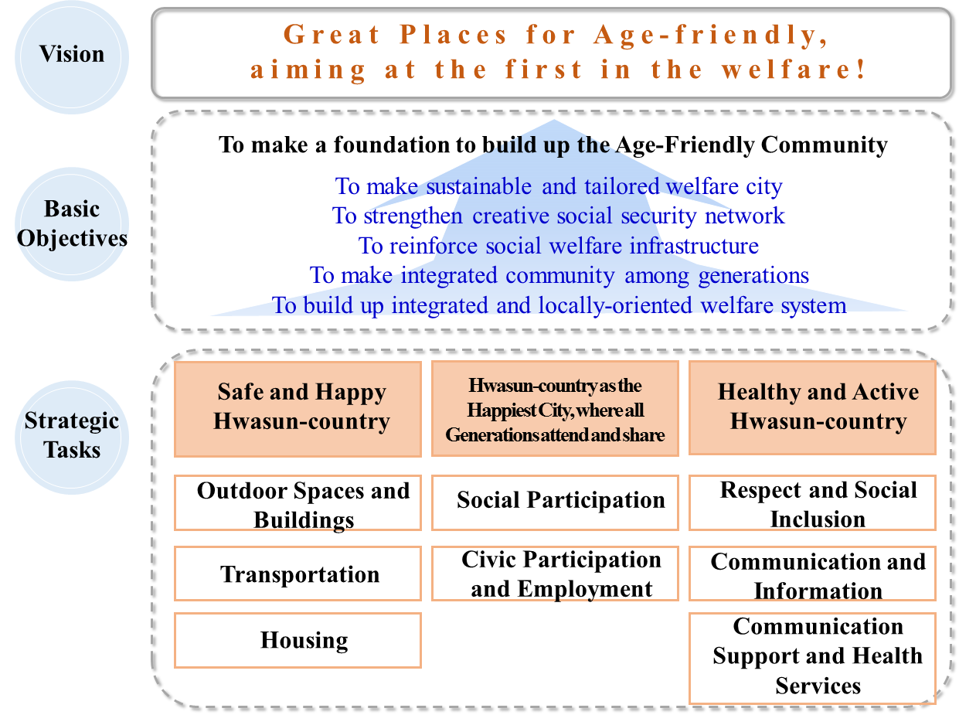
Age-Friendliness City/Community

- Implementation Strategy for the Hwasun-county to be a member of the Age-Friendly City

  - Business Process Flow

- Preparation Phase
○ Creating conditions necessary to implement the Age-Friendly City
○ Developing strategic plans for the Age-Friendly City in Hwasun-county
○ Establishing the Age-Friendly City Mission, Vision and Objectives in Hwasun-county
○ Forming Hwasun-county's Age-Friendly City Organization with Project Groups, Monitoring Groups, Steering Committees, and Advisory Boards
○ Determining main areas to implement the Age-Friendly City Project in Hwasun-county (based on the eight domains as set by WHO)

- Survey for the Age-Friendliness and Developing Guidelines
○ Establishing a model suitable for an Age-Friendly City in Hwasun-county (Urban and Rural Complex City Type)
○ Assessing the Age-Friendliness of Hwasun-county
○ Developing the Age-Friendly City Guidelines

- Action Plan Phase
○ Three-year plan to implement the Age-Friendly City concept and assessment plan
○ Establishing systems to educate the elderly and citizens of Hwasun-county, the Age-Friendly City Project
○ Planning to organize monitoring groups for the Age-Friendly City Project

- Implementation and Monitoring Phase
○ Pilot Project for an Age-Friendly City in Hwasun-county (designate areas: August 2020)
○ Organizing and operating monitoring groups, made up of Hwasun-county citizens and its organizations (2020)
○ Academic conference for the Age-Friendly City in Hwasun-county (2020)
○ International symposium for the Age-Friendly City in Hwasun-county (2021)
○ Expanding the Age-Friendly City Project in Hwasun-county (August 2021)

- Assessment, Feedback and Developing Long-mid-term Plan Phase
○ Establishing assessment plans, evaluating three-year plan to implement the Age-Friendly City Project
○ Developing long-mid-term plans for the Age-Friendly City of Hwasun-county with an assessment plan.

  - Implementation Structure
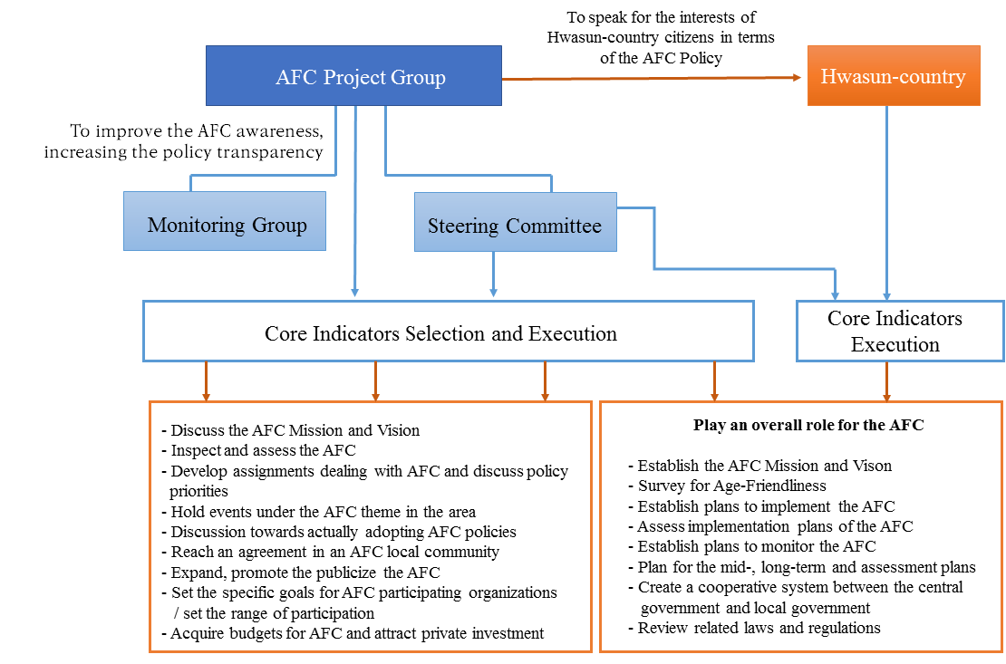

- Issues and Strategic Tasks of the AFC in Hwasun-county, referred from the WHO 8 Domains
○ Core tasks in 3 categories (8 domains, 14 detailed objectives, and 36 strategic tasks)
1. Outdoor Spaces and Buildings
• Reinforcing safety and convenience in urban plan by adopting universal design
- To set up safety handle on stairs and ascending lane without stairs.
- To improve guide design in public toilets.
- To enact an ordinance of universal design for improving environment in public
buildings and outdoor spaces.
• Making safe and cozy outdoor spaces and developing their infrastructure.
- To set up crosswalks on the core areas in consideration of extending the green light time, traffic signals showing remaining time to cross, and audible signals for the hearing-impaired.
- To install the LED guiding lights below pedestrian’s starting point and blinking lights for safety.
- To adopt universal design to senior zones.
- To recruit seniors for managing public outdoor toilets.
- To outsource private toilets for public purposes by providing electric bills and exempting water charge.
2. Transportation
• Increasing accessibility to destination by public transportation
- To extend ‘100-won taxi service’, which has been operated at a low price to increase the accessibility for seniors.
- To provide public transportation route, time-table, and daily essential information guide signs, applied to the universal design concept at senior’s hall, village hall, and living spaces with big letters to be easily identified.
• Forming safe environment of buses by recruiting senior as a helper.
- To introduce an assistant system for the safety of passengers when getting on and off by recruiting healthy seniors.
• Forming safe driving condition
- To apply universal design to road signs and direction signs, which can also be used at night.
- To provide drivers with night glow vest when driving cultivator, and bicycle
3. Housing
• Providing citizens with the guideline of retrofitting current house to the convenient one by educating them and publicizing pertinent information.
- To provide necessary information pro-actively and give an advice on housing improvement, setting up convenient support system in consideration of safety as in safety handle in the toilet, modification of toilet from wet type to dry one, and bathtub buried.
• Providing stability, convenience, and comfort in housing environment.
- To provide a periodical safety check and maintenance in electric and electronic items.
- To build safety system linked to head of the village and county situation room.
4. Social Participation
• Active senior participation in various events
- To provide seniors with proper information in advance regarding county events, meetings and festivals.
- To provide seniors with transportation service for the ease of attending public events designated by a county official who cares for 4 citizens
- To support circulatory buses for public events to facilitate night movement.
5. Respect and Social Inclusion
• Including seniors into social members through education on the ageing and the senior to recognize everyone’s future that they will also be seniors in the chain of life cycle.
- To hold a public event for seniors as a cornerstone to integrate local
community, promoting county’s information.
- To hold an event to integrate generation fellowship.
6. Civic Participation and Employment
• Providing more jobs for seniors without any discrimination.
- To enhance customized job support services for the senior they like in the recruit and re-employment by providing pertinent education related to the job to meet their needs.
• Enhancing customized job support service
- To produce more jobs for seniors, it is necessary to build up village company, which activates community integration.
7. Communication and Information
• Establishing information service base for the life after retirement.
- To teach information literacy for seniors.
- To adopt universal design concept to publications, newspapers, and scripts issued by local community through the improvement of visual effect as in font-size enlargement, contrast in color, the senior and the impaired can easily access to the information as required.
- To consider auditory inconvenience, it is required for volunteer seniors, government officials, and helpers to provide correct information with loud and clear voice, proper speed of pronunciation, speaking core contents first, brief contents and its composition, and direct demonstration.
- To provide proper and timely information delivery services in the IOT and ICT technology with the Korean Mobile Communication Services in KT “Doran-doran(= Whispering to each other)”, SKT “Geongang-toktok (Healthy life)”, preparing measures for the senior living alone.
8. Community Support and Health Services
• Providing health services to construct “active senior and stay young society”
- To provide necessary information on the local health and social services.
- To make a periodical health examination, making it obligatory.
- To reimburse transportation fare for visiting medical facilities upon getting a transportation receipt,
- To provide visiting home-care services in terms of building home-care system.
- To provide village-based drugstores, it is necessary to operate them every other day.
- To construct senior care system..
• Constructing safe community network.
- To improve the first aid treatment, it is proper to set up “the first aid alarm bell system”.
- To rectify medicine abuse, it is necessary for health care center in a small town to educate proper medicine use by returning unused medicines immediately to the health care center.
- To provide counseling and education service for making a proper exercise and menu composition.

Ⅴ. Action Plan for the Age-Friendly City, Hwasun-county

1. Basic Direction of the Action Plan
1.1. Targets of Establishing AFC Action Plan for Phase#1

○ According to the AFC subscription and its basic plan, the Action Plan for Phase#1 (2020~2022) is set up with the motto of “Great Places for the Age-friendly, aiming at the first in the welfare.” To promote social infrastructure environment of the AFC in Hwasun-county, Action Plan for Phase#1 is based on the review of 8 domains recommended by the WHO.
○ It is the Bottom-Up policy making process that WHO Global Network for Age-Friendly Cities and Communities (GNAFCC) has put a stress on by inducing citizen’s positive participation. Unfortunately, some Asian countries like India, Hong Kong, China, Japan, etc., has shown Top-Down process commonly by government, which directly against the WHO policy.
○ It is favorable to make a policy process in two steps: firstly Hwasun-county should establish a quick policy to design the city where every citizen is safe and healthy through the Top-Down process, secondly followed by the construction of the physical infrastructure for the AFC, the policy should be shifted to the Bottom-Up to meet the WHO policy as stated above.
Phase#1 (2020~2022)  The greatest city for  the AFC where seniors can live lively with strong bond  among each  generation | Phase#2 (2023~2025)  Stabilization  of the AFC | Phase#3 (2026~2028)  Settlement of the AFC. Hwasun-specific

1.2. Action Plan Establishment Flow

○ It is established that a draft on the Action Plan for making environment of the AFC in Hwasun-county and its subscription basic plan as a future basis of setting up the Action Plan, which can be further used for basic materials as in public hearings, policy review meetings, policy workshops, expertise meetings, site surveys and so on.
2019 | Making a draft on the Action Plan
March 2020 | Working-level meeting presentation  Meeting for reviewing the Action Plan
April 2020 | Policy Workshop  Review on the Action Plan
May 2020 | Advisory Meeting with Expertise
June to July 2020 | Visit sites concerned
Aug. to Sept. 2020 | Public hearing from citizens
Oct. to Dec. 2020 | Finalizing and publicizing the Action Plan
Establishment of the AFC Action Plan

2. Summary of the Action Plan for the AFC Hwasun-county
○ 3 Major Categories and 32 Core Tasks
Category |  | WHO Domain |  | Core Task | Task  Number |  | Business |  |  | New (N) or  Being carried (B) |  | Point of Contact
Hwasun- county as a safe and happy city |  | Outdoor Spaces and Buildings |  | To make safe environment to do outdoor activities anywhere | 1 |  | Establishing barrier free (BF) environment for the ease of movement. |  |  | B |  | Div. of Social Welfare
 |  |  |  |  | 2 |  | Maintaining the housing to make age-friendly environment |  |  | B |  | Div. of City
 |  |  |  |  | 3 |  | Preparing the basic plan of the Universal Design in Hwasun |  |  | N |  | Div. of City
 |  | Transportation |  | To make traffic environment safe | 4 |  | Renovating the senior protection area for security. |  |  | B |  | Div. Disaster safety
 |  |  |  |  | 5 |  | Making a business plan on establishing the traffic safety system in Hwasun-county |  |  | B |  | Div. Disaster safety
 |  | Housing |  | To make housing environment safe and convenient | 6 |  | Providing stability,  convenience, and  comfort in housing  environment. |  |  | B |  | Div. of City
 |  |  |  |  | 7 |  | Establishing smart welfare housing system in Hwasun-county |  |  | N |  | Div. of General Affairs
Hwasun-county as the Happiest City, where all generations attend and share |  | Social Participation |  | To provide various senior-specific programs considering age and sex at the welfare center and senior hall. | 1 |  | Finding new senior specific jobs at senior center and village hall. |  |  | B |  | Div. of Home Vitality
 |  |  |  |  | 2 |  | Developing leisure programs at senior center and village hall to attract frequent use of those facilities |  |  | B |  | Div. of Home Vitality
 |  |  |  |  | 3 |  | Making and extending village companies for making senior jobs. |  |  | B |  | Div. of Home Vitality
Category | WHO Domain |  | Core Task |  |  | Task  Number |  | Business | New (N) or  Being carried (B) |  | Point of Contact
Hwasun-county as the Happiest City, where all generations attend and share | Civic Participation and Employment |  | To develop social relation program with in village, suited for seniors. |  |  | 4 |  | Activating social relations for seniors living alone | B |  | Div. of Home Vitality
 |  |  | To increase leisure program by utilizing existent facilities. |  |  | 5 |  | Extending life-long education program for the age 100. | B |  | Div. of Home Vitality
 |  |  | To provide job training services for seniors and helping find a job with support of pertinent job finding organizations. |  |  | 6 |  | Establishing and operating job service center for the second life. | N |  | Div. of Job Policy
 |  |  |  |  |  | 7 |  | Promoting Age-Friendly corporate. | N |  | Div. of Job Policy
 |  |  |  |  |  | 8 |  | Operating and expanding Senior Job Training Center. | B |  | Div. of Job Policy
 |  |  | To develop and distribute senior-suited jobs in Hwasun-county |  |  | 9 |  | Activating senior jobs in the private sectors. | B |  | Div. of Job Policy
 |  |  |  |  |  | 10 |  | Extending senior jobs and social activities support business. | B |  | Div. of Home Vitality
 |  |  |  |  |  | 11 |  | Promoting senior-produced items. | B |  | Div. of Job Policy
 |  |  | - |  |  | 12 |  | Forming an environment for the senior-friendly tourism. | B |  | Div. of Tourism Promotion
 |  |  | To provide information on senior’s job and social contribution at the same time. |  |  | 13 |  | Organizing volunteer service group and sharing their talents. | N |  | Div. of Home Vitality

Category | WHO Domain | Core Task | Task  Number | Business | New (N) or  Being carried (B) | Point of Contact
Health and Active Hwasun-county | Respect and Social Inclusion | To create an environment of respecting seniors by considering them. | 1 | Surveying and developing senior’s human right sensitivity scale. | N | Div. of Home Vitality
 |  | Developing and operating the generation integration program. | 2 | Developing and operating the generation integration program. | N | Div. of Home Vitality
 |  |  | 3 | Developing campaign of the filial duty encouragement. | B | Div. of Home Vitality
 | Community Support and Health Services | To develop care-giver’s mentoring program and train caring skills for seniors. | 4 | Providing community care services for the low-income, dementia, and seniors living alone. | B | Div. of Welfare /Community Health Center
 |  |  | 5 | Developing and operating counseling support program for the care-givers. | N | Div. of Social Welfare
 |  |  | 6 | Providing a voluntary meeting for the family having dementia patient and operating its program. | B | Community Health Center / Dementia Care Center
Healthy and Active Hwasun-county | Communication and Information | To resolve alienation from community, proper communication is required based on information, news, and senior characteristics. | 7 | Finding a program to resolve information gap. | B | Div. of General Affairs
 |  |  | 8 | Publicizing the AFC | N | Div. of Home Vitality
 |  | Operating information of AFC | 9 | Operating Homepage of the AFC. | N | Div. of Home Vitality
 |  | - | 10 | Surveying the basic welfare needs of seniors to assess the current situation in Hwasun-county. | N | Div. of Social Welfare
 |  | To invite seniors to the decision making process on the AFC and develop its monitoring system. | 11 | Constructing monitoring system of the AFC policy. | N | Div. of Home Vitality
 |  |  | 12 | Senior welfare policy committee in Hwasun-county | N | Div. of Home Vitality

