Current Issues 2022-06
Evaluation of Changwon City's 1st Age-Friendly City Action Plan (2020-2022)

Sunhee Park, Hyejin Lee, Myungjin Kang

Gyeongnam Institute

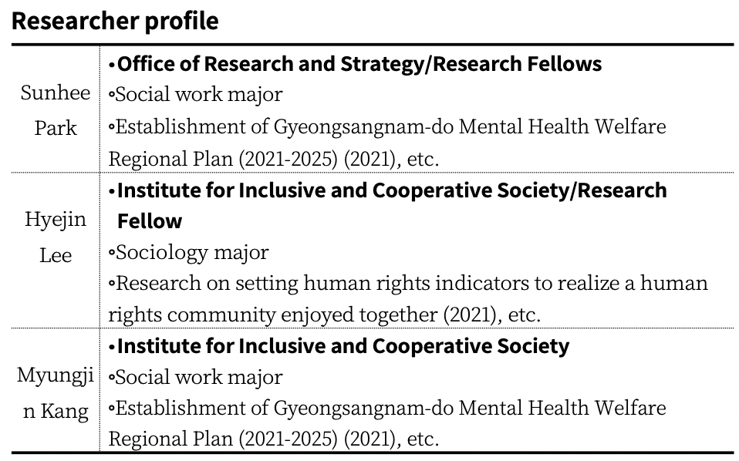
Summary and Policy Implications

Background and Purpose

o The Global Network for Age-Friendly Cities (GNAFCC) was launched in 2010 to connect cities that share the same goals as the World Health Organization (WHO) in order to effectively respond to the global aging and rapid urbanization trends.
- Upon completion of the implementation of the three-year First Period Action Plan, GNAFCC member states are required to submit a more advance Second Period Plan (five-year) to the GNAFCC, along with an evaluation of the Action Plan.
- Changwon City joined the WHO Global Network for Age-Friendly Cities (GNAFCC) in 2020 to effectively respond to the growing elderly population.
o There is a need to provide implications and directions for the establishment of the second period action plan through the evaluation and inspection of the first action plan for Changwon Age-Friendly City.

Purpose of the study and what was studied

o This study aims to evaluate Changwon City’s First Age-Friendly City Action Plan (2020-2022) and propose perspectives and plans for establishing a more advanced 5-year Second Plan (2023-2027).
o The contents of the study are a review of prior research and an evaluation of the First Action Plan for Changwon City’s Age-Friendly City and a direction for establishing the Second Action Plan.

Concept of Age-Friendly Cities and Status of Joining the International Network of Age-Friendly Cities

o The concept of age-friendly cities is theoretically based on the WHO’s concept of active ageing and seeks to create physical and social conditions in communities that enable people to continue living in their homes as they age (ageing in place) and enable all citizens to lead active lives.
o As of May 2019, 847 cities from 43 countries have joined the GNAFCC, and Changwon City became the 21st city in Korea to join the GNAFCC in 2020.

Evaluation of the status of Changwon City’s promotion of an Age-Friendly City and the First Action Plan

o Progress
- Changwon City’s First Action Plan for Age-Friendly City is “A vibrant city the realizes the value of old age”, and has set three goals under the vision of “realizing Changwon” and has presented a total of 38 practical tasks (detailed projects.)
- Of the projects presented, 17 are newly proposed projects and 21 are existing ongoing projects that have been expanded and strengthened, and some projects have been modified or changed due to COVID-18 prevention measures and changes in business conditions. Of the 38 total projects, 9 projects were revised, including 5 new projects and 4 ongoing projects.

o Evaluation Methods and Procedures
- In this study, the level of achievement was quantitatively evaluated by quantifying business goals and performance, and a summary table was presented according to the projects implementation rate proposed in the first plan.
- In addition, since quantitative evaluation based on business promotion rate is difficult to qualitatively evaluate the actual business promotion content and process, we conducted qualitative evaluation through expert advisory meetings.

Evaluation Results of Changwon City’s First Age-Friendly City Action Plan and Implication for the Second Plan

o Evaluate progress on action items
- The first action plan for creating an age-friendly city consists of 3 policy goals, 12 sub-goals, and 38 action tasks.
- Out of a total of 38 detailed projects, 19 projects had a goal achievement rate of 100% or more, 13 projects were in progress, and 6 projects were incomplete.
- Most of the projects that did not meet their targets (83.3%) were due to restrictions on countermeasures and facility operations due to the strengthening of “social distancing” in response to the spread of COVID-19.

o Improve action plan operationalization process and evaluation system
- It is necessary to establish a transparent procedure for modifying and changing business plans, prepare measures to enhance business sustainability, improve the process of collecting periodic citizens opinions, and actively respond to new infectious diseases (expand non-face-to-face welfare services).
- In addition, with regard to improving the evaluation system, it is necessary to systematize qualitative evaluation, involve parties in evaluation, and disclose project implementation status and results.

o Second Action Plan Implication
- Diversification of non-face-to-face welfare service discovery and promotion methods, enhancement of media literacy capabilities of the elderly, expansion of citizen participation, systematization of procedures such as evaluation methods and processes, strengthening of the role of public-private partnership governance (age-friendly city planning committee), and application of gender and cultural perspectives are needed.

Table of Contents

I. Introduction
1. Background and Purpose
2. Scope and Methods
3. Research
4. Research Procedures

II. Concept and Status of Age-Friendly City
1. Age-friendly city concept
2. International Network of Age-Friendly Cities
3, Status of Changwon City’s Age-Friendly City

III. Changwon City Age-Friendly City Evaluation Direction
1. Trends in Age-Friendly City Action Plan Evaluation
2. Evaluation of Changwon City’s Action Plan for an Age-Friendly City

IV. Evaluation of Changwon City’s Age Friendly City Action Plan
1. Create a safe and comfortable urban environment (Policy Goal 1)
2. Achieving understanding and respectful generational integration (Policy Goal 2)
3. Supporting Healthy and Affordable Retirement Life (Policy Goal 3)
4. Composite

V. Year 1 Action Plan Evaluation Results and Implication
1. Detailed Business Evaluation Results and Path Forward in Second Period
2. Evaluate Action Plan Operations
3. Improve the evaluation system
4. Second Period Action Plan Implications

References

Tables

(Table 2-1) Eight Areas of Age-Friendly Guidance and Checklists
(Table 2-2) WHO GNAFCC Domestic Registration Status
(Table 2-3) Status of Changwon City's Age-Friendly City Promotion
(Table 2-4) Operation status of Changwon City's First Action Plan for Age-Friendly Creation
(Table 3-1) Evaluation Criteria for Detailed Tasks of Seoul’s First Age-Friendly City Action Plan
(Table 3-2) Evaluation Indicators for Changwon City’s Research on Creating an Age-Friendly City (Supplementary)
(Table 4-1) Goal 1 (Enhancing Urban Safety and Convenience) Implementation Tasks, Project Details, and Lead Department
(Table 4-2) Project No. 1-1-① (Expanding Barrier-Free Building (Public Sector)) Business Plan and Performance
(Table 4-3) Project No. 1-1-① (Expanding Accessible Building (Public Sector)) Progress Status
(Table 4-4) Project No. 1-1-② (Expansion of Barrier-Free Buildings Private Sector)) Business Plan and Performance
(Table 4-5) Project No. 1-1-② (Expanding Accessible Building (Private Sector)) Progress Status
(Table 4-6) Project No. 1-2 (Changwon City Citizen Safety Insurance) Business Plan and Performance
(Table 4-7) Project No. 1-2 (Changwon City Citizen Safety Insurance) Progress Status
(Table 4-8) Project No. 1-3 (Distribution of Smart City Solutions in Vulnerable Areas) Business Plan and Performance
(Table 4-9) Project No. 1-3 (Distribution of Smart City Solution in Vulnerable Areas) Progress Status
(Table 4-10) Goal 2 (Creating a Walkable Living Environment) Implementation Tasks, Project Details, and Lead Department
(Table 4-11) Project No. 2-1 (Promoting the Real Name System for Sidewalk Construction) Project Plan and Performance
(Table 4-12) Project No. 2-1 (Sidewalk Construction Real Name System) Progress Status
(Table 4-13) Project No. 2-2 (Smart Traffic Light Creation) Business Plan and Performance
(Table 4-14) Project No. 2-2 (Smart Traffic Light Creation) Progress Status)
(Table 4-15) Project No. 2-3 (Installation of Crosswalk Shade Shelters) Business Plan and Performance
(Table 4-16) Project No. 2-3 (Installation of Crosswalk Shade Shelters) Progress Status
(Table 4-17) Project No. 2-4 (Expanding Rest Areas in Urban Centers) Business Plan and Performance
(Table 4-18) Project No. 2-4 (Expanding Rest Areas in Urban Centers) Progress Status)
(Table 4-19) Goal 3 (Create a Safe Transportation Environment) Implementation Tasks – Project Description – Lead Department
(Table 4-20) Project No. 3-1 (Low-floor Bus Expansion Operation) Business Plan and Performance
(Table 4-21) Project No. 3-1 (Low-floor Bus Expansion Operation) Progress Status
(Table 4-22) Project No. 3-2 (Establishment and Operation of Priority Parking Zones for the Elderly) Business Plan and Performance
(Table 4-23) Project No. 3-2 (Establishment and Operation of Priority Parking Zones for the Elderly) Progress Status
(Table 4-24) Project No. 3-3 (Issuance of Senior Driving Consideration Stickers) Business Plan and Performance
(Table 4-25) Project No. 3-3 (Issuance of Senior Driving Consideration Stickers) Progress Status
(Table 4-26) Project No. 3-4 (Promote Customized Traffic Safety Education) Business Plan and Performance
(Table 4-27) Project No. 3-4 (Promote Customized Traffic Safety Education) Progress Status
(Table 4-28) Goal 4 (Ensure Housing Stability) Implementation Tasks, Project Description, and Lead Department
(Table 4-29) Project No. 4-1 (Creating socially inclusive housing) Business Plan and Performance
(Table 4-30) Project No. 4-1 (Creating socially inclusive housing) Progress Status
(Table 4-31) Project No. 4-2 (Provide Public Silver Housing Utilizing Vacant Land) Business Plan and Performance
(Table 4-32) Project No. 4-2 (Provide Public Silver Housing Utilizing Vacant Land) Progress Status
(Table 4-33) Goal 5 (Improving Awareness of Elderly Policy) Implementation Tasks, Project Details, and Responsible Departments
(Table 4-34) Project No. 5-1 (Changing Dementia Terminology) Business Plan and Performance
(Table 4-35) Project No. 5-1 (Changing Dementia Terminology) Progress Status
(Table 4-36) Project No. 5-2 (Strengthening the Rights of the Elderly) Business Plan and Performance
(Table 4-37) Project No. 5-2 (Strengthening the Rights of the Elderly) Progress Status
(Table 4-38) Goal 6 (Improving Awareness of Elderly Policy) Implementation Tasks, Project Details, and Responsible Departments
(Table 4-39) Project No. 6-1 (Creating an Elderly-friendly Environment in the Civil Affairs Center) Business Plan and Performance
(Table 4-40) Project No. 6-1 (Creating an Elderly-friendly Environment in the Civil Affairs Center) Progress Status
(Table 4-41) Goal 7 (Promoting Intergenerational Bonding) Implementation Tasks, Project Details, and Responsible Departments
(Table 4-42) Project No. 7-1 (Operating a Generational Convergence Program) Business Plan and Performance
(Table 4-43) Project No. 7-1 (Operating a Generational Convergence Program) Progress Status
(Table 4-44) Project No. 7-2 (Establishment of Changwon Wellness Center) Business Plan and Performance
(Table 4-45) Project No. 7-2 (Establishment of Changwon Wellness Center) Progress Status
(Table 4-46) Goal 8 (Ensuring Vibrant 100-Year-Olds) Implementation Tasks, Project Details, and Lead Departments
(Table 4-47) Project No. 8-1 (Operation of Tele-Consultation Medical Services Using ICT) Business Plan and Performance
(Table 4-48) Project No. 8-1 (Operation of Tele-Consultation Medical Services Using ICT) Progress Status
(Table 4-49) Task No. 8-2 (Smart Healthcare System Operation) Business Plan and Performance
(Table 4-50) Task No. 8-2 (Smart Healthcare System Operation) Business Plan and Performance
(Table 4-51) Project No. 8-3 (Visiting Health Care for Vulnerable Populations) Business Plan and Performance
(Table 4-52) Project No. 8-3 (Visiting Health Care for Vulnerable Populations) Progress Status
(Table 4-53) Project No. 8-4 (Memory Raise Happiness Empathy Dementia Integrated Management Project) Business Plan and Performance
(Table 4-54) Project No. 8-4 (Memory Raise Happiness Empathy Dementia Integrated Management Project) Progress Status
(Table 4-55) Project No. 8-5 (Gugupalpal Silver Life Youth Project) Business Plan and Performance
(Table 4-56) Project No. 8-5 (Gugupalpal Silver Life Youth Project) Progress Status
(Table 4-57) Project No. 8-6 (Gyeongnam Community Care Pilot Project) Business Plan and Performance
(Table 4-58) Project No. 8-6 (Gyeongnam Community Care Pilot Project) Progress Status
(Table 4-59) Project No. 8-7 (ICT-linked Artificial Intelligence Integrated Care Project) Business Plan and Performance
(Table 4-60) Project No. 8-7 (ICT-linked Artificial Intelligence Integrated Care Project) Progress Status
(Table 4-61) Goal 9 (Support for colorful elderly life) Implementation tasks, Project Details, Responsible Departments
(Table 4-62) Project No. 9-1 (Senior Culture Classes) Business Plan and Performance
(Table 4-63) Project No. 9-1 (Senior Culture Classes) Progress Status
(Table 4-64) Project No. 9-2 (Operation New Generation Senior Center Program) Business Plan and Performance
(Table 4-65) Project No. 9-2 (Operation New Generation Senior Center Program) Progress Status
(Table 4-66) Project No. 9-3 (Senior Center Construction) Business Plan and Performance
(Table 4-67) Project No. 9-3 (Senior Center Construction) Business Plan and Performance
(Table 4-68) Project No. 9-4 (Creating Age-Friendly Stores) Business Plan and Performance
(Table 4-69) Project No. 9-4 (Creating Age-Friendly Stores) Progress Status
(Table 4-70) Project No. 9-5 (Park Golf Course for the Elderly) Business Plan and Performance
(Table 4-71) Project No. 9-5 (Park Golf Course for the Elderly) Progress Status
(Table 4-72) Goal 10 (Support for social activity revitalization) Implementation Project, Project details, Responsible Department
(Table 4-73) Project No. 10-1 (Operation of Uichang Library Senior Program) Business Plan and Performance
(Table 4-74) Project No. 10-1 (Operation of Uichang Library Senior Program) Progress Status
(Table 4-75) Project No. 10-2 (Create 60,000 job for the elderly (social activity support)) Business Plan and Performance
(Table 4-76) Project No. 10-2 (Create 60,000 job for the elderly (social activity support)) Progress Status
(Table 4-77) Goal 11 (Focus on mid-and long-term jobs) Implementation Tasks, Project Details, Responsible Department
(Table 4-78) Project No. 11-1 (Customized Vocational Skills Training for Middle-aged and Older Adults) Business Plan and Performance
(Table 4-79) Project No. 11-1 (Customized Vocational Skills Training for Middle-aged and Older Adults) Progress Status
(Table 4-80) Project No. 11-2 (Social Contribution and Career-type Job Project for New Elder) Business Plan and Performance
(Table 4-81) Project No. 11-2 (Social Contribution and Career-type Job Project for New Elder) Progress Status
(Table 4-82) Goal 12 (Focus on mid-and long-term jobs) Implementation Tasks, Projects Details, Responsible Department
(Table 4-83) Project No. 12-1 (Development of Age-Friendly Jobs through Senior Capability Survey) Business Plan and Performance
(Table 4-84) Project No. 12-1 (Development of Age-Friendly Jobs through Senior Capability Survey) Progress Status
(Table 4-85) Project No. 12-2 (Supporting an Age-Friendly Work Environment and Strengthening Human Rights of the Elderly) Business Plan and Performance
(Table 4-86) Project No. 12-2 (Supporting an Age-Friendly Work Environment and Strengthening Human Rights of the Elderly) Progress Status
(Table 4-87) Project No. 12-3 (Expanding the Elderly Employment Agency) Business Plan and Performance
(Table 4-88) Project No. 12-3 (Expanding the Elderly Employment Agency) Progress Status
(Table 4-89) Project No. 12-4 (6080 Senior Social Activities) Business Plan and Performance
(Table 4-90) Project No. 12-4 (6080 Senior Social Activities) Progress Status
(Table 4-91) Execution Task Progress
(Table 4-92) Performance of Detailed Projects for Creating Age-Friendly Cities in the 1st Period (2020-2022) (Comprehensive Table)
(Table 4-93) 1st Period (2020-2022) Budget for Detailed Projects for Age- Friendly Cities (Comprehensive Table)
Figures

<Figure 1-1> Procedure for conduction research
<Figure 2-1> Determinants of active aging
<Figure 2-2> WHO Age-Friendly Cities Guidelines
<Figure 2-3> Global Network of Age-Friendly Cities (GNAFCC) Membership Status
<Figure 2-4> Management system of WHO International Network of Age- friendly Cities member cities
<Figure 2-5> Steps for Changwon City to join the 1st Age-Friendly City and implement the action plan
<Figure 2-6> Changwon City Age-Friendly City Action Plan and Baseline Assessment Report
<Figure 2-7> Confirmation of application for certification to join Changwon City as an Age-Friendly City
<Figure 2-8> WHO GNAFCC Member City (Changwon) Homepage
<Figure 2-9> Policy Vision System for Creating Changwon-type Age- Friendly City
<Figure 3-1> Changwon City's 1st Age-Friendly City Action Plan
Evaluation Process

I. Introduction

1. Background and Purpose
Research Background
o Age-Friendly cities is a global project that the World Health Organization (WHO) has been promoting since 2006 to effectively respond to the global aging and rapid urbanization trends.
- As the world's population ages, the WHO wants cities around the world to embrace the idea of "aging," and to take a preventive and positive approach to active later life and prepare for it.
- The Global Network for Ageing Friendly Cities & communities (GNAFCC) was established in 2010 to connect countries and communities with a common vision to make the world's cities, communities, and organizations "age-friendly" (GNAFCC website).

o Changwon City joined the WHO Global Network of Age-Friendly Cities (GNAFCC) in 2020 to effectively respond to the growing elderly population.
- Changwon City has prepared a vision and action tasks for the establishment of the 1st Action Plan (2020-2022) for an age- friendly city through a research contract for the creation of an age-friendly city since 2019.
- In June 2020, the city enacted the "Ordinance on the Creation of Changwon-si Age-Friendly City" to lay the institutional foundation for the promotion of age-friendly cities, and in October of the same year, it completed its membership in the WHO Global Network of Age-Friendly Cities (GNAFCC).

o Upon completion of the implementation of the three-year Phase I Action Plan, GNAFCC member states are required to submit a more advanced Phase II Plan (five years) to the GNAFCC, along with an evaluation of the Action Plan.
- Changwon City shall evaluate the first action plan for three years and establish a second plan this year when the first action plan is finalized.
- There is a need to provide implications and directions for the establishment of the second action plan through the evaluation and inspection of the first action plan of Changwon City's Age-Friendly City.

Research Objectives
o This study aims to propose implications and planning measures for establishing a more advanced five-year second plan (2023- 2027) through the evaluation of Changwon City's first action plan (2020-2022) for an age-friendly city.

2. Scope and Methods
o Scope
- Temporal scope: 2020-2022
- Spatial Scope: Changwon Special City
- Content scope: Review and evaluation of 38 action tasks for age-friendly cities
1)

o Research Methods
- Collecting and evaluating data on the progress of 38 action projects including the 1st plan (quantitative evaluation)
◦ Distribute performance evaluation forms for business managers to evaluate the achievement of 38 action items (detailed projects) and complete them
◦ Review and verify performance errors and omissions, and calculate goal achievement rate
- Expert advice (qualitative assessment)
◦ Qualitative assessment of business content and progress.
◦ Discuss ways to improve for year 2 planning

3. Research
o Review the research
- Review the WHO Guidelines for Age-Friendly Cities
- Review cases of evaluating action plans for age-friendly cities in Seoul, Busan, and other cities

o Quantitative Evaluation of Action Tasks for Changwon City’s First Age-Friendly City
- Review the evaluation system of the first plan and prepare evaluation criteria
- Evaluate progress and achievement of 38 action items (milestones)

o Qualitative Evaluation of Changwon City’s First Age-Friendly City Action Plan
- Qualitative assessment of business contents and implementation
methods and evaluation of improvement points

o Deriving Direction for Establishing the 2nd Action Plan for Changwon City's Age-Friendly City
1) The evaluation of age-friendliness(large-scale survey research) and expert research(IPA/FGI)will be conducted by the organization establishing the 2nd Plan (Changwon Welfare Foundation) in accordance with prior consultation, and this study focuses on the evaluation of the operation and management aspects of the detailed projects (action tasks) of the 1st Plan.

- Suggest next business direction by identifying improvements in business execution
- Suggestions on the implications of the second term plan, including ways to improve business operations, management, and evaluation.

4. Advancing Research Procedures
o It was promoted as a current issue at the request of Changwon City, and research was conducted after reviewing prior research, analyzing the status of project implementation, and consulting with experts.
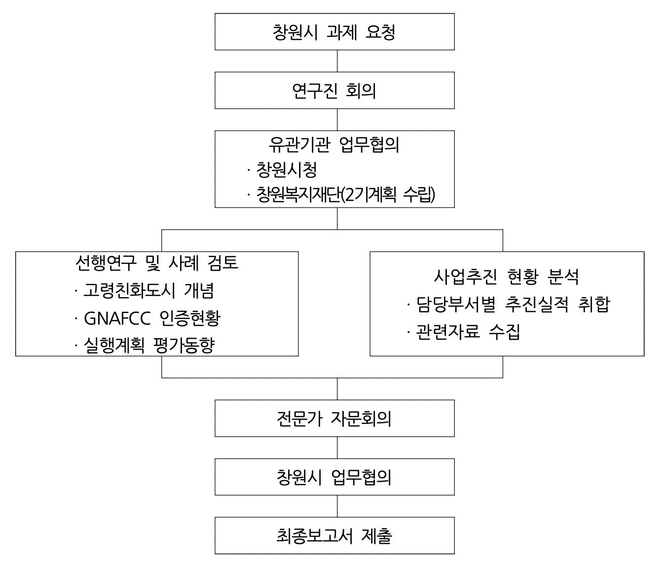
Changwon City Business Consultation
Submit Final Report
Expert Advisory Board
Analyzing the status of project implementation
- Collecting the results of implementation by department in charge
- Collecting relevant data
Prior research and case review
- Concept of Age-Friendly City
- GNAFCC Certification Status
- Execution Plan Evaluation Trends
Consultation with related organizations
- Changwon City Hall
- Changwon Welfare Foundation
(Establish second plan)
Faculty Meetings
Changwon City Assignment Request
<Figure 1-1> Procedure for conducting research

II. Age-Friendly Cities Concept and Status

1. Age-Friendly Cities Concept
1) Rationale Basis: Active Ageing2)

The concept of active aging
o The age-friendly city concept is theoretically grounded in the WHO's active ageing concept.
- The term "active" does not refer only to physical vigor or the ability to participate in the labor market, but also to sustained participation in social, economic, cultural, spiritual, and civic activities (WHO, 2002).
- In other words, "active ageing" is defined as the process of optimizing opportunities for health, participation, and safety to improve the quality of life of individuals as they age (WHO, 2002).

o Based on the rights, preferences and capacities of older people, the WHO recommends that governments, states and civil society work together to ensure advocating for "active aging" policies and programs
- WHO recognizes that older people, even those who are retired, ill or disabled, can make active contributions to their families, colleagues, communities and countries. Active ageing aims to enable people of all ages to extend their healthy life span and quality of life as they age.

Characteristics of active aging
o Human rights-based concepts
- Active aging is based on the concept of human rights and
represents a shift from a needs-based approach that assumes older people are passive targets.
2) The term "active ageing" has been translated as "active aging" or "vibrant aging" by different researchers, but in this study, we use "vibrant aging" to reflect the life-cycle perspective that older adults live healthy lives of active participation and intergenerational solidarity in a variety of areas, including social, economic, and cultural activities.

o Emphasize interdependence and intergenerational solidarity
- Active ageing is about maintaining autonomy and independence as people age, and recognizes the importance of interdependence and intergenerational solidarity, as "yesterday's children are today's adults and tomorrow's grandmothers and grandfathers" (WHO, 2007).
- In other words, creating a social, cultural, and economic foundation that supports vibrant aging is for all ages.

o Many factors need to be considered for active aging
- The culture that surrounds every individual shapes how we age. Gender should also be a lens through which to consider the appropriateness of various policies (WHO, 2007)
- Other influences include economic factors, health and social services, behavioral factors, social factors, physical environment, and personal factors.
- Therefore, in order to create an age-friendly city, it is necessary to develop an action plan to influence the various factors that affect active aging.

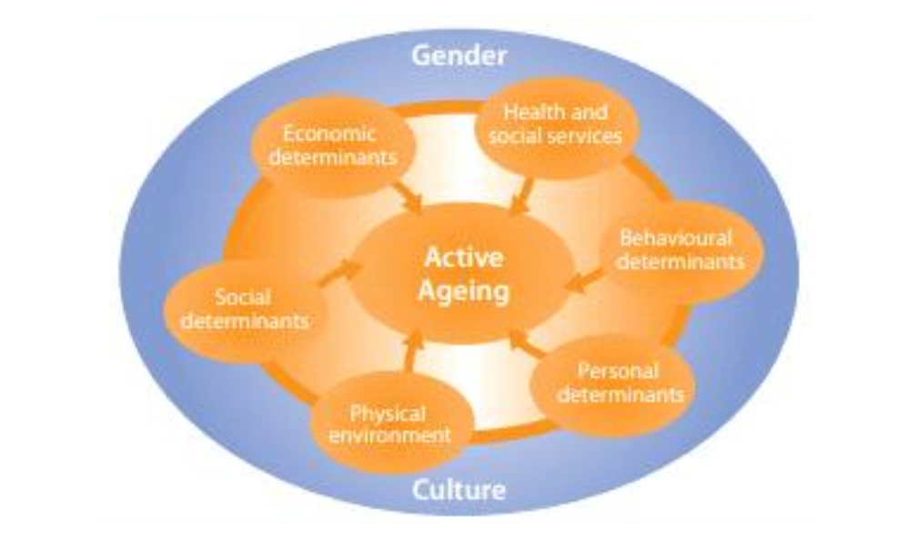
Source) WHO (2007), p.5
<Figure 2-1 Determinants of active aging>

2) Age-friendly city concept
Age-friendly city concept
o Age-friendly cities can be defined as inclusive and accessible urban environments that promote active aging (Jung Kyunghee, 2010)
- The WHO recognizes that as individuals age, they undergo physical and social changes that require a complementary and empowering living environment to support them.
- The concept of "elder-friendly communities" is based on the idea that age-friendly cities should build community foundations that reflect the needs and characteristics of older adults.
- The goal is to create physical and social conditions in communities that enable people to remain in their homes as they age (ageing in place), and to ensure that all citizens have the opportunity to live a vibrant later life.

o An age-friendly city is a city for all ages
- Making cities more age-friendly is essential for promoting the well-being and contribution to society of older people living in cities and sustaining their prosperity, and since everyone goes through the process of 'ageing', age-friendly cities are cities for all ages (WHO, 2007).
- In addition, creating urban environments and social structures that enable the elderly to be healthy, participate in society, and engage in economic activities can prevent or slow down disabilities and chronic diseases that burden individuals, families, and health care systems, so creating age-friendly cities should be understood as a project for all ages, including the elderly.

A guide to creating age-friendly cities
o The WHO provides a 'Guide to Age-Friendly Cities' with items and contents to be checked to create an age-friendly city.
- The Age-Friendly Cities Guide consists of 84 items in 8 categories;
◦ First, the criteria for urban infrastructure and physical environment conditions consist of 26 items, including external environment and facilities (12), convenience of transportation (7), and convenience of living environment (7).
◦ Second, the socio-economic environment, which consists of 25 items, including leisure and social activities (8), social participation and jobs (8), and social respect and integration (9)
◦ Third, social supportive environment (health and services), which consists of 23 items, including communication and information (11), community support and health services (12), etc.

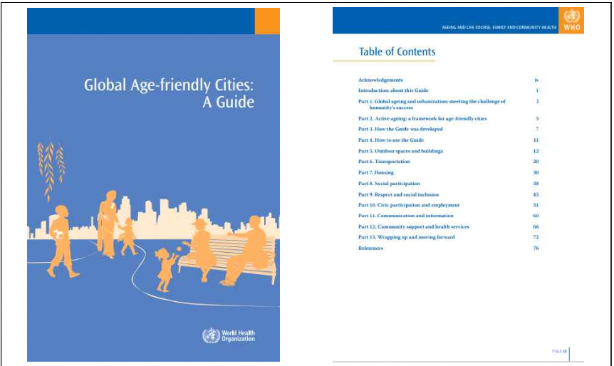
Resource) WHO (2007)
<Figure 2-2> WHO Age-Friendly City Guidelines

o The Age-Friendly Cities Guide recognizes that not all cities and regions need to use the same organization of areas in their action plans.
- The organization of the areas may be refreshed according to the characteristics of the planning city. However, it is recommended that the contents included in the eight areas be addressed in some way to reflect the intention of an age-friendly city (Jung, Eunha, 2016).

(Table 2-1) Eight Age-Friendly Guide Areas and Checklists
Eight Zones |  | Key Contents | Checklist
Physical Environment | Outdoor spaces and building | It covers outdoor environments and public buildings, and improves the safety, convenience, and accessibility of urban infrastructure.  Improve quality of life | Environment, green spaces and sidewalks, outdoor chairs, sidewalks, stability, service facilities, buildings, public restrooms, etc.
 | Transportation convenience (Transportation) | Improving social participation and access to health care for the elderly by making public transportation more accessible and affordable | Low cost, Reliability and distribution, Senior friendly vehicles, Special services for disabled seniors, Senior seats, Driver, Safety and comfort, Taxis, road, parking, etc.
 | Housing Stability | The structure, design, location, cost, and public services of age-friendly housing can be designed to make in comfortable and safe. | Affordability, design, modification, management, aging in place, community integration, housing options, housing facilities, living environments, etc.
Socio Economic Environment | Leisure and social participation | Increase social belonging by providing access to family, social, cultural, religious, and leisure activities for older adults, and establishing administrative and information support systems. | Accessibility of events and activities, low cost, wide choice of events and activities, facilities and venues, promotion of programs, and outreach to underserved populations. Audience engagement, etc.
 | Civic participation and employment | Encourage civic engagement and contribute to the community by developing a workforce based on the needs of older adults and expanding the availability of volunteer and employment opportunities. | Volunteer options, employment options, education, accessibility, civic engagement, respect for social contributions, entrepreneurship, remuneration
 | Social respect and integration (Understanding and social engagement) | To improve the public image of older adults, incorporate primary and secondary education content, utilize mass media outlets, and strengthen the role of older adults in the community based on their needs.  Increase intergenerational integration with | Services that foster respect and inclusion, public myths about aging, generational integration and family interaction, public education, and community integration, Supporting economically disadvantaged seniors
 | Communication and information | Social activities by establishing information that characteristics of the elderly and strengthening accessibility various systems reflect the and relationship activation | Informational, oral communication, written information, plain language, communication devices, computers and the Internet
 | Health and community care (Community support and health services) | Increase the health and independence of older adults by strengthening the sufficiency, appropriateness, accessibility, and quality of community services and health care for older adults. | Accessible services, service delivery, volunteer recruitment, and emergency preparedness and management.
Resources) WHO (2007) Age Friendly Cities website (https://extranet.who.int/agefriendlyworld)

2. Joining the International Network for Age-Friendly Cities Status

1) What it means to join the International Network of Age- Friendly Cities
Sharing information, knowledge, and experience with cities around the world to create age-friendly cities.
o GNAFCC was founded in2 010, and as of May 2019, 41 countries and 847 cities have joined (Park, Jinkyung and Kim Sangmin, 2020).
- GNAFCC has healthy, active ageing and ageing in place as key values, sharing experiences from cities and communities around the world.
- By joining the International Network of Age-Friendly Cities, Changwon City is eligible to participate in an international exchange for the creation of age-friendly cities.

GNAFCC is also helping cities and communities find appropriate innovations and evidence-based solutions.
- GNAFCC's main activity is to connect cities and communities around the world to share information, knowledge, and experiences for change, so it is possible to plan an effective age- friendly city project that fits the conditions of Changwon through various examples.
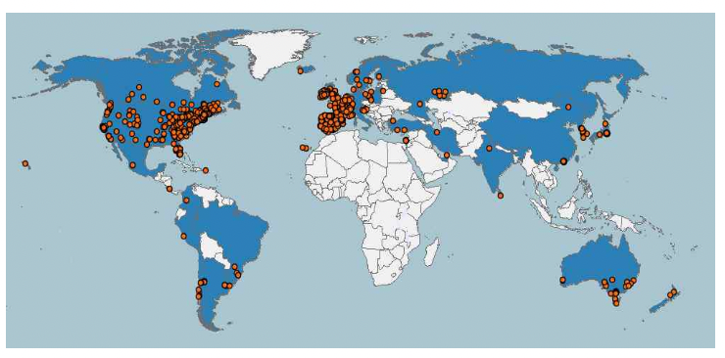
Resource) WHO Age-Friendly City Homepage(https://extranet.who.int/agefriendlyworld).
<Figure 2-3> Global Network for Age-Friendly Cities (GNAFCC Membership Status

2) Age-Friendly City Network management system
Member City Management System
o Membership in the GNAFCC is determined by evaluating whether various citizen opinions have been collected and whether the action plan is comprehensive, sufficient, timely, and feasible, reflecting the characteristics of the city (Korea Industrial Development Institute, 2019).
- To create an age-friendly city, it is necessary to establish a cooperation system with various stakeholders such as local residents, including the elderly, civic organizations, the government, and civil society, and to establish an age- friendliness assessment and a three-year action plan and collaborate with related departments.
- Establish a homepage with information, create a monitoring plan, and enforce it

o GNAFCC has a management system in place to ensure that member cities continue to make progress in creating age-friendly cities.
- It is recommended to establish a three-year action plan when initially joining, and an improved five-year plan thereafter (Jung Eunha, Song Inju, and Hwang Hyeshin 2015).

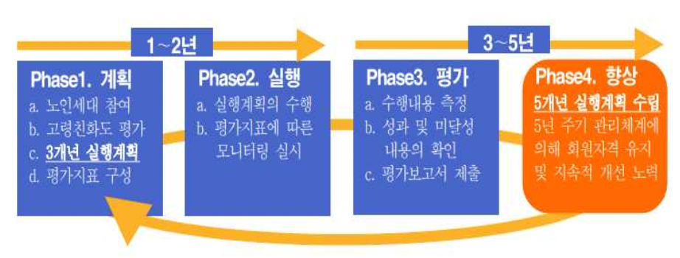
3~5 years
1~2 years
Phase1. Improve

Establish 5-year Action Plan
Maintaining membership and continuous improvement through a five-year cycle management system

Phase3. Evaluation

a. Estimate performance contents
b. Check the result contents
c. Submit evaluation report
Phase1. Performance

a. Performing Action Plan
b. Monitoring by evaluation index
Phase1. Plan

a. Participation of Senior
b. Evaluation of Age-Friendly Rate
c. 3-year Action Plan
d. Configure Evaluate Index
Resources) Jung Eunha, Song Injoo, and Hwang Hye Shin (2015).
< F i g u r e 2-4> Management system of W H O International N e t w o r k of Age- Friendly Cities m e m b e r cities

- Changwon City joined the GNAFCC in 2020 and established the first action plan (action tasks) for three years from 2020 to 2022, and this year, the third year of membership, Changwon City must evaluate the first action plan and establish a second plan.

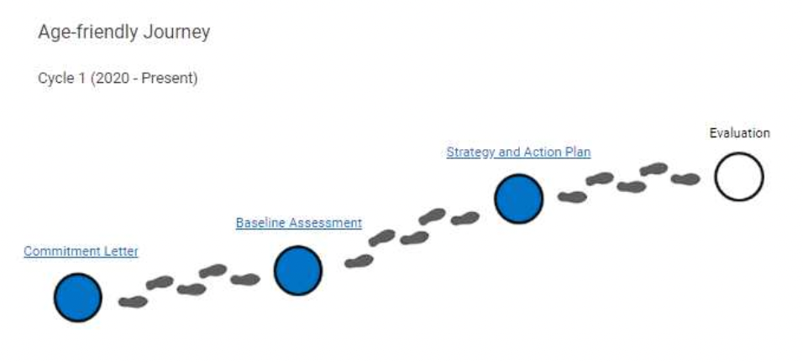
Resource) Changwon City page on the WHO Age-friendly Cities website (https://extranet.who.int/agefriendlyworld/network/changwon-city).
<Figure 2-5> Steps for Changwon City to join the 1st Age-Friendly City and implement the action plan

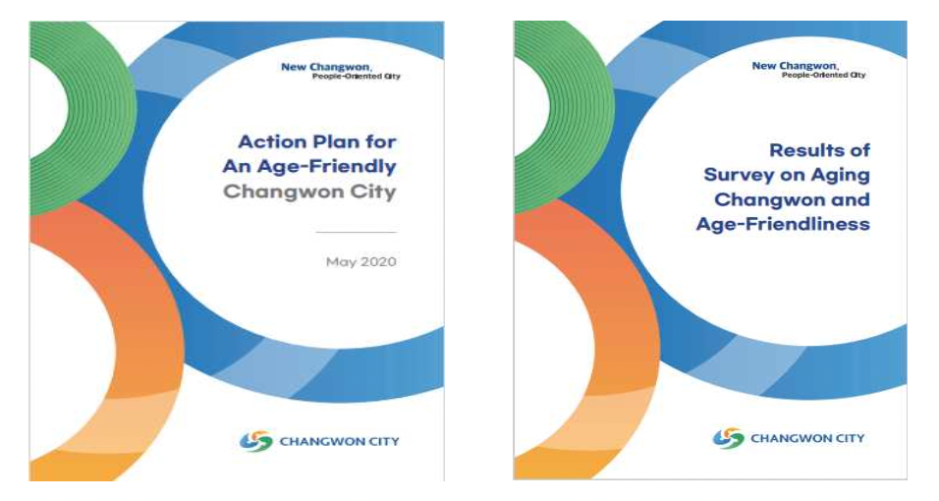
Resource) Changwon City page on the WHO Age-Friendly Cities website (https://extranet.who.int/agefriendlyworld/network/changwon-city) (2020.05.25, submitted upon joining the WHO GNAFCC).

<Figure 2-6> Changwon City's Age-Friendly City Action Plan and Baseline Assessment Report

Subscription Status
o As of the end of February 2022, 37 cities in Korea have joined the GNAFCC as member cities.
- In the case of metropolitan-level cities, Seoul was the first to join in 2013, and seven metropolitan cities have joined, including Busan Metropolitan City (2016) and Sejong Autonomous City (2019).
- At the local government level, Jeong-eup City in Jeollabuk-do was the first to join in 2014, followed by Suwon City (2016) and Dong-gu, Gwangju Metropolitan City (2017), and 30 cities, counties, and districts have joined.
- GNAFCC sign-ups at the municipal level have been growing since 2018

o Changwon became the 21st senior-friendly city in Korea in 2020.

(Table 2-2) WHO GNAFCC Domestic Participation Status
Year | Join Year | City name |  | Remarks
 |  | Metropolita areas | Municipalities
Total |  | 7 metropolitan areas | 30 cities, counties, and districts | -.
1 | 2013 | Seoul | -. | Wide Area (1)
2 | 2014 | Jeollabuk-do | Jeong-eup City | Boroughs (1)
3 | 2016 | Gyeonggi-do | Suwon | Metropolitan area(1)，Autonomous region(1)
4 |  | Busan Metropolitan City | -.
5 | 2017 | Jeju Special Self-Governing Province | -. | Metropolitan area(1)，Autonomous region(1)
6 |  | Gwangju Metropolitan City | Dong-gu
7 | 2018 | Chungcheongnam-do | Nonsan-si | Boroughs (5)
8 |  | Gyeonggi-do | Bucheon-si
9 |  | Seoul | Gangbuk-gu
10 |  | Seoul | Yangcheong-gu
11 |  | Seoul | Dobon-gu
12 | 2019 | Gwangju | Seo-gu | Metropolitan (1), Borough (4)
13 |  | Jeollanam-do | Naju-si
14 |  | Gyeongsangnam-do | Namhae-gun
15 |  | Sejong Autonomous City | -.
16 |  | Seoul | Nowon-gu
17 | 2020 | Gwangju | -. | Metropolitan (3), Borough (7)
18 |  | Ulsan Metropolitan City | -.
19 |  | Gyeongsangbuk-do | Chilgok County

Resources) WHOGNAFCC domestic participation status(Age-friendly Seoul websitehttps://afc.welfare.seoul.kr)

(Table 2-2) WHO GNAFCC Domestic Participation Status (continued)
Year | Join Year | City name |  | Remarks
 |  | Metropolita areas | Municipalities
20 | 2020 | Seoul | Seocho-gu | Metropolitan (3), Borough (7)
21 |  | Gyeongsangnam-do | Changwon City
22 |  | Seoul | Seongdong-gu
23 |  | Seoul | Jongno-gu
24 |  | Gyeonggi-do | Seongnam-si
25 |  | Gyeongsangnam-do | Tongyeong City
26 |  | Hwasun-gun, Jeollanam-do | -.
27 | In 2021 | Gyeongsangnam-do | Goseong-gun | Boroughs (9)
28 |  | Seoul | Yongsan-gu
29 |  | Chungcheongnam-do | Gongju-si
30 |  | Incheon Metropolitan City | Dong-gu
31 |  | Gyeonggi-do | Uiwang-si
32 |  | Seoul | Geumcheon-gu
33 |  | Incheon Metropolitan City | Michuhol-gu
34 |  | Jeollabuk-do | Wanju-gun
35 |  | Seoul | Yeongdeungpo-gu
36 | 2022 | Chungcheongnam-do | Buyeo-gun | Boroughs (2)
37 |  | Seoul | Mapo-gu

3. Changwon City promotes an age-friendly city status
1. Progress Status
o Changwon City established an action plan for the first term of 2020 after conducting an elderly friendliness survey and collecting opinions from the elderly in order to join the 2019 Senior Friendly City.
- Collecting opinions from seniors and citizens to develop age- friendliness and guidelines, conducting sensitivity surveys on the actual situation of seniors and policy bodies, and conducting in-depth interviews with focus groups of citizens
o After applying for certification to join the Changwon City Elderly Friendly City (2020.5.27), enacted the Ordinance on the Creation of Changwon Age-Friendly City. (2020.7.13)
o In October 2020, Changwon City was certified as an aging-friendly city (2020.10.15.), and since then, we have conducted s e l f - monitoring on the progress of the project three times.

(Table 2-3) Status of Changwon City's Elderly Friendly City Promotion
Duration | Progress
February 2019 | Started research on creating a Changwon-type senior-friendly city (Changwon Municipal Research Institute)
May 2019 | Collected opinions on the development of age-friendly cities and guidelines (750 citizens)
June 2019 | Elderly Situation and Policy Experience Survey (1,000 citizens) Changwon City Elderly Friendly Policy Advisory Group Meeting (Presentation of research overview)
July 2019 | Changwon City Elderly Friendly Urban Environment Survey (Identifying Distinct Elderly Vulnerable Areas)
August 2019 | In-depth interviews with citizen focus groups (2 total)
October 2019 | Changwon City Age-Friendly Policy Advisory Group Meeting (Interim Report)
December 2019 | Research experts to set vision
January 2020 | Changwon City Elderly Friendly Policy Advisory Group Meeting (Final Report)
May 2020 | Application for certification to join Changwon City as an Elderly Friendly City  <Figure 2-7> Confirmation of application for certification as an age-friendly city in Changwon  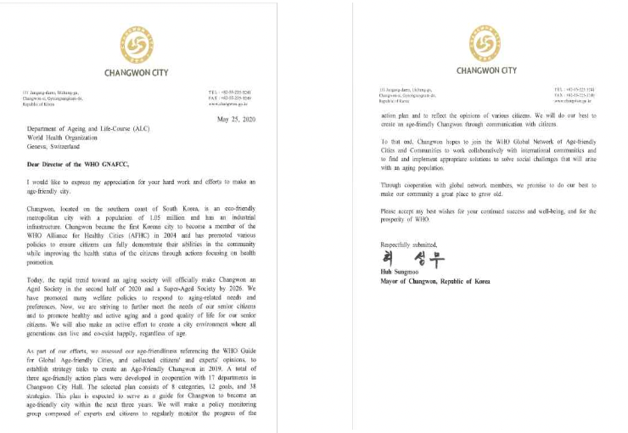
June 2020 | Changwon City enacted an ordinance on creating an age-friendly city
September 2020 | Establishment and operation of an age-friendly city committee (15 members)

(Table 2-3) Status of Changwon City's Elderly Friendly City Promotion (Continued)
Duration | Progress
October 2020 | Achieve certification as a World Health Organization (WHO) International Age Friendly City  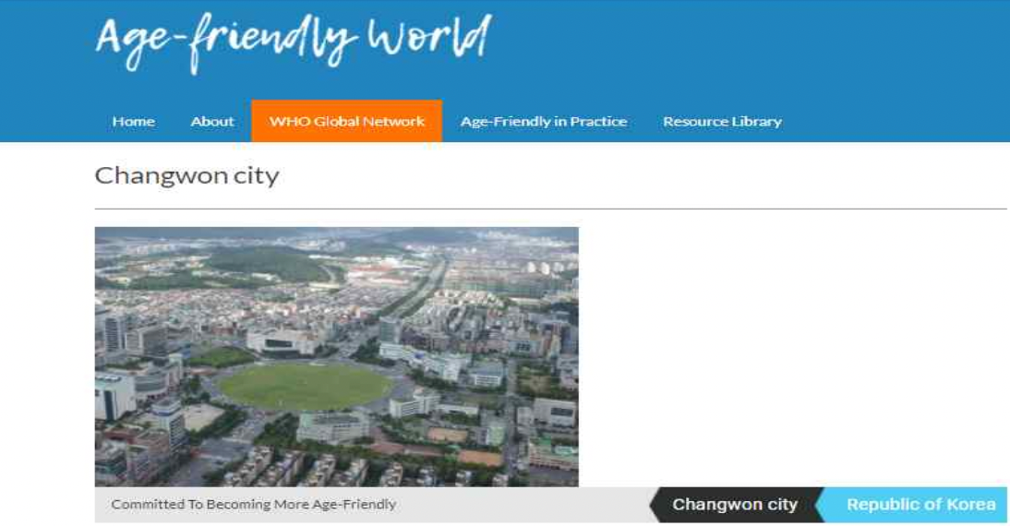  <Figure 2-8> WHO GNAFCC Member City (Changwon City) Homepage  Data) WHO Age-friendly Cities website Changwon City page https://extranet.who.int/agefriendlyworld/network/changwon-city
December 2020 | 2020 Changwon City Comprehensive Report on the Progress of Action Tasks to Create an Elderly Friendly City  Enacted an ordinance on the establishment and operation of priority parking areas for the elderly in Changwon City
February 2021 | Establish guidelines for setting up and operating senior priority parking zones  Guidelines for Installing and Operating Priority Parking for Seniors in Public Facilities and Multi-Use Facilities
June 2021 | Agreement and opening of "Is this the place? Playground" for the elderly in Changwon City
July/December 2021 | Changwon City Progress on Action Tasks to Create an Elderly Friendly City  First half monitoring (July) and monitoring (December)  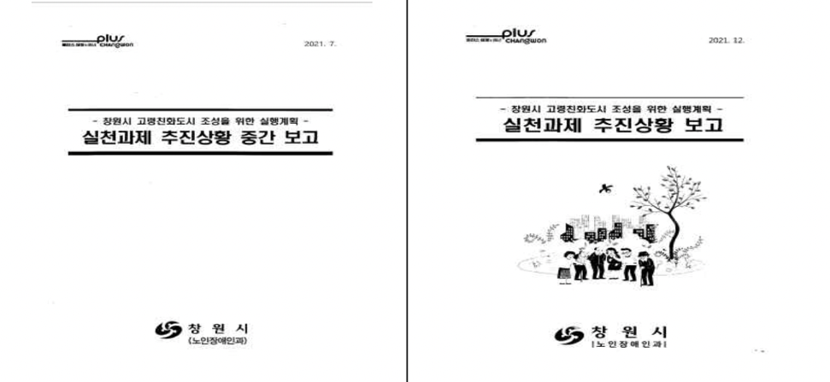
June-December 2022 | Changwon City Evaluation of the 1st period of Consideration Friendly City and planning for the 2nd period

Source) Changwon City internal data.
2) Establishment and operation of an age-friendly city committee
○ Configuration Rationale
- The Committee for the Creation of an Age-Friendly City was formed in September 2020 with 15 members in accordance with Article 17 (Establishment and Functions of the Committee) of the Ordinance on the Creation of an Age-Friendly City in Changwon City.
- The chairperson of the Age-Friendly City Committee is the vice mayor, and the vice chairperson is selected from among the members.
- The Director of Welfare and Women's Health is an ex officio member, and academics, city councilors, field experts (welfare officers), nursing hospitals, the Korea Senior Citizens Association, YMCA, and other civil society organizations participate.

○ Key features
- The Committee for the Creation of an Age-Friendly City has the function of proposing, deliberating, and advising on research, manpower training, and infrastructure construction related to the establishment and implementation of plans and certification of age-friendly cities.
- It may also deliberate and advise on performance measurement, monitoring and evaluation related to the promotion of age-friendly cities and other matters deemed necessary by the mayor

○ Activity History
- Changwon City's Committee to Create an Age-Friendly City was
formed in September 2020 during the COVID-19 pandemic.
- As in-person meetings were not possible due to strong quarantine measures in place at the time, written meetings were held to sign up as an Age-Friendly City and report on the first action plan.
- Despite the recent return to normalcy, little progress has been made in the last two years on the Age-Friendly City Commission.

3) Action Plan Operational Status
○ The Changwon City Elderly Friendly City 1st Action Plan set 3 goals under the vision of "Realizing a vibrant Changwon that realizes the value of old age" and presented a total of 38 actions and projects (detailed projects).
- The first policy goal is to create a safe and comfortable urban environment, which includes 13 projects to improve the city's safety performance, pedestrian environment, transportation, and residential environment.
- The second policy goal, "Realizing Understanding and Respectful Intergenerational Integration," includes 12 initiatives to improve elderly rights and awareness, strengthen access to information, and promote intergenerational integration and health.
- The third policy goal is to support healthy and leisurely retirement, which includes 13 projects such as leisure and social activities and human resource utilization.
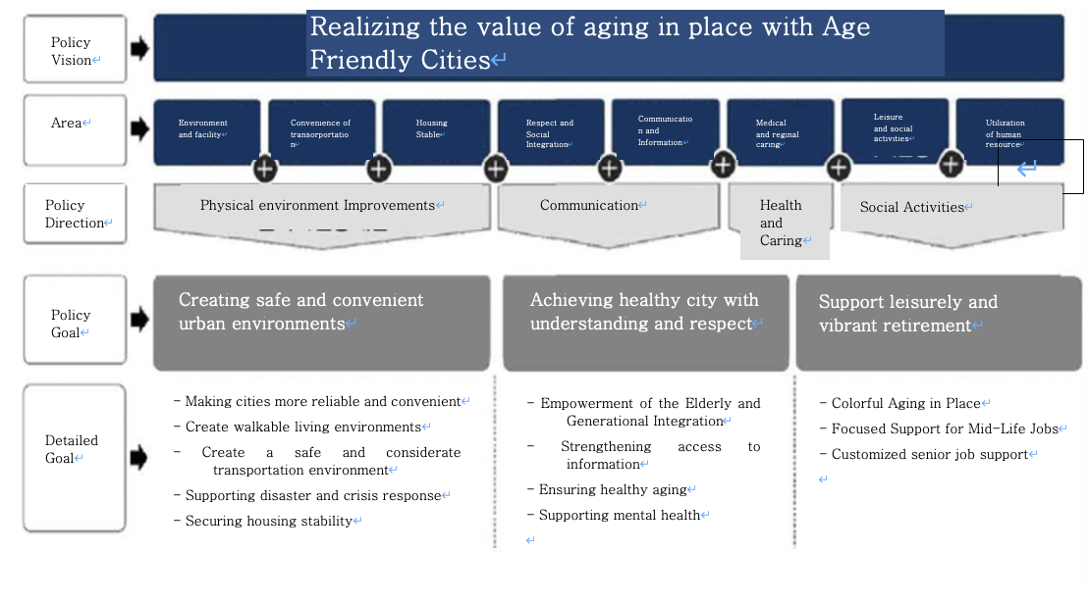
Resources) Lee Young, Kwak Sohee, Jung Ohhyun, Yoon Jaebong (2020).
< Figure 2-9> Policy Vision System for Creating Changwon-type Senior Friendly City

○ Of the projects presented, 17 are new proposals and 21 are expansion and strengthening of existing ongoing projects.
- Some projects were revised and changed due to changes in COVID-19 prevention measures and business conditions. Of the 38 total projects, 10 were revised, including 6 new projects and 4 ongoing projects.
- Out of a total of 38 detailed projects (action projects), 5 projects (creation of smart traffic lights, expansion of rest areas in the city center, creation of an elderly-friendly environment in the civil affairs office of the administrative welfare center, promotion of the Gyeongnam-type community care pilot project, and creation of an elderly-friendly store) were terminated after completion of the project, and 14 projects are being continuously promoted after achieving their goals.

(Table 2-4) Operation Status of Changwon City's 1st Action Plan for Elderly Friendly Creation
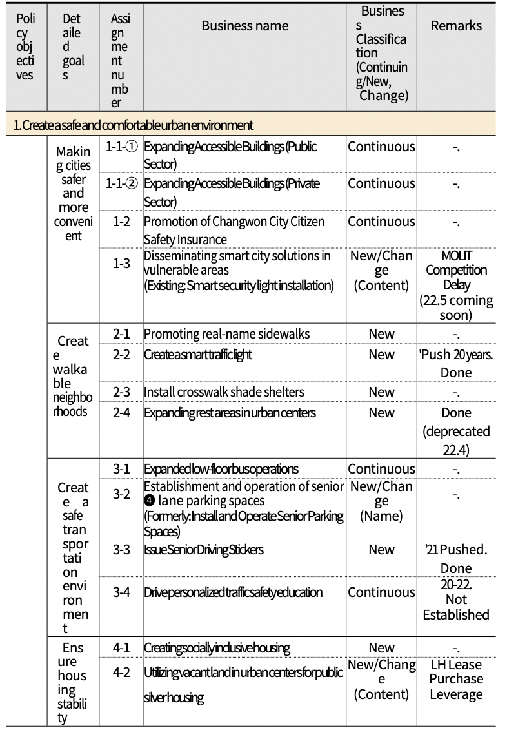
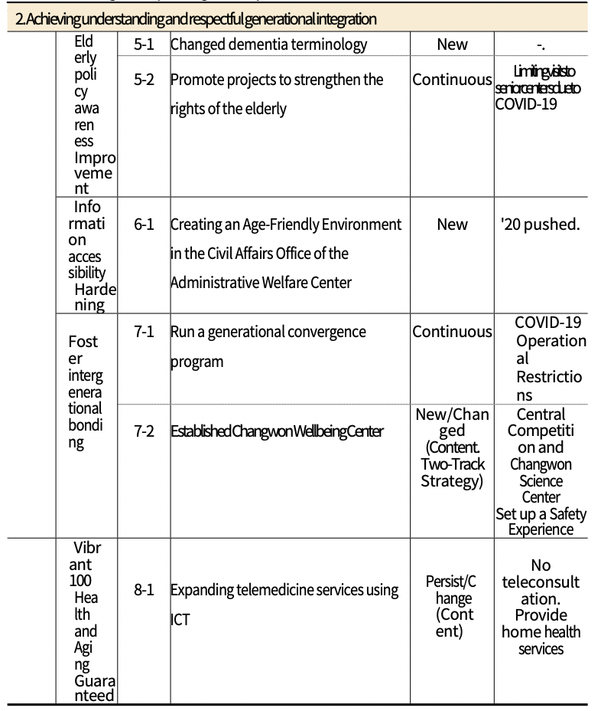

(Table 2-4) Operation Status of Changwon City's 1st Action Plan for Elderly- Friendly Creation (continued)
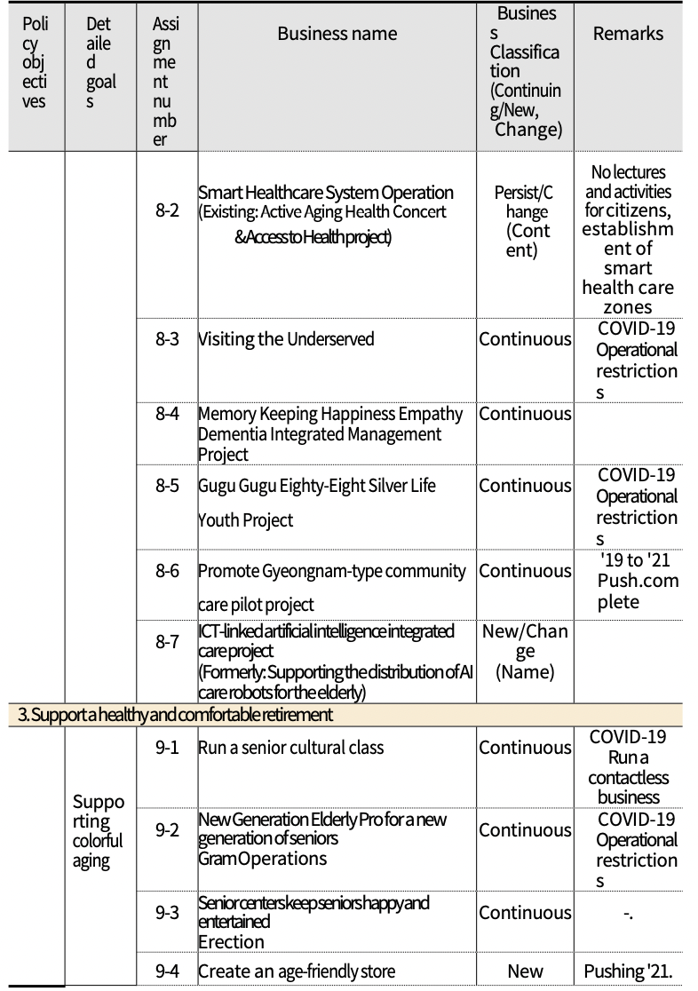

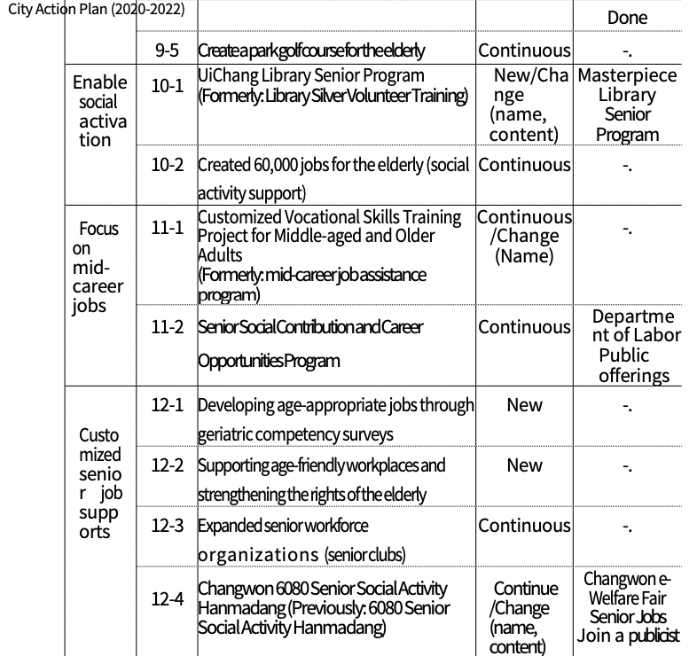

III. Changwon City Age-Friendly City Evaluation Direction

1. Age-Friendly Cities Action Plan Evaluation Trends
1) Seoul
□ First city to join GNAFCC in Korea
○ Seoul was the first city in Korea to join the International Network of Age-Friendly Cities in 2013.
- In 2010, the city of Seoul established the "2020 Master Plan for an Aging Society" and mentioned an age-friendly city as a medium- to long-term plan and proposed to join the GNAFCC as a goal.
- Established Seoul's guidelines for an age-friendly city by conducting research and collecting opinions according to the eight areas of the 2011 WHO guidelines.
- Seoul joined the GNAFCC as a member city in 2013 based on the 2012 Seoul Senior Citizens' Comprehensive Plan.
- The first Action Plan (2013-2015) consisted of 35 projects in six areas and was evaluated by applying the Action Plan Evaluation Criteria presented at the time of plan formulation.
- Published an interim inspection report on the Action Plan for Age-Friendly Cities in 2014 and completed a final evaluation report on the 1st Action Plan in 2015.
○ Seoul City established a second action plan in 2016 and obtained GNAFCC recertification.

□ Evaluation Methods
○ Seoul conducts both quantitative and qualitative evaluations of the detailed tasks of the 1st Action Plan based on their performance.
- Quantitatively evaluate the rate of progress against business goals and categorize it as normal progress, revised progress, or insufficient progress.
- For major achievements, present a qualitative assessment of the project's progress and significance.

(Table 3-1) Evaluation Criteria for Detailed Tasks of Seoul's 1st Age-Friendly City
Categorizing  Progress | Details
Normalize | Achieved more than 100% of three-year goal performance.  If a subtask has more than one goal, judge the overall level of achievement.
Push to Correction | 3-year target performance was adjusted during policy implementation and pushed forward Adjusted target was met Revised and determined to be on track
Insufficient | Failed to achieve any of the three-year targets or achieved less than 50% of the targets. Determined that progress was insufficient; need to develop an action plan and adjust targets for 2015
Resources) Jung Eunha, Song Injoo, and Hwang Hye Shin (2015).

○ In addition, the evaluation of the elderly parties is presented by utilizing the activity interviews of the "Elderly Policy Monitoring Group" operated during the project implementation process.

□ Evaluation Subject
○ Involving diverse stakeholders in the evaluation of Seoul's Age- Friendly City Action Plan
- Officials from business departments, field experts from related organizations, academics, and the Elderly Policy Monitoring Group are participating.
- Officials from the departments in charge are in charge of submitting the results of the program and quantitative evaluation based on the rate of implementation, and the opinions of field experts, academic experts, and the Elderly Policy Monitoring Group are comprehensively presented on major achievements and improvement measures.

2) Busan
□ GNAFCC Phase 2 certified cities (metropolitan areas)
○ Busan joined the International Network for Age-Friendly Cities in 2016 and completed its second term in 2019.
- In September 2021, Busan entered the super-elderly society the fastest among the seven special metropolitan areas, with the proportion of seniors aged 65 and older reaching 20.1% of the total population.
- Busan has established a second action plan to maintain its membership in the GNAFCC and to establish a comprehensive plan for its entry into the ultra-elderly society.

□ Preparing for an ultra-elderly society 'Creating an elderly-friendly
15-minute happiness city in Busan'
○ Recently, Busan City announced that it will promote a 15-minute city creation project in connection with an age-friendly city to make people live happily while enjoying a convenient life where they live (Busan Metropolitan City Press Release, September 9, 2021).
- The 15-minute city in Paris, France, the Barcelona superblock in Spain, and the '20 minute neighborhood' in Melbourne, Australia are attempts to expand the city's structure, public infrastructure, transportation, etc. to make the city's living areas efficient and systematic to increase the convenience of living in close proximity.
- Busan City plans to promote the vision of expanding urban infrastructure and expanding services that are good for everyone to live, not just the elderly, through the realization of 15-minute cities in developed countries.

□ Evaluation Methods
○ Quantitative assessment of goal achievement
- Busan City conducted an evaluation of the 1st Action Plan in 2018, when the 1st Action Plan ended, and evaluated it as Achieved / Normal Progress / Sluggish based on whether it was achieved against the target, but the criteria were not clearly stated.
○ Qualitative assessment
- Establish an external evaluation team composed of relevant experts (professors in the fields of environment, health, and social welfare) to assess the validity and sustainability of the contents and goals of the first plan.

□ Evaluation Subject
○ The city of Busan has been continuously checking the progress of its age-friendly city through the Elderly Policy Committee (Lee Jae-jung, Kim Soo-young, Lee Min-hong, 2018), but no specific timing or methods are given.
○ In addition, we run the Super Senior Policy Conference to review and propose opinions on senior welfare policies through the direct participation of senior citizens.
3) Suwon
□ Cities (municipalities) certified to join GNAFCC Phase 2
○ SuwonjoinedtheGlobalNetworkofAge-FriendlyCities(GNAFCC)in2016 - Suwon has a similar population size to Changwon and the
same legal status as a special city.
- After the first action plan (2016-2018), Suwon City developed a medium- to long-term plan to establish the second action plan and obtained the second certification in 2019.

□ Evaluation Methods
○ Quantitative evaluation with goal achievement assessments
- To evaluate the 53 detailed tasks in the six areas of the first action plan, Suwon City is presenting detailed task performance figures by utilizing the progress reports of the three action plans and annual work plans.
○ Expert research
- Surveyed experts to assess task satisfaction and persistence
- Satisfaction is the level of satisfaction with the effectiveness of the Year 1 action plan areas, as measured by the extent to which experts (n=37) felt they were effective.
- Persistence is an expert's assessment of whether a business should continue, with a higher persistence indicating a higher opinion of staying in business.
○ In addition, an Age-Friendly City Monitoring Group has been appointed to report quarterly results.

□ Evaluation Subject
○ Evaluation was conducted primarily through expert participation, including evaluation of researchers' project implementation performance and expert surveys.

4) Implications
□ Evaluation is a combination of quantitative and qualitative
○ The evaluation of the action plan is quantitative by evaluating the achievement of the goal, and expert evaluation or expert research is used for qualitative evaluation of the project implementation.
○ In addition, the city is evaluating the level and perception of age-friendliness of the city through a survey method,

□ Engage a variety of experts
○ Officials in charge of projects and related experts are participating in the evaluation of the Action Plan for Age- Friendly Cities, and in some cases, their opinions are reflected in the evaluation by conducting age-friendliness surveys among the general public and the elderly.

□ Incorporate older adult input into business processes and
evaluations
○ Older people are the best experts on their own lives, so the WHO emphasizes the importance of a bottom-up, participatory approach to policy-making in age-friendly cities.
- In the process of implementing an age-friendly city, the city operates a monitoring group composed of elderly parties to monitor the needs, policy experiences, and inconveniences of the elderly and directly propose opinions to ensure the participation of the elderly.

2. Changwon City Age-Friendly City Action Plan Evaluation

1) Evaluation purpose
○ Check your progress on your Year 1 action plan
- The 1st Action Plan for Age-Friendly Cities was an important
opportunity for Changwon to join the WHO GNAFCC as a certified city. Through the evaluation of the 1st Action Plan, it was necessary to check the performance of the detailed tasks promoted over the past three years and to adjust or modify the projects that did not achieve the goals or promote the projects.

○ Based on the evaluation of the first phase of the Age-Friendly City Action Plan, suggestions for a more advanced second phase are proposed.
- One of the key objectives of the evaluation of the first action plan is to prepare the city for the second recertification as a member of the Global Network of Age-Friendly Cities. Changwon needs to maintain its membership as a GNAFCC member city so that it can continue and develop its policy
efforts to create an age-friendly city.
- Recertification requires the submission of a Year 1 Action Plan Evaluation Report and a Year 2 Action Plan (2023-2027), with implications for the development of a more advanced Year 2 plan.

○ Setting the direction for responding to an aging society by creating
age-friendly cities
- Provide direction for mid- and long-term planning to create
safe and accessible urban environments for all generations across the lifespan, including seniors.

2) Evaluation Methods
○ To evaluate the Year 1 Action Plan, we first reviewed the
evaluation plan in the Year 1 Action Plan.
- According to the 1st Action Plan, the evaluation is proposed to be a combination of quantitative and qualitative evaluation. Quantitative evaluation is proposed to be based on the rate of progress against the goals (plans) as shown in the table below.
- In this study, we refer to the evaluation criteria of the first plan and the goal achievement evaluation criteria of previous studies, and classify it as complete if the target plan has been promoted more than 100%, ongoing if the business is progressing normally to achieve the target plan, and insufficient if it has been promoted less than 50% compared to the target.

(Table 3-2) Evaluation Indicators for Changwon City's Research on Creating an Age-Friendly City
Classifications | Details | Remark (supplemental)
Pushrate100% (●) | Achieved 100% of targeted outcomes | Achieved 100%or higher  : Done (●)
In Progress (⊙) | You’re working on an assignment toward a goal | In Progress (⊙)  → In Progress (⊙)
Not Pushed(○) | If an assignment isn't moving forward or is proving difficult to accomplish, consider adjusting goals. | Incomplete (○) →  Less than 50 Not met (○)

○ In this study, the level of achievement was quantitatively evaluated by quantifying the business goals and performance, and the evaluation according to the project implementation rate proposed in the first plan was presented as a summary table.
- The qualitative evaluation of the 1st Plan based on citizen surveys and expert surveys will be conducted by the organization establishing the 2nd Plan (Changwon City Welfare Foundation) in accordance with prior consultation, while this study focuses on the operation and management evaluation of the detailed projects (action tasks) of the 1st Plan.
- Considering that the evaluation point of the study is the end of March 2022, we also identified the business volume and budget execution performance, as well as the implementation plan until the end of this year, to complement the criteria presented at the time of plan formulation, and evaluated the implementation rate by reviewing them.

○ In particular, since the business period was mostly during the period when the spread of COVID-19 was rapidly increasing, it is presented separately whether the low business goal achievement rate was due to social distancing or other factors.

○ In addition, we conducted a qualitative assessment of the actual business contents and process in addition to the project implementation rate through expert advisory meetings.
- The expert evaluation was conducted by four experts, including academics, field experts, and civil society organizations, among the members of the Changwon City Committee for Age- Friendly Development.
- In addition, the organization establishing the 2nd plan (Changwon City Welfare Foundation) plans to conduct a qualitative evaluation through an age-friendly experience survey.

3) Evaluation Subject
○ Business representatives (government employees) participate in
performance evaluation (quantitative evaluation), including business goals and achievement rates.
○ Relevant experts will conduct a qualitative assessment of the project implementation process and the overall project to create an age-friendly city (qualitative assessment).
○ Senior citizens and general citizens under the age of 65 can also participate in the evaluation of age friendliness perceived and experienced by Changwon citizens, but this requires a large- scale research study, which will be conducted by the relevant organization (Changwon Welfare Foundation) in charge of establishing the second plan.

4) Evaluation Process
○ To evaluate the first action plan, the performance collection form was distributed to each business manager to collect data and evaluate the achievements.
○ Through expert advisory meetings, we conducted a qualitative evaluation of business performance, implementation process, and business development direction, and based on this, we conducted a comprehensive evaluation of the business operation

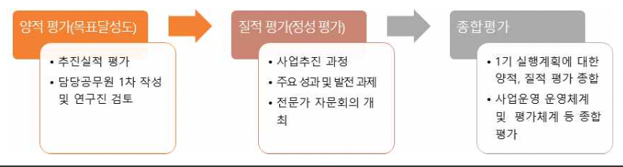
Comprehensive evaluation
Qualitative evaluation
Quantitative Evaluation
- Synthesize quantitative and qualitative assessments of the 1st Action Plan
- Comprehensive evaluation of business operation system and evaluation system, etc.
- The business process
- Key achievements and challenges
- Hosting an expert advisory board
- Evaluate progress
- Initially completed by officials and reviewed by researchers
<Figure 3-1> Changwon City's 1st Age-Friendly City Action Plan Evaluation Process

IV. Evaluation of Changwon City's Aging Friendly City Action Plan

1. Create a safe and comfortable urban environment (Policy Goal 1)
○ The first policy goal of the First Action Plan is "Creating a Safe and Comfortable Urban Environment," with four sub-goals to establish an action plan.
- Goal 1 (Strengthening the safety and convenience of cities) is a sub-goal linked to "Outdoor spaces and buildings" of the eight areas of t h e WHO Guide to Age-Friendly Cities, and sets three action items
- Goal 2 (Promoting walkable living environments) is a sub-goal linked to "Outdoor spaces and buildings" of the eight domains of t h e WHO Age-friendly Cities Guide and sets four action items.
- Goal 3 (Creating a safe transportation environment) is a sub-goal linked to "Transportation" of the eight areas of the WHO Age- Friendly Cities Guide, and sets four action items
- Goal 4 (Ensure Housing Stability) is a goal linked to Housing, one of the eight domains of the WHO Age Friendly Cities Guide, and sets two action items
○ This area demonstrates policy efforts to improve the internal and external environment and transportation infrastructure to enable older adults to live safely and securely in their communities.
- The basic direction is the stability and convenience of the internal and external environment and urban infrastructure such as public buildings.
∙To improve accessibility.
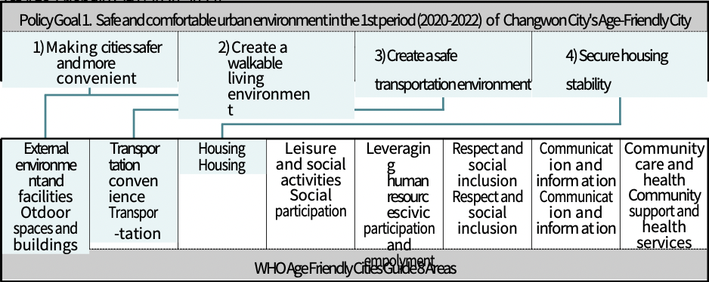

1) Make cities safer and more convenient (Goal 1)
○For the sub-goal 'Strengthening Urban Safety and Convenience', three action tasks were set: ➀ Expanding barrier-free buildings (public and private), ② Promoting citizen safety insurance in Changwon, and ➂ Disseminating smart city solutions in vulnerable areas.
○ We'd like to look at the background and key milestones for each action item.

(Table 4-1) Goal 1 (Enhancing Urban Safety and Convenience) Implementation Tasks, Project Details, and Lead Departments
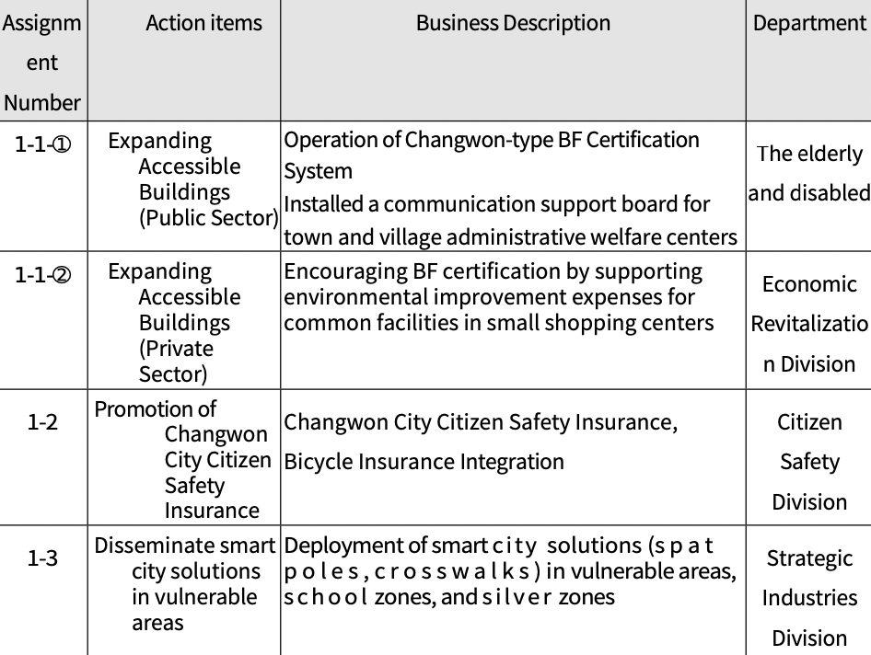
(1) Expand Accessible Buildings (Public)
○ Pushback
- Need for maintenance and improvement of the facility environment so that all citizens, including the elderly, disabled, and those with limited mobility, can use public and private facility without inconvenience,
- In particular, it is necessary to operate the Changwon-type BF certification system for safe and convenient use of public facilities, and to actively discover and promote BF facilities to raise citizens' awareness of them.
- Technical efforts are needed to improve access to information for the elderly and people with disabilities with low literacy and to enhance communication support for administrative processes.

○ Business Description
- Operation of Changwon-type BF Certification System
◦ Establishment and operation of a public-private council to discover Changwon-type BF certified facilities
◦ Identify and select public and private BFW facilities
- Communication support boards in town and village administrative welfare centers

○ Business plan and performance
- As of the end of March 2022, the number of business executions was 85, showing an achievement rate of 104.9% compared to the plan, and the executed budget was 5 million won, showing an execution rate of 100.0% compared to the plan.
◦ Looking at the performance of each detailed project identified during the monitoring of project implementation in the second half of 2021, there were 16 members of the public-private council for the discovery of Changwon-type BF certified facilities and 55 locations for the distribution of communication support boards.

(Table 4-2) Project No. 1-1-① (Expansion of Barrier-Free Buildings (Public Sector))
Project No. | Task | Classification | Business volume (locations) |  |  |  | Budget (million won)
 |  |  | '20 | '21 | '22.3 | 計 | '20 | '21 | '22.3 | 計
1-1-① | Expand barrier-free buildings  （Public sector) | Planning | 21 | 30 | 30 | 81 | Non-Budget | Non-Budget | 5 | 5
 |  | Performance | 32 | 42 | 11 | 85 | Non-Budget | Non-Budget | 5 | 5
 |  | achievement rate  （%） | 104.9 |  |  |  | 100.0
○ Progress (as of March 31, 22)
- The project has not been changed or canceled from the original plan.
- As of the end of March 2022, 74 projects have been completed, 11 are in progress, and a budget of 5 million won is being executed.

(Table 4-3) Progress on Task No. 1-1-① (Expanding Accessible Buildings (Public Sector))
Project No. | Task | Whether to cancel/change from original plan | Business volume (locations) |  |  | Budget (million won)
 |  |  | Complete | Unimplemented (in preparation) | In Progress （Executing) | Complete | Unimplemented (in preparation) | In Progress （Executing)
1-1-① | Expand barrier-free buildings  （Public sector) | Not applicable | 74 | -. | 11 | -. | -. | 5
○ Business valuation
- The BF certification system is operated by the Korea Disability Development Institute, and the Changwon-type BF certification system is a project that aims to strengthen the movement and accessibility of mobility disadvantaged people such as the disabled, the elderly, and pregnant women by applying stronger standards to public facilities that have already been certified.
◦ The members of the public-private council are composed of members of the Changwon City Social Security Council's Disability Subcommittee to promote the BF Certification Program, but it was found that practical activities were insufficient in '20 and '21 as the project was carried out without budgeting.
◦ Secured 5 million won in the '22 supplementary budget to actively identify and promote BF-certified facilities
◦ In order to improve the effectiveness of the project, it is necessary to clarify the entity executing the project and continuously secure the budget (e.g., establishing the project cost and designating the project management agency/organization).
- Placement of communication support boards in town and village administrative welfare centers is a project to help the elderly and people with disabilities with weak literacy skills conveniently access administrative services.
◦ It is determined that the communication support board will help improve administrative convenience to the complainant.
◦ Provision of communication support boards and training on civil service for people with communication disabilities for government officials, administrative and welfare assistants, etc.
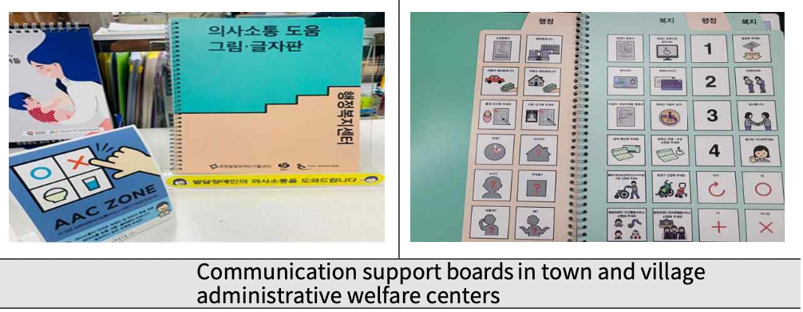
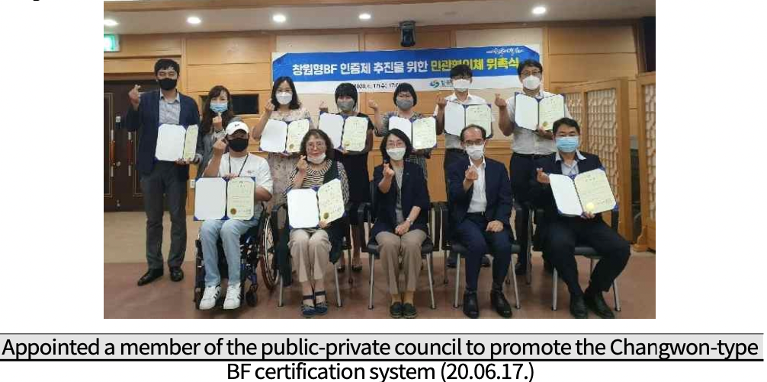

(2) Expand Accessible Buildings (Civilian)
○ Pushback
- It is necessary to expand the creation of barrier-free living environments so that the mobility impaired, such as the elderly and the disabled, do not have any inconvenience when using private facilities such as shopping malls.
- In the case of small-scale shopping centers with small businesses, there is a high financial burden to promote environmental improvements at their own expense, and there are limitations in inducing voluntary renovation to barrier-free buildings.
- Therefore, it is necessary to promote the expansion of barrier-free buildings for the private sector in conjunction with the small-scale commercial center joint-use old facility renovation support project by providing preferential treatment when applying for facility improvement for the disabled, the elderly, and pregnant women among the supported facilities.

○ Business Description
- Support for environmental improvement and renovation of common aging facilities in small commercial centers according to the year of construction, use, and degree of aging of each facility.
◦ Eligibility: (1) Shopping centers that are more than 10 years old and have a merchant association (prosperity association); (2) shopping centers that have more than 20 wholesale, retail, or service businesses in the same shopping center; and (3) preferential treatment for improving facilities for the mobility impaired.
◦ Scale: Within 20 million won per storefront

○ Business plan and performance
- As of the end of March 2022, business execution performance was 37 locations, showing a 102.8% achievement rate compared Friendly City (2020-2022) to the plan, and the executed budget was KRW 651 million, showing an execution rate of 93.0% compared to the plan.

(Table 4-4) Project No. 1-1-② (Expansion of Barrier-Free Buildings (Private Sector)) Business Plan and Performance
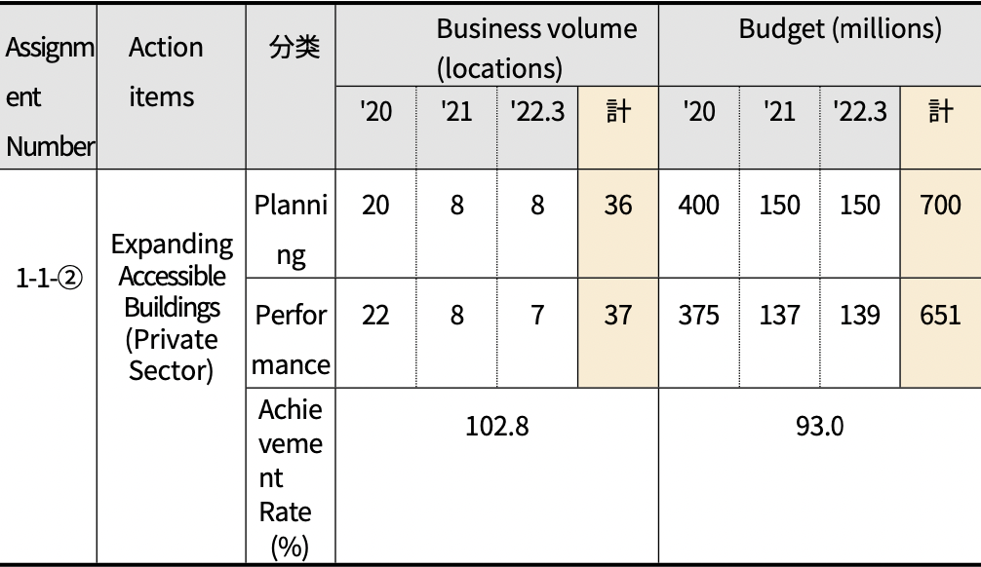
Total
Total
Classification

○ Progress (as of 03/31/22)
- The project has not been changed or canceled from the original
plan.
- Completed 30 locations in 3 years, with 7 in progress
- A total of KRW 512 million has been executed over three years, and
KRW 139 million is in progress

(Table 4-5) Progress on Task No. 1-1 and 2 (Expansion of Barrier-Free Buildings (Private Sector))
Project No. | Task | Whether to cancel/change from original plan | Business volume (locations) |  |  | Budget (million won)
 |  |  | Complete | Unimplemented (in preparation) | In Progress （Executing) | Complete | Unimplemented (in preparation) | In Progress （Executing)
1-1-① | Expand barrier-free buildings  （Public sector) | Not applicable | 30 | -. | 7 | 512 | -. | 139

○ Business valuation
- Promoting the expansion of barrier-free buildings in public and private facilities is crucial to ensuring the mobility rights of citizens with disabilities.
◦However, there are limits to inducing voluntary environmental improvement by the private sector, and Changwon City is promoting the project in the form of preferential installation of amenities for the mobility impaired when supporting the renovation of old facilities in small-scale shopping malls.
◦ Going forward, the program will need to continue to expand.
◦ On the other hand, it is also necessary to promote additional projects such as establishing monitoring groups and campaigns in cooperation with merchant associations to encourage the private sector to voluntarily expand barrier- free buildings.
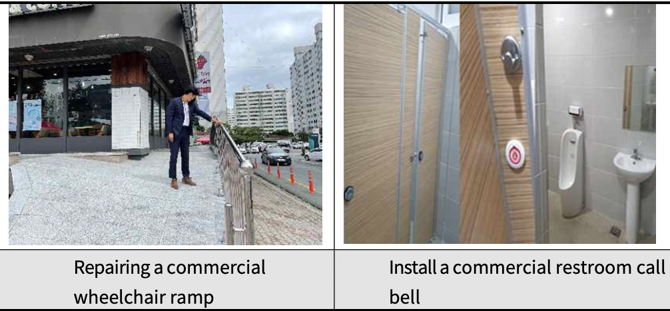

(3) Promotion of Changwon City Citizen Safety Insurance
○ Pushback
- As various types of disaster incidents occur every year, citizens' anxiety is increasing rapidly, and it is necessary to prepare measures to support the minimum living security and welfare of citizens who are affected by unexpected disasters or accidents.
- It is necessary to support the rapid recovery of damage caused not only by natural disasters but also by various social disasters and accidents, and to promote support projects for citizens' bicycle accidents, especially in Changwon City, which aims to be a bicycle city.

○ Business Description
- Enrollment in Citizen Safety Insurance for Changwon Citizens
◦ Eligibility: All citizens who are registered as residents of Changwon City (including foreigners and Korean residents)
◦ What's covered
Citizen Safety Insurance (10 items: natural disasters, accidental injuries, public transportation injuries, etc.)
Bicycle insurance (9 items: general bicycle accident, nuisance bicycle accident, etc.)

○ Business plan and performance
- As of the end of March 2022, the business implementation performance showed a 100.0% achievement rate compared to the plan with 3 subscriptions, and the execution budget was KRW 14.3 million, showing a 100.0% execution rate compared to the plan.
- The number of beneficiaries of the Citizen Safety Insurance project was 13 in 20, 212 in 21 (24 for citizen safety insurance and 188 for bicycle insurance), and 259 as of the end of April 22 (6 for citizen safety insurance and 253 for bicycle insurance).

(Table 4-6) Project No. 1-2 (Changwon City Citizen Safety Insurance Promotion)
Assignment Number | Action items | Classification | Business volume (times) |  |  |  | Budget (million won)
 |  |  | '20 | '21 | '22.3 | Total | '20 | '21 | '22.3 | Total
1-2 | Changwon City  Promoting Citizen Safety Insurance | Planning | 1 | 1 | 1 | 3 | 240 | 590 | 600 | 1,430
 |  | Performance | 1 | 1 | 1 | 3 | 240 | 590 | 600 | 1,430
 |  | Set the achievement to  （%） | 100.0 |  |  |  | 100.0
Note) Promoting the re-enrollment of Citizen Safety Insurance every September.

○ Progress (as of 03/31/22)
- The project has not been changed or canceled from the original plan.
- Signed up 3 times in 3 years, looking to sign up again every September
- Completed a total of KRW 14.3 million over 3 years

(Table 4-7) Progress of Task No. 1-2 (Changwon City Citizen Safety Insurance)
Project No. | Task | Whether to cancel/change from original plan | Business volume (locations) |  |  | Budget (million won)
 |  |  | Complete | Unimplemented (in preparation) | In Progress （Executing) | Complete | Unimplemented (in preparation) | In Progress （Executing)
1-2 | Changwon City  Promoting  Citizen Safety Isurance | Not applicable | 3 | - | - | 1430 | - | -

○ Business valuation
- Changwon City Citizen's Safety Insurance is a project that supports the life stability and early recovery of city residents who are damaged by unexpected disaster accidents.
◦ Initially, citizen safety insurance and bicycle insurance were operated separately, but through the unification of the insurance window, it is possible to reduce the budget and provide quick and convenient services.
◦ Steady funding year after year keeps the business on track
◦ In the future, it is necessary to continue to increase the citizens' experience of the policy through more active publicity and frequent disclosure of the status of benefits.
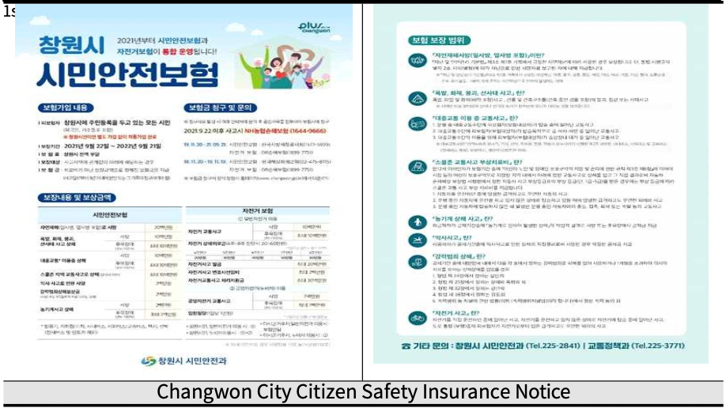
(4) Disseminate smart city solutions in vulnerable areas
○ Pushback
- Continued efforts are needed to improve livability so that citizens can live and work in their communities comfortably and safely.
- In particular, it is necessary to establish a safety system that combines ICT technology with smart systems such as crime prevention CCTV, security lights, and new concept crosswalks.
- Need to introduce a new type of citizen safety system that is responsible for the safety of citizens and provides various information.

○ Business Description
- Ministry of Land, Infrastructure, and Transport "2022 Smart City
Solution Spreading Project" Competition Application and
Promotion
- Project will be phased in starting in 2022, subject to final selection
∙Business Period: 2022-2024
∙Business expenses: 26 billion won (120 national, 24 provincial, 96
municipal, 20 private)
∙Business Area: Jinhae-gu Yeojwa, Chungmu, and Taebaek-dong areas ∙Project details: Installation of 100 smart poles, 25 smart
crosswalks, etc.
*Smart pole: An IOT-integrated installation pole required for smart city services such as security lights, CCTV, Wi-Fi, etc.
*Smart crosswalks: provide safety-related information to drivers and pedestrians, coordinate signal timing, etc.

○ Business plan and performance
- In the meantime, MOLIT's "Regional Base Smart City Creation Project" contest process is underway, and it was finally selected in December 2021, and a full-scale project is scheduled to start after signing an agreement with MOLIT in May this year.

(Table 4-8) Tasks 1-3 (Distribution of Smart City Solution in Vulnerable Areas) Business Plan and Performance
Project No. | Task | Classification | Business volume (expression) |  |  |  | Budget (million won)
 |  |  | '20 | '21 | '22.3 | Total | '20 | '21 | '22.3 | Total
1-3 | Disseminating smart city solutions in vulnerable areas | Plan!
 |  | Performance
 |  | Achievement rate  （%） | 0.0 |  |  |  | 0.0

○ Progress (as of 03/31/22)
- This project has not been changed or canceled from the original plan, but the overall implementation schedule tends to be delayed depending on the progress of the public offering.
- December 2021. Final selection of the contest to create a regional- based smart city
- In the future, the project is planned to be promoted after signing an agreement with MOLIT, followed by an application to the smart city solution diffusion project competition

(Table 4-9) Progress on Tasks 1-3 (Dissemination of Smart City Solutions in Vulnerable Areas)
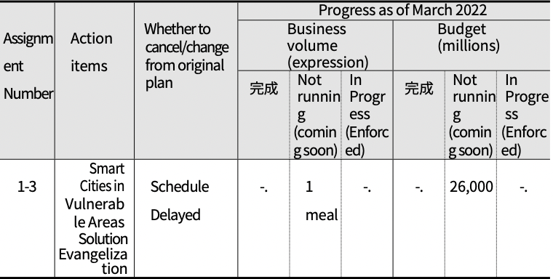
Complete
Complete

○ Business valuation
- The project to distribute smart city solutions in vulnerable areas is to establish a smart safety system linked to ICT technology for safety vulnerable areas to strengthen the infrastructure for improving the safety of citizens.
◦ Changwon City was finally selected for the MOLIT support project related to the construction of a smart city based on active administrative efforts, and the project is being promoted smoothly according to MOLIT procedures.
◦ Requires ongoing business management to ensure that the project is completed reliably.
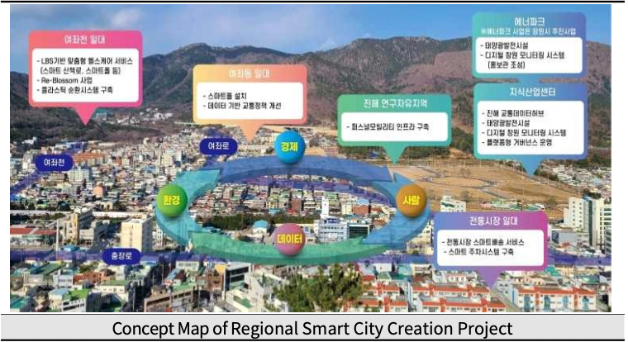

2) Create walkable living environments (Goal 2)
○For the sub-goal 'Creating a walking-friendly living environment', four action tasks were set: ➀Promoting a real- name system for sidewalk construction, 2Creating smart traffic lights, ➂Installing shade shelters at crosswalks, and 4Expanding rest areas in the city center.
○ We'd like to look at the background and key milestones for each action item.

(Table 4-10) Goal 2 (Create a walkable living environment) Implementation Tasks, Project Details, and Lead Departments
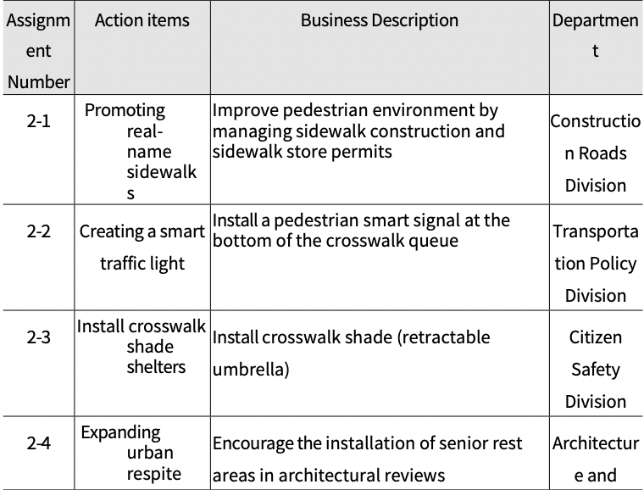

(1) Promoting real-name sidewalks
○ Pushback
- Uneven sidewalks due to tree roots, underground utilities, etc. can cause falls in older adults.
- Need to improve the quality of pedestrian environment to ensure
safe walking for the elderly
- In particular, it is necessary to give responsibility to technicians and provide a pleasant and safe walking environment for citizens through thorough sidewalk management during sidewalk construction and road store use permits.

○ Business Description
- Enforce thorough sidewalk management during sidewalk
construction and road store permits: Road Management Review
Committee
- Installing signposts after installing sidewalks

○ Business plan and performance
- As of March 2022, the number of projects executed was 199, which was 85.8% of the plan, and was executed on a non- budgeted basis.
◦ Held road management deliberations in each of Changwon's five wards to supervise the progress of sidewalk construction each quarter.

(Table 4-11) Task No. 2-1 (Promotion of Sidewalk Construction Real Name System) Business Plan and Performance
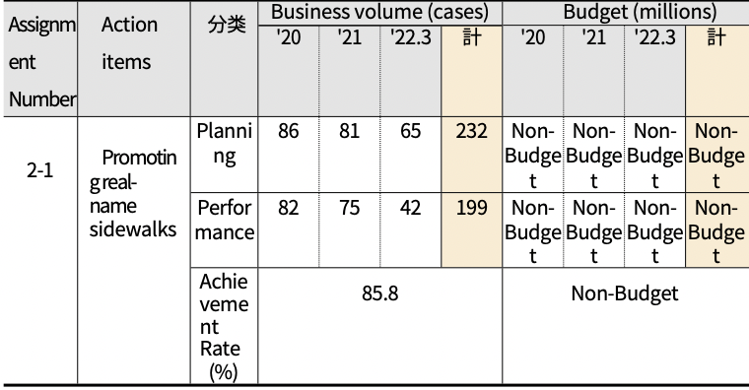
Total
Total
Classification
○ Progress (as of 03/31/22)
- The project has not been changed or canceled from the original
plan.
- Completed 199 projects over three years, with 10 in progress

(Table 4-12) Progress on Task 2-1 (Sidewalk Construction Real Name System)
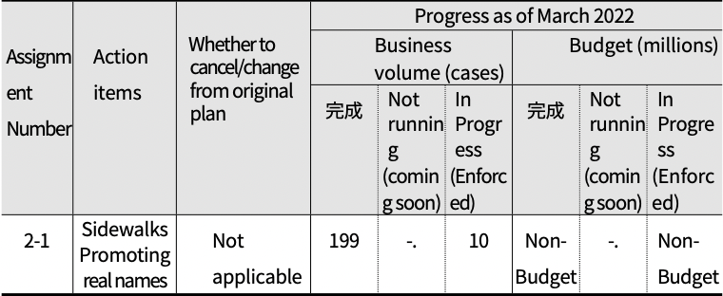
Complete
Complete

○ Business valuation
- Need to continue to manage and supervise the progress of sidewalk construction through the 'Road Management Council'
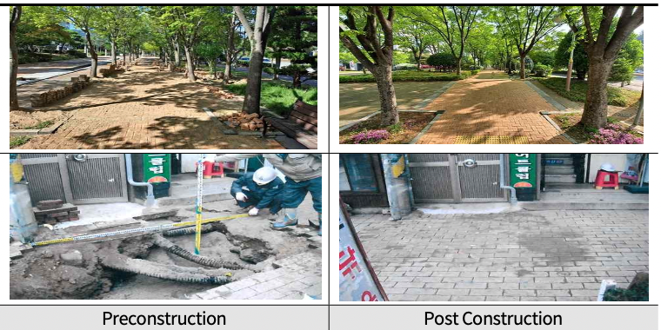
(2) Create a smart traffic light ○ Pushback
- The number of traffic accidents is decreasing every year, but the number of pedestrian accidents is increasing, so there is a need for devices to improve pedestrian safety.
- In particular, there are various walking behaviors of citizens using crosswalks, and the number of traffic accidents at crosswalks is increasing due to the recent use of smartphones, so it is necessary to find ways to reduce pedestrian traffic accidents.
- Need to install pedestrian signal lights at the bottom of crosswalk queues to improve pedestrian safety and prevent traffic accidents
○ Business Description
- Install floor signals in protected areas and high pedestrian traffic.
◦ 1 location in Seongsan-gu, 1 location in Masanhappo-gu, and 3 locations in Masanhoewon-gu
○ Business plan and performance
- As of the end of March 2022, the business execution performance was 5 locations, showing an achievement rate of 100.0% compared to the plan, and the executed budget was KRW 212 million, showing an execution rate of 235.6% compared to the plan.

(Table 4-13) Task No. 2-2 (Smart Traffic Light Creation) Business Plan and Performance
Assignment Number | Action items | Classification | Business volume (locations) |  |  |  | Budget (million won)
 |  |  | '20 | '21 | '22.3 | Total | '20 | '21 | '22.3 | Total
2-2 | Create a smart traffic light | Planning | 5 | 0 | 0 | 5 | 90 | 0 | 0 | 90
 |  | Performance | 5 | 0 | 0 | 5 | 212 | 0 | 0 | 212
 |  | Set the achievement to  （%） | 100.0 |  |  |  | 235.6

○ Progress (as of 03/31/22)
- The project has not been changed or canceled from the original plan.
- Completed a total of 5 locations in 3 years, with no new initiatives underway
- A total of KRW 212 million has been executed over the past three years, and no new cases are pending.

(Table 4-14) Progress on Task No. 2-2 (Smart Traffic Light Creation)
Assignment Number | Action items | Stretch/change from original plan | Business volume |  |  | Budget (millions)
 |  |  | Complete | Unimplemented (in preparation) | In Progress （Executing) | Complete | Not implemented (in preparation) | In Progress （Executing)
2-2 | Create a smart traffic light | Not applicable | 5 | -. | -. | 212 | -. | -.

○ Business valuation
- The smart traffic light project is an important project to strengthen traffic and pedestrian safety for all citizens, not just pedestrians.
◦ Changwon City promoted the installation of floor-type pedestrian signals in five locations, all of which were completed in 2020.
◦ However, there are still many areas such as elderly protection zones and child protection zones that need to be prioritized for the installation of floor traffic lights, and additional installations are needed for these areas.
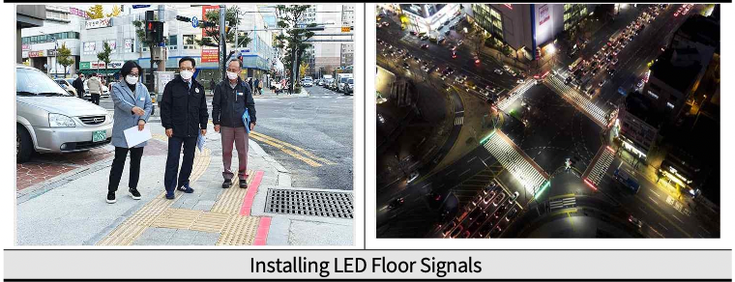

(3) Install crosswalk shade shelters
○ Pushback
- In preparation for the summer heat wave, an increasing number of communities across the country are installing shade structures around crosswalks for the comfort of residents.
- In preparation for the heat wave, it is necessary to install additional shade barriers at crosswalks along main roads in urban areas with a high flow of people to protect the health of residents and prevent safety accidents due to the heat wave.

○ Business Description
- Provide shade at crosswalks along high-traffic city streets.
◦ Open: May-September annually (*flexible based on heat wave conditions)
◦ Installation type: Folding parasol

○ Business plan and performance
- As of the end of March 2022, the number of business executions was 122, a 106.1% achievement rate compared to the plan, and the executed budget was KRW 214.3 million, an 86.4% execution rate compared to the plan.

(Table 4-15) Task No. 2-3 (Installation of Crosswalk Shade Shelters) Business Plan and Performance
Assignment Number | Action items | Classification | Business volume (cases) |  |  |  | Budget (million won)
 |  |  | '20 | '21 | '22.3 | Total | '20 | '21 | '22.3 | Total
2-3 | Install crosswalk shade shelters | Planning | 40 | 45 | 30 | 115 | 100 | 72 | 76 | 248
 |  | Performance | 65 | 57 | -. | 122 | 99.8 | 114.5 | -. | 214.3
 |  | Set the achievement to  （%） | 106.1 |  |  |  | 86.4

○ Progress (as of 03/31/22)
- The project has not been changed or canceled from the original plan.
- Completed a total of 122 projects in 3 years, with KRW 214.3 million executed
- Project status and volume for '22 are currently undecided but will be continued after the granting of a special grant tax for heat wave management in '22.

(Table 4-16) Progress on Task #2-3 (Install crosswalk shade shelters)
Assignment Number | Action items | Whether to cancel/change from original plan | Business volume (cases) |  |  | Budget (millions)
 |  |  | Complete | Unimplemented (in preparation) | In Progress （Executing) | complete | Unimplemented (in preparation) | In Progress （Executing)
2-3 | Install crosswalk shade shelters | Heat Wave of '22  Will continue to be implemented after the administrative special tax is issued | 122 | -. | -. | 214.3 | -. | -.

○ Business valuation
- The installation of shade shelters at crosswalks is a typical proactive initiative to prevent summer safety accidents for all citizens, not just the elderly.
- If you add up the existing shade trees and the additional shade trees installed during the 1st Age-Friendly Project, there were 252 shade trees installed in Changwon City as of March 22 (Uichang 47, Seongsan 58, Masanhappo 32, Masanhoewon 44, Jinhae 71)
- Climate change is causing earlier and longer heat waves, so there is a need to increase administrative attention to ensure that the project is implemented and installed early.
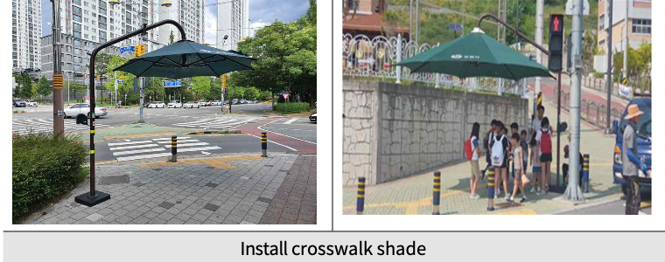

(4) Expanding urban rest areas
○ Pushback
- Need to create rest areas in urban centers for the elderly and people with mobility issues to take breaks while walking.
- Need to strengthen the installation of rest facilities for public announcements and encourage the expansion of rest facilities for non-public announcements.
- There is a need to prevent safety accidents for pedestrians by creating rest areas (shelters) throughout the city center.

○ Business Description
- Strengthening the installation of senior rest areas during architectural review of new buildings subject to public notice.
*Target of public announcement: Business facilities with a gross floor area of 5,000 square meters or more, sales facilities, accommodation facilities, religious facilities, cultural and assembly facilities, and transportation facilities.
- Encourage the expansion of recreational facilities (greenery, chairs, pagodas, water features, etc.) for buildings that are not subject to public announcement and are subject to architectural review.
- Enhance maintenance of established shelters, including installing signage to make them more identifiable.

○ Business plan and performance
- As of the end of March 2022, there were 11 projects, showing a 100.0% achievement rate against the plan, and the projects were executed off-budget.
◦ The construction entity is private, and the local government recommends expanding the rest area during the architectural review process, so no separate budget is required.

(Table 4-17) Task No. 2-4 (Expanding Rest Areas in Urban Centers) Business Plan and Performance
Assignment Number | Action items | Classification | Business volume |  |  |  | Budget (million won)
 |  |  | '20 | '21 | '22.3 | Total | '20 | '21 | '22.3 | Total
2-4 | Expanding urban rest areas | Planning | 3 | 5 | 3 | 11 | Non-Budget | Non-Budget | Non-Budget | Non-Budget
 |  | Performance | 3 | 5 | 3 | 11 | Non-Budget | Non-Budget | Non-Budget | Non-Budget
 |  | Set the achievement to  （%） | 100.0 |  |  |  | -.

○ Progress (as of 03/31/22)
- The ministry has stated that the project has been abolished.
◦ Reason: The project implementing entity is a private entity, and its performance fluctuates depending on the number of applications for architectural review, and it cannot be enforced if it is not subject to legal obligations. In addition, the architectural review is conducted at the planning stage, and the actual installation can be confirmed at least two years after the use approval (completion). Therefore, it is difficult to continue managing the business, so it was abolished after the project was completed.
- Over a three-year period, there were 11 recommendations for publicly posted rest areas in architectural committee reviews.

(Table 4-18) Progress on Tasks 2-4 (Expanding Rest Areas in Urban Centers)
Assignment Number | Action items | Whether to cancel/change from original plan | Business volume |  |  | Yes | Mountain (million won)
 |  |  | Complete | Unimplemented (in preparation) | In Progress （Executing) | Complete | Unimplemented (in preparation) | In Progress （Executing)
2-4 | Expanding urban rest areas | Abolished after completion of business （2022.04.） （202022 | 11 | -. | -. | Non-Budget | -. | -.

○ Business valuation
- Establishing rest areas (shelters) in various parts of the city center is a project that requires public-private cooperation to provide a place for the elderly to rest while walking.
- While the decision was made to discontinue the existing business, efforts to develop small shared spaces in the community (small libraries, shelters, etc.) should continue.

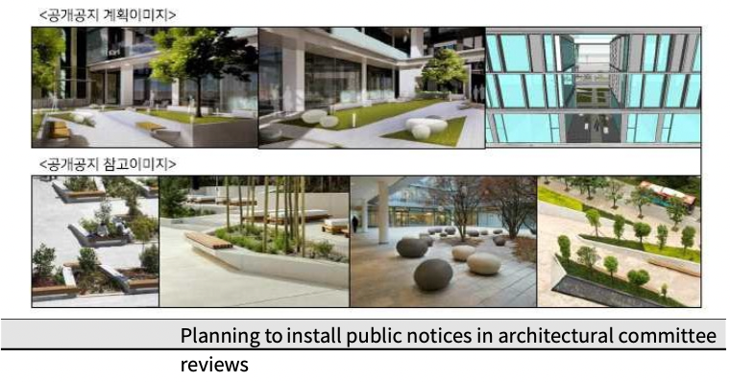

3) Create a safe transportation environment (Goal 3)
○ For the sub-goal 'Creating a Safe Traffic Environment', four action tasks were set: ➀ Expanding the number of low-floor buses, ② Installing and operating priority parking areas for the elderly, ➂ Providing stickers for elderly drivers, and 4 Promoting customized traffic safety education.
○ We'd like to look at the background and key milestones for each action item.

(Table 4-19) Goal 3 (Create a Safe Transportation Environment) Implementation Tasks - Project Description - Lead Department
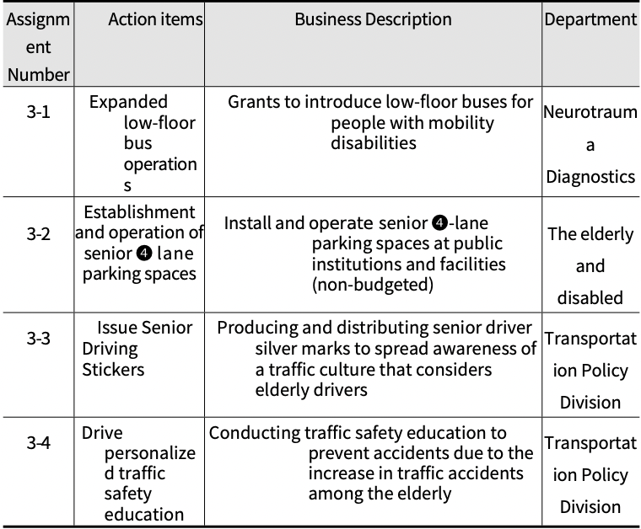

(1) Expanded low-floor bus operations
○ Pushback
- Low-floor buses are expanding under the Para-transit Act.
- Continued expansion of low-floor buses is necessary to promote the mobility rights of the transportation disadvantaged, including the elderly and disabled with limited mobility.

○ Business Description
- Continue to introduce more low-floor buses each year

○ Business plan and performance
- As of the end of March 2022, the business execution performance showed a 54.6% achievement rate compared to the plan by completing the introduction of 100 units, and the executive budget was KRW 9,030 million compared to the plan with 62.7% enforcement rate

(Table 4-20) Task No. 3-1 (Low-Floor Bus Expansion Operation) Business Plan and Performance
Assignment Number | Action items | Classification | Business volume (logarithmic) |  |  |  | Budget (million won)
 |  |  | '20 | '21 | '22.3 | Total | '20 | '21 | '22.3 | Total
3-1 | Expanded bus operations | Planning | 93 | 70 | 20 | 183 | 8,386 | 5,830 | 184 | 14,40  0
 |  | Performance | 93 | 7 | 0 | 100 | 8,386 | 644 | 0 | 9,030
 |  | Set the achievement to  （%） | 54.6 |  |  |  | 62.7
○ Progress (as of 03/31/22)
- The project has not been changed or canceled from the original plan.
- A total of 100 units have been introduced in 3 years, and KRW 9,030 million has been spent.
- Currently working on securing funding to continue the project

(Table 4-21) Progress on Task No. 3-1 (Low-floor bus expansion)
Assignment Number | Action items | Stretch/change from original plan | Business volume (large) |  |  | Budget (Million KRW)
 |  |  | Complete | Unimplemented (in preparation) | In Progress （Executing) | Complete | Unimplemented (in preparation) | In Progress （Executing)
3-1 | Expanded bus operations | Not applicable | 100 | -. | Working to secure budget | 9,030 | -. | Working to secure budget

○ Business valuation
- Low-floor buses are a key mode of transportation to promote mobility rights for people with disabilities and need to continue to be expanded.
- In particular, it is necessary to continue to secure eco- friendly subsidy budgets for the introduction of eco-friendly low-floor buses such as regular buses and hydrogen buses.
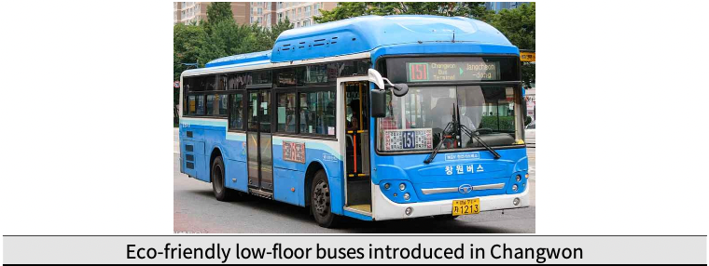
(2) Establishing and operating priority parking areas for the elderly
○ Pushback
- Need to promote the welfare of the elderly by providing consideration and convenience for elderly drivers visiting public facilities and multi-use facilities.
- Changwon City is implementing the "Ordinance on the Installation and Operation of Priority Parking Zones for the Elderly," and needs to continue to expand its business to improve the effectiveness of the ordinance.

○ Business Description
- Establishment and operation of senior priority parking areas in public institutions and multi-use facilities
◦ Recommended for: Seniors 70+ years old
(Vehicles driving themselves while displaying senior driver placards)
◦ Installation target: (Mandatory) Public institutions, (Recommended) Multi-use facilities
◦ Installation threshold: 2-4% of parking spaces, but no more than 10 spaces

○ Business plan and performance
- As of the end of March 2022, the business execution performance was 100.0% of the plan with 144 installations completed, and the budget was operated off-budget.

(Table 4-22) Task No. 3-2 (Installation and Operation of Senior Citizen Parking Area) Business Plan and Performance
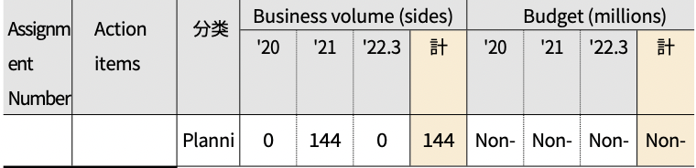
Classification
Total
Total
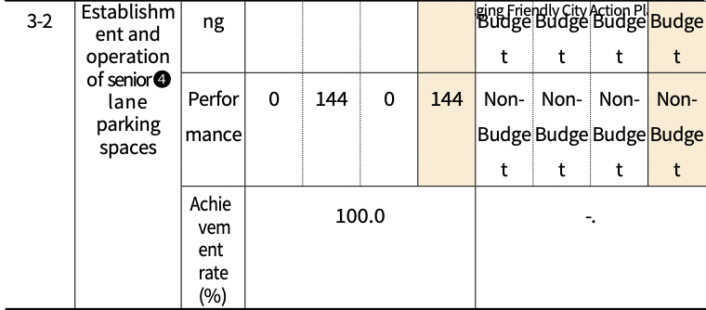

○ Progress (as of 03/31/22)
- Only the name of the business has changed from the original plan.
- In 2021, 144 screens have been installed in 50 public facilities and are in operation to date.
- No further installations and operations have been performed since

(Table 4-23) Progress of Task No. 3-2 (Installation and operation of parking area for the elderly)
Assignment Number | Action items | Whether to cancel/change from original plan | Business volume (sides) |  |  | Yes | Budget (million won)
 |  |  | Complete | Unimplemented (in preparation) | In Progress （Executing) | complete | Unimplemented (in preparation) | In Progress （Executing)
3-2 | Establish and operate priority parking for seniors | Business name change （Initially: Introduced parking for the elderly) | 144 | -. | -. | Non-Budget | -. | -.

○ Business valuation
- The business of installing priority parking areas for the elderly is a business that provides convenience services for driving and movement of the elderly.
◦ Although the project is being carried out in accordance with relevant ordinances and operating guidelines, it seems to be limited to actively promote the project due to the limited number of existing parking spaces in the case of public facilities and recommendations in the case of private facilities.
◦ There is a need for public outreach and awareness-raising activities on the installation of priority parking areas for the elderly.
◦ More active policy implementation efforts are needed, such as providing information on existing facilities and incentives for private participation

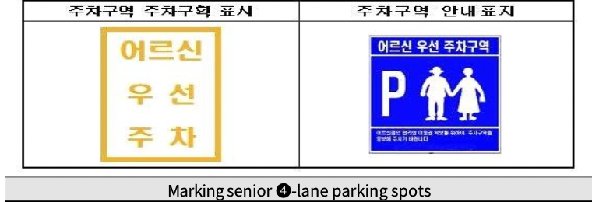

(3) Issue Senior Driving Stickers
○ Pushback
- The number of traffic accidents involving elderly drivers is increasing, and measures are needed to reduce traffic accidents involving elderly drivers.
- Need for a campaign to spread a culture of civic consideration for older drivers and establish a culture of yielding and caring transportation.
- Changwon City is implementing the "Ordinance on Traffic Accident Prevention for Elderly Drivers," and based on this ordinance, it is necessary to promote a sticker issuance project to consider elderly drivers.

○ Business Description
- Issue courtesy stickers to older drivers
◦ Who: Older drivers age 70 and older
◦ Distribution locations: Town and village administrative welfare
centers
◦ Method: Verify and distribute driver's licenses

○ Business plan and performance
- As of the end of March 2022, the project implementation performance showed a 100.0% achievement rate compared to the plan by producing and distributing 5,000 copies in each town and village, and the execution budget was KRW 10 million, showing a 100.0% execution rate compared to the plan.

(Table 4-24) Task No. 3-3 (Issuance of Senior Driving Consideration Stickers) Business Plan and Performance
Assignment Number | Action items | Classification | Business volume (sales) |  |  |  | Budget (million won)
 |  |  | '20 | '21 | '22.3 | Total | '20 | '21 | '22.3 | Total
3-3 | Senior Driving Stickers  footᄇ | Planning | 2,000 | 1,500 | 1,500 | 5,000 | 4 | 3 | 3 | 10
 |  | Performance | 2,000 | 1,500 | 1,500 | 5,000 | 4 | 3 | 3 | 10
 |  | Acievement Rate  （%） | 100.0 |  |  |  | 100.0

○ Progress (as of 03/31/22)
- The project has not been changed or canceled from the original plan.
- Produced and distributed a total of 5,000 copies for 3 years, and spent a total of KRW 10 million.
- '22 business executed early in March to move forward quickly

(Table 4-25) Progress of Task No. 3-3 (Issuance of Senior Driving Consideration Stickers)
Assignment Number | Action items | Whether to cancel/change from original plan | Business Volume（Sales |  |  | Budget (millions)
 |  |  | Complete | Unimplemented (in preparation) | In Progress （Executing) | Complete | Unimplemented (in preparation) | In Progress （Executing)
3-3 | Issue Senior Driving Stickers | Not applicable | 5,000 | -. | -. | 10 | -. | -.
○ Business valuation
- The Senior Driving Consideration Sticker Program is a project
to spread the culture of driving consideration among citizens and prevent traffic accidents among elderly drivers.
◦ Need for greater public awareness of senior driving stickers
◦ Need to conduct a survey on the overall business, such as actual distribution, attachment, and satisfaction, in addition to
town-to-town distribution performance.
◦ Along with the caring sticker project for elderly drivers, there is a need for transportation support projects for the elderly, such as returning driver's licenses for elderly drivers and supporting public transportation passes.
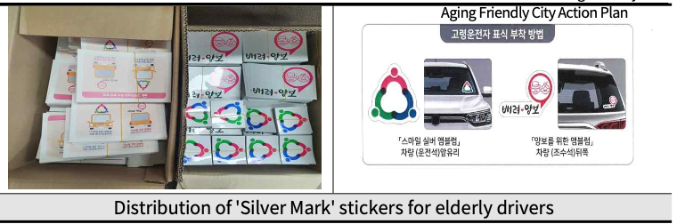

(4) Drive personalized traffic safety education
○ Pushback
- The need for accident prevention measures continues to grow as the number of traffic accidents among the elderly increases
- Changwon City enforces the "Ordinance on Traffic Accident Prevention for Elderly Drivers," and it is necessary to continue to promote traffic safety education for the elderly based on this ordinance.
- There is a need to prevent traffic accidents by promoting customized traffic safety education for the vulnerable.
○ Business Description
- Promote traffic safety education tailored to seniors
◦ Conducted at a location requested by the applicant, such as a senior center, senior college, senior center, etc.
- Promoting non-contact training using videos and other materials due to the COVID-19 situation
○ Business plan and performance
- As of the end of March 2022, there were only 4 projects (2nd half of 21), and due to COVID-19, there was virtually no active education promotion.

(Table 4-26) Task No. 3-4 (Promote Customized Traffic Safety Education)
Assignment Number | Action items | Classification | Business volume (cases) |  |  |  | Budget (million won)
 |  |  | '20 | '21 | '22.3 | Total | '20 | '21 | '22.3 | Total
 |  | Planning | -. | -. | -. | -. | Non-Budget | Non-Budget | Non-Budget | Non-Budget
3-4 | Customized  Traffic Safety⁰ | Performance | 0 | 4 | 0 | 4 | Non-Budget | Non-Budget | Non-Budget | Non-Budget
 | Traffic safety training  Push | Set the achievement to  （%） | 100.0 |  |  |  | Non-Budget
○ Progress (as of 03/31/22)
- The project has not been changed or canceled from the original plan.
- Due to the spread of COVID-19 in 2020, in-person trainings were not held, and in 2021, four non-face-to-face trainings were held at senior welfare centers.
- No separate budget for in-person training with videos

(Table 4-27) Progress on Task No. 3-4 (Promote Personalized Traffic Safety Education)
Assignment Number | Action items | Whether to cancel/change from original plan | Business volume (cases) |  |  | Yes | Mountain (million won)
 |  |  | Complete | Unimplemented (in preparation) | In Progress （Executing) | Complete | Unimplemented (in preparation) | In Progress （Executing)
3-4 | Drive personalized traffic safety education | Not applicable | 4 | -. | -. | Non-Budget | -. | -.

○ Business valuation
- Senior-centered traffic safety education is for all seniors, not just older drivers.
◦ Difficulties in conducting face-to-face training due to COVID-19
◦ Need to clearly set the appropriate business cost and target volume before launching the business
◦ Need for more systematic business execution and performance management by securing appropriate business costs and designating a business execution organization
◦ To improve traffic safety awareness among the elderly, it is necessary to expand the project in the future based on the evaluation of educational effectiveness and satisfaction.

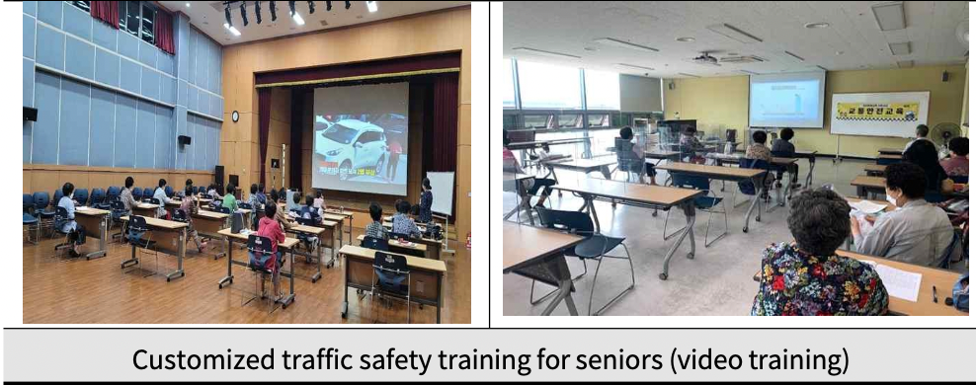

4) Ensure housing stability (Goal 4)
○ For the sub-goal 'Securing Residential Stability', two action tasks have been set: ➀Creating socially vulnerable housing spaces, and ② Providing public silver housing utilizing vacant land in the city center.
○ We'd like to look at the background and key milestones for each action item.

(Table 4-28) Goal 4 (Ensure Housing Stability) Action Tasks - Project Description - Lead Department
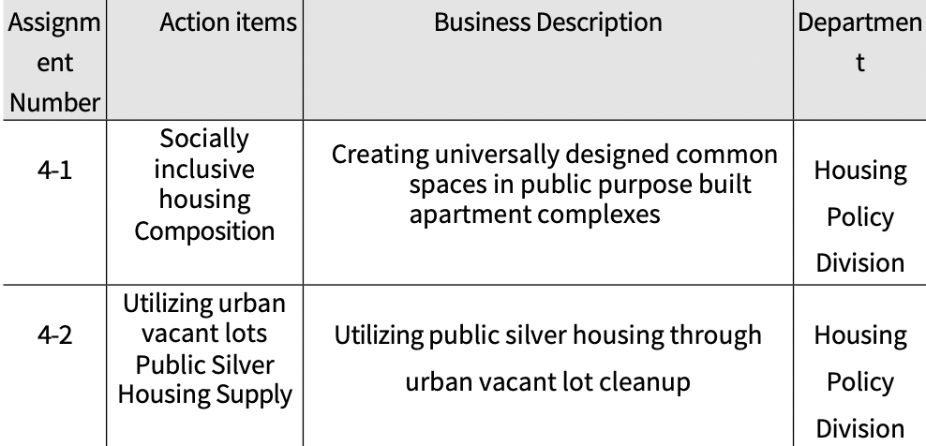

(1) Creating socially inclusive housing
○ Pushback
- Seniors living in urban centers prefer to live in shared housing due to the convenience and safety of their living space (preferred housing type: apartments 60.0%, single-family homes 35.0%, etc.).
- Improving the environment of shared housing is necessary to improve the housing satisfaction of vulnerable people living in shared housing.
- Provide living convenience for vulnerable people by encouraging the creation of shared spaces that reflect universal design, especially for apartment buildings built for public purposes.

○ Business Description
- Creating universally designed communal spaces in public
purpose built apartment complexes
◦ Creating shared spaces that are accessible regardless of the socioeconomic class of the residents (creating healing parks that incorporate barrier-free gardens, playgrounds, exercise facilities, etc.)
◦ Requesting universal design in planning for publicly-rented and publicly-owned communities

○ Business plan and performance
- As of the end of March 2022, there were 2 projects with an achievement rate of 66.7% against the plan, and they off-budget.
- '20: LH Gapo Happy Housing (422 units) requested to create a shared space
- '21: Hyundai Gyeongnam Development Corporation (1,159 units) requested to create a shared space

(Table 4-29) Task No. 4-1 (Creating Socially Vulnerable Housing) Business Plan and Performance
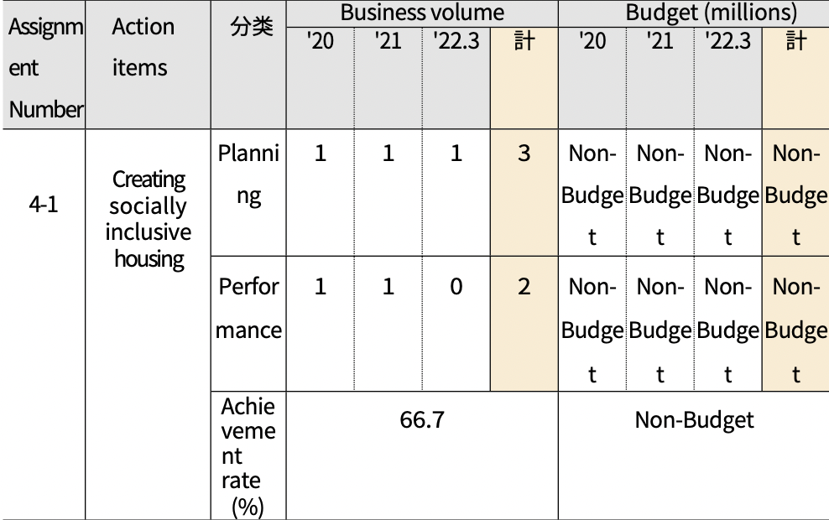
Total
Total
Classification

○ Progress (as of 03/31/22)
- The project has not been changed or canceled from the original plan.
- Two cases in three years, and we continue to request universally designed common spaces for public purpose built apartment buildings.

(Table 4-30) Progress on Task No. 4-1 (Creating Socially Vulnerable Housing)
Assignment Number | Action items | Whether to cancel/change from original plan | Business volume |  |  | Yes | 1 Mountain (million won)
 |  |  | Complete | Unimplemented (in preparation) | In Progress （Executing) | Complete | Unimplemented (in preparation) | In Progress （Executing)
4-1 | Creating socially inclusive housing | Not applicable | 2 | -. | Hustling | Non-Budget | -. | -.

○ Business valuation
- The project to create socially disadvantaged-friendly residential spaces is being promoted to create a win-win culture by supplying shared housing that considers the socially disadvantaged, and to create a proactive residential culture for the growing elderly population.
◦ However, there are difficulties in overall business planning, implementation, and performance management due to the inability to predict future construction plans for publicly built apartment buildings.
◦ In order to improve the effectiveness of this project, it is necessary to promote the project in closer consultation with housing providers such as LH on the project target volume, implementation and management plan, and budget.

(2) Utilizing vacant land in urban centers to provide public silver housing
○ Pushback
- The aging population is increasing the demand for senior living facilities, but there is a lack of dedicated housing for low-income seniors.
- Need to utilize vacant space in urban centers to secure housing for low-income seniors and improve their living conditions

○ Business Description
- After completing the survey of vacant houses in the jurisdiction and establishing a maintenance plan, we prepared a direction to promote vacant house utilization in cooperation with LH.
◦ Survey vacant homes in your neighborhood
◦ Promote vacant house maintenance plan establishment service, deliberate on vacant house maintenance plan

○ Business plan and performance
- As of the end of March 2022, there were 3 business executions,
representing an achievement rate of 150.0% against the plan.
◦ However, performance here does not refer to the number of public silver housing units supplied. It refers to the performance of survey and planning to promote this project.
- The executed budget is $97 million, which is a 100.0% execution rate against plan.

(Table 4-31) Task No. 4-2 (Providing Public Silver Housing Utilizing Vacant Space) Business Plan and Performance
Assignment Number | Action items | Classification | Business volume |  |  |  | Budget (million won)
 |  |  | '20 | '21 | '22.3 | Total | '20 | '21 | '22.3 | Total
4-2 | Utilizing vacant land for public silver housing | Planning | Vacant house  Research | Maintenance  Planning  Establish | -. | 2 | 58 | 39 | 0 | 97
 |  | Performance | Vacant house  Research | Maintenance  Planning  Services | Maintenance  Planning  Establish | 3 | 58 | 39 | 0 | 97
 |  | Set the achievement to  （%） | 150.0 |  |  |  | 100.0
*Dec. 20: Completion of the vacant house survey (1,506 vacant houses in the jurisdiction were surveyed) '21: Planning, contracting, and launching a service to establish a vacant house maintenance plan '22: Establishment of a vacant house maintenance plan

○ Progress (as of 03/31/22)
- The project is proceeding with related procedures such as surveying the actual situation of vacant houses and establishing utilization plans according to the original plan.
- Unavoidable change of business direction in the course of business pursuit
◦ Due to the characteristics of the site and location of the vacant house, the residential space is cooperative, and the settlement conditions are poor, so it is diagnosed as a difficult place to live for the elderly.
◦ In consultation with LH Corporation, it was determined that the supply of silver housing utilizing empty houses was n o t feasible, and the business effectiveness was also judged to be insufficient.
◦ Overall, it was determined that the business effectiveness of supplying silver houses utilized as empty houses is low.
◦ In response, the project to supply silver housing for the elderly has been reoriented to actively utilize LH's current purchase- to-rent housing supply project.
(e.g., requesting a higher percentage of seniors when recruiting
tenants for buy-to-let housing.)

(Table 4-32) Progress on Task No. 4-2 (Provide Public Silver Housing Utilizing Vacant Land)
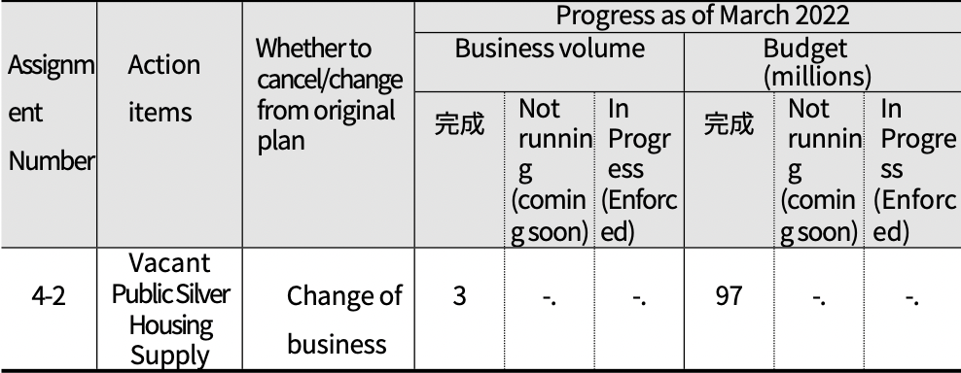
Complete
Complete

○ Business valuation
- There is an ongoing need to secure housing and improve
living conditions for low-income seniors.
◦ However, there are several methodological alternatives to consider
◦ As of now, it is difficult to promote the supply of public silver housing using vacant houses, and it is judged that it is necessary to comprehensively review and plan a 'low-income elderly housing support plan' to complement this.
◦ Need to establish a comprehensive housing support plan in conjunction with existing policies such as LH purchase rental housing support and support for joint living homes for the elderly under the ordinance.
2. Realize understanding and respectful generational integration (Policy Goal 2)
○ The second policy goal of the first action plan is "Realizing understanding and respectful intergenerational integration," which has four sub-goals for implementation.
- Goal 1 (Improving awareness of ageing policies) is a sub-goal linked to 'Respect and social inclusion' of the eight areas of the WHO Age Friendly Cities Guide, and sets two action items
- Goal 2 (Strengthening access to information) is a sub-goal linked to 'Communication and information', one of the eight areas of the WHO Age Friendly Cities Guide, with one action item
- Goal 3 (Promoting intergenerational cohesion) is a sub-goal linked to "Respect and social inclusion" of the eight domains of the WHO Age Friendly Cities Guide, and sets two action points
- Goal 4 (Ensure vibrant 100 years of healthy ageing) is a goal linked to the WHO Age-Friendly Cities Guide's eight domains of "Community support and health services" and sets seven action items.

○ This area demonstrates policy efforts to support the promotion of the human rights of older people and their ability to lead healthy older lives, with a focus on intergenerational integration.
- The basic direction is to promote respect for the elderly, intergenerational integration, and better communication and access to information.

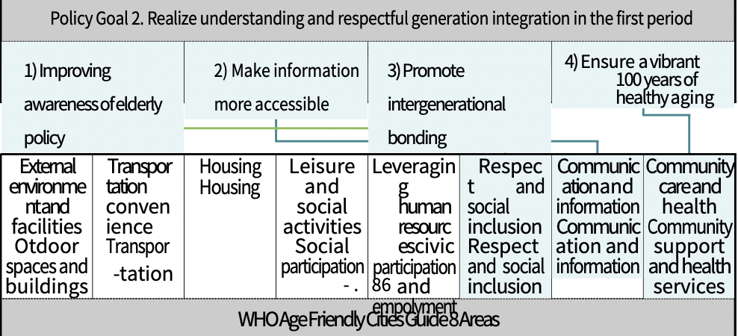
1) Increase awareness of elderly policy (Goal 5)
○ For the sub-goal 'Improving Awareness of Elderly Policy', two action tasks were set: ➀ Changing the terminology of dementia to Changwon, and 2 Promoting projects to strengthen the human rights of the elderly.
○ We want to understand the context and key milestones for each action item.

(Table 4-33) Goal 5 (Improving Awareness of Elderly Policy) Implementation Tasks, Project Details, and Responsible Departments
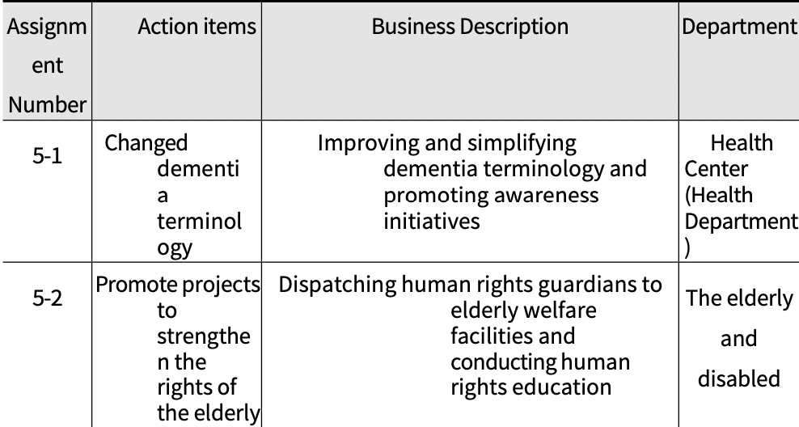

(1) Changed dementia terminology
○ Pushback
- Dementia (癡呆) means 'stupid and foolish', which causes negative perceptions, leading to difficulties in promoting dementia management projects such as early diagnosis and treatment.
- There is a need for improved terminology, as many disease characteristics of cognitive decline with age are incorrectly labeled as dementia.
- Need to improve and purify dementia terminology with negative connotations, improve awareness of dementia to create a prejudice-free community environment and highlight the image of age-friendly cities

○ Business Description
- Improve and simplify the use of dementia terminology
◦ Use existing terminology for formal dementia-related business, but minimize the use of dementia terminology in programming, early screening, and outreach.
ex) Use familiar terminology such as mnemonic classroom,
mnemonic village, cognitive screening, etc.
- Working to change the stigma around dementia
◦ Publish a newsletter, become a Dementia Action Leader, create a Dementia Partner, and more.

○ Business plan and performance
- As of the end of March 2022, the number of business executions was 15,929, a 75.8% achievement rate compared to the plan, and the executed budget was KRW 15 million, a 100.0% execution rate compared to the plan.

(Table 4-34) Task No. 5-1 (Changing Dementia Terminology) Business Plan and Performance
Assignment Number | Action items | Classification | Business volume (times) |  |  | Budget (million won)
 |  |  | '20 | '21 '22.3 | Total | '20 | '21 '22.3 | Total
 |  | Planning | 6,200 | 7,420 I,400 | 21,020 | 5 | ^5^5 | 15
5-1 | Dementia terminology | Performance | 6,723 | 7,753 M,453 | 15,929 | 5 | ^5^5 | 15
 | Changing Changed | Set the achievement to  （%） | 75.8 |  |  | 100.0

○ Progress (as of 03/31/22)
- The project has not been changed or canceled from the original
plan.
- Completed a total of 15,929 times in 3 years, with 1.5 million won in
execution
- Promoting various publicity and awareness projects related to dementia

(Table 4-35) Progress on Task No. 5-1 (Changing Dementia Terminology)
Assignment Number | Action items | Whether to cancel/change from original plan | Business volume (times) |  |  | Budget (millions)
 |  |  | Complete | Unimplemented (in preparation) | In Progress （Executing) | Complete | Unimplemented (in preparation) | In Progress （Executing)
5-1 | Changed dementia terminology | Not applicable | 15,929 | -. | 15,929 | 15 | -. | 15

○ Business valuation
- Dementia is a formalized disease, making it difficult to revise terminology at the local level.
- Since this project is a variety of dementia-related publicity and awareness improvement projects, it is necessary to revise the project name to fit the project content and clarify the target amount for each project.

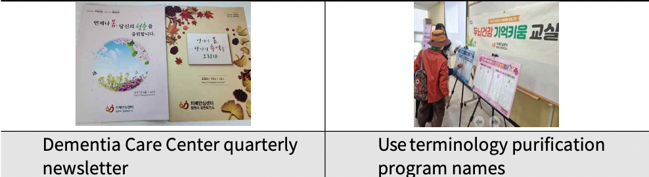

(2) Promote projects to strengthen the rights of the elderly
○ Pushback
- While the elderly population is increasing, nuclear familyization, de-familialization of the elderly, and intergenerational conflicts are leading to various elderly issues, including elder abuse.
- There is a need to educate citizens on elder abuse prevention and strengthen human rights protection activities for elderly people living in welfare facilities.
- There is a need to raise awareness and understanding of elderly human rights, create an environment that protects elderly human rights, and increase sensitivity to elder abuse.

○ Business Description
- Dispatching human rights defenders to elderly welfare facilities
◦ Establish an operational plan for human rights protection activities at senior welfare facilities
◦ Conducting human rights defender activities in elderly welfare facilities: Dispatching human rights defenders once a month
➡ Monitor human rights and conduct human rights training for workers

○ Business plan and performance
- As of the end of March 2022, we dispatched 35 people 14 times, achieving 42.4% of the number of dispatches and 70.0% of the number of people compared to the plan.
- Execution budget is 3.5 million won, with an execution rate of 32.4% against plan

(Table 4-36) Project No. 5-2 (Strengthening the Rights of the Elderly) Project Plan and Performance
Assignment Number | Action items | Classification | Business volume |  |  |  | Budget (million won)
 |  |  | '20 | '21 | '22.3 | Total | '20 | '21 | '22.3 | Total
5-2 | Promote projects to strengthen the rights of the elderly | Planning | 9 times/ 20 people | 12 sessions/ 15 people | 12 sessions/ 15 people | 33h/ 50 people | 3.6 | 3.6 | 3.6 | 10.8
 |  | Performance | 4 times/ 20 people | 10 times/ 15 people | -. | 14 times/ 35 people | 1.5 | 2 | -. | 3.5
 |  | Set the achievement to  （%） | 42.4% / 70.0 |  |  |  | 32.4
○ Progress (as of 03/31/22)
- The project has not been changed or canceled from the original
plan.
- Completed 14 deployments in 3 years, 35 people, and 3.5 million
won in expenditures.
- The program has been in place since October 2020, and overall project performance has been low as the spread of COVID-19 has limited human rights defenders' access to facilities and contacts.

(Table 4-37) Progress on Task No. 5-2 (Strengthening Human Rights for the Elderly)
Assignment Number | Action items | Whether to cancel/change from original plan | Business volume (times) |  |  | Budget (millions)
 |  |  | Complete | Unimplemented (in preparation) | In Progress （Executing) | Compete | Unimplemented (in preparation) | In Progress （Executing)
5-2 | Promote projects to strengthen the rights of the elderly | Not applicable | 14 times/ 35 people | 12 sessions/ 15 people | -. | 3.5 | 3.6 | -.

○ Business valuation
- The Elderly Rights Enhancement Project is a project that initially consisted of elderly rights promotion education for citizens (elderly abuse prevention education) and operation of elderly rights guardians for elderly welfare facilities to prevent elderly rights violation issues including elderly abuse.
◦ However, the actual project is promoted by conducting human rights protection activities for elderly welfare facilities and elder abuse prevention education and human rights education for workers in such facilities.
◦ Strengthening elderly human rights is necessary not only for facility workers but also for citizens. In the future, it is necessary to strengthen elderly human rights education for citizens in addition to the continuous activities of the Human Rights Defenders of Elderly Welfare Facilities.
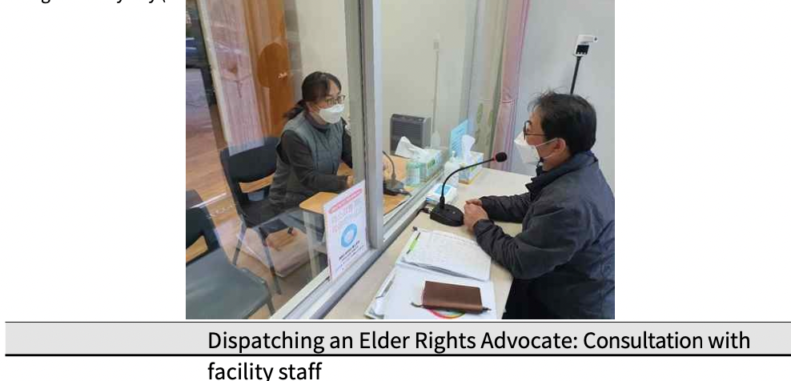

2) Increase access to information (Goal 6)
○ For the sub-goal "Strengthening Access to Information," one action task was set, including ➀Creating an elderly-friendly environment in the Civil Affairs Office of the Administrative Welfare Center.
○ We'd like to look at the background and key milestones for each action item.

(Table 4-38) Goal 6 (Improving Awareness of Elderly Policy) Implementation Task, Project Description, and Lead Department
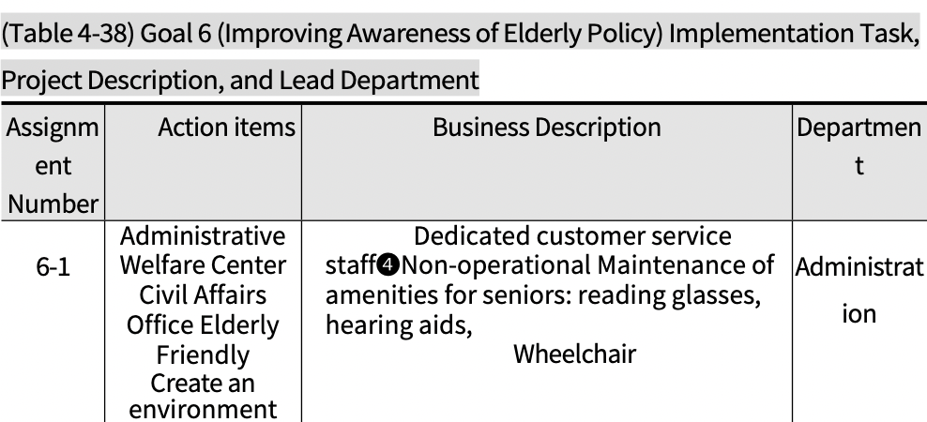
(1) Creating an Age-Friendly Environment in the Civil Affairs Office of the Administrative Welfare Center
○ Pushback
- Demand for complaints from the elderly is increasing at administrative welfare centers due to the accelerated entry of the elderly into society
- Need to create a customized environment for the elderly visiting administrative welfare centers to support their social activities and strengthen their access to administrative complaints and information
- Need to create an age-friendly environment for administrative services and increase satisfaction with public services by operating citizen information assistants at administrative welfare centers and providing age-friendly convenience items.
○ Business Description
- Survey of all elderly-friendly environments in government offices in each town, village, and city
- Dedicated complaint helpline:
◦ Help filling out application materials, information on the
complaint process, etc.
- Maintain amenities for seniors
◦ Have reading glasses, hearing aids, wheelchairs, etc.
- Creating and placing stickers for the "Elderly Window" in the
Civil Affairs Office
○ Business plan and performance
- As of the end of March 2022, all 61 town and village administrative welfare centers have completed the project, showing a 100.0% achievement rate compared to the plan, and it is a non-budgeted project.

(Table 4-39) Project No. 6-1 (Creating an Elderly Friendly Environment in the Civil Affairs Office of the Administrative Welfare Center) Project Plan and Performance
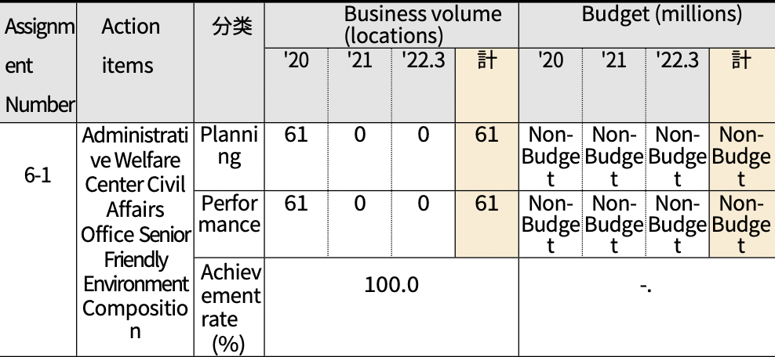
Classification
Total
Total

○ Progress (as of 03/31/22)
- The project has not been changed or canceled from the original plan.
- Immediately after conducting a full survey of elderly-friendly environments in town and village administrative welfare centers in 2020, the provision of convenience items for the elderly and the designation of a dedicated window for the elderly were completed.

(Table 4-40) Progress of Task No. 6-1 (Creating an Elderly-friendly Environment in the Civil Affairs Office of the Administrative Welfare Center)
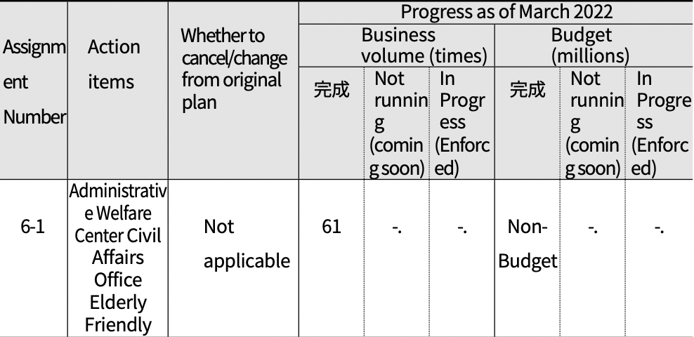
Complete
Complete

○ Business valuation
- It is also necessary to expand the ways to support the elderly to actively use civil service assistants to handle civil affairs when visiting town and village administrative welfare centers.
- In addition, since strengthening information access for the elderly requires efforts to improve conditions in everyday environments other than administrative welfare centers, it is necessary to actively promote the expansion of education on the use and accessibility of kiosks and smart devices.
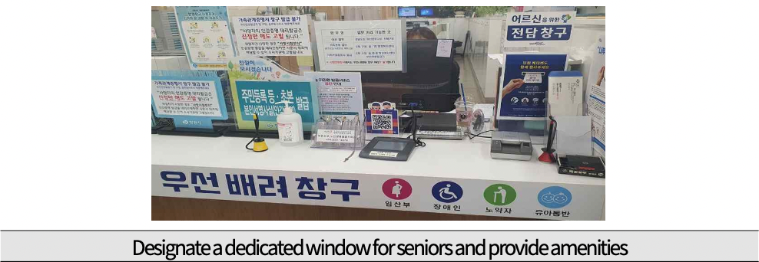

3) Foster intergenerational connections (Goal 7)
○ For the sub-goal "Promoting intergenerational bonding," one action task was set, including ➀ operating a generation convergence program and 2 establishing the Changwon Wellbeing Center.
○ We'd like to look at the background and key milestones for each action item.

(Table 4-41) Goal 7 (Promote Intergenerational Bonding) Action Item - Project Description - Lead Department
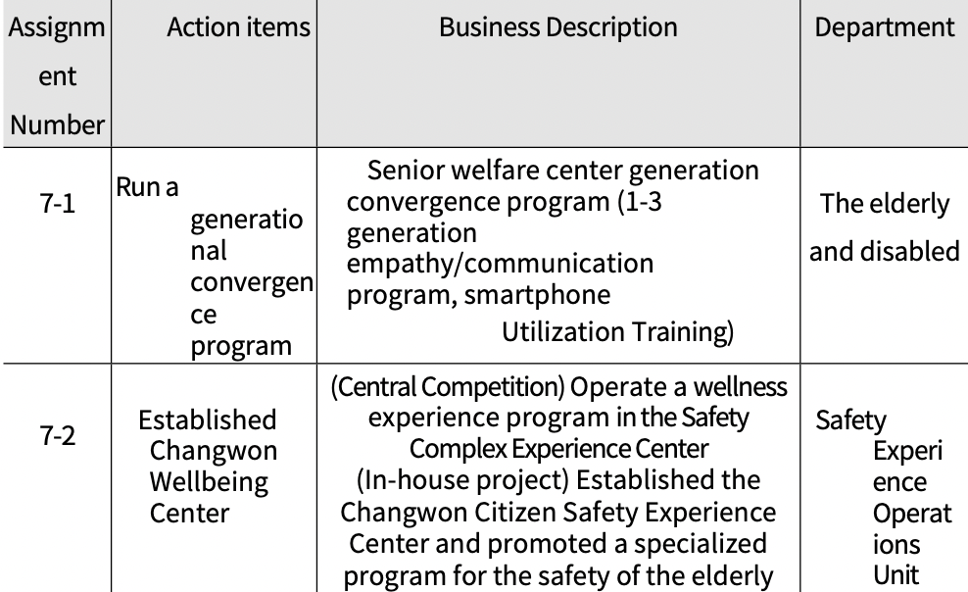
(1) Run a generational convergence program
○ Pushback
- Rapid social change and technological advancements have led to a growing cultural divide and heterogeneity between generations.
- Need to promote various initiatives to share and fuse intergenerational cultures
- Provide a place for 1-3 generations to enjoy the same cultural life and communicate and exchange, thereby easing the disconnect between generations and creating an age-friendly, generationally empathetic environment.

○ Business Description
- Promote generation convergence programs hosted by local senior
welfare centers (7 locations)
◦ Focus on small programs to minimize COVID-19 concerns ◦ Recruit and pre-train volunteers to run the program
◦ Run your program according to social distancing guidelines

○ Business plan and performance
- As of the end of March 2022, the number of business executions was 238 with 2,728 people, which was 47.6% of the number of executions and 21.6% of the number of people compared to the plan.
- Business budgets are driven by each senior center's own business expenses
- Due to the long-term closure of senior welfare centers due to COVID-19 and social distancing measures, many programs were reduced or not operated, resulting in a low overall performance rate.

(Table 4-42) Task No. 7-1 (Operation of Generation Convergence Program) Business Plan and Performance
Assignment Number | Action items | Classification | Business volume (locations) |  |  |  | Budget (million won)
 |  |  | '20 | '21 | '22.3 | 計 | '20 | '21 | '22.3 | 計
7-1 | Run a generational convergence program | Planning | 114 times/ 4572 people | 204 times/ 3284 people | 182 times/ 4799 people | 500 times/ 12 people | Non-Budget | Non-Budget | Non-Budget | Non-Budget
 |  | Performance | 80 h/ 1332 people | 155 times/ 132 people | 3 times/ 74 people | 238 times / 2,728 people | Non-Budget | Non-Budget | Non-Budget | Non-Budget
 |  | Set the achievement to  （%） | 47.6% / 21.6 |  |  |  | -.

○ Progress (as of 03/31/22)
- The project has not been changed or canceled from the original plan.
- Expect to activate programs in response to future social distancing guidance

(Table 4-43) Progress of Task No. 7-1 (Operation of Generation Convergence Program)
Assignment Number | Action items | Whether to cancel/change from original plan | Business volume (times) |  |  | Budget (millions)
 |  |  | Complete | Unimplemented (in preparation) | In Progress （Executing) | Complete | Unimplemented (in preparation) | In Progress （Executing)
7-1 | Run a generational convergence program | Not applicable | 238 times / 2,728 people | -. | 3 times/ 74 people | Non-Budget | -. | -.

○ Business valuation
- Promoting creative generation convergence programs for each
senior welfare center
◦ Programs have been slow to take off due to COVID-19, but are expected to pick up steam as social distancing eases.
◦ Need to develop non-face-to-face programs and expand business by securing additional business funds other than the welfare center's own business expenses

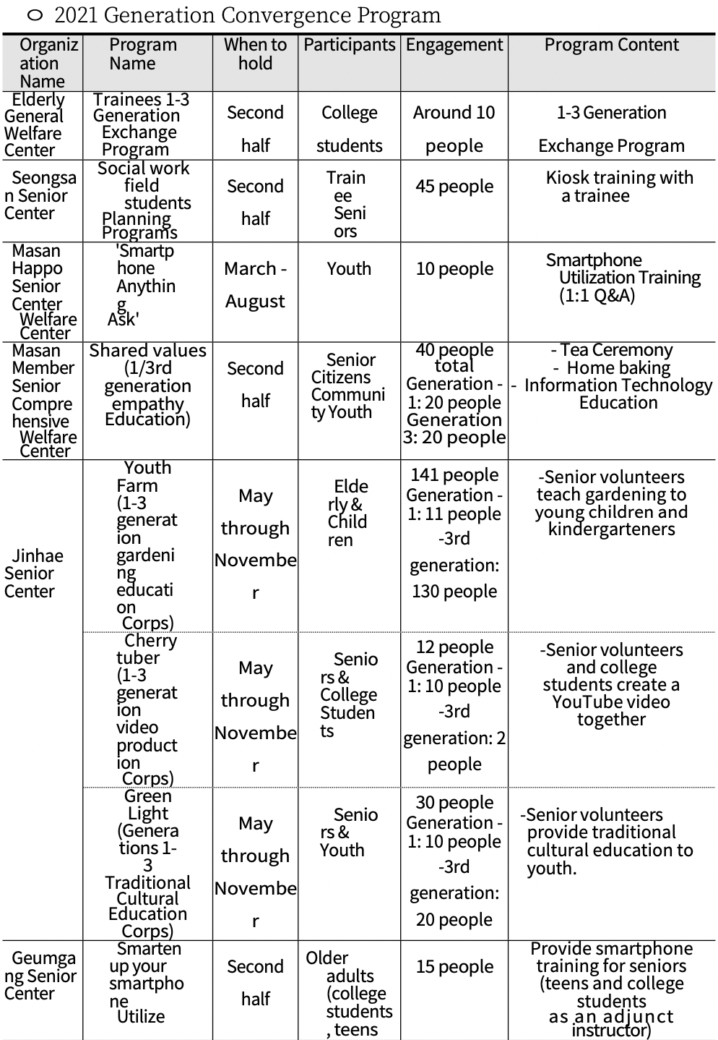

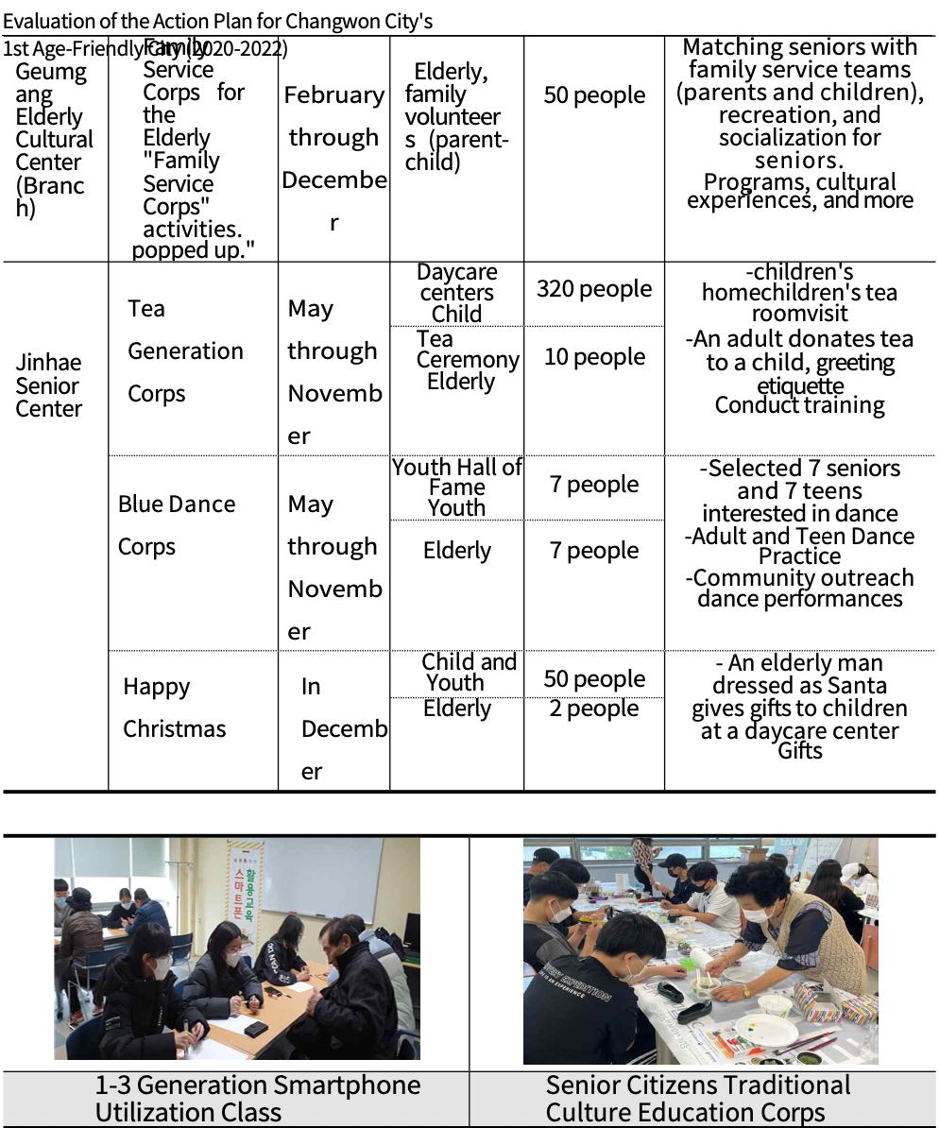

(2) Established Changwon Well-Aging Center (Citizen Safety Experience Center)
○ Pushback
- Need to activate experiential education to reduce safety accidents among the elderly in preparation for the entry of the ultra-elderly society
◦ Declining physical capabilities due to aging are a vulnerability factor when exposed to various hazards, requiring regular safety training.
- Need to promote experiential programs on the lives of the elderly to improve empathy and inclusion of the elderly among the general public
○ Business:
- Pursuing the establishment of a wellness center; in-house alternative due to the suspension of the project by the Ministry of the Interior and Safety.
Continue to promote the project and establish a comprehensive center (two-track strategy: centralized public offering, in-house project)

Centralized Public Offering | ◊ | Own business
Installed and operated a wellness center in Changwon City's Safety Complex Experience Center |  | Opened Changwon Citizen Safety Experience Center and operated specialized safety programs for the elderly
-（Location) Within the planned site for the construction of a self-sufficient complex administrative town in Masan Member District.  -（Duration) 2024~2027 - (Scale) 3/1 floor, 6,000m gross floor area² - (Project cost) 23.6 billion won *Excluding land cost  （Soan tax 100, local fee 100, other 36） -（Program)  - Operate senior life experience and dementia experience programs for citizens  - Run a Silver Safety Experience program for seniors |  | -（Location) Citizen Safety Experience Center on the 3rd floor of Changwon Science Center -（Duration) 2021 ~ January 2022 -（Scale） 3-story exhibition hall (1,044.7m² ）  （Outdoor 400m² ）  -(Project Cost) 1.8 billion won (municipal expenses)  -（Regular Program)  - Course A: Boarding Safety and Life Safety Experience Zone  - Course B: First Aid and Traffic Safety Experience Zone - (Specialized Program)  - Monthly citizen-centered planning events before opening (city citizen climbing class)  - Promote monthly events and organize specialized programs for seniors

○ Business Plan and Performance
- (Centralized Competition) Changwon was selected as the 3rd place among 5 attempts as a result of the report on the priority service of establishing an experience center organized by the Fire Prevention Bureau of the Fire and Disaster Management Agency.
*1st: Seoul, 2nd: Daejeon, 3rd: Changwon, 4th: Jeonnam, 5th: Gyeongbuk
- (In-house project) In January 2022, Changwon City opened the Citizen Safety Experience Center.
100% fairness rate

(Table 4-44) Project No. 7-2 (Establishment of Changwon Well-Aging Center) Business Plan and Performance
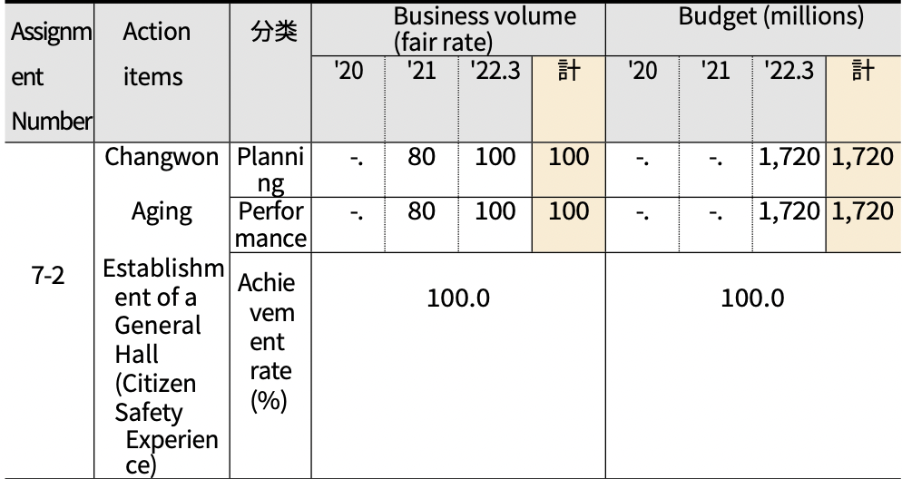
Classification
Total
Total

○ Progress (as of 03/31/22)
- In the case of the Changwon Wellbeing Center, the project is on hold due to a change in circumstances at the Ministry of the Interior, but periodic consultations with the Fire and Emergency Management Agency and the Ministry of the Interior and Safety are planned.
*Selected as a project target in '23, aim to promote the project with grant tax support from '24
- Various safety programs are being promoted since the opening of the Changwon City Citizen Safety Experience Center in January 2022
*Can organize and promote specialized programs for seniors

(Table 4-45) Progress of Task No. 7-2 (Establishment of Changwon Well-Aging Center)
Assignment Number | Action items | Whether to cancel/change from original plan | Business Volume (Process) |  |  | Budget (millions)
 |  |  | Complete | Unimplemented (in preparation) | In Progress | Complete | Unimplemented (in preparation) | In Progress
7-2 | Changwon  Established a wellness center (Citizen Safety Experience Center) | Drive a change to a two-track strategy | 100 | -. | -. | 1,720 | -. | -.
○ Business valuation
- Need to continue building wellness centers as the aging rate
increases
◦ Continued efforts are needed to monitor project implementation
and secure sites from the Ministry of Public Administration
◦ Continuous development of wellness-related specialized business (program) in conjunction with Changwon Citizen Safety Experience Center and welfare centers in the city, training of experts, and accumulation of know-how are needed.
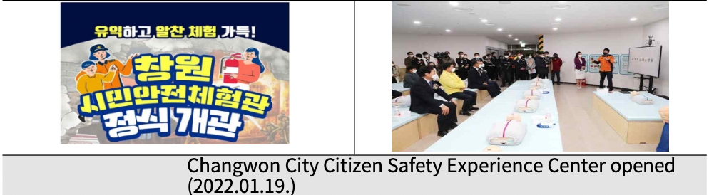

4) Ensure a vibrant 100th birthday (Goal 8)
○ The implementation tasks for the sub-goal 'Ensuring a healthy old age of 100 years old with vigor' include: ➀ Expanding remote consultation medical services using ICT, ② Operating a smart healthcare system, ➂ Visiting healthcare services for the vulnerable, 4 Memory Kium happiness empathy dementia integrated management company, 5 Creating a silver life youth project, 6 Promoting the Gyeongnam-type community care pilot project, and ➀ ICT-linked artificial intelligence integrated care project.
○ We'd like to look at the background and key milestones for each action item.

(Table 4-46) Goal 8 (Ensure Vibrant Centenarians) Action Tasks, Project Description, and Lead Departments
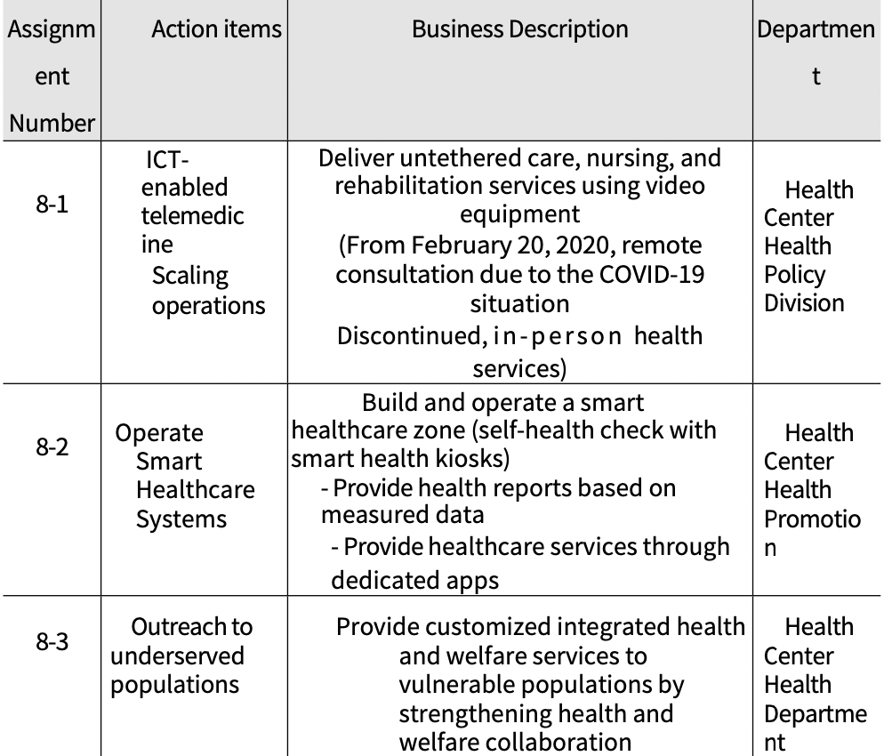
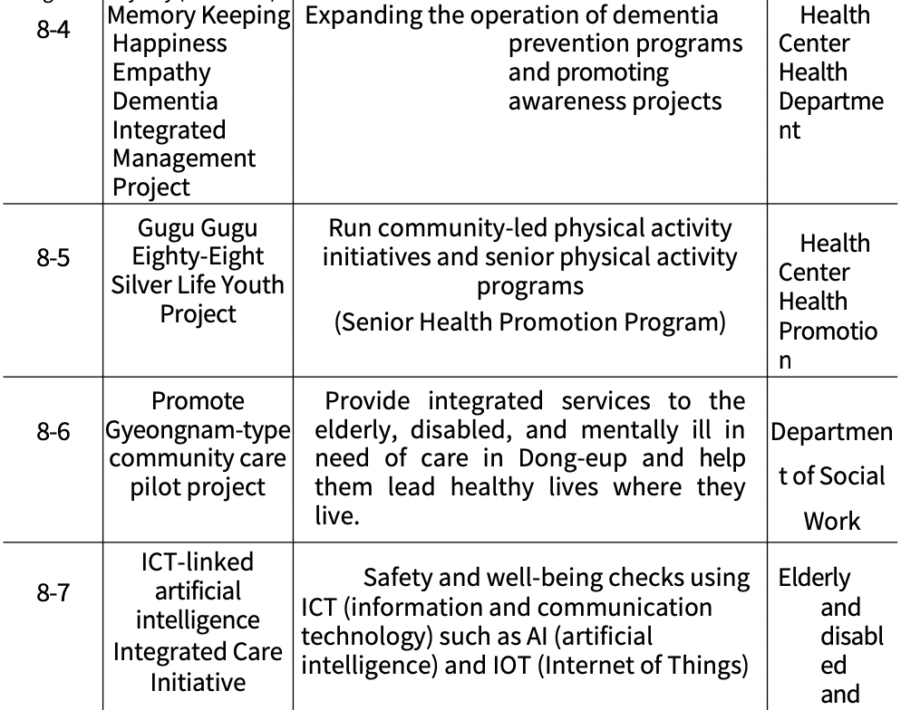

(1) Expanding telemedicine services using ICT
○ Pushback
- The number of people with chronic diseases continues to increase due to an aging population, lifestyle changes, etc.
- Provide systematic healthcare services to residents w h o live in the community and have difficulties in daily life due to illness, and reduce the socioeconomic burden of illness (need to eliminate medical dead zones and strengthen public healthcare)
- It is necessary to establish a teleconsultation medical service system using ICT (information and communication technology) and to expand the provision of medical services that reflect the diverse health needs of recipients.

○ Business Description
- (Target) People with chronic diseases in medically vulnerable areas (Dong-eup, Buk-myeon, Daesan-myeon) who are judged to be able to manage their health through remote consultation.
- (Content)
◦ Create a dedicated two-person visitation team (nurse, physical
therapist)
◦ Physician and nurse consultation via video equipment
◦ Provide healthcare, health education, nursing, and rehabilitation services

○ Business plan and performance
- As of the end of March 2022, 772 projects were executed, representing a 60.9% achievement rate against the plan, and the budget was executed at a 52.0% rate.
- Disruption of business operations such as closure of health centers due to COVID-19 response

(Table 4-47) Project No. 8-1 (Operation of Tele-Consultation Medical Service Utilizing ICT) Business Plan and Performance
Assignment Number | Action items | Classification | Business volume (cases) |  |  |  | Budget (million won)
 |  |  | '20 | '21 | '22.3 | Total | '20 | '21 | '22.3 | Total
8-1 | Expanding telemedicine services using ICT | Planning | 552 | 451 | 264 | 1267 | 102 | 100 | 94 | 296
 |  | Performance | 471 | 301 | -. | 772 | 78 | 76 | -. | 154
 |  | Set the achievement to  （%） | 60.9 |  |  |  | 52.0

○ Progress (as of 03/31/22)
- The project has not been changed or canceled from the original plan.
- In 3 years, a total of 772 cases including remote consultation and visiting healthcare services were completed and KRW 154 million was executed, but it was not actively promoted due to COVID-19.
- In particular, remote consultations have been suspended since February 20 due to public health doctors' duties in the COVID-19 situation room (however, they continue to provide in-person health services).

(Table 4-48) Progress on Task No. 8-1 (Operation of Tele-Consultation Medical Service Utilizing ICT)
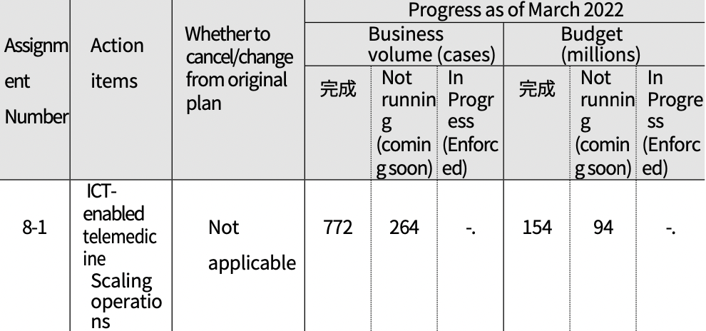
Complete
Complete

○ Business valuation
- It is a community-centered healthcare project for the elderly with chronic diseases in medically vulnerable areas that combines ICT and home healthcare services.
◦ Business has been challenged by COVID-19
◦ Healthcare using information and communication technology (ICT) is expected to become more widespread
◦ Can be actively used as a way to improve access to healthcare, especially for the elderly in medically vulnerable areas outside of urban centers
◦ We need to continue to expand our business and budget, expand our professional staff, and expand the number of local medical institutions participating in the project.
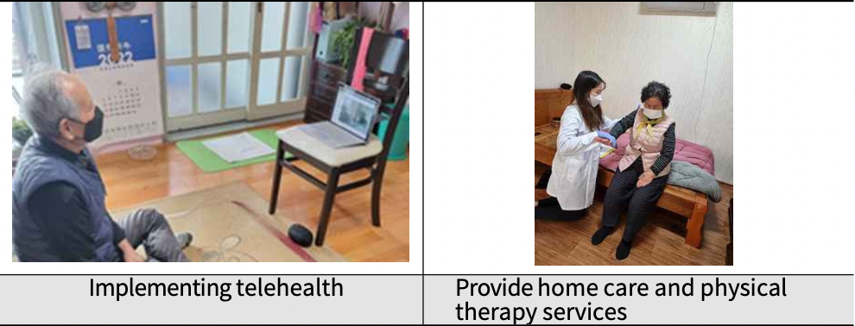

(2) Operate Smart Healthcare Systems
○ Pushback
- Need to minimize economic losses and improve healthcare efficiency through chronic disease prevention
- The need for mobile-based healthcare services using ICT in the post-COVID-19 era is growing
- Need to prevent chronic diseases and improve self- management capabilities and quality of life by building a healthcare system utilizing ICT and big data technologies

○ Business Description
- Build and Operate a Smart Healthcare Zone
◦ (Scale) Established 3 locations in Changwon City
◦ (Location) Dong-eup Administrative Welfare Center, Sangnam-dong
Residents' Autonomy Center, Seongsan Sports Center
◦ (In this article) Self-health checks with smart health kiosks
*Analyzes the risk of developing chronic diseases (diabetes, hypertension, cardiovascular disease) by physical age, healthcare index, and chronic disease category according to measured data Provides health reports
*Provide healthcare services through dedicated apps (customized diet and exercise prescriptions, etc.)

○ Business plan and performance
- As of the end of March 2022, the business implementation performance was 2,827 users in 3 locations, with an achievement rate of 76.4%.
- Budget was $1.8 million, with an 85.7% execution rate against plan

(Table 4-49) Task No. 8-2 (Smart Healthcare System Operation) Business Plan and Performance
Assignment Number | Action items | Classification | Business volume (locations/people) |  |  |  | Budget (million won)
 |  |  | '20 | '21 | '22.3 | Total | '20 | '21 | '22.3 | Total
8-2 | Operate Smart Healthcare Systems | Planning | 0 | 3 locations / 1,200 people | 3 locations / 2,500 people | 3 locations / 3,700 people | 0 | 11 | 10 | 21
 |  | Performance | 0 | 3 locations / 1,370 people | 3 locations/ 1,457 people | 3 locations / 2,827 people | 0 | 11 | 7 | 18
 |  | Set the achievement to  （%） | 100.0% / 76.4 |  |  |  | 85.7

○ Progress (as of 03/31/22)
- Changing course after the COVID-19 outbreak
Originally | -> | Change
Active Aging Health Concert & Access to Living Places The (THE) Health Project Promotion |  | Operate Smart Healthcare Systems
- Teach health classes and activities to citizens  - Health lessons by disease and theme  - Physical activity programs linked to health classes  - Run health booths to provide health lectures and health information to seniors at senior welfare centers |  | - Build and operate smart healthcare zones (e.g., self-health checks via smart health kiosks)
- Since '21, three smart healthcare zones have been built, a total of 2,827 people have used them, and a budget of KRW 18 million has been invested.

(Table 4-50) Progress of Task No. 8-2 (Smart Healthcare System Operation)
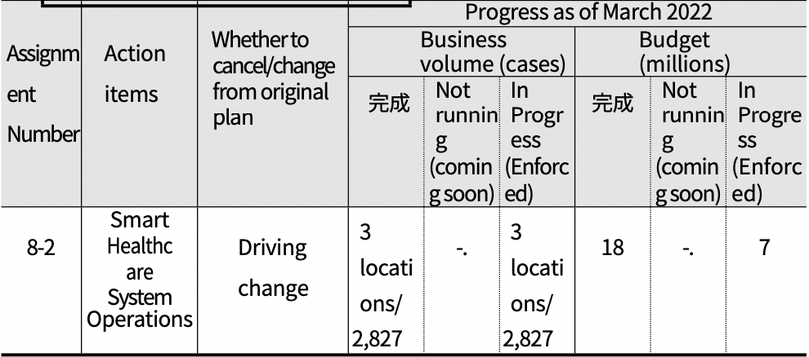
Complete
Complete
○ Business valuation
- It is a business that established a kiosk and mobile-based self-health management service system utilizing ICT.
◦ Continued business expansion is necessary due to the development of information and communication technology and the increasing demand for non-face-to-face healthcare services
◦ However, there is a need to find ways to make digital devices more accessible and usable for seniors who are not used to using them.
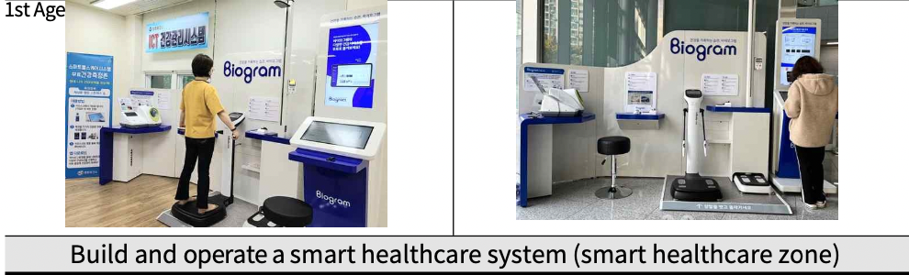

(3) Outreach to underserved populations
○ Pushback
- The socioeconomic burden of an aging and chronically ill population is increasing, and the need for more community- centered and diverse healthcare delivery is growing.
- Need for health services to raise health awareness, improve self- management skills, and maintain and improve health status among vulnerable populations.
- Need for regular healthcare monitoring to help vulnerable populations manage chronic diseases and prevent complications

○ Business Description
- Outreach to underserved populations
◦ (Target) Health vulnerable groups such as the elderly living alone, disabled, chronically ill, and basic subsistence recipients.
◦ (Main services) Providing home health care services, linking with integrated health and welfare services, managing cancer patients a t home, supporting medical expenses for low-income people, etc.
◦ (Highlights)
*Manage chronic diseases by providing regular visit healthcare services
*Manage door-to-door registration for seniors aged 65 and over
*Provide health news alerts for vulnerable populations
*Coordinate resources within and outside the health center and provide integrated care services through volunteer groups

○ Business plan and performance
- As of the end of March 2022, the number of business executions was 6,078, representing an achievement rate of 56.1% against the plan.
- Execution budget was KRW 244.2 million, with an execution rate of 72.6% against plan

(Table 4-51) Project No. 8-3 (Visiting Healthcare for the Vulnerable) Business Plan and Performance
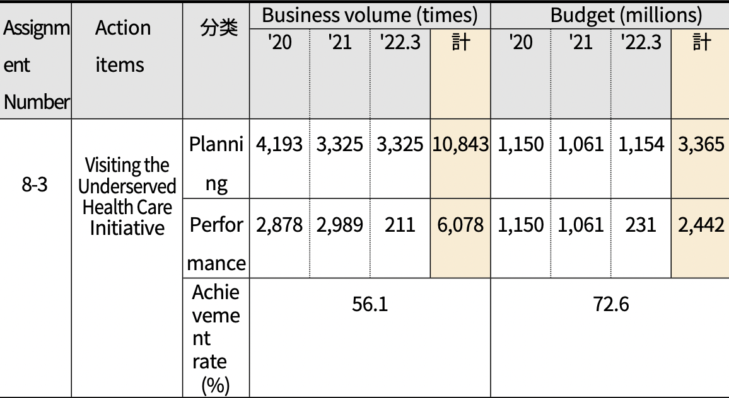
Classification
Total
Total

○ Progress (as of 03/31/22)
- The project has not been changed or canceled from the original
plan.
- Provided 6,078 services in 3 years, with a budget of KRW 244.2 million
- As a project sponsored by a health center ,there were many difficulties in supporting big data services due to COVID-19.

(Table 4-52) Progress of Task No. 8-3 (Visiting Healthcare for Vulnerable Populations)
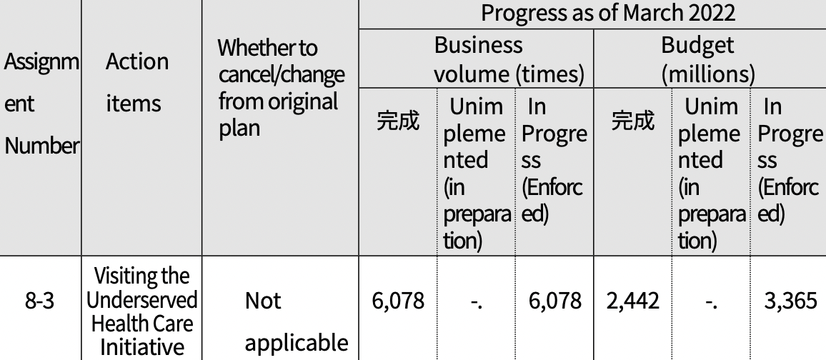
Complete
Complete
○ Business valuation
- The visiting health care business is a business that provides integrated health and welfare services to the elderly who are vulnerable to physical health such as chronic diseases.
◦ To identify the health problems of the elderly and chronically ill living alone comprehensively and proactively with limited mobility and provide regular healthcare services.
◦ In order to respond to an aging society, we need to continue to expand the business targets of the elderly, and for this purpose, we need to continue to expand manpower and budget.
◦ Need to prevent duplication and omission of services and improve efficiency and effectiveness by linking with public and private case management businesses
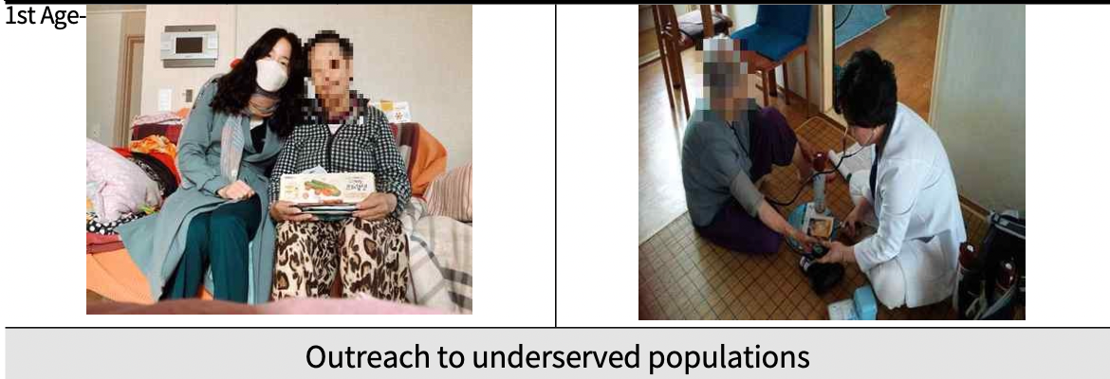

(4) Memory Keeping Happiness Empathy Dementia Integrated Management Project
○ Pushback
- With the rapid growth of the elderly population, there is a growing interest in dementia and a need for prevention.
- In September 2017, the government announced a national accountability plan for dementia, strengthening the role of government and local authorities in dementia care.
- Comprehensive management and support for people with dementia through the Dementia Integrated Management Project and awareness-raising projects for citizens need to be expanded.

○ Business Description
- Memorykium Happiness Empathy Dementia Integrated Management Project (Dementia Relief Center)
◦ (Target) Changwon citizens, dementia patients and their families
◦ (Highlights) Expanding the operation of dementia prevention programs and promoting awareness projects
◦ (Main services) Registration and customized case management of dementia patients, provision of dementia treatment management fees and support items, screening, diagnosis, and differential tests for early detection and prevention, GPS, identification tags, and fingerprint registration for dementia patient disappearance prevention projects, shelters for dementia patients, family classrooms, dementia prevention classes, cognitive enhancement classes, training of dementia partners and partners to improve dementia awareness, designation of dementia overcoming leadership organizations and lighthouse bases, designation of safe merchants, etc.

○ Business plan and performance
- As of the end of March 2022, business execution performance was 25,905, a 100.4% achievement rate against the plan.
- The executed budget was $90 million, with an execution rate of
100.0% against plan.

(Table 4-53) Project No. 8-4 (Memory Kium Happiness Empathy Dementia Integrated Management Project) Business Plan and Performance
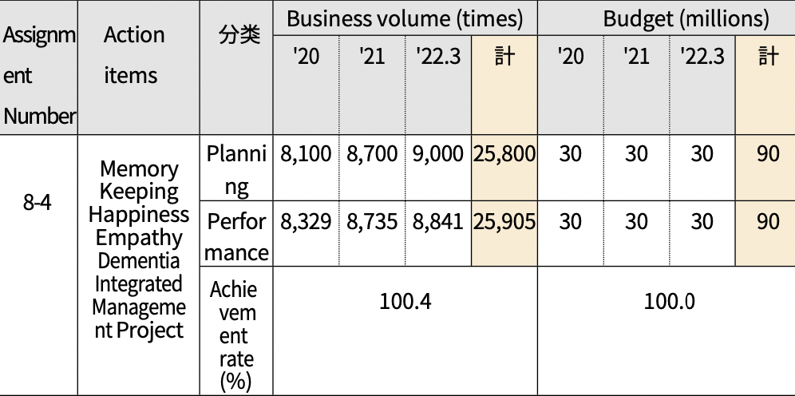
Classification
Total
Total

○ Progress (as of 03/31/22)
- The project has not been changed or canceled from the original plan.
- Provided 25,905 services in 3 years with a budget of $90 million

(Table 4-54) Progress of Task No. 8-4 (Memory Keeping Happy Empathy Dementia Integrated Management Project)
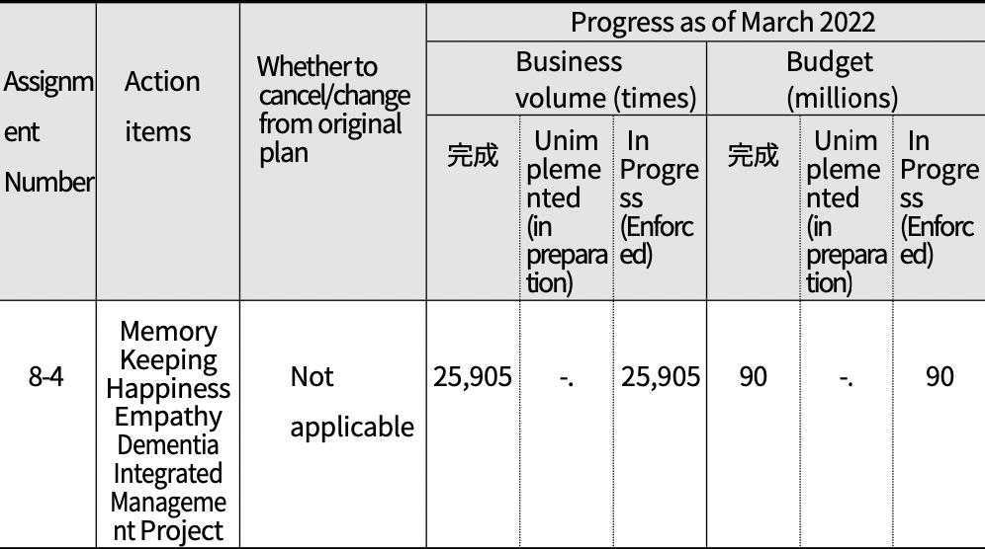
Complete
Complete
○ Business valuation
- The Dementia Integrated Management Project is a project that provides comprehensive support for people with dementia and their families and promotes various awareness programs for the general public.
◦ Concerned about business contraction due to COVID-19, but need to continue to expand services through various methods such as non-face-to-face programs and small group operations
◦ Aggressive efforts to expand services to reduce family burden of dementia are needed
◦ Need for early detection and awareness of dementia to reduce public anxiety and increase understanding
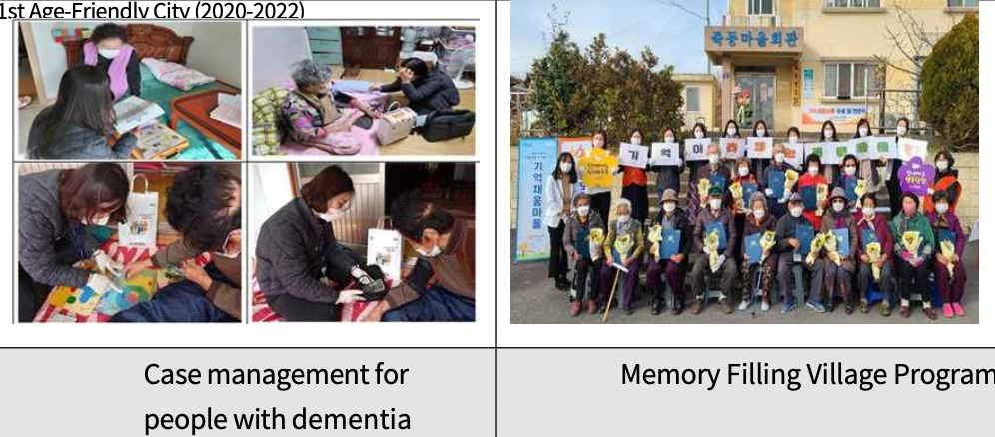

(5) Gugu Gugu Eighty-Eight Silver Life Youth Project
○ Pushback
- Disparities in healthcare access and uptake of health services and health programs based on where you live
- Need to run health promotion programs through community partnerships in underserved areas to reduce health inequality
- Need for health promotion programs tailored to the elderly to prepare for an aging society and create age-friendly cities

○ Business Description
- Community-led physical activity initiatives and senior wellness programs
◦ (For) Seniors 65 and older ◦ (Highlights)
*Meeting with walking leaders and health movement leaders in Dong-eup Village
*Operation of physical activity programs for the elderly (body composition measurement and exercise counseling, cardiovascular disease "high sugar classroom")

○ Business plan and performance
- As of the end of March 2022, the number of business executions was 11, showing a 73.3% achievement rate against the plan.
- The executed budget was 32 million won, with an execution rate of 50.0% against plan

(Table 4-55) Project No. 8-5 (Nine Eighty Eight Silver Life Project) Business Plan and Performance
Assignment Number | Action items | Classification | Business volume (times) |  |  |  | Budget (million won)
 |  |  | '20 | '21 | '22.3 | Total | '20 | '21 | '22.3 | Total
8-5 | Gugu Gugu Eighty-Eight Silver Life Youth Project | Planning | 0 | 10 | 5 | 15 | 0 | 32 | 32 | 64
 |  | Performance | 0 | 11 | 0 | 11 | 0 | 32 | 0 | 32
 |  | Set the achievement to  （%） | 73.3 |  |  |  | 50.0
○ Progress (as of 03/31/22)
- The project has not been changed or canceled from the original
plan.
- Due to COVID-19, virtually all business will be in-person in '21
◦ In '20, the Department of Health and Human Services guidelines and initiatives to prevent and combat the spread of COVID-19-related infectious diseases were suspended.
◦ In '21, due to the impact of COVID-19, we were unable to conduct face-to-face business smoothly, so we switched to non- face-to-face business (such as producing and distributing guides for physical activity and healthy lifestyle practices).
◦ In the first half of '22, the project could not be carried out due to the business manager's assignment to the Corona Situation Room. Business will be resumed in the second half of the year

(Table 4-56) Progress of Task No. 8-5 (Nine Eighty-Eight Silver Life Project)
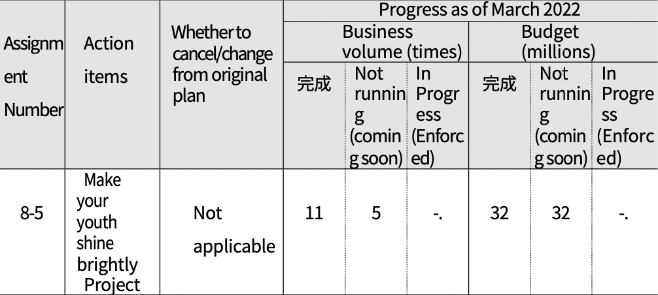
Complete
Complete
○ Business valuation
- The Nine Eighty Eight Silver Lives for Youth project provides customized health promotion programs for the elderly in areas with limited access to healthcare.
◦ Business has been disrupted by COVID-19
◦ Need to continue to develop and expand new health promotion programs for older adults in medically underserved areas (designate dedicated staff, increase budget, etc.)
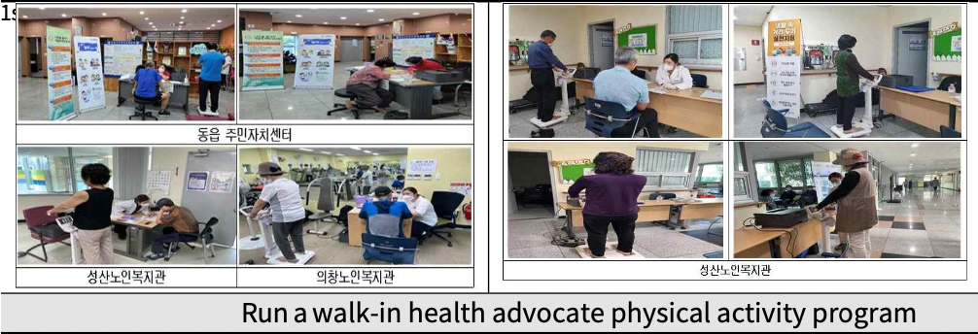
(6) Promote Gyeongnam-type community care pilot project
○ Pushback
- In preparation for an aging society, we need to build the infrastructure to allow older adults to age in place in the community rather than in a hospital or institution.
- Provide integrated services such as welfare, health, housing, and care to the elderly, disabled, and mentally ill in need of care in the community, enabling them to lead healthy lives where they live.
- Need to improve the quality of life of care recipients by providing services tailored to their individual needs

○ Business Description
- Provide integrated services such as health, welfare, medical, housing, and
care to care recipients.
◦ (Business period) 2019.7. ~ 2021.12.
◦ (Business location) Dong-eup, Uichang-gu, Changwon-si
◦ (Major projects) Operation of the Care Information Counter at the Dong-eup Administrative Welfare Center, formation of a community care promotion group, establishment of a public- private partnership group, operation of a community care village center, etc.
◦ (Details) Holding a meeting of practitioners of the Gyeongnam-type community care pilot project, promoting residential environment improvement projects, training and managing AI speaker users, providing healthcare services to Dong-eup, supporting daily necessities for care recipients, promoting projects, and conducting satisfaction surveys.

○ Business plan and performance
- Served 892 people by the end of March 2022, achieving 124.9% against plan
- Execution budget was KRW 271 million, with a 71.7% execution rate against plan
(Table 4-57) Project No. 8-6 (Gyeongnam Community Care Pilot Project) Business
Plan and Performance
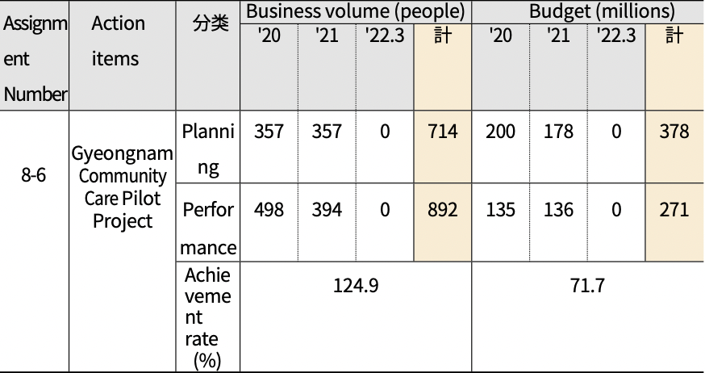
Classification
Total
Total
○ Progress (as of 03/31/22)
- The project has not been changed or canceled from the original
plan.
- By '21, the program served 892 people with a budget of KRW 271 million.
◦ The'Gyeongnam-type Community Care Pilot Project' is a project that was promoted for 3 years ('19.7.~'21.12.), and the project ended in '22

(Table 4-58) Progress of Task No. 8-6 (Gyeongnam Community Care Pilot Project)
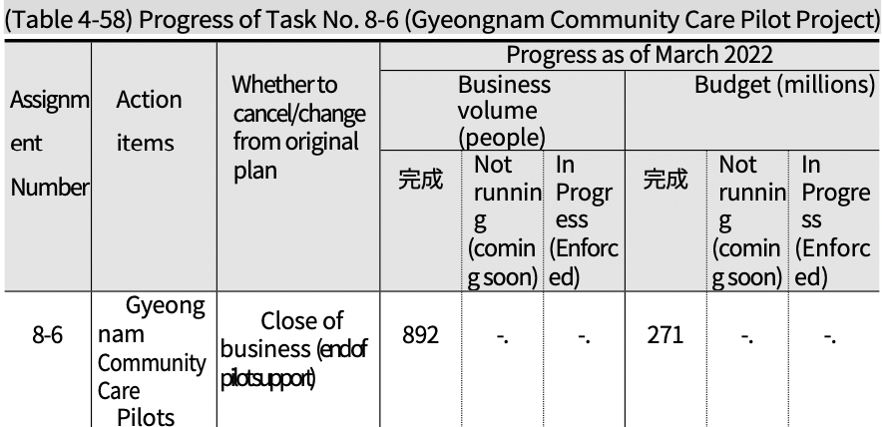
Complete
Complete

○ Business valuation
- The community care business is a business that builds social infrastructure and provides community integrated care services so that people in need of care can lead a healthy life where they live.
◦ The pilot project was conducted in Dong-eup, Changwon for about 3 years, but the project was discontinued due to the end of the project period. Based on the performance evaluation of the community care pilot project, efforts are needed to prepare follow-up measures such as strengthening cooperation between ward offices and towns and villages and expanding resource development and linkages.
- In addition, specialized case management through ward and town cooperation should be strengthened to respond to the diverse need of the elderly.
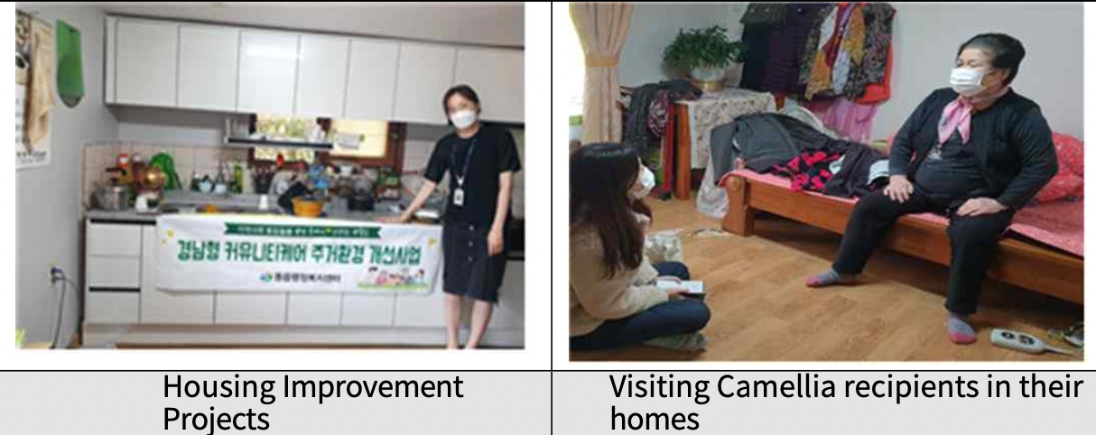

(7) ICT-linked artificial intelligence integrated care project
○ Pushback
- Elderly single-person households and elderly couple households
continue to increase each year
- Need to provide integrated care services for the vulnerable (elderly living alone, disabled, etc.) by utilizing ICT (information and communication technology), such as living convenience and safety confirmation.
- Need to establish a system that can effectively respond to emergencies in conjunction with local dispatch services (e.g., 119 rescue and emergency services)

○ Business Description
- Artificial intelligence (AI) and Internet of Things (IOT) sensors provide care for the elderly and disabled alone
- Counseling, home visits, and referrals to related services through Care Managers
- Details
◦ Manage people served in real time with Care Manager
*Monitoring, case management, complaint response, etc. via computer and mobile phone apps
◦ Selecting additional people to serve
◦ Installing an existing IOT sensor in a covered household ◦ Hiring additional care managers
◦ Installation of new service household devices, etc.

○ Business plan and performance
- Served 1,120 people by the end of March 2022, achieving 100.0% of plan.
- Execution budget was KRW 522 million, with an execution rate of 63.3% against plan

(Table 4-59) Project No. 8-7 (ICT-linked AI Integrated Care Project) Business Plan and Performance
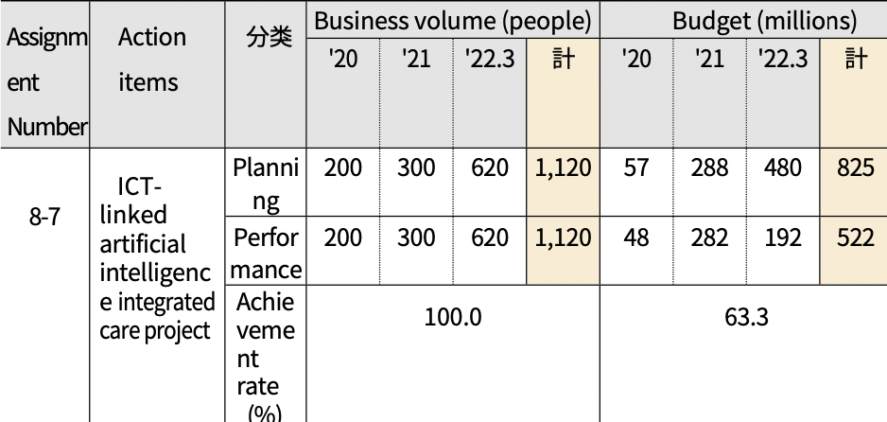
Classification
Total
Total
○ Progress (as of 03/31/22)
- This project is being implemented under a different name than
originally planned.
*(Initial) Support for the distribution of AI care
robots for the elderly (Change) ICT-linked artificial intelligence integrated care project
- As of March 22, 892 people were served and 522 million won was disbursed.
- However,installationsin'22arebeingdelayedduetoCOVID-19andthe Omicron outbreak.
(Table 4-60) Progress of Task No. 8-7 (ICT-linked AI Integrated Care Project)
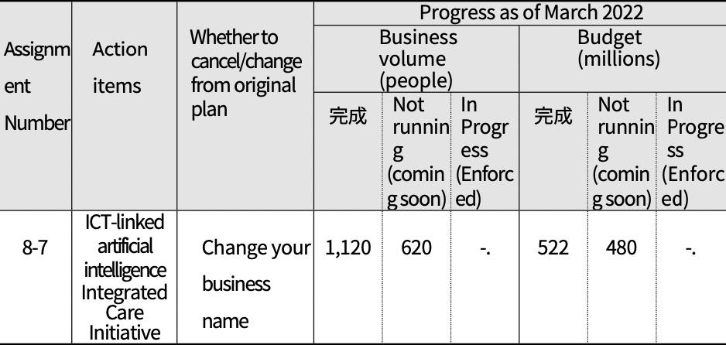
Complete
Complete

○ Business valuation
- The ICT-linked artificial intelligence integrated care business is a business that provides safety checks, emergency response, and integrated care services for the elderly living alone by utilizing AI (artificial intelligence) and IoT (Internet of Things) sensors.
◦ Continued expansion of ICT-linked integrated care services (targets, budget, etc.) is needed due to the increase in per capita households and the need for non-face-to-face services.
◦ Regular training and case management supervision are needed to improve the expertise of dedicated staff, and efforts to improve treatment are needed for stable working conditions.
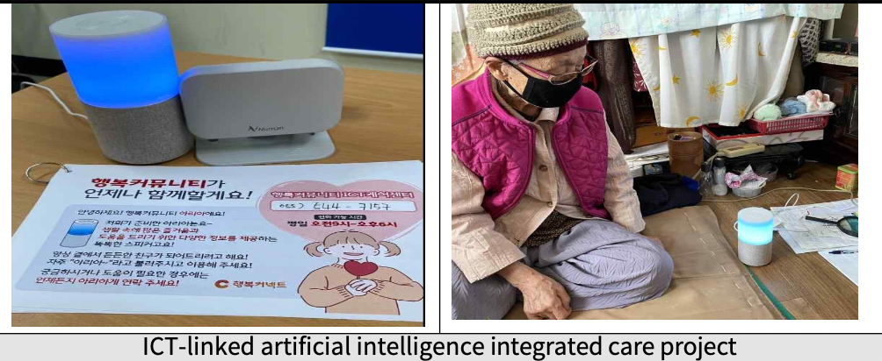

3. Suppor thealthy and affordable retirement( Policy Goal 3)

○ The third policy goal of the first action plan is "Supporting healthy and leisurely retirement," which is implemented by setting four sub-goals.
- Goal 1 (Supporting colorful later life) is a goal linked to "Leisure and social participation" of the eight domains of the WHO Age Friendly Cities Guide, and sets five action items
- Goal 2 (Supporting the promotion of social activities) is a sub- goal linked to 'Leisure and social participation' of the eight domains of the WHO Age Friendly Cities Guide, and sets two action items
- Goal 3 (Focus on mid- and long-term jobs) i s a goal linked to the WHO Age Friendly Cities Guide's eight areas of civic engagement and empowerment, and sets two action items
- Goal 4 (Supporting customized work for older people) is a sub- goal linked to "civic participation and empowerment" of the eight areas of the WHO Age Friendly Cities Guide, and sets four action items
○ This is an area that promotes a variety of social activities and job policies to enable active aging in society.
- The primary focus is on enabling older adults, including baby boomers, to live active lives, using their skills to benefit their communities through economic and social activities.

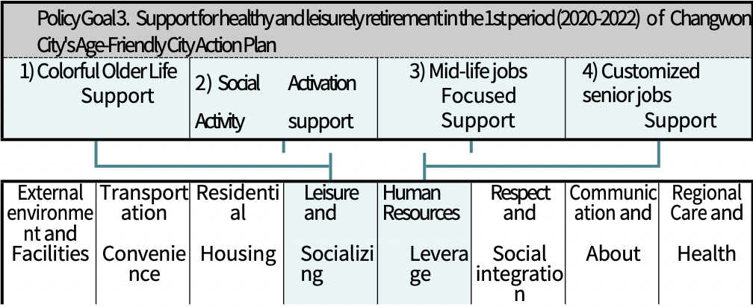
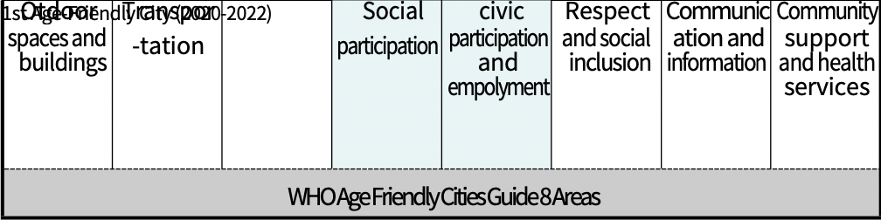

1) E n a b l e colorful aging (Goal 9)
○ For the sub-goal "Supporting Colorful Senior Life," five action tasks were set: ➀ Operate senior cultural lectures, ② Operate a new generation senior center program for the new generation of seniors, ➂ Build a senior center that adds happiness and enjoyment to seniors, 4 Create a senior-friendly store, and 5 Create a park golf course for seniors.
○ We'd like to look at the background and key milestones for each action item.

(Table 4-61) Goal 9 (Supporting Colorful Aging) Action Tasks, Project Description, and Lead Agency
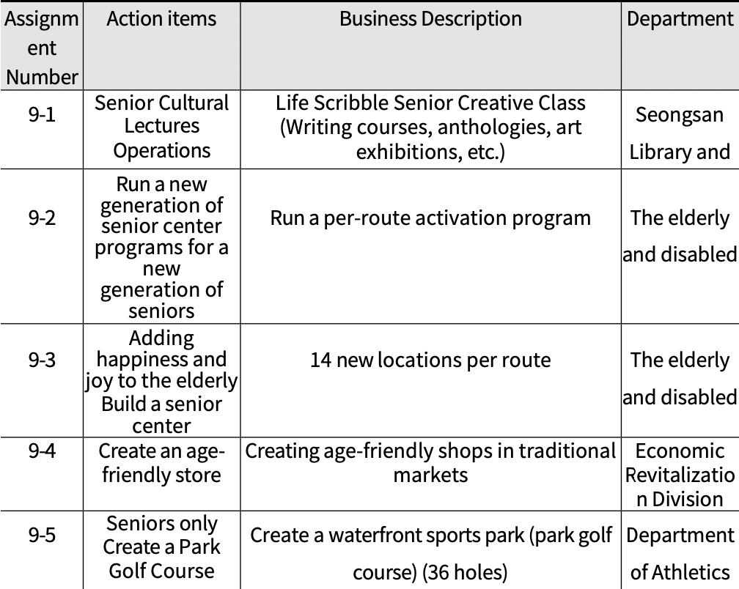

(1) Run a senior cultural class
○ Pushback
- With an accelerating aging society, libraries need to differentiate their programs for older adults.
- Need to run programs tailored to seniors to support cultural and
leisure activities
- The need for self-reflection through writing and helping seniors lead colorful and vibrant lives in later life
○ Business Description
- Life Scribble Senior Creative Class
◦ Sponsored by: Seongsan Library
◦ Highlights: writing classes in various formats, anthologies,
exhibitions of work, and more. ○ Business plan and performance
- As of the end of March 2022, we've conducted 39, with a 56.5% achievement rate against plan.
- The executed budget was $4 million, with a 57.1% execution rate compared to the plan.

(Table 4-62) Task No. 9-1 (Senior Culture Lecture Operation) Business Plan and Performance
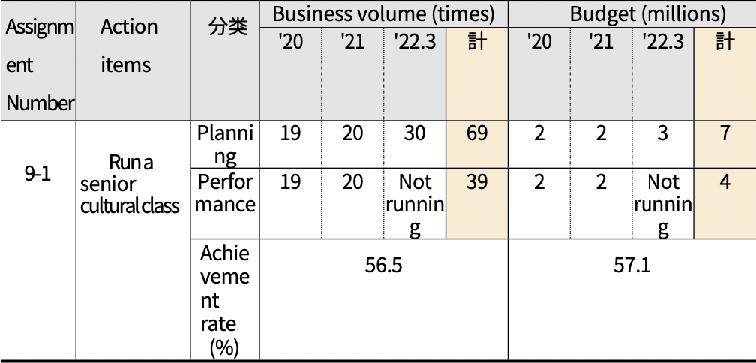
Total
Total
Classification

○ Progress (as of 03/31/22)
- The project has not been changed or canceled from the original plan.
- Conducted 39 times in 3 years, with 20 planned for FY22
- A total of 4 million won has been executed in 3 years, and 3 million
won will be executed in '22
- Operated non-face-to-face programs in parallel due to COVID-19

(Table 4-63) Progress of Task No. 9-1 (Run Senior Culture Lecture)
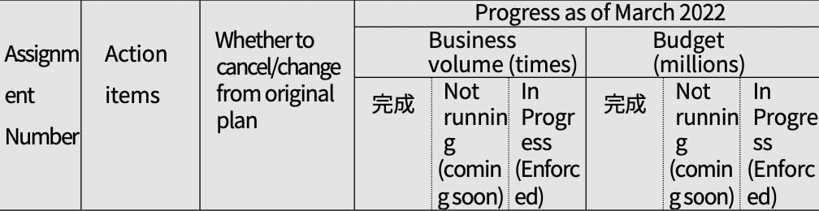
Complete
Complete
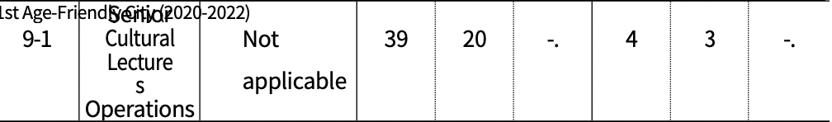

○ Business valuation
- Senior Cultural Classes is a project that supports the elderly to enjoy cultural and leisure life through creative writing classes, as well as self-reflection and active aging.
◦ Need to expand business in conjunction with other libraries or community centers other than Seongsan Library
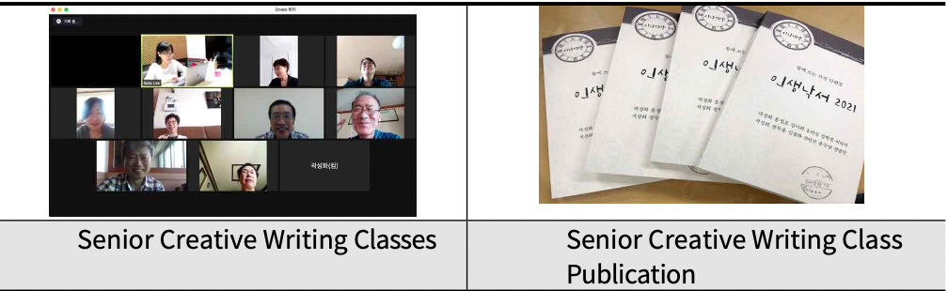

(2) Run a new generation of senior center programs for a new generation of seniors
○ Pushback
- Increased need to adapt programs to the needs of a rapidly growing senior population, and a new generation of highly educated seniors.
- Need for programmatic support to help senior centers move beyond the concept of shelter to function as cultural and welfare spaces
- Need to support programs that meet the diverse needs of the elderly to promote healthy interaction and satisfaction with leisure spaces
○ Business Description
- Run a per-route activation program
◦ Promoted as part of the senior center activation project operated by each senior center in the jurisdiction
*Total 65 locations (24 Changwon Branch, 25 Masan Branch, 16 Jinhae Branch)
◦ Highlights: Provides leisure activities such as silver aerobics, gymnastics, and acupuncture.
○ Business plan and performance
- As of March 2022, more than 200 seniors have used the service, with a 6.6% achievement rate against the plan.
- Execution budget was KRW 3.5 million, with a 66.0% execution rate against plan
- As a result of the overall shutdown of the per-pathway program due to the prolonged COVID-19 pandemic, we expect it to become more active as social distancing eases in '22

(Table 4-64) Task No. 9-2 (Operate the New Generation Seniors Program) Business Plan and Performance
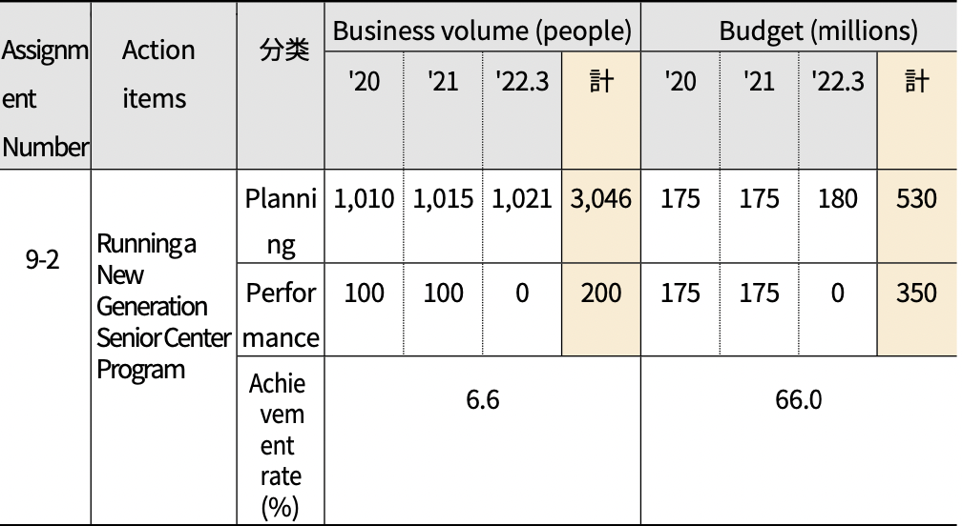
Classification
Total
Total
○ Progress (as of 03/31/22)
- The project has not been changed or canceled from the original
plan.
- A total of 1,021 seniors participated in the program over three years
- COVID-19 disrupted the program, but participation is expected to increase significantly in '22 and beyond
- A total of KRW 350 million has been executed in 3 years, and KRW 180 million is planned for '22

(Table 4-65) Progress on Task No. 9-2 (Operate New Generation Per Capita Program)
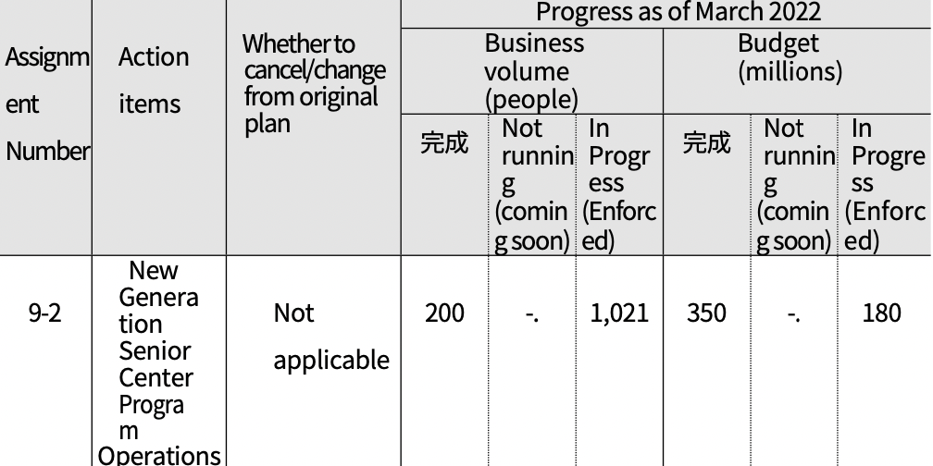
Complete
Complete
○ Business valuation
- A senior center is a space where local seniors can lead a leisure life with fellow seniors, and it is not just a shelter, but a space for senior community activities and various leisure and cultural activities.
◦ COVID-19 has disrupted our overall business performance, including suspension of program operations.
◦ From '22 onwards, the number of trips per route is expected to increase due to social distancing, etc.
◦ In addition, it is necessary to develop and disseminate standard programs to plan and operate professional programs in addition to budgetary support for the private sector, and to prepare support measures to activate programs for each pathway, such as worker education and training.
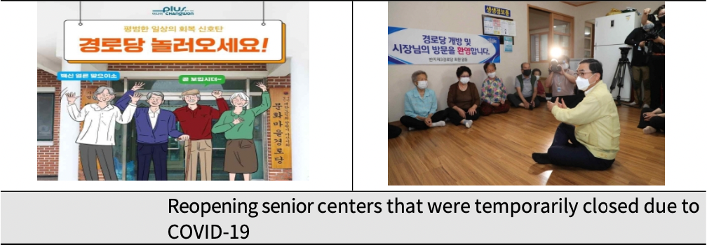

(3) Building a senior center to keep seniors happy and entertained
○ Pushback
- Senior centers are one of the primary community-based senior living facilities where older adults engage in cultural and leisure activities.
- New construction of senior centers with poor environments due to aging facilities is necessary for the safe use of facilities by the elderly.
- In addition, it is necessary to expand welfare leisure facilities for the elderly by building new senior centers in areas where there are no senior centers.

○ Business Description
- New construction of 14 locations per route (total project cost of 8,165 million won: 2,430 government funds and 5,735 city funds)
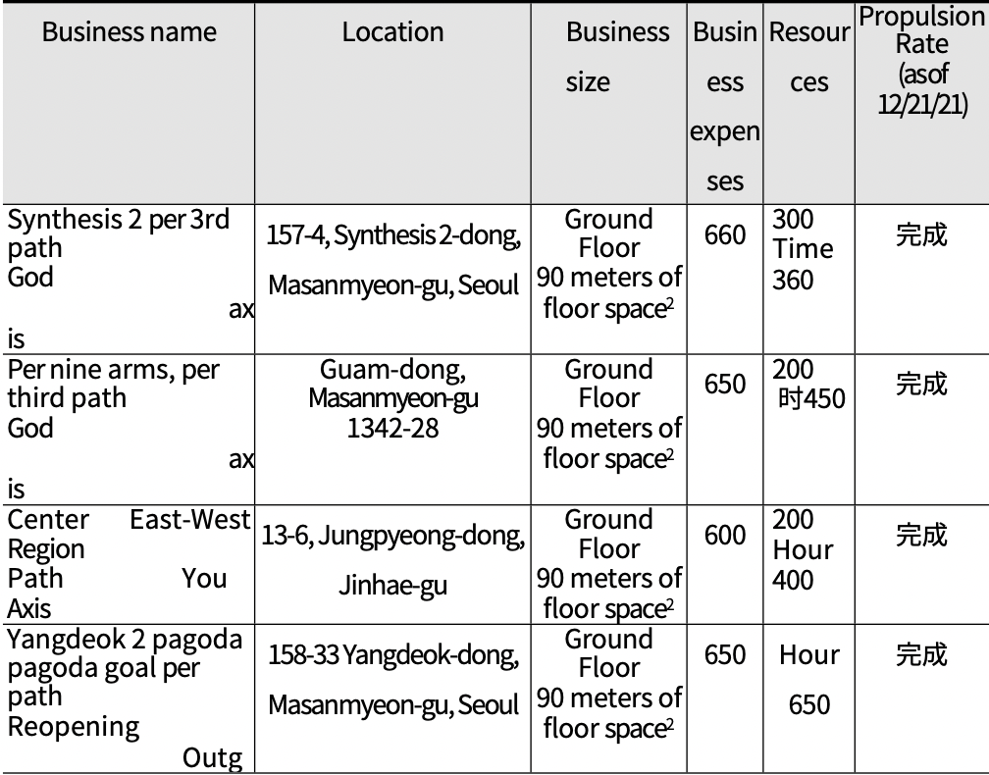
Haspseong 2-dong
Complete
Complete
Complete
Complete

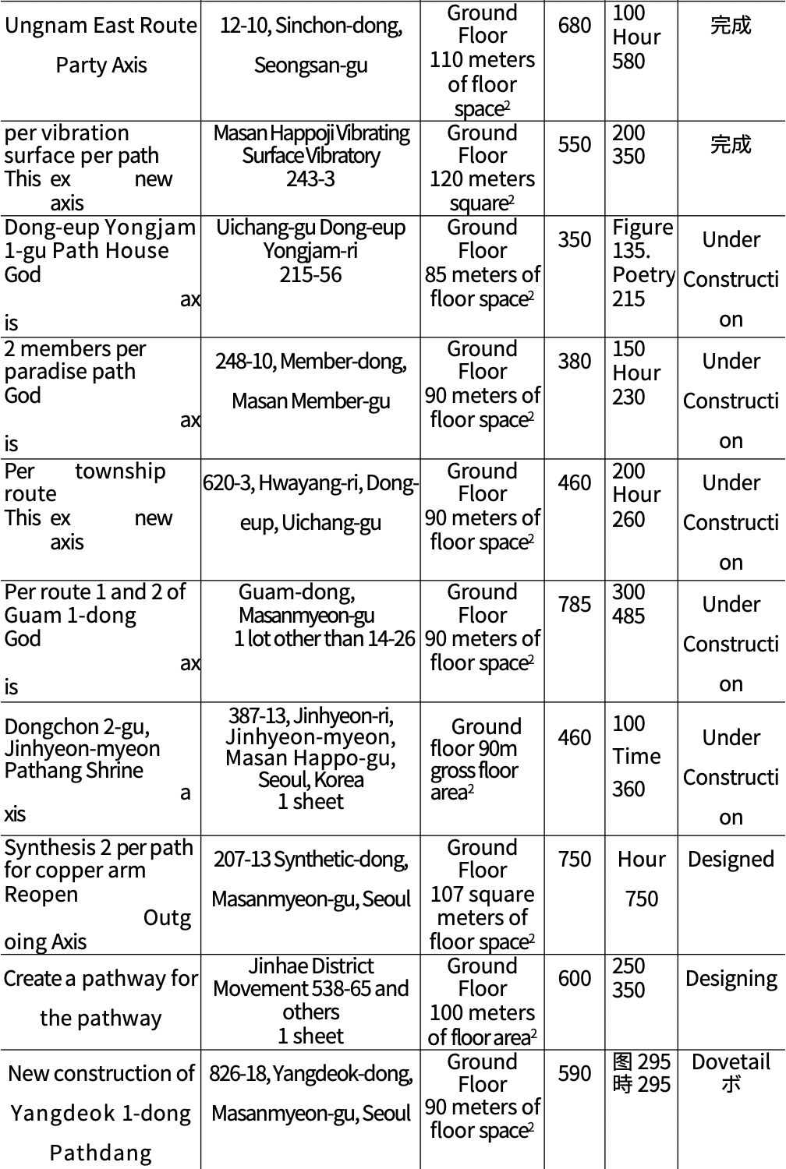
248-10, hoewon-dong
Masanhoewon-gu
Yi-dong
Haspseong-dong

Complete
Complete

○ Business plan and performance
- At the end of March 2022, 13 new locations per route were completed or underway, representing a 76.5% achievement rate against plan.
- Execution budget was KRW 71.1 million, with an execution rate of 76.3% against plan

(Table 4-66) Project Plan and Performance for Task No. 9-3 (Building a Senior Center)
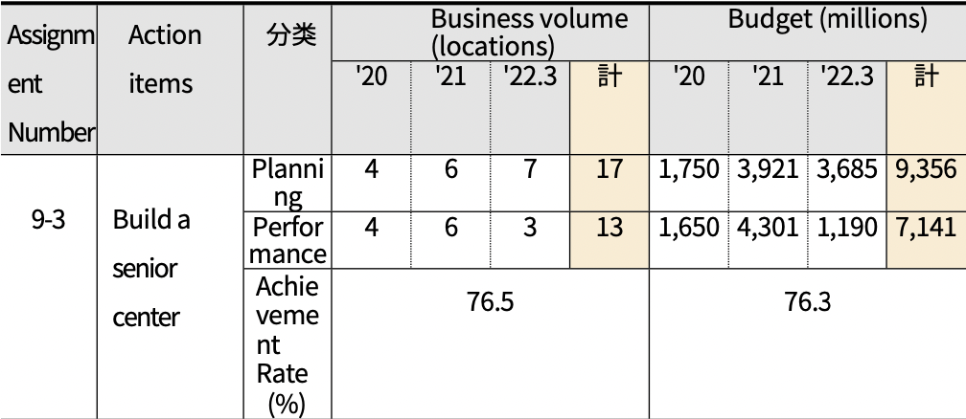
Total
Total
Classification
○ Progress (as of 03/31/22)
- The project has not been changed or canceled from the original plan.
- A total of 13 senior centers have been built or under construction over the past three years, with a budget of KRW 71.14 million.
- Six sites are expected to be completed in 1H22, with two sites targeted for completion in 2H22
(Table 4-67) Progress on Task 9-3 (Build a Senior Center)
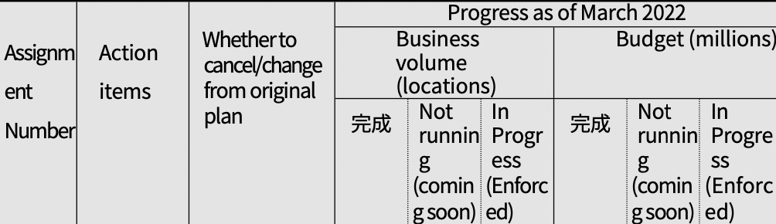
Complete
Complete
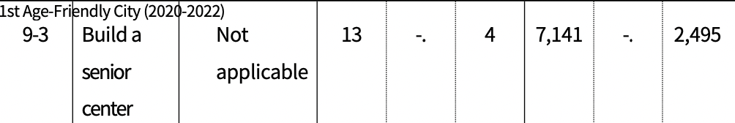

○ Business valuation
- Need to secure a stable budget for new construction per route and promote the project
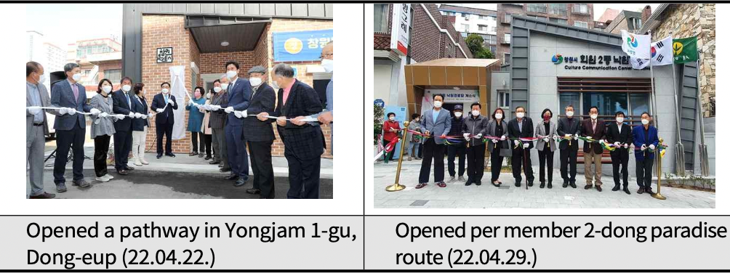
(4) Create an age-friendly store
○ Pushback
- As the purchasing power of the elderly gradually increases, it is necessary to create an elderly-friendly store where they can comfortably and safely engage in consumption activities.
- In particular, it is necessary to create senior-friendly stores centered on traditional market shopping centers, reflecting the tendency of the elderly to continue to use local and regular shops.
- Need to create a social atmosphere that considers the elderly by encouraging voluntary participation from merchants

○ Business Description
- Selecting and supporting senior-friendly stores in traditional
markets
◦ (Business location) Return market
◦ (Highlights) Turning a market near a senior center into a senior-
friendly store
*Providing participating stores with goods: Creating and issuing age-friendly store marks and support items
*Run a campaign to use traditional markets

○ Business plan and performance
- Selected and supported 5 stores by the end of March 2022, with a 50.0% achievement rate against plan
- Execution budget was 5 million won, resulting in a 50.0% execution
rate against plan
- Business plan for this year is planned but not implemented
after promoting business in '21

(Table 4-68) Task No. 9-4 (Creating an Elderly Friendly Store) Business Plan and Performance
Assignment Number | Action items | Classification | Business volume (locations) |  |  |  | Budget (million won)
 |  |  | '20 | '21 | '22.3 | Total | '20 | '21 | '22.3 | Total
9-4 | Create an age-friendly store | Planning | 0 | 5 | 5 | 10 | 0 | 5 | 5 | 10
 |  | Performance | 0 | 5 | 0 | 5 | 0 | 5 | 0 | 5
 |  | Set the achievement to  （%） | 50.0 |  |  |  | 50.0
○ Progress (as of 03/31/22)
- The project has not been changed or canceled from the original plan.
- Selected and supported 5 senior-friendly stores in '21

Assignment Number | Action items | Whether to cancel/change from original plan | Business volume (people) |  |  | Budget (millions)
 |  |  | Complete | Unimplemented (in preparation) | In Progress （Executing) | Complete | Unimplemented (in preparation) | In Progress （Executing)
9-4 | Create an Age-Friendly Store | Not applicable | 5 | -. | -. | 5 | -. | -.

○ Business valuation
- An elderly-friendly store is a business that promotes a culture of voluntary consideration for the elderly while enabling the elderly to engage in convenient and safe consumption activities.
◦ City supports designation as an age-friendly store, folding chairs, non-slip mats, l a r g e print menu boards, etc.
◦ Administrative and financial support from Changwon City needs to be further expanded to encourage active and voluntary participation of shops and to promote the spread of elderly-friendly shops throughout Changwon City.
◦ It is necessary to designate and operate markets based on senior-friendly stores in cooperation with local market merchants' associations to spread other traditional markets in the jurisdiction.
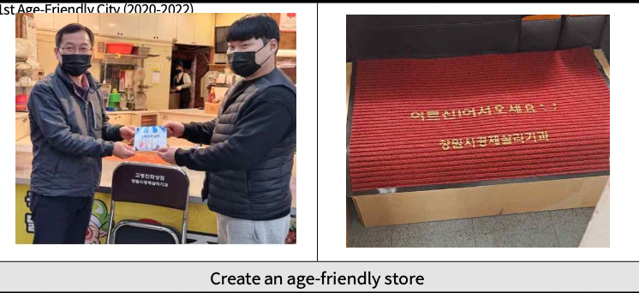
(5) Create a park golf course for the elderly
○ Pushback
- Need to build park golf courses, a preferred sport for the elderly, as the elderly population increases
- Need to support healthy leisure activities and promote health among the elderly through park golf, a nature-friendly sport.
- Need to create a leisure and family space where three generations - elderly, young adults, and children - can enjoy leisure together by creating a park golf course
○ Business Description
- Establishment of a senior park golf course
∙(Location) 139-8, Bukbu-ri, Daesan-myeon, Uichang-gu ∙(Timeframe) 2017 to 2021
∙(Scale) Waterfront Sports Park A=35,395m2 (36 holes of park golf
course)

- Propulsion
∙ Streamside Use Permit : '17.10
∙ Phase 1 (Course A) Construction (9 Holes) Groundbreaking and
Completion : '18.11.~'19.04.
∙ Conceptual Design and Small Scale Environmental Impact Assessment for a
Waterfront Sports Park : '19.04.~'19.12.
∙ Streamside Use Permit : '20.06.
∙ Phase2(Course C)Construction(9Holes)Ground breaking and Completion : '20.07.~'20.10.
∙ Ground breaking and completion of Phase 3 (Course D) TurfField(9holes)
: '21.01.~'21.03.
∙ Phase4 (CourseB) TemporaryField (9holes) Turfing and Facility Maintenance
: '21.04.~'21.05.
○ Business plan and performance
- 36 holes built as of end-March 2022, representing 133.3% completion
against plan
- Execution budget was KRW 975 million, with an execution rate of 86.7& against plan

(Table 4-70) Project No. 9-5 (Park Golf Course f o r the Elderly) Business Plan and Performance
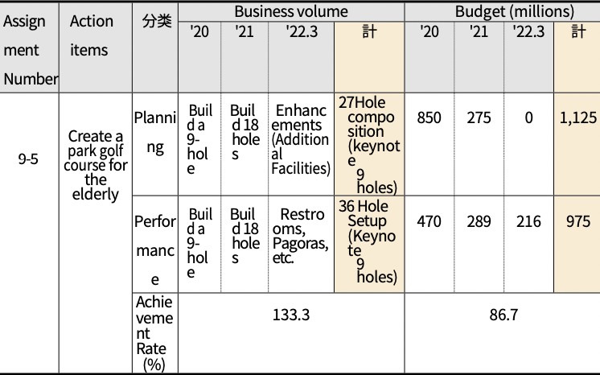
Total
Total
Classification

○ Progress (as of 03/31/22)
- The project has not been changed or canceled from the original
plan.
- Promoted the project for about 4 years from 2017 and completed
the funding in 2021
- Execution balance will continue to be used to supplement
facilities

(Table 4-71) Progress of Task No. 9-5 (Park Golf Course for the Elderly)
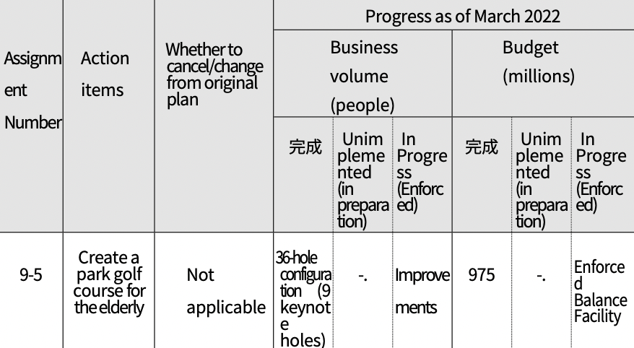
Complete
Complete

○ Business valuation
- Park golf course is a family-friendly sports activity space, especially customized for the elderly, and is intended to help them lead a healthy leisure life.
◦ Need to improve safety and facility management to ensure seniors can use facilities safely
◦ Consideration should be given to operating various programs by region, income level, and other characteristics to ensure that seniors are not excluded from using the facility.
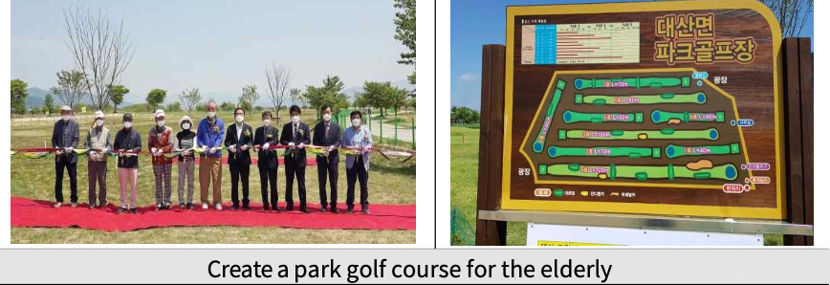

2) E n a b l e social activism (Goal 10)
○ For the sub-goal 'Supporting the activation of social activities', two implementation tasks were set: ➀ Operate the Uichang Library Senior Program, and ➁ Create 60,000 jobs for the elderly (supporting social activities).
○ We'd like to look at the background and key milestones for each action item.

(Table 4-72) Goal 10 (Supporting the Revitalization of Social Activities) Implementation Tasks, Project Details, and Responsible Departments
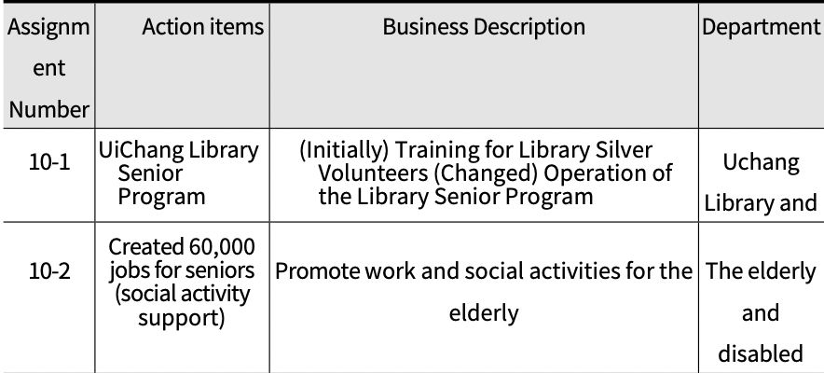

(1) UiChang Library Senior Program
○ Pushback
- As Baby Boomers retire, seniors need to be supported in their cultural endeavors
- With the number of senior citizens in libraries on the rise, cultural programs for seniors are needed to help them lead a healthy lifestyle.
- There is a need to encourage seniors to read and enjoy a healthy leisure culture.

○ Business Description
- UiChang Library Senior Program Contents: Selection of senior reading king, operation of senior reading clubs and cultural classes, provision of recommended book lists, expansion of large-letter books, operation of large- letter book corners, etc.

○ Business plan and performance
- As of the end of March 2022, we've conducted 33, with a 45.8%
achievement rate against plan.
- 343 participants in the program, a 47.6% achievement rate against plan - The executed budget was KRW 2.84 million, showing an execution
rate of 47.3% compared to the plan.

(Table 4-73) Task No. 10-1 (Operation of UiChang Library Senior Program) Business Plan and Performance
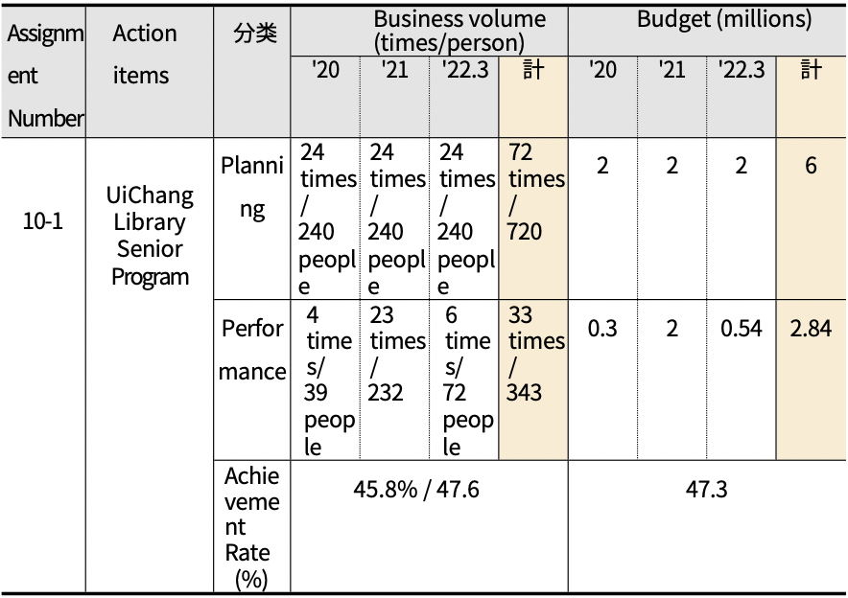
Total
Total
Classification

○ Progress (as of 03/31/22)
- This project was initially planned as 'Library Silver Volunteer Training', but was changed to 'Library Senior Program' in the course of the project implementation.
- Conducted 33 times in 3 years, with 6 planned for FY22
- AtotalofKRW2.84millionhasbeenexecutedin3years,andKRW0.54
million is scheduled to be executed in '22
- Business performance has been low due to COVID-19
- In'21,duetothereorganizationoftheadministrativedistrictof Changwon City, the library management department was reorganized and the name was changed (22.1.13), and the performance was replaced by the Myeonggok Library operation project.

(Table 4-74) Progress of Task No. 10-1 (Operation of UiChang Library Senior Program)
Assignment Number | Action items | Whether to cancel/change from original plan | Business volume (times) |  |  | Budget (millions)
 |  |  | Complete | Unimplemented (in preparation) | In Progress （Executing) | Complete | Unimplemented (in preparation) | In Progress （Executing)
10-1 | UiChang Library Senior  Program Operations | Change of business | 33 times/ 343 people | -. | 6 times/  72 people | 2.84 | -. | 0.54

○ Business valuation
- The Library Senior Program is a specialized program for seniors who use libraries, and it is necessary to expand the program as the number of seniors increases in the future.
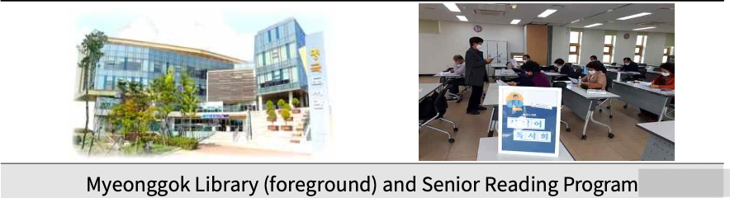

(2) Created 60,000 jobs for the elderly (social activity support)
○ Pushback
- Need to provide jobs for the elderly to enhance their social participation and help them lead a stable retirement life by improving their income.
- Need to improve the quality of life for older adults by promoting rewarding and self-esteem through quality senior jobs

○ Business Description
- Senior Social Activity Support and Senior Work Support
◦ Eligibility: Basic pensioners aged 65 or older or seniors aged 60 or older
◦ Business type
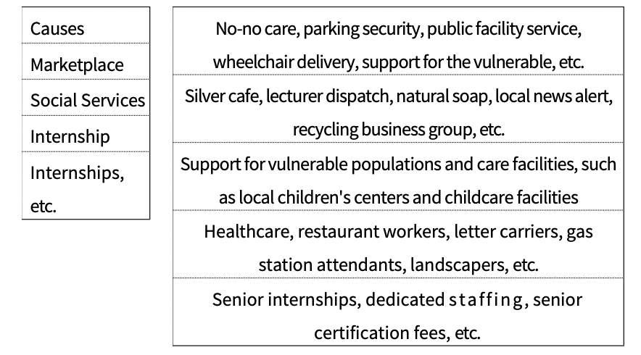
○ Business plan and performance
- As of the end of March 2022, 42,407 seniors participated in senior jobs (social activity support), a 100.7% achievement rate compared to the plan.
- The executed budget was KRW 126,077 million, showing an execution rate of 100.1% of the plan.

(Table 4-75) Project No. 10-2 (Creating 60,000 Jobs for the Elderly (Social Activity Support)) Business Plan and Performance
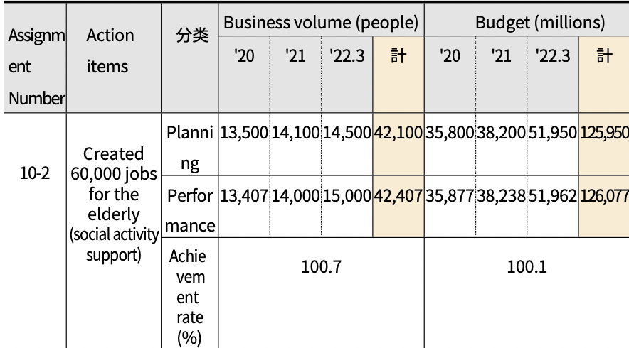
Total
Total
Classification

○ Progress (as of 03/31/22)
- The project has not been changed or canceled from the original plan.
- In three years, a total of 42,407 seniors participated in the Senior Work and Social Activity Support Project, a n d 12,2 4 0 seniors will continue to participate.
- A total of KRW 126,077 million has been spent over three years, and KRW 25,980 million will continue to be spent.

(Table 4-76) Progress on Task No. 10-2 (Creating 60,000 jobs for the elderly (social activity support))
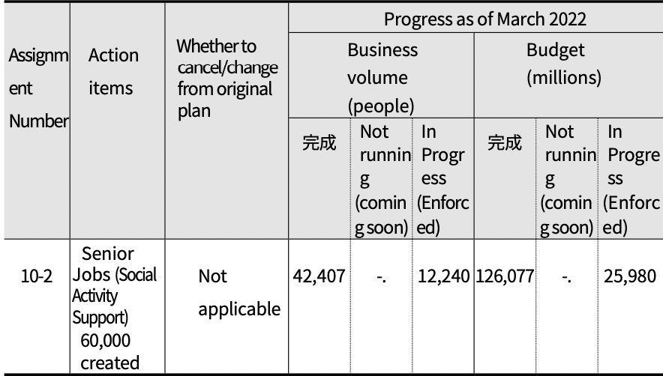
Complete
Complete
○ Business valuation
- The Elderly Work and Social Activity Support Project is a project that provides opportunities for social activities and income generation for the elderly.
◦ With a rapidly growing senior population, continued efforts are needed to meet senior job and benefit needs
◦ There is an ongoing need to create safe and stable jobs for older adults
◦ Need to support the continuous development of new jobs and business management through active networking among organizations promoting elderly jobs and social activity
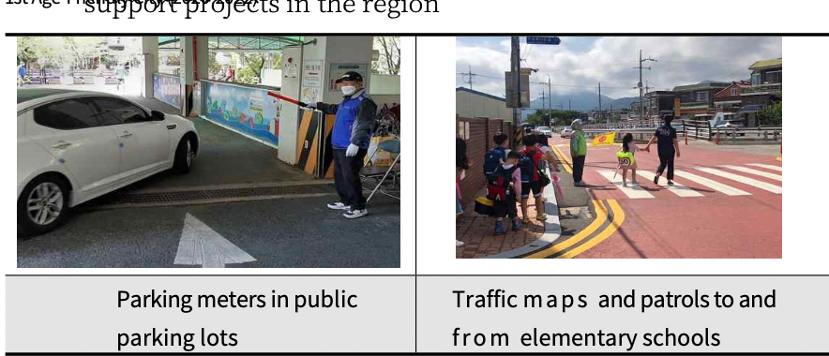

3) Focus on mid-career jobs (Goal 11)
○ For the sub-goal 'Intensive Support for Jobs for the Middle- aged and Older Adults', two implementation tasks were set: ➀ Customized Vocational Skills Training Project for the Middle- aged and Older Adults, and ② Social Contribution and Career- type Job Project for the New Middle-aged and Older Adults.
○ We want to understand the context and key milestones for each action item.

(Table 4-77) Goal 11 (Focus on Mid- and Long-Term Jobs) Action Tasks, Project Description, and Responsible Departments
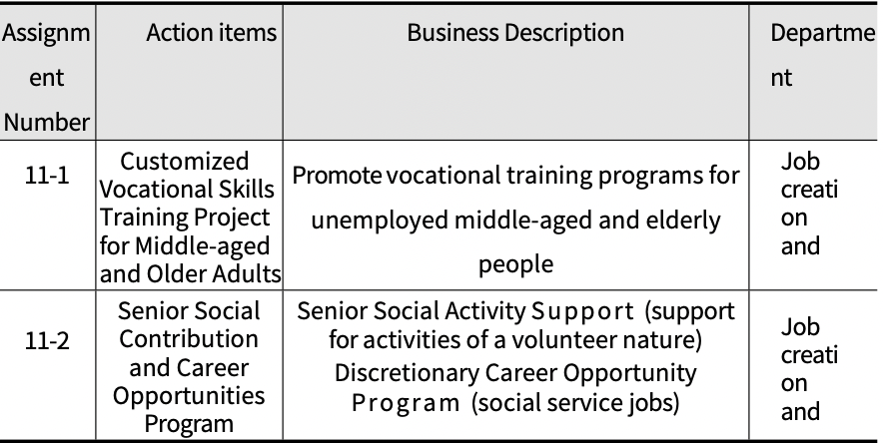

(1) Customized Vocational Skills Training Project for Middle- aged and Older Adults
○ Pushback
- Social change and retirement preparation require customized measures for successful midlife planning
- Run customized job training programs for job seekers and retirees looking to re-enter the workforce to help them stay employed
- Need to improve the employment rate of middle-aged and elderly people by providing them with professional certification and vocational skills training to help them re-enter the workforce and start their own businesses.

○ Business Description
- Customized vocational skills training program for unemployed
middle-aged adults
◦ What: 5 courses (construction carpentry, painting and flooring, office administration, nursing home caregiver, career counselor, etc.)

○ Business plan and performance
- As of the end of March 2022,348 people participated in the project, representing a 58.0% achievement rate against the plan.
- Execution budget was KRW 2.4 million, with a 66.7% execution rate compared to plan

(Table 4-78) Project No. 11-1 (Customized Vocational Skills Training for Middle and Older Adults) Business Plan and Performance
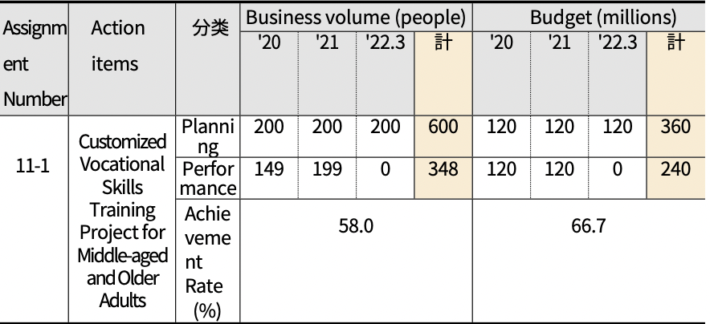
Total
Total
Classification
○ Progress (as of 03/31/22)
- This project was originally called 'Operation of a job support program for middle-aged and elderly people', but only the name of the project was changed in the process of promoting the project.
- 348 total participants in 3 years, with 200 planned for '22
- A total of KRW 240 million has been executed in 3 years, and KRW 120
million will be executed in '22

(Table 4-79) Progress of Task No. 11-1 (Customized Vocational Skills Training for Middle-aged and Older Adults)
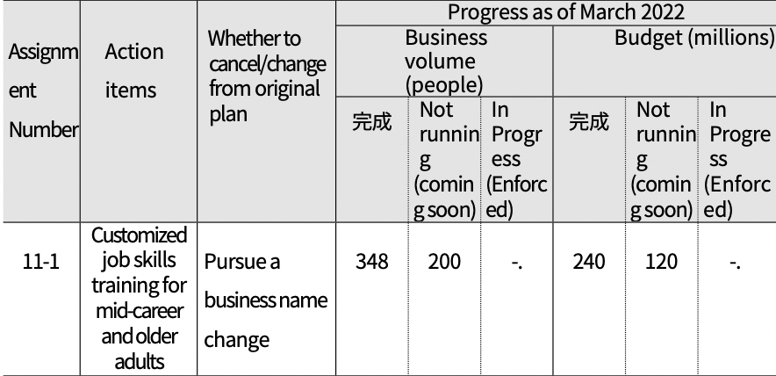
Complete
Complete
○ Business valuation
- The customized vocational skills training project for middle-aged people does not apply to the legal elderly (65+), but it is very important for middle-aged people who need to prepare for their old age.
- Vocational training programs to support the reemployment of middle-aged and elderly people are very necessary as it can lead to difficulties in preparing for retirement.
- Need to promote more active business in conjunction with similar programs (National Employment Support System, etc.)
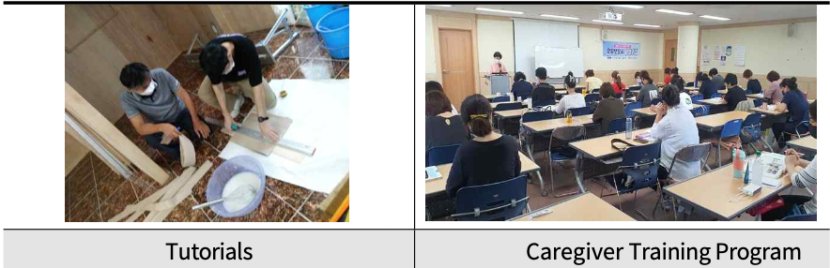

(2) Senior Social Contribution and Career Opportunities
○ Pushback
- The age of labor market participation is increasing due to demographic changes and increased life expectancy, but the number of unemployed and underemployed is also increasing due to a lack of jobs.
- There is a growing need for support programs to mitigate the impact of retirement for prudent people with expertise and practical skills, and for social adjustment after retirement.
- Need to strengthen the community role of older adults by utilizing retired professionals to provide needed services to the community and provide opportunities for income supplementation

○ Business Description
- Cautious Social Contribution and Career-type Job Project (a public offering organized by the Ministry of Employment and Labor)
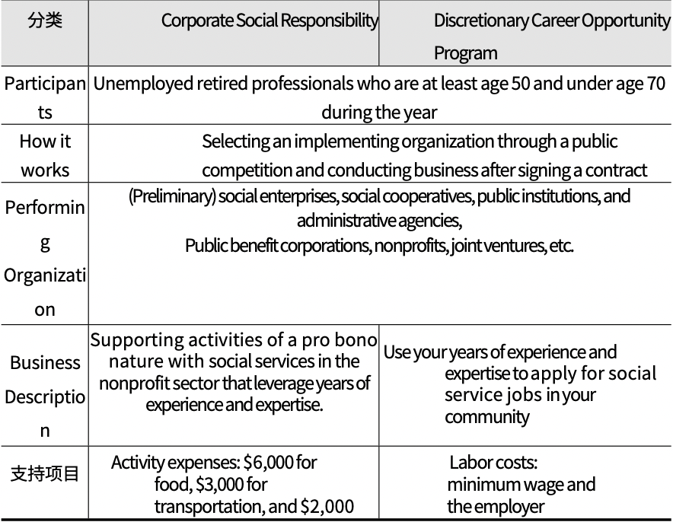

○ Business plan and performance
- BytheendofMarch2022,497peopleparticipatedintheproject, with a 76.0% achievement rate against the plan.
- The executed budget was KRW 253 million, with an execution rate of 44.0% compared to plan

(Table 4-80) Project No. 11-2 (Careful Years Social Contribution and Career Job Project) Business Plan and Performance
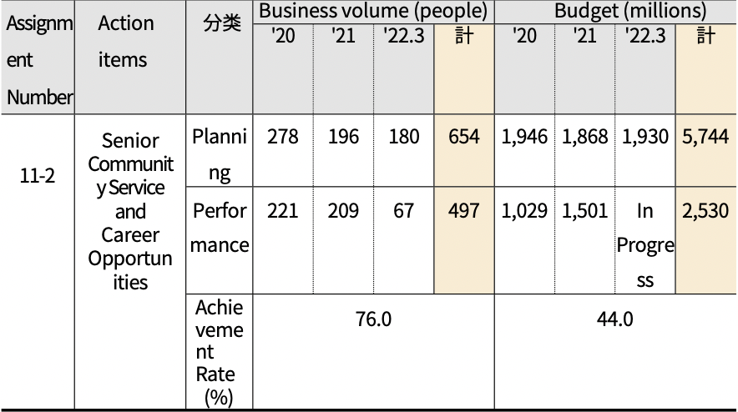
Total
Total
Classification
○ Status of the Career Opportunity Program in 2021
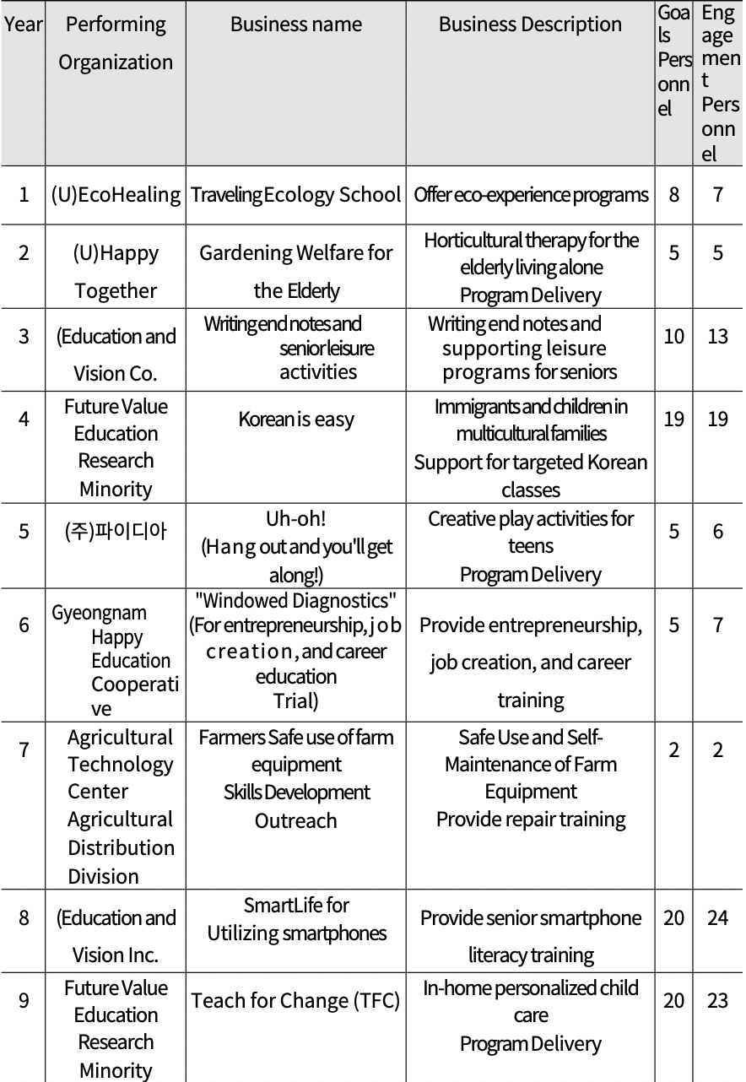

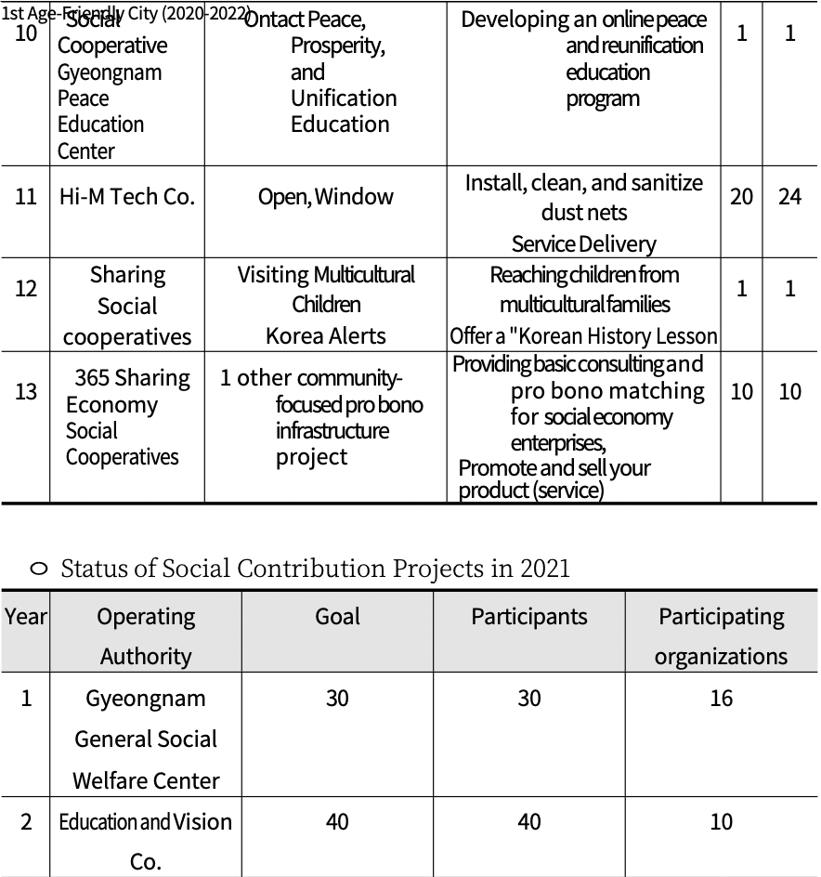

○ Progress (as of 03/31/22)
- A total of 497 people participated in the project in 3 years, with 67
participating in '22
- Total o fKRW 25.3 million over 3 years and ongoing in FY22

(Table 4-81) Progress of Task No. 11-2 (Careful Years Social Contribution and Career Job Project)
Assignment Number | Action items | Whether to cancel/change from original plan | Business volume (people) |  |  | Budget (millions)
 |  |  | Complete | Unimplemented (in preparation) | In Progress （Executing) | Complete | Unimplemented (in preparation) | In Progress （Executing)
11-2 | Senior Community Service and Career Opportunities | Not applicable | 497 | -. | 67 | 2,530 | -. | In Progress

○ Business valuation
- The Senior Social Contribution and Career Job Project is a project that provides opportunities for retired senior citizens to contribute to the community by utilizing their careers while also providing opportunities for income generation.
◦ It is a project that combines community development and income activities for senior citizens, and needs to be expanded in the future.
◦ In particular, early detection and customized activity support for prudent people who experience retirement shock due to early retirement, etc. are needed to make it a business that satisfies both participants and participating organizations.
◦ On the other hand, there are currently difficulties in recruiting participants who meet certain qualifications and iendly City (2020-2022)
career conditions, so it is necessary to come up with a plan to discover and recruit participants.
◦ Since the project was transferred from the Ministry of Employment and Labor to local governments as a social contribution project for 22 years, the willingness of local governments to carry out the project is also very important.
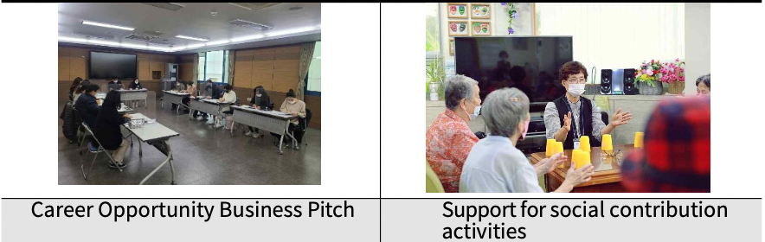
4) Personalized senior job support (Goal 12)
○ Four action tasks were set for the sub-goal 'Supporting Customized Jobs for the Elderly': ➀ Developing jobs suitable for the elderly through the Elderly Competency Survey, ② Supporting an age-friendly working environment and strengthening the rights of the elderly, ➂ Expanding the number of organizations dedicated to jobs for the elderly, and 4 Holding the Changwon 6080 Senior Social Activity Fair.
○ We'd like to look at the background and key milestones for each action item.

(Table 4-82) Goal 12 (Focus on mid- and long-term jobs) Action Tasks-Project Description-Lead Department
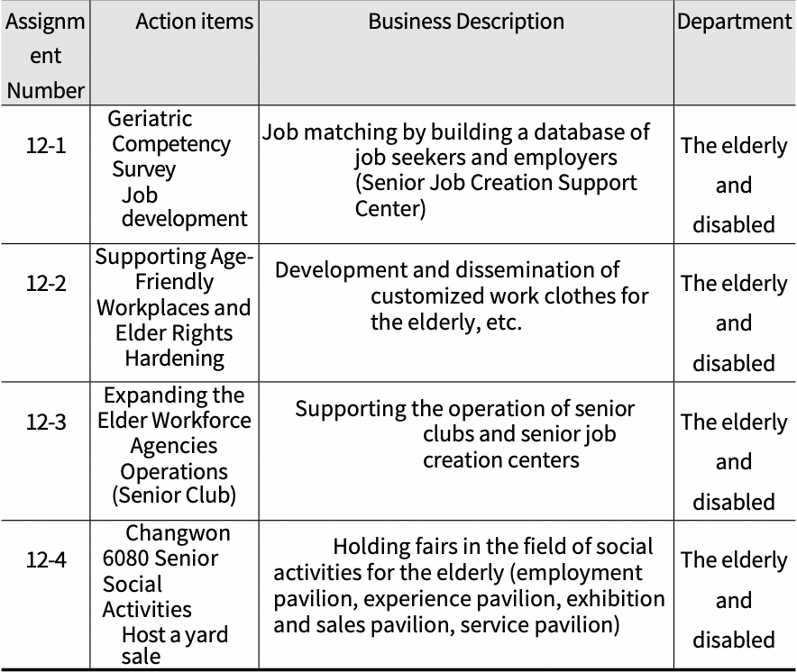

(1) Developing age-appropriate jobs through elderly competency surveys
○ Pushback
- Need for efficient management of job seekers and employers by
establishing a data base related to jobs for the elderly
- Need to manage job seekers' job desires and work requirements to help match them with the right jobs
- Need to develop new business areas based on statistics of job seekers and job applicants using the senior citizen job DB
○ Business Description
- DB construction and management through the Senior Job Creation
Support Center (2 locations)
◦ Job search DB construction, job seeker (employer) registration and
management, employment performance, follow-up management, etc.
○ Business plan and performance
- Managed a database of 4,297 job seekers as of March 2022, with a
76.7% achievement rate against plan.
- Execution budget was KRW 15.4 million, with an execution rate of
100.0% against plan

(Table 4-83) Task No. 12-1 (Developing Senior-Friendly Jobs through Senior Capability Survey) Project Plan and Performance
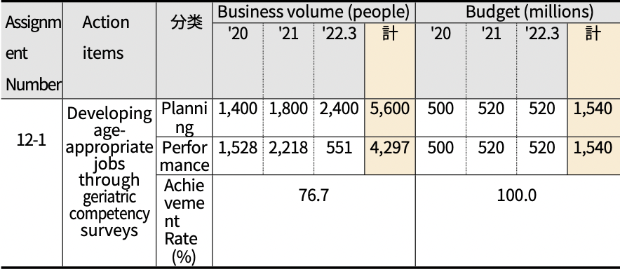
Total
Total
Classification
○ Progress (as of 03/31/22)
- This project has not been canceled or changed from the original plan.
- Managed a total of 4,297 job applicant DBs in 3 years and 551 in '22
- A total of KRW 1,540 million has been executed in 3 years, and KRW2.7
million is underway in '22

(Table 4-84) Progress on Task No. 12-1 (Developing Senior-Friendly Jobs through Senior Capability Survey)
Assignment Number | Action items | Whether to cancel/change from original plan | Business volume (people) |  |  | Budget (millions)
 |  |  | Complete | Unimplemented (in preparation) | In Progress （Executing) | Complete | Unimplemented (in preparation) | In Progress （Executing)
12-1 | Geriatric Fitness with the Geriatric Competency Survey  Job development | Not applicable | 4,297 | -. | 551 | 1,540 | -. | 270

○ Business valuation
- Continuous development and discovery of age-appropriate jobs is needed as society changes
- Need to conduct regular supply and demand surveys together to identify job prospects and new jobs for seniors in the general labor market outside of the public sector
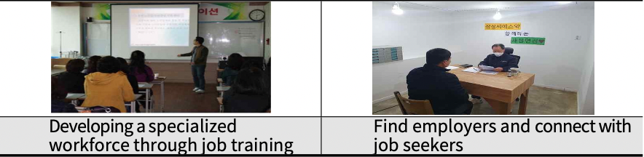

(2) Supporting age-friendly workplaces and strengthening the rights of the elderly
○ Pushback
- There is a need to move away from traditional policies on older work and work to create environments where older adults feel safe, respected, and happy where they work.
- Need to improve the employment environment for seniors to increase their social activities and satisfaction with participating in senior work.
- Need to strengthen elderly human rights education for participating seniors and workers to conduct human rights- friendly senior job projects

○ Business Description
- Developing and disseminating designs for elderly-oriented products
(Work wear, clutches, etc.)
*Focus on public sector jobs (janitorial, traffic safety, school lunch, etc.)
- Create large print for things like work instructions and safety
signs.
- Improving the working environment for Silver Cafe employees (changing lightweight materials such as coffee cups and glasses, expanding lighting fixtures in indoor spaces, installing anti-slip devices, etc.)
- Conducting human rights education for the elderly once a year for employees and participants of organizations implementing elderly work projects

○ Business plan and performance
- Business plan and volume for this business is unknown
◦ However, each organization conducts elderly rights education for participants and workers at least once a year.
◦ Safety supplies and workplace improvements for older workforce participants continue to be supported

(Table 4-85) Project No. 12-2 (Supporting Age-Friendly Work Environment and Strengthening Human Rights of the Elderly) Project Plan and Performance
Assignment Number | Action items | Classification | Business volume (cases) |  |  |  | Budget (million won)
 |  |  | '20 | '21 | '22.3 | Total | '20 | '21 | '22.3 | Total
12-2 | Supporting Age-Friendly Workplaces and Elder Rights  Hardening | Planning | 11,550 | 11,800 | 12,500 | 35,850 | Non-Budget | Non-Budget | Non-Budget | Non-Budget
 |  | Performance | 11,650 | 12,100 | 12,240 | 35,990 | Non-Budget | Non-Budget | Non-Budget | Non-Budget
 |  | Set the achievement to  （%） | 100.5 |  |  |  | Non-Budget

○ Progress (as of 03/31/22)
- The project has not been changed or canceled from the original plan.
- Unable to identify business volume and budget for 3 years
- While each individual organization conducts its own labor environment improvement and human rights education through the senior citizen job project fund, it appears that the citywide performance for this project is not separately collected and managed.

(Table 4-86) Progress on Task No. 12-2 (Supporting an Age-Friendly Work Environment and Strengthening Human Rights of the Elderly)
Assignment Number | Action items | Whether to cancel/change from original plan | Business volume |  |  | Yes | Mountain (million won)
 |  |  | Complete | Unimplemented (in preparation) | In Progress （Executing) | Complete | Unimplemented (in preparation) | In Progress （Executing)
12-2 | Supporting age-friendly workplaces and strengthening the rights of the elderly | Not applicable | -. | -. | -. | -. | -. | -.

○ Business valuation
- The senior citizen work program is very important for seniors to live a healthy and active life and generate income.
◦ Need to develop, check, and manage Changwon City's own safe working environment checklist to promote safe senior workplace projects
◦ Need to develop human rights indicators for the elderly and establish a management plan for elderly jobs
◦ Need to produce and manage statistical data on annual inspection and improvement results of working conditions riendly City (2020-2022) for the elderly, level of human rights indicators for the elderly, etc.
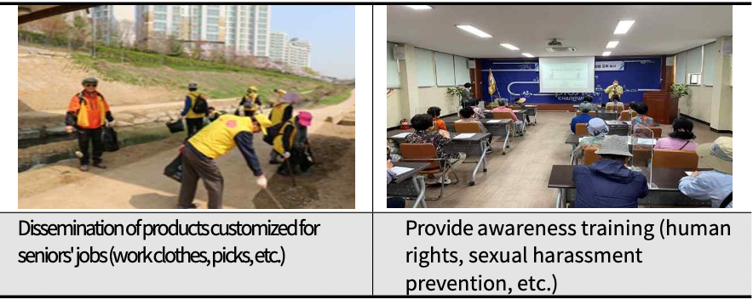

(3) Expanded senior workforce organizations (senior clubs)
○ Pushback
- As the aging population intensifies, it is necessary to establish a comprehensive senior work support system to provide social activities and income-generating opportunities for retired seniors.
- Need to help seniors lead active, stable lives by promoting re-employment opportunities and building self - esteem
- Need to continue to develop Changwon-type senior-friendly jobs by expanding the dedicated agency for the elderly

○ Business Description
- Supporting the operation of senior clubs and senior job creation centers
◦ Expanded operation of senior clubs from 3 to 5 locations (added Seongsan-gu and Masanhoewon-gu)
◦ Operated 2 job creation centers for the elderly (Changwon, Masan)
◦ 5,597 senior jobs created in 2021
- Developing and disseminating senior jobs tailored to seniors' abilities and aptitudes
- Identify localized businesses with a high sense of well-being and expand quality jobs

○ Business plan and performance
- As of March 2022, there are 5 senior clubs operating in Changwon City.
- Execution budget was KRW 44.5 million over three years, with an
execution rate of 100.0% against plan

(Table 4-87) Task No. 12-3 (Expanded Operation of Senior Citizens' Job Centers) Business Plan and Performance
Assignment Number | Action items | Classification | Business volume (locations) |  |  |  | Budget (million won)
 |  |  | '20 | '21 | '22.3 | Operating Authority | '20 | '21 | '22.3 | Total
12-3 | Expanded Senior Workforce Agencies | Planning | 5 | 5 | 5 | 5 | 1,450 | 1,500 | 1,500 | 4,450
 |  | Performance | 5 | 5 | 5 | 5 | 1,450 | 1,500 | 1,500 | 4,450
 |  | Set the achievement to  （%） | 100.0 |  |  |  | 100.0
○ Progress (as of 03/31/22)
- The project has not been changed or canceled from the original
plan.
- Expanded and installed 2 additional senior clubs in 3 years (Seongsan, Masanhoewon-gu) and develops and promotes various senior job projects through senior clubs and senior job creation support centers.

(Table 4-88) Progress on Task No. 12-3 (Expanding the Elderly Employment Agency)
Assignment Number | Action items | Whether to cancel/change from original plan | Business volume (cases) |  |  | Budget (million won)
 |  |  | Complete | Unimplemented (in preparation) | In Progress （Executing) | Complete | Unimplemented (in preparation) | In Progress （Executing)
12-3 | Expanded Senior Workforce Agencies | Not applicable | 5 | -. | 5 | 4,450 | -. | 760

○ Business valuation
- Senior Clubs, a senior jobs organization, develops and provides customized senior jobs for local seniors and promotes community development.
◦ While the number of seniors participating in senior jobs is increasing, the number of senior jobs available for placement is limited.
◦ A combination of administrative and legislative support at the city level is needed to help each organization develop new jobs.
◦ In addition, efforts to improve working conditions and treatment are needed to enhance the professionalism of workers dedicated to elderly work and to foster professionals with know-how.
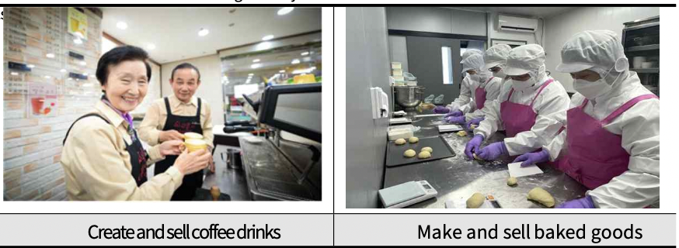

(4) Changwon 6080 Senior Social Activity Hanmadang held
○ Pushback
- Need to create an age-friendly urban culture by holding a comprehensive employment, job search, and job fair for seniors to support job hunting, as well as an age-friendly festival.
- It is necessary to provide on-the-spot employment counseling and job search information for seniors at the Senior Social Activity Hanmadang site, and to inform and provide Changwon-type senior social activity information to citizens.

○ Business Description
- Initially, we planned to hold "Senior Social Activity Hanmadang," but due to COVID-19, we canceled the event and participated in the alternative event "Changwon e-Welfare Fair Senior Job Platform".

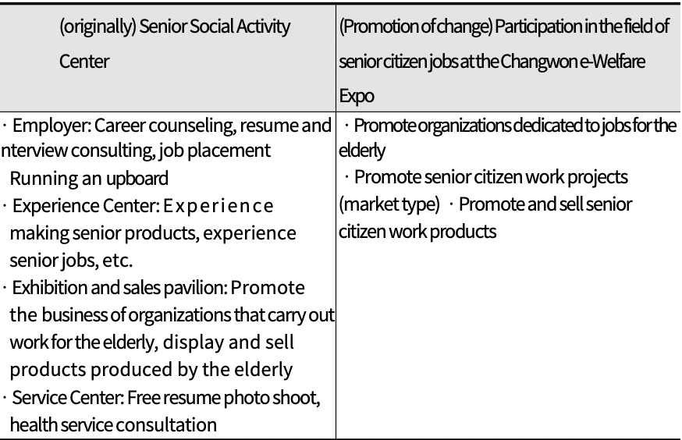

○ Business plan and performance
- Changwon 6080 Senior Social Activity Hanmadang was not held due to COVID-19
- Participated in the 'Changwon-Welfare Expo' as a public relations center in the field of senior citizen jobs as an alternative project

(Table 4-89) Project Plan and Performance for Task No. 12-4 (6080 Senior Social Event)
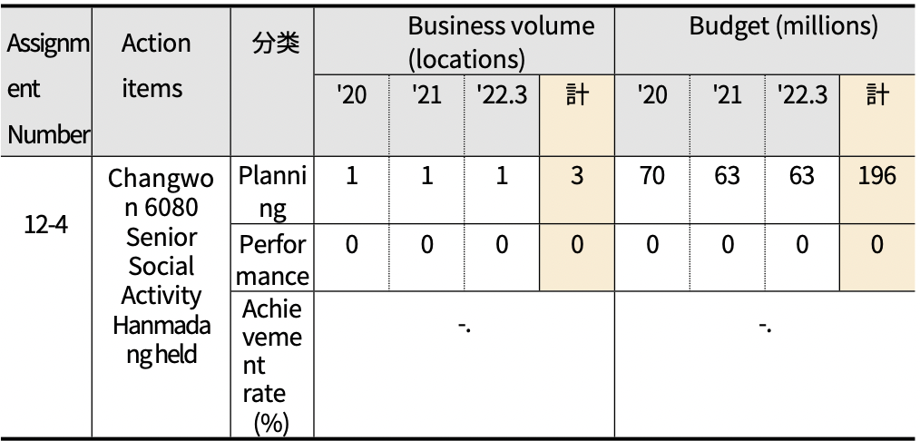
Total
Total
Classification
○ Progress (as of 03/31/22)
- Due to COVID-19, this event was not held
- As an alternative project, participated in the platform of the public relations center dedicated to the senior citizen job project at the Changwon e-Welfare Fair event.

(Table 4-90) Progress of Task No. 12-4 (6080 Organize Senior Social Activities)
Assignment Number | Action items | Compared to the original plan | Business volume (cases) |  |  | Mountain (million won)
 |  | Repeal/change status | Complete | Unimplemented (in preparation) | In Progress （Executing) | Complete | Unimplemented (in preparation) | In Progress （Executing)
12-4 | Changwon 6080 Senior Social Activities  Host a yard sale | Driving change | -. | -. | -. | -. | -. | -.

○ Business valuation
- Changwon 6080 Senior Social Activity Plaza can provide on- the-spot job search support services to seniors, and can be a promotional venue for citizens to learn about Changwon-type senior-friendly social activity projects.
◦ As social distancing eases, it's time to prepare for a full-scale senior social event
◦ In particular, the event should be held online as well as offline and used as an opportunity to promote Changwon as an age-friendly city to citizens.
◦ In addition, it is necessary to organize programs to encourage and support the elderly who are participating in various social activities such as senior citizen jobs, so that it can become a place of social recognition and reward.

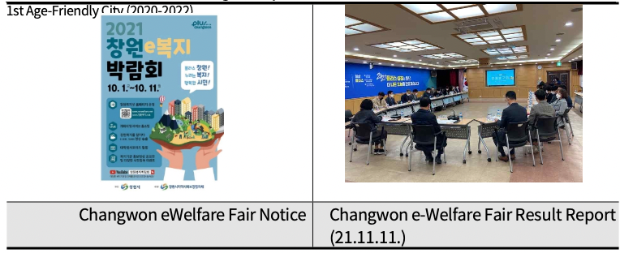

4. Synthesis

○ Progress on action items
- The first action plan for creating an age-friendly city consists of
3 policy goals, 12 sub-goals, and 38 action tasks.
- Of the detailed projects, 19 (50.0%) have achieved their goals, 13 (34.2%) are in progress, and 6 (15.8%) have not been absorbed. Considering the plan for the second half of the year, if the 'in- progress' projects are executed on schedule, the number of targeted projects is expected to increase to 32 (84.2%).

(Table 4-91) Action Item Progress
Policy Goal | Detail Goal | Task Number | Progress (Number of Project)
 |  |  | Achieve goal |  | In Progress | Insufficient
 |  |  | Continue | Finished |  | 50% or less of goal achieved
Total | 12 | 38 | 14 | 5 | 13 | 6
I  Create a safe and convenient urban environment | 4 | 13 | 7 | 2 | 3 | 1
 | 1) Making cities safer and more convenient | 3 | 2 | - |  | 1 (Delayed)
 | 2) Create a walkable living environment | 4 | 2 | 1 | 1
 | 3) Create a safe transportation environment | 4 | 3 | - | 1
 | 4) Secure housing stability | 2 | - | 1 | 1
II  Achieving understanding and respectful generational integration | 4 | 12 | 5 | 1 | 4 | 2
 | 5) Improving awareness of elderly policy | 2 | - | - | 1 | 1 (COVID-19)
 | 6) Make information more accessible | 1 | - | 1
 | 7) Promote intergenerational bonding | 2 | 1 | - |  | 1 (COVID-19)
 | 8) Ensure a vibrant 100 years of healthy aging | 7 | 4 | - | 3
II Supporting a healthy, leisurely retirement | 4 | 13 | 2 | 2 | 6 | 3
 | 9) Supporting colorful aging | 5 | - | 1 | 3 | 1 (COVID-19)
 | 10) Support for social activation | 2 | 1 | - |  | 1 (COVID-19)
 | 11) Focus on middle-aged jobs | 2 | - | - | 2
 | 12) Personalized senior job support | 4 | 1 | 1 | 1 | 1 (COVID-19)
※Progress: Target achieved (100% or more), in progress, insufficient (less than 50%, brackets for insufficient performance due to operational restrictions due to COVID-19)

○ Business performance
- Out of a total of 38 detailed projects, 19 projects have a goal achievement rate of 100% or more, 13 projects are in progress, and 6 projects are incomplete.
- The majority (83.3%) of the projects that did not meet their targets were due to restrictions on countermeasures and facility operations due to the strengthening of "social distancing" in response to the spread of COVID-19.
- In the second plan, we should review the projects that were not implemented in part and actively develop new projects in response to social changes to create an advanced senior- friendly city.

(Table 4-92) Performance of Detailed Projects for Creating Age-Friendly Cities in the 1st Period (2020-2022) (Comprehensive Table)
Task No. | Execution Task | Unit | Plan |  |  |  | Performance |  |  |  | Achievement rate | Progress Status
 |  |  | ‘20 | ‘21 | ’22.3 | Total | ‘20 | ‘21 | ’22.3 | Total
1-1-① | Expanding Accessible Buildings (Public Sector) | Place | 21 | 30 | 30 | 81 | 32 | 42 | 11 | 85 | 104.9 | ●
1-1-② | Expanding Accessible Buildings (Private Sector) | Place | 20 | 8 | 8 | 36 | 22 | 8 | 7 | 37 | 102.8 | ●
1-2 | Promotion of Changwon City Citizen Safety Insurance | Time | 1 | 1 | 1 | 3 | 1 | 1 | 1 | 3 | 100.0 | ●
1-3 | Disseminating smart city solutions in vulnerable areas | Number | - | - | - | - | - | - | - | - | Delayed | ○
2-1 | Promoting real-name sidewalks construction | Case | 86 | 81 | 65 | 232 | 82 | 75 | 42 | 199 | 85.8 | ⦿
2-2 | Create a smart traffic light | Place | 5 | 0 | 0 | 5 | 5 | 0 | 0 | 5 | 100.0 | ●
2-3 | Install crosswalk shade shelters | Case | 40 | 45 | 30 | 115 | 65 | 57 | - | 122 | 106.1 | ●
2-4 | Expanding urban rest areas | Case | 3 | 5 | 3 | 11 | 3 | 5 | 3 | 11 | 100.0 | ●
3-1 | Expanded low-floor bus operations | Number | 93 | 70 | 20 | 183 | 93 | 7 | 0 | 100 | 54.6 | ⦿
3-2 | Establishment and operation of priority parking zones for the elderly | Myeon | 0 | 144 | 0 | 144 | 0 | 144 | 0 | 144 | 100.0 | ●
3-3 | Issue Senior Driving Stickers | Number | 2,000 | 1,500 | 1,500 | 5,000 | 2,000 | 1,500 | 1,500 | 5,000 | 100.0 | ●
3-4 | Drive personalized traffic safety education | Case | - | - | - | - | 0 | 4 | 0 | 4 | 100.0 | ●
4-1 | Creating socially inclusive housing | Case | 1 | 1 | 1 | 3 | 1 | 1 | 0 | 2 | 66.7 | ⦿
4-2 | Utilizing vacant land in urban centers for public silver housing | Case | vacant house survey | Build a maintenance plan | Build a maintenance plan | Build a maintenance plan | vacant house survey | Build a maintenance plan | Build a maintenance plan | Build a maintenance plan | 100.0 | ●
5-1 | Change dementia terminology Changwon-type | Time | 6,200 | 7,420 | 7,400 | 21,020 | 6,723 | 7,753 | 1,453 | 15,929 | 75.8 | ⦿
Notes) Progress: 100% (●), In Progress (⊙), Not Progressing (○)

(Table 4-92) Performance of Detailed Projects for Creating Age-Friendly Cities in the 1st Period (2020-2022) (continued)
Task No. | Execution Task | Unit | Plan |  |  |  | Performance |  |  |  | Achievement rate | Progress Status
 |  |  | ‘20 | ‘21 | ’22.3 | Total | ‘20 | ‘21 | ’22.3 | Total
5-2 | Promote projects to strengthen the rights of the elderly | Time  /  People | 9/20 | 12/15 | 12/15 | 33/50 | 4/20 | 10/15 | - | 14/35 | 42.4  70.0 | ○
6-1 | Creating an Age-Friendly Environment in the Civil Affairs Office of the Administrative Welfare Center | Place | 61 | 0 | 0 | 61 | 61 | 0 | 0 | 61 | 100.0 | ●
7-1 | Run a generational convergence program | Time  /  People | 114  /  4,572 | 204  /  3,284 | 182  /  4,799 | 500  /  12,655 | 80  /  1,332 | 155  /  1,322 | 3  /  74 | 238  /  2,728 | 47.6  21.6 | ○
7-2 | Established Changwon Wellbeing Center | Process rate | - | 80 | 100 | 100 | - | 80 | 100 | 100 | 100.0 | ●
8-1 | Expanding telemedicine services using ICT | Case | 552 | 451 | 264 | 1267 | 471 | 301 | - | 772 | 60.9 | ⦿
8-2 | Operate Smart Healthcare Systems | Place  /  People | 0 | 3  /  1,200 | 3  /  2,500 | 3  /  3,700 | 0 | 3  /  1,370 | 3  /  1,457 | 5  3  /  2,827 | 100.0  76.4 | ●
8-3 | Visiting the Underserved Health Care Project | Time | 4,193 | 3,325 | 3,325 | 10,843 | 2,878 | 2,989 | 211 | 6,078 | 56.1 | ⦿
8-4 | Memory Keeping Happiness Empathy Dementia Integrated Management Project | Time | 8,100 | 8,700 | 9,000 | 25,800 | 8,329 | 8,735 | 8,841 | 25,905 | 100.4 | ●
8-5 | 9988 Silver Life Youth Project | Time | 0 | 10 | 5 | 15 | 0 | 11 | 0 | 11 | 73.3 | ⦿
8-6 | Promote Gyeongnam-type community care pilot project | People | 357 | 357 | 0 | 714 | 498 | 394 | 0 | 11 | 124.9 | ●
8-7 | ICT-linked artificial intelligence integrated care project | People | 200 | 300 | 620 | 1,120 | 200 | 300 | 620 | 1,120 | 100.0 | ●
9-1 | Run a senior cultural class | Time | 19 | 20 | 30 | 69 | 19 | 20 | Not implement | 39 | 56.5 | ⦿
9-2 | Run a new generation of senior center programs for a new generation of seniors | People | 1,010 | 1,015 | 1,021 | 3,046 | 100 | 100 | 0 | 200 | 6.6 | ○
9-3 | Building a senior center to keep seniors happy and entertained | Place | 4 | 6 | 7 | 17 | 4 | 6 | 3 | 13 | 76.5 | ⦿
9-4 | Create an age-friendly store | Place | 0 | 5 | 5 | 10 | 0 | 5 | 0 | 5 | 50.0 | ⦿
9-5 | Create a park golf course for the elderly | - | Build a 9-hole | Build a 18-hole | Supplemental Facilities (Additional Facilities) | Build 27 holes (9 pre-built holes) | Build a 9-hole | Build a 18-hole | Restrooms, Pagora,  etc. | Build 36 holes (9 pre-built holes) | 133.3 | ●
10-1 | Uichang Library Senior Program | Time  /  People | 24/  240 | 24/  240 | 24/  240 | 72/  720 | 4/  39 | 23/  232 | 6/  72 | 33/  343 | 45.8  47.6 | ○
10-2 | Created 60,000 jobs for the elderly (social activity support) | People | 13,500 | 14,100 | 14,500 | 42,100 | 13,407 | 14,000 | 15,000 | 42,407 | 100.7 | ●
Notes) Progress: 100% (●), In Progress (⊙), Not Progressing (○)

(Table 4-92) Performance of Detailed Projects for Creating Age-Friendly Cities in the 1st Period (2020-2022) (continued)
Task No. | Execution Task | Unit | Plan |  |  |  | Performance |  |  |  | Achievement rate | Progress Status
 |  |  | ‘20 | ‘21 | ’22.3 | Total | ‘20 | ‘21 | ’22.3 | Total
11-1 | Customized Vocational Skills Training Project for Middle-aged and Older Adults | People | 200 | 200 | 200 | 600 | 149 | 199 | 0 | 348 | 58.0 | ⦿
11-2 | Senior Social Contribution and Career Opportunities | People | 278 | 196 | 180 | 654 | 221 | 209 | 67 | 497 | 76.0 | ⦿
12-1 | Developing age-appropriate jobs through geriatric competency surveys | People | 1,400 | 1,800 | 2,400 | 5,600 | 1,528 | 2,218 | 551 | 4,297 | 76,7 | ⦿
12-2 | Supporting age-friendly workplaces and strengthening the rights of the elderly | Case | 11,550 | 11,800 | 12,500 | 35,850 | 11,650 | 12,100 | 12,240 | 35,990 | 100.4 | ●
12-3 | Expanded Senior Employment Organizations (Senior Clubs) | Place | 5 | 5 | 5 | 5 | 5 | 5 | 5 | 5 | 100.0 | ●
12-4 | Changwon 6080 Senior Social Activity Hanmadang held | Case | 1 | 1 | 1 | 3 | 0 | 1 | 0 | 0 | 33.3 | ○
Notes) Progress: 100% (●), In Progress (⊙), Not Progressing (○)

○ Budget for Project Implementation
- The total budget of 38 detailed projects is about 160 billion won, and the execution rate is 82.7% compared to the original plan.
- There are some non-budgeted projects in the project contents, and it is necessary to improve the quantity and quality of projects by investing the city's own specialized project budget to revitalize these projects.

(Table 4-93) Budget for the 1st Period (2020-2022) for Detailed Projects for Creating Age-Friendly Cities (Comprehensive Table)
Task No. | Execution task | Plan (Unit: KRW One hundred) |  |  |  | Performance (Unit: KRW One hundred) |  |  |  | Progress rate
 |  | ‘20 | ‘21 | ’22.3 | Total | ‘20 | ‘21 | ’22.3 | Total
38 |  | Input budget: Total 160,231.64 million won / Execution rate: 82.7
1-1-① | Expanding Accessible Buildings (Public Sector) | Non-Budget | Non-Budget | 5 | 5 | Non-Budget | Non-Budget | 5 | 5 | 100.0
1-1-② | Expanding Accessible Buildings (Private Sector) | 400 | 150 | 150 | 700 | 375 | 137 | 139 | 651 | 93.0
1-2 | Promotion of Changwon City Citizen Safety Insurance | 240 | 590 | 600 | 1,430 | 240 | 590 | 600 | 1,430 | 100.0
1-3 | Disseminating smart city solutions in vulnerable areas | - | - | - | - | - | - | - | - | Delayed
2-1 | Promoting real-name sidewalks construction | Non-Budget | Non-Budget | Non-Budget | Non-Budget | Non-Budget | Non-Budget | Non-Budget | Non-Budget | Non-Budget

(Table 4-93) 1st Period (2020-2022) Detailed Budget for Age-Friendly Urbanization (Comprehensive Table) (continued)
Task No. | Execution task | Plan (Unit: KRW One hundred) |  |  |  | Performance (Unit: KRW One hundred) |  |  |  | Progress rate
 |  | ‘20 | ‘21 | ’22.3 | Total | ‘20 | ‘21 | ’22.3 | Total
2-2 | Create a smart traffic light | 90 | 0 | 0 | 90 | 212 | 0 | 0 | 212 | 235.6
2-3 | Install crosswalk shade shelters | 100 | 72 | 76 | 248 | 99.8 | 114.5 | - | 214.3 | 86.4
2-4 | Expanding urban rest areas | Non-Budget | Non-Budget | Non-Budget | Non-Budget | Non-Budget | Non-Budget | Non-Budget | Non-Budget | Non-Budget
3-1 | Expanded low-floor bus operations | 8,386 | 5,830 | 184 | 14,400 | 8,386 | 644 | 0 | 9,030 | 62.7
3-2 | Set up and operate senior priority parking zones | Non-Budget | Non-Budget | Non-Budget | Non-Budget | Non-Budget | Non-Budget | Non-Budget | Non-Budget | Non-Budget
3-3 | Issue Senior Driving Stickers | 4 | 3 | 3 | 10 | 4 | 3 | 3 | 10 | 100.0
3-4 | Drive personalized traffic safety education | Non-Budget | Non-Budget | Non-Budget | Non-Budget | Non-Budget | Non-Budget | Non-Budget | Non-Budget | Non-Budget
4-1 | Creating socially inclusive housing | Non-Budget | Non-Budget | Non-Budget | Non-Budget | Non-Budget | Non-Budget | Non-Budget | Non-Budget | Non-Budget
4-2 | Utilizing vacant land in urban centers for public silver housing | 58 | 39 | 0 | 97 | 58 | 39 | 0 | 97 | 100.0
5-1 | Change dementia terminology Changwon-type | 5 | 5 | 5 | 15 | 5 | 5 | 5 | 15 | 100.0
5-2 | Promote projects to strengthen the rights of the elderly | 3.6 | 3,6 | 3,6 | 10,8 | 1,5 | 2 | - | 3.5 | 32.4
6-1 | Creating an Age-Friendly Environment in the Civil Affairs Office of the Administrative Welfare Center | Non-Budget | Non-Budget | Non-Budget | Non-Budget | Non-Budget | Non-Budget | Non-Budget | Non-Budget | Non-Budget
7-1 | Run a generational convergence program | Non-Budget | Non-Budget | Non-Budget | Non-Budget | Non-Budget | Non-Budget | Non-Budget | Non-Budget | Non-Budget
7-2 | Established Changwon Wellbeing Center | - | - | 1,720 | 1,720 | - | - | 1,720 | 1,720 | 100.0
8-1 | Expanding telemedicine services using ICT | 102 | 100 | 94 | 296 | 78 | 76 | - | 154 | 52.0
8-2 | Operate Smart Healthcare Systems | 0 | 11 | 10 | 21 | 0 | 11 | 7 | 18 | 85.7
8-3 | Home Visiting Program for Vulnerable Populations | 1,150 | 1,061 | 1,154 | 3,365 | 1,150 | 1,061 | 231 | 2,442 | 72.6
8-4 | Memory Keeping Happiness Empathy Dementia Integrated Management Project | 30 | 30 | 30 | 90 | 30 | 30 | 30 | 90 | 100.0
8-5 | 9988 Silver Life Youth Project | 0 | 32 | 32 | 64 | 0 | 32 | 0 | 32 | 50.0
8-6 | Promote Gyeongnam-type community care pilot project | 200 | 178 | 0 | 378 | 135 | 136 | 0 | 271 | 71.7
8-7 | ICT-linked artificial intelligence integrated care project | 57 | 288 | 480 | 825 | 48 | 282 | 192 | 522 | 63.3
9-1 | Run a senior cultural class | 2 | 2 | 3 | 7 | 2 | 2 | Not implemented | 4 | 57.1
9-2 | Run a new generation of senior center programs for a new generation of seniors | 175 | 175 | 180 | 530 | 175 | 175 | 0 | 350 | 66.0
9-3 | Building a senior center to keep seniors happy and entertained | 1,750 | 3,921 | 3,685 | 9,356 | 1,650 | 4,301 | 1,190 | 7,141 | 76.3
9-4 | Create an age-friendly store | 0 | 5 | 5 | 10 | 0 | 5 | 0 | 5 | 50.0
9-5 | Create a park golf course for the elderly | 850 | 275 | 0 | 1,125 | 470 | 289 | 216 | 975 | 86.7
10-1 | Uichang Library Senior Program | 2 | 2 | 2 | 6 | 0.3 | 2 | 0.54 | 2.84 | 47.3
10-2 | Created 60,000 jobs for the elderly (social activity support) | 35,800 | 38,200 | 51,950 | 125,950 | 35,877 | 38,328 | 51,962 | 126,077 | 100.1
11-1 | Customized Vocational Skills Training Project for Middle-aged and Older Adults | 120 | 120 | 120 | 360 | 120 | 120 | 0 | 240 | 66.7
11-2 | Senior Social Contribution and Career Opportunities | 1,946 | 1,868 | 1,930 | 5,744 | 1,029 | 1,501 | In progress | 2,530 | 44.0
12-1 | Developing age-appropriate jobs through geriatric competency surveys | 500 | 520 | 520 | 1,540 | 500 | 520 | 520 | 1,540 | 100.0
12-2 | Supporting age-friendly workplaces and strengthening the rights of the elderly | Non-Budget | Non-Budget | Non-Budget | Non-Budget | Non-Budget | Non-Budget | Non-Budget | Non-Budget | Non-Budget
12-3 | Expanded Senior Employment Organizations (Senior Clubs) | 1,450 | 1,500 | 1,500 | 4,450 | 1,450 | 1,500 | 1,500 | 4,450 | 100.0
12-4 | Changwon 6080 Senior Social Activity Hanmadang held | 70 | 63 | 63 | 196 | Not implemented | Not implemented | Not implemented | Not implemented | Not implemented

V. Year 1 Action Plan Evaluation Results and Implications

1. Detailed business evaluation results and second phase development Direction
1) Creating safe and comfortable urban environments
□ Making cities safer and more convenient
○ To strengthen the safety and convenience of the city, we expanded barrier-free buildings in the public and private sectors, and promoted safety and security projects to protect citizens from disasters and bicycle accidents.
○ Efforts to make public and private buildings more accessible to the mobility impaired, including the elderly, need to be more aggressively promoted, not only through project promotion and case studies through members of the public- private consultative body, but also through cooperation and awareness-raising among relevant actors, such as the original merchants' association in the area where the old shopping district was renovated.
○ The smart city solution project was selected as a MOLIT project at the end of 2021, and the project was delayed from the original plan. Before proceeding with the project in earnest, it is necessary to reflect the opinions of various residents in the area (children including the elderly, pregnant women, and the mobility impaired) to promote the project.
○ Utilizing public building guidelines, proactive inspections are needed to make accessibility more convenient and safe for the elderly and other vulnerable populations.

□ Create walkable neighborhoods
○ Ensuring that sidewalk surfaces are flat and accessible to wheelchairs is an important factor in improving the safety and convenience of the elderly. In this regard, improving the sidewalk environment is a project that needs to be expanded.
○ In addition to installing smart traffic lights, it is also necessary to pay attention to whether there are enough pedestrian signals for the elderly to cross the street safely. In addition, the 'shade shelter installation' project should be actively budgeted and promoted considering the prolonged heat wave.

□ Create a safe transportation environment
○ In the case of the low-floor bus expansion project, the central government's matching budget for eco-friendly low-floor buses has not been secured, resulting in a low project implementation rate. In particular, the operation of eco- friendly low-floor buses requires the expansion of related facilities, such as charging facilities. It is necessary for the central government and Changwon City to more actively promote the project.
○ The parking area for the elderly was completed in 2021 by creating 144 spaces in accordance with the Changwon City Ordinance on the Installation and Operation of Priority Parking Areas for the Elderly , but it will be necessary to continue to expand it. In addition, publicity and awareness should be promoted so that a culture of concession and consideration for the elderly driving vehicles can spread. On the other hand, in the driving environment of the elderly, it is necessary to expand support projects not only for the elderly who drive, but also for the elderly who stop driving (from the current age of 70 to the age of 65 or older). In the case of Busan, the city is actively promoting projects to prevent traffic accidents among the elderly, such as providing transportation support to elderly drivers who return their driver's licenses and 5-50% discounts at hospitals, restaurants, and opticians.
○ Customized traffic safety training was not implemented in 2020 due to the spread of COVID-19, and four events were held in 2021. Traffic safety education could be expanded to target wartime populations such as the elderly and children, and strategies to make public transportation more convenient for the elderly to use more safely are also needed. Examples include subsidizing transportation costs, installing accessible seats at stops, and preventing buses from departing and stopping abruptly.

□ Ensure housing stability
○ Housing is essential for a comfortable and happy life (WHO, 2007). Securing affordable housing for the elderly is a crucial task, which requires more active administrative efforts in the future.
○ In order to secure residential stability, home improvement support projects can be expanded to make the current homes of the elderly more convenient and safe, and guidelines for home improvement support projects for the elderly can be prepared and distributed.
○ In order to secure the residential stability of the elderly, it is necessary to promote the Changwon City Elderly Residential Status Survey, etc. to identify the elderly who are in a housing crisis, and provide support such as home repair and moving at the same time.

2) Achieve generational integration with understanding and respect
□ Raise awareness of elder policy
○ Efforts to raise awareness of older adults need to include not only the milder use of terms like "dementia," but also a social culture that honors older adults. Current dementia awareness programs and human rights education programs need to be expanded. Especially since there are media reports that elder abuse has increased since COVID-193), it is necessary to further expand awareness-raising efforts to protect the human rights and safety of the elderly.

□ Making information more accessible
○ All 61 administrative welfare centers in Changwon City, a frontline administrative agency, have been equipped with equipment for the elderly, which can be seen as an improvement in age-friendly conditions in public service organizations. However, due to the expansion of non-face-to- face services after COVID-19, many face-to-face services have been converted to digital information devices such as kiosks, and efforts to improve the accessibility of information for the elderly need to be further expanded.
○ As many services that the elderly encounter in their daily lives, such as medical appointments and public transportation notifications, are provided through smart information devices, it is necessary to improve their access to information and information literacy skills. At the same time, alternatives for the elderly and socially disadvantaged who are not familiar with digital information devices should be developed.

□ Foster intergenerational bonding
○ Generation convergence programs are not reaching their operational targets due to restrictions on senior welfare centers due to COVID-19. In the future, face-to-face programs need to diversify their service delivery methods so that they can be converted to non-face-to-face methods.
○ The establishment of the Changwon Well-Aging Center has been followed by the opening of the Changwon Citizen Safety Experience Center, which operates some programs for the safety of the elderly. In addition to the establishment and operation of specialized facilities, it is necessary to provide early education on aging for a wide range of ages to promote intergenerational bonding, so it is necessary to consider additional projects in this regard in the future.

□ Ensuring a vibrant 100th birthday
○ It is no exaggeration to say that healthcare and support services for the elderly are the most important factors for a happy old age. Changwon City has promoted various health support projects for the elderly with health vulnerabilities and the general elderly population. Due to the constraints caused by COVID-19, it was difficult to secure health personnel (health center personnel were put into COVID-19 prevention projects), which resulted in somewhat lower project implementation performance.
○ It is necessary to expand the discovery of non-face-to-face healthcare businesses in preparation for similar situations in the future, and it is necessary to continue to promote care businesses using AI and IoT, especially for those who are in the blind spots of health and safety, such as elderly households living alone.

3) Supporting healthy, affordable retirement
□ Supporting colorful aging
○ For the social participation of the elderly, projects such as senior cultural lectures and activation programs at senior centers were promoted, but the promotion rate was lower than the target due to restrictions on the use of facilities due to the spread of COVID-19. Need to discover and develop non-face-to-face services in the future
○ In addition, as the number of people using senior centers is g r a d u a l l y increasing to the late elderly (75+), the operation and utilization of senior centers may need to be revisited.
○ In addition, it is necessary to continue to promote the establishment of senior-friendly stores, etc. to create senior- friendly living conditions and local culture, even though the budget is small.

□ Enable social activation
○ The original project plan was to train senior volunteers for libraries, but the content of the project was changed. Volunteer activities have a positive impact on the health and longevity of older adults (WHO, 2007), so there is a need for projects that support volunteer activities among older adults in the future.
○ It is necessary to give the elderly a better choice of jobs, but it is also necessary to find jobs that match their physical strength and ability to do actual work. Most of the current jobs for the elderly are based on the guidelines of a centralized organization (Korea Senior Citizens Workforce Development Institute), and it is necessary to find jobs that fit local characteristics.
○ Considering that Korea's elderly poverty rate (the percentage of the elderly population below 50% of the median income) is very high at 43.4%, it is necessary to promote job support projects for unemployed middle-aged and elderly people who have the ability and desire to work.
○ Alongside the elderly jobs program, it is also important to improve and support age-friendly working environments. Although the performance of senior job projects is somewhat lower (76.7%) due to restrictions on business due to COVID-19, education on human rights for working seniors should be more actively promoted this year. In addition, senior job fair organizers were able to conduct business normally by holding non-face-to-face events despite the restrictions imposed by the spread of COVID-19.

4) Comprehensive assessment
□ It is necessary to consider that most of the implementation period of Changwon City's 1st Action Plan for the creation of an age-friendly city was an unprecedented global crisis situation due to the 'COVID-19 pandemic'.
○ Considering the specificity of the situation, 51.3% of projects are at or above 100% of target, and 84.6% of projects are expected to be on track, including those currently underway
○ Many of the projects that did not meet the target of 50% or less were mainly face-to-face, and many of the health workers were deployed to COVID-19 prevention projects, which limited the operation of the bureau's elderly health business, and there were limitations in converting the existing face-to-face business to a non-face-to-face business. Diversification of service delivery methods should be actively considered in the future.

2. Action Plan Operationalization Process Evaluation
□ Need to establish a transparent process for modifying and
changing the business plan
○Business plans (targets) are inconsistent across multiple businesses, increasing or decreasing based on business or year- to-year conditions.
○ Appropriate adjustment of the target amount according to changes in social situations and conditions, such as the spread of new infectious diseases, is necessary to increase the feasibility and realism of business implementation, but the process needs to be transparent and rational.
○ Therefore, it is necessary to establish a procedure to evaluate and adjust the appropriateness of the project implementation plan (target amount) about twice a year in the first and second halves of the year while monitoring the entire project implementation process in the project department (Department of Elderly and Disabled Persons).
○ In this regard, the Committee for the Creation of Age-Friendly Cities has the function of deliberating and advising on matters related to the establishment and implementation of plans related to the creation of age-friendly cities. Therefore, it is necessary to establish a procedure to transparently and rationally adjust matters related to project modifications and changes by regularly holding the Age-Friendly City Creation Committee twice a year.

□ Plan for business continuity
○ Age-friendly city projects aim to change the culture and systems of society as a whole to consider and socially include not only the elderly, but also the disabled, women, children, and other vulnerable people in our society.
○ In this regard, it is difficult to expect the effectiveness of an aging-friendly city project if a specific task is promoted once and then ended, and it should be promoted for a long period of time so that a large number of citizens can empathize and improve their awareness.
○ Designating priority parking zones for the elderly and creating senior-friendly stores are projects that need to be promoted continuously because they not only expand convenience for the elderly, but also have secondary effects such as improving social awareness and creating a culture of caring for the elderly. In particular, it takes a long time to change social perceptions, so it is necessary to prepare relevant budgets and establish institutional grounds.
○ The Gyeongnam Community Care Pilot Project aims to prevent long-term hospitalization of the elderly and to provide an integrated care system at the community level so that they can age in place and receive the care they need. Currently, the aging rate in Changwon is 16.0% (as of the end of 2022.5), and in order to prepare for an ultra-elderly society in the future, Changwon needs to actively prepare alternatives to continue these efforts even after the pilot project ends. To this end, the project needs to be revised and continued based on a systematic evaluation of project performance and problems.

□ Improve periodic citizen feedback processes
○ Changwon City Ordinance on the Creation of an Age-Friendly City According to Article 8, Age-Friendly City. It is stated that citizens' opinions on the creation should be collected regularly, but it seems that there was a lack of consideration on how to collect citizens' opinions within the subtasks of the 1st Action Plan or within the implementation system.
○ Collecting opinions through large-scale surveys such as age- friendliness assessments should be promoted over a medium- to long-term period, such as the establishment of an action plan for an age-friendly city, but it is expected that if citizens directly participate and regularly monitor and participate in the process of creating an age-friendly city, it will result in more citizens' interest and awareness improvement.
○ In addition, a small activity fee can be paid to the elderly who participate in monitoring, in conjunction with the socially responsible elderly job project, to expand the participation and interest of the elderly parties.

□ Actively responding to new infectious diseases: Expanding non-face-to-face welfare services
○ Due to the suspension of facility operations due to COVID-19 and measures to strengthen social distancing, there have been a number of cases where business promotion has been suspended or reduced.
○ As medical and health experts predict that new infectious diseases such as COVID-19 may continue to emerge in the future, it is necessary to diversify business promotion methods and discover and strengthen non-face-to-face welfare services so that important services and businesses can be carried out without interruption even when social contacts are limited.

3. Improving the evaluation system
□ Organize qualitative assessments
○ The 1st Action Plan proposes two ways to evaluate businesses. The first is a quantitative evaluation method such as normal/insufficient according to the project promotion rate. The second is to present subjective satisfaction/perception through large-scale surveys, such as the Age-Friendly Experience Survey.
○ Quantitative assessments are limited by the difficulty of qualitative assessments of actual business operations. In addition, large-scale surveys are cost-prohibitive to conduct annually, and it may be more effective to track changes periodically over a period of time to coincide with recertification (every five years after the second plan).
○ In addition to evaluating the performance of the project on an annual basis, relevant experts and members of the Committee for the Creation of Age-Friendly Cities should conduct a qualitative evaluation of the project implementation procedures and methods to enable a comprehensive evaluation of the project operation.

□ Establish a participatory evaluation system
○ The Age-Friendly City project emphasizes the importance of establishing bottom-up policies through the participation of parties, and in the case of other cities, it has been promoting the operation of a 'monitoring group' to ensure the participation of the elderly.
○ In the case of Changwon City, the participation of the elderly in the project process of creating an age-friendly city is not guaranteed. It is necessary to establish a system in which the opinions and evaluations of the parties can be fed back into the overall operation and evaluation of the project by creating an 'Elderly Monitoring Group for the Creation of an Age- Friendly City'.

□ Disclose progress and results
○ To enhance administrative accountability and ensure the public's right to know, the status of the senior-friendly project can be posted on the Changwon City website. This will increase the interest and participation of citizens and contribute to improving the overall trust in the city by increasing administrative accountability and transparency.
○ In addition, if necessary, an online platform (homepage, etc.) can be established as in the case of other cities for efficient information disclosure, promotion, and communication on the creation of an age-friendly city.

4. Implications for developing a Year 2 action plan
□ Diversify ways to discover and promote non-face-to-face welfare services
○ Welfare services that traditionally rely on direct person-to- person contact may be disrupted in the event of a social disaster such as a pandemic, leaving vulnerable populations even more isolated, disconnected, and neglected.
○ Therefore, it is necessary to diversify methods to convert existing face-to-face services into non-face-to-face or contactless services. Alternatively, it is necessary to identify and plan new elderly-friendly non-contact services so that the elderly do not fall out of the safety net of social care in any case. It will be required, and the plan will need to include a strategy to systematically drive this forward.
□ Empowering older adults with media literacy
○ Non-face-to-face devices are rapidly spreading and being utilized in various facilities and institutions in society, such as banks and public institutions, hospitals, and general stores. In addition, ICT utilization technologies are increasing, such as using smartphone apps to manage cases such as physical health projects for the elderly, and non-face-to-face services are expected to expand in the future.
○ Therefore, there is a need to expand training for older adults on how to use their smartphone devices to find and utilize information that is useful and relevant to them.
○ There is also a need to improve media literacy skills so that people can remain objective and rational in the face of information overload.
□ Increase civic engagement
○ It is necessary to organize and operate an 'Age-friendly city creation adult monitoring group' in which general citizens and elderly parties can participate.
○ The Elderly Monitoring Group is in line with the WHO's focus on bottom-up policymaking, which emphasizes the participation of older people, and can be expected to play a positive role in enhancing older people's social participation and sense of policy efficacy.
○ It would be desirable for the composition of the monitoring group to be generationally integrated so that the general public and the elderly can participate together and have opportunities for generational integration and exchange, and it is thought that the activities of the monitoring group should be regularly conducted not only during the project evaluation stage but also during the project operation process, so that the opinions and suggestions from the field experienced by citizens can be well utilized.

□ Organize procedures, including evaluation methods and processes
○ There is a need to better systematize the evaluation method in the second phase of the plan to create an age-friendly city. As mentioned earlier, the evaluation of the first period was divided into a quantitative evaluation based on the achievement of project goals and a qualitative evaluation based on a survey of perceptions, but the basis for establishing project goals was not presented. Therefore, it is unclear whether the amount of project targets set is appropriate, and it is necessary to set periodic indicators based on the overall goal. In other words, it should be possible to check the rate of progress or achievement against the overall goal of the project that Changwon City is promoting. It is important to clearly present the basis for calculating the target, as it can also determine the appropriateness of the target level.
○ In addition, a formalized procedure should be established to make reasonable adjustments in the event of revisions and changes to the project target amount or changes to the budget and project contents. For example, it is necessary to enhance the transparency and rationality of project operations by strengthening the functions of the Committee for the Creation of Age-Friendly Cities to advise and evaluate the overall project evaluation and operation. In particular, securing a budget for the project should be the primary effort of the department in charge of the project, but it is also necessary to actively utilize non-budgeted projects when necessary.
○ As for the evaluation method, it is necessary to conduct quantitative and qualitative evaluations according to the achievement of goals at regular intervals (e.g., twice a year) and report the results to the Committee for the Promotion of Age-Friendly Cities. For qualitative evaluation, it is necessary to present evaluation items such as evaluation of the appropriateness and continuity of project implementation in advance, and to present performance indicators to evaluate the achievement of goals other than project goals.
○ Evaluation of age-friendliness as perceived by citizens should be measured over a planning cycle (3 or 5 years), as is currently the case, but should be supplemented by a party- participatory evaluation in the form of an annual monitoring group of older people to inform planning.

□ Apply gender and cultural perspectives
○ Produce gender statistics on senior welfare center users and senior welfare project beneficiaries to identify and manage user information to analyze whether the expected effects of the policy are being realized for both men and women, and to identify the vulnerability of certain genders, which may require more direct and active support.
○ Efforts should also be made to ensure that a culture of gender equality for older people is realized in the physical and cultural environment. For example, there should be at least one restroom for each sex in senior centers and other facilities used by the elderly. In addition, gender equality education should be provided to the elderly and those who work in facilities for the elderly to promote cultural change.
○ In order to improve the social participation and cultural enjoyment of the elderly, it is necessary to provide programs that reflect the rapidly changing market and reflect the needs of the participants. There is a need to design programs that respond to different needs in daily life, such as cooking programs for older men who live alone.

□ Strengthening the role of collaborative public-private-academic
governance (Age-Friendly City Council)
○ Many of the projects to promote age-friendly cities are carried out with the participation and cooperation of public and private citizens. To improve the efficiency and effectiveness of the project implementation process, it is necessary to establish a governance management system that allows various public, private, and academic stakeholders to cooperate.
○ This is because the project of creating an age-friendly city is not a single project for the elderly and disabled, but a project that is promoted by various departments such as the urban environment, transportation, housing, and jobs, etc. In the planning stage, it is necessary to clarify the departments in charge of the project and the departments in charge of cooperation so that a consultation and cooperation system can be established within the relevant departments and administrative system, and to establish a regular communication structure for the implementation of the project and the promotion of cooperation.
○ The Committee on Age-Friendly Cities was formed for this purpose, and it is necessary to expand and strengthen the role and function of the committee.
○ In addition, it is necessary to increase the systematicity and transparency of business operations by requiring the deliberation and consultation of the Age-Friendly City Creation Committee in the process of changing detailed projects (action tasks) and revising goals during the project implementation process.

References
Park Jin-Kyung Kim and Kim Sang-Min (2020), 「Development of an Elderly Welfare Model for Jeonbuk, a super old society, to Support the Creation of an Elderly Friendly City」, Korea Institute of Local Government Administration.
Young, Yoon-Jae-Bong, Kook, So-Hee, and Jung, Oh-Hyun (2020), "Changwon-
type Age-Friendly City Creation Study," Changwon Municipal Research Institute.
Korea Industrial Development Institute (2019), 「Sejong-type Age-Friendly City
Creation Research Service」, Sejong Special Self-Governing City. Lee, Jae-Jung,
Kim, Sooyoung, and Lee, Min-Hong (2018), 「 The 2nd Elderly Welfare
Implementation for the Creation of an Age-Friendly City in Busan City
Plan (2019-2023)", Busan Metropolitan City-Busan Welfare Development Institute
Lee, Young-An, Han, Yeon-Joo, Lee, Geun-Hyeok (2019), "Establishing a Mid- to Long-Term Plan for Suwon's Second Age-Friendly City," Suwon Municipal Research Institute.
(2010), "International trends in building age-friendly cities: background and significance", International Trends in Health and Welfare Policy 2, Korea Health and Social Research Institute .
Eunha Jung, Inju Song, and Hye-Shin Hwang (2015), "Evaluation of Seoul's 1st Age- Friendly City Action Plan (2013-2015)". Seoul Welfare Foundation.
<Home Page
WHO (2002), 「 Active Ageing: A Policy Framework 」 . Available at https://extranet.who.int/agefri endlyworld/
WHO (2007), Global Age-friendly Cities: A Guide. https://extranet.who.int/agefriendl yworld/
Age-friendly Seoul website https://afc.welfare.seoul.kr
Sejong Special City Citizen's Window Homepage https://www.sejong.go.kr/citizen/sub05_0401.do
<Press Release
News Release (2022.6.14.), "Elder abuse increased by 75% in 2 years. Gyeongnam National Police operates prevention and eradication promotion period"
Yonhap News Agency Press Release (June 21, 2022), "Elderly people being pushed out of work...
Busan Metropolitan City Press Release (September 9, 2021), "Mayor Park Hyung Joon, "Creating an Elderly-Friendly 15-Minute Happiness City Busan that Helps All Citizens".
Evaluation of the Action Plan for Changwon City's 1st Age-Friendly City (2020-2022))
Publish | July 25, 2022
Issue | July 29, 2022
Publisher | Kim Tae Young
Published by | Gyeongnam Research Institute
248 Yongji-Ro, Seongsan-Gu, Changwon-Si, Gyeongsangnam-Do 51430
Tel (055)267-7447 | Fax (055)266-2079
Homepage : www.gni.re.kr
ISBN : 978-89-8351-000-0

□ You may quote freely from this book as long as you give credit to the source, but it is against the law to paraphrase or copy.
□ This research does not necessarily represent the official views of the author.

