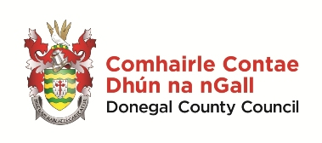

Qualitative Evaluation of ‘Ceol le Chéile’,
the Donegal Intergenerational Choir

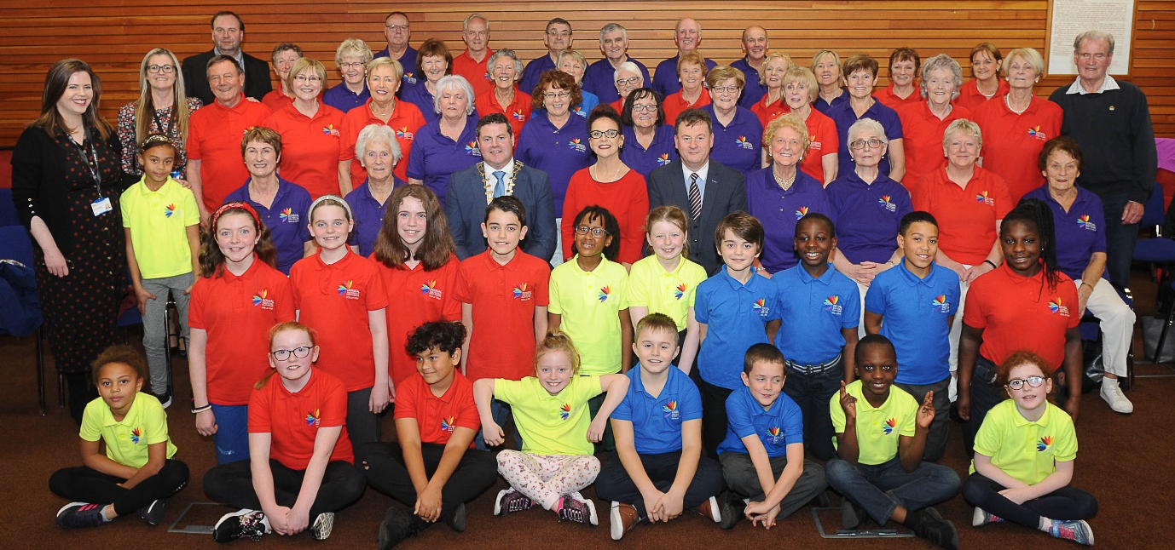

Research carried out by Rebecca Prunty, BSc (Hons) Public Health and Health Promotion, Institute of Technology Sligo

Acknowledgements
I would like to express my appreciation to all the participants who took part in this research.
Firstly, I would like to thank all the choir participants for their time completing questionnaires, attending focus groups and participating in individual interviews. This project would not have been possible without their contribution. I would also like to thank the parents who contributed to this research.
I would like to acknowledge the Social Inclusion Unit, Donegal County Council; the choir Director and Liaison Officer, and representatives from the key agencies including the HSE, Local Link and LYIT for their time and participation in the interviews.
I would also like to thank members of the Health Promotion Unit, HSE in Letterkenny for their support throughout the project, particularly my supervisors Anne McAteer and Louise Callaghan.
I would like to extend my thanks to Charles Sweeney and Mairead Cranley for their guidance and assistance during the research.

Foreword/Réamhfhocal
Tá lúcháir orm an taighde seo ar an tionchar atá ar na rannpháirtithe, idir óg agus aosta, i gCór Idirghlúine Dhún na nGall “Ceol le Chéile” a chur i láthair. Agus Straitéis Aoisbhá Dhún na nGall á hullmhú agus á cur i bhfeidhm, mheas baill Chomhaontas Aoisbhá Dhún na nGall an tábhacht a bhaineann le tionscnaimh rannpháirtíochta sóisialta a chur ar fáil mar gheall ar an nasc le sláinte agus folláine dhearfach in aoisghrúpaí níos sine. Is ábhar bróid dúinn go léirítear sa taighde seo go bhfuil tionchar an-dearfach orthu siúd atá mar bhaill den chór, beag beann ar aois.
I am delighted to present this research into the impact that membership of the Donegal Intergenerational Choir “Ceol le Cheile” has had on both the youth and adult participants. In preparing and implementing the Donegal Age Friendly Strategy the members of the Donegal Age Friendly Alliance have considered the importance of delivering social participation initiatives due to their connection to positive health and wellbeing in older age groups.
Since the establishment of Ceol le Chéile in February 2018 we have been hugely impressed by their public performances, achieving high levels of musical excellence under the expert guidance of Veronica McCarron but we were also receiving anecdotal evidence that being a member of this choir was having positive health and wellbeing benefits across all age groups. It is very important to us at his stage that we have documented these positive aspects of the project.
The Social Inclusion Unit of Donegal County Council have ensured that this choir remains unique, retaining a high social inclusion and wellness content while also ensuring that special memories are made such as performing on the stage of An Grianan with internationally renowned singers Daniel O Donnell and Moya Brennan.
This project has been delivered by the Donegal Age Friendly Alliance and without the commitment of all stakeholders this project would not have progressed. We are particularly grateful to the HSE, LYIT, Healthy Ireland, Local Link and Creative Ireland for their ongoing support in this connection. It is an excellent example of a multi-agency, collaborative initiative, and a model that Age Friendly Ireland wish to roll out nationwide.
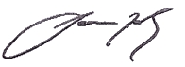
We wish the membership of Ceol le Chéile ongoing enjoyment in their participation in the choir and we look forward to developing the model further over the next year.

Seamus Neely
Chairman
Donegal Age Friendly Alliance

Table of Contents
Acknowledgements i
Foreword ii
Aim 1
Literature Review 1
Introduction: 1
Intergenerational Learning: 2
Social Benefits of Choirs: 4
Physical Benefits of Singing: 6
Mental Health, Singing & Choirs: 9
Conclusion: 11
Background and Context 12
Vision 12
Partnerships 12
Donegal County Council: 13
Healthy Ireland: 13
Letterkenny Institute of Technology: 13
Local Link: 14
Creative Ireland: 14
Project Format 14
Participants on the Programme 14
Project Funding 15
Achievements 15
Methodology 16
Questionnaire 16
Focus Group 17
Interviews 17
Results 19
Summary of Overall Findings 19
Infographic of Key Findings 20
Review with Older Adults 21
Children’s Review 22
Older Adults’ Focus Group 23
Theme 1: Increase in Social Inclusion: 23
Theme 2: Positive Health Benefits: 24
Theme 3: Enjoyment: 25
Children’s Focus Group 27
Theme 1: Social Connection: 27
Theme 2: Enjoyment of Experience: 28
Individual Interviews 29
Theme 1: Social Connectedness: 29
Theme 2: Change in Attitudes: 29
Theme 3: Enjoyable Experience: 30
Key Personnel/Partnership Interviews 31
Donegal County Council: 31
HSE: 31
Choir Director: 32
Liaison Officer: 32
Letterkenny Institute of Technology: 33
Local Link: 33
Key Findings: 34
Theme 1: Social Inclusion: 34
Theme 2: Benefits to Health & Well-Being: 35
Discussion 36
Conclusion 39
Five a Day for Well-Being: 39
Recommendations 40
Recommendations from Stakeholders: 40
Further Comments 42
References 43
Appendix 1 48
Information Sheet 48
Appendix 2 49
Consent Form: Children 49
Consent Form: Adult 50
Appendix 3 51
Choir Review: Children 51
Choir Review: Adult 52
Appendix 4 53
Focus Group: Children 53
Focus Group: Adult 55
Appendix 5 59
Individual Interview 1 59
Individual Interview 2 60
Individual Interview 3 61
Appendix 6 62
Donegal County Council Interview 62
HSE Interview 63
LYIT Interview 64
Local Link Interview 65
Choir Director Interview 66
Choir Liaison Officer Interview 67

Aim
The purpose of this present research is to explore the impact of one intergenerational choir through analysing the thoughts, opinions and attitudes of ‘Ceol le Chéile’ members and key personnel/agencies.

Literature Review
The purpose of this literature review is to explore the impact of intergenerational choirs through investigating the outcomes of intergenerational learning as well as the social, physical and mental health benefits of singing/choirs.

Introduction:
Since the 1980s the population of Ireland has been getting older. From the latest census, it can be observed that the 65 years and over age category saw the largest inflation. The age profiles in this category rose from just over a half a million (515,792) in 2011 to 637,567 in 2016 (CSO, 2017). This statistic is set to rise, as recent estimations expect a million people 65 years and over living in Ireland by 2030 (ESRI, 2017). Approximately 13% of the population of Donegal is over 60 years of age. This number too is set to rise over the next couple of years as people are now living longer, due to advances in health care, nutrition and quality of life (Donegal County Council, 2015).
The census highlights that around four in ten people, living on their own, are 65 or over. The number of retired individuals rose substantially from the previous census. In 2016 this number increased by 88,013 from the previous five years (CSO, 2017). As people age, they may experience a sense of isolation as a result of retirement from the workforce, bereavement, movement of family to other locations/countries, ill health and decreased mobility. The emerging isolation rates, among 65 and over age group, highlight the need for supportive housing, healthcare and other services to provide a supportive age friendly environment (Department of Health, 2016).
Social inclusion is an important element in growing old. It exercises a basic human right. An individual may feel socially, culturally, politically or economically excluded from society. Negative attitudes to aging, stereotypes and ageism create barriers to the inclusion and celebration of this stage of life. According to a study by Holt-Lunstad, et al. (2015) a causal factor in the increase in social isolation among the older population may be the transition from employment to retirement. Older adults may feel isolated through perceived negative attitudes and stereotypes held about them. Within a local community it is essential for people to feel accepted and be able to contribute to society in a purposeful manner.
The Donegal Age Friendly Strategy was launched in January 2014. This Strategy highlights that individuals of all ages can benefit from an age friendly community. The older population are valued and can share their life experiences, wisdom and expertise (Donegal County Council, 2015). Some of the aspirations of this strategy are to make the county a great place to grow old in; to combat negative attitudes towards aging and stereotypes about the elderly; to explore opportunities to improve engagement of older people within their community and to establish an environment where older people can be more independent (WHO, 2018). Together with the intergenerational choir, cookery classes and walkability audits are examples of other activities being implemented within the county.

Intergenerational Learning:
“Intergenerational practice aims to bring people together in purposeful, mutually beneficial activities which promote greater understanding and respect between generations and contributes to building more cohesive communities. Intergenerational practice is inclusive, building on the positive resources that the young and old have to offer each other and those around them” (Age Action Ireland, 2019).
Historically, different generations connected instinctively. The younger generation learnt from the older generation on how to be and how to become. The older generation provided experience and emotional support while the younger generation assisted their elders through limitations in health (Bosak, 2019). Intergenerational choirs can also encourage learning. When generations work together, they can support and aid development. Bjursell (2015) reported the importance of intergenerational communications. Participants were requested to rate the value of these relationships. Over half the participants believed that intergenerational relationships were “very important” while the other participants rated them as “important”. These intergenerational relationships were rated highly due to their learning opportunities, as some participants revealed that cross generational activites were an “exchanging experience” where they got an “insight into how other generations think” and where different generations learnt from each other.
In the study by De Souza (2003) it was reported through focus groups that the children had bonded with the elderly “we are afraid of discussing some subjects even with our parents, but we feel free to do so with the elders” and they also gained respect for the older adults “now we have learned how to respect them, we are able to understand and accept the way they are, and they understand us. This is really a way to share experience”. Intergenerational choirs promote the sharing of knowledge, skills and values. Intergenerational working decreases stereotyping and ageism, creates an age friendly environment, reduces social exclusion and increases respect between the younger and older population. In this research, it is highlighted that the younger population can greatly benefit from interacting with the older population and the older population can also benefit immensely from interacting with the younger population.
Research suggests that intergenerational activities can provide learning for the younger population in relation to attitudes towards older adults. In a study conducted in Brazil, focus groups acknowledged that the younger participants had a change of mind in relation to stereotyping of older people. They experienced the positive aspects of social interaction with the older population, through gaining understanding and improving their communication with other age groups. This study also suggests that older adults believed that engaging with different generations can promote mutual learning and encourage a positive mind set, “The integration is something fantastic. We learn with them, they learn with us. They become more and more affectionate and friendly with older people. It is happiness” (De Souza, 2003). Likewise, in a study conducted in an Irish university, social synergy between different generations resulted in intergenerational solidarity. Through one-to-one semi structured interviews, a business student viewed the intergenerational activity as a “fantastic opportunity to gain networking experience with a generation so far removed, from my own, and it was ultimately mutually beneficial” (Corrigan, et al., 2013).
Similar to the previously mentioned study, Andreoletti & Howard (2018) reported that young adults had a significant decrease in ageism and stereotyping, from partaking in an intergenerational activity, where students and the elderly engaged in the WISE programme (Working Together: Intergenerational Student/Senior Exchange). This programme was designed for older adults who were excluded from the community. A short qualitative survey reported that the young adults had a positive response to the older adults. Some of the younger participants revealed that “the stereotypes of old people aren’t true”, where parallels were discovered within the programme “highlighting similarities between generations” and acknowledged that the older adults were “really interesting”. Irish research by McNamara (2017), supports this evidence, where younger adults’ perceptions of the older adults had changed positively from completing an intergenerational activity. From conducting focus groups, several participants reported their “respect” towards the elderly. Another participant saw a positive change in their opinion, as they “notice older people more than I did before, like I see them now”. These statements clearly suggest that the attitudes of younger participants positively transform in relation to older adults.
Early research by Darrow et al. (1994) suggests that intergenerational activities can have an educational aspect. This was analysed through using ‘The Age Group Evaluation and Description Inventory’. Along with improving their musical abilities, the younger participants gained an insight into the older adults’ lifestyles, diminishing stereotypes such as older people having poor physical and mental health. This study also highlights that the younger population gain greater respect for older adults than their own peers when engaged in an intergenerational musical activity. The intergenerational choir had a positive effect on the older adults’ attitudes towards other older adults within the group. In comparison to the younger participants, there was no statistically significant difference in the attitudes of young adults towards young adults. This suggests that social interactions between the young and old can positively change perspectives of the individuals involved and that intergenerational activities can be an effective form of communication among different generations, which potentially could reduce the ‘generation gap’.

Social Benefits of Choirs:
There are many health benefits associated with intergenerational choirs. Older adults are at a higher risk of social isolation in comparison to the general population. According to the TILDA (2018) report, 37% of individuals over the age of 50 revealed that they were feeling lonely. This may be due to sickness, retirement from the workplace, loss of partners and friends and becoming physically weaker (HSE, 2018). One of the major health benefits is encouraging social interaction. Social inclusion is a major health benefit linked with older adults. Social isolation is a state in which someone lacks a sense of social acceptance and assurance with others (Hand, et al., 2014). According to Dallman & Power (1996), intergenerational choir projects encourage older adults to interact with others and make new friends. Using the CASP-12 and the Basic Needs Satisfaction scale, a study by Creech et al., (2014) conducted in London, revealed that an intergenerational choir promoted the development of social relationships, supported social affirmation and emotional wellbeing, encouraging social inclusion within the choir. A similar study by Belgrave (2011) found older adults had a positive experience when engaging in activities with the younger population. From partaking in half hour intergenerational singing therapy classes for ten sessions, participants were assessed using ‘The Age Group Evaluation and Description (AGED) Inventory’ and the participants social well-being was analysed using the ‘Loyola Generativity Scale’ and the ‘Rosenberg Self-Esteem Scale’. Towards the end of the intervention, approximately 70% of the older participants revealed they felt of more value to the children as they felt more useful.
A study by Conway & Hodgman (2008) showed that a choir which consisted of a community and college participants revealed both choirs were able to establish positive connections with the array of different age groups within the newly formed intergenerational choir. From gathering information through focus group interviews, the researchers found that engaging in musical activities was a source for new friendships along with stimulating a “social glue” between the participants. These older adults felt a “sense of belonging” and the choir gave them a deeper bonding when developing relationships. From this study it is evident that intergenerational choral singing can reduce social exclusion within the older population. Intergenerational choirs can also facilitate social interactions outside of the choir practices. Within their community, these intergenerational choirs encouraged older adults to engage in other activities such as meeting for a ‘coffee or dinner’ (Coffman & Adamek, 2001).
Research by Southcott & Joseph (2009), reported from semi-structured interviews, that members of a community choir suggested that the choir was like a “family” as it removes the sense of “emptiness” from everyday life. They felt that they belonged and bonded with a close group of people by being involved in a community activity. The study by Darrow et al., (1994) also concurs that partaking in an intergenerational choir can positively benefit the older adult’s social well-being. From completing a survey, the older adults scored high on the ‘goodness scale’, as they were socially included in a community-based activity. Participation in intergenerational choirs has a positive effect on the aging process of the members involved. It allows the participants to be socially included and be involved in a community activity, where this can improve their overall health and quality of life.
Dingle et al., (2012) reported a social connectedness within the choir. Disadvantaged adults were interviewed using semi-structured questions and it was evident from the responses that the participants felt accepted into both the choir and the community. Some described the choir as their “family” where they had a “sense of belonging to an awesome group of people”, while another labelled the choir as a “social outlet”. A study by Sun & Buys (2016), revealed that there was a strong relationship between participating in the singing sessions and improvements in “social support” and a “sense of social connectedness”. Levels of resilience also increased in participants after 18 months. These findings are comparable to Southcott & Joseph (2009) and Darrow et al., (1994).
Shakespeare & Whieldon (2018), reports that participation in community singing workshops can aid creation of social relationships. From partaking in SYHO (Sing Your Heart Out), some participants and facilitators noted the development of new friendships. One member suggested they were “all in this together”, which highlights the social connections that can be established, encouraging social inclusion. Livesey et al., (2012) also suggests that choral singing can help build social networks. Some of the singers revealed that “choral singing unites”, providing a “sense of community” as they mixed with fellow choir members.

Physical Benefits of Singing:
Physical health refers to absence of injury or disease. It is essential for overall positive well-being. An enduring, long-term health complication which is non-curable but can be managed is known as a chronic physical illness (NHS, 2018). There are many physical benefits to singing. When individuals sing, they encounter deep, rhythmical breathing. Deep breathing encourages oxygen flow to the brain and in the circulatory system, which occurs due to the increased capacity and strength of the lungs (American Thoracic Society, 1999). This regulates heart rate and decreases blood pressure. It is also reported that singing in a choir can enhance energy levels. According to Dingle et al., (2012), participants reported that they felt “energised” during and post choir sessions, where “endorphins are flying” and providing individuals with more “energy”.
Singing can improve individuals’ breathing and breathing pattern. Salomoni et al., (2016) found improvements in duration of inspiration, peak airflow and volume excursion during expiration in both classically experienced and inexperienced singers. This study also suggests that experienced classical singers use complex actions within different respiratory chambers which allow for improvements in breathing patterns. A similar study which examined breathing patterns during singing also revealed that thoracic volume increased and inspiratory time decreased which resulted in a development in inspiratory flow measured using a body plethysmograph (Binazzi, et al., 2006).
According to a study by Bonilha, et al., (2009), an MPG vacuum manometer was used to measure maximal respiratory pressure reporting that singing has a positive impact on PE_{max} (maximal expiratory pressure) on patients with Chronic Obstructive Pulmonary Disease (COPD). The promotion of PE_{max} is due to exclaiming musical notes, where there is a large demand of the expiratory muscles in the lungs. This reveals that singing is extremely beneficial to the older population as the lungs can lose strength and become weak as individuals age. Employing a spirometry (instrument measuring volume of air), Gale et al., (2012) found that there was no change in spirometric measures of lung function, although there was an increase of MEP (maximal expiratory pressure) among cancer patients who partook in choral singing sessions. Muscular strength within the respiratory system may increase due to the management of breathing and expansion of expiration stimulated when singing. The results are comparable to the study by Bonilha, et al., (2009), where COPD patients who attended choral singing groups had a higher level of MEP in comparison to patients who did not attend this activity.
Irish research undertaken by Moss, et al. (2017), supports studies that indicate singing improves respiratory health. Individuals reported their improvements in breath control, lung capacity and strength as well as easing symptoms of breathing disorders, “my asthma control has improved… (singing is) excellent breathing control and lung development”. Eley & Gorman (2010), examined how singing can improve the effect of asthma, among Aboriginal Australians through two test instruments, a spirometry and peak flow metres. The results show that there are improvements in peak expiratory flow (PEF), which rose from 67.7 ± 5.5% to 81.2 ± 5.5% (P <0.05) and an increase in forced vital capacity (FVC) from 79.3 ± 7.4% to 101.3 ± 5.3% (P <0.01), by partaking in singing lessons over a 6-month period. Approximately 1 in 10 of people in Ireland have asthma, with a forty percent increase in 13-14 year old teenagers between 1995-2003 (HSE, 2018). A study by Shakespeare & Whieldon (2018), hightlighted different respiratory benefits to engaging in singing workshops. Some participants suggested breathing techniques helped reduce the severity of anxiety attacks, aided the rehabilitation of speech as well as a reduction in the use of asthma medication. These studies suggest that singing interventions could possibly reduce the symptoms of asthma.
Other studies reveal that singing can improve other aspects of one’s physical health. It can also be observed that musical activities can benefit the overall health of older adults. In comparison to a control group, older adults who partook in weekly singing classes had fewer doctor appointments, a decrease in medication intake and an increased participation in additional physical activities (Cohen, 2006). In a study by Clift & Hancox (2001), participants completed a questionnaire where a small minority strongly agreed that singing helped them to avoid the cold and flu, thus enhancing an individual’s immune system. A report reveals that singing develops the levels of S-IgA in the body, which fights infections in the respiratory system (Kreutz, et al., 2003). Similar to the studies by Clift & Hancox (2001) and Kreutz et al., (2003), a study by Beck et al., (2000) also reports that singing can strengthen the immune system. A ‘salivette’ was used to measure the concentration of S-IgA, which can also be referred to as immunoglobulin A. Levels were elevated during choral rehearsals and performances.
Singing can improve the quality of life for individuals with a neurological disorder. It is evident from previous studies, that singing in a group choir environment can also improve the quality of life for an individual with Parkinson’s disease. After engaging in group singing for 5 months, there were large advances in speech, in phonation (production of vocal sounds) duration and less fatigue when reading. There were also benefits within the respiratory system of these individuals (Di Benedetto, et al., 2009). Another study by Stegemoller, et al., (2017) agrees with the previously mentioned paper as it suggests that individuals with Parkinson’s benefit from singing, as it can improve respiratory pressure and other respiratory outcome measures. Phonation range and vocal intensity was measured through an iPad application, while respiratory measures were examined by using a portable respiratory pressure meter. Oostendorp & Montel (2014) highlights that singing can evoke positive emotions and trigger sustained brain areas involved in memory on patients with Alzheimer disease. Episodic memory functioning improved in those individuals that took part in the singing sessions. Episodic memory refers to the recollection of autobiographical events. It was reported that despite having severe memory loss, these individuals can encode and retrieve new information. Another study by El Haj et al., (2012) supports the findings that singing can evoke positive emotions in individuals with Alzheimer disease. Using the MMSE (Mini Mental State Examination) to measure episodic memory, the researchers found that music which was familiar to people with Alzheimer’s disease, had the ability to generate old memories. This suggests music and singing have the capability to stimulate areas within the brain, to encourage memory retrieval.

Mental Health, Singing & Choirs:
According to the World Health Organisation, mental health can be defined as a “state of well-being in which every individual realises his or her own potential, can cope with the normal stresses of life, can work productively and fruitfully, and is able to make a contribution to her or his community” (WHO, 2014).
According to Mental Health Ireland (2015), one in four people at some stage experience a mental health issue with one in ten children experiencing a mental health issue at a young age. Approximately 1 in 4 adults will experience a mental health disorder. Depression, which is closely linked to mental ill health, affects one in twelve of the Irish population (Mental Health Ireland 2015). Mental health encapsulates both psychological, social and physical dimensions. Research reveals that singing can promote positive mental health. Singing can also lower stress levels. It can be observed that singing in a choir setting has a therapeutic benefit. Participants completed questionnaires which suggested that singing alone or singing within a group can decrease anxiety. Results also reveal that choral singing had more positive and extended psychological effects in comparison to solo singing (Schladt, et al., 2017). This study corresponds with Gale et al., (2012), where anxiety levels depreciated in cancer patients who were in involved in singing for the past 3 months. Anxiety levels were measured using the ‘Hospital Anxiety and Depression’ (HAD) scale.
Choir singing can also positively affect individuals with mental health problems, family/relationship problems, physical health issues/disabilities and individuals who have endured a recent bereavement. Some of these individuals revealed that choir singing “lifted my self-esteem”, “restored self-belief”, and “when you sing, you cannot be sad for long”. It is evident that singing in a community group can positively improve the mood of an array of individuals in different situations (Clift, et al., 2007).
Within a community singing group setting, it was reported that older adults greatly benefited from this activity, improving their mental health quality of life after 6 months, which was analysed using the ‘York SF12’. After 3 months, there were indications that anxiety and depression levels had decreased. Anxiety and depression levels were examined by the ‘Hospital Anxiety and Depression Scale’ (Coulton, et al., 2015). A study conducted in Australia also suggests that a community singing programme can reduce levels of depression. Eighty percent of participants revealed that singing “all the time” improved their overall well-being. Before participating in the singing sessions, only 1 in 3 participants agreed with the statement. This study also reported psychological distress levels reduced by approximately 17%, after 18 months involvement in the choir (Sun & Buys, 2016).
In the study by Clift & Hancox (2001), approximately 1 in 2 participants strongly agreed that participating in singing had a positive impact on their mood. It is evident that singing has an emotional impact on individual’s health. Myskyja & Nord (2008), examined if there were any effects of singing on older adults with depression. Using the ‘Montgomery Aasberg Depression Rating Scale’, it was observed that there was a significant reduction in the levels of anxiety and depression when individuals engaged in a 6-week singing group intervention. Like Coulton et al., (2015) and Myskja & Nord (2008), research by Kreutz et al., (2003) also notes the psychological benefits of singing. Semi-structured interviews found negative emotions decreased, while positive emotions increased in participants when singing. This study reports that singing can refresh an individual’s mind as well as being emotionally satisfying. Another study also supports the concept that choral singing has a positive effect on participants’ mental health, where high levels of satisfaction were recorded, as performing is a hugely exhilarating experience (Beck, et al., 2000).
A study that involved choral singers from three different countries, England, Germany and Australia, revealed singing in a group setting was supportive of the health of the choir participants, during times of depression and low self-esteem. Some participants described the choir singing as a time where they “forget family worries”, “put troubles on hold” while another exclaimed that it lifts “my spirits out of depression” (Grindley, et al., 2011). Choir singing can also release tension, alleviating stress and creating a sense of togetherness. It is suggested that there is a connection with spiritual health, as it “encourages your soul to feel part of something bigger than yourself… being part of a group making a beautiful sound is very creative and instantly rewarding”. Responses were reported from a questionnaire which contained 28 quantitative questions and 2 qualitative questions that explored the benefits of participating in a choir (Moss, et al., 2017).

Conclusion:
It can be observed that intergenerational activities benefit both the younger and older populations involved, benefiting the older adults through social inclusion and benefitting the younger participants by gaining an insight into different generations reducing negative stereotypes and ageism. It can be suggested that intergenerational activities can improve empowerment and social cohesion for all members. It is also evident from the above studies that there are many physical health benefits of singing, on the respiratory system and to individuals who are suffering from a disease or disorder. Furthermore, singing can also positively affect the well-being of individuals through social inclusion and promoting positive mental health, reducing levels of anxiety and depression as well as improving mental health-related quality of life.

Background and Context
‘Ceol le Chéile’ also known as ‘Choir of Ages’, is the Donegal intergenerational choir set up by the Social Inclusion Unit in the Donegal County Council in 2018. ‘Ceol le Chéile’ meaning ‘singing together’ is a project established as part of the Donegal Age-Friendly Strategy under the social participation theme. The aim of this intergenerational choir is to promote social inclusion and improve relationships between different generations (Donegal County Council, 2018). The intergenerational choir was established and based in Letterkenny. Travel arrangements are made to facilitate participation of members from other parts of Donegal. It is directed by Veronica McCarron, a well-known choir director (Creative Ireland, 2018).
The choir consists of participants of all ages, young and old and has approximately 100 members. Spaces in the choir are in high demand and there is currently a long waiting list. The youngest member in the choir is 6 and the oldest is 90. The children’s ages range from 6 to 13 years and the adults are aged 60 years and above. The choir practises each week in the Letterkenny Institute of Technology. They have performed 13 concerts, on occasions alongside famous singers including Daniel O’Donnell and Moya Brennan.
In Ireland, two other ‘Choir of Ages’ located in Leitrim and Dublin, directed by David Brophy, were set up as part of a television series. The aim of these choirs was to reduce social exclusion and to eliminate the differences that occur between the generations. The benefits and outcomes of ‘Choir of Ages’ has yet to be evaluated.

Vision
The vision of ‘Ceol le Chéile’ is to give different generations the opportunity to participate in choral singing and in doing so encourages intergenerational learning, along with other potential benefits including social, physical and mental health and well-being improvements.

Partnerships
This project is led by Donegal County Council, in collaboration with a number of agencies including the HSE, LYIT, Local Link and Creative Ireland. Without this partnership approach, a project like this would not be possible given the size of the choir and the geographic spread of the membership.

Donegal County Council:
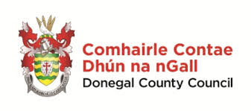
Donegal County Council is the authority responsible for local government in County Donegal. The Social Inclusion Unit was established in 2007. Their role is to raise awareness of and address social inclusion and poverty. The Donegal Age Friendly Alliance was set up to improve the lives of all older people in Donegal. The Age Friendly strategy draws on the eight themes of the World Health Organisation (WHO). The Social Inclusion Unit supports interculturalism and is involved in many multi-agency structures including the Interagency Group on Traveller Issues and the Social Inclusion Measures Implementation Group (Donegal County Council, 2019).

Healthy Ireland:
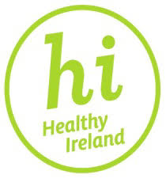
Healthy Ireland was first launched in 2015. It is a government led initiative which aims to create an Irish society where everyone can enjoy physical and mental health and where well-being is valued and supported at every level of society. Its vision is to increase the proportion of people who are healthy at all stages of life (Healthy Ireland, 2019). The HSE’s Healthy Ireland in the Health Service National Implementation Plan (2015-2017) places a significant emphasis and dependency on partnership and collaboration externally with other sectors. Staff are supported to work in cooperation with local authorities and the LECP’s ensuring a focus on health and well-being objectives, particularly health inequalities and related outcomes. Action 126: support the development of Age Friendly Cities and Counties in conjunction with the local authorities and other community and voluntary organisations.

Letterkenny Institute of Technology:
The LYIT was established as a third level education college in 1998. The Institute provides a wide range of courses in many different faculties. The state of the art building is easily accessible with a large car park located at the front and a smaller car park at the rear of the building. The Institute’s buildings are fully accessible with lifts, automatic doors and accessible toilets (Letterkenny IT).

Local Link:
Local Link is a development of the Rural Transport Programme (RTP) and in 2013 responsibility was transferred to the National Transport Authority (NTA). Local Link provides public transport services in rural locations around Ireland. It aims to reduce social isolation, enhance mobility and accessibility for community participation for local rural people. There are currently twelve routes operating within Donegal (National Transport Authority, 2018).

Creative Ireland:
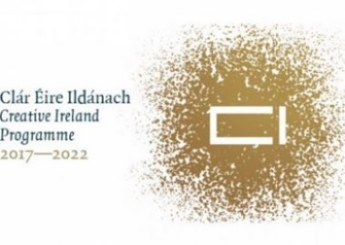
Creative Ireland’s vision is that everyone in Ireland will have the opportunity to recognise his/her full creative ability. It is a cultural organisation constructed to promote individual, community and national well-being. It works in partnership with Government departments, organisations and agencies. There are Creative Communities all over Ireland with Culture and Creativity Strategies devised to identify, activate and support communities from 2018-2022 (Creative Ireland 2019).

Project Format
‘Ceol le Chéile’ was established in 2018, initially as a 6 month project. The choir has performed in many different locations throughout Donegal. Some of the performances include the Earagail Arts Festival, Donegal Bay and the Bluestacks Festival, Connecting for Life Conference, the National Age Alliance Convention 2019 and Christmas shows. The choir rehearses every Friday and in the run up to a performance this is increased to twice weekly. The choir engage in other intergenerational activities including trips to nursing homes and Glenveagh National Park.

Participants on the Programme
Approximately 150 people have participated in ‘Ceol le Chéile’ since its establishment less than 24 months ago. The participants come from all over Donegal. The majority of adults are over the age of 65. The children range from 6 to 13 years of age. There are approximately 20 children choir members.

Project Funding
‘Ceol le Chéile’ is primarily funded by Donegal County Council with additional funding from HSE. LYIT and Local Link provide ‘funding in-kind’, supporting transport and rehearsal space for the choir. The future of the choir is dependent on the budget available for 2020 and beyond.

Achievements
Since the choir was established over eighteen months ago, they have had 13 successful public performances. These performances include 3 Christmas shows; visits to Community Hospitals and Nursing Homes during Bealtaine; recitals at the launch of TILDA, the Pan Celtic Festival, National Convention for Older People and the Earagail Arts Festival. ‘Ceol le Chéile’ was runner-up in the National Pride of Place Awards 2018 and has been shortlisted for an Age Friendly Ireland Recognition Award 2019.

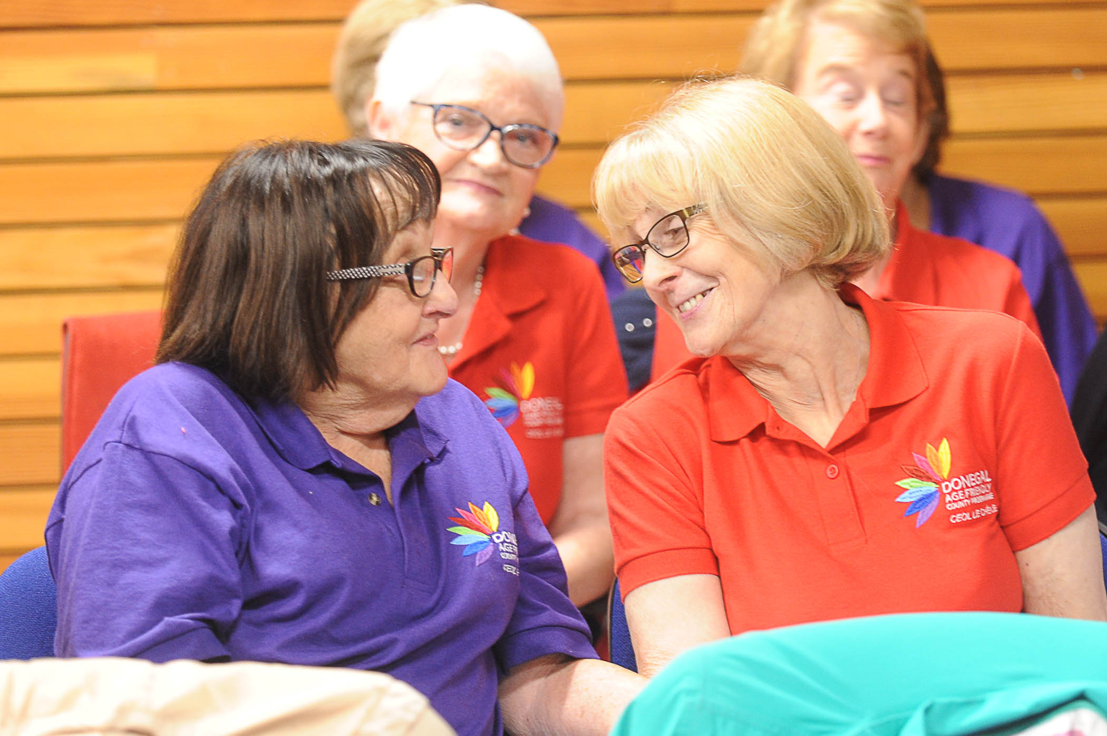

Methodology
This is a mixed methods study but mainly consists of qualitative research. Qualitative data was obtained from focus groups with choir members, interviews with key personnel/agencies and a child friendly questionnaire. Quantitative data was collected from the older adult’s questionnaire. A week prior to the beginning of data collection, an information leaflet (Appendix 1) was distributed to all members of the choir and the parents/guardians of the children. This leaflet outlined of the aim of the study, details of the different data collection methods, how participants could register interest in being involved in the study and information about the researcher. The data was collected over a 5 week period, from the 31st of May to the 5th of July. Participants under the age of 18 required parental consent before completing a questionnaire and/or taking part in the focus group (Appendix 2).

Questionnaire
A review questionnaire for the adults and a child-friendly evaluation questionnaire were developed. The choir review investigated the members’ views on the logistics of the choir. Fifty-three participants completed choir reviews, 44 older adults and 9 children. The adult choir review required responses from 10 questions, with a section for additional comments. Nine of the questions required the participant to rate each statement while the other question required a yes/no answer. The choir review was devised from a previous study in Ireland, “Music in Mind” conducted by Mental Health Ireland. The older adults’ questionnaire was distributed before a choir practice. The responses were completely anonymous as no personal details were required from the participants. The questionnaire took approximately 5 minutes to complete. The data was analysed using descriptive statistics. Scores from the questionnaires were analysed and tabulated using Excel. Participants rated each statement on a 5-point Likert-type scale. The responses ranged from 1 being “None of the Time” and 5 being “All of the time”. An average score was formulated for each question.
The children’s review consisted of five questions. Qualitative data was collected from 3 of the questions. Age and gender was requested from the children. A scribe was available for children if required. The children’s choir review was constructed to be as child friendly as possible.

Focus Group
The aim of the focus group was to explore choir members thoughts, opinions and attitudes towards ‘Ceol le Chéile’. Eleven older adults took part in the adult focus group and 5 children engaged in a child friendly focus group discussion. The focus group for the older adults took place 1 hour prior to choir practice. The children’s focus group lasted approximately 20 minutes. A protocol and topic guide were developed prior to data collection. The purpose of these instruments is to assist the researcher during the focus group, through having pre-prepared, open-ended questions. The focus groups obtained a deeper level of meaning as participants’ own personal responses were gathered. Focus groups are a flexible research tool, encouraging discussion between a smaller number of people who have a common interest or characteristic. The information was collected through the use of a voice recorder and written information was collected through the moderator scribing small details throughout the session. Before any data was collected, participants were informed about the study and signed the consent form where they were informed that the information gathered would be confidential and the voice recordings would be destroyed after the report was produced. The data was analysed through thematic analysis (Braun & Clarke, 2006). This is a systematic procedure of recognising patterns of meaning in participants’ opinions, thoughts and attitudes of a certain topic. Interviews were transcribed and coded. The transcripts were read extensively to produce many different codes. Potential codes were formulated into themes.

Interviews
Information was sought about each interviewee’s involvement in the Donegal Intergenerational Choir through one-to-one, semi-structured interviews. The Choir Director, the Donegal County Council Coordinators; representatives from HSE West, the transport provider (Local Link) and the choir practice venue provider (LYIT) were interviewed for the purpose of this research. Information was also obtained from individual interviews with two choir members and a parent of one child participant in the choir. These interviews were audio recorded and written information was collected through the moderator scribing small details during each interview. Before any data was collected, participants were informed about the study. The interviewees had the option to publish their identity or remain anonymous. A protocol and topic guide were developed prior to data collection. The data was analysed through a systematic procedure of recognising patterns of meaning in participants’ opinions, thoughts and attitudes on each topic. Interviews were transcribed and coded. A similar procedure to analysing the focus groups was followed. The transcript were extensively read to produce many different codes. Potential codes were formulated into themes.
Refer to Appendices 3, 4, 5 & 6 for data collection tools. These tools include the questionnaire for the older adults, the child friendly questionnaire, the protocols and topic guides for the focus groups, the individual interviews and the key stakeholder/personnel interviews.

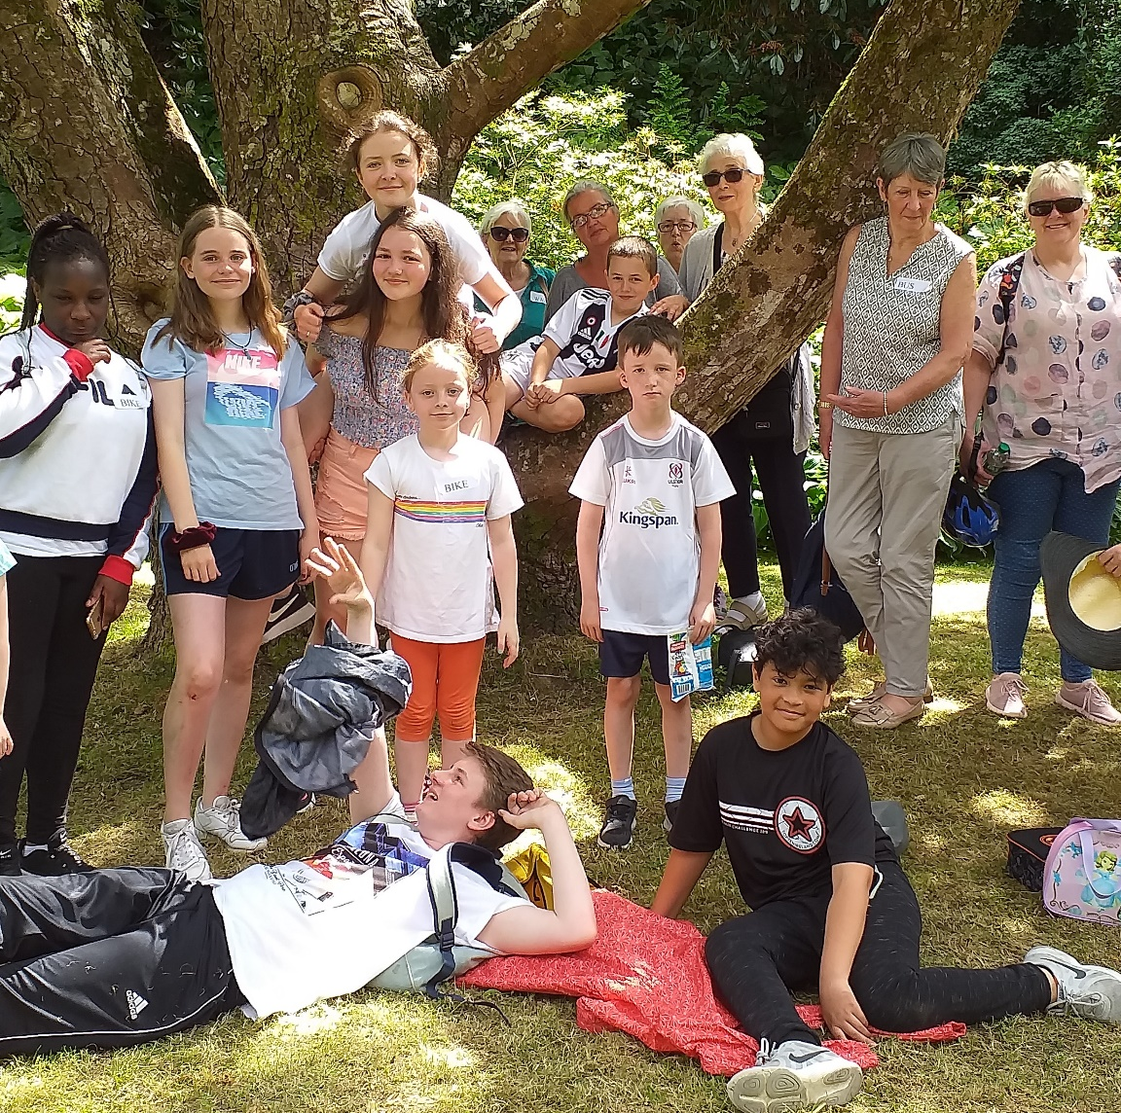

Results

Summary of Overall Findings
It was highlighted that the choir positively benefitted the members’ physical health. Singing can activate the brain and concentration levels, improving memory. Numerous participants in the research suggested that the warm-up breathing exercises and singing can enhance respiratory health. It was also suggested that singing in a choir can aid rehabilitation and recovery from health issues.
‘Ceol le Chéile’ had a positive impact on choir members mental health. Many participants suggested that the choir was an enjoyable experience and some revealed that it was the highlight of the week. The development of confidence levels and sense of achievement elevated the mood and happiness levels. It was also highlighted that the choir’s performances positively impacted their audiences.
This choir has given its members the opportunity to create and build friendships. This can reduce social isolation. A sense of camaraderie had been generated within the choir as the choir was compared to a big family. A comfortable, trustworthy environment was created where choir members commented on the social connectedness during performances and rehearsals.
The benefits of intergenerational learning was evident in this research. A positive shift in attitudes was observed. It was acknowledged that the children’s respect towards the older adults had positively changed. The younger choir members were willing to assist older adults and were enthusiastic to engage in social interactions. There was also an appreciation in the variety of music, influenced by the intergenerational aspect.

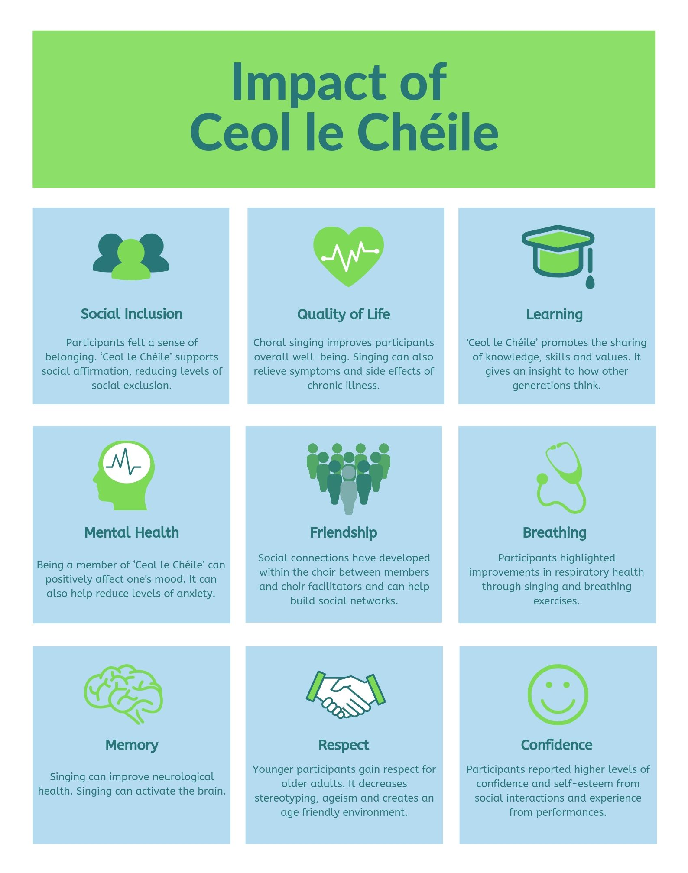
Infographic of Key Findings

Review with Older Adults
The chart below (Figure 1) illustrates the results obtained from the review with the adult choir members. The data was calculated by formulating the average scores between 1-5 for each question. All of the scores ranged between ‘Often’ and ‘All of the Time’ indicating high satisfaction with the logistics or practical arrangements for the choir. Q1-3 relating to perceived benefits and enjoyment, with an average score of 4.8 indicating very positive views on participation. Q4-9 sought a response to how participants rated the practical arrangements for the choir. Respondents rated the arrangements 4 or 5, again reflecting high levels of satisfaction.
Figure 1- Average Scores of Adults Choir Review
1=None of the Time 2=Rarely 3=Some of the Time 4=Often 5=All the Time
Two additional questions were asked at the end of the survey. 100% of participants would recommend the choir to a friend. In the any other comments section, both negative and positive comments were recorded. 77% of the comments were positive. Some of the positive comments include: “a most enjoyable experience”; “enjoy meeting new people and having a laugh”; “music is medicine”; “great social event”; “fabulous choir”; “helped gain confidence”; “Veronica is amazing”, “improvements in general well-being”; “enjoy meeting new people of all ages and love learning the new songs and harmonies”. In relation to the negative comments, the following were noted: “quite intense at times”; “practices are sometimes too long and depending on the performance venue”; “the stage can be too small and cramped”.

Children’s Review
All of the children’s responses (100%) revealed that they had made new friendships since joining the choir. 89% of these friendships consisted of friendships with both the older adults and the younger participants. Only one response highlighted that they only developed friendships with the children, and not with the older adults.

Figure 2 – Formation of Friendships
It was evident from the choir review that the children enjoy participating and singing in this choir. All of the participants enjoy coming to the choir. Most of the children indicated that they enjoy performing at “concerts”. The children also indicated that they enjoy the social engagement aspect of the choir as they “get to meet new people and make friends”, “seeing my friends every week” while another noted that they enjoyed “socialising with elderly people and people my age”. When questioned on what they have become good at, 75% of the children revealed that they had improved their “singing” abilities. Others noted improvements in their “posture” and in their abilities to “socialise with others”. Most of the participants revealed that “singing and meeting friends”, “seeing my friends” and “getting to know others” was their favourite part of the choir.

Older Adults’ Focus Group

Theme 1: Increase in Social Inclusion:
Many participants acknowledged the benefits of the social aspect associated with being a member of this intergenerational choir.

1.1 Formation of Relationships
Being involved in ‘Ceol le Chéile’ gave its members the opportunity to form new friendships with other members, both young and old. The participants revealed that they have “got to know so many people”, enjoy “meeting all these nice people and having a chat at the tea breaks”, “generating new friendships” as the choir is so “friendly and welcoming”. The choir also encourages social engagement, through the use of name badges. One participant revealed it is a “great help” in promoting social interactions. Many participants also suggested that they had built up strong relationships with the choir co-ordinators and director as they were “loyal” to them and described them as “amazing” and “organised”. Other participants highlighted that they admire the choir director’s personality and her enthusiasm for her work.

1.2 Connection during Performances
A connection with the audience during a performance was frequently mentioned. When questioned about their most memorable/favourite moment, many participants associated it with the warm reception they received from the audience during or after performances. Some audience members were in “tears” while “passing the tissues to one another”. Others recalled the “standing ovations” and “praise” they received from relatives and friends. A sense of connectedness during the performances was identified, “I think that’s nice, it brings people together”. One member reminisced on a “wonderful moment” where a younger member assisted one of the older adults down from the stage at one of the performances. They compared the feeling to holding “the little hand, of your own new born, for the first time”.

1.3 Sense of Purpose
The choir provides a new sense of purpose and adjustment for the retirees. Having a reliable activity to attend was something to look forward to each week. “Since I retired about 9 years ago, I’ve been looking for a choir to join…. I just love that social aspect of singing together”, while another remarked “since retiring last June, I was looking for something” as I enjoy “meeting new people”. Many participants revealed that the choir was the “highlight of my week”. The reasons behind this was the “challenge”, the “variety of music”, the “social aspects” as well as the professionalism of the choir director. One member revealed that she had previously dedicated her life to her family and now in her retirement she “wanted to go and get out of the house for a couple of hours”.

Theme 2: Positive Health Benefits:
Many participants acknowledged the benefits to their physical health from being a member of a choir.

2.1 Improvements in Memory
Participants highlighted that “learning new songs, new harmonies…. new words and the new languages such as Gaeilge and Italian” improved their memory. They believed it was an effective “mindfulness exercise” as their full focus was completely on the choir. “Your brain is activated all the time” during the choir rehearsal or during the week “you’ve always something to think about with the choir”. Between rehearsals, participants suggested that they would have homework, researching the songs and figuring out the different tunes. One participant recognised the importance in keeping her mind active as her “sister who had Alzheimer’s, was one thing that pushed me”. She identified the “importance” of singing for a healthy mind.

2.2 Improvements in Respiratory System
Positive breathing benefits were reported by numerous participants. It was highlighted by one participant that their breathing had “improved immensely” through the exercises that are conducted at the beginning of each rehearsal along with participating in singing itself. As part of the breathing exercises and singing, the choir director has the choir members “standing constantly” on their feet, which “is good” eliminating bad posture, improving breathing. From improvements in their respiratory systems, choir members revealed that they “could bottle” the energy and stamina.

2.3 Increase in Positive Mental Health
It was evident from the focus group that participating in the choir “elevates the mood” of the choir members. The elevation in mood was demonstrated during both the choir rehearsals and the anticipation of a choir rehearsal or performance. Participants constantly referred to the choir director as humorous and rehearsals as fun. “I think laughter is as good as singing” and one member describes the choir director as “funny” as she constantly includes “anecdotes” which are in their heads all week. Another participant highlighted that the humour “really gels people together”. Other members enjoy the relaxation aspect of the choir, it gives them the opportunity to “wind down”.

Theme 3: Enjoyment:
Enjoyment was a main theme throughout the focus group and the joy the choir brings to the participants cannot be underestimated.

3.1 Enthusiasm to Learn
A number of participants reported that the choir had provided them with a learning objective. They highlighted the enjoyment and sense of achievement they obtained since participating in the choir. One member of the choir suggested that they “love the discipline” in relation to the difficulties associated with some of the songs they had learnt. Other participants compared the choir to a “school environment”, as they are keen to learn and be attentive. When asked what they enjoy most about belonging to the choir, a re-occurring response was the ability to “learn new songs”. Some participants describe their ability to learn the words of each song without any books as “brilliant”. It was also evident that choir members enjoy the challenge and discipline. Rising to the challenge was an important aspect for many participants as they believed that engaging in singing allowed them to keep their “minds active”.

3.2 Appreciation of the Intergenerational Aspect
Although the intergenerational aspect was not one of the main reasons for joining the choir, older participants appreciated the younger members. One describes the children’s interaction with the older adults as “amazing” as they have noticed the development in the children, as they are “able to verbalise about topics and things” that they couldn’t before. Others acknowledged the children’s change in attitude as they’ve shown respect towards the older adults, through “helping them walk down stairs” and “minding” them while dancing. Participants described many “wonderful moments” they had with the children and it is evident that they enjoy their company. The older adults believe that the children enhance the choir through the “beautiful harmonies”, their “talent” and “without the children, the choir would not be the choir that it is”. One participant suggested that the younger choir members “keeps us young at heart” as they recognise the energy and enthusiasm brought by the children.

3.3 Enjoyment of Experience
It was clear from the data collected, that all members enjoyed the overall experience and high quality of standards achieved. Choir members labelled the choir sessions as “enjoyable” as they really “like the music” and look forward to attending each week. As previously mentioned, the choir was described as the “highlight of my week”. Many participants praised the choir director. Some joined the choir only because of the well-known director whilst others were not acquainted with who she was. Although the choir director was described as assertive, it was also suggested that she was “fabulous”, “amazing” and an “inspiration” as she “inspires confidence during performances”. When questioned about performances and rehearsals, they revealed that the overall experience was positive with a few minor drawbacks. The duration of choir rehearsals was described as monotonous, when only one song was rehearsed, but when a variety of songs were practised, the experience was more enjoyable. The comments “excitement” and “preparations for performances raise emotions”, were noted in the focus groups and interviews.

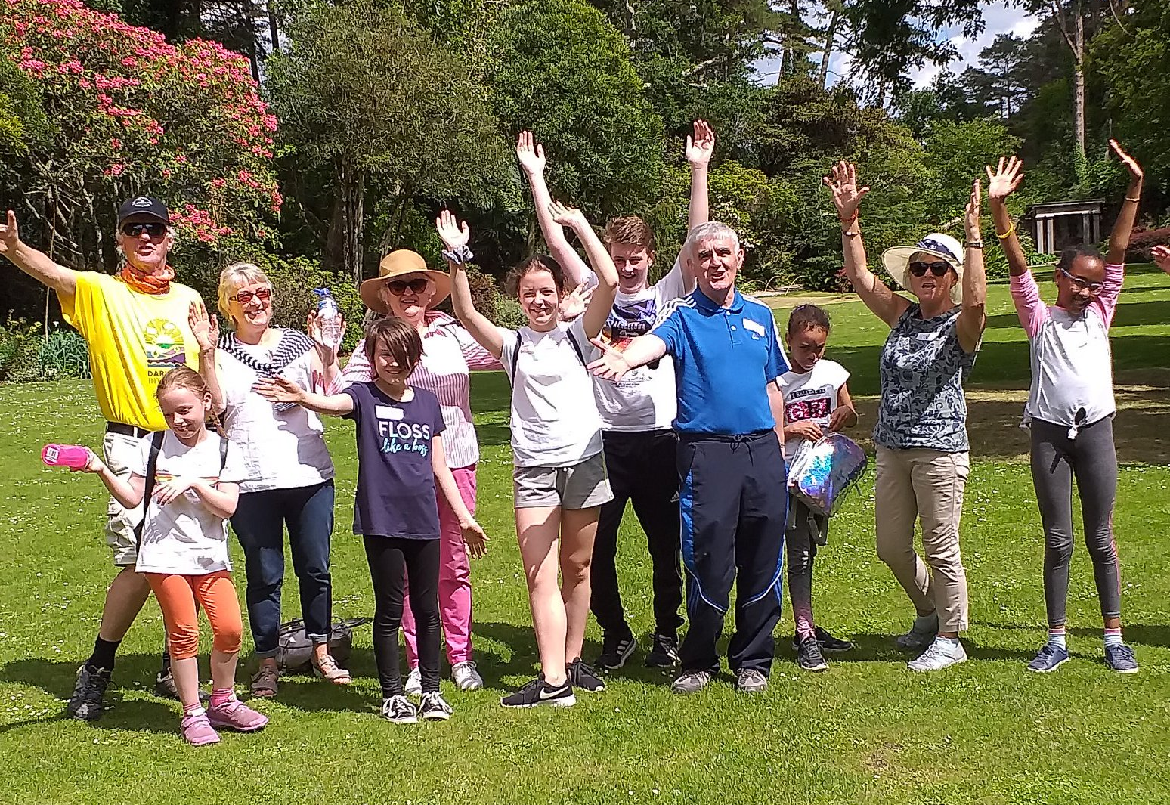

Children’s Focus Group

Theme 1: Social Connection:
Reasons for joining the choir varied for the children but the social aspect was an evident factor for motivating and encouraging the younger members to continually attend this intergenerational choir. This mirrors what the older people said.
  - Creating Friendships
It was highlighted by many participants that a sense of camaraderie had been generated in the choir group and had created a bond within the entire group as it is “like a big family because you have friends that are young and old”. Some children made a special mention about relationships that they had developed with the older adults as they had a “positive” rapport with them, as they “sang with them and you got to know them”. It was also mentioned that the older adults had “become friendlier” and the children felt more “confident in themselves” and their ability to converse with the adult members. The children revealed that they established new friendships with the younger participants through “making” and “developing new friends”.
  - Positive Social Contact
The young participants suggested that the choir had helped them improve and increase their social interactions. From joining the choir, one individual revealed that the choir had assisted them to “learn more about people” within the group. Another child highlighted the importance of the social activity to “help us bond” with the more senior members in ‘Ceol le Chéile’. Participants suggested that their ability to speak with people enhanced through their improvements in “socialising skills” as they now “love meeting new people”. Positive interaction between members was highlighted, “the older ones are good craic and fun to talk to”. Any previous negative stereotypes the children held were diminished as they developed a “positive view of the older people”.

Theme 2: Enjoyment of Experience:
All the younger participants revealed that ‘Ceol le Chéile’ was a pleasurable activity and they enjoyed the experience.

2.1 Recognition of Opportunity
It was evident that the children appreciated the opportunity they had been given by ‘Ceol le Chéile’. Some participants identified the “great experience” they were given from “performing on stage” and were grateful for the experience which will be significant for them in their future musical careers. It was indicated that these performances on stage and engagement with other choir members “increases confidence levels”. This “fun experience” had allowed the children to improve their choral abilities, one individual commenting that they had “gotten better at singing”. Participants highlighted the indispensable choir director. One individual suggested that “you don’t have a [choir director] in any other choir. She’s a big part of it”. Some participants were thankful for the learning they had received from the director, as they had improved their “posture”, “breathing” and discovered “different ways of singing”.

2.2 Intergenerational Appreciation
The intergenerational aspect was acknowledged by the children when comparing ‘Ceol le Chéile’ to other choirs. The children highlighted the influence of the intergenerational facet through the significance of the variety of songs as they “like the songs what we sing. All the songs, the new and old songs”. These songs catered for the musical interests of all the different age groups. The choice of modern and old music was welcomed by the younger members of the choir. Although it was suggested by one individual to eliminate the separation of choir rehearsals by having “all ages singing and not certain amounts” at different rehearsal times. One individual also highlighted the management of his insecurities of singing as his “voice has broken”. Singing with the older men alleviated anxiety associated with singing with people of his own age.

Individual Interviews

Theme 1: Social Connectedness:
It was highlighted throughout all the individual interviews that the formation of friendships was an aspect valued by members of the choir. Due to recent “retirement” and “living alone”, levels of social connectedness dwindled during this new life stage. A parent indicated that their child “gets so much out of mixing with older and younger people” in this choir and that they “enjoy going to meet friends” when they are “out and about”. One individual acknowledged the importance of the social aspect for men’s health, as “men are reluctant to discuss issues” but they suggested that ‘Ceol le Chéile’ was a “comfortable” social environment, as it delivered “a sense of trust-worthiness”. Choir members reported the significance of “belonging” to an “exciting social experience” as for people who were once “acquaintances”, but now “great friendships” have developed since the beginning of the project. It was suggested that this choir is the only social activity during the week for some members, as this was the only engagement on their “social calendars”. It was recommended to introduce more social activities to promote the intergenerational aspect, to “create and build friendships” between the different age groups.

Theme 2: Change in Attitudes:
It was evident from the individual interviews that there was a shift in attitudes in members, both young and old from when they first joined. The change of attitudes among the younger members was a popular recurring theme. Participants highlighted the development in the children’s “confidence” by singing “solos”, boosting their self-esteem. The choir has allowed children to “move outside themselves”. It was reported that the social engagement in ‘Ceol le Chéile’ had increased the children’s “willingness and confidence to interact with the adults”, as they had gained “respect and appreciate the senior members” as they became more considerate of the age gap. Aspects of intergenerational learning were referenced as the children greatly benefited “from the general life experience of the older people”. Individuals also indicated that the adult’s confidence benefitted from participating in this choir, through their “never die” attitude and in their “need to succeed”. As a group, the members “learn” and feel “more confident with each other”.

Theme 3: Enjoyable Experience:
Being a member of ‘Ceol le Chéile’ results in positive outcomes for all involved as singing can increase “levels of happiness” and “elevates mood” through the “safe environment” which is created. Participants suggested a “sense of achievement” not exclusively through singing but from “working with people” from different generations and cultures. Participants suggested that the overall experience of the intergenerational choir was a “delight” to be a part of through the “variety of songs”, “impact of the musical director” and attention to detail, through the “designated” practice day, time and venue. It was evident that choir members ultimately “enjoy singing” and appreciate the opportunity to be involved in a “dynamic musical group”. From this the children are given the chance to kickstart their musical careers where there may have previously had anxiety or insecurities about their futures.

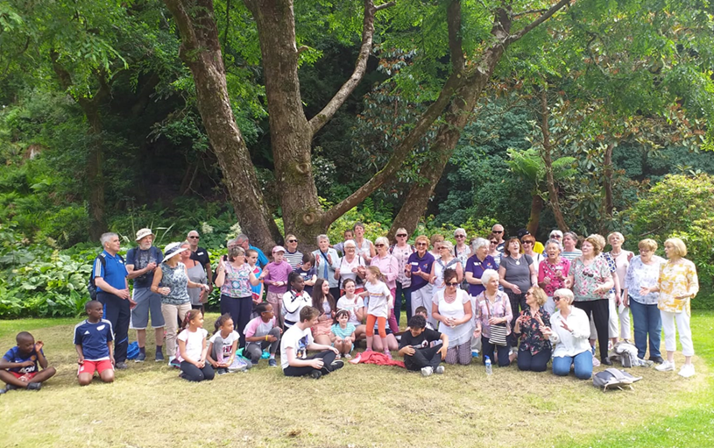

Key Personnel/Partnership Interviews

Donegal County Council:

Charles Sweeney, Social Inclusion Coordinator & Mairead Cranley, Assistant Social Inclusion Coordinator
In 2014, the Donegal County Council became involved in ‘Age-Friendly’ initiatives. To make the county more age-friendly, a practical set of actions were devised. One of the eight themes is social participation. From this many intergenerational projects were initiated by the Social Inclusion Unit. Gardening, cooking, dancing, walkability audits, customs and traditions were all projects launched as part of this strategy. ‘Ceol le Chéile’ was introduced as a pilot project based on a best practice model. The aim of the project is to bring older and younger people together to work on a theme, an action or an activity, with a showcase at the end of the project. ‘Ceol le Chéile’ participants were recruited through the press, social media, schools, church newsletters and bingo halls. The Donegal Age Friendly Strategy encouraged collaboration with other agencies. They believe this project “benefits the older people, as they are able to play a more active role in their communities, by getting out and becoming more confident. There is a societal benefit for older people, but you are also creating more inclusive and energy based communities”.

HSE:

Representative from Health Promotion
The HSE and the Donegal County Council have developed an important partnership over the years. One of the main collaborative projects is the Donegal Youth Council. When Donegal County Council decided to continue following the initial success of the choir, they approached the HSE in relation to funding. Health Promotion, HSE was aware of the evidence citing the benefits of singing on health and currently funds workplace choirs. Not only was this intergenerational choir seen to benefit the health of the participants but to also create a supportive environment within the community. The HSE see this choir as an important investment and essential in the support of their ongoing collaboration with Donegal County Council. “The Donegal community benefits from reduction in social isolation, encouraging active engagement, promoting positive relationships. This choir reduces social isolation, builds body strength, improves breathing and posture, memory, and it helps builds social networks.”

Choir Director:

Veronica McCarron
From a very early age, Veronica McCarron has been involved in choirs. She graduated from the Royal Scottish Academy of Music and Drama with a degree in Choral Music. She auditioned and studied many complex pieces. She has been teaching music for over 40 years in countries all around the world including Ireland, Scotland, Australia and America. In 1996 she retired and came back to Kilkenny. She has had a successful career in music directing and recently directed the Kilkenny Presentation Choir which appeared on ‘Britain’s Got Talent’. She then moved to Ballyshannon, Co. Donegal.
She believes “members feel of more value to their community. The older adults and children have definitely formed valuable friendships, increasing confidence, self-esteem and assurance. I see this choir differently, as it is a different kind of perfection and I’m loving it”. Veronica highlighted the importance of singing in a team, to work together to achieve a common goal. She suggested that singing can be beneficial for an individual’s entire well-being. Singing can improve “breathing”, develop “facial muscles”, increase “consciousness” and improving “memory” and reducing “loneliness”. She believes that being a member of a choir can provide a “feel good factor, when in the moment releases endorphins when individuals are completely engrossed”. She has noticed many positive changes in attitudes in both the younger and older participants. Veronica revealed how the choir has not only benefitted its members, as it has also been beneficial for her as she has created many friendships and has helped her transition into her retired by being “involved in the community”.

Liaison Officer:

Triona Sweeney
Triona is the Liaison Officer for the choir. Although she has a musical background, she has a non-musical role. Triona sends out emails, keeps a list of up-to-date contacts details, prepares lyric sheets and informs the choir participants of any special arrangements in regard to rehearsals and performances. An important aspect of her job is to protect the welfare of the children. It is essential to have a child protection liaison adult present during intergenerational activities. This person must ensure the children are supervised at all times and are safe.

Letterkenny Institute of Technology:

Paul Hannigan, President of the LYIT
The Letterkenny Institute of Technology plays a vital role in the implementation of ‘Ceol le Chéile’. The LYIT was involved in the initial discussions of the Donegal Age-Friendly Strategy. A venue is provided for rehearsals free of charge, with the intergenerational choir rehearsing every Friday in the LYIT. The provision of space for rehearsals, includes the use a tiered lecture theatre, located near a canteen area and toilet facilities. A section of the college is set aside for them on a Friday afternoon. LYIT is committed to continue to support this project as it makes a “significant community contribution”.

Local Link:

Fiona O’Shea, Donegal Local Link Manager
Through the Donegal Age Friendly Alliance, Local Link became involved in this project. They wanted to remove the transport barrier for participants as they believe this choir supports everything Local Link stands for in relation to social inclusion. They provide transport to choir members free of charge. Local Link supports ‘Ceol le Chéile’ by providing transport to approximately 15 participants for rehearsals and performances. They also provide transport to the group on activity days/outings. Local Link will continue to provide for members of ‘Ceol le Chéile’ that need to avail of the service.

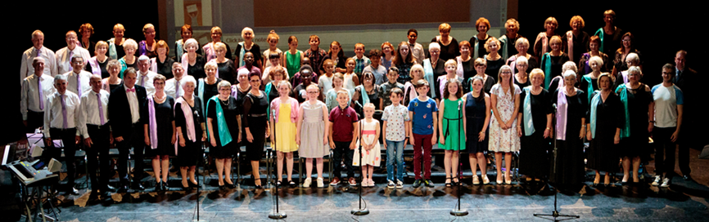

Key Findings:
The following key findings are taken from the key personnel/partnership interviews mentioned above.

Theme 1: Social Inclusion:

1.1 Development of Social Networks
Involvement in ‘Ceol le Chéile’ benefitted the welfare of the younger and older participants in the choir as “it’s a real community development initiative”. It provides important social engagement for people in Donegal who may lack frequent social contact. Emphasis on social involvement is an essential aspect of this choir, as “social participation is a priority area” in the Donegal Age-Friendly Strategy, from which this project was conceived. Along with the performance aspect of the choir, it was noted that the social outings and activities are fundamental, “it can’t be a choir that only rehearses and performs in concerts, it also has to be about the social inclusiveness”. It was highlighted in the interviews that the older members “feel of more value to their communities within the county”. This intergenerational choir provides social support towards those who are “recently retired”, “suffering from loneliness” or “dealing with bereavements”. The choir gives participants a “sense of purpose and allows for easier retirement transition”. One individual suggested that the “impact is immeasurable” in terms of social connectedness.

1.2 Promoting Positive Relationships
Many interviewees highlighted the connection between the choir members. The spirit of friendship which was generated within the group has developed a “sense of camaraderie”. Some compared the choir to a “solid family group”. The relationships which have been created along with the mixture in generations allows for positive engagement for younger members who “might not have a granny or grandad” figure in their life. From numerous interviews, it was evident that the choir has “built relationships” and “it creates an appropriate positive connection between the children and older people, where they gain more respect for each other building more cohesive relationships and communities”. It was suggested that this may be due to the “shift in attitudes towards each other”. ‘Ceol le Chéile’ has also created the possibility of other social engagement as it was observed that choir members “would meet for lunch before choir rehearsals”.

Theme 2: Benefits to Health & Well-Being:

2.1 Mental Health
One individual highlighted the importance of the LYIT as a venue as for younger members of the choir as it is “opening up opportunities to see what their future might be like”. This opportunity may offer the children reassurance in the future as “anxiety is a big issue affecting the younger members”. The “learning aspect” has a positive impact on the participants’ mental health. The experienced choir director appreciates and attends to this aspect. Whilst learning new skills, the “challenge and discipline” can have a positive impact on the choir members. They have a “sense of achievement and satisfaction”. Lifelong learning can improve one’s quality of life. Many interviewees highlighted the development in the children’s confidence. The children “enjoy the recognition” they receive after performances, boosting their self-esteem. It was also suggested that the children have become more “confident in society” evidenced when they approach the older members of the choir whilst out in the public. Others reported the significance the choir has on external audiences, revealing it is “very uplifting” and “moving” when engaging with the choir.

2.2 Physical Health
The interviewees highlighted the different physical health benefits to the choir members. Interviewees suggested that singing in the choir can reduce health issues and aid rehabilitation among the participants, “some of the older people were getting cancer treatment and it was helping them with their recovery, to take their mind of the recovery”. Advances in memory were also identified. For the older members “alertness” and “concentration” and ability to learn new songs has improved memory function. Many interviewees also stated that ‘Ceol le Chéile’ has a positive impact on “breathing”, “posture” and “facial muscles”, through the exercises that are conducted before rehearsals.

Link to Choir Video:
https://www.dropbox.com/s/3ewhkwg53b83fz3/ceol%20le%20ch%C3%A9ile%20-%20final%20version.mp4?dl=0

Discussion
Themes that emerged from this study support previous research that intergenerational choir groups have positive benefits on social, physical, relational and mental health.
Past research recognised the positive social implications of intergenerational activities. Throughout the different data collection methods in this research, participants identified the formation of relationships. ‘Ceol le Chéile’ offered the participants the opportunity to establish new friendships and build their social networks. This finding can be compared to research by Shakespeare & Whieldon (2018), Creech et al., (2014) and Livesey et al., (2012). From creating these positive friendships between the different age groups, respect is increased and assumed stereotypes are dispelled thus reducing the generation gap. Within this research it can be highlighted that the children had gained respect for older people from engaging in this intergenerational choir. Similarities are reported in an Irish study by McNamara (2017), where the young participants’ attitudes towards the older members had positively been affected. It was highlighted in this research that the children greatly benefited from the general life experience of the older people. Similar to the study by Bjursell (2015) and Darrow et al., (1994), participants gained an insight into other generations’ lifestyles and behaviours. The increase in social engagement within the choir’s younger participants enhanced their willingness to interact with the older members. From this it can be suggested that social interaction between the different age groups in an intergenerational activity can diminish stereotypes and enhance respect. It is acknowledged that there has been a shift in demographics and epidemiology since the Darrow et al., (1994) research but this current study supports the findings. This establishment of social connections between the different generations can encourage the circulation of knowledge, skills and values.
‘Ceol le Chéile’ was widely perceived as a “social glue” for participants. It was evident that a social connection had developed among participants. Strong family-like relationships comprising of trust-worthiness and love, encourages feelings of self-worth. From this research it can be suggested that intergenerational choirs can be compared to a solid family group, through the development of friendships between the different generations. A positive rapport had been developed between the members of ‘Ceol le Chéile’. This finding was consistent with previous studies by Southcott & Joseph (2009) and Dingle et al., (2012), that indicated a family environment was created within the choir groups. This creates a supportive community. Coffman & Adamek (2001), stated how choirs encouraged social interaction outside of the organised activity. This was also evident in this research as choir members’ social contact had extended beyond choir rehearsals and performances, as members were meeting up for tea and lunch, encouraging social companionship.
Researchers have reported emotional and mental health benefits derived from the enjoyment of the experience, having a sense of purpose, boosting confidence and encouraging satisfaction. In this study and in a study by Clift & Hancox (2001), participants proclaimed that the choir rehearsal was the highlight of their week. Having a sense of purpose where participants can work together towards a shared goal can increase levels of satisfaction. The learning aspect was an important finding in this research. The determination and enthusiasm of the older choir members was notably evident. The older participants enjoy the challenge and discipline associated with singing, allowing them to keep their minds active. They also highlighted their appreciation for the assertive and experienced choir director. With high levels of concentration required and participants eagerness to learn, this intergenerational choir allows participants to stimulate their minds, promoting positive mental health.
This study also suggests that ‘Ceol le Chéile’ gives its members the opportunity to relax from their everyday worries whilst engaging in the choir. Choir members can alleviate pressure and release tension, decreasing stress levels. This key finding is similar to previous research by Moss et al., (2017) and Grindley et al., (2011). In addition, the observations of rehearsals and performance showed that participants visibly became more positive and animated as they sang. In particular the younger participants appreciated the opportunity they were given to perform on stage. Like Beck et al., (2000), choir members young and old, reported high levels of enjoyment associated with performances. Some participants appreciated the satisfaction element connected with an emotional audience, while others highlighted the enjoyment of the experience. Confidence levels were also boosted in both the younger and older members of the choir. Through performances and social interactions, it was evident from this research that participants’ increased self-esteem and self-belief positively affected the individual’s mental health. As in Dingle et al., (2012) the choir can be seen as an opportunity for choir members to build and develop their confidence.
Improvements in physical health were noted in this study. Participants in ‘Ceol le Chéile’ suggested that singing in this choir improved their respiratory health, through the deep breathing exercises. This finding supports previous research by Salomani et al., (2016), Binazzi et al., (2006) and Shakespeare & Whieldon (2018) which indicates improvements in respiratory health through the management of breathing and expansion of lungs while singing. Studies by El Haj et al., (2012) and Oostendorp & Montel (2014) support findings that singing can evoke positive memories and encourage stimulation of the brain in Alzheimer patients. Although participants in this study did not disclose their health status, choir members did recognise their improvement in memory, through their alertness and ability to new learn new songs. ‘Ceol le Chéile’ members recognised the increase in their energy levels and stamina as singing can release endorphins, the brain’s feel good hormone. Similar findings were found in the research by Dingle et al., (2012) where choir participants felt energised both during and after the choir rehearsals. It was highlighted in this study that being a member of ‘Ceol le Chéile’ can reduce health concerns among participants. Cohen (2016) and Clift & Hancox (2001) also found that participating in choirs can improve one’s health, reducing intake of medication and fewer doctor appointments. A key finding from this current study suggests that choir members posture improved from participating in this choir. The participants believed that the elimination of bad posture enhanced their breathing. This study has identified postural benefits of singing which have not been acknowledged in previous research. This research only reports subjective benefits in contrast to the previously mentioned studies where physiological tests were conducted to reveal the physical benefits of singing on one’s health.

Conclusion
For many centuries humans have been producing and shaping music. Previous evidence suggests that making music and singing can create and improve relationships, activate an array of muscles and have a positive impact on mental health. Extra benefits derive from choral singing than solo singing. From this research it can be concluded that an intergenerational choir group can strengthen social inclusion through providing a recurring social event and the development of friendships. ‘Ceol le Chéile’ also contributes positively to its members physical health and mental well-being. This intergenerational choir is making a significant contribution to the welfare of people in Donegal.

Five a Day for Well-Being:
The 5-a-day concept to improve mental well-being has been adapted from the 5-a-day fruit and vegetable message for healthy nutrition. The 5-a-day for Well-being has been adopted and is used by Mental Health Ireland and Jigsaw. The concept involves being connected; being active; taking notice; learning and giving. The choir gives its members the opportunity to socially connect with other choir members. This allows them to talk about different personal matters and develop close relationships. Choir members are active when engaging in warm-up breathing exercises and dance movements whilst singing. ‘Ceol le Chéile’ offers its participants the opportunity to take notice of the world around them and allows them to express emotions. Every rehearsal and performance is a learning experience, where choir members increase their skills and knowledge. Learning helps build confidence and encourages engagement. ‘Ceol le Chéile’ creates positive experiences for its members and allows participants to feel needed and valued. In giving their time for rehearsals and performing in Nursing Homes, the choir members volunteer their time and talents and make a significant contribution to their community. This 5-a-day concept can boost ‘Ceol le Chéile’ participants’ well-being and support their mental health (Jigsaw , 2018).
.

Recommendations
For a project similar to this, it is fundamental to ensure there is strong interagency collaboration. Interagency collaboration brings together critical stakeholders to achieve a common goal, where they can cooperate contributing services and supports to achieve the best possible outcome.
It is essential to have commitment, both financial and in-kind funding. Securing financial funding is important to pay for the costs of running the project. In-kind funding is also essential, where organisations provide their goods or services free of charge. When planning an intergenerational choir, it is important to identify the sources of funding. Funding is vital in ensuring sustainability of the project.
Currently there is little research in this area. For future research, it is suggested to conduct a long-term evaluation of the choir, to measure the physical and mental health benefits. Both objective and subjective measurements are imperative and would provide statistical scientific data. Physiological testing would evidence the health benefits. Research can be used to evidence need and also to leverage funding.
This is an intergenerational project. For most of the time, younger and older participants rehearse separately. It is essential to build in additional activities, to ensure interaction between the generations. These additional activities will encourage social connectedness and underpin the concept of intergenerational learning, dispelling ageism and stereotypes of aging.

Recommendations from Stakeholders:
The following advised changes were noted by stakeholder interviewees. In relation to recruitment, it is suggested that there is a greater emphasis on the hard-to-reach members of the county. There was an open call when recruiting participants for ‘Ceol le Chéile’. It is suggested that social prescribing is the chosen method; “the public health nurse, as they are the people dealing with the hard-to-reach at home, identifying the vulnerable”, where the main objective is “they need the choir, rather than the choir needing them”. Donegal has a well-established Social Prescribing Programme and links between these two initiatives should be forged.
It is advised to have no shortcuts in regard to preparations when implementing the project. Key areas to focus on include child protection, methodology, required resources (employment of organiser) and it is essential to “know your model”. It was suggested to introduce an “In-House Jobs Committee” to ensure efficiency and reduce workload on project organiser. The small tasks assigned in the “Jobs Committee” could encourage a sense of purpose and ownership in choir members. It is suggested that the Jobs Committee along with the Older Persons’ Committee would report to the Choir Director and the Council to “encourage sustainability”.
A reduction on performances was also suggested. Although show-casing the choir’s achievements is an important aspect of this project, performances can bring pressure. The concept of “turn up and sing” approach was recommended which would encourage “singing for feeling good”. Similar to ‘Come & Try’ sessions organised by Donegal Sports Partnerships, where individuals are given the opportunity to select different activities and join in on the fun. The project could host community singing sessions emphasising fun and the social outlet as opposed to performance and musical excellence. This idea was suggested as a different concept to consider.
Practicalities of the choir were also discussed through the introduction of required “attendance” and formal “uniforms” for performance, creating a strong sense of identity and belonging for ‘Ceol le Chéile’ members.

Further Comments
The following comments were noted by older adult choir members and parents of the children, regarding the success of the choir and their continued commitment:
“Thank you for setting up this wonderful project. In all my years I never experienced the way I felt after the concert. I couldn’t imagine I would ever perform on stage, never mind performing with Moya Brennan.”
“Getting old can be scary and lonely but the choir creates a whole new excitement feeling in my life, which I love. Thank you for keeping that young feeling in me, the excitement I had after the concert was an amazing feeling and I will miss the choir during the summer.”
“I was so proud of the kids on Sunday night, their confidence has grown so much in the last year.”
“All our work in the last few weeks was worth it. It’s really beneficial having this break from the choir - time to recharge and give time to other interests which may have felt a bit neglected! Time also, to reflect on the choir and the significant difference it has made to my life. I juggle ‘everything else’ AROUND the practices, which speaks volumes!”
“Delighted to hear they are back in September. It is amazing how much my child has missed the choir. I think she had withdrawal symptoms after the concert!”
“Really looking forward to (for me) 20th September. Veronica’s passion and enthusiasm inspires us. Mairead is the motivating factor which drives us on, week after week. I observe so many positive changes in so many of the members since the choir began, so thank you all for continuing to make it happen.”
“Is choir rehearsals staying on Fridays? My child doesn’t want to take on any other activity that is going to clash with it."

References
Age Action Ireland, 2019. Generations Together. [Online]
Available at: https://www.ageaction.ie/how-we-can-help/generations-together
[Accessed 24 April 2019].
American Thoracic Society, 1999. Dyspnea: Mechanisms, Assessment and Management: A Consensus Statement. American Journal of Respiratory and Critical Care Medicine, 159(1), pp. 321-340.
Andreoletti, C. & Howard, J., 2018. Bridging the Generation Gap: Intergenerational service-learning benefits young and old. Gerontology & Geriatrics Education, 39(1), pp. 46-60.
Beck, R., Cesario, T., Yousef, A. & Enamoto, H., 2000. Choral Singing, Performance Perception, and Immune System Changes in Salivary Immunoglobulin A and Cortisol. Music Perception, 18(1), pp. 87-106.
Belgrave, M., 2011. The effect of a music therapy intergenerational program on children and older adults' intergenerational interactions, cross-age attitudes, and older adults' psychosocial well-being.. Journal of Music Therapy, 48(4), pp. 486-508.
Binazzi, B. et al., 2006. Breathing pattern and kinematics in normal subjects during speech, singing and loud whispering. Acta Physiologica, 186(3).
Bjursell, C., 2015. Organizing for Intergenerational Learning and Knowledge Sharing. Journal of Intergenerational Relationships, 13(4), pp. 285-301.
Bonilha, A. et al., 2009. Effects of singing classes on pulmonary function and quality of life of COPD patients. International Journal of Chronic Obstructive Pulmonary Disease, Volume 4, pp. 1-8.
Bosak, S., 2019. Benefits of Intergenerational Connections: Legacy Project. [Online]
Available at: https://legacyproject.org/guides/intergenbenefits.html
[Accessed 10 May 2019].
Braun, V. & Clarke, V., 2008. Using Thematic Analysis in Psychology. Qualitative Research in Psychology, 3(2), pp. 77-101.
Clift, S. & Hancox, G., 2001. The perceived benefits of singing: findings from preliminary surveys of a university college choral society. The Journal of the Royal Society for the Promotion of Health, Volume 4, pp. 248-256.
Clift, S. et al., 2007. Choral Singing and Psychological Wellbeing: Findings from English Choirs in a Cross-National Survey using the WHOQOL-BREF. International Symposium on Performance Science, pp. 201-207.
Coffman, D. & Adamek, M., 2001. Perceived Social Support of New Horizons Band Member. Contributions to Music Education, pp. 27-40.
Cohen, G., 2006. Research on Creatvitiy and Aging. The positive impact of the arts on health and illness. Generations, 30(1), pp. 7-15.
Conway, C. & Hodgman, T., 2008. College and Community Choir Member Experiences in a Collaborative Intergenerational Performance Project. Journal of Research in Music Education, pp. 220-237.
Corrigan, T., McNamara, G. & O'Hara, J., 2013. Intergenerational Learning: A Valuable Learning Experience for Higher Education Students. Eurasian Journal of Educational Research, Issue 52, pp. 117-136.
Coulton, S., Clift, S., Skingley, A. & Rodriguez, J., 2015. Effectiveness and cost-effectiveness of community singing on mental health-related quality of life of older people: randomised controlled trial. The British Journal of Psychiatry, pp. 250-255.
Creative Ireland, 2018. ‘Ceol le Chéile’. [Online]
Available at: https://www.creativeireland.gov.ie/en/donegal/ceol-le-Chéile-2018
[Accessed 25 April 2019].
Creative Ireland, 2019. About Us. [Online]
Available at: https://www.locallink.ie/en/about/
[Accessed 2 July 2019].
Creech, A., Hallam, S., Varvarigou, M. & McQueen, H., 2014. Active Music Making: a route to enhanced subjective well-being amongst older people. Perspective in Public Health.
CSO, 2017. Census 2016: Profile 3 - An Age Profile of Ireland. [Online]
Available at: https://www.cso.ie/en/csolatestnews/pressreleases/2017pressreleases/pressstatementcensus2016resultsprofile3-anageprofileofireland/
[Accessed 31 May 2019].
CSO, 2017. Census 2016: Profile 4 - Households and Families. [Online]
Available at: https://www.cso.ie/en/csolatestnews/pressreleases/2017pressreleases/pressstatementcensus2016resultsprofile4-householdsandfamilies/
[Accessed 31 May 2019].
Dallman, M. & Power, S., 1996. Kids and Elders. Forever Friends.
Darrow, A., Johnson, C. C. & Ollenberger, T., 1994. The Effect of Participation in an Intergenerational Choir on Teens' and Older Persons' Cross-Age Attitudes. Journal of Music Therapy, 31(2), pp. 119-134.
De Souza, E., 2003. Intergenerational Interaction in Health Promotion: A Qualitative Study in Brazil. Rev Saude Publica, pp. 463-469.
Department of Health, 2016. Positive Ageing 2016 - National Indicators Report, Dublin: Department of Health.
Di Benedetto, P., Cavazzon, M., Mondolo, F., Rugiu, G., Peratoner, A., Biasutti, E., 2009. Voice and choral singing treatment: a new approach for speech and voice disorders in Parkinson's disease.. European Journal of Physical and Rehabilitation Medicine , 45(1), pp. 13-19.
Dingle, G., Brander, C., Ballantyne, J. & Baker, F., 2012. "To Be Heard": the social and mental health benefits of choir singing for disadvantaged adults. Psychology of Music, pp. 1-17.
Donegal County Council, 2015. Donegal Age Friendly Strategy. [Online]
Available at: https://www.donegalcoco.ie/media/donegalcountyc/community/pdfs/Age%20Friendly%20County%20Strategy.pdf
[Accessed 10 May 2019].
Donegal County Council, 2018. Do you want to be part of '‘Ceol le Chéile’' Donegal’s Choir of Ages?. [Online]
Available at: http://www.donegalcoco.ie/yourcouncil/communicationsoffice/pressreleases/doyouwanttobepartofceolleChéiledonegal/
[Accessed 25 April 2019].
Donegal County Council, 2019. Social Inclusion Unit. [Online]
Available at: http://www.donegalcoco.ie/community/supportingcommunities/socialinclusionunit/
[Accessed 2 July 2019].
El Haj, M., Fasotti, L. & Allain, P., 2012. The involuntary nature of music-evoked autobiographical memories in Alzheimer's disease.. Consciousness and Cognition, 21(1), pp. 238-246.
Eley, R. & Gorman, D., 2010. Didgeridoo playing and singing to support asthma management in Aboriginal Australians. The Journal of Rural Health.
ESRI, 2017. Projections of demand for healthcare in Ireland, 2015-2030: First report from the Hippocrates Model. [Online]
Available at: https://www.esri.ie/system/files/media/file-uploads/2017-10/Infographic-26-October-2017.pdf
[Accessed 31 May 2019].
Gale, N., Enright, S., Reagon, C., Lewis, I., Van Deursen, R., 2012. A pilot investigation of quality of life and lung function following choral singing in cancer survivors and their carers. eCancer Medical Science, 6(261).
Grindley, H., Astbury, J., Sharples, J. & Aguirre, C., 2011. Benefits of Group Singing for Community Mental Health and Wellbeing, Victoria: VicHealth.
Hand, C., McColl, MA., Birtwhistle, R., Kotecha, JA., Batchelor, D., Barber, KH., 2014. Social Isolation in Older Adults who are frequent users of Primary Care Services. Can Fam Physician, 60(6), pp. 322-329.
Healthy Ireland, 2019. Healthy Ireland. [Online]
Available at: https://www.gov.ie/en/campaigns/healthy-ireland/?referrer=/
[Accessed 2 July 2019].
Holt-Lunstad, J., Smith, T., Baker, M., Harris, T., Stephenson, D., 2015. Loneliness and Social Isolation as Risk Factors for Mortality: A Meta-Analytic. Perspectives on Psychological Science, 10(2), p. 227–237.
HSE, 2014. Healthy Ireland in the Health Services: National Implementation Plan 2015-2017, Dublin: HSE .
HSE, 2018. About Asthma. [Online]
Available at: https://www.hse.ie/eng/health/hl/living/asthma/aboutasthma/
[Accessed 29 April 2019].
HSE, 2018. Loneliness in Older People. [Online]
Available at: https://www2.hse.ie/wellbeing/mental-health/loneliness-in-older-people.html
[Accessed 24 April 2019].
Jigsaw , 2018. Five a Day for Wellbeing. [Online]
Available at: https://www.jigsaw.ie/news-and-events/post/five-a-day
[Accessed 08 August 2019].
Kreutz, G., Bongard, S., Rohrmann, S., Grebe, D., Gunther Bastian, H., Hodapp, V., 2003. Does Singing Provide Health Benefits?. Proceedings of the 5th Triennial ESCOM. Conference Experience, pp. 216-219.
Letterkenny IT, 2019. Discover LYIT. [Online]
Available at: https://www.lyit.ie/About/Discover-LYIT
[Accessed 2 July 2019].
Livesey, L., Morrison, I., Clift, S. & Camic, P., 2012. Benefits of Choral Singing for Social and Mental Well-Being: qualitative findings from a cross-national survey of choir members. Journal of Public Mental Health, 11(1), pp. 10-26.
McNamara, I., 2017. The Impact of Intergenerational Projects on the Younger Person's View of Older People. Journal of Social Care, 1(1).
Mental Health Ireland, 2015. Strategic Plan 2015-2017, Dublin: s.n.
Moss, H., Lynch, J. & O'Donoghue, J., 2017. Exploring the perceived health benefits of singing in a choir: an international cross-sectional mixed-methods study. Royal Society for Public Health , 20(11), pp. 1-9.
Moss, H., O'Donoghue, J. & Lynch, J., 2017. Sing Yourself Better: The Health and Well-Being Benefits of Singing in a Choir, Limerick: Irish World Academy of Music and Dance.
Myskja, A. & Nord, P., 2008. A Pilot Study on Music and Depression in a Nursing Home. Nordic Journal of Music Therapy, Volume 17, pp. 30-40.
National Transport Authority, 2018. About Local Link. [Online]
Available at: https://www.locallink.ie/en/about/
[Accessed 2 July 2019].
NHS, 2018. What is physical health? - The Parallel Young People's Health Service in Bolton. [Online]
Available at: http://www.bridgewater.nhs.uk/bolton/the-parallel/physical-health/
[Accessed 02 May 2019].
Oostendorp, J. & Montel, S., 2014. Singing Can Enhance Episodic Memory Functioning in Elderly People with Alzheimer's Disease. Journal of the American Geriatrics Society, 62(5).
Salomoni, S., Van den Hoorn, W. & Hodges, P., 2016. Breathing and Singing. Objective Characterization of Breathing Patterns in Classical Singers. PLoS One, 11(5).
Schladt, T., Nordmann, G., Emilius, R., Kudielka, B., de Jong, T., Neumann, I., 2017. Choir versus Solo Singing: Effects on Mood and Salivary Oxytocin and Cortisol Concentrations. Frontiers in Human Neuroscience.
Shakespeare, T. & Whieldon, A., 2018. Sing Your Heart Out: community singing as part of mental health recovery. Medical Humnities, 44(3), pp. 153-157.
Southcott, J. & Joseph, D., 2009. Sharing community through singing: The Bosnian Behar Choir in Victoria. e-journal of Studies in Music Education, 8(2), pp. 17-27.
Stegemoller, E., Radig, H., Wingate, J. & Sapienza, C., 2017. Effects of singing on voice, respiratory control and quality of life in persons with Parkinson’s disease. Disability & Rehabilitation, 39(6), pp. 594-600.
Sun, J. & Buys, N., 2016. Effects of Community Singing Program on Mental Health Outcomes of Australian Aboriginal and Torres Strait Islander People: A Meditative Approach. American Journal of Health Promotion, 30(4), pp. 259-263.
TILDA, 2018. Epidemic of loneliness is leading to chronic health problems. [Online]
Available at: https://tilda.tcd.ie/news-events/2018/1804-loneliness-chronic-health/
[Accessed 24 April 2019].
WHO, 2014. Mental Health: A State of Well-Being. [Online]
Available at: http://www.who.int/features/factfiles/mentalhealth/en/
[Accessed 25 April 2019].
WHO, 2018. Age Friendly World-County Donegal. [Online]
Available at: https://extranet.who.int/agefriendlyworld/network/county-donegal/
[Accessed 10 May 2019].

Appendix 1

Information Sheet
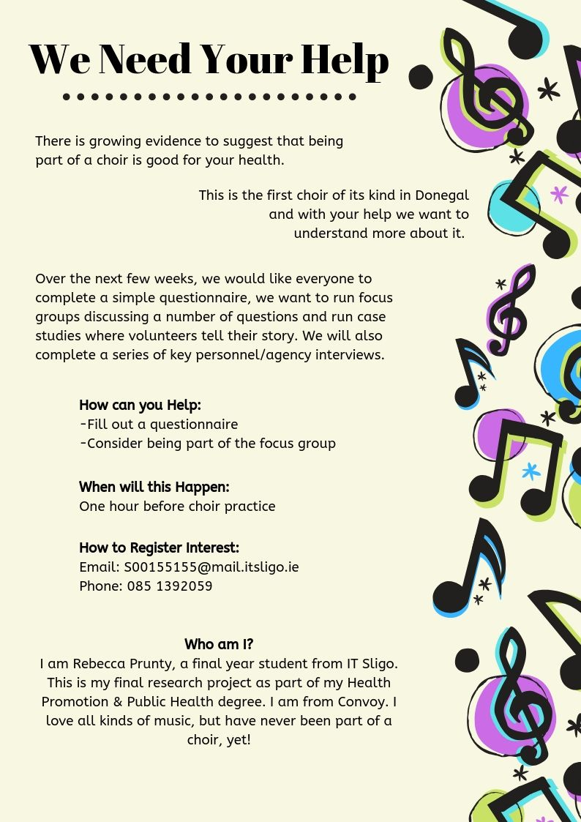

Appendix 2

Consent Form: Children

Date
Dear Parent / Guardian,
I am carrying out research on behalf of Donegal County Council on ‘Ceol le Chéile’, the Donegal Intergenerational choir. This consent form is requesting to use your child’s contribution to the evaluation. This consent form is asking for the permission for your child to participate in a focus group and/or a simple questionnaire. Your child’s involvement in this research is voluntary and they can withdraw from this research at any stage. Responses from your child will be reported but their identity will be kept private and confidential.
Thank you for allowing the time for your child to participate in this research study.
Rebecca Prunty
IT Sligo

(Please tick the appropriate boxes)
I give consent for my child to fill out a questionnaire
I give consent for my child to participate in a focus group
I have read the above information and give consent for my child _____________, to take part in this research into ‘Ceol le Chéile’, the Donegal Intergenerational Choir.
Print Name: _______________________
Sign Name: _______________________ Date: ___________
Parent / Guardian

Consent Form: Adult
Date
Dear Participant,
I am carrying out research on behalf of the Donegal County Council and the HSE on ‘Ceol le Chéile’, the Donegal Intergenerational Choir. This consent form requests permission to use your contribution to the evaluation. You are being asked to participate in a focus group. The focus group questions will be based on different aspects of this choir. The aim of the focus group is to explore the thoughts and opinions of ‘Ceol le Chéile’ participants. There are no right or wrong answers to the questions being asked.
The focus group will be audio recorded and transcribed. Audio files will be deleted after they are analysed. Responses will be anonymised in the report ensuring confidentiality. You are also requested not to share responses from other individuals outside of this room, to respect the privacy of the focus group participants. Involvement is completely voluntary, and you can withdraw from this research at any stage.
Thank you for taking the time to participate in this research study.
Rebecca Prunty
IT Sligo

I have read the above information and give consent that my responses are included in this research into ‘Ceol le Chéile’, the Donegal Intergenerational Choir.

Print Name: _______________________
Sign Name: _______________________ Date: ___________

Appendix 3

Choir Review: Children
Are you a …? Boy Girl
What age are you?
Q1. Do you enjoy coming to this choir? Yes No

Q2. What are the 3 things you like the most about this choir?
1. __________________________________________________________
_________________________________________________________
2. __________________________________________________________
__________________________________________________________
3. __________________________________________________________
__________________________________________________________
Q3. Since joining the choir what have you become good at?
__________________________________________________________
__________________________________________________________
Q4. What is your favourite part of the choir?
__________________________________________________________
__________________________________________________________
Q5. Did you make new friends in the choir? Yes No
Were these friendships with the:
Older Adults
Children
Both
THANK YOU

Choir Review: Adult
Please rate these statements by circling a number from 1 to 5.

 | - None of the Time | - Rarely | - Some of the Time | - Often | - All of the Time
Taking part in ‘Ceol le Chéile’ is enjoyable | 1 | 2 | 3 | 4 | 5
‘Ceol le Chéile’ benefits me socially | 1 | 2 | 3 | 4 | 5
‘Ceol le Chéile’ benefits my well-being | 1 | 2 | 3 | 4 | 5
Practice sessions and performances were well organised | 1 | 2 | 3 | 4 | 5
I can apply some of the things I learn in the choir to other aspects of my life | 1 | 2 | 3 | 4 | 5
The venue for practices was suitable | 1 | 2 | 3 | 4 | 5
The length of the practices was about right | 1 | 2 | 3 | 4 | 5
The time of practices was suitable | 1 | 2 | 3 | 4 | 5
The frequency of practices was right | 1 | 2 | 3 | 4 | 5
Would you recommend to a friend? YES / NO
Any other comments?

Thanks for helping by filling out the questionnaire.

Appendix 4

Focus Group: Children
Protocol:
My name is Rebecca. I will be asking you some questions about ‘Ceol le Chéile’, the Donegal Intergenerational choir. I will be also be taking short notes throughout. I would ask you to discuss the questions among yourselves and respond to each other’s answers. This is not a test, there is no right or wrong answers. I want to hear your thoughts and opinions about the choir.
The focus group will be audio recorded and no one will have access to this voice recording and files will be destroyed when this research is completed. It is intended to make everyone feel comfortable that they can speak openly and honestly. I ask that the information shared during the focus group doesn’t leave this room.
Your parents/guardians have signed a consent form, allowing you all to participate. It is important that everyone knows that they have the opt out of the focus group and from this research at any stage.
If there is a question you don’t understand, please let me know and I will say it differently. I may directly ask someone a question. This is not to pick on someone, it is to ensure everyone’s opinions are included.

Topic Guide:
 | QUESTIONS | PROMPTS
1. | What were your reasons for joining this choir?  (why did you join, where did you hear about the choir) | - enjoy singing  - friends  - hobby
2. | What thing(s) do you like about the choir?  (what have you enjoyed the most, what aspects did you like) | - singing  - practices  - performances  - friends
3. | How could the choir be improved?  (what changes would you make) | - practices  - performances
4. | What knowledge, skills and attitudes have you developed since joining the choir? | - confidence  - self-esteem  - singing
5. | From joining the choir, what changes have you noticed about yourself?  (how have you changed) | - confidence  - self-esteem  - belong to family
6. | How did your participation in this choir influence your views on older adults?  (how have your thoughts of older adults changed) | - ageism  - stereotypes  - healthier  - respect
7. | Why do you like singing with the older adults? | - fun  - friends
8. | If you weren’t a member of this choir, what would you be doing instead?  (what would your other hobbies be) | - gaming  - exercise  - nothing
9. | What makes you want to come back to the choir each week?  (what encourages/motivates you to come back) | - friends  - enjoyment  - likes choir

Focus Group: Adult
Protocol:
My name is Rebecca and today I am going to be the moderator for this focus group. I would like to create a discussion within the group. I will be asking questions along with taking short notes throughout the session. This research is being conducted to explore the impact of ‘Ceol le Chéile’, the Donegal Intergenerational Choir, through asking the members their thoughts, opinions and viewpoints.
The information gathered will be analysed and confidentiality will be ensured as participants names will be coded during the analysis of the discussion. The focus group will be audio recorded and notes will be taken of participants’ opinions and comments, to enhance the research by including every detail. No one will have access to this voice recording and files will be destroyed when this research is completed.
It is intended to make everyone feel comfortable so that they can speak openly and honestly. It would be greatly appreciated that everything said during this focus group does not leave this room. I am asking everyone to keep each other’s opinions confidential to the group.
A consent form will be distributed, seeking that each participant agrees to fully participating in the focus group. The consent form requests your permission to be audio recorded for the duration of the focus group.
It is essential that everyone knows that they have the option to withdraw from this research at any stage. If any participant requests to be withdrawn from the research, their involvement and responses will be removed from the transcripts.
This is an informal focus group, where I will ask you to discuss the topics among yourselves and respond to each other’s answers. There are no right or wrong answers, and this is not a test. I would like everyone to share your experience and opinions on this topic. Different viewpoints and opinions are appreciated and welcomed. If there is a question you don’t understand, please let me know and I will rephrase it.
Also, if I feel the engagement is low among the group, I may directly ask someone for their response to the question. This is not to put anyone on the spot, but to try to have full co-operation from all group members and ensure that everyone’s opinion is included.
Ground Rules:
I would like to go through a few simple ground rules:
- Please keep information confidential to this group
- Respect everyone’s views as everyone is entitled to their own opinion
- Turn off mobile phones or put them on silent
- Be honest and open with your responses
- Listen to each other’s opinions and feel free to respond to each other
- Only one person speaks at one time

Topic Guide:

 | QUESTIONS | PROMPTS
1. | How did you first hear about the Donegal Intergenerational Choir? | - radio  - newspaper  - online  - friend
2. | What were your reasons for joining the choir? | - social inclusion  - past time  - enjoy singing
3. | Your first few days at the choir, can you remember how it was? What was it like?  (how did you feel on that day) | - friends  - emotions  - like or dislike
4. | How long have you been in the choir and what encourages you to come back?  (what motivates you) | - incentives  - friendship  - enjoy choir
5. | In what ways has this choir impacted on your health?  (have there been improvements or deterioration on your health / visits to the GP/ general outlook on life)  (Have you noticed any other effects of being in the choir in terms of your mental/physical health & wellbeing) | - positive  - negative  - well-being  - physical  - social
6. | What have you enjoyed most about belonging to this choir? | - singing  - friendships
7. | What has been your favourite moment so far from being in this choir?  (memory that sticks out, you remember the most) | - performance  - practice
8. | How do rehearsals differ from performances? | - Warm-up exercises – longer  - Anxiety  - Audience  - Conductor  - Enjoyment
9. | What do you like the most about this choir?  (what have you enjoyed the most, what aspects did you like) | - singing  - belonging  - performances  - friendships
10. | What did you dislike about this choir?  (anxious, nervous, didn’t enjoy) | - location  - time
This is an intergenerational choir with older adults and children. I am going to ask you about the benefits/negatives of this intergenerational approach.
10. | What did you gain from the intergenerational aspect?  (Were there any benefits to you from interacting with the children?) | - intergenerational learning
11. | For you, were there any drawbacks from the intergenerational aspect?  (Any negatives to singing with the children?) | - practices  - uncomfortable
12. | What would you say to a friend about intergenerational choirs?  (How would you encourage them if you wanted them to join?) | - mental health  - social inclusion  - physical health
13. | If this choir were to continue what advice would you give to organisers or participants?  (Is there any change you would like to see made?) | - location  - time  - venue  - ages  - songs

Appendix 5

Individual Interview 1
 | QUESTIONS
1 | Why have you become involved in the choir?
2 | As you have previously mentioned you are been involved in many choirs. What are the differences in ‘Ceol le Chéile’ in comparison to the others?
3 | This is an intergenerational choir for young and old. What are the benefits of being in a choir like this?
4 | How could the intergenerational aspect be promoted?
5 | The number of men in the choir is considerably lower. How would you encourage more men to attend?
6 | In relation to men’s health, what are the benefits to men from being a member of this choir?
7 | The Donegal County Council has loads of money to spend on other initiatives. Why should the council keep investing in this choir?
8 | In what ways do you think the children benefit from being in this choir?

Individual Interview 2
 | QUESTIONS
1 | How did you hear about the choir?
2 | Why have you become involved?
3 | What aspects of the choir have been beneficial and what aspects have been unprofitable?
4 | In the last year what have you noticed about the progress of the choir?
5 | This is an intergenerational choir for young and old, what are the benefits of this?
6 | How could the intergenerational aspect be promoted?
7 | The Donegal County Council has limited funding. For what reasons should the Council keep investing in this initiative?
8 | If the choir was open for applications for new members, how would you recommend it to a friend? What would you say to them to encourage them?

Individual Interview 3
 | QUESTIONS
1 | From a parent’s perspective, why do you think your child goes to the choir each week?
2 | What does he/she enjoy going?
3 | From being a member of the choir for over a year, what has your child’s positive/negative experiences been?
4 | What changes have you noticed in your child since joining the choir?
5 | Have you noticed any changes in how your child interacts with adults since joining the choir?
6 | Any other comments?

Appendix 6

Donegal County Council Interview
 | QUESTIONS
1 | What is your role within the Donegal Social Inclusion Unit?
2 | What is the Donegal County Councils involvement in ‘Ceol le Chéile’?
3 | As other social activities were previously implemented, what was the rationale behind introducing an intergenerational choir? How did ‘Ceol le Chéile’ come about?
4 | How were the participants recruited for the Donegal intergenerational choir?
5 | From your perspective, how do the participants, young and old, benefit from participating in an intergenerational choir? How would you rate these relationships?
6 | What are the positive impacts ‘Ceol le Chéile’ has on communities within Donegal? In what ways do intergenerational activities build more cohesive communities?
7 | What are the positive or negative outcomes in this investment for the Donegal County Council?
8 | In your opinion, has ‘Ceol le Chéile’ been implemented effectively as part of the Donegal Age Friendly Strategy?
9 | In what ways do you see the council benefiting from supporting ‘Ceol le Chéile’?
10 | If other councils were interested what advice would you give them? (organisation, participants etc)
11 | Who are the other partners in ‘Ceol le Chéile’? Why are they important partnerships?
12 | There is currently a waiting list for members wanting to join. How are new members selected?
13 | What is the future of the choir?

HSE Interview
 | QUESTIONS
1 | What is the HSE involvement in ‘Ceol le Chéile’?
2 | Why did the HSE decide to fund this project?
3 | Why was this project prioritised over other health promotion initiatives? (funding etc)
4 | What do you believe are the benefits of belonging to ‘Ceol le Chéile’, the Donegal Intergenerational choir?
5 | What, if any, are the drawbacks or negatives from participating in this choir?
6 | What is your opinion on the importance of relationships between the older and younger participants in this choir? How would you rate these relationships?
7 | What is your viewpoint on this choir promoting social inclusion? Has this aim been met as part of the Donegal Age Friendly Programme?
8 | What do you feel encourages and motivates participants to repeatedly attend the choir sessions?
9 | If you had to make any changes to the implementation of ‘Ceol le Chéile’, what would they be? (organisation, recruit of participants)

LYIT Interview
 | QUESTIONS
1 | How did you first hear about ‘Ceol le Chéile’?
2 | How does the LYIT contribute to ‘Ceol le Chéile’?
3 | The LYIT have been generous providing a venue for choir rehearsals. Why does the college provide the venue free of charge?
4 | This choir is different, the intergenerational aspect, people from 6 to 90 years old. What do you think are the benefits of an intergenerational activity?
5 | What have the comments been about the choir over the last year? From staff and/or students?
6 | The council have many demands on budget and resources. How do you see this intergenerational choir as an investment?
7 | Why do you think this venue is appropriate for choir rehearsals?
8 | In the future, what are your thoughts of the LYIT’s involvement in this choir?

Local Link Interview
 | QUESTIONS
1 | How did you hear about this choir?
2 | How does Local Link/SITT contribute to ‘Ceol le Chéile’?
3 | Why does Local Link/SITT support the choir?
4 | Who can avail of Local Link/SITT services?
5 | Local Link/SITT provide transport all over Donegal, what were the reasons for providing transport for this choir?
6 | From what areas does Local Link/SITT provide its services for the choir members?
7 | How many choir members avail of this service?
8 | How significant is this transport service in enabling the participants to attend the choir rehearsals/performances?
9 | As the choir continues, do you see Local Link/SITT continuing to be involved?

Choir Director Interview
 | QUESTIONS
1 | How did you first get involved in choirs?
2 | What is your role within ‘Ceol le Chéile’? How did you get involved?
3 | Having so many years’ experience with choirs, in what ways is being in a choir good for your health?
4 | What changes, if any, have you noticed in the choir and the members since the start?
5 | What are the challenges associated with an intergenerational choir?
6 | Working with an intergenerational group brings up challenges but what are the benefits?
7 | Previous research suggest that intergenerational activities can encourage the formation of valuable relationships between the different age groups. Would you agree with this statement in relation to ‘Ceol le Chéile’? Why/Why not?
8 | Looking into the future, what changes would you make to the choir?
9 | In your opinion what methods or approaches are the most effective in attaining the best possible outcomes for an intergenerational choir?
10 | Why should councils and the Donegal County Council continue to invest in this/intergenerational choirs?

Choir Liaison Officer Interview
 | QUESTIONS
1 | What is your role within ‘Ceol le Chéile’?
2 | From your perspective, how do younger participants benefit from participating in this choir?
3 | What benefits have you noticed to the older participants?
4 | If you had to pick negatives from the choir, what drawbacks would you suggest are associated with intergenerational choirs?
5 | What are the positive aspects of intergenerational choirs?
6 | How could the intergenerational aspect be promoted?
7 | If other councils were interested in forming an intergenerational choir, what advice would you give them?

Donegal County Council – Social Inclusion Unit:
Mr. Charles Sweeney, Social Inclusion Co-ordinator,
Community, Development & Enterprise, Donegal County Council,
Public Service Centre, Milford,
Co. Donegal.
Email: charles.sweeney@donegalcoco.ie
Tel: 074 9153900

Ms. Mairead Cranley, Assistant Social Inclusion Co-ordinator,
Community and Planning, Donegal County Council,
Gweedore Road, Dungloe,
Co. Donegal.
Email: mairead.cranley@donegalcoco.ie
Tel: 074 9561326

