The views of older people in Monaghan
A report on public consultation 2019
During January and February 2019, Monaghan Age Friendly programme conducted a countywide consultation process to identify the current issues and challenges impacting on older people in our communities. The aim of this consultation was to inform the development of a new Age friendly strategy for county Monaghan that will be delivered over the next five years. (2020-2025). Over 400 submissions were received from older peoples groups, organisation supporting older people and individual older people in the community. The level of engagement in the consultation process has brought the issues, challenges and recommendations from older people all over the county to the attention of the Age friendly programme. Monaghan age friendly county programme appreciate each and every person who completed a questionnaire, submitted written or verbal response or who attended a public consultation meeting.
To begin the process of developing a new Age friendly strategy for county Monaghan we have prepared a report on the issues, concerns, challenges and recommendations that were highlighted during the public consultation process. The World Health Organisation Age Friendly Cities and Counties programme set out eight key themes of the age friendly programme. This report sets out the issues identified through consultation under each of the eight themes.
The eight themes are the age friendly programme are:
- Outdoor spaces, buildings and the physical environment
  - To make our outdoor spaces and buildings in the county, accessible and safe for older people.
- Transport
  - To promote safe, accessible, reliable and comfortable transport services for older people.
- Housing
- To provide supports and information to enable the appropriate continuum of housing choices and options for people in Monaghan as they grow older.
- Respect & Social Inclusion
  - To challenge stereotypes and negative attitudes towards ageing and eliminate discrimination against older people.
- Social Participation
  - To provide information and opportunities for older people to stay socially connected and to play an active part in social clubs and activities.
- Communication and Information
  - To ensure that older people can easily access information about services, supports and activities in their communities.
- Civic participation and employment
  - To increase employment, volunteering and civic participation among older people
- Community support and health services
  - To provide older people with easily accessible health and community services and with help with, and access to, everyday activities and support in their communities.

Theme One: Outdoor spaces, buildings and the physical environment
Without proper planning, the physical environment and many essential public services e.g. transport, health, shops, and Gardaí, as well as private services e.g. shops, postal services and banking, can act as a barrier to older people remaining active in their community. This, in turn, can lead to deterioration in people’s physical and psychological health.
Issue identified | Recommendation
Inaccessible streetscapes | Proposed actions
- Footpaths uneven, cracked and dangerous.  - Footpaths very narrow in places with no warning.  - Uneven paths at Market St, Monaghan near church a number of falls reported in consultation.  - More seating needed around towns/villages.  - Street lighting in some rural areas is limited and can be dangerous for older people. | - Review of streetscapes in the five main towns to be carried out to identify access issues that are impacting on older people.  - Any planned upgrading of streets and footpaths should use the Accessible procurement strategy to ensure the needs of people with mobility difficulties are accommodated.  - Audit of Market street and access to St Joseph’s church should be carried out and remedial works to improve access and safety in this area.  - Programme of installing more accessible seating throughout the streets in the main towns should be delivered.  - Any programme for installing street lighting should be prioritised in areas with higher population of older people.
Access to buildings and services | Proposed actions
- Access can be difficult, no handrails or ramps into some services making it very difficult for some older people. | - Age Friendly Programme should develop an information guide for business and services in the county to highlight some of the barriers to access experienced by older people and people with mobility difficulties. The guide should include information on how services and shops can improve access.
Accessible parking | Proposed actions
- Disabled parking spaces frequently used by people without a permit.  - Need for age friendly parking for those without a badge | - Awareness raising programme needs to be developed and implemented to tackle the issue of illegal parking in accessible parking bays.  - A programme of Age Friendly parking spaces to be developed to provide parking spaces in key service areas and town centres for older people with mobility difficulties who don’t have an accessible parking permit.
Outdoor recreation | Proposed actions
- Walkways in Ballybay park uneven and dangerous to walk.  - Some pathways in Rossmore are uneven.  - More seating in needs in parks/greenways to allow people to rest.  - More seating in playground for grandparents . | - Upgrading of walkways in Ballybay town parking to be upgraded to improve accessibility.  - Review of walkways in Rossmore to identity the most accessible routes and provide signage to information people of the most accessible walkways.  - All new playgrounds developed and upgrading of existing playgrounds should ensure adequate accessible seating are provided.
Buildings | Proposed actions
- Permanent accommodation for U3A group  - Errigal Church & road very dangerous  - Clara hall is unused | - Age Friendly programme to work with Monaghan County Council to identify and secure a permanent location for Monaghan U3A group.  - Monaghan County Council to review the road and access to Errigal church to identify measures to be taken to improve safety and access at the site.  - Age friendly programme to arrange meeting with Clara hall committee to identify any supports that can be given to bring hall into community use again in particular for older people.

Theme One: Outdoor spaces, buildings and the physical environment
Issue identified | Recommendation
Pedestrian crossings | Proposed actions
- Some pedestrian crossing doesn’t allow enough time to allow people with mobility difficulties to cross safely.  - Some pedestrian crossings reported to have sounds deactivated causing difficulties for people with visual impairments | - An audit programme of all pedestrian crossing to be carried out to ensure a consistent crossing time is available at each crossing.  - Monaghan County Council to ensure every pedestrian crossing the country has audit signal crossing and visual crossing signals activated.
Adult Changing places | Proposed actions
- There are currently no adult changing toilet facilities in county Monaghan. | - A programme to establish Adult changing facilities in a number of locations throughout county Monaghan in line with Changing Places Ireland standards.
Age Friendly Libraries | Proposed actions
- Monaghan Library services were identified as an excellent service, outlet and resource for older people in the county. | - Support the roll out of Monaghan town library , Age Friendly Library programme, a programme that delivers a number of actions aimed at making Monaghan branch library more age friendly.  - Develop a programme to support the roll out the Age Friendly library programme to all branch libraries in the county.

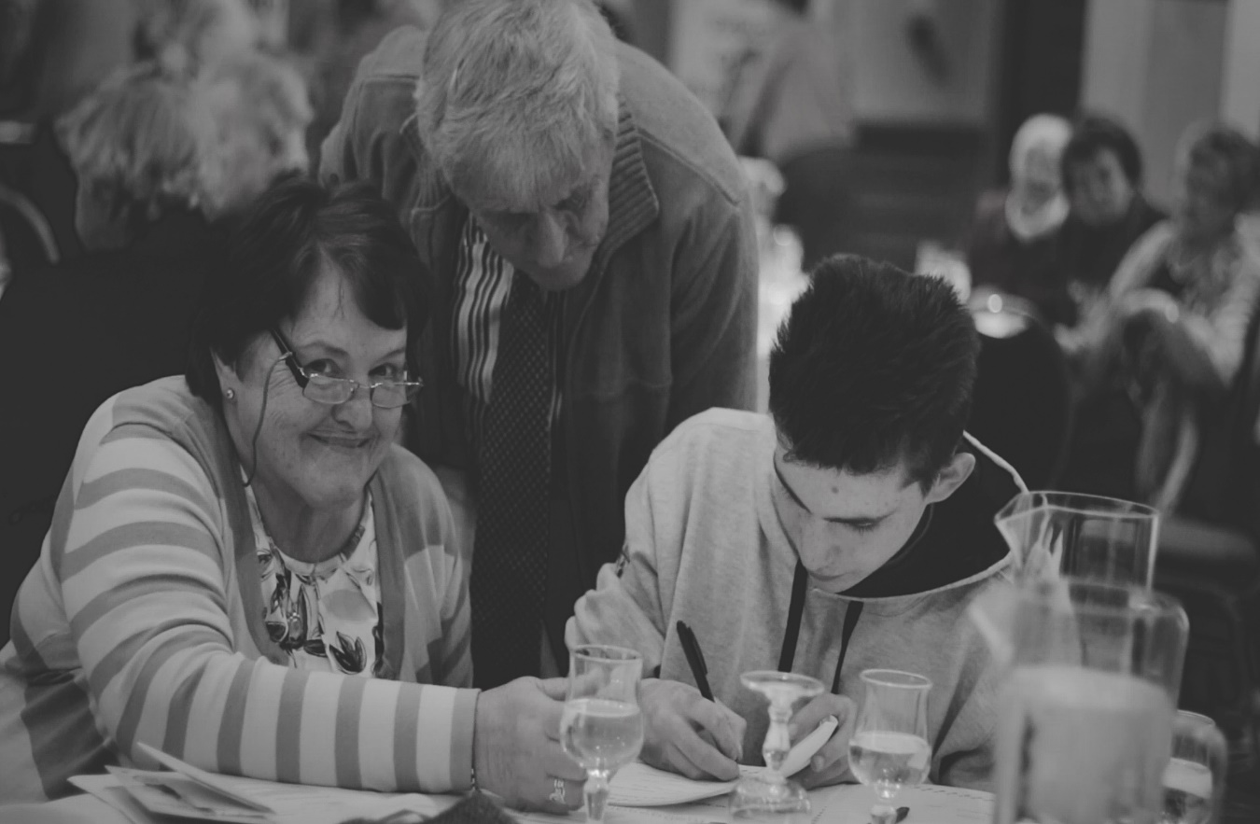

Theme two :Transport
Owning and being able to use one’s own transport or having access to affordable public transport, are key contributors to active ageing. Being able to move about influences social and civic participation and facilitates access to community and health services. The inability to use a car is a very significant loss.
Issue identified | Recommendation
Road Safety | Proposed actions
- Since 2016 to date 50% of people killed on Co Monaghan’s roads were aged over 60. Our road safety programmes have little or no interaction with older people’s groups.  - Local Link Bus stops not safe or well signposted  - Bus stops /shelters along new bus routes aren’t safe | - To roll out a road safety programme specifically designed by the Road Safety Authority for older people.  - To work with LOCALINK to review current signposting/bus stops and bus shelters on Localink routes in Monaghan to identify where improvements or additional resources are required.
Availability of transport | Proposed actions
- Better information on all bus services needed - easy to read  - Transport of patients to Carrickmacross day care Centre - Volunteers not insured to facilitate  - Transport to social activities and services some people are not aware of transport services that could bring them to services and activities | - Collation of easy to read bus timetable to include all new routes/stops / promote use of bus pass.
Costs related to accessing transport | Proposed actions
- Motor Insurance for older people Car insurance - Can't afford high payments  - Me Introduction of fares on HSE transport routes for older people and people with a disability are unfair  - Medical report for over 70's drivers licence | - Monaghan Older people’s network to ensure this issue is included in the work of the National older peoples Council.  - Monaghan Older peoples network to continue to raise this issue locally to highlight the negative impact on older people of this new charge.
Poor access to taxi services | Proposed actions
- It is very difficult to get a taxi service , especially in rural communities, people relying on family or neighbours.  - There is a need for a community car scheme or similar model in rural communities. | - Collate list of taxi service providers in the county and include in user friendly guide to transport information.  - Explore the possibility of developing a “Rural Uber” type model in county Monaghan.
Access to Transport | Proposed actions
- At present the Bus Eireann bus from Carrickmacross to Dublin is not permitted to stop/pick up on the main street. This requires passengers to walk to outside the town in order to access this bus. This is a particular difficulty for older people.  - Lack of transport services at night and during winter evenings means older people don’t get to socialise after 6pm. | - Monaghan Age Friendly programme to arrange meeting with the relevant agencies involved to highlight the difficulties experienced by older passengers.  - Explore current availability of Localink services in evenings and weekends, and possibility of services becoming available.

Theme three: Housing
It is well-documented that older adults wish to “age in their own home”. This requires that, as we age, we can continue to live in a way that is safe, affordable and connected to the community where the supports and services we need are available.

Issue identified | Recommendation
Downsizing | Proposed actions
- Older people living in large family homes would be interested in moving to smaller homes but have no information or support on how you could begin this process.  - Older people struggling to maintain large homes but have no alternative but to remain in the larger home.  - Older people living in very isolated rural communities would like to live nearer services and shops but no options available. | - Need to carry out some further consultation to identify the level of need/interest in relation to downsizing/relocation.  - Discuss with Housing department in relation to the issue and future priorities for older persons housing .  - Support the implementation of the Castleblayney pilot town centre living initiative in relation to the Age friendly programme.
Adapting your home- supports for older people | Proposed actions
- There was limited knowledge of supports and resources available to older people for adapting your home.  - People find the current information very complex and difficult to understand.  - Other people had no knowledge at all about supports and assistance that may be available. | - There is a need for clear, easy to read information about grants, support and assistance that is available for people who wish to adapt their home to allow them to continue to live independently.  - Promotion and circulation of this information needs to reviewing in order to ensure the information is getting to older people in the county.
Eircode Awareness | Proposed actions
- Many older people do not know their Eircode, and don’t know how to find it if they need it in a hurry.  - Many people did not know the importance of Eircode in relation to emergency services , Gardai etc. | - There is a need to develop and roll out and Eircode awareness programme that is easy to read and circulated among the older population, in particular older people living alone.
Safety and Security | Proposed actions
- Seniors Alert Scheme is not available in some areas of the county.  - There is a lack of awareness about:  - The Seniors Alert Scheme and how to access it.  - Community Alert/Text scheme.  - Monaghan Alerts programme.  - Getting to know your community Gardai and staying safe in the community. | - The Age Friendly programme needs to review the current availability of the Seniors Alert scheme and identify areas of need and support interested community groups to establish the scheme their communities.  - There is a need to prepare a safety information booklet/leaflet that provides information on these key safety schemes for older people and how to access them.  - Community Garda information sessions- Roll out a series of information talks with local community Garda to support older people who may have a fear of crime and offer tips on how to keep safe at home.

Theme Four : Respect and Social Inclusion
Older people in general feel included as part of their community and neighbourhoods. Good neighbours and a sense of community identity are
essential to this and it was noted that both are important to developing a sense of inclusion and identity regardless of what age you are. Identity with
place was seen as being very important.
Issue identified | Recommendation
More Intergenerational opportunities with younger children | explore programme between older people and pre-school groups to share skills and stories
More opportunity for storytelling/social history | Reminiscence programme - link with the Museum to run series of storytelling on certain topics
Many older people are caring for grandchildren - would like to meet others | Set up some Granny groups- like mother and toddler groups but for grandparents
People are embarrassed because they require help | Promote positive age campaign to challenge stereotypes about aging
Poor adjustment to retirement. | Retirement clubs for people new to retirement - informal chance to meet others

.

Theme Five Social participation
Social participation has a very positive impact on quality of life as well as physical and psychological health. It provides a feeling of being part of a community, family or network.
Therefore social participation in older age has a positive impact Social participation and health
have a symbiotic relationship; an older person’s feeling of health/well being has an impact on the level of active and passive social participation while active
social participation can increase a person’s sense of health and well being. It is worth noting that the level of social participation is dependent on the level
of social resources and support available to the older person. These resources include access to transport, information, sense of security and finances.
Issue identified | Suggestions from older people
- Lack of awareness of what is going on in local communities | - Need to gather info on activities/events happening in each MD and promote it where older access info
- People don’t come to activities happening in their local area. | - Look into new ways of encouraging people to attend, or maybe research into why people don’t go
- There is never anything new to do always the same activities. | - Give members an opportunity to suggest new ideas and try new activities.
- Many people lonely and won’t go on their own to club | - Look at rolling out Dochas for women DATE NIGHT -
- Many carers in the community are over 65 and isolated, stressed and lonely. | - Explore possibility of " Caring for Carers" at very local level -providing support to carers
- Older men who can no longer drive or walk long distances don’t get to attend GAA matches anymore | - GAA Outreach programme - identify isolated men and link in with people who can take them to games
- No opportunities to visit other older peoples clubs in the county | - Social Networking – setup visits to other clubs and groups a few times a year.
- Bereavement is a very hard | - Create chance for people who a grieving to met and have a chat, doesn’t always have to be formal meetings

Develop a range of physical activity programmes for older people throughout the county.

The consultations sessions also highlighted that networking and sharing
information between community groups was poor, with members of some
groups saying that they would have helped another group out if they knew
when they were organising an activity. It was suggested that a calendar of
events for a local area should be developed and displayed in an appropriate
public building such as a library or a post office. It was also suggested that
there should be an overall development committee for an area which would
be a central hub for sharing information locally. However some participants
felt this would be placing an extra burden on already overworked volunteers.
The role of the PPN and the Volunteer Centre in supporting or developing
networking opportunities should be explored.
• Communications between branches of the same organisation such as Active
Retirement should be enhanced to facilitate interaction between older
people from different areas.
• Church for mass and services was seen as a valuable opportunity for social
participation. A number of areas have developed a tradition of tea/coffee in
local coffee shop/church hall or community centre after church during the
week to increase social participation. This could be replicated around the
county with minimum cost.
• During the consultation the issue of isolation among older men was raised
as a serious issue. Projects and groups which encourage participation
among men should be focused on. Suggestions included support for Men’s
shed and the development of a policy for community gardens/ allotments as
a way of involving men was put forward as possible actions to include men.
• While some sports do facilitate older people to continue playing and remain
engaged it was felt that more should be done to ensure that older people
remain physically active. The view was expressed that when you get older
you go on committees but do not remain physically active, GAA Healthy
Clubs initiative was seen as a way of getting people back active.

Throughout the county there is a wide range of community and voluntary
groups which older people actively participate in these include the GAA,
Active Retirement, ICA, Friendship Groups, Social Dancing, book clubs, art
and crafts groups, drama groups tidy towns, etc. However it was recognised
that in some areas especially rural areas there is not as much choice and an
older person needs access to transport to get involved.

Poor diet/nutrition
Poor mental health
"Fair deal" Scheme | Reps that can be made on this, Information for Farmers
Everything is online (internet) | Information to be available in local papers also
Poverty/low incomes
Age Friendly Communication practice very important | Promote and roll out Age Friendly training across the county
The language used and the effect it can have was raised
Dementia Awareness very important

Theme six : COMMUNICATION & INFORMATION
Issue identified | Recommendation
Lack of awareness of services available for older people or where you can access them. | Local clubs, groups and churches are a great way to get information to older people.
Everything is online | Services should be advised that not everyone can use the internet. It shouldn’t be the only way to get information.
Information on health is difficult to find, what if you have questions about something | Community information talks are great way to get information and meet people
Internet Safety/Technology | Security of mobile phones - courses needed/online scams/using a computer/online banking
Lack of awareness amongst policy-makers and service-providers of that it is like to be an older person in Monaghan. | Awareness raising work with services providers about aging and getting older. Promote and roll out Age Friendly training across the county
Age Friendly Communication practice very important | More work on the guide to communication needed so services and not very age friendly.

Theme Seven: CIVIC PARTICIPATION & EMPLOYMENT

Issue identified | Recommendation
Monaghan Older peoples network is not a good representation of older people in Monaghan. | Need to find new ways of engaging older people to give everyone a chance to have their voice heard.
lifelong learning as well as participation | More support to encourage older people to take up courses with CMETB
Age Friendly business scheme is very good | Keep this programme going and look to get more shops to join
Greater access to politicians to raise issues and concerns nationally | Older peoples network should create the opportunity for discussion and debate with politicians
Support for carers | Can the volunteer centre recruit people to give carers a break once or twice a week.
Taking care of Grandchildren - Responsibility & time pressures | Granny groups - around the county - similar to mother and toddler put for grandparents
Skills sharing older people | develop a programme with Local Enterprise office on skills sharing -esp for self employed

Theme eight : COMMUNITY SUPPORT & HEALTH SERVICES

Issue identified | Recommendation
Unable to get appointment with GP's for a number of days | Approach HSE & GP's
Unable to make appointment for 1 week in advance | Approach HSE & GP's
No wheelchair available - Day Care Centre | Funding - HSE stores
A nurse to visit the centre on a regular basis
Services the Pharmacist can provide | Better information to be published
Significant lack of awareness of Primary care centres and what they provide

Community Alert Scheme - Personal Alarms/pendants | Requires a community group to roll this out & promotion of service available

