September 11, 2019 First Annual Steering Committee Meeting
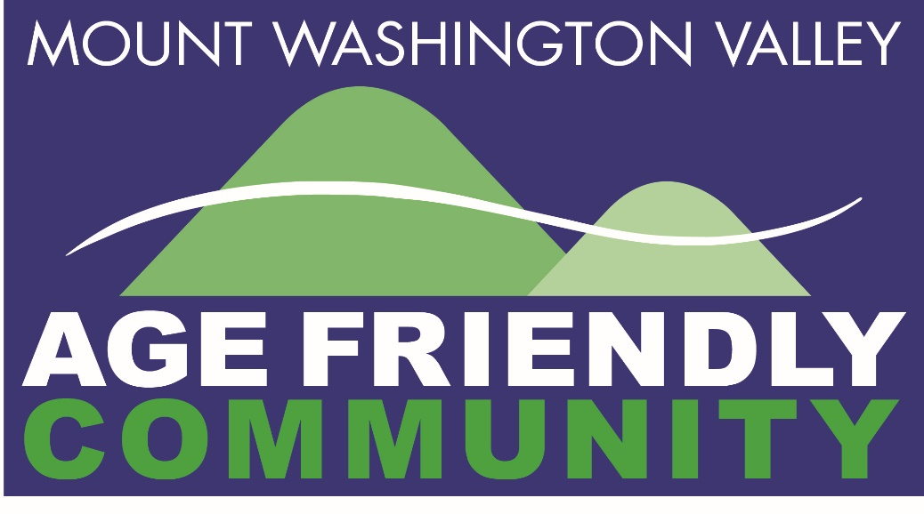
Our Mission:
Using the AARP Livable Community Framework, we combine the talents and resources from all of our 11 towns to further develop the Mount Washington Valley as a place for people of all ages and abilities to thrive.

Our Vision:
Citizens of all ages can say they would rather live here than anywhere else

Our Domains: Community Connections, Health, Housing, Outdoor Spaces, Transportation

Our Progress to date

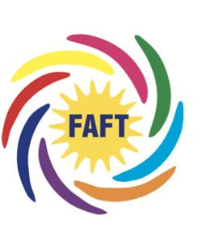
Welcome - Fryeburg Age-Friendly Taskforce – 8-10 regular members meeting weekly through the spring and summer of 2019 surveying the towns people, investigating rural transportation options, replicating emergency preparedness programs, participating in housing weatherization, and working to repurpose the Snow School for senior housing

Community Connections
Goal #1: Foster more intergenerational relationships within educational institutions
- We have established contacts with administrative offices of SAU 9 and 13 and MASD 72. Additionally, we have had direct contact with Freedom Elem, Children Unlimited, Bartlett Elementary and Molly Ockett to explore ideas for various programs in their schools.
- We will also be meeting with Mandy MacDonald to talk about the End 68 Hours of Hunger program and with Margaret Rieser & Sue Colton re the Oasis tutoring programs in Tamworth and Madison.
- We have had conversations with John Eastman and Sut Marshall (Conway Rec) and Rick Buzzell (Fryeburg Rec) and Carrie MacLane Burkett (North Conway Community Center) about using their new facilities with all ages.

Goal #2: To set up town specific service directories and to establish email exchanges, replicating the Freedom model (and Tamworth Exchange, Madison Boulder, etc.) for all 11 towns as desired by them.
See Goal #4

Goal #3: Explore streamlining the vetting process of volunteers across Valley agencies and non-profits.
Research with the SAU’s and a survey done in conjunction with the Chamber of Commerce revealed the non-standardized levels of background checking done for volunteers. To address this, we met with Stephen Woodcock about developing legislation pertaining to vetting that we can support. Steve has also addressed this with local and state police. We will also be in contact with AARP National and with Todd Fahey (NH State AARP Director) to enlist them in approaching the national and NH state orgs regarding the vetting issues we all face.

Goal #4: Enhance the service/resource lists maintained by ServiceLink Aging and Disability Resource Center and develop linkages with each Town and the Gibson Center
- Freedom’s selectmen have approved and have hired a paid part time position for a senior services coordinator!
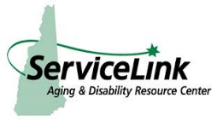
- Ele Border and Dawn Barnett (head of Service Link in Tamworth) are currently gathering information on all of the services that are available in the Valley to seniors and preparing a resource guide in paper and digital format. Publication by February 2020.

- Service Link and the Gibson Center are partnering to train volunteers who will assist seniors enroll in Medicare Part D prescription drug plans beginning in October 2019

Special - Added Goal #5 – Directory of Volunteer Opportunities
We are applying for a Tufts Health Fund Momentum Grant for development of the MWV Age-Friendly Directory of Volunteer Services.
This web-based guide will allow all Valley non-profit agencies with more than 5 volunteers to list their opportunities with descriptions of the positions including hours or days needed, age requirements, skills needed or not, vetting processes, special one-time event vs ongoing service, contact persons, website links, and ability for agencies to edit/update their information. The directory will be hosted at the Gibson Center but available to all. Coming in 2020.

Health
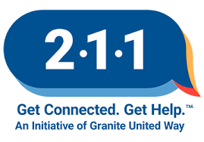
Goal #1: Upgrade local services’ information on the 211 website – “211 Day”
211 NH is our statewide “go-to” site for all resources available to citizens! Everyone should know about it, use it and the information should be accurate and current.
Almost 90 organizations, towns, departments and resources were contacted to raise awareness and provide instructions for updating their information on 211. Response was highly favorable. Follow up contact will be done this fall with further tracking.

Goal #2: Age Friendly Walkable Trails -Collaboration with Memorial Hospital 100 Days of Wellness
Beginning in May, Memorial Hospital sponsored the 100 Days of Wellness campaign with challenges and prizes for participation of community members of all ages. Wellness included the parameters of the 5-2-1-0 program of healthy eating, reduced screen time, exercise and elimination of sugary drinks. 119 people registered (and some of us just did it!) Participants received bonus points for walking the Most Walkable Valley Trails – see Outdoor spaces. We would like to replicate the program in 2020.

Goal #3: Intergenerational Music and Memory ®
Tricia Maddox-Larson – speech pathologist with VNHCH and Sue Ruka with the Adult Day Center are exploring the options of obtaining grants to permit certification for volunteers and purchase of equipment vs developing our own modified program with donated iPods and downloadable music. Kiwanis Key Club kids are potentially eager to participate and since our nursing homes are already served, we would change our target to home bound patients.

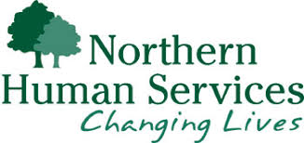
Goal #4: Increase the utilization of the REAP (Referral, Education, Assistance, Prevention) in-home mental health services from Northern Human Services. This consists of 6 free mental health counseling visits by counselors of Northern Human Services for caregivers or those being cared for.
Maureen Hanlon (counselor) reports - Prior to spring 2019, we only had one counselor and 1 or 2 active cases most months for several years. Now we have 11 open cases in Norther Carroll County. It has grown quite a bit thanks to the recent push! We have three counselors now (each has other responsibilities). REAP is a grant and NHS received $27,000 the past budget year for the 3 northern counties. The budget for 2020 has not been passed.
REAP Activity for June & July 2019 - Northern Carroll County (Only two months!)
Referrals: Madison – 5; Tamworth – 2; Center Conway – 1; Intervale – 1
Referrals were made by VNHCH, private therapist, BEAS, general inquiry. Maureen plans to make presentations to Mountain Center for Physical Therapy and Saco River Medical Group

Goal #5: Reach capacity of the “Project Good Morning” (Conway PD) and “Good Morning” County Sheriff’s department – partnering with our local police and sheriff departments to maximize utilization and awareness in all 10 NH towns. Explore what is available in Fryeburg.
Sandy Ruka reports: In NH- towns of Conway, Bartlett, Jackson, Eaton, Albany, Madison, Tamworth all have capacity and willingness to expand program. Except for Conway all these calls are routed through Carroll County Sheriff.
For the towns covered by the Sheriff’s Department there appears to be capacity to do actual wellness checks if needed but we are working on a collaborative program to see if home care services can assist in any way. We anticipate a final answer within one month.
Fryeburg is in talks with the Oxford County Sheriff’s department to replicate the service for Fryeburg.
Housing
Goal #1: Create MWV Accessory Dwelling Unit Town-by-town specific Guide
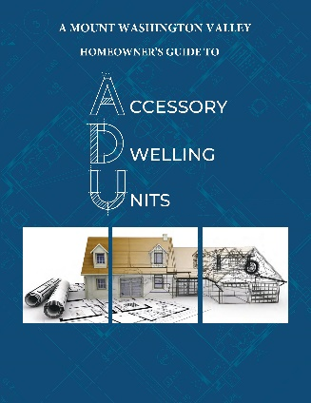
This guide provides a town-by-town resource guide for the requirements to meet zoning by allowed square feet, parking, number of bedrooms allowed, owner occupied or not, detached allowed or not, and more. Additional information is provided to assist homeowners estimate costs, set rental pricing, assess contractors and walk them through the feasibility steps of renovating for an ADU.

Goal #2: Create a Directory and Resource guide for people seeking subsidized housing
Done!
Access at MWV Housing Coalition www.mwvhc.org

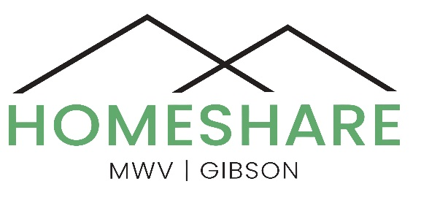
Goal #3: Create HomeShare MWV-Gibson
We have developed all the documents, waivers, handbooks, interviews, background check services and agreements to begin our HomeShare service. We received one of the 186 Community Challenge Grants (out of thousands submitted) for development of the HomeShare MWV-Gibson website that we are happy to unveil for you for the first time right here:
Goal #4: Develop recommendations for zoning improvements to allow more diverse housing units to meet the current needs of citizens

Goal #5: Develop NH State and local Town Legislation to incentivize long-term rentals. After we met with Anita Burroughs, Ed Butler and Harrison Kanzler, Anita drafted language for the legislative services office to research what is or has been done to:
- Enable individuals participating in a home share model to protect their added income from being counted against them in terms of property tax, particularly for low-income people.

- Clarify that home share matching would not be considered a real estate transaction since the challenge by the real estate commission law is vague. How do we right the law so that we can move forward with the home share model?

- Explore tax incentives to keep units as affordable housing.

Outdoor Spaces
Goal #1: Age-Friendly Community Garden in Bartlett
As noted in the Conway Daily Sun: “The dream of late property owner Stoney Morrell for a community recreation complex of gardens, a fitness path, ballfields and possibly someday an outdoor track oval which broke ground in July for the first phase of a Morrell Family Community Complex.”
Annette Libby noted the first phase of the project will consist of creating a three-quarter-mile, 10-station fitness and nature trail on the westernmost parcel, along with a community garden, with the 30-raised garden plots intended for use by residents of all ages, including having higher, 3-foot beds for the elderly.

Goal #2: Age Friendly Walkable Trails (See Goal #2 Health – Memorial Hospital 100 Days of Wellness)
Deb Fauver and her trail friends identified and posted 39 easily walkable trails – representing each of our towns. These are all described with locations and distances on the Gibson Center – MWV Age-Friendly website.
Transportation
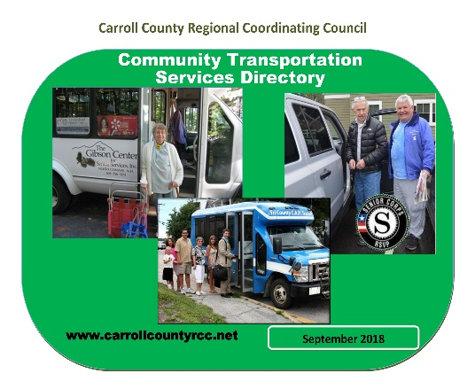
Goal #1: Disseminate the revised Community Transportation Services Directory of Carroll County

