EXPLANATIONS ON ELDERLY SERVICES IN BEŞİKTAŞ MUNICIPALITY 2024-2029 STRATEGIC PLAN
CORPORATE HISTORY / INFORMATION ABOUT BEŞİKTAŞ DISTRICT
According to 2024 data from the Turkish Statistical Institute (TÜİK), the Beşiktaş district hosts a population of 167,264. Despite being one of Istanbul's least populous districts, Beşiktaş welcomes over 2 million Istanbulites daily due to its location between the July 15th Martyrs' Bridge and the Fatih Sultan Mehmet Bridge, its universities, business and entertainment centers, tourism facilities, and its central location in Istanbul's transportation system. Considering that municipalities receive budgets from the central government based on nighttime population, the Beşiktaş Municipality takes this significant difference into account when planning its services and is making significant efforts to address the resulting economic deficit.
Another characteristic of the Beşiktaş district is its high population of 65+ residents, representing 17.3%. Considering that this rate is 10.6% in Turkey (TÜİK 2024), the service responsibility of the Beşiktaş Municipality is even greater. Due to this demographic structure, the Beşiktaş Municipality provides numerous services for the elderly. While our district appears to be home to high-income individuals socioeconomically , one of the biggest problems facing the elderly population is elderly poverty. The fact that elderly people mostly live on pensions, pensions that fall below the minimum wage, the high cost of living due to inflation, and the fact that Beşiktaş is relatively more expensive than other districts, creates a significant level of elderly poverty in our district.

Türkiye's Elderly Population Movements
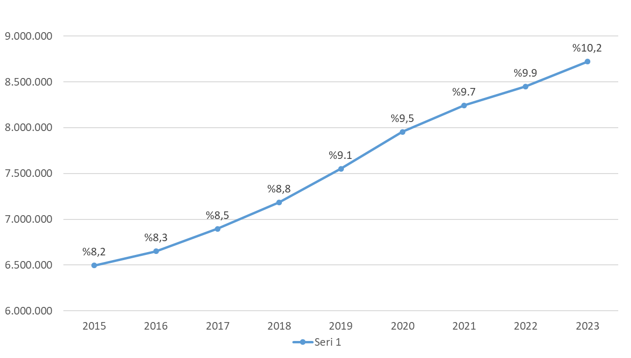

Beşiktaş Population Movements

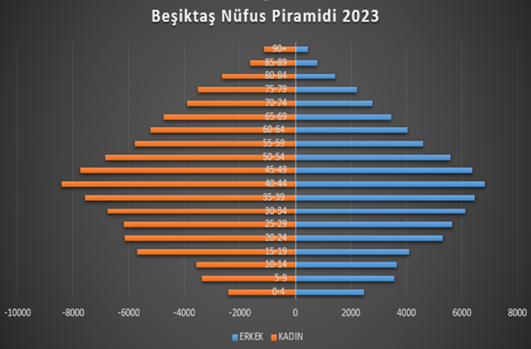
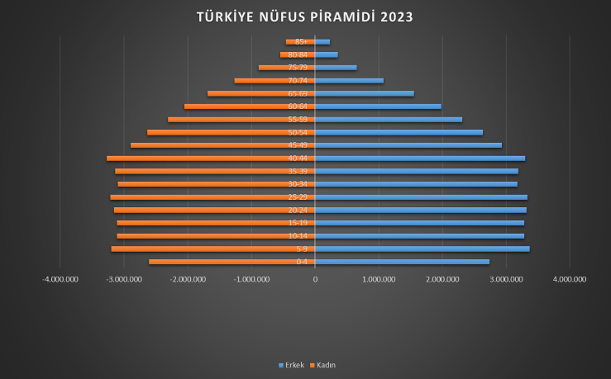

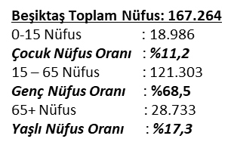
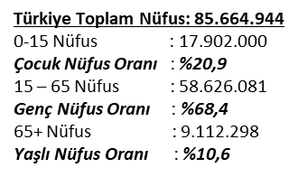

A CLOSE LOOK AT BEŞİKTAŞ DISTRICT DEMOGRAPHICS

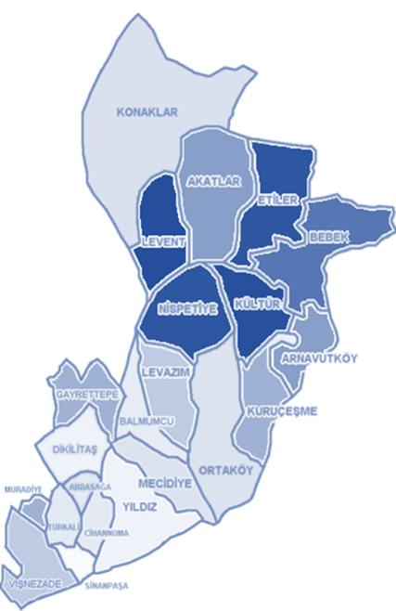
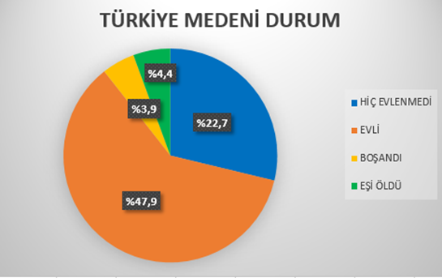
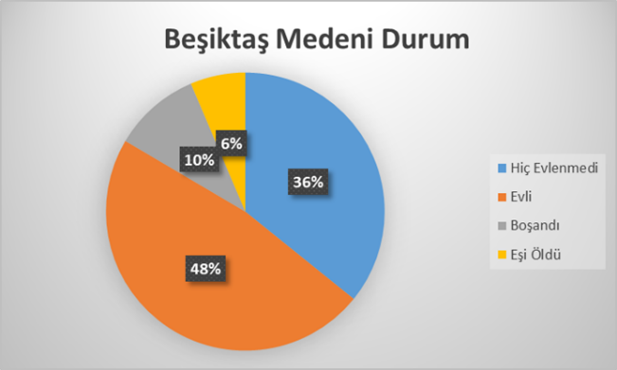

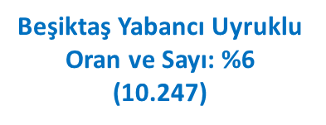

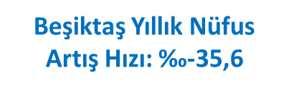
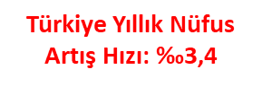


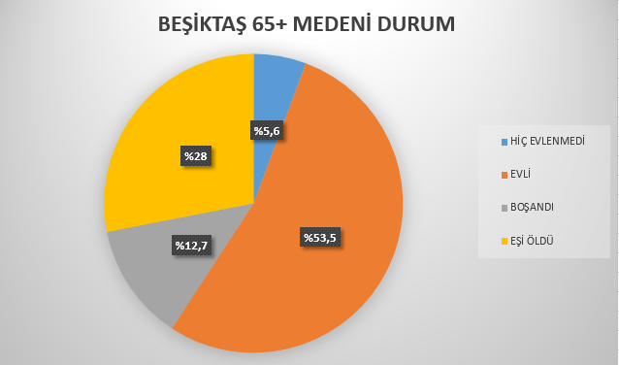
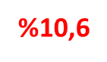

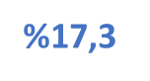



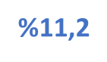




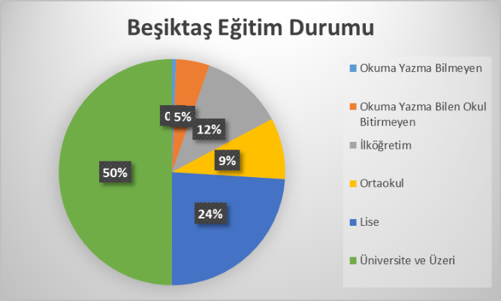

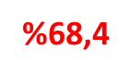

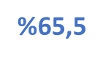

Our country's annual population growth rate is 3.4‰, and in our district, this rate is -35.6‰. While the proportion of the never-married population in our country is 22.7% of the total population, this rate is around 36% in our district. This situation indicates that we will soon be facing a significant number of elderly people living alone. While the rate of bachelor's degrees in our country is 24.6%, the rate of bachelor's degrees in our district is 50%. This high education rate in our district can be attributed to its history as home to palaces, the presence of palaces around Beşiktaş, and the continued residence there over time, as well as the presence of nine universities within the district's borders. Considering that as education levels increase, marriage and child birth rates decrease, and divorce rates increase, it's easily foreseeable that the proportion of elderly people living alone will continue to increase.
EVALUATION OF THE STRATEGIC PLAN FOR THE YEARS 2015-2019
Our Municipality's years 2015-2019 between period for prepared Strategic The Plan strategic in article 2 of its aims and objectives place area of society components life standards improvement and social welfare and social services effective One in this way subheading " execute " to actualize To this end , training and activities were organized for women, children, the elderly, and citizens in need. Services were provided to raise the economic and social living standards of our citizens in need. An audio library and a Braille library were created, a Disability Coordination Center was opened, and a Disability Assembly was established. Steps were taken to make Beşiktaş a city friendly to disadvantaged groups by establishing an Equality Unit. Some goals, such as the Disability Map and Database, the Disability Rights Center, the Accessibility Action Plan for a Barrier-Free Beşiktaş, the Trauma Center, the Family Counseling Center, and the Women's Shelter, were not achieved due to physical limitations and the inability to develop projects for some of them.
EVALUATION OF THE 2020-2024 STRATEGIC PLAN
The 2020-2024 Strategic Plan includes 33 objectives under seven goals. This plan, which includes performance indicators measuring both qualitative and quantitative data, has illuminated the institution's decision-making processes over the past five years. An evaluation of the strategic plan, currently in effect before the new term's Strategic Plan is presented below under the headings of current objectives.
Creating a Healthy City by Increasing Awareness and Accessibility in the Area of Healthy Living for All Living Creatures
By improving preventive and therapeutic healthcare services for our citizens, accessible, convenient, and effective healthcare and home healthcare support services have been provided in our district. We have met the healthcare demands and needs of our citizens with a 24/7 online medical consultancy service, a 24/7 emergency ambulance, a patient transport ambulance, a pediatric oral and dental clinic, and psychological counseling services. The '65+ Life Office' and the ' Podology (Foot Health) Unit,' a first in local governments, have been established to manage the services provided to citizens aged 65 and over under a single umbrella organization and to transform our city into a universally recognized 'age -friendly city. ' We have become a member of the Age-Friendly Cities Network, run by the World Health Organization (WHO), and continue to provide services to improve our aging policies and to ensure their sustainability.
STRATEGIC PLAN FOR 2025-2029
FINDINGS
• The demand for health services is quite high due to the large number of elderly people living alone in our district.
• Since the proportion of elderly people in Beşiktaş district is almost twice the population of the country, there is a need to improve existing elderly services and add new services.
NEEDS
• Service delivery is carried out in coordination with the Ministry of Health.
• Physical space in compliance with legislation .
• Increasing cooperation with relevant institutions.
• Increasing the opportunity for municipalities to take a more active role in elderly services through legislative changes.

PURPOSE 1.
To raise awareness, produce accessible services and ensure the sustainability of services to create a healthy city.
Goal 1. Supporting the Elderly by Encouraging Individuals to Age Actively and Healthy
Goal 2. Maintaining and Improving Preventive and Curative Health Services with an Inclusive Approach
ACTIVITIES AND PROJECTS
• Providing 24/7 Emergency Assistance Service
• Providing Doctor and Nursing Services at Home
• Providing Patient Transport Ambulance Service
• Providing Home Physiotherapy Services
• Providing Polyclinic Services
• Providing Healthy Living Center Services
• Providing Volunteer Testing and Counseling Center Services
• Providing Dietitian Services
• Providing Psychological Counseling Services
• Providing Hemodialysis Patient Transport Service

Goal 3. Supporting the Elderly by Encouraging Individuals to Age Actively and Healthy
ACTIVITIES AND PROJECTS
• Providing Gerontology Services
• Providing Podology Services
• Providing Digital Literacy Training
• Providing Cognitive Activity Workshops Service
• Providing Alzheimer's Prevention Training
• Support Programs for Elderly Relatives
• Providing training on Aging Experience Workshops
• Implementation of the Alzheimer and Dementia Daycare Center Project
• Implementation of the Neighborhood Nursing Home Project
• Preparation of a Local Ageing Action Plan
• Implementation of the 65+ 24/7 Emergency Service Line Project
PURPOSE 2.
DEVELOPING INCLUSIVE AND SUSTAINABLE POLICIES AND SERVICES TO ENSURE ACCESS TO SOCIAL RIGHTS FOR ALL GROUPS OF SOCIETY, ESPECIALLY DISADVANTAGED INDIVIDUALS, AND TO FULLY BENEFIT FROM THESE RIGHTS

Goal 1. To ensure that all individuals have equal rights and opportunities regardless of their differences and to reduce existing inequalities through a social equality approach.
Goal 2. Supporting Disadvantaged Social Segments Who Have Difficulty in Meeting Their Basic Needs in the Context of Social Policies, Increasing the Standards of Services for the Disabled and the Elderly, and Implementing Sustainable Projects

ACTIVITIES AND PROJECTS
Continuing and increasing the activities of daycare centers and higher education student dormitories. • Continuing and increasing the activities of Nutrition Unity Points.

WHAT AWAITS US?

P  (POLITICAL) | TO  (ECONOMIC) | S  (SOCIAL) | T  (TECHNOLOGICAL) | TO  (ENVIRONMENTAL) | L  (LEGAL)
-The intense migration to Turkey will change the usual elderly profile .  -Maintenance Services  -Age Discrimination  -Social Security System  (care insurance, social assistance  Old age pension 5,389.94 TL)  -Women are more active in working life  (causes a decrease in the number of caregivers in the family) | -Economic crises  - Retirement pension status  (16,881 TL)  - Minimum wage:  (22,104 TL)  -Elderly Poverty  -Maintenance problems  -Economic dependence  -Migration movements | - Loneliness  (having to deal with health problems alone)  - Poverty  -Physiological, biological, psychological problems  -Age discrimination  - Losses  -The place of the elderly in society  -Shrinking of family structure  (close ties with elders are disappearing) | -Urbanization and industrialization  The place of the elderly in society with developing technology  - Security  - Speed of digitalization  -Artificial intelligence applications  - Industry | -Housing Problem  (expensive rents)  -Transport  (public transport and roads are not suitable for the elderly)  -Streets and Parks  (lack of streets and parks suitable for the elderly)  -Social Facilities  (Lack of social facilities suitable for the elderly)  -Climate Change  (excessively hot weather)  -Natural Resources Management  -Disaster Situations  (expected major Istanbul earthquake and old houses are generally inhabited by elderly people) | -Old Age Rights  -Elder Abuse  -Financial Abuse/Fraud  -Urban Transformation  -Inadequate Nursing Home/Hospice Status  -Maintenance Contracts

