Project Brief: Age Friendly Cities

Project Title: | AGE FRIENDLY CITIES
Author | Natalie Smyth – Senior Coordinator Healthy Ageing
Date | 1 June 2018
Project manager | Natalie Smyth
Project sponsor | Maria Weiss – Manager Community Strengthening
TRIM reference | Include file and folder references, or other details where relevant
Document Version | Final draft
Last Updated | For document control
Approval Status | Awaiting Approval
Project Number | TRIM PROJ file no.

Description

Age friendly cities and communities are places where older people live safely, enjoy good health and stay involved. The development of Age Friendly places is a process that actively involves older people in decision-making, implementation and evaluation of a plan of action to bring about sustainable change.

Background and context

Approximately 124,000 people call Moonee Valley home. It is expected an additional 25,000 people will be living in Moonee Valley by 2036. Within Moonee Valley, there is potential for significant increases in the number of older people, as people choose to age in place.
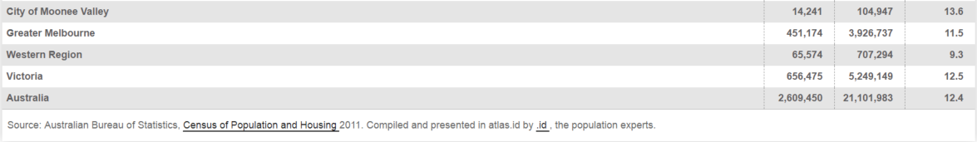
People are now living longer and healthier lives. People aged 65 and over are the fastest-growing age group and this drives the need for social change.
Our health is also determined in part by access to social and economic opportunities; the resources and supports available in our homes, neighbourhoods, and communities
An Age Friendly world enables people of all ages to actively participate in community activities and treats everyone with respect, regardless of their age. In Age Friendly communities older people live safely, enjoy good health and stay involved.
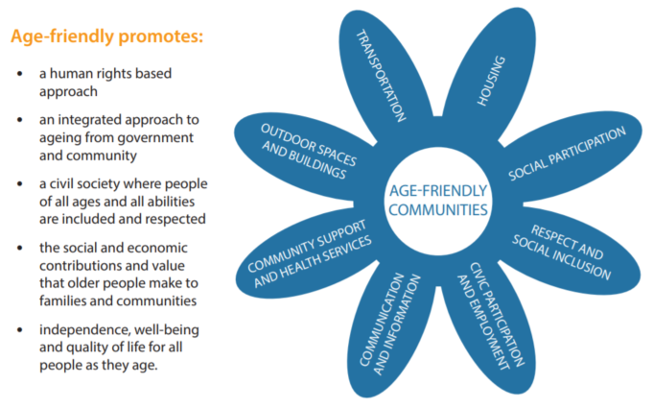

As outlined in our Council Plan (integrating the Health Plan) 2017- 2021 there are a number of challenges, opportunities and priorities noted for the coming years. Council has identified the need to address certain challenges to ensure we are well suited and prepared to support our ageing population.

What are the opportunities?
- Provide services and infrastructure appropriate for a growing, ageing, diverse population
- Promote healthy settings and enhance road and footpath safety for older adults, cyclists and pedestrians
- Create multi-use community facilities in appropriate locations
- Design services with a focus on equity

Contained within the Methodology is an outline for the next 3 years to move towards an Age Friendly City and achieve World Health Organisations accreditation through the delivery of age appropriate, inclusive and sustainable services.

Strategic linkages

MV2040

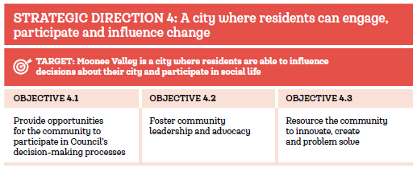

Council Plan

1. Friendly and safe: An equitable, inclusive and healthy community.
1.1 Our community is socially inclusive and healthy.
1.2 People have access to the services they need.
1.3 Our community and our city are safe and resilient.
1.4 Our community is empowered to thrive.

5. Resilient organisation: A resilient organisation that is sustainable, innovative, engaging and accountable.
5.1 Innovation is central to the way we work.
5.2 Good governance is everyone’s responsibility.
5.3 We are financially sustainable.
5.4 Our community is informed and has a say.
5.5 We demonstrate leadership.

Aged Care 2017 legislation
https://agedcare.health.gov.au/legislated-review-of-aged-care-2017-report

Aged Care Reform
As part of the changes to aged care announced in 2012, a comprehensive review was included in Aged Care (Living Longer Living Better) Act 2013 (the Act). The Aged Care Legislated Review (the Review) looked at the impact and effectiveness of the changes and has made recommendations for future reform to the aged care system.
With the appointment of an independent reviewer, the review commenced in 2016 for a 3 year period to scope the following key matters:
- whether unmet demand for residential and home care places has been reduced
- whether the number and mix of places for residential care and home care should continue to be controlled
- whether further steps could be taken to change key aged care services from a supply driven model to a consumer demand driven model
- the effectiveness of means testing arrangements for aged care services, including an assessment of the alignment of charges across residential care and home care services
- the effectiveness of arrangements for regulating prices for aged care accommodation
- the effectiveness of arrangements for protecting equity of access to aged care services for different population groups
- the effectiveness of workforce strategies in aged care services, including strategies for the education, recruitment, retention and funding of aged care workers
- the effectiveness of arrangements for protecting refundable deposits and accommodation bonds
- the effectiveness of arrangements for facilitating access to aged care services.

Scope
The scope of the project is:
- Development and implementation of Age Friendly City services, programmes, partnership/networks and environments
- Membership of the WHO (World Health Organisation) Global Network (Age-friendly World website)
- Age Friendly Victoria Declaration – Municipal Association of Victoria (appendix A)
- Development of a sustainable business/operational model for Age Friendly cities

Considerations:
- The project has been forecast for delivery over the next 3 years
- Additional deliverables may be added due to timing and opportunity
- Most deliverables included in this project brief are within allocated operational budget, some deliverables may require unforeseen funding which is not available and requires renegotiation – (either through MVCC budget process and/or grant application)
- Staff development and education – a different way of thinking related to community engagement, development and delivery of services, programmes and environments.

Project Aim

The Age Care Reforms have initiated a time of change in how services to our ageing population are delivered.
A key strategy to facilitate the inclusion of older persons is to make our world more age-friendly. An age-friendly world enables people of all ages to actively participate in community activities and treats everyone with respect, regardless of their age. It is a place that makes it easy for older people to stay connected to people that are important to them. And it helps people stay healthy and active even at the oldest ages and provides appropriate support to those who can no longer look after themselves.
Many municipalities and communities are already taking active steps towards becoming more age-friendly.
“Age friendly environments (such as the home, community) foster healthy active ageing by building and maintaining intrinsic capacity across the life course and enabling greater functional ability in someone with a given level of capacity”

Deliverables

Outputs
Development and implementation of Age Friendly initiatives in line with the World Health Organisations guidelines and MV2040 as outlined below (Methodology).

Outcomes
The implementation of an Age Friendly municipality that actively involves older people in the development and delivery of services for our ageing community.
In practical terms, age-friendly environments are free from physical and social barriers and supported by policies, systems, services, products and technologies that:
● promote health and build and maintain physical and mental capacity across the life course; and
● enable people, even when experiencing capacity loss, to continue to do the things they value.
Age-friendly practices help build older peoples abilities to:
● meet their basic needs;
● learn, grow and make decisions;
● be mobile;
● build and maintain relationships; and
● contribute.
In doing so, age-friendly practices:
● recognise the wide range of capacities and resources among older people;
● anticipate and respond flexibly to ageing-related needs and preferences;
● respect older people's decisions and lifestyle choices;
● reduce inequities;
● protect those who are most vulnerable; and
● promote older people's inclusion in and contribute to all areas of community life.³

Methodology
Where applicable “Sub”- Project briefs and or Communication Plans (using Councils existing framework) will be developed and approved to develop and implement the phases below.

Phases, milestones and timelines

Deliverables  (Sub-Projects) | Description / Purpose | Time Frame | Consultation / Approval
Age Friendly Cities Launch – Age-Friendly Victoria Declaration | As part of the Oct 2018 Seniors Festival, Moonee Valley will launch its commitment to the development of a sustainable Age Friendly municipality/city.  The Seniors Festival will host an event which will include community groups within the municipality that already operate under and promote an Age Friendly ethos. This event will not only celebrate Seniors Festival and related events but demonstrate MVCC’s commitment to an Age Friendly municipality through the MAV Age-Friendly Victoria Declaration signing by the Mayor | October 2018 | Councilor Support  Review / Evaluation: Nov 18
Selfie with a Senior | Promotional theme of this year’s Seniors Festival as the kick off to start talking about and celebrating what we do, how we interact and value our ageing community. | October 2018 | Seniors Festival project brief  Review / Evaluation: Nov/Dec 18
Aged Care Ambassadors – Concept Launch | Older people are a resource for their families, communities and economies in supportive and enabling living environments.  The World Health Organisation recommends engaging and tapping into the skills from life-long learning and the potential that older people have to represent humanity. In practical terms, an age friendly city adapts it’s practices and services to be inclusive of older people contributing, supporting, and influencing “active ageing” and the development of Age Friendly Cities | Concept Launch October 2018  Ambassadors programme - Commencing 2019 (timeframe subject to participants knowledge and level of training required) | Review / Evaluation: June 19
Ageing Well Reference Group (AWRG) | Establish a reference group comprising of senior representatives from the MVCC community.  The reference group will convene quarterly (with an option of an extra ordinary meeting if required) to discuss the development of an Age Friendly city and assist Council Officers shape the services and environment and discuss related issues to support Council in meeting the needs of our ageing community.  In an age-friendly city, policies, services, settings and structures support and enable people to age actively by:  • recognising the wide range of capacities and resources among older people  • anticipating and responding flexibly to ageing-related needs and preferences  • respecting their decisions and lifestyle choices  • protecting those who are most vulnerable  • promoting their inclusion in and contribution to all areas of community life. | Commence EOI through the Seniors Festival - October 2018 and convene the first meeting in Dec 2018 | Review / Evaluation: June 19
Engaging Seniors - Volunteer | Celebrate the volunteer contribution through CEO updates and advertising the service support Volunteers Offer.  Programme development specific for Volunteer under the CHSP – Social Support Individual. (helping Hero’s concept) – Individual Project brief to be developed. | Current - 2020 | Review / Evaluation: June 19
Men’s Shed = Father & Son workshop | Reigniting a lost generation of skills. In today’s busy lifestyle of work, commitments, school, sports and extra-curricular activities gone are the days of “fathers and sons” tinkering and bonding in the back shed. Utilising the skill of our ageing Men’s Shed volunteers and participants to work and partner with a “father and son” who would otherwise not undertake handy man activities of build something together. A valuable exercise of one generation passing down skills, knowledge even the odd “DAD” joke to a younger generation to enjoy and use for a lifetime. | 2019 - 2020 | Calculate the cost per client (workshop) and advertise through an EOI to determine if there are the numbers to run the programme
Planned Activity Group | The call for an EOI  • dementia specific activities/groups  • culturally specific activities/groups  • senior run activities/groups  • collaboration with existing community groups (external to Council) | 2019 - 2020 | Review / Evaluation: Dec 19
Seniors Expo – featured in the 2019 and/or 2020 Seniors Festival | Showcasing a range of services, programmes, talents delivered by our ageing residents to our community | October 2019 & 2020 | Review / Evaluation: Dec 19 & Dec 20
Seniors Award | Annual award by nomination of a Senior
Union road – age friendly scape (Ascot Vale Neighbourhood Centre | An opportunity to collaborate with internal stakeholders to influence the design of Union Road at the Ascot Vale Neighbourhood Centre location.  As outlined in the Global Age Friendly Cities Guide key features of a city’s physical environment, has a strong influence on personal mobility, safety from injury, security, health and social participation.  Taking the opportunity to engage the AWRG and users of the Community Centre to influence the streetscape around/near the Centre | Commencing July 2018 - 2019 | Consultation to include:  Buildings:  - Ramps  - Wide doorways (wheelchair access)  - Suitable stairs  - Suitable railing  - Rest areas  - Comfortable seating  - Non slip surfaces  - Smooth level surface  - Curbs that tapper off – level to the road  - Clearance from obstacles/obstructions  - Priority access for pedestrians  - Adequate signage  - Public toilets  - Accessible Transport
Healthy Ageing promotion - out and about in the community | Expanding on the Healthy Ageing Mobile Office and in line with MV2040 and Neighbourhood planning the Healthy Ageing area aims to:  • place key individuals out into the community that they support though existing services – Team Leaders are located in the geographical area they look after  • providing support at Local GP clinics to access and understand MAC and available service through MVCC and within the Municipality  • partnering with local shopping centres - regular, scheduled and cross promoted attendance by MVCC officers to support our community to access and understand MAC and promote MVCC services  • booked presentation (Age Well Mobile Office) for and by community groups | Current – additional promotion commencing in 2019 | Review / Evaluation: June 19
Valley View – Age well article | Bi-annual feature article of either:  • “Sensational Senior” for their work, contribution or engagement with the broader Community  • A senior who receives or is supported by MVCC services which enables them to live in place and remain connected to their community | TBC – Commencing in 2019 | Confirmation with Communication department to have an article in Valley View or other MVCC community publication

Project roles & responsibilities

Name | Department | Council Role | Project Role
Natalie Smyth | CS | Snr Co-ord. Healthy Ageing | Project Lead
Juliane Reissle | CS | Co-ord. Home Support | Sub-project (deliverable) Lead
Jorene Walsh | CS | Co-ord. Community Support | Sub-project (deliverable) Lead
Jasmine Graham | CS | Snr. Co-ord Disability and Access | Project Support
Luke Naimo | CS | Co-ord. Assessment and Care Planning | Project Support
Nino Piscitelli | CS |  | Sub-project (deliverable) Lead
Cassie Morris | CS |  | Sub-project (deliverable) Lead
Rose Marie McQueen | CS | Business Support | Project support
Diane Jakin | CS | Case Manager | Project Support
Heidi Fernando | CS | Case Manager | Project Support
Kerry Crawford | CS | CHSP Team Leader | Project Support
Amanda Monaghan | CS | CHSP Team Leader | Project Support
Rory Lewis | CS | CHSP Team Leader | Project Support
Marty Danks | CS | CHSP Team Leader | Project Support
Leigh McKinnon | CS | Business Resource and Development Officer | Project Support – Policy & Procedure
Emma Patterson | Comms | Communications Advisor | Project Support – Communication Plan
Sarah Schwager | Comms | Strategic Media Advisor | Project Support – Communication Plan
Internal Officer TBA |  |  | Negotiated as required
HR |  | HR support/advice | Support/advice
IT |  | IT support/advice | Support/advice
Councillors TBA |  | Councillors | Sponsorship / endorsement
External contacts TBA |  |  | Negotiated as required  Including but not limited to:  • COTA  • Co-Health  • National Seniors Australia
- CS = Community Strengthening

Stakeholder engagement and mapping

Stakeholder  Internal – (I)  External – (E) | Importance  High – (H)  Medium – (M)  Low – (L) | What’s Required from the Stakeholder | Consultation / Communication
Community Strengthening (I) | H | • Project support  • Project and service delivery | • Leadership Group meeting  • Aged Care Reform working Group  • Team Meetings
Comms (I) | M-H | • Promotional support  • Communications support | • Updates as deliverables are planned through scheduled meetings  •
Councilors (I) | H | • Project sponsorship/endorsement | • Councillor update  • Councillor briefing (if requested/required)
Internal Council Officer (other departments) | M | • Project support / advise / collaboration | • Meeting by invitation (working group where required)
IT | H | • Project support / advise / collaboration | • Meeting by invitation (working group where required)
HR | H | • Project advice in relation to any industrial matters (eg. EA, work hrs, change in conditions, PD adjustment) | • Meeting by invitation (working group where required)

Related Projects

Healthy Ageing Mobile Office
Healthy Ageing Ambassadors – Volunteers (PROJ/18/26)

Governance and Issue Resolution

Maria Weiss – Departmental Approvals
Natalie Smyth – Project lead decisions and budget

Risk Identification and Management

What is the risk? | Risk rating  (refer to risk matrix) | What will control the risk? | Resources required | Costs
Financial – funding requirement exceeds operational budget | Low – Moderate  Depending on what level of service delivery promotion is anticipated and undertaken | • Only deliver Home Support Service to the allocated Federal funding received  • Apply for Grant funding for additional/ ongoing services  • Request for additional funding through Council budget approval process | • Staff resource to complete suitable grant application process  • Briefing to council for additional funding for Community Strengthening services
Competitive neutrality post block funding – promotion of these services boosts service referrals/demand | Moderate –  In breach as existing services | Cease service that in breach of competitive neutrality of external providers/organisations | Legal representation | • Reputational cost to Council  • Potential fines  • Legal fees
Replacement of Electronic Client (& staff) Management System | High | Replacement of Sharikat to offer mobile device application | • IT support  • purchase of new suitable software  • purchase of suitable mobile devices | TBA

Budget and costings

Deliverables  (Sub-Projects) | Estimated cost (budget)
Age Friendly Cities Launch – Age-Friendly Victoria Declaration | $0.00 external to Healthy Ageing Budget – cost associated with staff resource  Cost incorporated as part of a Seniors Festival Activity which includes the Mayor
Selfie with a Senior | $0.00 external to Healthy Ageing Budget – cost associated with staff resource  Seniors Festival activity - and cost associated with seniors festival
Aged Care Ambassadors – Concept Launch | $0.00 external to Healthy Ageing Budget – cost associated with staff resource  Cost incorporated as part of a Seniors Festival Activity which includes the Mayor
Ageing Well Reference Group (AWRG) | $0.00 external to Healthy Ageing Budget – cost associated with staff resource
Engaging Seniors - Volunteer??? | $0.00 external to Healthy Ageing Budget – cost associated with staff resource (Volunteer Coordinator)
Men’s Shed = Father & Son workshop | $0.00 external to Healthy Ageing Budget – cost associated with staff resource  Overtime expense depending on day and time of workshop for x1 paid facilitator  Based on Dec 2018 EA  Workshop that runs on 1 weekend day for 4 hours, over 8 weeks.  Additional cost exceeding the budget by approx. $1152.64 per 8 week workshop (based on Band 4 – double time)
Planned Activity Group | $0.00 external to Healthy Ageing Budget – cost associated with staff resource
Seniors Expo – featured in the 2019 and/or 2020 Seniors Festival | $0.00 external to Healthy Ageing Budget – cost associated with staff resource  Cost incorporated as part of the Seniors Festival Budget
Union road – age friendly scape (Ascot Vale Neighbourhood Centre | $0.00 external to Healthy Ageing Budget – cost associated with staff resource  Cost incorporated in Capital Budget
Healthy Ageing promotion - out and about in the community | Healthy Ageing Budget – cost associated with staff resource  Cost of replacement client management system and associated mobile devices TBA – anticipated > $250K  Cost of associated Communication Plan - TBA
Valley View | $0.00 external to Healthy Ageing Budget – cost associated with staff resource  ??TBA associated cost with Comms plan and potential promotion

Project Scale

It has been determined that this project is a Medium project

Approval process and dates

Authority to Proceed:
Age Friendly Cities
Name | Maria Weiss
Position | Manager Community Strengthening
Signed
Date
Notes/Comments:

Appendix A
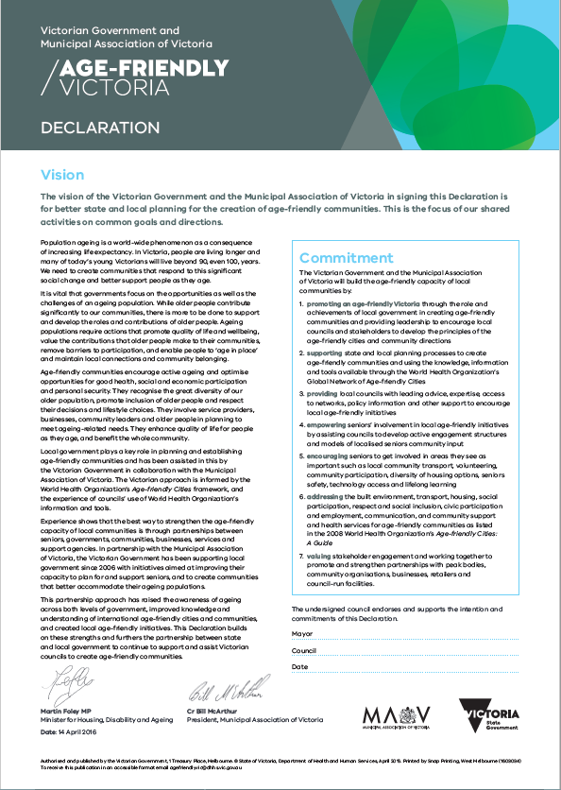

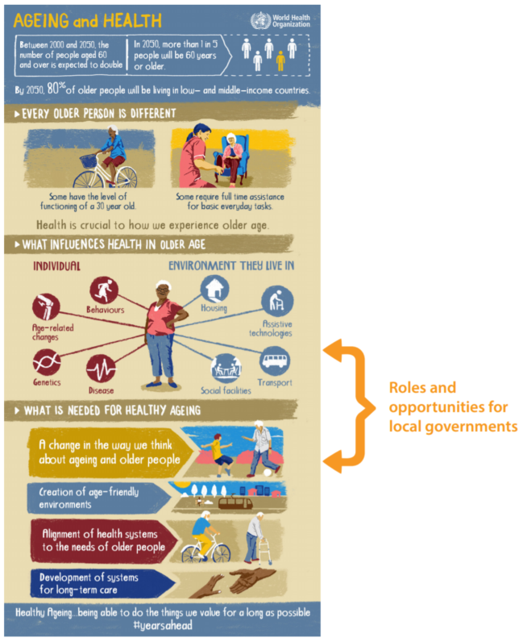

Robert Wood Johnson Foundation. A new way to talk about the Social Determinants of Health. http://rwjf.ws/1BwVG0K
Council Plan 2017-21 (integrating the Health Plan) http://www.mvcc.vic.gov.au/about-the-council/plans-and-strategies/council-plan.aspx
http://www.who.int/ageing/projects/age-friendly-cities-communities/en/ WHO Age-friendly cities and communities
http://www.who.int/ageing/publications/Global_age_friendly_cities_Guide_English.pdf Global Age-Friendly Cities: A Guide – World Health Organization

