Dr John Beard, Director
Department of Ageing and Life Course
Office 5030
WORLD HEALTH ORGANIZATION
20, AVENUE APPIA
CH-1211 GENEVA 27
Switzerland
August 27, 2018
Dear Diane,

On behalf of Donegal County Council I wish to apply to the World Health Organisation for membership to your Global Network of Age-Friendly Cities.

Under the auspices of Ireland's National Age Friendly Programme, I can confirm that Donegal Age Friendly Strategy Programme has been working towards becoming Age Friendly for three years and has achieved the following objectives in order to establish our county as Age Friendly:
- An multi sectoral Age Friendly Alliance has been established, chaired by the local authority Chief Executive, comprising the most senior decision makers from the key public, private and not-for-profit agencies responsible for service provision to and key decision making for older people including Local Authority, Health Service Executive, An Garda Siochana, Academia, Business Community and the Community & Voluntary sector.
- We have carried out comprehensive, county-wide consultation process with older people to listen to the issues that really matter to them and the things they would like to see change in their county, making it a better place to grow old in. These have included round table sessions, focus groups, questionnaires, one to ones and desktop research
- Following this extensive consultation with older people, service providers and others, we have developed our Age Friendly County Strategy. This document contains specific commitments by agencies, service providers and older people’s organisations to implement agreed changes. It reflects the priorities expressed by older people in the consultation process and the co designed solutions that alliance members and other key stakeholders have committed to
- With these solid foundations for the programme now in place, we have held a public launch, letting the people of (city/county programme area) that we are committed to delivering on the strategy and making our (city/county) a sustainable place that will be future proofed for the increased ageing population that we anticipate

I trust that this application is in order and look forward to hearing from you in the near future with confirmation of our membership.

Yours sincerely,
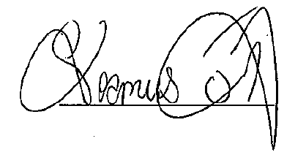
Cathaoirleach/Mayor of County Donegal

