Village of Greendale
SAGE Action Plan 2023 – 2027
Updated: 04/10/2023
Based on a variety of data and input from community residents, local and state partners and with the endorsement of the Village of Greendale Board of Trustees, the Greendale Health Department will lead this multi-year initiative called SAGE (Successful Aging in Greendale for Everyone). The plan incorporates guidance from the AARP network of Age-Friendly Communities and the Domains of Livability developed by the World Health Organization.
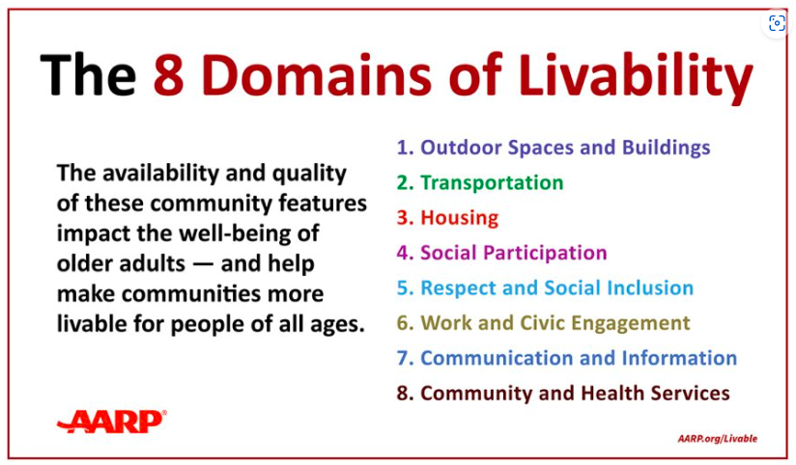

The SAGE Steering Committee is responsible for overseeing the implementation of the strategic plan with input from a diverse partnership of community residents and organizations.
SAGE will adhere to these values during this action period: 1) partnerships, 2) coordination, 3) collaboration, 4) diversity, 5) sustainability
PRIORITY AREA: Healthy Aging (from the Greendale 2020 Community Health Improvement Plan)

VISION STATEMENT: Greendale will be a livable community where everyone can age successfully.

MISSION STATEMENT: Explore and support innovative ideas to promote healthy and productive lives for the residents of Greendale, especially older adults and those most vulnerable by fostering a strong sense of community and the assurance of inclusiveness.

DOMAIN 1: Outdoor Spaces and Buildings
GOAL: Greendale will have adequate outdoor spaces and buildings so that residents can spend quality time enjoying nature.
OBJECTIVE: Assess and improve walking path accessibility
Action Items and Metrics | Target Date | Lead/Partner Organizations | Action Steps, Progress Notes and Outcomes
Assess accessibility of Greendale walking paths using the AARP Walking Audit tool.  Create an improvement plan for green space in Greendale building upon last audit completed in 2018-2019. | 03/01/2023-06/01/2024 | Greendale Health Department, SAGE, Department of Public Works (DPW), Village of Greendale, Greendale Schools, Greendale Park and Rec. | - A walking audit to be completed by college students with AARP. (around schools)  - A walking audit with SAGE members completed on 7/23  - The Village and Schools are planning to conduct an indoor and outdoor recreation comprehensive assessment this year.  - Report and recommendations complete and submitted to Village staff and Board of Trustees 10/23.
Based on walking audit results and comprehensive recreation study, choose one priority area to take action towards improving. | 06/01/2024 | Greendale Health Department, SAGE, Department of Public Works (DPW), Village of Greendale, Greendale Schools, Greendale Park and Rec, Greendale Board of Trustees
Support development of updated walking maps, taking equity and accessibility into account. | 06/01/2025 | Greendale Health Department, SAGE Steering Committee, Girls Scout Troop 8035, Greendale Department of Public Works (DPW) | - SAGE will look for opportunities to promote the updated walking maps (i.e., Village Views article, Welcome Center, senior housing, businesses, Love Thy Neighbor meetings, School District).  - SAGE will utilize an online evaluation tool to assess map usage and/or satisfaction.
Identify pedestrian areas/crosswalks that may be inaccessible or puts pedestrian at risk for injury. | 6/01/2023 | Greendale Health Dept, SAGE, Village of Greendale, Police, DPW, Public Health, Welfare and Safety Committee

DOMAIN 7: Communication and Information
Goal: Greendale older adults will be offered the opportunity to increase their health literacy
Action Items and Metrics | Target Date | Lead/Partner Organizations | Progress Notes and Outcomes
Include development opportunities and presentations during SAGE meetings and events. | ongoing | Health Department, Feeding America | - Virtual Dementia Tour  - Presentation about the new case management position and older adult need  - Speaker from Feeding America-Mobile pantry, benefits
Promote and/or distribute senior resource directories to include hard copy and on-line versions of our community partners and other organizations. | ongoing | Greendale Health Department, SAGE Community Partners (students) | - Update Older Adult Resource Guide for website completed 11/23  - SAGE is promoted in the Life in the Village Magazine through ad space, three additions in 2023.  - ADRC to provide Dementia Newsletter on behalf of the county stared 7/23
Work with student group to share information on decluttering and hoarding | 2023/2024 | SAGE, Deb Barth, Alverno/MSOE Student
Disseminate information/educate about Dementia risk reduction | ongoing | Greendale Health Department, Healthy Brain Initiative, SAGE | - Megan to present brain health information at Senior Social Club 9/23  - Participation in Brain Health Fair and Family Generations Expo
Collect information from older adults in Greendale to inform current and future initiatives using the AARP Community Survey | 1/15/2024 | Greendale Health Department, SAGE, Village of Greendale, Greendale Park and Recreation | - Meeting with Amber and National AARP reps 11/13  - AARP Survey launch to be published in Winter/Spring Park and Recreation program book with Facebook campaign. Potentially coordinate outreach with winter event if awarded SDBI grant funding.

DOMAIN 8: Community and Health Services
GOAL: Greendale older adults will have access to a variety of health services in the community.
OBJECTIVE: Partner with the Greendale Community Garden, Greendale Children’s Garden and the Greendale High School Garden to provide fresh produce donations for seniors in our community.
Action Items and Metrics | Target  Date | Lead/Partner Organizations | Progress Notes and Outcomes
Arrange for produce donation, location, procedure, and how to track progress and impact. | 06/01/2023 through 09/01/2023 | Greendale Health Department, SAGE, Greendale Children’s Garden, Greendale High School Garden, Greendale Community Garden | - Look into current process to offer additional support
Promote heart and brain healthy foods and encourage residents to eat fresh foods. | ongoing | Greendale Health Department, Healthy Brain Initiative, Alzheimer’s Association, Greendale Step Up to Better Health, Greendale Children’s Garden, Greendale High School Garden, Greendale Community Garden, Greendale Downtown Market | - Shawne to talk about nutrition at the Senior Social Club/Harbour Village 7/23  - Eating for brain health information to be included in Children’s Garden and High School Garden program offerings

DOMAIN 8: Community and Health Services
Goal: Greendale older adults will have access to a variety of health services in the community.
Action Items and Metrics | Target Date | Lead/Partner Organizations | Progress Notes and Outcomes
Implement twice yearly, 7-week evidenced-based Stepping On Fall Prevention Program. Share data from the WI Institute for Healthy Aging Stepping On Health and Demographic Survey for each class specific to an increase in knowledge about fall prevention strategies. | Bi-annually | Greendale Health Department, SAGE Steering Committee, Wisconsin Institute on Healthy Aging | - Cathy Trecek
Implement twice yearly, evidenced-based Walk with Ease Program from the Wisconsin Institute on Healthy Aging. | Bi-annually | SAGE, Harbour Village, St Stephen the Martyr | - Walk with ease, Shawne Johnson and Yvonne D. Spring and Fall 2023
Implement twice yearly, evidenced-based Boost Your Brain and Memory from the Mather Lifeways. | Bi-annually | SAGE, Health Department, Healthy Brain Initiative, Milwaukee ADRC | - Megan to hold one virtual cohorts 9/23
Memory Screenings | Bi-annually | SAGE, Milwaukee ADRC | - Candice LeGros to provide screenings at GHD 1/24 scheduled
Community Blood Pressure (BP) Screening will be offered at 3 community sites each month with results reported to the Greendale Board of Health and Board of Trustees. | ongoing | Greendale Health Department, SAGE Steering Committee, senior apartment complexes | - Free monthly BP screenings continue to be offered at 3 community sites accessible to seniors. Free BP screenings are also available on a walk-in basis at the Greendale Health Department.
Health Fair organization/participation | Every 2 years | Greendale Health Department, SAGE Steering Committee, and other health-related community organizations | - Promote Generations Expo  - Participate in Brain Health Fair
Dementia Memory Book Creation | Piloting | SAGE, Nikki & James, Harbour Village | - Deb and Katie to coordinate with Nikki and James on project  - Will report out to the group on success and ability to offer service more widely in community.
Care for the Caregiver Event | Annually | SAGE, Healthy Brain Initiative, Alzheimer's Association, AARP, ADRC, Harbour Village | - 11/4

