**AGE FRIENDLY PROFILE**

**COUNTY KERRY**

County Kerry has a total population of 147,707. Of these, 34,190 are aged 60+, while 9,910 are aged 75+. Thus, persons aged 60+ comprise 23.1% of the population, while those aged 75+ make up 6.7% of the county’s population.

After Mayo, Kerry has the oldest population of any county in the State. Returns from the 2016 Census of Population shows that nationally, 18.4% of the population is aged 60+. In Kerry, the corresponding figure is 23.15% - a gap of almost five percentage points (4.75%). The following graph shows the percentage breakdown by age cohort of the counties with the oldest and youngest populations in Ireland.

**Percentage of Persons in defined Age Cohorts in Selected Counties and Ireland, 2016.**

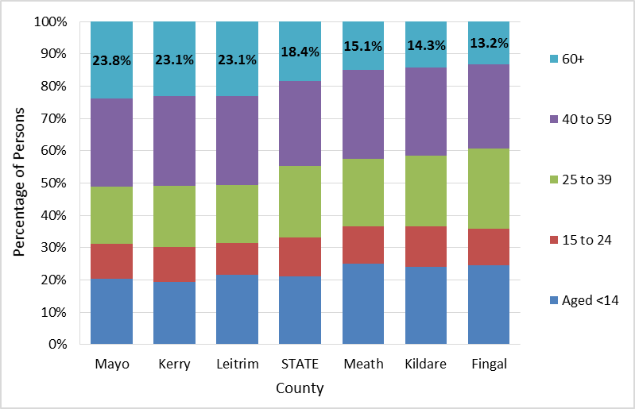

As the following graph shows, Kerry has more in common with the counties of Connaught (except Galway) than it has with the rest of the State in respect of the proportion of persons aged 60 to 75 years and aged 75 and older.

**Percentage of Persons Aged 60 to 75 and Aged 75+ by County, 2016**

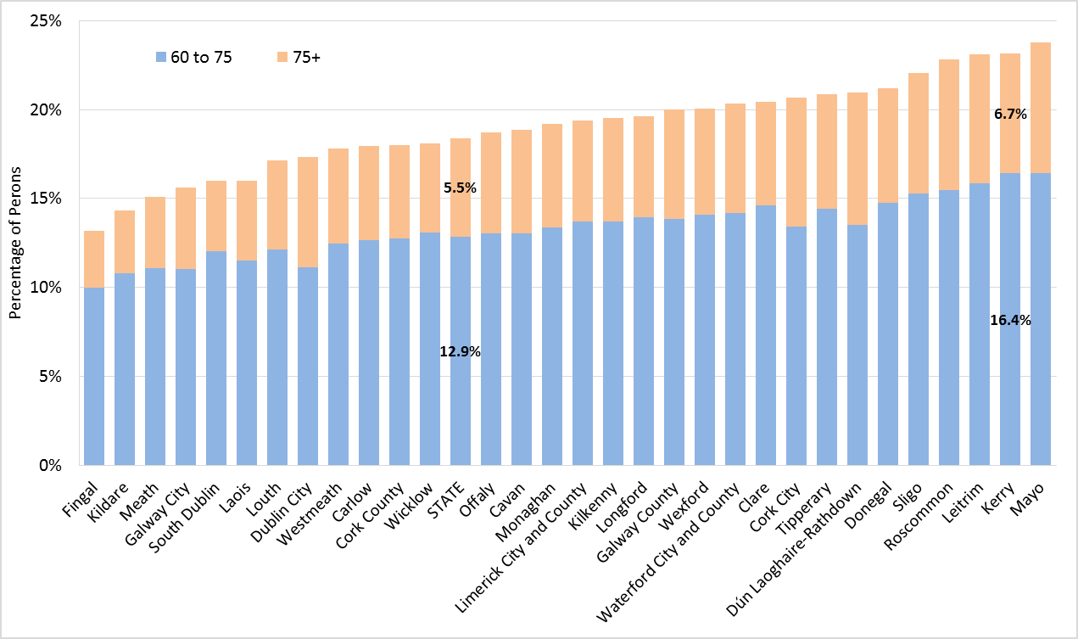

The following table provides a gender breakdowns of the cohorts aged 60+ and 75+ in selected geographies.

**Percentage of Persons by Gender in defined Age Cohorts in Selected Counties and Ireland, 2016.**

|  |  |  |  |  |  |  |  |  |  |  |  |
| --- | --- | --- | --- | --- | --- | --- | --- | --- | --- | --- | --- |
| **County** | **Males** | | | | |  | **Females** | | | | |
| **Age 0 to 14** | **15 to 24** | **25 to 39** | **40 to 59** | **60+** |  | **Age 0 to 14** | **15 to 24** | **25 to 39** | **40 to 59** | **60+** |
| Mayo | 20.9% | 11.1% | 17.4% | 27.2% | 23.4% |  | 19.8% | 10.5% | 18.0% | 27.4% | 24.2% |
| Kerry | 20.0% | 10.9% | 18.5% | 28.1% | 22.6% |  | 19.0% | 10.5% | 19.3% | 27.5% | 23.7% |
| STATE | 21.9% | 12.4% | 21.6% | 26.4% | 17.6% |  | 20.4% | 11.8% | 22.4% | 26.2% | 19.1% |
| Kildare | 24.9% | 12.9% | 21.1% | 27.3% | 13.9% |  | 23.2% | 12.2% | 22.7% | 27.1% | 14.7% |
| Fingal | 25.6% | 11.8% | 24.0% | 26.2% | 12.5% |  | 23.5% | 10.9% | 25.6% | 26.2% | 13.8% |

As the table shows, females are proportionately over-represented in the older age cohort across all geographies. In Kerry, 22.6% of males are aged 60+, while the corresponding figure for females is 23.7%.

The following population pyramids confirm both, Kerry’s older age profile and the higher proportion of females aged 60+. Moreover, Kerry has a higher proportion of persons aged 55+, indicating that the current ‘older than average’ age profile is likely to continue – thus necessitating a medium to long-term strategic approach.

**Population Pyramids for Ireland and County Kerry, 2016.**

|  |  |  |
| --- | --- | --- |
|  |  | |
| Ireland | | Kerry |

The population pyramids also reveal Kerry’s demographic composition, as they illustrate a relative undersupply of young people. This phenomenon can also be enumerated in respect of age dependency and economic dependency ratios, as pre the following table. This shows that Kerry has:

* The second highest Elderly Dependency Ratio;
* The twelfth highest Economic Dependency Ratio; and
* The fifth lowest Youth Dependency Ratio.

**Youth, Elderly and Economic Dependency Ratios in Irish Counties, 2016**

|  |  |  |  |
| --- | --- | --- | --- |
| **County** | **Dependency Ratios** | | |
| **Youth** | **Elderly** | **Economic** |
| Mayo | 0.203 | 0.176 | 0.379 |
| **Kerry** | **0.195** | **0.169** | **0.364** |
| Leitrim | 0.216 | 0.169 | 0.385 |
| Roscommon | 0.212 | 0.166 | 0.378 |
| Sligo | 0.203 | 0.162 | 0.365 |
| Dún Laoghaire-Rathdown | 0.184 | 0.159 | 0.343 |
| Cork City | 0.143 | 0.157 | 0.300 |
| Donegal | 0.220 | 0.157 | 0.377 |
| Tipperary | 0.213 | 0.153 | 0.366 |
| Waterford City and County | 0.211 | 0.150 | 0.361 |
| Clare | 0.215 | 0.149 | 0.364 |
| Wexford | 0.220 | 0.147 | 0.367 |
| Galway County | 0.227 | 0.145 | 0.372 |
| Longford | 0.233 | 0.142 | 0.375 |
| Kilkenny | 0.219 | 0.142 | 0.361 |
| Limerick City and County | 0.203 | 0.141 | 0.344 |
| Monaghan | 0.227 | 0.140 | 0.367 |
| Cavan | 0.231 | 0.137 | 0.369 |
| Offaly | 0.227 | 0.136 | 0.363 |
| **STATE** | **0.211** | **0.134** | **0.345** |
| Dublin City | 0.150 | 0.130 | 0.281 |
| Wicklow | 0.227 | 0.130 | 0.357 |
| Cork County | 0.229 | 0.130 | 0.359 |
| Carlow | 0.222 | 0.129 | 0.351 |
| Westmeath | 0.223 | 0.128 | 0.351 |
| Louth | 0.230 | 0.125 | 0.355 |
| Laois | 0.246 | 0.113 | 0.359 |
| Galway City | 0.168 | 0.112 | 0.281 |
| South Dublin | 0.230 | 0.111 | 0.341 |
| Meath | 0.251 | 0.107 | 0.357 |
| Kildare | 0.241 | 0.099 | 0.340 |
| Fingal | 0.245 | 0.091 | 0.337 |

Between 2006 and 2016, the number of persons aged 60 years and over in County Kerry increased from 26,701 to 34,190. This represents an increase of twenty-eight percent. This level of increase is below the national average of thirty-five percent (34.9%) over the same period. Other counties that have large proportions of older people (e.g., Mayo and Leitrim) also recorded below average increases in the proportion of person aged 60+, but indicating that the trend toward an ageing population has been established in Kerry and in rural Connaught over a longer period of time than is the case elsewhere.

Between 2006 and 2016, the proportion of the State’s population aged 60+ increased from 15.3% to 18.4%, an increase of 3.1 percentage points. The percentage point increase in Kerry was 4.1%, behind South Dublin (5.1%), Mayo (4.4%) and Clare (4.14%). The following diagram shows the inter-censual changes for all counties. Counties are sequenced on the graph in descending order, beginning with the county that experienced the largest percentage point increase.

**Percentage of the Population aged 60+ in Irish Counties and the State, 2006 and 2016**

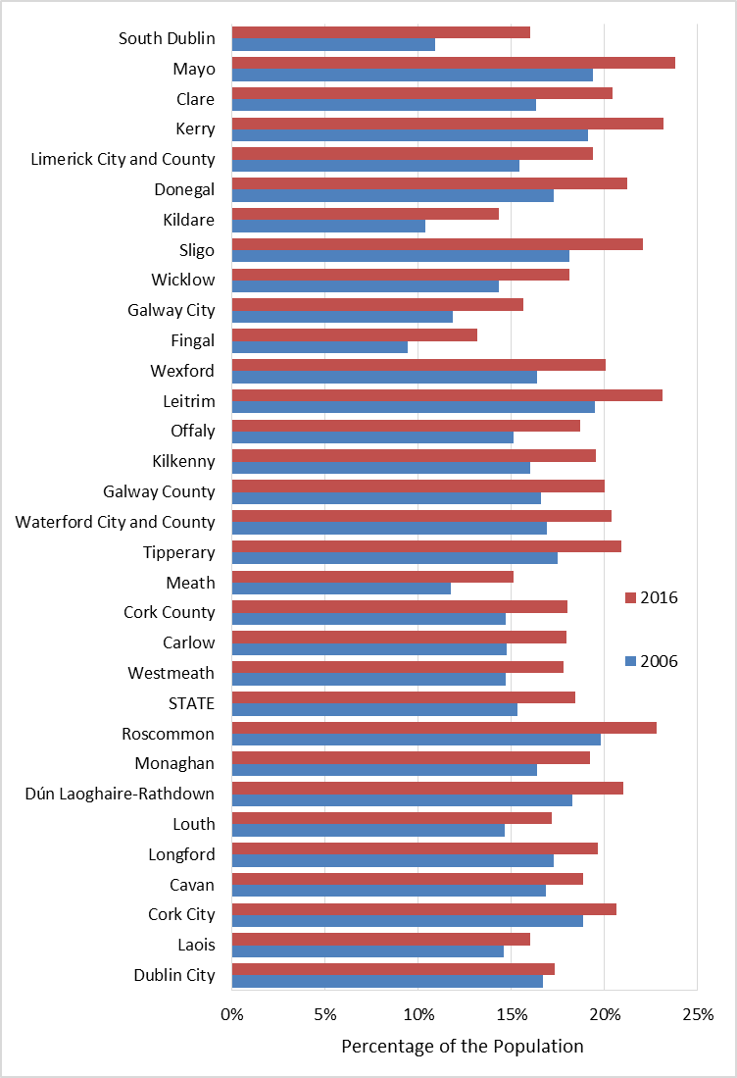

The Central Statistics office (CSO) projects that the ageing trend will continue, as presented in the following tables:

**Projected Population from 2011 ( M1) (Thousand) by Criteria for Projection, Age Group and Year**

|  |  |  |  |  |  |  |  |  |
| --- | --- | --- | --- | --- | --- | --- | --- | --- |
| **Cohort** | **2011** | **2016** | **2021** | **2026** | **2031** | **2036** | **2041** | **2046** |
| 60 - 64 years | 217.1 | 235.4 | 262.2 | 292.7 | 318.4 | 348.7 | 374.2 | 349.4 |
| 65 - 69 years | 172.1 | 205.8 | 226.4 | 253.9 | 284.2 | 309.9 | 340 | 365.7 |
| 70 - 74 years | 130.1 | 157.8 | 192.3 | 213.6 | 240.9 | 270.8 | 296.3 | 326.1 |
| 75 - 79 years | 101.4 | 112.3 | 139.9 | 172.9 | 194.1 | 220.6 | 249.6 | 274.7 |
| 80 - 84 years | 69.8 | 78.7 | 90.4 | 115.6 | 145.2 | 165.4 | 190.3 | 217.6 |
| 85 years and over | 58.2 | 69.9 | 85.2 | 104.6 | 136.6 | 179.5 | 221.8 | 266.9 |

Within Kerry, there is considerable spatial variation in respect of distribution of persons aged 60+. As the following table shows, the South and West Municipal District has the highest proportion of persons aged over 60.

**Persons Aged 60+ by Age Cohort and Municipal District (MD) in County Kerry, 2016.**



The following table lists the twenty Electoral Divisions with the highest proportions of older people, by gender.

**Electoral Divisions in County Kerry with the highest Proportions of Persons aged 60+, 2016**

|  |  |  |  |  |  |  |
| --- | --- | --- | --- | --- | --- | --- |
| **ED** | **Females** | |  | **ED** | **Males** | |
| **% aged 60+** | **% aged 65+** |  | **% aged 60+** | **% aged 65+** |
| 013 Darrynane | 34.9% | 23.3% |  | 013 Darrynane | 41.7% | 27.4% |
| 156 Knockglass | 33.5% | 28.4% |  | 054 Glanmore | 34.4% | 25.0% |
| 107 Gullane | 32.7% | 22.8% |  | 042 Márthain | 32.9% | 21.4% |
| 049 Castlecove | 31.3% | 18.8% |  | 006 Ballybrack | 28.8% | 22.0% |
| 103 Cloontubbrid | 31.0% | 27.7% |  | 049 Castlecove | 28.5% | 20.0% |
| 042 Márthain | 30.9% | 24.3% |  | 060 Sneem | 28.4% | 18.6% |
| 059 Reen | 30.9% | 21.0% |  | 103 Cloontubbrid | 28.2% | 23.3% |
| 055 Greenane | 30.2% | 23.8% |  | 019 Loughcurrane | 28.0% | 17.3% |
| 017 Killinane | 29.8% | 19.8% |  | 046 Ardea | 28.0% | 16.9% |
| 023 St. Finan's | 29.0% | 21.7% |  | 090 Muckross | 27.8% | 19.5% |
| 060 Sneem | 28.4% | 21.4% |  | 153 Killahan | 27.6% | 18.4% |
| 105 Duagh | 28.2% | 24.1% |  | 027 Ballyduff | 27.1% | 20.3% |
| 037 Inch | 28.2% | 22.4% |  | 055 Greenane | 27.0% | 20.5% |
| 094 Astee | 27.8% | 21.2% |  | 014/011 Cloon/Daoire Ianna | 26.7% | 16.4% |
| 054 Glanmore | 27.6% | 22.0% |  | 032 Deelis | 26.4% | 16.9% |
| 025 Valencia | 27.6% | 22.6% |  | 037 Inch | 26.1% | 19.3% |
| 148 Gneeves | 27.4% | 21.3% |  | 125 Tarmon | 26.1% | 20.1% |
| 001 Killarney Urban | 27.4% | 21.3% |  | 004 Bahaghs | 25.2% | 17.1% |
| 004 Bahaghs | 27.3% | 19.2% |  | 113 Kilshenane | 24.8% | 17.3% |
| 006 Ballybrack | 27.0% | 23.8% |  | 059 Reen | 24.7% | 20.6% |

While the majority of EDs with high proportions of persons aged 60% are in rural areas, Kerry’s main towns also have considerable numbers of older persons, as the following table shows:

**Persons in Kerry’s Main towns aged 60+, in Absolute Numbers and as a Proportion of the Population**

|  |  |  |  |  |  |  |  |  |
| --- | --- | --- | --- | --- | --- | --- | --- | --- |
| **ED** | **60 - 64 years** | **65 - 69 years** | **70 - 74 years** | **75 - 79 years** | **80 - 84 years** | **85 years and over** | **Total Persons** | **% Aged 60+** |
| Killarney Urban | 577 | 550 | 514 | 373 | 232 | 177 | 10,194 | 23.8% |
| Killarney Rural | 312 | 251 | 203 | 146 | 94 | 42 | 6,585 |  |
| Listowel Urban | 219 | 164 | 135 | 127 | 80 | 82 | 3,901 | 20.7% |
| Listowel Rural | 86 | 66 | 57 | 47 | 39 | 35 | 1,397 |  |
| Tralee Urban | 297 | 267 | 238 | 205 | 150 | 87 | 5,456 | 22.8% |
| Tralee Rural | 661 | 614 | 467 | 332 | 224 | 158 | 16,611 |  |
| **Town and Environs** |  |  |  |  |  |  |  |  |
| Killarney | 889 | 801 | 717 | 519 | 326 | 219 | 16,779 | 20.7% |
| Listowel | 305 | 230 | 192 | 174 | 119 | 117 | 5,298 | 21.5% |
| Tralee | 958 | 881 | 705 | 537 | 374 | 245 | 22,067 | 16.8% |
| **Other Towns[1]** |  |  |  |  |  |  |  |  |
| Castleisland | 171 | 147 | 114 | 104 | 74 | 51 | 3,285 | 20.1% |
| Dingle | 77 | 63 | 54 | 56 | 36 | 39 | 1,775 | 18.3% |
| Killorglin | 197 | 161 | 129 | 92 | 72 | 59 | 3,868 | 18.4% |
| Kenmare | 107 | 100 | 76 | 64 | 55 | 57 | 2,462 | 18.6% |
| Milltown | 81 | 64 | 43 | 34 | 36 | 26 | 1,447 | 19.6% |
| Cahersiveen | 110 | 72 | 97 | 83 | 48 | 42 | 2,127 | 21.3% |

**Quality of Life Issues**

The CSO projects that an increasing number of persons aged 60+ years will remain in the labour force, as the following table illustrates:

**Actual and Projected Labour Force from 2011 (M2) by Age Group, statistical indicator and Year**

|  |  |  |  |  |  |
| --- | --- | --- | --- | --- | --- |
| **Age Cateogory** | **Cohort** | **2011** | **2016** | **2021** | **2026** |
| 60 - 64 years | Persons (Thousand) | 97.8 | 110.9 | 125.8 | 139.8 |
| Males (Thousand) | 60.8 | 70 | 79.9 | 88.6 |
| Females - all (Thousand) | 37 | 40.9 | 45.9 | 51.2 |
| Females - married (Thousand) | 33.2 | 36.3 | 40.1 | 44.7 |
| Females - other (Thousand) | 3.8 | 4.6 | 5.8 | 6.5 |
| 65 years and over | Persons (Thousand) | 48.9 | 66.3 | 92.6 | 125.4 |
| Males (Thousand) | 33.3 | 46.1 | 61.3 | 79.8 |
| Females - all (Thousand) | 15.6 | 20.2 | 31.3 | 45.6 |
| Females - married (Thousand) | 14.2 | 17.5 | 27.2 | 39.7 |
| Females - other (Thousand) | 1.4 | 2.6 | 4.1 | 5.9 |

The CSO data suggest that the increase in older people’s participation in the labour force will be more pronounced in respect of females.

Health and ability/ disability issues are particularly relevant to the quality of life of older people. As the following table shows, the number and proportion of persons with a disability in Kerry and across Ireland is increasing. These increases are associated with the ageing of the population.

**Persons with a Disability as a Percentage of All Population, 2011 to 2016 in Ireland and Co. Kerry.**

|  |  |  |
| --- | --- | --- |
| **Classification** | **State** | **Kerry** |
| Total persons 2011 (Number) | 4,588,252 | 145,502 |
| Total persons 2016 (Number) | 4,761,865 | 147,707 |
| Persons with a disability 2011 (Number) | 595,335 | 19,168 |
| Persons with a disability 2016 (Number) | 643,131 | 19,965 |
| Persons with a disability as a % of total persons (%) | 13.5 | 13.5 |
| Actual change in persons with a disability since previous census (Number) | 47,796 | 797 |
| Percentage change in persons with a disability since previous census (%) | 8 | 4.2 |

The census data also include an enumeration on self-declared health status. The following table presents the responses provided by older persons:

**Self-Declared Health Status among persons in County Kerry, Aged 60+, 2016**



The table illustrates the association between ageing and health challenges. The following table provides details on some of these health challenges – specifically, the types of disabilities which affect older persons.



**Annex: Percentage of the Population aged 55+ and 65+ by ED in County Kerry, 2006 and 2016.**

|  |  |  |  |  |  |  |  |  |
| --- | --- | --- | --- | --- | --- | --- | --- | --- |
|  | **2006** | |  | **2016** | |  | **% Change** | |
| **ED** | **% aged 55+** | **% aged 65+** |  | **% aged 55+** | **% aged 65+** |  | **Proportion aged 55+** | **Proportion aged 65+** |
| 001 Killarney Urban | 29.8% | 18.1% |  | 31.9% | 20.2% |  | 2.1% | 2.1% |
| 002 Listowel Urban | 26.9% | 15.1% |  | 30.5% | 18.5% |  | 3.6% | 3.4% |
| 003 Tralee Urban | 28.5% | 17.4% |  | 31.4% | 18.9% |  | 2.9% | 1.5% |
| 004 Bahaghs | 34.3% | 18.1% |  | 34.5% | 21.3% |  | 0.2% | 3.2% |
| 005 Ballinskelligs | 32.4% | 16.9% |  | 40.3% | 22.3% |  | 7.9% | 5.4% |
| 006 Ballybrack | 34.4% | 23.0% |  | 44.6% | 21.7% |  | 10.2% | -1.3% |
| 007 Caher | 27.3% | 16.1% |  | 36.3% | 22.3% |  | 9.0% | 6.2% |
| 008 Caherdaniel | 31.0% | 13.5% |  | 48.9% | 26.8% |  | 17.8% | 13.3% |
| 009/020 Ceannúig/Máistir Gaoithe | 31.7% | 13.3% |  | 40.6% | 19.3% |  | 8.8% | 6.1% |
| 010 Castlequin | 24.3% | 11.6% |  | 35.2% | 19.2% |  | 11.0% | 7.6% |
| 012 Curraghbeg | 25.4% | 11.7% |  | 32.9% | 17.1% |  | 7.6% | 5.4% |
| 013 Darrynane | 48.8% | 25.3% |  | 45.3% | 30.7% |  | -3.6% | 5.4% |
| 014/011 Cloon/Daoire Ianna | 36.5% | 16.7% |  | 40.4% | 28.1% |  | 3.9% | 11.4% |
| 015 Emlagh | 28.6% | 14.4% |  | 36.5% | 21.9% |  | 7.9% | 7.5% |
| 016 Glanbehy | 28.3% | 15.1% |  | 35.1% | 20.5% |  | 6.8% | 5.4% |
| 017 Killinane | 37.0% | 17.2% |  | 40.6% | 25.8% |  | 3.6% | 8.6% |
| 018 Lickeen | 22.0% | 13.6% |  | 26.5% | 11.8% |  | 4.4% | -1.8% |
| 019 Loughcurrane | 35.8% | 18.2% |  | 36.0% | 22.5% |  | 0.2% | 4.3% |
| 021 Maum | 22.9% | 10.9% |  | 29.8% | 16.7% |  | 6.9% | 5.8% |
| 022 Portmagee | 28.2% | 13.3% |  | 35.1% | 18.9% |  | 6.9% | 5.6% |
| 023 St. Finan's | 27.9% | 16.2% |  | 36.0% | 16.5% |  | 8.1% | 0.2% |
| 024 Teeranearagh | 28.2% | 13.7% |  | 37.5% | 16.1% |  | 9.3% | 2.3% |
| 025 Valencia | 29.2% | 18.8% |  | 39.9% | 20.7% |  | 10.7% | 1.9% |
| 026 Ballinvoher | 27.1% | 12.2% |  | 29.5% | 16.1% |  | 2.4% | 3.9% |
| 027 Ballyduff | 29.4% | 19.3% |  | 44.2% | 17.7% |  | 14.8% | -1.6% |
| 028 Ballynacourty | 31.4% | 15.5% |  | 30.3% | 20.1% |  | -1.1% | 4.6% |
| 029 Brandon | 29.2% | 8.9% |  | 40.5% | 17.6% |  | 11.4% | 8.7% |
| 030 Castlegregory | 29.2% | 13.9% |  | 31.7% | 20.4% |  | 2.5% | 6.5% |
| 031 Cloghane | 27.5% | 17.2% |  | 40.1% | 19.0% |  | 12.6% | 1.7% |
| 032 Deelis | 35.1% | 16.7% |  | 35.8% | 21.2% |  | 0.7% | 4.5% |
| 033 An Daingean | 24.7% | 14.0% |  | 34.9% | 19.8% |  | 10.1% | 5.8% |
| 034 Dunquin | 32.1% | 8.8% |  | 40.7% | 21.4% |  | 8.6% | 12.6% |
| 035 Dunurlin | 26.8% | 16.9% |  | 35.5% | 20.1% |  | 8.7% | 3.2% |
| 036 Glin | 22.5% | 10.2% |  | 27.4% | 13.5% |  | 4.9% | 3.4% |
| 037 Inch | 41.6% | 20.8% |  | 41.8% | 28.4% |  | 0.2% | 7.6% |
| 038 Kilmalkedar | 29.9% | 16.7% |  | 41.8% | 18.5% |  | 11.9% | 1.8% |
| 039 Cill Chuáin | 25.3% | 12.3% |  | 38.2% | 18.9% |  | 12.9% | 6.6% |
| 040 Kinard | 25.5% | 12.6% |  | 32.5% | 16.8% |  | 7.0% | 4.2% |
| 041 Lack | 27.2% | 14.5% |  | 32.1% | 17.7% |  | 4.9% | 3.2% |
| 042 Márthain | 43.5% | 22.8% |  | 35.8% | 21.5% |  | -7.7% | -1.3% |
| 043 An Mhin Aird | 25.3% | 14.0% |  | 34.5% | 16.3% |  | 9.2% | 2.4% |
| 044 An Sráidbhaile | 26.6% | 13.5% |  | 28.9% | 17.6% |  | 2.3% | 4.0% |
| 045 Ceann Trá | 27.8% | 15.5% |  | 40.9% | 20.7% |  | 13.1% | 5.2% |
| 046 Ardea | 34.4% | 14.6% |  | 42.1% | 24.7% |  | 7.7% | 10.1% |
| 047 Banawn | 29.4% | 14.0% |  | 28.3% | 16.4% |  | -1.1% | 2.4% |
| 048 Cappagh | 24.0% | 12.6% |  | 26.8% | 14.6% |  | 2.7% | 2.0% |
| 049 Castlecove | 37.9% | 19.5% |  | 45.3% | 23.9% |  | 7.4% | 4.5% |
| 050 Dawros | 29.7% | 16.4% |  | 37.8% | 22.9% |  | 8.1% | 6.6% |
| 051 Dromore | 26.2% | 12.5% |  | 35.8% | 20.4% |  | 9.6% | 7.9% |
| 052 Glanlee | 29.0% | 15.9% |  | 32.8% | 19.5% |  | 3.8% | 3.7% |
| 053 Glanlough | 25.3% | 15.8% |  | 35.3% | 19.9% |  | 10.0% | 4.0% |
| 054 Glanmore | 41.6% | 23.5% |  | 46.6% | 28.0% |  | 5.0% | 4.5% |
| 055 Greenane | 33.9% | 22.2% |  | 36.5% | 22.0% |  | 2.6% | -0.2% |
| 056 Kenmare | 24.3% | 14.3% |  | 29.3% | 17.2% |  | 5.0% | 2.9% |
| 057 Kilgarvan | 29.9% | 18.2% |  | 30.6% | 18.7% |  | 0.7% | 0.6% |
| 058 Loughbrin | 25.9% | 15.9% |  | 41.1% | 26.0% |  | 15.2% | 10.1% |
| 059 Reen | 30.3% | 20.8% |  | 41.6% | 22.7% |  | 11.2% | 1.9% |
| 060 Sneem | 36.0% | 19.9% |  | 31.0% | 20.0% |  | -5.1% | 0.1% |
| 061 Tahilla | 32.1% | 14.5% |  | 52.2% | 28.1% |  | 20.1% | 13.6% |
| 062 Aghadoe | 19.2% | 8.7% |  | 23.9% | 12.3% |  | 4.7% | 3.7% |
| 063 Aglish | 20.4% | 10.4% |  | 23.3% | 13.1% |  | 2.8% | 2.8% |
| 064 Ballyhar | 23.3% | 11.7% |  | 27.3% | 10.4% |  | 4.0% | -1.3% |
| 065 Brewsterfield | 17.0% | 7.5% |  | 21.3% | 10.7% |  | 4.3% | 3.2% |
| 066 Caragh | 29.3% | 15.7% |  | 28.4% | 18.1% |  | -1.0% | 2.4% |
| 067 Churchtown | 19.3% | 9.8% |  | 24.5% | 13.6% |  | 5.2% | 3.8% |
| 068 Clydagh | 27.8% | 16.7% |  | 38.5% | 24.6% |  | 10.7% | 7.9% |
| 069 Coolies | 16.0% | 7.2% |  | 19.8% | 10.6% |  | 3.8% | 3.4% |
| 070 Coom | 23.3% | 12.1% |  | 29.1% | 15.6% |  | 5.8% | 3.5% |
| 071 Curraghmore | 23.2% | 12.6% |  | 28.0% | 14.3% |  | 4.8% | 1.7% |
| 072 Currans | 27.1% | 12.8% |  | 33.6% | 19.9% |  | 6.4% | 7.1% |
| 073 Doocarrig | 22.7% | 13.5% |  | 24.4% | 13.6% |  | 1.8% | 0.1% |
| 074 Dromin | 24.0% | 14.2% |  | 25.3% | 14.1% |  | 1.3% | -0.1% |
| 075 Dunloe | 22.9% | 11.9% |  | 30.9% | 17.7% |  | 7.9% | 5.8% |
| 076 Flesk | 20.7% | 8.8% |  | 27.5% | 14.4% |  | 6.8% | 5.6% |
| 077 Headfort | 19.6% | 9.4% |  | 23.0% | 12.1% |  | 3.3% | 2.7% |
| 078 Kilbonane | 21.0% | 8.9% |  | 22.8% | 11.8% |  | 1.7% | 2.9% |
| 079 Kilcummin | 22.8% | 11.4% |  | 26.5% | 15.7% |  | 3.7% | 4.2% |
| 080 Kilfelim | 27.7% | 18.1% |  | 27.5% | 17.8% |  | -0.2% | -0.3% |
| 081 Kilgobnet | 19.2% | 10.3% |  | 25.9% | 14.5% |  | 6.6% | 4.2% |
| 082 Killarney Rural | 21.9% | 11.2% |  | 26.5% | 14.3% |  | 4.6% | 3.2% |
| 083 Killeentierna | 21.7% | 12.1% |  | 28.8% | 13.5% |  | 7.1% | 1.4% |
| 084 Killorglin | 24.2% | 13.3% |  | 27.2% | 15.6% |  | 3.0% | 2.3% |
| 085 Kilnanare | 23.9% | 13.4% |  | 24.7% | 15.2% |  | 0.8% | 1.7% |
| 086 Knocknahoe | 18.0% | 10.6% |  | 21.6% | 11.0% |  | 3.6% | 0.4% |
| 087 Lahard | 23.7% | 11.8% |  | 26.4% | 13.4% |  | 2.7% | 1.6% |
| 088 Milltown | 24.5% | 14.0% |  | 22.4% | 14.6% |  | -2.1% | 0.5% |
| 089 Molahiffe | 20.0% | 10.6% |  | 21.0% | 12.4% |  | 0.9% | 1.7% |
| 090 Muckross | 33.6% | 19.6% |  | 30.7% | 17.6% |  | -2.9% | -1.9% |
| 091 Rathmore | 21.1% | 13.2% |  | 26.5% | 14.0% |  | 5.5% | 0.7% |
| 092 Rockfield | 19.2% | 10.7% |  | 20.5% | 11.0% |  | 1.3% | 0.3% |
| 093 Ardagh | 23.9% | 12.7% |  | 32.3% | 14.6% |  | 8.4% | 1.9% |
| 094 Astee | 31.2% | 19.3% |  | 33.5% | 19.8% |  | 2.3% | 0.5% |
| 095 Ballincloher | 22.1% | 11.2% |  | 31.5% | 16.8% |  | 9.4% | 5.7% |
| 096 Ballyconry | 29.9% | 14.3% |  | 36.8% | 23.2% |  | 7.0% | 9.0% |
| 097 Ballyduff | 28.3% | 16.7% |  | 35.0% | 19.0% |  | 6.7% | 2.3% |
| 098 Ballyegan | 18.1% | 9.5% |  | 33.0% | 13.9% |  | 14.9% | 4.4% |
| 099 Ballyhorgan | 30.1% | 18.3% |  | 23.3% | 15.6% |  | -6.8% | -2.7% |
| 100 Beal | 30.9% | 19.1% |  | 33.6% | 18.2% |  | 2.7% | -1.0% |
| 101 Carrig | 29.3% | 16.9% |  | 41.9% | 21.9% |  | 12.5% | 5.1% |
| 102 Causeway | 23.8% | 11.4% |  | 32.3% | 16.7% |  | 8.5% | 5.3% |
| 103 Cloontubbrid | 36.5% | 25.5% |  | 39.8% | 30.1% |  | 3.3% | 4.7% |
| 104 Drommartin | 28.2% | 16.1% |  | 28.7% | 17.8% |  | 0.5% | 1.7% |
| 105 Duagh | 32.6% | 20.2% |  | 31.8% | 19.7% |  | -0.8% | -0.5% |
| 106 Ennismore | 26.0% | 13.2% |  | 33.9% | 18.6% |  | 7.9% | 5.4% |
| 107 Gullane | 34.1% | 20.0% |  | 35.5% | 20.6% |  | 1.4% | 0.6% |
| 108 Gunsborough | 26.6% | 16.7% |  | 28.3% | 14.8% |  | 1.7% | -1.9% |
| 109 Kilfeighny | 22.2% | 9.8% |  | 27.8% | 15.2% |  | 5.6% | 5.3% |
| 110 Killehenny | 29.5% | 15.9% |  | 35.6% | 20.7% |  | 6.2% | 4.8% |
| 111 Killury | 28.0% | 14.6% |  | 31.3% | 19.3% |  | 3.3% | 4.7% |
| 112 Kilmeany | 25.2% | 14.0% |  | 29.5% | 14.8% |  | 4.2% | 0.8% |
| 113 Kilshenane | 40.3% | 17.1% |  | 48.9% | 28.2% |  | 8.6% | 11.1% |
| 114 Kiltomy | 27.0% | 13.9% |  | 31.8% | 18.4% |  | 4.8% | 4.5% |
| 115 Leitrim | 26.1% | 12.8% |  | 28.3% | 17.4% |  | 2.2% | 4.6% |
| 116 Lislaughtin | 27.7% | 14.6% |  | 37.6% | 22.7% |  | 9.9% | 8.1% |
| 117 Lisselton | 26.9% | 15.8% |  | 32.2% | 17.3% |  | 5.3% | 1.6% |
| 118 Listowel Rural | 30.1% | 17.5% |  | 32.4% | 20.8% |  | 2.3% | 3.3% |
| 119 Lixnaw | 19.9% | 11.9% |  | 19.0% | 10.4% |  | -0.9% | -1.5% |
| 120 Moynsha | 24.0% | 12.3% |  | 30.1% | 15.7% |  | 6.1% | 3.4% |
| 121 Newtownsandes | 26.4% | 14.2% |  | 34.8% | 18.2% |  | 8.4% | 4.0% |
| 122 Rathea | 30.5% | 16.9% |  | 35.5% | 20.9% |  | 5.0% | 4.0% |
| 123 Shronowen | 29.7% | 19.2% |  | 40.5% | 25.3% |  | 10.8% | 6.1% |
| 124 Tarbert | 32.8% | 15.9% |  | 40.9% | 23.7% |  | 8.0% | 7.7% |
| 125 Tarmon | 32.7% | 20.3% |  | 34.5% | 22.3% |  | 1.7% | 1.9% |
| 126 Trienearagh | 26.8% | 14.8% |  | 27.7% | 15.0% |  | 0.9% | 0.1% |
| 127 Urlee | 33.4% | 18.3% |  | 35.5% | 21.8% |  | 2.1% | 3.5% |
| 128 Abbeydorney | 27.7% | 13.7% |  | 26.5% | 17.1% |  | -1.1% | 3.4% |
| 129 Arabela | 28.4% | 14.6% |  | 34.1% | 18.5% |  | 5.7% | 3.8% |
| 130 Ardfert | 20.3% | 10.2% |  | 28.0% | 13.4% |  | 7.6% | 3.2% |
| 131 Ballyegan | 21.6% | 10.0% |  | 21.0% | 12.2% |  | -0.6% | 2.2% |
| 132 Ballyheige | 30.2% | 16.0% |  | 34.7% | 19.0% |  | 4.5% | 3.0% |
| 133 Ballynahaglish | 25.4% | 13.4% |  | 28.9% | 15.8% |  | 3.5% | 2.4% |
| 134 Ballynorig | 27.5% | 14.5% |  | 30.3% | 17.4% |  | 2.8% | 2.9% |
| 135 Ballyseedy | 17.0% | 10.4% |  | 24.1% | 12.9% |  | 7.1% | 2.6% |
| 136 Banna | 24.7% | 12.0% |  | 31.0% | 16.9% |  | 6.3% | 4.9% |
| 137 Baurtregaum | 32.2% | 17.2% |  | 38.4% | 24.3% |  | 6.2% | 7.1% |
| 138 Blennerville | 22.6% | 11.1% |  | 33.9% | 17.5% |  | 11.2% | 6.4% |
| 139 Boolteens | 24.9% | 13.3% |  | 29.7% | 18.5% |  | 4.8% | 5.2% |
| 140 Brosna | 30.6% | 16.7% |  | 36.7% | 20.9% |  | 6.1% | 4.2% |
| 141 Carker | 24.9% | 16.0% |  | 33.2% | 16.7% |  | 8.3% | 0.7% |
| 142 Castleisland | 26.3% | 14.9% |  | 30.4% | 17.1% |  | 4.1% | 2.1% |
| 143 Clogherbrien | 21.6% | 9.9% |  | 33.8% | 17.1% |  | 12.2% | 7.2% |
| 144 Cordal | 28.4% | 16.2% |  | 34.2% | 17.6% |  | 5.8% | 1.4% |
| 145 Crinny | 20.5% | 13.0% |  | 38.1% | 14.9% |  | 17.5% | 1.8% |
| 146 Derreen | 29.3% | 16.0% |  | 29.2% | 16.7% |  | -0.1% | 0.6% |
| 147 Doon | 18.4% | 8.1% |  | 26.7% | 12.6% |  | 8.3% | 4.5% |
| 148 Gneeves | 30.3% | 17.1% |  | 29.1% | 17.0% |  | -1.2% | -0.1% |
| 149 Kerryhead | 29.6% | 13.4% |  | 30.3% | 19.6% |  | 0.7% | 6.2% |
| 150 Kilflyn | 31.4% | 14.3% |  | 35.5% | 22.7% |  | 4.1% | 8.4% |
| 151 Kilgarrylander | 24.4% | 12.1% |  | 35.9% | 16.2% |  | 11.5% | 4.0% |
| 152 Kilgobban | 23.7% | 11.1% |  | 36.8% | 19.1% |  | 13.1% | 8.0% |
| 153 Killahan | 34.4% | 17.4% |  | 32.4% | 20.1% |  | -2.0% | 2.8% |
| 154 Kilmurry | 19.7% | 10.5% |  | 35.3% | 11.1% |  | 15.6% | 0.6% |
| 155 Kiltallagh | 22.1% | 12.1% |  | 29.7% | 19.5% |  | 7.6% | 7.4% |
| 156 Knockglass | 32.5% | 22.2% |  | 34.3% | 23.8% |  | 1.8% | 1.6% |
| 157 Knocknagashel | 29.0% | 16.1% |  | 33.6% | 19.1% |  | 4.6% | 3.0% |
| 158 Lackabaun | 20.0% | 10.1% |  | 30.6% | 15.2% |  | 10.6% | 5.1% |
| 159 Millbrook | 26.4% | 13.2% |  | 31.7% | 15.9% |  | 5.2% | 2.7% |
| 160 Mount Eagle | 25.4% | 13.5% |  | 29.4% | 16.4% |  | 4.0% | 2.9% |
| 161 Nohaval | 19.5% | 10.0% |  | 32.5% | 14.4% |  | 13.0% | 4.4% |
| 162 O'Brennan | 18.8% | 8.9% |  | 25.1% | 12.0% |  | 6.3% | 3.2% |
| 163 Ratass | 20.4% | 7.9% |  | 28.2% | 15.2% |  | 7.7% | 7.3% |
| 164 Scartaglin | 20.9% | 10.9% |  | 27.2% | 13.9% |  | 6.3% | 2.9% |
| 165 Tralee Rural | 19.5% | 10.8% |  | 23.7% | 13.4% |  | 4.2% | 2.6% |
| 166 Tubrid | 26.0% | 12.3% |  | 29.1% | 17.3% |  | 3.1% | 5.0% |
|  |  |  |  |  |  |  |  |  |
| **Kerry** | 25.4% | 13.8% |  | 29.8% | 16.9% |  | 4.4% | 3.1% |

1. Figures are based on the entire ED (Electoral Division) in which the town is located.