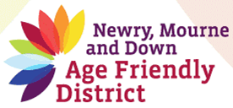

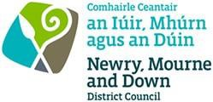

AGE FRIENDLY ACTION
PLAN: 2016-2019
Newry, Mourne and Down District

Summary
Age friendliness is about making Newry Mourne and Down a really great place in
which to grow older, and a region where older people can thrive.

THIS DOCUMENT IS AVAILABLE IN A RANGE OF FORMATS ON REQUEST

Acronyms

AS: Alzheimer’s Society
Age NI: Age Northern Ireland
CCG: Confederation of Community Groups
CDRCN: County Down Rural Network
CT: Newry, Mourne Community Transport/Down Community Transport
NMDDC: Newry, Mourne and Down District Council
NMSCC: Newry and Mourne Senior Citizens
OPF: Older People’s Forum/Down Senior Forum
PAW: Positive Aging Week
PCSP: Policing and Community Safety Partnership
PHA: Public Health Agency
PSNI: Police Service of Northern Ireland
PWT: Promoting Wellbeing Team/Safe and Well Caring Communities
SPACE: Supporting People and Communities (Formerly SDFHI – South Down Family Health Initiative)
SH: Southern Health and Social Care Trust/ South Eastern Health and Social Care Trust

1. Introduction

Age friendliness means making Newry, Mourne and Down an area where people of all ages and backgrounds can thrive with a good quality of life as they grow older. This action plan has been developed with older people, not for them, and indeed older people’s priorities and concerns have been the driving force behind discussions, consultations, and meetings with older people and relevant organizations, agencies, and groups. This summary document remains a work-in-progress which will continue to be influenced by Age Friendly Strategic Alliance, the Older People’s Forum, and indeed older people in general through ongoing consultation and engagement.

1.1 Background
The Newry, Mourne and Down Strategic Alliance has been working actively with a wide range of partners on initiatives to understand and improve the health, well-being and quality of life of older people. Comprehensive consultation processes ensured that decisions about actions and priorities were evidence based. This consultation included a wide range of awareness-raising sessions, a mapping exercise of current services and supports, plus a comprehensive survey of over 250 community based older adults (see O’Hanlon & Mackin,
2013a). This work arises from the WHO (World Health Organization) study on age-
friendliness that took place in cities and towns in 22 countries (WHO, 2004). Older adults and carers were asked about age-friendliness across eight main themes. These eight themes can be seen in Table 1.1, under four community planning subject areas.1

Table 1.1: Theoretical frameworks contributing to age friendliness

Health and Well-  Being | Economic Development  Regeneration and Tourism | Environment and Spatial | Safety and Good  Relations
1. Social  participation  2. Community &  health services | 3. Civic participation and  employment | 4. Outdoor spaces  5. Transport  6. Home & Housing | 7. Respect and  inclusion
8. Communication and Information

1 Community planning offers opportunities for local involvement in the planning and management of their local communities so that these become safer, stronger, wealthier and more sustainable.

1.2 Summary
Table 1.2 summarizes the process of developing an Age Friendly Action Plan for the area, the people involved, and the eight WHO themes representing age-friendliness.2

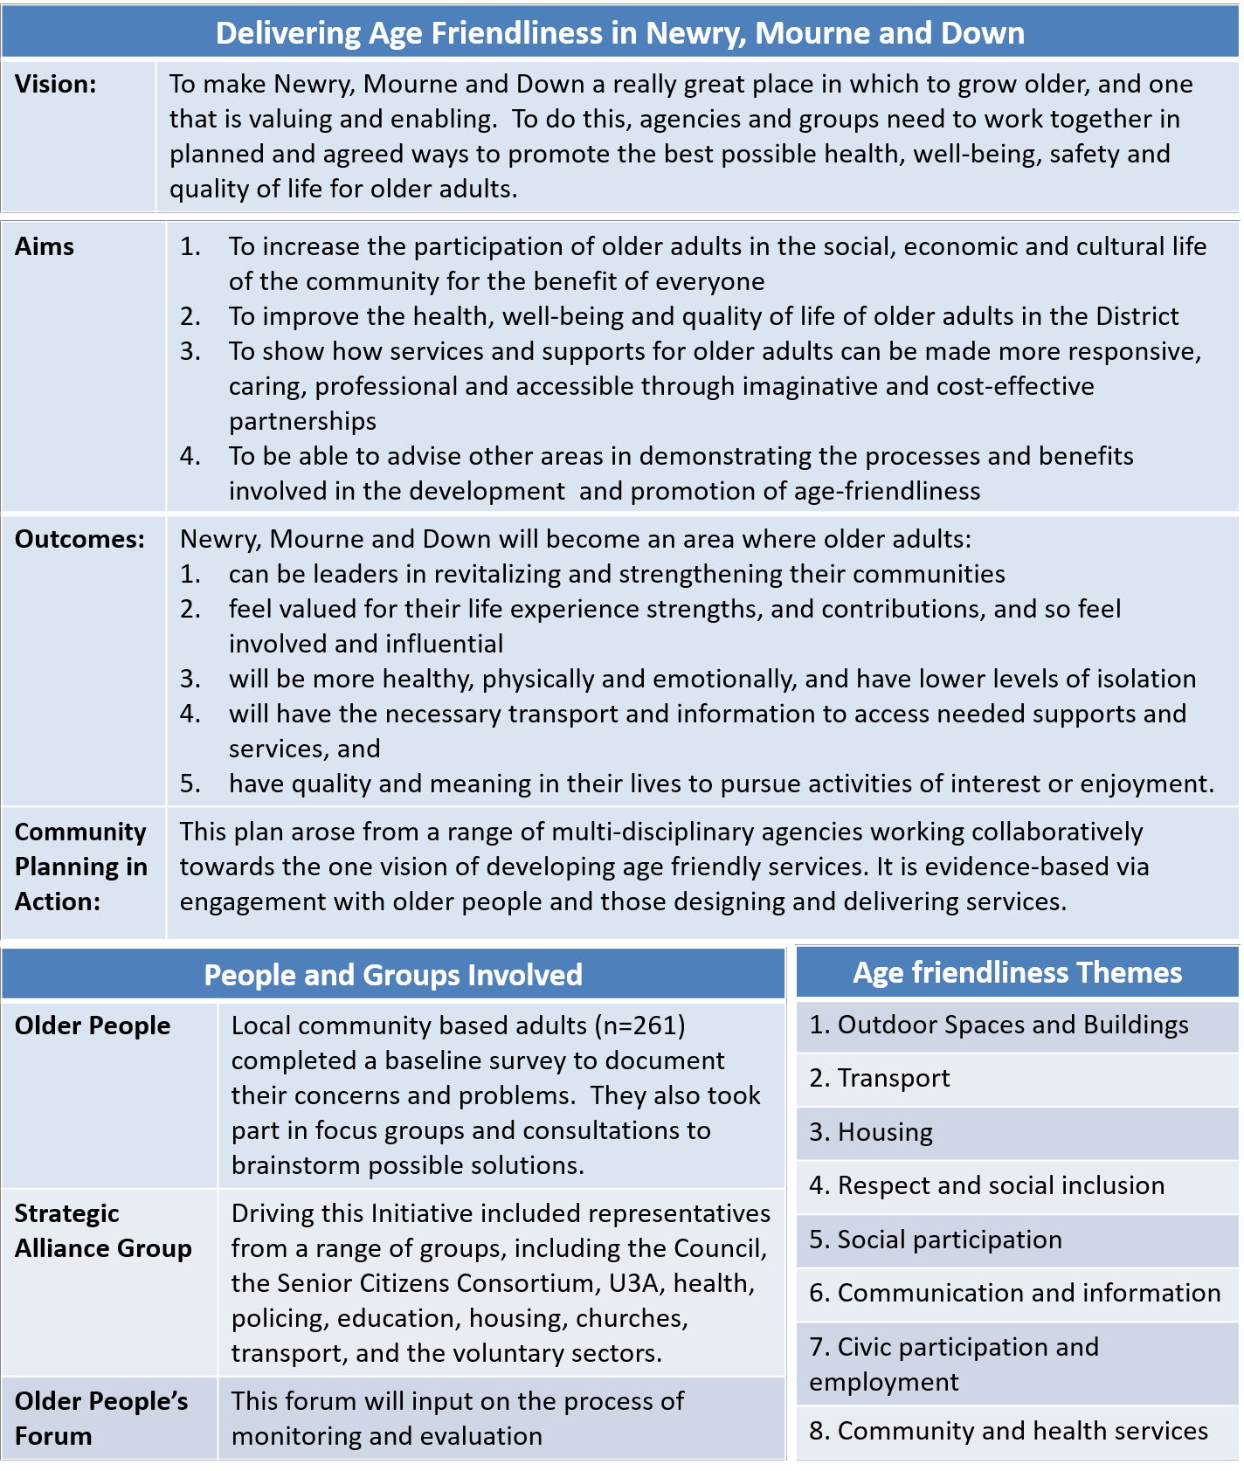
Table 1.2: An overview

2 In 2015 Newry and Mourne became Newry, Mourne and Down, and further work in Down is planned so that this Action Plan will cover the new Newry, Mourne and Down district.

2. Challenges and Solutions: The Actions

Each of the four community planning areas to follow will begin with a short summary of aims, followed by the strategies agreed and in process. The Age Friendly Strategic Alliance is committed to securing funding to ensure full implementation of this plan.

2.1 Health and Well-being
Work on this community planning theme particularly links to the WHO age-friendly themes of:
‘social participation’, and ‘community and health services’.

“We aim to promote health and well-being among older people: by challenging negative stereotypes of ageing; by working collaboratively to combat isolation and promote participation; and by providing a wide range of services and initiatives to empower and enable older people to improve their health and well-being.

We plan to: | Lead Partners
1. work in partnership with the OPF to deliver the action  plan | AFSA and OPF
2. explore better ways of working together to improve health  and social wellbeing outcomes for older people | AFSA and OPF
3. deliver and develop a range of health and well-being, educational, social activity and intergenerational programmes appropriate to the needs and interests of  older adults | NMDDC, NMSCC, CCG,  PHA, SHSCT, Age NI, CDRCN; Volunteer Now, OPF, SPACE, U3A, Linking Generations and AS
4. deliver the annual Positive Ageing event, and develop a range of positive ageing events that challenge negative stereotypes of ageing, and raise awareness about the potential of later life. Fear of dementia and negative stereotypes are such barriers to diagnosis, information and support | NMDDC, NMSSC,  SHSCT, CCG, Volunteer  Now, U3A, SPACE, OPF, CDRCN and AS
5. develop, provide and maintain an easily-accessible  information system for older people which includes a new district-wide website on age friendliness | NMDDC, SHSCT, All
6. promote and publicize opportunities for volunteering  including offering opportunities to older people living in sheltered accommodation and residential care | Volunteer Now, CCG,  U3A, NMCT and AS
7. deliver workshops to promote Alzheimer’s Society and disability friendly communities | AS,  Linking Generations, SHSCT

2.2 Economic Development, Regeneration and Tourism
This theme is particularly relevant to the WHO theme: ‘Civic participation and employment’.

“We aim to value and promote the civic, economic and social contributions older people can make within their local communities: through volunteering or mentoring opportunities, through access to further training, or by post retirement employment including entrepreneurship.

We plan to: | Lead Partners
1. work with organizations, businesses and services to encourage and promote age friendly initiatives and to encourage business to value older employees | NMDDC
2. promote and support entrepreneurship and small businesses  amongst older people, including those recently retired and those interested in turning a hobby into a business, e.g. ‘shop local’ initiatives | NMDDC,  Chambers of  Commerce
3. work with business agencies and others to establish a database  of older people willing to act as mentors to young entrepreneurs in the early stages of their business development | NMDDC, U3A
4. promote an age-friendly charter for use by organizations, business and services to demonstrate their commitment and support for age friendliness | All
5. ongoing improvements to safety and security which includes  promoting the Purple Flag Zone in the city centre, seeking approval for lighting improvements (DFI), examining the feasibility of cameras and increasing police / community patrols | NMDDC, PCSP,  PSNI
6. develop and explore opportunities for age friendly awards with businesses, organizations and services | AFSA, Chambers of Commerce

2.3 Environment and Spatial
This community planning theme particularly links to three subthemes within the WHO
framework: “home and housing”, “outdoor spaces”, and “transport”.

“We aim to promote access for older people to all places and spaces: by supporting older people to live independently in their own homes; and by enabling older people to participate fully in community life by having places and spaces that are safe, and by having more transport options.

We plan to: | Lead Partners
1. engage with older people, using a participative design approach,  in the design of public spaces and buildings, e.g. libraries, parks, leisure centres | All
2. promote safer spaces which are accessible for older people | All
3. promote greater transport options and opportunities, including  maximizing connections via public transport networks, and supporting the needs of more vulnerable or isolated older people | CT, Translink;
4. support older people to live safely and independently in their  own homes | All
5. promote confidence and feelings of personal safety in  communities through a range of methods and initiatives. | PSNI, PCSP, NMDDC

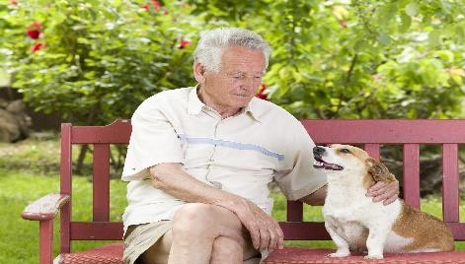
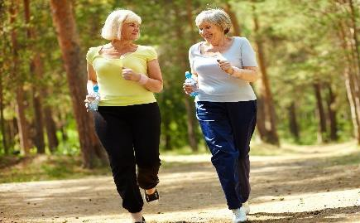
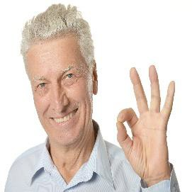
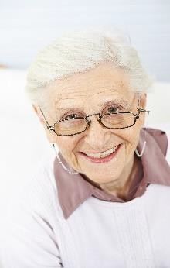
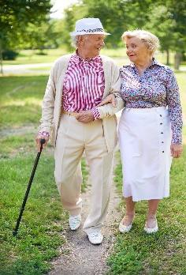
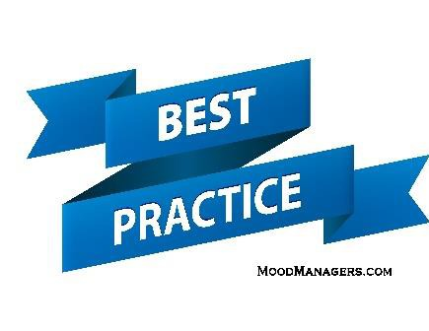
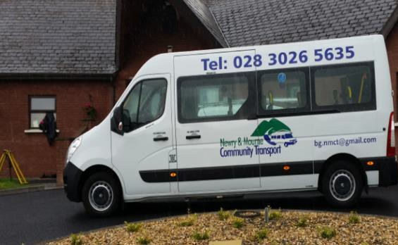
Making communities accessible, supportive and empowering

2.4 Safety and Good Relations

This theme particularly links to the WHO subtheme of “respect and social inclusion”. Information and communication crosses all themes, but is addressed specifically in this theme, and as a way to show respect to older people.

“We aim to keep people safe by working towards safer, shared and more confident communities: by promoting ongoing consultation and involvement of older people with others, and by tackling crime and antisocial behavior.

We plan to: | Lead Partners
1. work towards reducing fear of crime especially among older people through a range of initiatives and activities | PSNI, PCSP and AFSA
2. develop intergenerational relationships across the District to increase understanding, respect and support between people of  all ages | AFSA, Linking  Generations
3. engage with a range of groups, particularly those most vulnerable, to build positive relations and safer communities | PSNI, DFC, AS AFSA, and SHSCT
4. to have all agencies communicate effectively which includes all agencies providing information to a new website on age friendliness for the region. | All

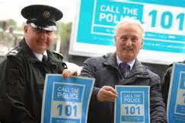
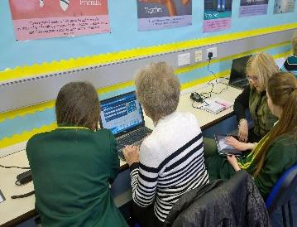
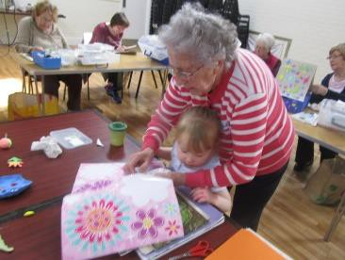
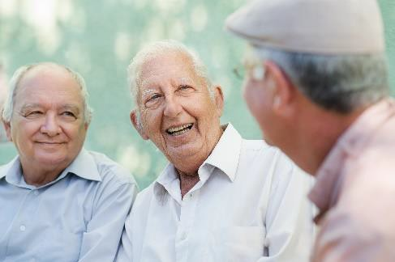
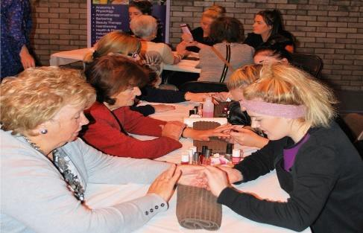
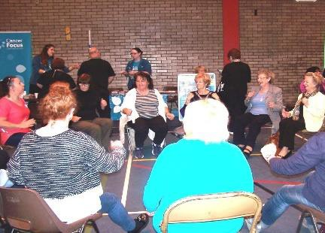
Making communities safe, friendly, respectful and inclusive

3. Conclusions

We would like to thank the many contributors to this Age Friendly Action Plan especially the older people of the Newry, Mourne and Down District who enthusiastically gave of their time, attitudes and experiences over the past year. We encourage all citizens of the region, whatever their ages, to take the time to consider and give their views on these actions. In this way, together we can improve the plan further and make Newry, Mourne and Down a truly great place in which to grow older

3.1 Research and monitoring
It is crucial to monitor and evaluate actions in order to assess how successful these have been in achieving and promoting age friendliness. A range of research techniques will be used in consultation with older people via The Older People’s Forum and the Newry, Mourne and
Down Strategic Alliance. Indeed, The Older Peoples Forum will be core to decisions about evaluation and monitoring.

The Age Friendly Strategic Alliance leads within each of the four community planning areas will collaborate regarding evaluation and monitoring. In conjunction with The Older People’s Forum they will provide updates every six months, with an annual report to the Age Friendly Strategical Alliance. A summary update form for consideration is available in Appendix 1.

3.2 Follow up contact

For further information, or to comment on this action plan, please contact:

Mr Eoin Devlin,

Assistant Director of Active and Healthy Communities
Newry, Mourne and Down District Council, Monaghan Row, Newry,
Co Down.

Email: eoin.devlin@nmandd.org

Tel: (028) 3031 3112

Appendix: Organizations involved in the development of the Newry, Mourne and Down Age Friendly Action Plan

Alzheimer’s Society
Age NI
County Down Rural Community Network
Linking Generations NI
Newry and Mourne Community Transport
Newry and Mourne Confederation of Community Groups
Newry and Mourne Senior Citizens Consortium
Newry and Mourne Older People’s Forum
Newry, Mourne and Down District Council
NI Housing Executive
NI Fire and Rescue Service
Policing and Community Safety Partnership
PSNI
Public Health Agency
Salvation Army
SPACE
Southern Health & Social Care Trust
The I Can Centre
Translink NI
University of the Third Age (U3A)
Volunteer Now

