6/7/2024
McCAUSLAND, Gareth
Lisburn Castlereagh City Council

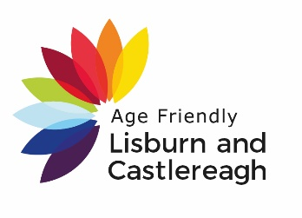

A G E F R I E N D L Y
B A S E L I N E R E P O R T

Contents
Alignment of local and national objectives: 2
Projected Population 3
Health and Care 4
Loneliness 4
Self-Efficacy 4
Lisburn & Castlereagh Survey Your Age, Your Community, Your Opinion 5
Outdoor Spaces & Buildings 6
Transport 7
Housing 8
Social Participation 9
Civic Participation 11
Communication & Information 12
Community & Health Services 13
Digital Technology 14
Age Friendly Indicators 15
15

Alignment of local and national objectives:
The following table illustrates the close alignment of the objectives and themes of Making
Life Better and Active Ageing with the Lisburn & Castlereagh community planning thematic
groups.
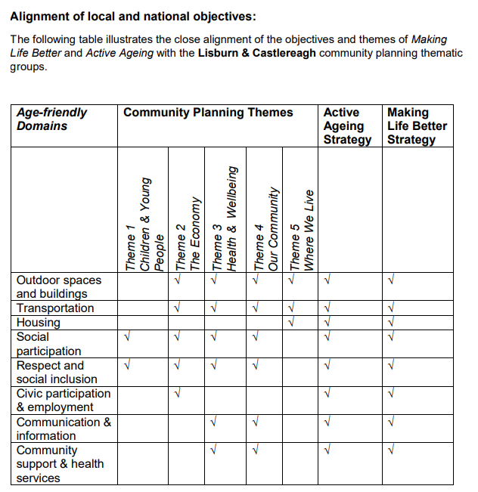

Projected Population
The population of Lisburn and Castlereagh LGD2014 aged 60+ is expected to rise to
52,320 by 2043 Age Group – LCCC (Mid-2016 to Mid-2030 Projections) In LCCC, between 2016 and 2030, the age group with the largest percentage increase is the ‘90+’ (114%). It is projected that the number of people in this age group will more than double from 962 in 2016 to 2,055 in 2030. Over the same time period in LCCC, the age group that is projected to have the largest increase in the actual number of people is the ‘65-69’ age group. Increasing from 6,856 in 2016 to
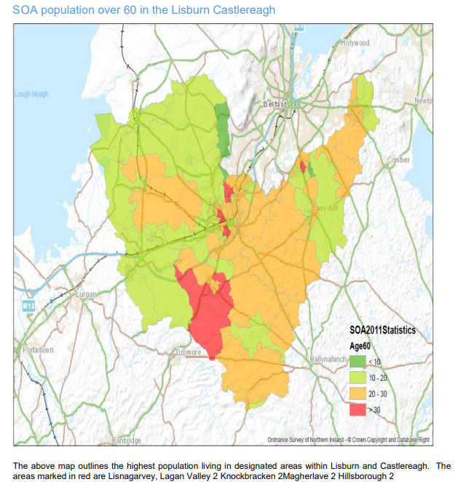
10,150 in 2030 (48%).

Health and Care
In the 2021 Census people aged 65+ years of age in Lisburn & Castlereagh 53% stated that their health was good/very good. This is a notable decline from the age band 40-65 year’s age band. Fig 3.1 demonstrates the general health and care of residents in Lisburn & Castlereagh. NHS England² state through early identification and offering support and self-management through, for example, healthy ageing and healthy caring guides supporting public services can reduce ill health among older people.
Fig 3.1 Health and Care Lisburn Castlereagh
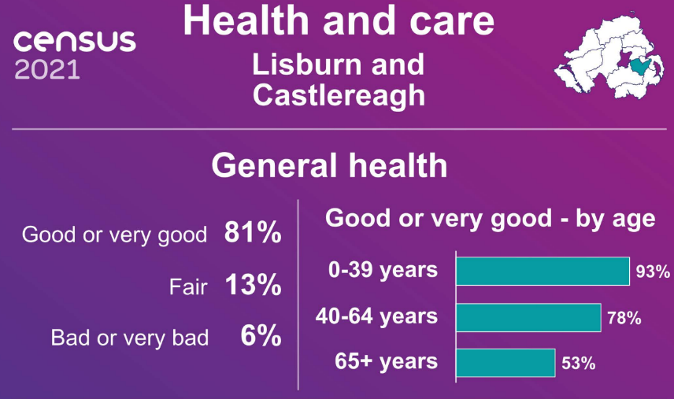

Population
Lisburn and Castlereagh has an ageing population. According to the latest 2021 Census the age demographic with the largest increase is in the 65+ age range, with a 2% increase from 2011. The 65+ age band now represents 18% of the total population for Lisburn & Castlereagh. This means 26,200 people are over 65 years of age in the Lisburn Castlereagh area. If LCCC was represented as 100 people, 18 would be 65+. This increase in age can be seen below in Fig 3

Fig 3: Age demographic Lisburn and Castlereagh
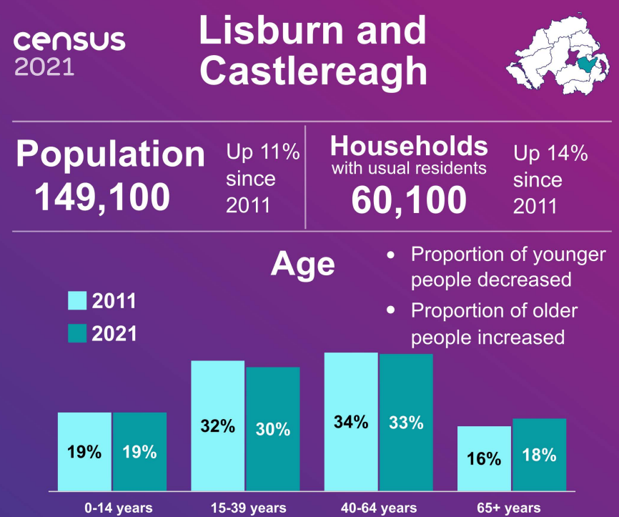

Loneliness
If we do not connect to people around us, we can start to feel lonely which can have serious impacts on mental health and wellbeing. One common description of loneliness is the feeling you get when the need for rewarding social contact and relationships is not always the same as being alone. People can chose to be alone and live happily with limited contact with others. Likewise you may have lots of social contact, be in a relationship or part of a family, and still feel lonely especially if you do not feel understood or cared for by the people around you. According to Wellbeing in Northern Ireland Report 2021/223 people of Lisburn & Castlereagh 20.7% of people reported being lonely some of the time.

Self-Efficacy
Self-efficacy is a concept describing a person’s beliefs about their capability to produce results or effects and their ability to exercise influence over events that affect their lives. Those with high self-efficacy have confidence in their abilities and make sustained efforts to achieve goals.

Self-efficacy affects the decisions a person makes and what they see as achievable. It has been shown to influence physical and mental health, learning and achievement, career and job satisfaction and family relations. (Scores of 5-17 are classed as low self-efficacy, while scores of 18-25 are considered high)

1 file:///P:/AgeFriendly/Age%20Friendly/AF%20Statistics/2021%20Census/LCCC%20Population.pdf 2 https://www.england.nhs.uk/ourwork/clinical-policy/older-people/improving-care-for-older-people/
3 https://www.executiveoffice-ni.gov.uk/publications/wellbeing-northern-ireland-report-202122

Lisburn & Castlereagh Survey Your Age, Your Community, Your Opinion
Lisburn & Castlereagh City Council (LCCC), together with the Public Health Agency and the South Eastern Health and Social Care Trust, have gathered detailed information on the needs of older people which defined as 50 years and over, across the Lisburn & Castlereagh area. The purpose of this study was to understand the perception and needs of older residents in relation to issues they encounter in their community.

The survey was the first time people aged 50 years and over have been consulted directly around what it is like to grow older in Lisburn & Castlereagh. The survey responses totalled over 400 people who completed the online survey and attended facilitated 5 information sessions. The survey questionnaire addressed the eight Age Friendly Domains WHO domains:

- Outdoor Spaces and Buildings
- Transportation
- Housing
- Social Participation
- Respect and Social Inclusion
- Civic Participation and Employment
- Communication and Information
- Community Support & Health Services

Lisburn & Castlereagh reported a higher score for the Northern Ireland for average self-efficacy in the Health & Wellbeing Northern Ireland Report 2021/22. Lisburn & Castlereagh scored 19.9 where people who reported low self-efficacy, this is lower than the Northern Ireland average of 19.4.

 | Average  Self-Efficacy | Low Self-Efficacy
LCCC | 19.9 | 11.2
NI Average | 19.4 | 17.6

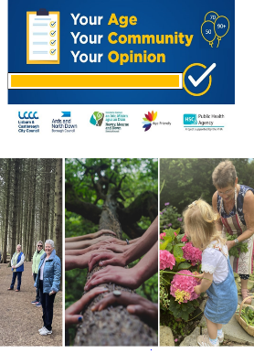

In addition to the 8 Age Friendly domains the survey includes questions addressing digital technology to supplement the Communication and Information domain and questions on finances, supplementing several domains. The next section will show the results of the Your Age, Your Community, Your Opinion survey, relating to the 8 Age Friendly domains.

Outdoor Spaces & Buildings
The outside environment and public buildings have a major impact on the mobility, independence and the quality of life of older people and affect their ability to “age in place”. The recurring themes are quality of life, access and safety. For older people, being able to access and enjoy public spaces is an important aspect of physical and mental wellbeing. As the population gets older and life expectancy increases, older people need outdoor places to walk, exercise and socialise.

There is an increasing body of research demonstrating the physical and mental health benefits of exercising outdoors in natural environments, often referred to as ‘Green Exercise’. Studies report the importance of the outdoor environment, especially for recreational walking ‘Walking has a greater effect and cognitive restorative effect for older people of poor mental health in green settings’.

The UK mental health charity MIND ran a study of green exercise – physical activity outdoors4 – questioning older people taking advantage of outdoor spaces. Of those surveyed, 90% said they feel green exercise benefits their physical health, however, an even high percentage – 94% feel it also improves their mental health. This helps demonstrate the importance of outdoor spaces for people as they age, especially green spaces, but not forgetting to ensure that these facilities need to be accessible to people with mobility issues.

With this in mind the Age Friendly survey focused on the level of satisfaction with outdoor public spaces frequently visited by the respondents and how they might be improved through open comments. The result and comments below demonstrate resident’s satisfaction levels to outdoor spaces facilities and services.

Lisburn & Castlereagh Outdoor Spaces Satisfaction Results
Facilities | Yes | No
Footpaths | 65% | 35%
Seats/Benches | 52% | 48%
Bins | 60% | 40%
Toilets | 23% | 77%
Pedestrian Parking | 62% | 38%
Car Parks | 64% | 36%
Service/Experiences | Yes | No
Streetlights | 79% | 21%
Green Spaces | 84% | 16%
Cleanliness of public spaces | 73% | 27%
Public places feel safe | 83% | 17%
Enough Public Spaces | 72% | 28%

High among the satisfaction rates were the safety of public spaces and green spaces at 84% and 83% feel safe in outdoor spaces. Toilets facilities were a stand out from the Age Friendly survey with least satisfaction % given at 23%. 77% stated that they were not satisfied with the toilet facilities. This does point to the need for improvement regarding toilets.
Comments include:

‘Older people generally need to use the toilet more often and most shops in the area do not have toilets so there is a need to have more accessible toilets.’ Male 75+ Urban.

More green space with seating for older people to enjoy outdoors and play games, i.e., French bowls dominoes. Have a social area to find company.’ Female 50-64 Rural

4. https://www.mind.org.uk/news-campaigns/news/go-green-to-beat-the-blues/

Transport
The respondents to the survey stated that a large percentage still have their own car at 85% with 19% walking to where they need to go. 18% relied on a family or friend to get them where they need to go, 17% take the bus. A drop of on train usage occurs at 9% with only 4% cycling. The data suggests that respondents walk to get their necessities from local shops and use the car for longer journeys. There is a high reliance on car usage and not as much on public transport 17%.

Ensuring that public transport is accessible to older residents is an important aspect of using public transport. The graph below outlines the satisfaction levels with elements of public transport

Transportation, including accessibility and affordable public transport, is a key factor influencing active ageing. Being able to move about an area (urban, rural and connections) determines social and civic participation and access to community and health services.

The ageing population presents particular challenges for the transport system which is ‘failing to meet the needs of too many older people’ in the UK. As evidenced in the survey returns, driving is the most commonly used form of transport amongst older people to get to where they need to go; Age UK research reveals that it is health issues rather than age that lead to older people giving up driving. Being able to get to where they need to go is important for older people to keep in touch with friends and family, helping to avoid feelings of loneliness and promote wellbeing. The graph below highlights the mode of transport used from the Age Friendly survey.

Graph Showing Yes % Satisfied With Public
Transport Services in Lisburn& Castlereagh

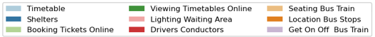
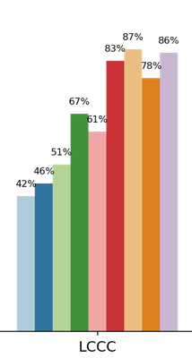

Graph showing % of How People Get About in Lisburn & Castlereagh

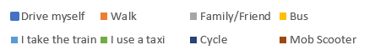

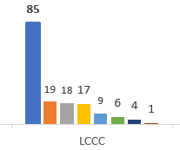
High satisfaction rates in were in seating on bus 87%, getting on and off the bus 86%, drivers and conductors at 83%, 78% happy with bus stop locations and 86% were happy with their experience getting on and off the bus. However only 42% of respondents were happy with the timetables meaning 58% were not happy with time tables and 46% were happy with bus shelters. A sample comment regarding public transport are stated below;

“Need a busy bus service to the new medical centre when it moves to the Lagan valley Hospital” male 70-75 rural

Housing
Housing is essential to safety and wellbeing. There is a link between appropriate housing and access to community and social services in influencing the independence and quality of life of older people. Housing and support that allow older people to age comfortably and safely within their community are universally valued.

Living independently is important to people as they grow older, as the survey returns evidence this is not always possible due to frailty, declining health or the loss of a spouse. However, there are many agencies and organisations that can help people remain in their own home before sheltered housing, residential or nursing care becomes necessary. In asking these questions the objective was to find out more about what older people know and think about the support that’s available to them and understand how they feel about remaining in their own home.

How important is it for you to live independently in your own home as you age?
LCCC | Extremely Important | Very Important | Somewhat Important
LCCC | 82% | 15% | 3%

The information suggests many people are unaware of housing options that are available to older people at 39%. 49% stated that they did not think there was enough support to stay at home, 38% did not know which suggests there is a gap in knowledge on what services are available. 35% stated that there was not enough home support and 40% did not know which suggests that this 40% are not aware of what services are available to them. 57% stated that they do not think it is easy to get help with home repairs to help people stay at home longer. This suggests there are not enough services around home repairs

Comments around housing from the survey included:

“Finding someone to do small repair jobs around the house is difficult and can be costly especially when professional people are involved i.e. electrician, plumber etc. 65+ Rural”.

“Sometimes you just need help for a while, e.g. after a hospital stay, but no help is available because you don’t need it all of the time.” 75+ Urban
Is there is affordable housing options for older people?
LCCC | Yes | No | Don’t Know
LCCC | 22% | 39% | 39%

Is there is enough home support as people age?
LCCC | Yes | No | Don’t Know
LCCC | 13% | 49% | 38%

Is there support to adapt homes as people age
e.g., ramps, steps, grab rails, stair lifts?
LCCC | Yes | No | Don’t Know
LCCC | 25% | 35% | 40%

Is it easy for people as they get older to get help with home repairs?’
LCCC | Yes | No | Don’t Know
LCCC | 7% | 57% | 36%

Social Participation
Social participation and social support are strongly connected to good health and wellbeing throughout life. Participating in leisure, social, cultural and spiritual activities in the community, as well as with the family, allows older people to continue to exercise their independence, to enjoy respect and esteem.

Social participation relating to older people is partly defined by community-based activities and interpersonal interactions resulting in personal satisfaction. The following answers are taken from the Social Participation section in the survey:

Q. I have enough people I feel comfortable asking for help at any time:
LCCC | Strongly agree | Agree | Disagree
LCCC | 77% | 13% | 9%

Q. I am content with my friendships and relationships’ are as follows:
LCCC | Strongly agree | Agree | Disagree
LCCC | 82% | 12% | 6%

Q. My friendships and relationships are as satisfying as I would want them to be’
LCCC | Strongly agree | Agree | Disagree
LCCC | 81% | 12% | 7%

The results show that people have strong links with friendships and relationships. However, the respondents who answered ‘disagree’ are the respondents who are mostly likely to have experienced social isolation and/or loneliness. Comments around social participation included;

‘Community Centre send out newsletters about events, put up posters in local shops or have a community notice board in the estate not everyone has access to the internet.’
Male 65-74 Urban

‘Better provision of information on relevant social activities that might interest me’.
Female’ 50-64yrs, Rural

Respect & Inclusion
The respect and inclusion of older people can depend on culture, gender, health status and economic status. The extent to which older people participate in the social, civic and economic life of where they live is closely linked to their experiences of inclusion.

Age UK promotes an inclusive society where everyone, including all older people, is treated with dignity and respect. This will not only benefit older people but will also help to develop greater social cohesion, tolerance, stability and prosperity in the wider society. Older people often experience conflicting types of behaviour towards them with many feeling they’re respected yet others feel there is a lack of consideration for them and their needs. The World Health Organisation sees an Age friendly community as including education about ageing, inter-generational activities and respectful and inclusive services. Below are the findings based on respect and inclusion;
Q. Do you feel a sense of belonging in your community?
LCCC | Yes Mostly | Sometimes | Mostly No
LCCC | 57% | 32% | 10%

Q. Do you feel your needs are recognised in Your Community?
LCCC | Yes Mostly | Sometimes | Mostly No
LCCC | 41% | 45% | 14%

Q. Do you feel you are treated with respect in Your Community?
LCCC | Yes Mostly | Sometimes | Mostly No
LCCC | 69% | 24% | 8%

Q. Do you feel valued in Your Community?’
LCCC | Yes Mostly | Sometimes | Mostly No
LCCC | 48% | 36% | 16%

Q. Are you aware of services that exist in Your Community?
LCCC | Yes Mostly | Sometimes | Mostly No
LCCC | 23% | 33% | 44%

Q. Do you feel you have enough information to make informed decisions about local issues?’
LCCC | Yes Mostly | Sometimes | Mostly No
LCCC | 37% | 36% | 28%

57% felt a sense of belonging in their community and 32% stating sometimes. 41% felt needs were recognised with a high 45% only feeling sometimes. 69% of respondents felt mostly were treated with respect in their community and 48% feel valued. A concern around what services are available in the community where 44% felt they mostly were not aware of services in their community. 64% felt sometimes/did note have the information they need to make informed decisions.

‘Unless unhealthy or belong to community groups you are unaware of provision of services for this age group ’
Female, 50-64yrs, Rural

‘Doctor appointments are so difficult. You need to know when you are going to be sick to make an appointment”a doctor.’ Male 50-64 Urban

‘

Civic Participation
Older people do not stop contributing to their communities on retirement. Many continue to provide unpaid and voluntary work for their families and communities and are a lead contributor to the economy. Age Friendly provides options for older people to continue to contribute to their communities through paid employment or voluntary work, if they so choose, and be engaged in the political process.

Age Friendly communities provide training and opportunities for older people to stay involved in civic life, recognising the worth of them remaining economically active for longer and at the level of their choosing. This section of the survey sought to explore older people’s views on staying economically active and on being involved in local decision-making. Employers used to be able to force workers to retire at 65 (known as the Default Retirement Age), but this law was scrapped in April 2011, following a campaign by Age UK. This means that you can keep working beyond 65 if you wish to.

Graph Showing Importance of Staying in
Work after 65 years
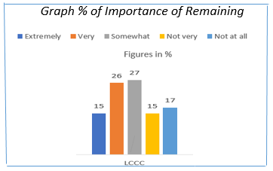

41% found it extremely/very important to remain in work past the age of 65. At the other end of the scale, 32% of respondents felt remaining in work was not very important/not at all important.

Q. Are You Aware of Working Past Age of 65?
LCCC | Yes | No | Don’t Know
LCCC | 19% | 14% | 67%

Q. Are you aware of your benefits entitlement?
LCCC | Yes | No | Don’t Know
LCCC | 25% | 22% | 53%

Q. Would you like more involvement/knowledge in decision-making?
LCCC | Yes | No | Don’t Know
LCCC | 25% | 22% | 53%

Civic Participation asked people to think about employment in later life and access to what information and benefits are available to them.
67% did were not aware of the ability to work past 65 years of age. 53% of people did not know what benefits entitlement they were eligible for and 53% also stated they would like more involvement in decision making process.

Comments from Civic Participation included;

Experience is not valued or availed of, which could avoid a lot of the very expensive mistakes made in the past.’ Female 65-74 Rural

would like to be better informed of council/organisation initiatives, proposals and activities, and how the public can input to them. Male 50-64 Urban

want or need to.

#

Communication & Information

Staying connected with events and people and getting timely, practical information to manage life and meet personal needs is vital for active aging. Age Friendly communities have relevant information that is readily accessible to older people with varying capacities and resources.

Making older people aware of services they need to know about is important to help them stay connected, engage in and contribute to their community and access support when they need it. Councils and many statutory, private and third sector organisations produce information that can help older people, but does it get to them? This part of the survey sought to find out and to understand how best to get information to older residents in Lisburn and Castlereagh.

People in the Lisburn & Castlereagh area prefer to be contacted though a physical leaflet or magazine giving information on services and opportunities (64%). Although older residents are perceived to perhaps not use technology however (55%) would retrieve information through email if given the opportunity to sign up to an email data base and (40%) get their information through social media channels. (26%) would get information through council website. Only 6% answered council e-zine. This indicates that not all individuals are signed up to the council e-zine as it is more directed at local community groups.

Q. Good Access to Information?
LCCC | Agree | Disagree
LCCC | 75% | 25%

75% stated they have access to information from a range of sources. It must be stated that the 25% would possibly fall into the lonely and isolated category.

Graph Showing % of How People Like to Receive Information



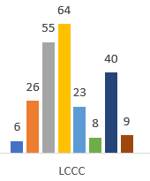

Community & Health Services
Is there enough initiatives and activities to promote healthy living?’
LCCC | Yes | No | Don’t Know
LCCC | 39% | 34% | 27%

Is there good access to hospital services?
LCCC | Yes | No | Don’t Know
LCCC | 49% | 32% | 19%

Do you have good access to GP?
LCCC | Yes | No | Don’t Know
LCCC | 54% | 35% | 11%

Data suggests that 61% felt that they either felt there were not enough activities and initiatives in their community that promote heathy ageing. 49% reported they have good access to hospital services. 54% stated they had good access to their GP although waiting times to get to see a GP were increasing.

‘So far I’m impressed with local primary care services for elderly. Have experience of support from health and social care as well regarding my elderly mother with dementia who is now in residential care. This service has been 1st class. ‘Female, 65-74yrs, Rural

‘Unless unhealthy or belong to community groups you are unaware of provision of services for this age group.’ Female, 50-64yrs, Rural
Health and support services are vital to maintaining health and independence in the community. Civil society can provide a role in supporting the health of the community. The WHO checklist focuses on the aspects within the scope of Age Friendly.
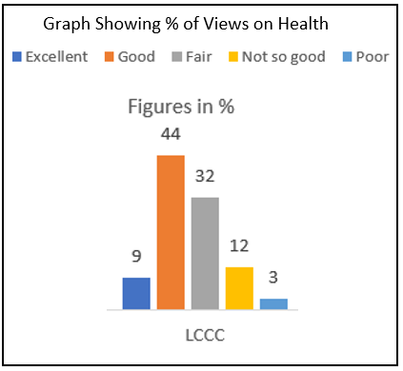

There was a high % of people undertaking physical activity with 40% of respondents in the LCCC area reported that they undertake physical activity a few times per week. 18% rarely/never. This group could possibly be those who are not mobile and/or isolated

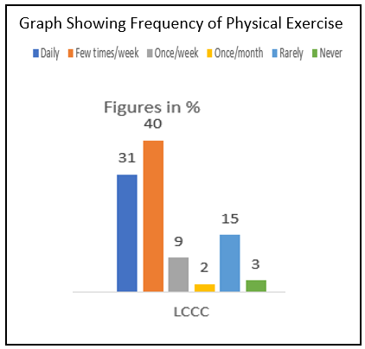
44% considered their health and wellbeing to be good and only 9% stated excellent. 44% were fair/not so good and 15% not good/poor.

There was a high % of people undertaking physical activity with 40% of respondents in the LCCC area reported that they undertake physical activity a few times per week. 18% rarely/never. This group could possibly be those who are not mobile and/or isolated

Digital Technology
Access to and the use of digital technology is essential as people age in order to help keep them connected to family, friends and neighbours, to update themselves on local issues, to enable them to engage with service providers and to receive information. The ability to use digital technology impacts on several of the WHO Age Friendly domains; it is for this reason that the survey incorporated questions on digital technology, presented as follows

96 % stated they have access to the internet

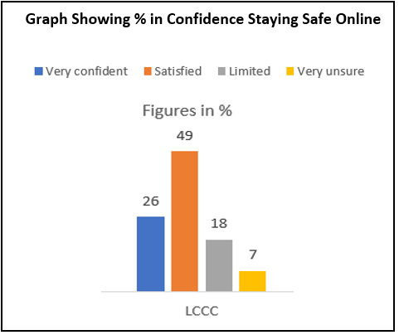
9% of people were satisfied that they were satisfied with their online safety Online.
Only 26% stated they were very confident.
Graph Showing % of How People Use Internet To Communicate

A high proportion of people are using the internet and will check their email regularly with 94% using email as a way of communication. A high proportion are using what’s App 88%. This may be to the pandemic where people used what’s App for video calling relatives and staying in touch with loved ones. A relatively large proportion are using Facebook also at 75%

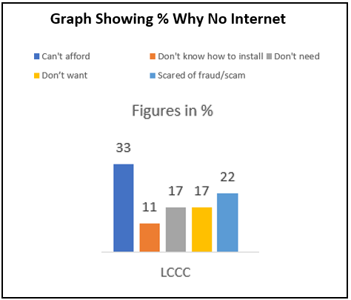
33% stated that they could not afford internet and 22% did not have the internet due to fear of being scammed. 17 stated they simply did not want to interact with the internet.
‘I need training courses to be provided in order to teach me the rudiments of applications other than email.’ Female, 75+ yrs, Urban
‘My postcode area has dreadful broadband and despite many years of complaints nothing from any agency on what is proposed to improve this vital service. Male, 65- 74 yrs, Rural

Age Friendly Indicators

Age Friendly Indicators
Domain 1: Outdoor Spaces and Buildings
Walkability Indicators

- Parks and open spaces will be accessible to all ages by undertaking Age Friendly
walking audits, to establish barriers to using local parks and open spaces by residents.
- The development of LCCC walkability strategy will help improve connectivity and further regenerate the city centre to encourage residents and visitors to enjoy the nearby green parks and open spaces.

Domain 2: Transportation Options Indicators

- Availability of a range of affordable options for transportation (e.g., public/private
partnerships, volunteer driving program).2. Bus stops/shelters are safe and accessible (e.g.,
with seating for older people)
- Close to seniors' residences).
- Residents have their voice heard on matters relating to fleet transport by sitting on advisory
Panels
4. Resident are informed and part of any consultation process in relation to transport changes.

Domain 3: Housing Indicators

- Availability of affordable housing that is appropriately located, well-built, well-designed, secure, and for which waiting times are short.
- Strategy on grants for warm homes, boiler replacements, adaptations
- maximising the use of floating support services to ensure people age in place for as long as possible.
- Availability of programs for increasing accessibility, safety and adaptability of housing hand rails, ramps, smoke detectors).
- Availability of a resource listing age-friendly home maintenance, support and caregiving
services.

Ability to Age in Place

18. Proportion of people age 65+ who want to remain in their current residence and are confident they will be able to afford to do so.

Housing Support Awareness

19. Awareness of rent subsidy or other programs (e.g., home loans) among seniors.

Domain 4: Social Participation Indicators

- Improve access and increase opportunities for people age 65+ who engage in active positive ageing activities.
- Availability of recreation and learning programs specifically for seniors (e.g., computer
courses, community gardens)
- Availability of intergenerational recreation and social programs.
- Affordability of seniors' recreation programs. Accessibility of Participation Opportunities
- Public venues for community-based activities are accessible (e.g., adapted washrooms, a ramp to enter the building, better)
- Access to arts and culture programmes especially to areas most ‘at risk’ and areas of
deprivation

deprivation.

Domain 5: Respect and Social Inclusion Indicators

1. Availability of Intergenerational Activities to create a link and bond between generations.
2. Initiatives to break down the stigma of ageing by combating isolation and loneliness.
3. Level of sense of belonging in the community

Domain 7: Civic Participation and Employment Indicators

1. Employers are aware of an ageing workforce that promotes employer pledges to older people.
2. Availability of training opportunities related to the accommodation of seniors' needs in the
workplace.

Domain 7: Communication and Information Indicators

1. Availability of assistance to seniors for filling out forms.
2. Availability of a live person option on telephone calls.
3.Useability of Information Materials
4. Materials for the public are produced in large print, plain language and/or with age-friendly
considerations.
5. Seniors develop skills to prevent ‘Digital Exclusion’ throughout the community in a variety of
methods

Domain 8: Community Support and Health Services Indicators

1. Availability of prevention programs related to health issues of high relevance to seniors
including (Home Accident Prevention checks, Home Fire Assessments, floating support
services)
2. Availability of end-of-life support for seniors, their families and caregivers (information on
social care costs, end of life services)
3. Availability of healthy eating and low-cost food programs (e.g., meals on wheels, food bank,
community fridges).
4. Availability of assistance for activities of daily living (referral services and signposting
opportunities)

