RESOLUTION NO. 972
SECTION 5. EFFECTIVE DATE. This Resolution shall take effect immediately upon its adoption.
A RESOLUTION OF THE CITY OF SATELLITE BEACH, BREVARD COUNTY, FLORIDA, SUPPORTING THE WORLD HEALTH ORGANIZATION'S AGE-FRIENDLY CITIES AND COMMUNITIES PROGRAM AND APPROVING THE CITY'S ENROLLMENT INTO THE AARP AGE-FRIENDLY COMMUNITIES INITIATIVE; PROVIDING FOR TRANSMITTAL; PROVIDING FOR AUTHORIZATION; AND PROVIDING AN EFFECTIVE DATE
WHEREAS, the AARP Network of Age-Friendly Communities is an affiliate of the World Health Organization's (WHO) Age-Friendly Cities and Communities, an international effort launched in 2006 to help cities prepare for the aging population; and
WHEREAS, the AARP Network of Age-Friendly Communities (the "Network") helps participating communities become great places for all ages by adopting such features as safe, walkable streets; better housing and transportation options; access to key services; and opportunities for residents to participate in community activities; and
WHEREAS, the benefits of joining the Network include, but are not limited to, access to key information about best practices among age-friendly communities, access to a global network of participating communities, and public recognition of the City's commitment to become more age-friendly; and
WHEREAS, the City's Council has supported the City's efforts to become more age-friendly through the Communities for a Lifetime Program; and
WHEREAS, well-designed, livable communities promote health and sustain economic growth, and they make for happier, healthier residents of all ages; and
WHEREAS, the City Council of the City of Satellite Beach finds that the adoption of this Resolution is in the best interest and welfare of the residents of the City.
NOW, THEREFORE, BE IT RESOLVED by the City Council of the City of Satellite Beach, Brevard County, Florida, as follows:
SECTION 1. RECITALS. The above recitals are true and correct and are incorporated herein by this reference.
SECTION 2. CITY COUNCIL SUPPORT. The City Council supports initiatives and opportunities of the World Health Organization's Age-Friendly Cities and Communities and the City's enrollment into the AARP Network of Age-Friendly Communities.
SECTION 3. TRANSMITTAL. The City Clerk is hereby directed to transmit a copy of this Resolution to the AARP along with the required membership application.
SECTION 4. AUTHORIZATION. The City Manager is authorized to take any and all steps necessary to implement the intent and purpose of this Resolution.

RESOLUTION NO. 972 PAGE 2
PASSED AND ADOPTED at a regular meeting of the City Council of the City of Satellite Beach, Florida, the 3rd day of August, 2016.
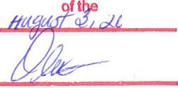

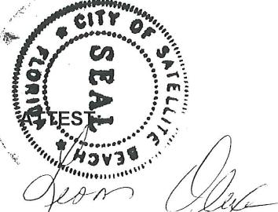
LE'ONOR OLEXA, CMC, CITY CLERK
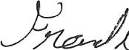
FRANK P. CATINO, MAYOR
I hereby cellify th₎ais is a trt#e
copy of lycOlIti/A-ri •
adopted by the City C • uncil
Satellite ach on
C'ty of

n r Olexa, CMC City Clerk

