The following report outlines the current and projected demography of Lisburn & Castlereagh. The report also highlights how the area fits into the 8 domains of Age Friendly
INTRODUCTION TO AGE FRIENDLY IN THE LISBURN & CASTLEREAGH AREA
V:1
AGE FRIENDLY

Table of Contents
Age Friendly 2
Introduction 2
Context 2
Alignment of local and national objectives……………………………………………………………………………3
Demography 4
Population 4
Projected Population. 4
Deaths ……………………………………………………………………………………………………………………………………...........5
Life Expectancy………………………………………………………………………………………………………………………………….6
Deprivation……………………………………………………………………………………………………………………………………….6
SOA Over 60 Income Deprivation………………………………………………………………….7
SOA population over 60……………………………………………………………………………..8
8 Domains ……………………………………………………………………………………………………………………………………9
Outdoor Spaces & Buildings………………………………………………………………………………………………………………………………………….9
Transportation…………………………………………………………………………………………………………………………………12
Housing……………………………………………………………………………………………………………………………………………13
Social Participation………………………………………………………………………………………………………………………….17
Respect & Social Inclusion……………………………………………………………………………………………………………….19
Civic participation &Employment…………………………………………………………………………………………………….22
Communication& Information…………………………………………………………………………………………………………25
Community and Health Services………………………………………………………………………………………………………26
Age Friendly Wheel………………………………………………………………………………………………………………………….30
AGE FRIENDLY INTRODUCTION/CONTEXT
Age Friendly Profile for Lisburn and Castlereagh Local Government District (LGD2014).

'An Age-friendly world is a place that enables people of all ages to actively participate in community activities. It is a place that treats everyone with respect, regardless of their age. It is a place that makes it easy to stay connected to those around you and those you love. It is a place that helps people stay healthy and active even at the oldest ages. And it is a place that helps those who can no longer look after themselves to live with dignity and enjoyment. Many cities and communities are already taking active steps towards becoming more age-friendly'. (World Health Organization WHO).

The World Health Organisation (WHO) has established a global network of Age Friendly Cities and Communities that encourage active ageing by optimising opportunities for health, participation and security in order to enhance quality of life as people grow older. The WHO has proposed eight areas that can help to identify and address barriers to the well-being and participation of older people. Key statistics on each of these themes are included below. By way of background, demographic and deprivation profiles have also been included for the local council areas.

'Northern Ireland is an age friendly region in which people, as they get older, are valued and supported to live actively to their fullest potential; with their rights and dignity protected' (OFMDFM Vision).

This report provides useful statistics on the age-friendliness of Lisburn and Castlereagh Local Government District (LGD2014)
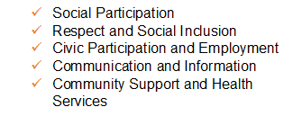
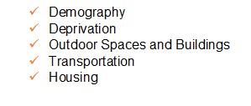

Alignment of local and national objectives:
The following table illustrates the close alignment of the objectives and themes of Making Life Better and Active Ageing with the Ards and North Down community planning thematic groups.

Age-friendly Domains | Community Planning Themes |  |  |  |  | Active Ageing Strategy | Making Life Better Strategy
 | Theme 1  Children & Young People | Theme 2  The Economy | Theme 3  Health & Wellbeing | Theme 4  Our Community | Theme 5  Where We Live
Outdoor spaces and buildings |  | √ | √ | √ | √ | √ | √
Transportation |  | √ | √ | √ | √ | √ | √
Housing |  |  |  |  | √ | √ | √
Social participation | √ | √ | √ | √ |  | √ | √
Respect and social inclusion | √ | √ | √ | √ |  | √ | √
Civic participation & employment |  | √ |  |  |  | √ | √
Communication & information |  |  | √ | √ |  | √ | √
Community support & health services |  |  | √ | √ |  | √ | √

DEMOGRAPHY
Population

On 30 June 2016, the estimated population of Lisburn and Castlereagh LGD2014 was 141,181, accounting for 7.6% of the Northern Ireland total.

22.3% (31,510 people) of the population of Lisburn and Castlereagh LGD2014 were aged 60+ years. Of those aged 60+ in Lisburn and Castlereagh LGD2014, 45.5% (14,322 people) were male and 54.5% (17,188 people) were female.

2.1% (2,941 people) of the population of Lisburn and Castlereagh LGD2014 were aged 85+ years. Of those aged 85+ in Lisburn and Castlereagh LGD2014, 33.7% (991 people) were male and 66.3% (1,950 people) were female.

DEMOGRAPHY
Projected Population

Age Group – LCCC (Mid-2016 to Mid-2030 Projections)
In LCCC, between 2016 and 2030, the age group with the largest percentage increase is the ‘90+’ (114%). It is projected that the number of people in this age group will more than double from 962 in 2016 to 2,055 in 2030.
Over the same time period in LCCC, the age group that is projected to have the largest increase in the actual number of people is the ‘65-69’ age group. Increasing from 6,856 in 2016 to 10,150 in 2030 (48%).

Deaths

There were 12,655 deaths registered for persons aged 65+ years in Northern Ireland in 2015. Of these deaths 27% were to malignant neoplasms, 16% were to respiratory disease and 26% were to circulatory disease.

There were 961 deaths registered for persons aged 65+ years in Lisburn and Castlereagh LGD2014 in 2015. Of these deaths 25% were to malignant neoplasms, 16% were to respiratory disease and 27% were to circulatory disease.

In 2015, the median age at death was 82 in Lisburn and Castlereagh LGD2014; the corresponding figure for Northern Ireland was 80.
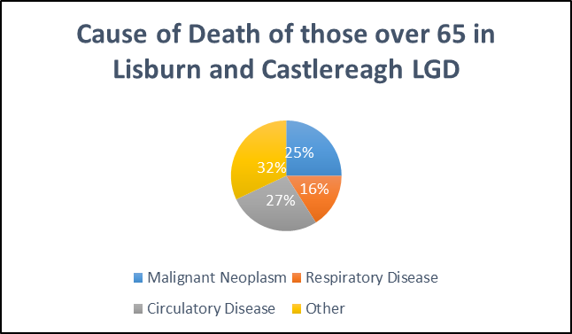

Life Expectancy

Average life expectancy measures the expected years at birth based on the mortality rates of the period in question. In Northern Ireland, life expectancy at birth for males is 78.1 years and 82.4 years for females. In Lisburn and Castlereagh LGD2014, life expectancy at birth for males is 79.4 years and 83.2 years for females (Calculated using information aggregated from 2011 to 2013).

Deprivation

Deprivation - NIMDM 2010
The Northern Ireland Multiple Deprivation Measure 2010 (NIMDM 2010) report was published in May 2010. The report identifies small area concentrations of multiple deprivation across Northern Ireland.
Ten measures are presented at the Super Output Area (SOA) level: The Multiple Deprivation Measure, seven domains of deprivation and two supplementary income measures for older people and children.

Income Deprivation affecting Older People

The Income Deprivation Affecting Older People (IDAOP) counts those aged 60+ living in income deprived households. Within Lisburn and Castlereagh LGD2014 the most deprived Super Output Area based on the IDAOP measure is Old Warren, where 68% of older people were income deprived (ranked 77 out of 890 in NI). The least deprived Super Output Area based on the IDAOP measure is Cairnshill 2, where 8% of older people are income deprived (ranked 877 out of 890 in NI).

*1 is the most deprived SOA in Nothern Ireland and 890 the least deprived.

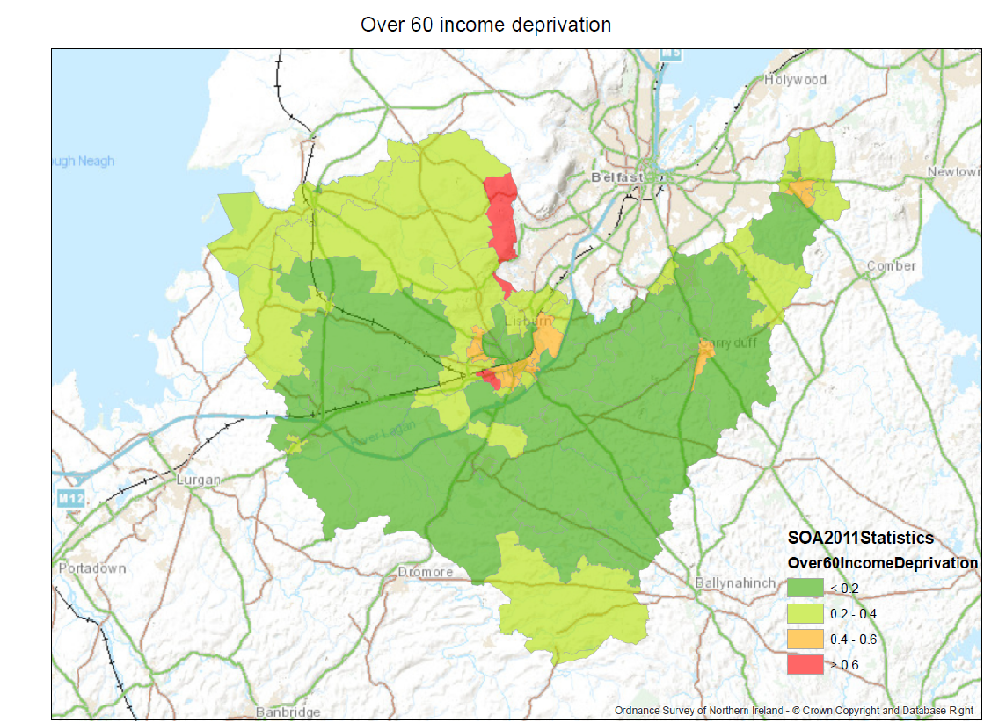
SOA Over 60 Income Deprivation in the Lisburn Castlereagh
The map above outlines the highest income deprivation within Lisburn and Castlereagh. This map highlights that Old Warren 1 Colin Glen 1 Derriaghy.
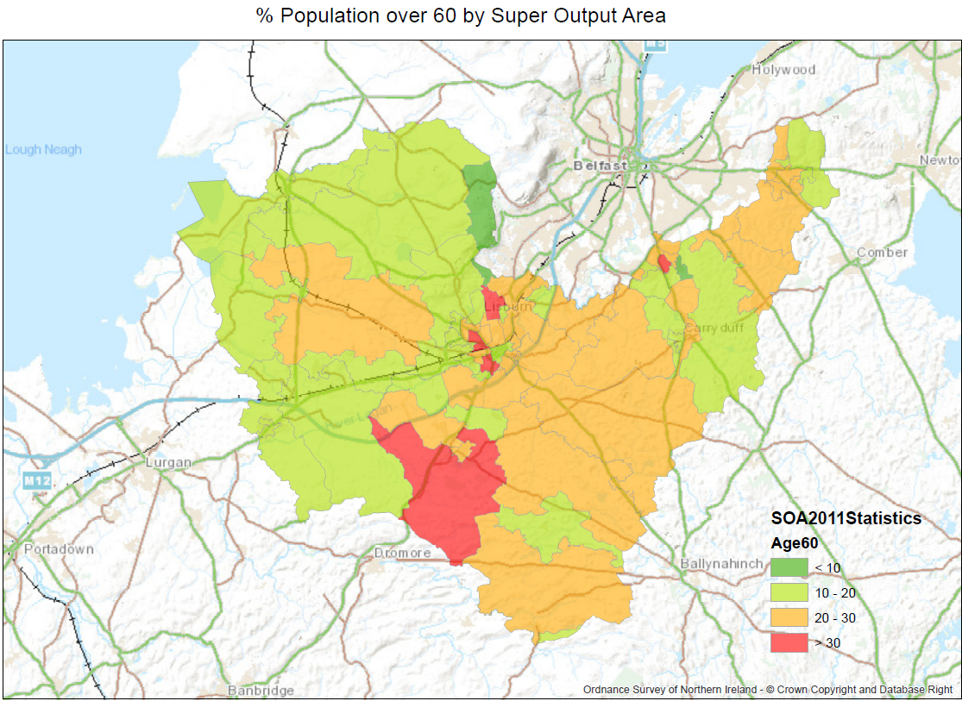
SOA population over 60 in the Lisburn Castlereagh

The above map outlines the highest population living in designated areas within Lisburn and Castlereagh. The areas marked in red are Lisnagarvey, Lagan Valley 2 Knockbracken 2Magherlave 2 Hillsborough 2

Outdoor Spaces and Buildings
The outside environment and public buildings have a major impact on the mobility, independence and quality of life of older people.
Living Environment Deprivation - Outdoor Physical Environment

The Northern Ireland Deprivation Measure 2010 Living Environment Domain - the purpose of this domain is to identify small areas experiencing deprivation in terms of the quality of housing, access to suitable housing and the outdoor physical environment. It comprises three separate sub-domains measuring each of these.
Within Lisburn and Castlereagh LGD2014 the most deprived Super Output Area based on the outdoor physical environment sub-domain measure is Hilden 1 (ranked 70 out of 890 in NI) and the least deprived Super Output Area is Ballymacbrennan 2 (ranked 887 out of 890 in NI).

Outdoor Spaces

Having green spaces is one of the most commonly mentioned age-friendly features. For its small area, Northern Ireland has a great variety of scenic countryside and although there are no National Parks, large areas of landscape of distinctive character and special scenic value have been designated Areas of Outstanding Natural Beauty (AONBs). This designation is designed to protect and enhance the qualities of each area and to promote their enjoyment by the public.

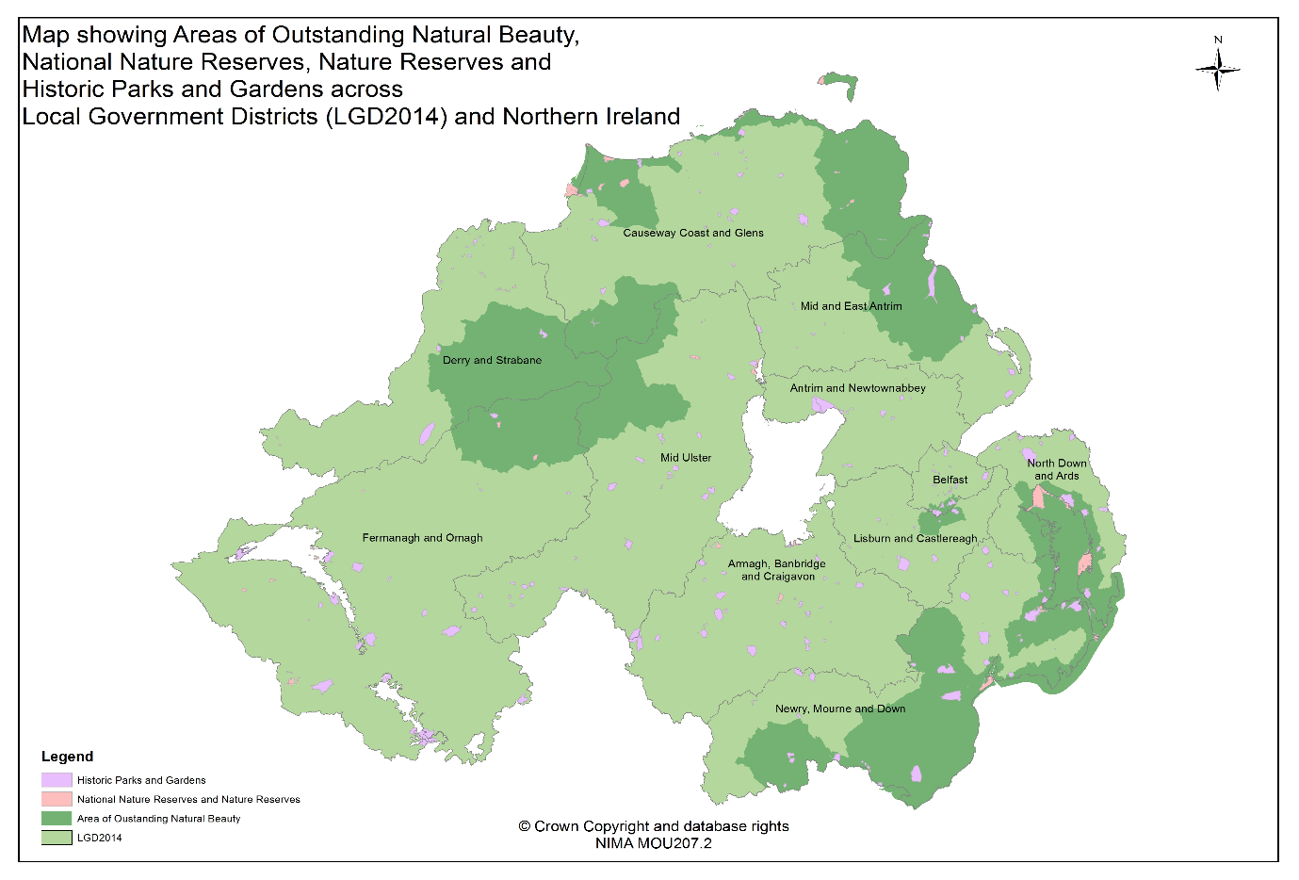
There are 8 Areas of Outstanding Natural Beauty in Northern Ireland as well as Northern Ireland Environment Agency Country Parks and nature reserves.

The WHO Outdoor Space and Buildings guide highlights that Services are clustered, located in close proximity to where older people live and can be easily accessed. Locational data including credit unions, dental surgeries, indoor bowling, pharmacies, shopping centres and visitor attractions are available to view on NINIS.

Outdoor Safety
Policing and Community Safety Partnerships (PCSPs) aim to make our community safer by focusing on the policing and community safety issues that matter most in each local council area. Recorded Crime statistics are available on NINIS and show there were 5,799 recorded crime offences in Lisburn and Castlereagh LGD2014 during 2016/17, which accounted for 5.9% of recorded crime offences in Northern Ireland. An interactive map showing Recorded Crime is available to view on NINIS.

‘Violence Against the Person’ offences, where victims are 60+ years old are shown in the table below.

TRANSPORTATION
Transportation, including accessible and affordable public transport, is a key factor influencing active ageing. It is a theme running through many other age-friendly topics. In particular, being able to move about the community determines social and civic participation and access to community and health services.

Public Transport

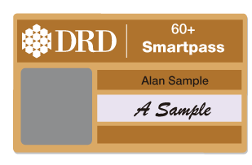
Concessionary fare scheme 'SmartPass' - Free travel is available to all senior citizens who are 60 years of age or over and who are resident in Northern Ireland. In 2016/17 312,593 smartpasses were held by older people. You can travel anywhere in Northern Ireland on any Translink bus or rail service completely free of charge. You can also enjoy free cross border rail travel. Locational data for bus and rail stations can be accessed via the People and Places theme on NINIS.

In Northern Ireland, Dept for Infrastructure (DfI) report that there were 1,361 buses used in 2016/17 as public service vehicles of which 1,079 have an accessibility certificate or low floor access.

DfI published a report on ‘Attitudes of disabled and older people to public transport’ (Nov 2014 to Jan 2015). Of those aged 70 and over, 39% answered ‘car’ either as a ‘driver’ and 12% as a ‘passenger’ as the type of transport they used most often with a further 28% of respondents stating ‘Bus – Translink (Ulsterbus, Metro)’. The main factor making it difficult to or preventing the use of public transport in the past 12 months for those in this age group was bus / train times don’t always meet my needs (31%), 24% stated difficulty getting on or off vehicles and 20% stated attitudes of bus drivers or other Translink (Ulsterbus / Metro / Northern Ireland Railways) staff.

Private Transport
On Census day 2011, there were 20,209 people aged 65+ years in Lisburn and Castlereagh LGD2014 living in households. 79% of these lived in households with access to a car or van.

Road Safety
The total number of reported road traffic collision casualties for persons aged 60+ in Northern Ireland in 2016 was 1,169. Of these 168 were killed/seriously injured and a further 1,001 were slightly injured.

The total number of reported road traffic collision casualties for persons aged 60+ in Lisburn and Castlereagh LGD2014 in 2016 was 86. Of these 16 were killed/seriously injured and 70 were slightly injured.

Housing
Housing is essential to safety and well-being. There is a link between appropriate housing and access to community and social services in influencing the independence and quality of life of older people.
Households

In Northern Ireland on Census day 2011, there were 263,720 people aged 65+ years. Of these, 96% lived in a household and 4% lived in communal establishments. On Census day 2011, there were 21,184 people aged 65+ years living in Lisburn and Castlereagh LGD2014; 95% lived in a household and 5% lived in communal establishments.

Of those 20,209 people aged 65+ years living in households in Lisburn and Castlereagh LGD2014, 81% lived in households that were owner occupied, 12% in households that were social rented, 3% in households that were private rented and 4% were living rent free. Comparative figures for Northern Ireland (people aged 65+ years) are 77% lived in households that were owner occupied, 14% in households that were social rented, 5% in households that were private rented and 4% were living rent free.

On Census day 2011, 5,762 households in Lisburn and Castlereagh LGD2014 were one person households where the resident was aged 65+ years. 4,473 households were one family houses where all people were aged 65+ years and 194 households were other household types where all residents were aged 65+ years.

Sufficient/Adequate Housing

Data from the Northern Ireland Housing Executive (NIHE) show that in March 2014, 5,909 applicants aged 60+ years were on the waiting list for housing in Northern Ireland and of these 3,499 (59.2%) were in housing stress.
A key objective of the NIHE House Condition Survey (HCS) 2011 was to provide a comprehensive picture of the dwelling stock and its condition in 2011 for NI and each of the 26 District Councils. This survey estimated that 42.0% of households in NI were in fuel poverty. For households where the Household Reference Person (HRP) was aged 60-74 years, 52.0% of households were in fuel poverty rising to 66.3% where the Household Reference Person was aged 75+ years.

Note - The definition of a fuel poor household is one needing to spend in excess of 10 per cent of its household income on all fuel use to achieve a satisfactory standard of warmth (21oC in the main living area and 18oC in other occupied rooms; World Health Organisation). Fuel Poverty assesses the ability to meet all domestic energy costs including space and water heating, cooking, lights and appliances.

Living Environment Deprivation - Housing Access and Housing Quality
The Northern Ireland Deprivation Measure 2010 Living Environment Domain - the purpose of this domain is to identify small areas experiencing deprivation in terms of the quality of housing, access to suitable housing and the outdoor physical environment. It comprises three separate sub-domains measuring these.

Within Lisburn and Castlereagh LGD2014 the most deprived Super Output Area based on the housing quality sub-domain measure is Ballymacbrennan 2 (ranked 42 out of 890 in NI) and the least deprived Super Output Area is Cairnshill 1 (ranked 884 out of 890 in NI).
LEAST DEPRIVED CAIRNSHILL 1
MOST DEPRIVED BALLYMACBRENNAN 2

Within Lisburn and Castlereagh LGD2014 the most deprived Super Output Area based on the housing access sub-domain measure is Lagan Valley 2 (ranked 3 out of 890 in NI) and the least deprived Super Output Area is Carryduff East 1 (ranked 887 out of 890 in NI).

MOST DEPRIVED LAGAN VALLEY 2

LEAST DEPRIVED CARRYDUFF EAST 1

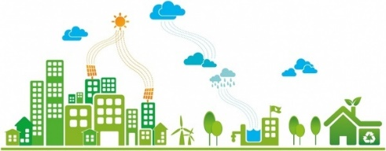
Affordable Housing

The Standardised Price of Residential Properties sold between April and June 2015 (Q2 2015) for Lisburn and Castlereagh LGD2014 was £135,977. The standardised price across Northern Ireland in Q2 2015 ranged from £93,806 in Derry and Strabane district to £135,988 in North Down and Ards district. Standardised prices and a price index for each LGD2014 can be found in the Northern Ireland Residential Property Price Index detailed statistics.

In 2013/14, the Disabled Facilities Grant, to improve the home of a person with a disability, was approved for 658 applicants aged 60 or over in Northern Ireland.
Note: This grant is to help to improve the home of a person with a disability, and may be based on the recommendation of an occupational therapist.

At June 2016, there were 1,670 Housing Benefit claimants aged 50-64 years and 1,880 Housing Benefit claimants aged 65+ years in Lisburn and Castlereagh LGD2014. An interactive map of Housing Benefit is available to view on NINIS.

Adaptation of Accommodation

On Census day 2011, there were 20,209 people aged 65+ years in Lisburn and Castlereagh LGD2014 living in households:
- 5.9% lived in households that had been adapted or designed for wheelchair use (NI: 7.1%)
- 0.4% lived in households that had been adapted or designed for visual difficulties (NI: 0.5%)
- 1.1% lived in households that had been adapted or designed for hearing difficulties (NI: 1.2%)
- 10.4% lived in households that had been adapted or designed for other physical or mobility issues (NI: 12.4%)
- 0.3% lived in households that had been adapted or designed for other circumstances (NI: 0.4%); and
- 84.4% lived in households that had no adaptation (NI: 81.5%)

Note - Household accommodation that has been adapted or designed for one or more of the following; wheelchair, visual, hearing, other physical or mobility difficulties - Percentages may not sum to 100% as there may be more than one type of adaptation per household.

SOCIAL PARTICIPATION
Social participation and social support are strongly connected to good health and well-being throughout life. Participating in leisure, social, cultural and spiritual activities in the community, as well as with the family, allows older people to continue to exercise their competence, to enjoy respect and esteem, and to maintain or establish supportive and caring relationships.
Events and Activities

Research was carried out by DCAL to obtain a deeper understanding of the relationship between older people and culture, arts and leisure. A literature review (DCAL, 2015) explored engagement in sport, arts, museums and libraries for older adults and identified a number of barriers to engagement. Further research used logistic regression to explore these barriers further and to identify the factors associated with engagement in culture, arts and leisure by older people.

The report found that, of those aged over 50, there were:
- 29% who participated in sport or physical activity;
- 28% who participated in arts activities;
- 57% who attended arts events;
- 25% who used a library; and
- 22% who visited a museum
all during the year prior to being asked.

The factors which appear consistently as having the most influence on an older persons engagement across the culture, arts and leisure areas are their level of educational attainment, i.e. having a degree or higher qualification; their socio-economic classification, i.e. classified as being in managerial and professional occupations; and their use of the internet.
Marriages

There were 481.00 marriages registered in Lisburn and Castlereagh LGD2014 in 2015. Analysis by age shows that 17 males and 8 females aged 60+ years were married in Lisburn and Castlereagh LGD2014 in 2015. An interactive map of Marriages by age and sex is available to view on NINIS.

Marital Status

On Census day 2011, there were 21,184 people aged 65+ years living in Lisburn and Castlereagh LGD2014. 6.1% of these were single, 59.8% were married or in a same sex civil partnership and 34.0% were widowed or surviving partner of a same sex civil partnership/separated/divorced or formerly in a same-sex civil partnership which is now legally dissolved.

RESPECT AND SOCIAL INCLUSION
The respect and social inclusion of older people depend on more than societal change: factors such as culture, gender, health status and economic status play a large role. The extent to which older people participate in the social, civic and economic life of the community is also closely linked to their experience of inclusion.

Respect

When respondents of the 2014 Northern Ireland Life and Times (NILT) Survey were asked if they think that older people are, on the whole, treated better or worse than people in the general population because of their age, NILT respondents had mixed views. One fifth of people (22%) thought that older people are treated better than others. Similar proportions thought that older people are treated the same as (36%), or worse than (37%), the general population.

People aged 75 years or over were the group most likely to think that older people are treated better (28%) than others. Nearly four out of ten respondents (37%) thought that, as they get older, they find that people treat them with more respect. A similar proportion (39%) said that people treated them about the same, whilst around one in five (22%) thought that people treated them with less respect.

Social Inclusion

On Census day 2011, 5,762 households in Lisburn and Castlereagh LGD2014 were one person households where the resident was aged 65+ years.

AgeNI is the leading charity for older people in Northern Ireland. Age NI has helped build an infrastructure of 11 Networks bringing together older people’s groups across NI to strengthen the regional voice of older people and support them to influence important decisions on local policy and services. More information on the 11 sub-regional networks can be found on the AgeNI Website

The Executive Office involved older people and their representative groups in the development and implementation of the Active Ageing Strategy and Action Plan.

The Northern Ireland Pensioners Parliament was launched in 2011 and allows older people from across Northern Ireland to have their say on the issues that matter to them. The parliament reaches out to give older people a chance to make their voice heard on issues that affect them and also provides a vehicle to make older people more aware of key information and practical advice on support services in their own areas, including information on health, benefits, transport and community safety. Over 1,100 NI Pensioners Parliament surveys were completed between January and April 2014. The results of the survey in each county set the agenda for the discussion and expert panels at each local parliament. Almost 500 pensioners attended the seven local parliaments which were held across Northern Ireland between February and April 2014. There was a parliament held in each county and an additional one in Belfast. The host towns and cities for 2014 were Belfast, Enniskillen, Newry, Larne, Craigavon, Magherafelt and Omagh.

2015 saw a new development for the Parliament - the hosting of themed parliaments on specific topics. These allowed for more in-depth discussion and debate on one exclusive topic.

In 2016, surveys conducted at local parliaments raised the following concerns by older people:
- Access to Health and Social Care 69.3%
- Transport 50.6%
- Keeping Warm in winter/Energy prices 49.3%
- Fear of Crime 48.2%

CIVIC PARTICIPATION AND EMPLOYMENT
Older people do not stop contributing to their communities on retirement. Many continue to provide unpaid and voluntary work for their families and communities. In some areas, economic circumstances force older people to take paid work long after they should have retired. An age-friendly community provides options for older people to continue to contribute to their communities, through paid employment or voluntary work if they so choose, and to be engaged in the political process.

Civic Participation
Carer's Allowance is a benefit for people who care for someone with a severe disability. 550 males and 710 females aged 65+ years living in Lisburn and Castlereagh LGD2014 claimed Carers Allowance in 2016.

In 2011, 12.2% of those aged 65+ years in Lisburn and Castlereagh LGD2014 undertook voluntary work without pay. The corresponding figure for those aged 65+ years in Northern Ireland was 10.7%.

In 2011, 51.5% of those aged 65+ years in Lisburn and Castlereagh LGD2014 provided unpaid care. The corresponding figure for those aged 65+ years in Northern Ireland was 45.9%.

Training and Employment

In the 2015/16 academic year, there were 215 enrolments aged 60+ years from Lisburn and Castlereagh LGD2014 at UK Higher Education Institutions. In the same year, there were 174 enrolments for those aged 60+ years from Lisburn and Castlereagh LGD2014 on a regulated course in Northern Ireland Further Education Institutions.

There were a total of 10 starts on the Steps to Success employment programme between October and December 2014 for participants aged 60+ years in Lisburn and Castlereagh LGD2014 on the programme.

Note the Steps 2 Success programme was introduced across Northern Ireland on 20 October 2014. It replaced the Steps to Work programme which stopped taking referrals on 30th May 2014. For further information see the DEL website.

On Census Day 2011, 9.4% (1,983) of those aged 65 + years in Lisburn and Castlereagh LGD2014 were economically active and 90.6% (19,201) economically inactive.
Over 65 (21,184)

ECONOMICALLY ACTIVE
9.4% (1,983)
ECONOMICALLY INACTIVE
90.6% (19,201)

Of the 1,329 NICS staff who were aged 60+, 98 had a home address of Lisburn and Castlereagh LGD2014 and 123 worked in a Lisburn and Castlereagh LGD2014 location.

Qualifications

In Lisburn and Castlereagh LGD2014 on Census day 2011, there were 21,184 people aged 65+ years. Of these, 16.5% had achieved Level 4 or higher qualifications, while 55.7% had no qualifications. In Northern Ireland, 63.7% of people aged 65+ years had no qualifications.

Benefits

In February 2016, 24,460 people living in Lisburn and Castlereagh LGD2014 were claiming retirement pension, 10,190 males aged 65+ and 14,270 females aged 60+. An interactive map showing Retirement Pension data is available to view on NINIS. In the same year 4,150 living in Lisburn and Castlereagh LGD2014 received pension credit.

COMMUNICATION AND INFORMATION
Staying connected with events and people and getting timely, practical information to manage life and meet personal needs is vital for active ageing.

Access to the Internet

Libraries have access to computers and the Internet for free or at very cheap rates. Locational information on libraries is available to view on NINIS. LibrariesNI, in partnership with Business in the Community, NI Direct Digital Inclusion Unit of the Department of Finance and Personnel, hold free annual IT taster sessions for the over 50s in a number of selected libraries across Northern Ireland on Silver Surfers' Day. This covers creating an e-mail account, using e-mail and browsing the internet.

There are 98 libraries in Northern Ireland - 4 of these are located in Lisburn and Castlereagh LGD2014.

Figures from the Labour Force Survey in 2013, reveal that 61.4% of people aged 65 years and over living in Lisburn and Castlereagh LGD2014 have never accessed the Interent. This compares to a Northern Ireland figure of 65.1%.

OVER 65 USED INTERNET
(38.6%)
OVER 65 NEVER USED INTERNET (61.4%)

COMMUNITY AND HEALTH SERVICES
Health and support services are vital to maintaining health and independence in the community.

Community Care
In Northern Ireland, 1,945 people aged 65+ received a meals service in 2016.
In 2016, there were 194 residential homes in Northern Ireland and on average there were 1,125 statutory and 2,980 independent places available (does not include residential places in nursing homes).
In 2016, there were 257 nursing homes in Northern Ireland and on average there were 25 statutory places, 5,916 independent places and 4,751 dual registered places available (includes dual registered homes but refers to nursing places only).

The number of clients receiving intensive domiciliary care in the Northern Ireland in 2016 was 8,752 with 82% of these aged 65 years and over.
Note: Intensive domiciliary is defined as 6 or more visits and more than 10 contact hours, as recorded during the survey week.

Health Service
In 2016/17 there were 113,451 people registered with a GP Practice (QOF Framework) in Lisburn and Castlereagh LGD2014. The list size for those aged 50+ years in Lisburn and Castlereagh LGD2014 was 40,115.

113,451 registered to GP Practice

40,115 of which are 50+

Some of the Quality and Outcomes Framework (QOF) registers are for diseases that tend to affect an older population. There were 819 people on the Dementia Register (all ages) and 334 people on the Osteoporosis Register (aged 50+ years) living in Lisburn and Castlereagh LGD2014.

Locational data on GP surgeries, Dentists, Opticians and fitness centres is available to view on NINIS.
General Health

On Census Day 2011, there were 21,184 people aged 65+ years living in Lisburn and Castlereagh LGD2014. 51.5% stated they had very good or good health, 36.6% had fair health and the remaining 11.9% had bad or very bad health.
- 14,391 (67.9%) of those aged 65+ years were living with a long-term health condition
- 4,301 (20.3%) had deafness or partial hearing loss
- 1,260 (5.9%) had blindness or partial sight loss
- 621 (2.9%) had a communication difficulty
- 7,440 (35.1%) had a mobility or dexterity difficulty
- 200 (0.9%) had a learning, intellectual, social or behavioural difficulty
- 953 (4.5%) had an emotional, psychological or mental health condition
- 5,300 (25.0%) had long-term pain or discomfort
- 3,468 (16.4%) had shortness of breath or difficulty breathing
- 1,476 (7.0%) had frequent periods of confusion or memory loss
- 4,410 (20.8%) had a chronic illness
- 1,949 (9.2%) had other conditions
Note - Percentages may not sum to 100% as a person may have more than one condition.

Of the 20,209 people aged 65+ years living in households in Lisburn and Castlereagh LGD2014, 28.6% said that their day-to-day activities were limited a lot, 23.3% a little and 48.2% were not limited.

Health Survey

- The 2015/16 Health Survey for Northern Ireland revealed that 41% of those aged 65-74 in Northern Ireland were overweight, a further 29% were obese. For those aged 75+ years, 43% were overweight, with a further 25% obese.
- 16% of males and 14% of females aged 60+ years in Northern Ireland were smokers.
- In 2013/14 over half (53%) of respondents aged 65-74 years in Northern Ireland undertook less than 30 minutes of exercise per day. This rose to almost three quarters (74%) of those aged 75+ years.
- 16% of males and 8% of females aged 65-74 years in Northern Ireland drank above recommended weekly limits. For those aged 75 and over 11% of males and 3% of females drank above recommended weekly limits.

Proximity to Services

The Northern Ireland Deprivation Measure 2010 Proximity to Services Domain - the purpose of this domain is to measure the extent to which people have poor geographical access to key services, including statutory and general services. The average time in minutes to travel to a service from a given Output Area was calculated and results are available on NINIS.
The summary table below shows that the maximum time to travel to a service from an Output Area was between three and 10 minutes for key health services.
Within Lisburn and Castlereagh LGD2014 the most deprived Output Area (OA) based on the proximity to services domain measure is 95SS110001 within Glenavy 2 SOA (ranked 191 out of 5,022 in NI) and the least deprived Output Area is 95II130002 within Graham's Bridge SOA (ranked 4747 out of 5,022 in NI).

Travel Time to: | Max travel time for Output Areas within Lisburn and Castlereagh LGD2014 (minutes) |  | Min travel time for Output Areas Lisburn and Castlereagh LGD2014 (minutes)
GP Premises | 9.49 | 0.22
Accident and Emergency hospitals | 25.98 | 0.29
Dentist | 11.82 | 0.14
Pharmacist | 8.62 | 0.13
Optician | 10.92 | 0.16

Health Related Benefits
There were 3,730 Attendance Allowance recipients aged 65+ years in Lisburn and Castlereagh LGD2014 in 2016. Attendance Allowance is a tax-free benefit paid to people, aged 65+ years, who need help with their personal care because of an illness or disability. An interactive map showing Attendance Allowance data is available to view on NINIS.

There were 11,450 Disability Living Allowance recipients in Lisburn and Castlereagh LGD2014. An interactive map showing Disability Living Allowance data is available to view on NINIS.

