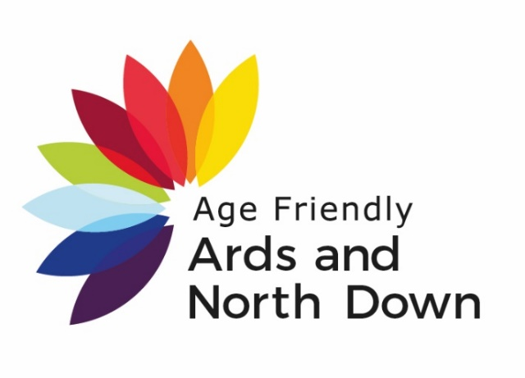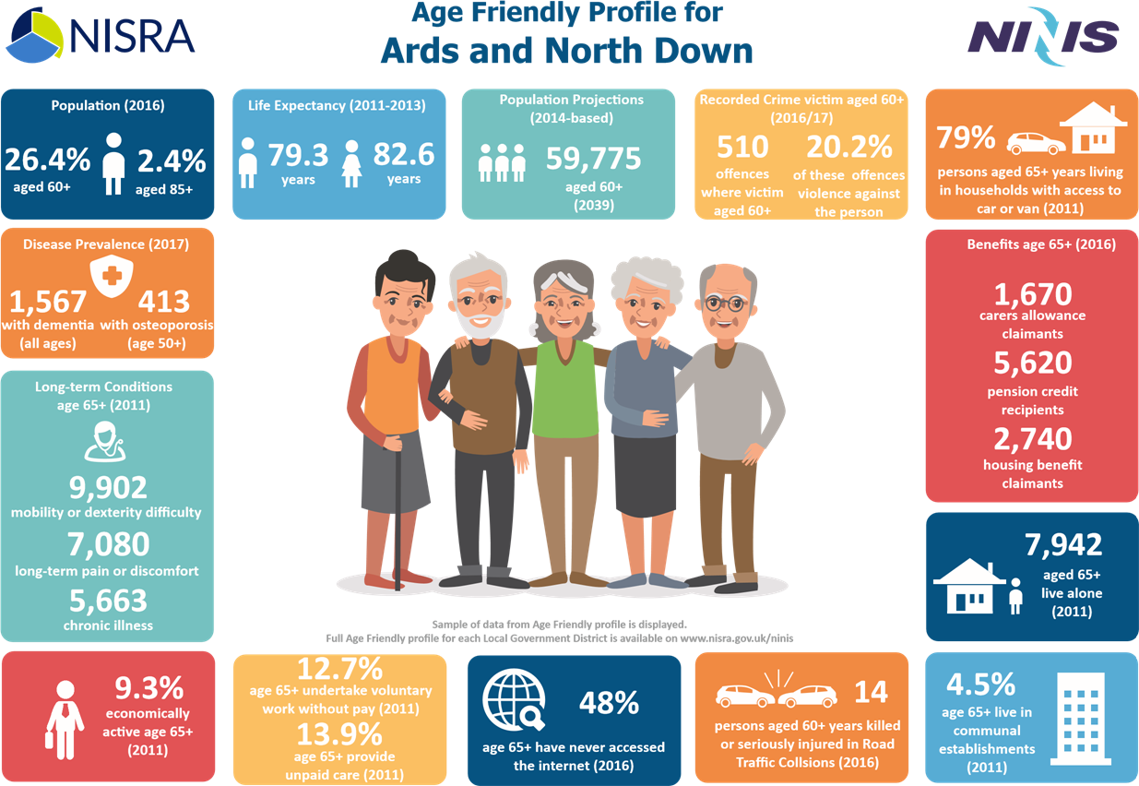

**AGE FRIENDLY**

Table of Contents

**Age Friendly 2**

Introduction 2

Context 2

Alignment of local and national objectives……………………………………………………………………………3

**Demography4**

Population4

Projected Population.4

Deaths ……………………………………………………………………………………………………………………………………...........5

Life Expectancy………………………………………………………………………………………………………………………………….5

SOA Over 60 Income Deprivation Map**…………………………………………………………….**6

SOA population over 60 Map……………………………………………………………………….6

**8 Domains ……………………………………………………………………………………………………………………………………7**

Outdoor Spaces & Buildings……………………………………………………………………………………………………………………………………………7

Transportation………………………………………………………………………………………………………………………………….8

Housing…………………………………………………………………………………………………………………………………………….9

Social Participation………………………………………………………………………………………………………………………….12

Respect & Social Inclusion……………………………………………………………………………………………………………….13

Civic participation &Employment…………………………………………………………………………………………………….16

Communication& Information…………………………………………………………………………………………………………18

Community and Health Services………………………………………………………………………………………………………19

**AGE FRIENDLY INTRODUCTION/CONTEXT**

Age Friendly Profile for Ards and North Down Local Government District (LGD2014).

*'An Age-friendly world is a place that enables people of all ages to actively participate in community activities. It is a place that treats everyone with respect, regardless of their age. It is a place that makes it easy to stay connected to those around you and those you love. It is a place that helps people stay healthy and active even at the oldest ages. And it is a place that helps those who can no longer look after themselves to live with dignity and enjoyment. Many cities and communities are already taking active steps towards becoming more age-friendly'.* (World Health Organization WHO).

The World Health Organisation (WHO) has established a global network of Age Friendly Cities and Communities that encourage active ageing by optimising opportunities for health, participation and security in order to enhance quality of life as people grow older. The WHO has proposed eight areas that can help to identify and address barriers to the well-being and participation of older people. Key statistics on each of these themes are included below. By way of background, demographic and deprivation profiles have also been included for the local council areas.

'Northern Ireland is an age friendly region in which people, as they get older, are valued and supported to live actively to their fullest potential; with their rights and dignity protected' (OFMDFM Vision).

This report provides useful statistics on the age-friendliness of Ards and North Down (LGD2014)

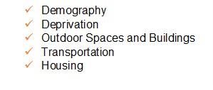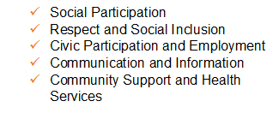

**Alignment of local and national objectives:**

The following table illustrates the close alignment of the objectives and themes of *Making Life Better* and *Active Ageing* with the Ards and North Down community planning thematic groups.

|  |  |  |  |  |  |  |  |
| --- | --- | --- | --- | --- | --- | --- | --- |
| ***Age-friendly Domains*** | **Community Planning Themes** | | | | | **Active Ageing Strategy** | **Making Life Better Strategy** |
|  | ***Outcome 1*** | **Outcome 2** | **Outcome 3** | ***Outcome 4*** | ***Outcome 5*** |  |  |
| Outdoor spaces andbuildings |  | √ | √ |  | √ | √ | √ |
| Transportation |  | √ |  |  | √ | √ | √ |
| Housing |  |  |  | √ | √ | √ | √ |
| Social participation | **√** | √ | √ |  |  | √ | √ |
| Respect and social inclusion | **√** | √ | √ |  |  | √ | √ |
| Civic participation & employment |  | √ | √ | √ |  | √ | √ |
| Communication & information | √ | √ |  |  |  | √ | √ |
| Community support & health services | √ | √ |  |  | √ | √ | √ |

**Demography**

On 30th June 2016, the estimated population of Ards and North Down LGD 2014 was 159,593, accounting for 8.6% of the Northern Ireland population. 26.4% (42,183 people) of Ards and North Down were aged 60+. Of those 60+ 46% (19,397 people) were male and 54% (22,786 people) were female.

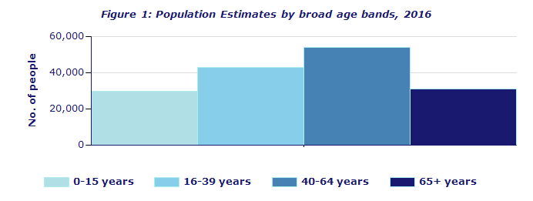2.4% (3,889 people) of the population of Ards and North Down were 85+ of those 85+ in Ards and North Down 31.5% (1,224 people) were male and 68.5% (2,665) were female.

**Population Projection**

The number of older people aged 65+ is projected to rise in Ards and North Down, from around 31,000 from 2014 to around 50,000 by 2039. The numbers of older people aged 85+ years is anticipated to more than double from under 4,000 residents from 2014 to about 10,000 residents by 2039. This growth in our population is one that should be viewed as a successful achievement. We as a council aim to make Ards and North Down a great place to grow old and one that is supportive, valuing and enabling for older people

The graph below shows the % of population growth from 2014-2039, with Ards and North Down ~~having the largest % population~~ in the 65+ range 20% in 2014 raising to 31% by 2039.

The graph below shows that life expectancy for males and females in AND compared to that of the rest of Northern Ireland. It shows an ~~steady~~ increase from 2001-03 – 2011-2013

**Deaths**

There were12,655 deaths registered for persons aged 65+ years in Northern Ireland in 2015. Of these deaths 27% were to malignant neoplasms, 16% were to respiratory disease and 26% were to circulatory disease.

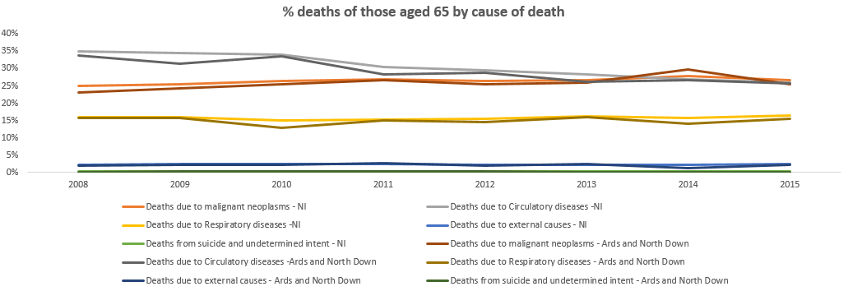There were **1,310** deaths registered for persons aged 65+ years in Ards and North Down LGD2014 in 2015. Of these deaths 25% were to malignant neoplasms, 16% were to respiratory disease and 26% were to circulatory disease

WAITING ON GIS MAPS

______________________

Sources/Datasets used: [Population Estimates: Broad Age Bands (administrative geographies)](http://www.ninis2.nisra.gov.uk/public/ViewDataSet.aspx?ds=8212&lh=38&yn=1991-2016&sk=74&sn=Population&yearfilter=), [Population Estimates - 5 year age bands (administrative geographies)](http://www.ninis2.nisra.gov.uk/Download/Population/Population%20Estimates%20-%205%20year%20age%20bands%20(admin%20geographies).zip), [Population Projections (administrative geographies) (administrative geographies)](http://www.ninis2.nisra.gov.uk/Download/Population/Population%20Projections%20(administrative%20geographies).zip), [Deaths by Cause and Age: 65+ years (administrative geographies)](http://www.ninis2.nisra.gov.uk/public/ViewDataSet.aspx?ds=7861&lh=73&yn=2008-2015&sk=74&sn=Population&yearfilter=), [Excess Winter Mortality (administrative geographies)](http://www.ninis2.nisra.gov.uk/public/ViewDataSet.aspx?ds=7020&lh=73&yn=1991-2014&sk=74&sn=Population&yearfilter=), [Life Expectancy at Birth and at age 65](http://www.ninis2.nisra.gov.uk/public/ViewDataSet.aspx?ds=6967&lh=73&yn=2000-2013&sk=74&sn=Population&yearfilter=) NISRA Demographic Statistics

**Outdoor Spaces and Buildings**

Living Environment Deprivation- Outdoor Physical Activity

The Northern Ireland Deprivation Measure 2017 Living Environment Domain- The purpose of this domain is to identify, at the small area level, the prevalence of shortcomings in the **quality of housing, access to suitable housing and the outdoor physical environment**. It comprises three separate sub-domains measuring each of these. Within Ards and North Down LGD2014, the most deprived Super Output Area based on the living environment domain measure is Harbour 1 (21 out of 890).

Within Ards and North Down LGD2014 the most deprived Super Output Area based on the outdoor physical environment sub domain measure in Harbour 1 (70 out of 890)

The least deprived Super Output Area based on the outdoor physical environment subdomain measure is Ballycrochan 2 (889 out of 890) This is based on *\*1 is the most deprived SOA in Northern Ireland and 890 the least deprived.*

|  |  |  |  |  |  |  |  |  |  |  |  |  |  |  |  |  |  |  |  |  |  |  |  |  |  |
| --- | --- | --- | --- | --- | --- | --- | --- | --- | --- | --- | --- | --- | --- | --- | --- | --- | --- | --- | --- | --- | --- | --- | --- | --- | --- |
| **Image result for Town graphic**  Least Deprived Ballycrochan 2  Most Deprived Harbour 1 | | | | | | | | | | | | | | | | | | | | | | | | | |
| Having green spaces is one of the most commonly mentioned age-friendly features. For its small area, Northern Ireland has a great variety of scenic countryside and although there are no National Parks, large areas of landscape of distinctive character and special scenic value have been designated Areas of Outstanding Natural Beauty (AONBs). This designation is designed to protect and enhance the qualities of each area and to promote their enjoyment by the public.  There are 8 Areas of Outstanding Natural Beauty in Northern Ireland as well as Northern Ireland Environment Agency Country Parks and nature reserves. | | | | | | | | | | | | | | | | | | | | | | | | | |
|  |  | | | | | | | | | | | | | | | | | | | | | | | | |
| There are 4 Green Flag Awarded areas within Ards and North Down (Ballymenoch Park, Castle Park, Kiltonga Nature Reserve and Londonderry Park.[1]  **Transport**    Transportation, including accessible and affordable public transport, is a key factor influencing active ageing. It is a theme running through many other age-friendly topics. In particular, being able to move about the community determines social and civic participation and access to community and health services  UP TO DATE FIGURES – 84% of those aged 65+ in Ards and North Down have access to a car (2016-17)  14  2016  Image result for northern ireland smartpass  Concessionary fare scheme 'SmartPass' - Free travel is available to all senior citizens who are 60 years of age or over and who are resident in Northern Ireland. In 2016/17 312,593 smartpasses were held by older people. You can travel anywhere in Northern Ireland on any Translink bus or rail service completely free of charge. You can also enjoy free cross border rail travel. Locational data for [bus](http://www.ninis2.nisra.gov.uk/Download/People%20and%20Places_Excel/2013/Bus%20Stations.XLS) and [rail](http://www.ninis2.nisra.gov.uk/Download/People%20and%20Places_Excel/2013/Train%20Stations.XLS) stations can be accessed via the [*People and Places*](http://www.ninis2.nisra.gov.uk/public/Theme.aspx?themeNumber=10) theme on [NINIS](http://www.ninis2.nisra.gov.uk/public/Theme.aspx?themeNumber=10&themeName=People%20and%20Places).    In Northern Ireland**,** Dept for Infrastructure (DfI) [report](http://www.drdni.gov.uk/index/statistics/stats-categories/ni_transport_statistics.htm) thatthere were 1,361 buses used in 2016/17 as public service vehicles of which 1,079 have an accessibility certificate or low floor access.    DfI published a report on ‘[Attitudes of disabled and older people to public transport’ (Nov 2014 to Jan 2015)](http://www.drdni.gov.uk/attitudes-of-disabled-and-older-people-to-public-transport-november-2014-january-2015-internet-version-2.pdf). Of those aged 70 and over, 39% answered ‘car’ either as a ‘driver’ and 12% as a ‘passenger’ as the type of transport they used most often with a further 28% of respondents stating ‘Bus – Translink (Ulsterbus, Metro)’. The main factor making it difficult to or preventing the use of public transport in the past 12 months for those in this age group was bus / train times don’t always meet my needs (31%), 24% stated difficulty getting on or off vehicles and 20% stated attitudes of bus drivers or other Translink (Ulsterbus / Metro / Northern Ireland Railways) staff. The Travel Survey for Northern Ireland reports that 36% of adults aged 60+ have difficulty with travel due to physical disability or long-standing health problem.  74% of those aged 60 and over in Ards and North Down report their main mode of transport as car, a further 17% walk, (DfI 2013-2015).  **Road Safety**  The total number of reported road traffic collision casualties for persons aged 60+ in Northern Ireland in 2016 was 1,169. Of these 168 were killed/seriously injured and a further 1,001 were slightly injured. The total number of reported road traffic collision casualties for persons aged 60+ in North Down and Ards LGD2014 in 2016 was 108. Of these 14 were killed/seriously injured and 94 were slightly injured.  ____________________  3 Sources/Datasets used: [Road Traffic Collision Casualties by Severity of Injury aged 60 and over (administrative geographies)](http://www.ninis2.nisra.gov.uk/public/ViewDataSet.aspx?ds=8390&lh=73&yn=2011-2016&sk=118&sn=Travel%20and%20Transport&yearfilter=), PSNI; [Number of Cars or Vans CT0098NI,](http://www.ninis2.nisra.gov.uk/Download/Census%202011_Excel/2011/CT0098NI.xlsx) NISRA Census |  |  | | | | | | | | | | | | | | | | | | | | | | |
| [2] |  |  |  |  |  |  |  |  |  |  |  |  |  |  |  |  |  |  |  |  |  |  |  |  |  |  |  |  |  |  |  |  |

**Housing**

Housing is essential to safety and well-being. There is a link between appropriate housing and access to community and social services in influencing the independence and quality of life of older people.

In Northern Ireland on Census day 2011, there were 263,720 people aged 65+ years. Of these, 96% lived in a household and 4% lived in communal establishments. On Census day 2011, there were 27,692 people aged 65+ years living in Ards and North Down LGD2014; 96% lived in a household and 4% lived in communal establishments. The graph below outlines AND household breakdown.







4,473

7,942

Households where all residents are aged 65+ years

One person households where the resident was aged 65+ years

A key objective of the [NIHE House Condition Survey (HCS) 2011](http://www.nihe.gov.uk/index/corporate/housing_research/house_condition_survey.htm) was to provide a comprehensive picture of the dwelling stock and its condition in 2011 for NI and each of the (then) 26 District Councils. This [survey estimated](http://www.nihe.gov.uk/2011_house_condition_survey_annex_tables__published_october_2012_.pdf) that 42.0% of households in NI were in fuel poverty. For households where the Household Reference Person (HRP) was aged 60-74 years, 52.0% of households were in fuel poverty rising to 66.3% where the Household Reference Person was aged 75+ years.

*Note - The definition of a fuel poor household is one needing to spend in excess of 10 per cent of its household income on all fuel use to achieve a satisfactory standard of warmth (21oC in the main living area and 18oC in other occupied rooms; World Health Organisation). Fuel Poverty assesses the ability to meet all domestic energy costs including space and water heating, cooking, lights and appliances.*

**Living Environment Deprivation - Housing Access and Housing Quality**

The Northern Ireland Deprivation Measure 2017 Living Environment Domain - the purpose of this domain is to identify small areas experiencing deprivation in terms of the quality of housing, access to suitable housing and the outdoor physical environment. It comprises three separate sub-domains measuring these

Within Ards and North Down LGD2014 the most deprived Super Output Area based on the **housing quality sub-domain measure is Holywood Demesne** (ranked 1 out of 890 in NI) and the least deprived Super Output Area is Conlig 2 (ranked 879 out of 890 in NI).

|  |
| --- |
| **Image result for Town graphic**  Most deprived Holywood Demesne  Least Deprived Conlig 2 |

*\*1 is the most deprived SOA in Northern Ireland and 890 the least deprived.*

|  |
| --- |
| **Image result for Town graphic** |

Within Ards and North Down LGD2014 the most deprived Super Output Area based on the **housing access sub-domain measure is Bradshaw’s Brae 2** (ranked 19 out of 890 in NI) and the least deprived Super Output Area is Bradshaw’s Brae 1 (ranked 886 out of 890 in NI). *1 is the most deprived SOA in Northern Ireland and 890 the least

Least Deprived Bradshaw’s Brae 1

Most deprived Bradshaw’s Brae 2

*\*1 is the most deprived SOA in Northern Ireland and 890 the least deprived.*

**Adaptation of Accommodation**

**\*no text re the chart below?**

|  |  |  |  |  |  |  |  |
| --- | --- | --- | --- | --- | --- | --- | --- |
|  | **All usual residents aged 65 and over in households** | Wheelchair usage | Other physical or mobility difficulties | Visual difficulties | Other | Hearing difficulties | No adaptation |
| **North Down and Ards** | **26,448** | 1,763 | 2,969 | 106 | 123 | 235 | 22,032 |
| **Northern Ireland** | **251,969** | **17,996** | **31,312** | **1,217** | **949** | **3,134** | **205,246** |

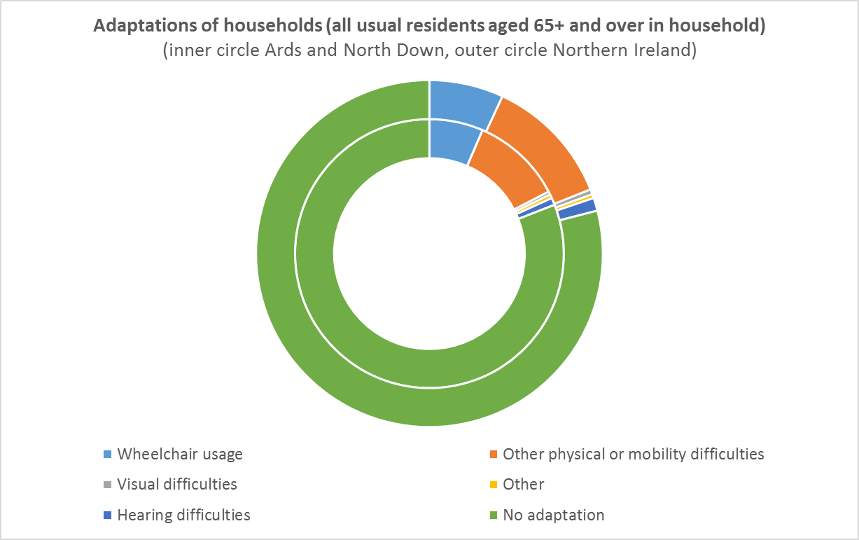

_________________

4 Sources/Datasets used: [Usual Resident Population CT0106NI](http://www.ninis2.nisra.gov.uk/Download/Census%202011_Excel/2011/CT0106NI.xlsx), [Tenure CT0107NI](http://www.ninis2.nisra.gov.uk/Download/Census%202011_Excel/2011/CT0107NI.xlsx), [Household Composition: KS105NI (administrative geographies)](http://www.ninis2.nisra.gov.uk/public/ViewDataSet.aspx?ds=4061&lh=73&yn=2011&sk=136&sn=Census%202011&yearfilter=), NISRA Census Office; [Housing Waiting List for aged 60 and over (administrative geographies)](http://www.ninis2.nisra.gov.uk/public/ViewDataSet.aspx?ds=6568&lh=37&yn=2014&sk=10&sn=People%20and%20Places&yearfilter=), [House Conditions Survey 2011](http://www.nihe.gov.uk/index/corporate/housing_research/house_condition_survey.htm), NI Housing Executive; Northern Ireland Multiple Deprivation Measure 2010 (statistical geographies), NISRA Demographic Statistics; [House Price Index](http://www.ninis2.nisra.gov.uk/Download/People%20and%20Places/Northern%20Ireland%20House%20Price%20Index%20(administrative%20geographies).ods)[,](http://www.nisra.gov.uk/housepriceindex/DetailedStatisticsQuarter12013.xlsm) DoF Land and Property Services; [Disabled Facilities Grants Approved for applicants aged 60 and over (administrative geographies)](http://www.ninis2.nisra.gov.uk/public/ViewDataSet.aspx?ds=6260&lh=37&yn=2011-2013&sk=10&sn=People%20and%20Places&yearfilter=) NI Housing

|  |  |  |
| --- | --- | --- |
|  | |  | | --- | |  | |

**SOCIAL PARTICIPATION**

Social participation and social support are strongly connected to good health and well-being throughout life. Participating in leisure, social, cultural and spiritual activities in the community, as well as with the family, allows older people to continue to exercise their competence, to enjoy respect and esteem, and to maintain or establish supportive and caring relationships.  
  
**Events and Activities**

[Research](http://www.dcalni.gov.uk/cal_and_older_people_-_literature_review.pdf) was carried out by DCAL to obtain a deeper understanding of the relationship between older people and culture, arts and leisure. A literature review (DCAL, 2015) explored engagement in sport, arts, museums and libraries for older adults and identified a number of barriers to engagement. Further research used [logistic regression](http://www.dcalni.gov.uk/cal_and_older_people_-_logistic_regressionv2.pdf) to explore these barriers further and to identify the factors associated with engagement in culture, arts and leisure by older people. Ards and North Down reported:

The factors which appear consistently as having the most influence on an older person’s engagement across the culture, arts and leisure areas are their level of educational attainment, i.e. having a degree or higher qualification; their socio-economic classification, i.e. classified as being in managerial and professional occupations; and their use of the internet.

___________________

5 Sources/Datasets used: Older people and engagement in culture, arts and leisure 2015, DfC; Marriages by age and sex (administrative geographies), Marriages by age and sex Interactive Map, NISRA Demographic Statistics; Marital and Civil Partnership Status by Age CT0105NI, NISRA Census Office

**RESPECT AND SOCIAL INCLUSION**

The respect and social inclusion of older people depend on more than societal change: factors such as culture, gender, health status and economic status play a large role. The extent to which older people participate in the social, civic and economic life of the community is also closely linked to their experience of inclusion.

**Respect**

When respondents of the 2014 Northern Ireland Life and Times (NILT) Survey were asked if they think that older people are, on the whole, treated better or worse than people in the general population because of their age, NILT respondents had mixed views. One fifth of people (22%) thought that older people are treated better than others. Similar proportions thought that older people are treated the same as (36%), or worse than (37%), the general population.

People aged 75 years or over were the group most likely to think that older people are treated better (28%) than others. Nearly four out of ten respondents (37%) thought that, as they get older, they find that people treat them with more respect. A similar proportion (39%) said that people treated them about the same, whilst around one in five (22%) thought that people treated them with less respect.

AgeNI is the leading charity for older people in Northern Ireland. Age NI has helped build an infrastructure of 11 Networks bringing together older people’s groups across NI to strengthen the regional voice of older people and support them to influence important decisions on local policy and services.

The Executive Office involved older people and their representative groups in the development and implementation of the [Active Ageing Strategy and Action Plan](http://www.ofmdfmni.gov.uk/active-ageing-strategy-2014-2020-consultation.pdf).

The [Northern Ireland Pensioners Parliament](https://www.agesectorplatform.org/ni-pensioners-parliament/overview) was launched in 2011 and allows older people from across Northern Ireland to have their say on the issues that matter to them. The parliament reaches out to give older people a chance to make their voice heard on issues that affect them and also provides a vehicle to make older people more aware of key information and practical advice on support services in their own areas, including information on health, benefits, transport and community safety. Over 1,100 NI Pensioners Parliament surveys were completed between January and April 2014. The results of the survey in each county set the agenda for the discussion and expert panels at each local parliament. Almost 500 pensioners attended the seven local parliaments which were held across Northern Ireland between February and April 2014.

2015 saw a new development for the Parliament - the hosting of themed parliaments on specific topics. These allowed for more in-depth discussion and debate on one exclusive topic.

In 2016, surveys conducted at local parliaments raised the following concerns by older people, with access to health and social care high up on the list of concerns for older people:

___________________________

6 Sources/Datasets used: [2016 Northern Ireland Pensioners Parliament Report](https://www.agesectorplatform.org/ni-pensioners-parliament/overview), Age Sector Platform; [AgeNI Sub-Regional Networks, AgeNI](http://www.ageuk.org.uk/northern-ireland/get-involved/regional-networks/)

[3]

**Civic Participation and Employment**

Older people do not stop contributing to their communities on retirement. Many continue to provide unpaid and voluntary work for their families and communities. In some areas, economic circumstances force older people to take paid work long after they should have retired. An age-friendly community provides options for older people to continue to contribute to their communities, through paid employment or voluntary work if they so choose, and to be engaged in the political process.

Carer's Allowance is a benefit for people who care for someone with a severe disability. We can see from the chart below from 2016 there are more female claimants50+ (1,870) in AND than male claimants (1,200).

Voluntary work by age from 55 years – 75 years and over. The base line tells us that Ards and North Down are slightly above average when it comes to unpaid voluntary work, still large percentage not volunteering. However slightly higher rates of 55+ volunteering in AND (12.7%) volunteering compared to the rest of Northern Ireland 55+ volunteering (10.7%)

I can’t edit the charts – but neither of these should be line charts as they are not timelines – should be changed to bar charts?

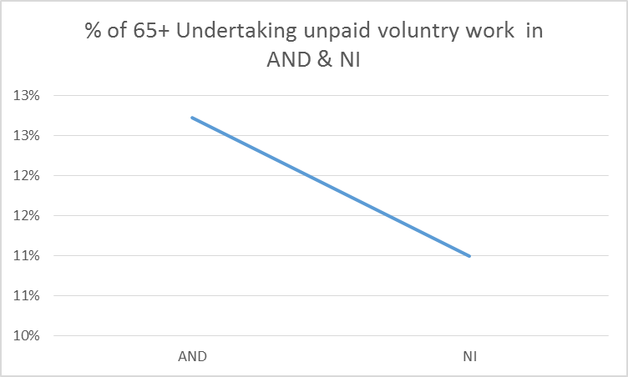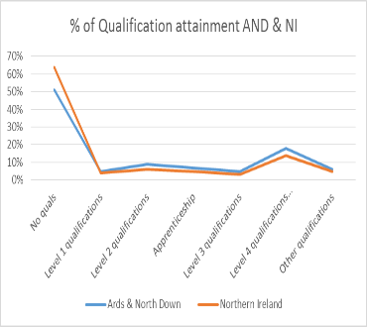

Qualifications:

In the 2015/16 academic year, there were **290** enrolments aged 60+ years from **Ards and North Down** LGD2014 at UK Higher Education Institutions. In the same year, there were **243** enrolments for those aged 60+ years from **Ards and North Down** LGD2014 on a regulated course in Northern Ireland Further Education Institutions. The table below shows educational attainment in 65+ taken from the 2011 Census.

There were a total of 8starts on the Steps to Success employment programme between October and December 2014 for participants aged 60+ years in **Ards and North Down** LGD2014 on the programme.

*Note the Steps 2 Success programme was introduced across Northern Ireland on 20 October 2014. It replaced the Steps to Work programme which stopped taking referrals on 30th May 2014.*

On Census Day 2011, 9.3% (2,572) of those aged 65 + years in **Ards and North Down** LGD2014 were economically active and 90.7% (25,120) economically inactive. Of those who were economically active, 758 work full-time, 773 work part-time, 990 were self-employed and 51 were unemployed

**Over 65 in AND (27,692)**

**ECONOMICALLY ACTIVE**

**2,572 (9.3%)**

**ECONOMICALLY INACTIVE**

**25,120 (90.7%)**

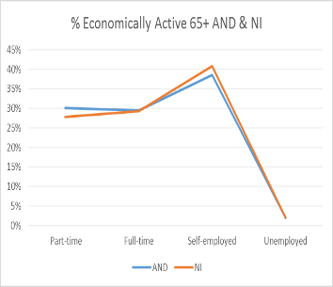**\*This chart shouldn’t be line chart.**

___________________

7 Sources/Datasets used: [Higher Education Enrolments (administrative geographies)](http://www.ninis2.nisra.gov.uk/public/ViewDataSet.aspx?ds=8021&lh=73&yn=1999-2015&sk=130&sn=Children%20Education%20and%20Skills&yearfilter=)[,](http://www.ninis2.nisra.gov.uk/public/ViewDataSet.aspx?ds=6751&lh=73&yn=1999-2013&sk=130&sn=Children%20Education%20and%20Skills&yearfilter=) [Further Education Regulated Enrolments (administrative geographies)](http://www.ninis2.nisra.gov.uk/public/ViewDataSet.aspx?ds=8016&lh=73&yn=1999-2015&sk=130&sn=Children%20Education%20and%20Skills&yearfilter=)[,](http://www.ninis2.nisra.gov.uk/public/ViewDataSet.aspx?ds=5859&lh=73&yn=1999-2012&sk=130&sn=Children%20Education%20and%20Skills&yearfilter=) DfE; [Civil Servants aged 60 and over by home and work location (administrative geographies)](http://www.ninis2.nisra.gov.uk/public/ViewDataSet.aspx?ds=6570&lh=73&yn=2013&sk=34&sn=Government&yearfilter=), NISRA HRCS; [Carers Allowance Claimants (administrative geographies)](http://www.ninis2.nisra.gov.uk/public/ViewDataSet.aspx?ds=7897&lh=73&yn=2001-2016&sk=10&sn=People%20and%20Places&yearfilter=), [Retirement Pension Claimants (administrative geographies)](http://www.ninis2.nisra.gov.uk/public/ViewDataSet.aspx?ds=7928&lh=73&yn=1999-2000,2002-2016&sk=10&sn=People%20and%20Places&yearfilter=), DfC; [Economic Activity by Age by Sex CT0092NI](http://www.ninis2.nisra.gov.uk/Download/Census%202011_Excel/2011/CT0092NI.xlsx),

**COMMUNICATION AND INFORMATION**

Staying connected with events and people and getting timely, practical information to manage life and meet personal needs is vital for active ageing.

**Access to the Internet**

Libraries have access to computers and the Internet for free or at very cheap rates. Locational information on [libraries](http://www.ninis2.nisra.gov.uk/Download/People%20and%20Places_Excel/2014/Libraries.XLS) is available to view on [NINIS](http://www.ninis2.nisra.gov.uk/Download/People%20and%20Places_Excel/2014/Libraries.xlsx). LibrariesNI, in partnership with Business in the Community, NI Direct Digital Inclusion Unit of the Department of Finance and Personnel, hold free annual IT taster sessions for the over 50s in a number of selected libraries across Northern Ireland on [Silver Surfers' Day](http://www.bitcni.org.uk/event/silver-surfers-day/). This covers creating an e-mail account, using e-mail and browsing the internet.

Figures from the Continuous Household Survey from 2016, reveal that 48% of people aged 65 years and over living in **Ards and North Down** LGD2014 have never accessed the Internet. This compares to a **Northern Ireland** figure of 53%.



**OVER 65 USED INTERNET AND**

**(52%)**

**OVER 65 NEVER USED INTERNET AND**

**(48%)**

____________________________

8 Sources/Datasets used: [Library Locations](http://www.ninis2.nisra.gov.uk/Download/People%20and%20Places_Excel/2014/Libraries.xlsx), LibrariesNI; [Internet Use by age and council area (administrative geographies)](http://www.ninis2.nisra.gov.uk/Download/People%20and%20Places_Excel/2013/Internet%20Use%20by%20age%20and%20council%20area%20(administrative%20geographies).xlsx), NISRA Economic & Labour Market Statistics

**Community & Health Services**

Health and support services are vital to maintaining health and independence in the community.

**Community Care**  
  
In Northern Ireland, 1,945 people aged 65+ received a meals service in 2016. In 2016, there were 194 residential homes in Northern Ireland and on average there were 1,125 statutory and 2,980 independent places available (does not include residential places in nursing homes).

In 2016, there were 257 nursing homes in Northern Ireland and on average there were 25 statutory places, 5,916 independent places and 4,751 dual registered places available (includes dual registered homes but refers to nursing places only).

The number of clients receiving intensive domiciliary care in the Northern Ireland in 2016 was 8,752 with 82% of these aged 65 years and over.  
*Note: Intensive domiciliary is defined as 6 or more visits and more than 10 contact hours, as recorded during the survey week.*

**Health Service**

**\*I can’t make out what’s going on with these figures – although it mentions Lisburn and Castlereagh?**

**I have that there were 158,511 registered with a GP of which 63,913 registered with a GP (50+)**

In 2016/17 there were 113,451 people registered with a GP Practice (QOF Framework) in Lisburn and Castlereagh LGD2014. The list size for those aged 50+ years in Lisburn and Castlereagh LGD2014 was 40,115.

**40,115 50+**

**113,451 registered to GP Practice AND**





Some of the Quality and Outcomes Framework (QOF) registers are for diseases that tend to affect an older population. In Ards and North Down there were 1,567 people on the Dementia Register (all ages) and 413 people on the Osteoporosis Register (aged 50+ years), Long term mobility or dexterity issues (35%), Long-term pain or discomfort: 65+ (25%), Long-term deafness or partial hearing loss: 65+ (36%) and long-term shortness of breath or difficulty breathing: 65+ (16%)

**413 1,567**

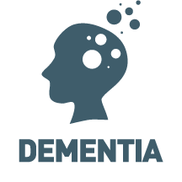**[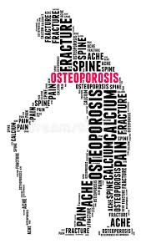](https://www.google.co.uk/imgres?imgurl=https://thumbs.dreamstime.com/b/osteoporosis-29662666.jpg&imgrefurl=https://www.dreamstime.com/royalty-free-stock-image-osteoporosis-image29662666&docid=u0vYMLSYnwJJ4M&tbnid=f2Yi7iHzkn_vBM:&vet=1&w=512&h=900&bih=486&biw=1095&ved=0ahUKEwilzL2v0KDZAhVkJ8AKHc6IDNIQxiAIGigF&iact=c&ictx=1)**

[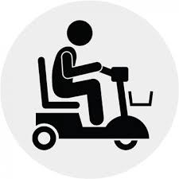](https://www.google.co.uk/imgres?imgurl=https://www.bluebadgemobilityinsurance.co.uk/image/cache/data/Product%20Icons/W-Scooter%20Icon-500x500.png&imgrefurl=https://www.bluebadgemobilityinsurance.co.uk/&docid=maRa_7CjwpCwaM&tbnid=NXxyXapICxnncM:&vet=10ahUKEwiH7qWs06DZAhWoDMAKHbyRAUwQMwiSAigKMAo..i&w=500&h=500&bih=486&biw=1095&q=mobility%20icon&ved=0ahUKEwiH7qWs06DZAhWoDMAKHbyRAUwQMwiSAigKMAo&iact=mrc&uact=8)**35% 25% 36% 16%**

[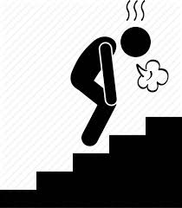](https://www.google.co.uk/imgres?imgurl=https://cdn3.iconfinder.com/data/icons/human-disease-illness-sickness-symptom-syndrome-si/308/irritation-001-512.png&imgrefurl=https://www.iconfinder.com/icons/2031021/breathless_climbing_fatigue_gasping_panting_staircase_tired_icon&docid=E73hQ7AxsgrxxM&tbnid=Q3ogVHG4bjJ9pM:&vet=10ahUKEwjbncGZ1aDZAhWrDcAKHXZhCUkQMwhlKA8wDw..i&w=450&h=512&bih=486&biw=1184&q=shortage%20of%20breath%20icon&ved=0ahUKEwjbncGZ1aDZAhWrDcAKHXZhCUkQMwhlKA8wDw&iact=mrc&uact=8)[](https://www.google.co.uk/imgres?imgurl=http://www.centralwesthealthline.ca/eventNetwork/images/Topics/Pain.png&imgrefurl=http://www.centralwesthealthline.ca/events.aspx&docid=-Lp6_Ll_PSMHGM&tbnid=DPIgyMALLwTCNM:&vet=10ahUKEwjtpuKz1KDZAhWKCMAKHePzDw84yAEQMwg4KDYwNg..i&w=500&h=375&bih=486&biw=1184&q=long%20term%20pain%20%20icon&ved=0ahUKEwjtpuKz1KDZAhWKCMAKHePzDw84yAEQMwg4KDYwNg&iact=mrc&uact=8)****

On Census Day 2011, there were 27,692 people aged 65+ years living in Ards and North Down LGD2014. 52.9% stated they had very good or good health, 35.8% had fair health and the remaining 11.3% had bad or very bad health

**Proximity to Services**

The Northern Ireland Deprivation Measure 2017 Proximity to Services Domain - the purpose of this domain is to measure the extent to which people have poor geographical access to key services, including statutory and general services. The average time in minutes to travel to a service from a given Output Area was calculated and results are available on NINIS.

The summary table below shows that the maximum time to travel to a service from an Output Area was between three and 10 minutes for key health services.  
  
Within **Ards and North Down** LGD2014 the most *deprived Output Area* (OA) based on the proximity to services domain measure Killinchy 1 SOA (ranked 35 out of 890 in NI) and the least deprived SOA was Donaghadee North 1 (ranked 790 out of 890 in NI

|  |  |  |  |
| --- | --- | --- | --- |
|  |  | |  |
|  |  |  | |
|  |  |  | |
|  |  |  | |
|  |  |  | |
|  |  |  | |

____________________

9Sources/Datasets used: [Meals Service (administrative geographies)](http://www.ninis2.nisra.gov.uk/public/ViewDataSet.aspx?ds=7954&lh=63&yn=2008-2016&sk=134&sn=Health%20and%20Social%20Care&yearfilter=)[,](http://www.ninis2.nisra.gov.uk/public/ViewDataSet.aspx?ds=6123&lh=63&yn=2008-2014&sk=134&sn=Health%20and%20Social%20Care&yearfilter=) [Intensive Domicilliary Care Clients (administrative geographies)](http://www.ninis2.nisra.gov.uk/public/ViewDataSet.aspx?ds=7995&lh=63&yn=2008-2016&sk=134&sn=Health%20and%20Social%20Care&yearfilter=)[,](http://www.ninis2.nisra.gov.uk/public/ViewDataSet.aspx?ds=6116&lh=63&yn=2008-2014&sk=134&sn=Health%20and%20Social%20Care&yearfilter=) [Residential Accomodation (administrative geographies)](http://www.ninis2.nisra.gov.uk/public/ViewDataSet.aspx?ds=7953&lh=63&yn=2008-2016&sk=134&sn=Health%20and%20Social%20Care&yearfilter=)[,](http://www.ninis2.nisra.gov.uk/public/ViewDataSet.aspx?ds=6124&lh=63&yn=2008-2014&sk=134&sn=Health%20and%20Social%20Care&yearfilter=) [Nursing Accomodation (administrative geographies)](http://www.ninis2.nisra.gov.uk/public/ViewDataSet.aspx?ds=7952&lh=63&yn=2013-2016&sk=134&sn=Health%20and%20Social%20Care&yearfilter=), [Disease Prevalance (Quality Outcomes Framework) (administrative geographies)](http://www.ninis2.nisra.gov.uk/public/ViewDataSet.aspx?ds=8294&lh=73&yn=2007-2017&sk=134&sn=Health%20and%20Social%20Care&yearfilter=), [Health Survey 2015/16](https://www.health-ni.gov.uk/topics/doh-statistics-and-research/health-survey-northern-ireland), DoH; [Northern Ireland Multiple Deprivation Measure 2010 Output Areas](http://www.ninis2.nisra.gov.uk/public/ViewDataSet.aspx?ds=6349&lh=44&yn=2010&sk=137&sn=Deprivation&yearfilter=), NISRA Demographic Statistics;[Attendance Allowance Recipients (administrative geographies)](http://www.ninis2.nisra.gov.uk/public/ViewDataSet.aspx?ds=7922&lh=73&yn=2011-2016&sk=10&sn=People%20and%20Places&yearfilter=)[,](http://www.ninis2.nisra.gov.uk/public/ViewDataSet.aspx?ds=5472&lh=73&yn=1999-2014&sk=10&sn=People%20and%20Places&yearfilter=2037) [Attendance Allowance Interactive Map,](http://www.ninis2.nisra.gov.uk/InteractiveMaps/People%20and%20Places/People/Benefits/AA_Map/atlas.html) [Disability Living Allowance Recipients (administrative geographies)](http://www.ninis2.nisra.gov.uk/public/ViewDataSet.aspx?ds=7935&lh=73&yn=2011-2016&sk=10&sn=People%20and%20Places&yearfilter=)[,](http://www.ninis2.nisra.gov.uk/public/ViewDataSet.aspx?ds=5481&lh=73&yn=1999-2014&sk=10&sn=People%20and%20Places&yearfilter=) [Disability Living Allowance Interactive Map](http://www.ninis2.nisra.gov.uk/InteractiveMaps/People%20and%20Places/People/Benefits/DLA_Map/atlas.html), DfC; [Type of Long-Term Condition by Age CT0111NI](http://www.ninis2.nisra.gov.uk/Download/Census%202011_Excel/2011/CT0111NI.xlsx), [Type of Long-Term Condition CT0100NI](http://www.ninis2.nisra.gov.uk/Download/Census%202011_Excel/2011/CT0100NI.xlsx), [General Health by Age: CT0101NI,](http://www.ninis2.nisra.gov.uk/Download/Census%202011_Excel/2011/CT0101NI.xlsx) NISRA Census

1. 2 Sources/Datasets used: [Northern Ireland Multiple Deprivation Measure 2010 (statistical geographies)](http://www.ninis2.nisra.gov.uk/public/ViewDataSet.aspx?ds=3602&lh=37&yn=2000-2012&sk=131&sn=Crime%20and%20Justice&yearfilter=), NISRA Demographic Statistics; [Police Recorded Crime](http://www.ninis2.nisra.gov.uk/public/ViewDataSet.aspx?ds=8411&lh=73&yn=1998-2016&sk=131&sn=Crime%20and%20Justice&yearfilter=) PSNI; [NI Crime Survey](http://www.dojni.gov.uk/index/statistics-research/stats-research-publications/northern-ireland-crime-survey-s-r/r-s-bulletin-1-2015-experience-of-crime-findings-from-the-2013-14.htm), DOJ
2.
3.