The Evaluation Report:

The 1st Action Plan for

Age-Friendly Jeju

(2017-2020)

2019. 12

Evaluation of the 1st Action Plan (2017-2020)

The Evaluation
In December 2019, the Jeju Ageing Society Research Center evaluated the 1st Action Plan based on each year's budget execution and a number of each strategy’s actual implementations. The evaluation standard is as follows:
Above Average ▲ | the budget execution rate and implementation rate is over 110%
Average ▶ | the budget execution rate and implementation rate is within 90-110%
Below Average▼ | the budget execution rate and implementation rate is less than 90%
N/A Ⓧ | No implementation record

Among the 40 projects, 7 projects were overly achieved; 13 projects were successfully implemented as they planned; 14 projects were insufficiently executed; 6 projects were not implemented. For more details, see the Appendix.

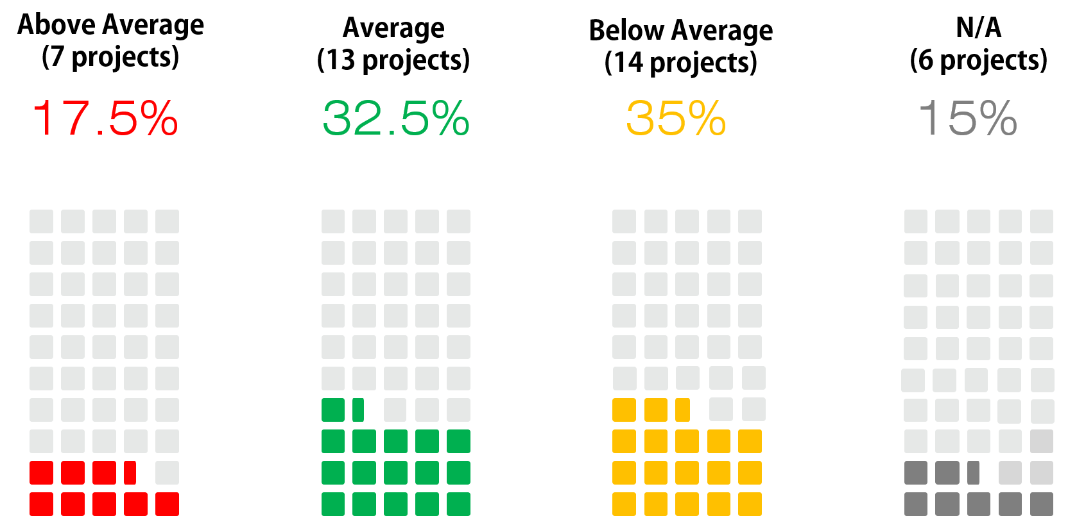

The 1st Action Plan Evaluation Comprehensive Chart
Jeju Domains | WHO  Domains | Strategic Agendas |  | Project Name | Evaluation
1.  Comfortable and Safe Senior Life | Outdoor Spaces/ Buildings | Create a safe environment for outdoor activities at all times | 1 | Promotion of the Barrier Free Environment Certification System | ▶
 |  |  | 2 | Maintenance of Urban and Residential Environment | ▼
 |  |  | 3 | Promotion of the Universal Design City Initiative | ▲
 | Transporta-tion | Enable a barrier-free access to public transport | 4 | Operation and Management of Bus Facilities | ▲
 |  |  | 5 | Popularization of Low-Floor Buses | ▶
 |  |  | 6 | Renovation of Elderly Protection Zones | ▼
 |  |  | 7 | Promotion of Local Traffic Safety Initiative | ▲
 | Housing | Supplying more houses exclusively for the elderly | 8 | Supplying Housing Only for the Senior | ▼
2.  Active and Leisurely Senior Life | Social Participation | Develop age-appropriate and sex-appropriate programs available at the welfare centers for the elderly/ halls for senior citizens and their user groups | 1 | Specialization and Further Functionalization of Halls for Senior Citizens | ▲
 |  |  | 2 | Promotion of Leisurely Activities by Developing and Activating Programs Available at Halls for Senior Citizens | ▼
 |  |  | 3 | Ensuring Economic Power through Establishing and elderly co-Workplace | Ⓧ
 |  | Develop and provide on-demand programs such as village-based programs with a focus on neighbor relationships | 4 | Constructing Social Network for Elderly Living Alone | ▼
 |  | Build infrastructures for leisure facilities including securing existing local facilities | 5 | Creation of Infrastructures for Leisure, Culture, and Education for a “Homo-Hundred” Era | ▼
 |  |  | 6 | Expanding Elderly Welfare Center | ▶
 |  |  | 7 | Expansion of Elderly Welfare Hall in Rural Region | ▶
 | Civic Participation/ Employment | Establish and run an intermediate support organization to provide an active service for the vocational training and job opportunities | 8 | Establishment and Operation of the Center for Double Cropping in Life | ▼
 |  |  | 9 | Incubating Age-Friendly Enterprise | ▲
 |  |  | 10 | Operating the Elderly Employment Training Center | ▶
 |  | Develop and Distribute new occupations that are suitable for the Jeju elderly | 11 | Activation of Job for Seniors in Private Sector | ▶
 |  |  | 12 | Support for Elderly’s Job Finding and Engaging in Social Activity | ▼
 |  |  | 13 | Activation of Sales of Products Made by Elderly | Ⓧ
3.  Healthy Senior Life for All | Respect/ Social Inclusion | Create an environment for respect and solicitude for the elderly | 1 | Expansion of Operation of Professional Service for Elderly Protection | ▲
 |  |  | 2 | Development of Indicators for Human Rights Sensitivity of the Elderly | Ⓧ
 |  | Develop policies and programs for social cohesion among the elderly and the young | 3 | Intergenerational Cultural Exchange Project | ▼
 |  |  | 4 | Basic Research for Establishment and Operation of Integrated Experience Center for Age-Friendliness | ▶
 |  |  | 5 | Promoting Campaign to Cultivate Respect for the Elderly | ▼
 | Community Support/ Health Service | - | 6 | Tailored Care Services for seniors | ▶
 |  | Develop a mentoring program for different caretaking skills depending on the condition of the patient and for the period of care | 7 | Development of the Healing Program for Families Caregivers | ▼
 |  |  | 8 | Integrated Management of Cases of Families Supporting Elderly People with Dementia | ▼
 |  | Support the elderly confined to a bed(including equipping more vehicles with beds) | 9 | Expansion of Transportation Support for Vulnerable People | ▲
 | Communi-cation/ Information | Have the elderly feel included by promoting communication considering the types of information and characteristics of the elderly | 10 | Information Gap Reduction Project | ▶
 |  |  | 11 | Promoting Age-Friendly City and Community | Ⓧ
 |  | Provide a variety of information on living | 12 | Managing “Age-Friendly Jeju” Webpage | ▼
4.  Regional Features of Jeju Island | N/A | - | 1 | Making Age-Friendly Tourism Environment | ▶
 |  | Provide integrated senior job information and opportunities for social contribution | 2 | Organization of the Jeju 50+ Volunteer Group | ▼
5.  Maintenance and Manage-ment of Age-Friendly Policies | N/A | - | 1 | Research on Status and Needs of Middle Aged and Elderly Jeju People | ▶
 |  | Establish a system where the elderly participate directly in developing the Jeju Age-Friendly Community Framework and monitor it | 2 | Operation of Monitoring Team | ▶
 |  |  | 3 | Senior Welfare Policy Committee | ▶
 |  |  | 4 | Age-Friendly City Promotion Council (Private Sector) | Ⓧ
 |  |  | 5 | Age-Friendly City Policy Working Group (Public Sector) | Ⓧ

The Implications
Three implications were derived from the evaluation report of the 1st Action Plan:
- Create more specific achievement index
Since the standard was mainly focusing on the budget execution rate, the evaluation for the second action plan should contain additional factors such as the inputs of the targeting population during the implementation process and the actual number of practices.

- Build a cooperative system
The second implication is the necessity of building a system of cooperation among various departments. The National Initiatives such as Community Care and Tailored Care Service for Older Adults require cooperativeness of departments. Accordingly, Jeju needs to create a private-public governance system for an age-friendly environment.

- Publicize age-friendly policies

The last implication would be publicity of an age-friendly environment. Since the vision of Jeju's Age-Friendly Action plan is to create a friendly environment for all, consensus-building on age-friendly Jeju among all generations is significant.

