The 3rd Action Plan for

Age-Friendly Jeju (2026~2027)

2026. 1

Center for Aging and Community

The 3rd Action Plan for Age-Friendly Jeju (2026–2027)

Ⅰ. Introduction

○ Research Needs

- As Korean society is rapidly aging, Korea will enter a super-aged society on December 23, 2024.
- Due to the increase of the older adults, there is a growing social need for more research on health, care, housing, and social participation for them, which provides further opportunities for the related industries to grow and develop.
- Jeju Special Self-Governing Province joined the World Health Organization (WHO) Global Network of Age-friendly Cities and Communities (GNAFCC) as a member city in August 2017 and has been making efforts to create an “Age-friendly Jeju” (Gong Sunhee et al., 2020).
- In an effort to make Jeju age friendly and to sustain the membership of GNAFCC, Jeju Special Self-Governing Provincial Government enacted the Basic Ordinance on Welfare for the Elderly in 2015 and established the 1st WHO Age-friendly Jeju Action Plan (2017–2020) in 2016 and proceeded with the 2nd WHO Action Plan (2021–2025) in 2020.
- The aim of the 2nd WHO Action Plan (2021–2025) was to continuously introduce and adopt policies suitable for the needs of older adults in Jeju, aiming to create a community where people aim to actively age and age in place where they feel familiar.
- Therefore, this research aims to establish the 3rd Action Plan after the 2nd WHO Action Plan in 2025, to continuously maintain the membership status of GNAFCC.

○ Research Purpose
- Establishment of the 3rd Jeju Age Friendly Communities Action Plan
- Establishment of the 3rd Jeju Age Friendly Communities Action Plan based on the outcome evaluation and current status analysis of the 2nd GNAFCC Action Plan.

<Research Process>

Step 1 |  | Setting the Research Direction and Identifying Research Priorities
Step 1 |  | - Justifying the research needs and purpose of the research  - Organizing the research contents and procedures  - Establishing the implementation plan and direction
 |  | ↓
Step 2 |  | Case Studies of the 3rd Age-Friendly City Action Plan
Step 2 |  | - Case Study in South Korea  - Jongno-gu, Seoul  - Bucheon city, Gyeonggi-do  - Naju city, Jeollanam-do  -Sejong Special Self-Governing City |  |  |  |  |  | - Case Study in Oversea Countries  -The United States of America  -Singapore
Step 2 |  | ↓
Step 2 |  | Evaluation of the 2nd Age-Friendly City Action Plan
Step 2 |  | - Quantitative Evaluation  Evaluation based on the implementation year and budget execution in the 2nd Age-Friendly City Action Plan |  |  |  |  |  | - Qualitative Evaluation  Evaluation of Age-Friendliness of the 2nd Age-Friendly City Action Plan (Using the Age-Friendly Impact Assessment Index)
 |  | ↓
Step 3 |  | Establishment of the 3rd Age-Friendly City Action Plan
Step 3 |  | - Establishment of the 3rd Age-Friendly City Action Plan  - Establishment of the vision, goals, strategic plans, and detailed projects  - Deliver the research report  - Completion of the research report for the establishment of the 3rd Age-Friendly City Action Plan

Ⅱ. Population Aging in Jeju Special Self-Governing Province

○ Status of Population Aging in Jeju Special Self-Governing Province
The proportion of older adults aged 65 and over in Jeju, compared to the total population, has shown a steady increase over the past five years since 2019. As of December 2025, the proportion reached 19.7%, which is an increase of 0.8 percentage points compared to 2024.

<Percentage of Older Adults between 2021-2025: National vs Jeju Special Self-Governing Province>
(Unit: Persons, %)
 | 2021 |  | 2022 |  | 2023 |  | 2024 |  | 2025
 | 65 and over | % | 65 and over | % | 65 and over | % | 65 and over | % | 65 and over | %
National | 8,851,033 | 17.1 | 9,146,396 | 17.7 | 9,730,411 | 19 | 10,256,782 | 20 | 10,650,949 | 20.8
Jeju SGP | 110,645 | 16.3 | 114,243 | 16.8 | 121,156 | 17.9 | 126,985 | 18.9 | 131,287 | 19.7
Source: Korean Ministry of the Interior and Safety, Resident registration population statistics 2021-2025, https://jumin.mois.go.kr,

○ Basic Plans and Policies Related to the Aging Society in Jeju Special Self-Governing Province
- Ministry of Health and Welfare: Basic Plan for Low Birthrate and Aging Society
- Korean National Assembly Low Birthrate and Aging Society Committee: Directions for Responding to Super-Aging
- Jeju Special Self-Governing Province: The 2nd Basic Plan for Elderly Welfare and Aging Society (2023–2027)

Ⅲ. WHO’s Age-Friendly City Project and Global Network
○ WHO Global Network of Age-Friendly Cities and Communities (GNAFCC)
- The WHO GNAFCC was established in 2010 with the vision of connecting cities, communities, and organizations around the world to create environments that are friendly for ageing.
- Member cities that have joined the WHO GNAFCC promote projects for building age-friendly cities by considering the characteristics of each city and region, based on the eight domains of the age-friendly city guidelines.

<WHO Age Friendly Cities 8 domains>
Domains |  | Concept
Physical Environment | 1) Outdoor spaces & buildings | This domain examines whether outdoor environments and places such as sidewalks, streets, public facilities, and buildings in the region can be safely and comfortably used and accessed by people of all ages
Physical Environment | 2) Transportation | This domain examines whether public transportation in the region (e.g., buses and taxis) is accessible and safe, and whether the driving environment for older adults is convenient. It considers the convenience and safety of transportation options and mobility within the area.
Physical Environment | 3) Housing | This domain examines whether the physical environment of homes where older adults reside is safe and comfortable, as an element directly related to residents’ quality of life. Furthermore, it checks whether there are any barriers to communication with the community
Social, economic, and cultural environment | 4) Social participation | This domain examines whether opportunities are provided for older adults to participate in social interactions, leisure and cultural activities, and lifelong learning to alleviate loneliness and isolation. It also considers whether programs are offered at a satisfactory level and whether these activities increase community exchange and a sense of closeness among residents.
Social, economic, and cultural environment | 5) Respect & social inclusion | This domain examines whether there is a culture of consideration and respect for older adults, how much age discrimination or disregard occurs, whether discrimination and exclusion of older adults are present in the community, family, and economic activities, and whether education and policy support for social inclusion of the elderly are being provided.
Social, economic, and cultural environment | 6) Civic participation & employment | This domain examines whether an environment is created in which older adults in the region can actively participate in civic activities and economic activities, such as contributing to the community and engaging in employment.
Information/  Community Support and Health Environment | 7) Communication & information | This domain examines whether all residents, including older adults, are not excluded from access to information and whether useful information is provided through various channels. It also considers whether tailored information is being offered to residents who are vulnerable in terms of vision, hearing, or ICT utilization.
Information/  Community Support and Health Environment | 8) Community support & health services | This domain examines whether older adults in the community receive appropriate support for health and care services, enabling them to live healthy and active independent lives. Securing public healthcare, well-aging services, home care (visiting care), and volunteer personnel are important in this area.
Sources:
Kong, Sunhee et al., (2021). 「Research on Age-Friendliness and Age-Friendly Impact Assessment in Jeju」; Ahn, Gayoung. (2024). 「Research on Indicator Development for Age-Friendly Impact Assessment in Jeju」

○ History of Jeju’s Membership in the WHO Global Network of Age-Friendly Cities and Communities
- Jeju Special Self-Governing Province has been promoting the creation of an age-friendly city since 2011 to join the World Health Organization Global Network of Age-Friendly Cities and Communities (WHO GNAFCC) and has been making continuous efforts to build an age-friendly environment.
< Progress of Age-Friendly City Initiatives in Jeju >
Year | Implementation Progress
2011 | - Basic research for the creation of an age-friendly city in Jeju
2014 | - Research on age-friendliness evaluation in Jeju
2015 | - Enactment of the Basic Ordinance on Welfare for the Elderly for the realization of an age-friendly city  - Development of guidelines for age-friendly city
2016 | - Established the Jeju Aging Society Research Center (formerly Jeju Longevity Culture Research Center)  - Establishment of the 1st Age-Friendly City Action Plan
2017 | - Official membership in the WHO Global Network of Age-Friendly Cities and Communities  - Implementation of the 1st Action Plan (2017–2020)
2020 | - Establishment of the 2nd Age-Friendly City Action Plan  - Renewal of WHO GNAFCC network certification
2021  ~2024 | - Implementation of the 2nd Action Plan (2021–2025)  - Research on Jeju age-friendly impact assessment  - Research on Jeju age friendly assessment index development

○ Examples of Domestic and International Age-Friendly City Initiatives

< Age-Friendly City Initiatives by Country and Region >
Age Friendly  8 domains | Communities | Examples
1) Outdoor spaces & buildings | Bucheon city, Gyeonggi | - Age-friendly public library services  - Senior rest areas called 'Masil' in public and collective buildings
1) Outdoor spaces & buildings | United States of America (USA) | - San Diego: Community garden for disability services  - Belchertown: Wayfinding project, Inclusive outdoor spaces  - Portland (Maine): 'Raise the ramps for accessibility' project  - Baltimore County: Bee Safe Project
2) Transportation | Jongno-gu, Seoul | - Senior care car
2) Transportation | USA | - Baltimore County: Shuttle service connecting senior residential facilities
3) Housing | Bucheon city, Gyeonggi | - Age-friendly safe housing
3) Housing | Sejong city | - Constructing homes for those in need
3) Housing | USA | - Baltimore County: Home repair and renovation support program
3) Housing | Singapore | - barrier-free design in multifamily housing complexes
4) Social participation | Jongno-gu, Seoul | - Making friends for seniors living alone  - Happiness Jongno Academy for generational integration
4) Social participation | Naju city, Jeonnam | - Clean Therapy for vulnerable populations e.g., Senior Cleaning/Organizing Consultants
4) Social participation | Sejong city | - Senior colleges  - Beautiful Story Grandma project
5) Respect & social inclusion | Bucheon city, Gyeonggi | - Bucheon Excellent Driver: Creating a culture of consideration for senior drivers
5) Respect & social inclusion | USA | - Bath: Generational Integration Project  - Belchertown: Dementia-friendly environments
6)Civic participation & employment | USA | - Portland (Oregon): Lloyd EcoDistrict
7) Communication & information) | Bucheon city, Gyeonggi | - Age-friendly second-life support center
7) Communication & information) | USA | - San Diego: Hosting a Technology Expo
8) Community support & health services | Jongno-gu, Seoul | - Jongno-type family service support project for vulnerable populations
8) Community support & health services | Naju city, Jeonnam | - Dementia Safety Village Initiative
8) Community support & health services | Bucheon city, Gyeonggi | - ICT Emergency Safety Service for seniors living alone
8) Community support & health services | Sejong city | - Well-dying for a beautiful end of life  - Door-to-door home-visit medical service for seniors

Drawing from both domestic and international examples of age-friendly cities, it becomes clear that effective strategies for addressing the challenges of an aging society can be summarized into five main pillars: delivering integrated services at the community level, emphasizing preventive care, fostering economic and social participation, promoting intergenerational integration, and advancing digital and environmentally inclusive practices. These foundational elements serve as a strategic guide for policy development in Jeju as it approaches the transition to a super-aged society.

Ⅳ. Analysis and Evaluation of the 2nd Age-Friendly Jeju Action Plan (2021–2025)

○ Overview of the Evaluation of the 2nd Age-Friendly City Action Plan
- Purpose of Evaluation: As the 3rd Action Plan (2026–2027) is set to be developed this year, the evaluation aims to identify challenges and issues encountered during the implementation of each domain in the 2nd Action Plan. The insights gained from this review and analysis will serve as essential reference data for shaping the new plan once the evaluation is complete.
- Subjects of Evaluation: The evaluation covers 46 detailed projects included in the 2nd Age-Friendly City Action Plan, focusing on the implementation performance over three years, from 2023 to 2025.
- Evaluation Method: The process includes establishing the evaluation plan, preparing data, conducting both quantitative and qualitative evaluations, and organizing and reflecting the evaluation results step by step.

○ Evaluation of the 2nd Age-Friendly City Action Plan

- Reviewing the combined average scores from both quantitative and qualitative assessments of the detailed projects across the five main domains of the 2nd Age-Friendly City Action Plan, the “Safe and Comfortable Aging” domain stood out with the highest score, achieving 89.5 points in the quantitative evaluation.
- On the other hand, the “Maintenance of Age-Friendly Policies” domain received a score of 80.9 points, falling just short of the benchmark of 81.5 points. This suggests that its implementation was not fully satisfactory.
- This outcome primarily stems from the fact that key strategies, such as conducting research on policies to address demographic and social changes, developing a database to support a super-aged society, and fostering public-private governance for age-friendly Jeju, were not continuously operated due to their specific time-limited nature.
- For the 3rd Age-Friendly City Action Plan, it is recommended to update and strengthen projects to ensure that long-term, sustainable initiatives are implemented through ongoing policy management, supporting the continuous advancement of an age-friendly city.

<Overall Evaluation of Detailed Projects by Domains (Quantitative + Qualitative) Average Score (Total of 100 points)>
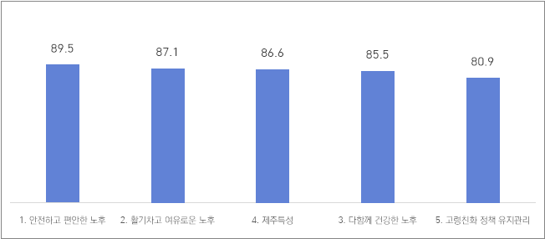

- Out of 46 projects, 42 (91.3%) were rated as successfully implemented, with average scores above 81.5 points (out of 100). 4 projects (8.7%) were rated as insufficiently implemented, with average scores below 81.5 points.
- The projects evaluated as successfully implemented were, in order: Operation of the Senior Policy Monitoring Group for Age-Friendly Villages (95.8 points); Development and provision of lifelong education programs for older adults (95.2 points); Housing support for low-income seniors (94.8 points); Tamnanun 5060 Project(2nd job preparation program for 5060 generation) (94.2 points); Activation of programs at senior centers and welfare centers (93.4 points).
- The following projects were recognized as having been carried out most successfully, listed in order of their evaluation scores: The Senior Policy Monitoring Group for Age-Friendly Villages (95.8 points); Lifelong education program development and provision for older adults (95.2 points); Housing support for low-income seniors (94.8 points); Tamnanun 5060 Project(2nd job preparation program for 5060 generation) (94.2 points); Program activation at senior centers and welfare centers (93.4 points).
- For the projects that were evaluated as insufficiently implemented, it was found that their scores were lower mainly because the projects had ended or were discontinued or were not sustained over time due to factors such as a temporary project. As a result, these initiatives could not be continuously maintained, which led to lower evaluation scores.

<Evaluation of the 46 Detailed Projects in the 2nd Age-Friendly City Action Plan>
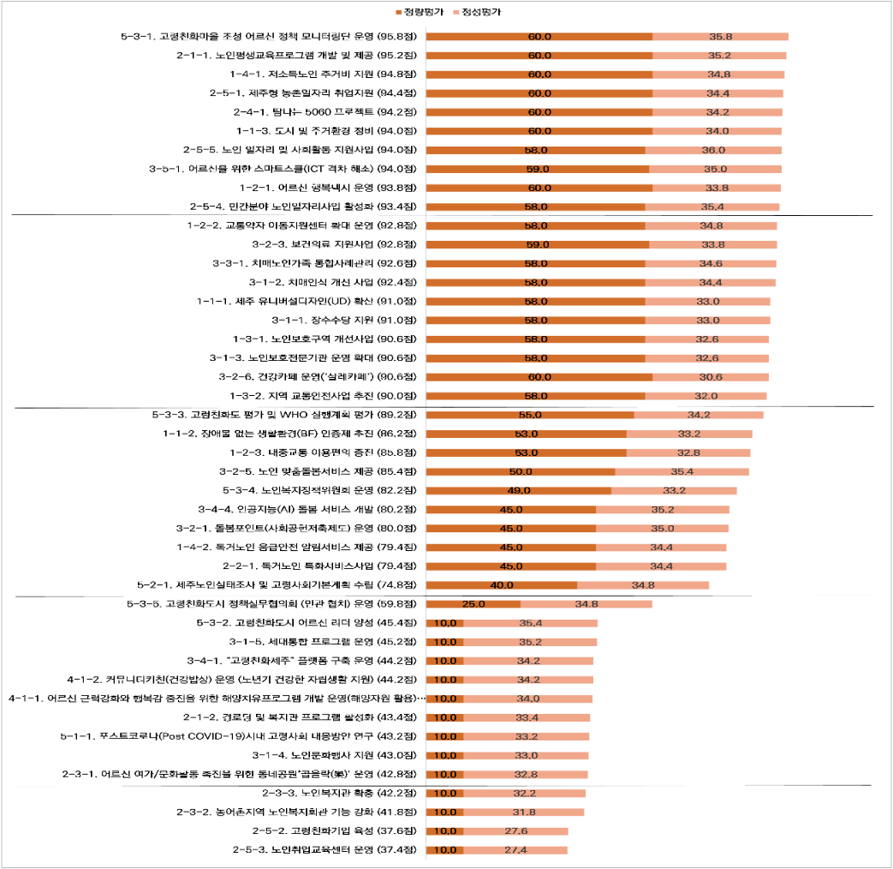

○ Analysis of Policy Proposals from the Senior Monitoring Group to Identify the Regional Characteristics of Jeju
- Purpose: Identifying Jeju’s Regional Characteristics and Formulating the 3rd Age-Friendly City Action Plan
- Target:
<Jeju Senior Policy Monitoring Group Number of Participants (2017~2024)>
2017 | 2018 | 2019 | 2020 | 2021 | 2022 | 2023 | 2024
1st group | 2nd group | 3rd group | 4th group | 5th group | 6th group | 7th group | 8th group
30 participants | 30 participants | 41 participants | 31 participants | 27 participants | 28 participants | 29 participants | 20 participants

- Key Implication: An analysis of policy proposals submitted by the Senior Policy Monitoring Group, based on activities conducted from 2017 to 2024, indicates that older adults in the Jeju region place particular importance on enhancing transportation options, improving outdoor space accessibility, expanding leisure activities and related infrastructure, and increasing opportunities for social engagement and volunteering.

Ⅴ. The 3rd Age-Friendly City Action Plan (2026~2027)

○ The 3rd Age-Friendly City Action Plan
- Vision
The 3rd Age-Friendly City Action Plan sets its vision as “Healthy and Vibrant Aging, Age-Friendly Jeju,” reflecting the societal shift in which seniors rediscover their own value through a newly defined concept of old age, and embrace healthy and active aging.

- Goals
The goals of the 3rd Age-Friendly City Action Plan are composed of three main objectives:
- Creating a safe and convenient living environment
- Establishing a foundation for a vibrant and stable “second life” for seniors
- Building an age-integrated community that strengthens intergenerational bonds

- Four Domains and Strategic Tasks
The four domains are: Comfortable and Safe Living Environment; Active and Confident Later Life; Healthy Senior Life Together; Management and Maintenance of Age-Friendly Policies”
These areas are composed of a total of ten strategic tasks.
1. Comfortable and Safe Living Environment
This area consists of three strategic tasks:
- Creating a safe environment for social activities
- Enhancing convenience and safety of mobility
- Establishing an age-friendly residential environment
2. Active and Confident Later Life
This area consists of two strategic tasks:
- Supporting leisure activities and social participation for older adults
- Supporting life redesign and senior employment
3. Healthy Senior Life Together
This area consists of three strategic tasks:
- Promoting generational integration and respect
- Building a community care system
- Expanding and supporting care services
4. Management and Maintenance of Age-Friendly Policies
This area consists of two strategic tasks:
- Researching policies and building databases to respond to a super-aged society
- Establishing a monitoring system for age-friendly policies (See the diagram below for reference)

<Vision, Goals, Four Key Areas, and Detailed Projects of the 3rd Age-Friendly City Action Plan>
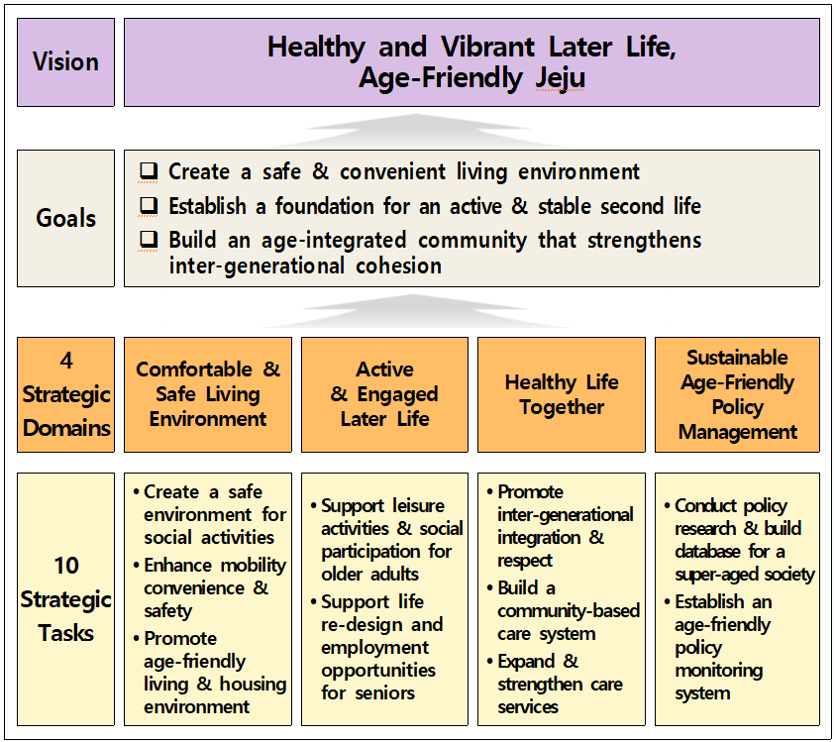
○ The 3rd Age-Friendly City Action Plan Detailed Projects
- The detailed projects of the Jeju 3rd Age-Friendly City Action Plan consist of a total of 46 projects, including 20 ongoing projects, 24 additional projects, and 2 new projects.

<The 3rd Age-Friendly City Action Plan Detailed Projects (Ongoing, Added and Brand-new projects>
Category | Strategic Projects | Project Title | Department | Notes
Comfortable and Safe Living Environment | 1-1.  Creating a safe environment for social activities | 1. Jeju universal design promotion pilot project | Dept of Architectural Landscape | Ongoing
Comfortable and Safe Living Environment | 1-1.  Creating a safe environment for social activities | - Expansion of the Barrier Free Living Environment Certification | Dept of Disability Welfare | Ongoing
Comfortable and Safe Living Environment | 1-1.  Creating a safe environment for social activities | - Jeju Crime Prevention through environmental design | Dept of Architectural Landscape | Ongoing
Comfortable and Safe Living Environment | 1-1.  Creating a safe environment for social activities | 4. Improvement Project for Senior Protection Zones | Traffic Information Center of the Autonomous Police Unit | Ongoing
Comfortable and Safe Living Environment | 1-2.  Enhancing convenience and safety of mobility | 1. Happiness Taxi Service for Seniors | Department of Transportation Policy | Ongoing
Comfortable and Safe Living Environment | 1-2.  Enhancing convenience and safety of mobility | 2.. Promoting the Operation of Special Transportation Services to Enhance Mobility Rights for Transportation-Vulnerable population | Department of Transportation Policy | Ongoing
Comfortable and Safe Living Environment | 1-2.  Enhancing convenience and safety of mobility | 3. Support for Operating Demand-Responsive Transportation (Observer Bus) | Department of Public Transportation | Added
Comfortable and Safe Living Environment | 1-2.  Enhancing convenience and safety of mobility | 4. Expansion of low-floor bus | Department of Public Transportation | Added
Comfortable and Safe Living Environment | 1-2.  Enhancing convenience and safety of mobility | 5. Promotion of local traffic safety | Department of Transportation Policy | Ongoing
Comfortable and Safe Living Environment | 1-2.  Enhancing convenience and safety of mobility | 6. Transportation Fare Support for Voluntary Driver’s License Surrender by Elderly Drivers. | Department of Transportation Policy | Ongoing
Comfortable and Safe Living Environment | 1-3.  Establishing an age-friendly residential environment | 1. Provision of public rental housing for older adults | Department of Housing and Land | Added
Comfortable and Safe Living Environment | 1-3.  Establishing an age-friendly residential environment | 2 Home Repair Project under Maintenance Benefit Program | Dept of Elderly Welfare | Added
Comfortable and Safe Living Environment | 1-3.  Establishing an age-friendly residential environment | - Housing support for vulnerable populations (Energy Dream) | Dept of Elderly Welfare | Added
Comfortable and Safe Living Environment | 1-3.  Establishing an age-friendly residential environment | 4. Support for emergency safety assurance services for the seniors who are living alone | Dept of Elderly Welfare | Ongoing
2.  Active and Confident Later Life | 2-1.  Supporting leisure activities and social participation for older adults | 1. Adult Literacy Education Programs and Support for Non-Formal Schools | Department of Educational Policy Cooperation | Ongoing
2.  Active and Confident Later Life |  | 2. Promotion of Keong-ro-dang Program | Dept of Elderly Welfare | Ongoing
2.  Active and Confident Later Life |  | 3. Support for Senior Leisure Activities Projects | Dept of Elderly Welfare | Added
2.  Active and Confident Later Life |  | 4. Support for Operating Senior Classes | Dept of Elderly Welfare | Added
2.  Active and Confident Later Life |  | 5. Strengthening the Operation of Senior Graduate Schools. | Dept of Elderly Welfare | Added
2.  Active and Confident Later Life |  | 6. Support for Senior Social Contribution Activities | Dept of Elderly Welfare | Added
2.  Active and Confident Later Life |  | 7. Well-Dying Education (Dignified End-of-Life)” | Department of Health and Sanitation | Added
2.  Active and Confident Later Life |  | 8. Specialization and Functional Enhancement of Keong-ro-dang | Dept of Elderly Welfare | Added
2.  Active and Confident Later Life |  | 9. Additional Establishment and Expansion of Senior Welfare Centers | Dept of Elderly Welfare | Ongoing
2.  Active and Confident Later Life |  | 10. Support for Economic Activities of Older Adults | Dept of Elderly Welfare | Added
2.  Active and Confident Later Life |  | 11. Cultural Sharing Program for Low-Income Seniors. | Department of Cultural Policy | Added
2.  Active and Confident Later Life | 2-2.  Supporting life redesign and senior employment | 1. Support for Life Re-Design Promotion Programs for Middle-Aged Adults | Dept of Elderly Welfare | Ongoing
2.  Active and Confident Later Life | 2-2.  Supporting life redesign and senior employment | 2. Support for Senior-Specific Employment Programs | Dept of Elderly Welfare | Added
2.  Active and Confident Later Life | 2-2.  Supporting life redesign and senior employment | 3. Senior Employment and Social Activity Support Project | Dept of Elderly Welfare | Ongoing
3.  Healthy Senior Life Together | 3-1.  Promoting generational integration and respect | 1. Longevity Allowance Support | Dept of Elderly Welfare | Ongoing
3.  Healthy Senior Life Together | 3-1.  Promoting generational integration and respect | 2. Operation of Specialized Elder Protection Agencies | Dept of Elderly Welfare | Ongoing
3.  Healthy Senior Life Together | 3-1.  Promoting generational integration and respect | 3. Green PC Donation Program | Department of Digital Innovation | Ongoing
3.  Healthy Senior Life Together | 3-1.  Promoting generational integration and respect | 4. Jeju-Style Population Policy Consensus Building Project | Population Policy Officer | Added
3.  Healthy Senior Life Together | 3-2.  Building a community care system | 1. Running Village-Based Care Centers in Jeju Style | Resident Welfare, Jeju City | Added
3.  Healthy Senior Life Together | 3-2.  Building a community care system | 2. Operation of Integrated Care Support Centers | Senior Welfare, Segwipo City | Added
3.  Healthy Senior Life Together | 3-2.  Building a community care system | 3. Improvement of Working Conditions for Long-Term Care Workers. | Dept of Elderly Welfare | Added
3.  Healthy Senior Life Together | 3-2.  Building a community care system | 4. Managing Support Centers for Seniors Living Alone | Dept of Elderly Welfare | Added
3.  Healthy Senior Life Together | 3-2.  Building a community care system | 5. Managing Regional Dementia Centers and Dementia Care/Safety Centers | Department of Health Management | Added
3.  Healthy Senior Life Together | 3-3.  Expanding and supporting care services | 1. Providing Personalized Care Services for Seniors | Dept of Elderly Welfare | Ongoing
3.  Healthy Senior Life Together | 3-3.  Expanding and supporting care services | 2. Support for Jeju Value-Based & Cooperative Care Services | Department of Welfare Policy | Added
3.  Healthy Senior Life Together | 3-3.  Expanding and supporting care services | 3. Pilot Program for Personal Health Doctors | Department of Welfare Policy | Added
3.  Healthy Senior Life Together | 3-3.  Expanding and supporting care services | 4. Telemedicine Collaboration Program for Underserved Region | Department of Welfare Policy | Added
3.  Healthy Senior Life Together | 3-3.  Expanding and supporting care services | 6. Senior Mental Health Support Initiative. | Department of Health Management | Added
4. Management and Maintenance of Age-Friendly Policies | 4-1.  Policy research and database construction responding to a super-aged society | 1. Operation of the Jeju Aging Society Research Center | Dept of Elderly Welfare | Added
4. Management and Maintenance of Age-Friendly Policies |  | 2. Building an International Network | Dept of Elderly Welfare | New
4. Management and Maintenance of Age-Friendly Policies |  | 3. Impact Assessment of Senior Policies | Dept of Elderly Welfare | New
4. Management and Maintenance of Age-Friendly Policies | 4-2.  Construction of a monitoring system for age-friendly policies | 1. Operation of Senior Policy Monitoring Group for Creating Age-Friendly Villages | Dept of Elderly Welfare | Ongoing
4. Management and Maintenance of Age-Friendly Policies |  | 2. Managing the Senior Welfare Policy Committee | Dept of Elderly Welfare | Ongoing

○ Analysis of the Importance of Detailed Projects in the 3rd Age-Friendly City Action Plan
- Purpose: To effectively implement and maintain the Jeju 3rd Age-Friendly City Action Plan as a sustainable initiative, priorities for the projects (based on 43 projects, 3 projects were added after the analysis) are identified, and it is proposed that projects deemed important should be carried out preferentially over others.
- Survey Participants: A total of 20 experts from academia (university professors and researchers) and related organizations.
- Evaluation Analysis: AHP (Analytic Hierarchy Process) analysis method

<Results of the Integrated Analysis of Detailed Projects in the 3rd Age-Friendly City Action Plan>
Project Details | Importance | Rank
Operation of Customized Mental and Psychological Counseling Services for Seniors | 0.053 | 1
Improvement of Working Conditions for Long-Term Care Workers | 0.048 | 2
Support for Jeju Value-Based & Cooperative Care Services | 0.040 | 3
Operation of Jeju-Style Village-Based Care Centers | 0.039 | 4
Emergency Safety Service Support for Seniors Living Alone | 0.038 | 5
Operation of Regional Dementia Centers and Dementia Safety Centers | 0.038 | 6
Senior Employment and Social Activity Support Program | 0.035 | 7
Economic Activity Support for Older Adults | 0.034 | 8
Operation of Support Centers for Seniors Living Alone | 0.034 | 9
Operation of Jeju Aging Society Research Center | 0.032 | 10
Senior Vocational Training (Professional Senior Development) and Career Counseling Services | 0.031 | 11
Operation of Integrated Care Support Centers | 0.030 | 12
Activation of Special Transportation Services to Improve Mobility Rights for Transportation-Vulnerable Groups | 0.029 | 13
Provision of Customized Care Services for Seniors | 0.028 | 14
Housing Support for Vulnerable Groups (Energy Dream Project) | 0.023 | 15
Support for Senior Social Contribution Activities | 0.023 | 16
Operation of Happiness Taxi for Seniors | 0.022 | 17
Well-Dying Education (Dignified End-of-Life Care) | 0.022 | 18
Expansion and Additional Installation of Senior Welfare Centers | 0.022 | 19
Operation of Senior Protection Agencies | 0.021 | 20
Mental Health Support Program for Seniors | 0.021 | 21
Expansion of Low-Floor Bus Introduction | 0.020 | 22
Home Repair Program under Maintenance Benefit Scheme | 0.020 | 23
Establishment of Database for Super-Aged Society Response | 0.020 | 24
Cultural Sharing Program for Low-Income Seniors | 0.018 | 25
Establishment and Operation of Life Redesign Support Centers | 0.018 | 26
Mobile Digital Classroom for Senior Centers | 0.018 | 27
Expansion of Barrier-Free Living Environment Certification System (BF) | 0.017 | 28
Operation of Senior Policy Monitoring Group for Age-Friendly Village Development | 0.017 | 29
Support for Senior Leisure Activity Programs | 0.016 | 30
Support for Demand-Responsive Transport Services (Observer Bus) | 0.015 | 31
Specialization and Functional Enhancement of Keong-ro-dang | 0.013 | 32
Intergenerational (1st & 3rd generation) Program- Let’s go & work together | 0.013 | 33
Supply of Public Rental Housing for Older Adults | 0.012 | 34
Promotion of Keong-ro-dang Program | 0.012 | 35
Jeju Universal Design Activation Pilot Project | 0.011 | 36
Promotion of Local Traffic Safety Projects | 0.011 | 37
Support for Adult Literacy Education Programs and Non-Formal Schools | 0.011 | 38
Operation of Senior Welfare Policy Committee | 0.011 | 39
Support for Operation of Senior Classes | 0.010 | 40
Improvement of Senior Protection Zones | 0.009 | 41
Distribution of Green PCs (Love Green PC Project) | 0.009 | 42
Jeju-Style Population Policy Consensus-Building Project | 0.009 | 43
Transportation Fee Support for Voluntary Driver’s License Return by Elderly Drivers | 0.008 | 44
Jeju CPTED (Crime Prevention Through Environmental Design) Project | 0.007 | 45
Support for Longevity Allowance | 0.007 | 46
Strengthening Operation of Senior Graduate Programs | 0.006 | 47
Consistency Index (C.I.) = 0.02

Ⅵ. Action Plan

○ Implementation and Monitoring System for the 3rd Age-Friendly City Action Plan
- To ensure the effective and sustainable development of an age-friendly city and the successful implementation of its action plan, it is crucial to first build a structured implementation system, with each stakeholder assigned responsibilities that are appropriate to their specific role.

<Stakeholders and Their Roles in the Implementation of the 3rd Age-Friendly City Action Plan>
Operational Entity |  | Department/Agency |  | Role
Jeju Special Self-Governing Province |  | - Department of Elderly Welfare | → | - Overall management of the implementation plan for creating a healthy and vibrant old age and an age-friendly city in Jeju  - Execution of detailed projects within the implementation plan  - Evaluation of project progress upon completion of the 3rd implementation plan
Jeju Special Self-Governing Province |  | - Department of Architectural Landscape  - Department of Disability Welfare  - Traffic Information Center of the Autonomous Police Unit  - Department of Transportation Policy  - Department of Public Transportation  - Department of Housing and Land  - Department of Educational Policy Cooperation  - Department of Cultural Policy  - Department of Digital Innovation  - Population Policy Officer  - Department of Health Management | → | - Execution of detailed projects within the implementation plan  - Submission of performance data
Administrative Cities (Jeju City, Seogwipo City) |  | - Department of Housing  - Department of Elderly Welfare  - Department of Resident Welfare  - Department of Transportation Administration  - Department of Culture and Arts  - Department of Health Promotion  - Department of Architecture  - Department of Health Administration | → | - Execution of detailed projects within the implementation plan  - Submission of performance data
Related Institutions for Senior Welfare |  | - Korea Senior Citizens Association Jeju Special Self-Governing Province Branch  - Senior Center Regional Support Center  - Senior Employment Implementing Agencies  - Specialized Elder Protection Agency  - Senior Graduate School |  | - Active promotion and cooperation for related projects to create an age-friendly city in the province
Provincial Residents |  | - Seniors in the Jeju Region |  | - Serving as a policy monitoring group within the province  - Identifying local issues and areas for improvement, and making policy proposals

- To effectively advance the age-friendly city action plan and its detailed projects, it is important to systematically review the policy implementation process and establish a monitoring system that ensures the achievement of the vision, goals, and strategic objectives. (See the diagram below for reference)
- However, as the Third Age-Friendly City Action Plan (2026–2027) is designed as a short-term implementation plan, and as it is intended to be implemented in an integrated manner with the Second Basic Plan for Elderly Welfare and the Aging Society (2023–2027), which concludes in 2027, the proposed monitoring and operational framework will be utilized during the evaluation process for the formulation of the Fourth Age-Friendly City Action Plan.

<Monitoring Operation System for the 3rd Age-Friendly City Action Plan>

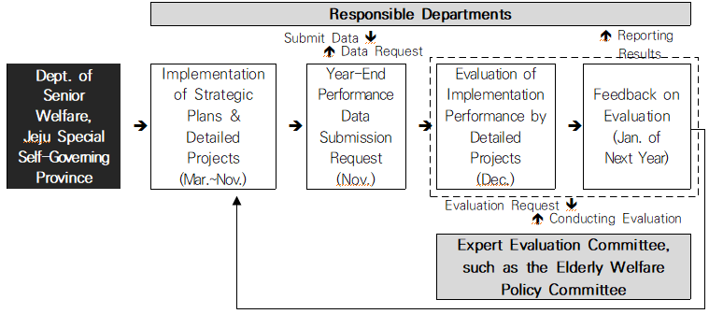

○ Recommendations for the Effective Management of the 3rd Age-Friendly City Action Plan
- Promote integrated management with the Basic Plan for Elderly Welfare and Aging Society.
- Establish strategies for collaboration with other departments and for conducting convergent and complex research and projects.
- Consider and reflect the needs and characteristics of older adults in the Jeju region.
- Incorporate changes in the domestic policy.
- Develop a Jeju-specific strategy to address the upcoming implementation of the age-friendly city provision in the Elderly Welfare Act, scheduled to come into force next year.
- Increase public awareness and actively support initiatives that ensure the long-term success of age-friendly city projects.

