TOWN OF BAR HARBOR
Manager’s Office
93 Cottage Street, Suite I
Bar Harbor, Maine 04609-1400
Tel. 207-288-4098 Fax 207-288-4461

Cornell F. Knight Town Manager email: cknight@barharbormaine.gov

February 10, 2017

Ms. Lori Parham, Director
AARP of Maine
53 Baxter Boulevard
Portland, Me 04101

Dear Ms. Perham:

On behalf of the Bar Harbor Town Council, I am pleased to submit this letter and application for membership in the AARP Age Friendly Community Network. The newly formed Task Force on Aging has ambitious plans to work on the 8 domains of livability for Bar Harbor senior citizens. Each member has been assigned a domain to spread the work out among members, as well as making sure each topic gets the group’s attention. The group’s next step is to survey the senior population and conduct focus groups to fully understand the most pressing issues and needs of the senior population. An action plan will be formulated from the survey.

The Town of Bar Harbor and the Task Force on Aging look forward to working with the AARP and other community members of the network to implement that plan’s strategies and meet the needs of the senior population.

Sincerely,
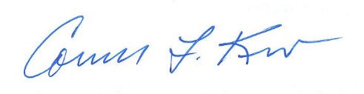
Cornell F. Knight
Town Manager

