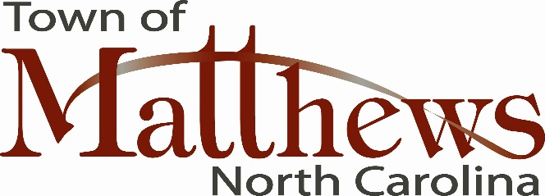

October 1, 2015

Mr. Doug Dickerson, Director
AARP North Carolina
1511 Sunday Drive, Suite 312
Raleigh, NC 27607

Dear Mr. Dickerson:

As Mayor of the Town of Matthews, I am honored to submit this letter of support for our Town to be considered by the World Health Organization (WHO) as an age-friendly community through the AARP’s Network of Age Friendly Cities and Communities Initiatives. We care about our citizens and especially our senior citizens, who are living longer, healthier lives. We value their history and wisdom and do our utmost to ensure that there are viable services to meet their needs in almost every facet of their lives.

Our partnerships are strong in the community with organizations that provide services to seniors. This includes their recreational needs as well as their social, emotional and financial stability.
Our commitment is as strong as our partnerships and we will continue to work with the mission of AARP for long-term success in securing open space and facilities that not only attract our seniors, but accommodate their needs.

Matthews was recently named in the August issue of “Family Circle” magazine as one of the top five places in the nation to live and work, and we are proud of that. More importantly, we are proud to be a diverse community that addresses the needs of our population.

I look forward to working with AARP in the state of North Carolina and becoming a member of the Age-Friendly Network. Matthews would be a great place to continue the vision of the age-friendly initiative.

Sincerely,

Jim Taylor
Mayor, Town of Matthews

