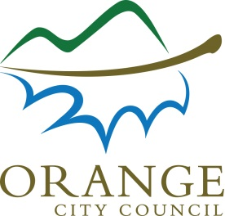D15/8824

2 April 2015

World Health Organisation

Avenue Appia 20

1211 Geneva 27

SWITZERLAND

**TO WHOM IT MAY CONCERN**

Dear Sir/Madam

### **ORANGE NSW AUSTRALIA – COMMITMENT TO WHO GLOBAL NETWORK OF AGE-FRIENDLY CITIES AND COMMUNITIES**

Orange is a regional city in central western New South Wales located three and half hours west of Sydney and three and half hours north of Canberra. Orange boasts thriving agriculture, viticulture and mining industries set in an environment with four distinct seasons which has led to Orange becoming known as Australia's colour city.

With a population nearing forty thousand residents, of which over seven and half thousand are aged sixty years or older, and surrounded by small country communities who rely on Orange for medical and Government services, along with everyday conveniences, Orange is committed to becoming an age-friendly city.

Throughout my term as Mayor of Orange I commit to work with Orange City Council to develop and maintain a cycle of continual improvement with the goal of Orange becoming, and remaining, an age-friendly city.

Yours sincerely



Cr John Davis OAM

# MAYOR OF ORANGE