OFFICE OF THE MAYOR
City of Welland
60 East Main Street, Welland, ON L3B 3X4
Phone: 905-735-1700 Fax: 905-735-1543
www.welland.ca

September 2, 2010

WHO Global Network of Age-Friendly Cities
c/o Deb Rollo, Community Coordinator
Niagara Age-Friendly Community Initiative
2201 St. David’s Road
Thorold, ON L2V 4T7

Dear Ms. Rollo:
On behalf of the Council of the City of Welland, and the Office of the Mayor please accept this letter as indication of formal commitment to undertake partnership with the Niagara Age-Friendly Communities Initiative.
The partners will include Rose City Seniors Centre, the City of Welland Senior Citizens Advisory Committee, the City of Welland, Parks, Facilities, Recreational and Cultural Services, the Niagara Region Integrated Community Planning and Seniors Services Departments and the Niagara Research and Planning Council.
All are ready to pursue actions required to make Welland an age-friendly community.

Sincerely,
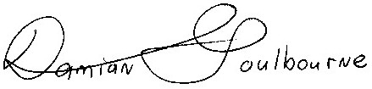
Damian Goulbourne
Mayor

