Country COVID-19 intra-action review (IAR)  Participant feedback form  28 April 2021 | 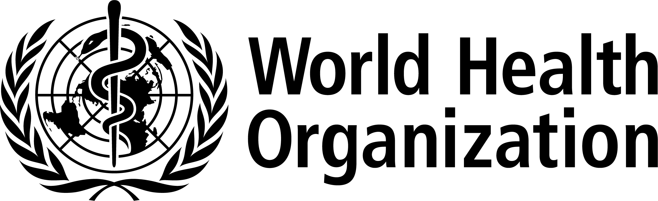

COUNTRY COVID-19 INTRA-ACTION REVIEW (IAR) – PARTICIPANT FEEDBACK FORM
- On a scale of 1 (fully disagree) to 5 (fully agree) to what extent do you agree that the Intra-Action Review (IAR) reached the following objectives?
 | 1 | 2 | 3 | 4 | 5
 | Fully disagree |  |  |  | Fully agree
i. The IAR allowed participants to identify challenges and gaps encountered during the COVID-19 outbreak response.
ii. The IAR allowed participants to share experiences and best practice encountered during the COVID-19 outbreak response.
iii. The IAR contributed to strengthening interdisciplinary collaboration and coordination among the health sector stakeholders involved in the COVID-19 outbreak response.
iv. The IAR contributed to strengthening multisectoral collaboration and coordination between health and non-health sectors involved in the COVID-19 outbreak response.
v. The IAR allowed participants to propose actions for improving the response to the ongoing COVID-19 pandemic.

- On a scale from 1 (very ineffective) to 5 (very effective), how effective was the IAR methodology in achieving the objectives:
 | 1 | 2 | 3 | 4 | 5
 | Very ineffective |  |  |  | Very effective
i. Presentations on the methodology and process of the IAR were clear and useful.
ii. Introductory session on the Country COVID-19 Response Plan and the actual timeline of the response was helpful and efficient.
iii. Session 1 (What went well? What went less well? Why?) was efficient.
iv. Session 2 (What can we do to improve for next time?) was efficient.
v. Session 3 (The Way forward) was efficient.
vi. Was the number of participants adequate?
vii. Were participants’ profiles adequate for the pillar(s)/function(s) of the response examined?
viii. Would you use this IAR methodology for other public health emergencies in your country?
ix. Overall, what is your assessment of the effectiveness of the IAR methodology to achieve the objectives and results?

- On a scale of 1 (not at all likely) to 5 (extremely likely), to what extent do you think the results of the IAR can contribute to:
 | 1 | 2 | 3 | 4 | 5
 | Not at all likely |  |  |  | Extremely likely
i. Addressing the most important gaps in the COVID-19 outbreak response in a timely manner.
ii. Address gaps in coordination and collaboration.
iii. Identify, replicate, and sustain productive practices.
iv. Empower individuals to better appreciate the challenges of emergency response.
v. Highlight best practices or new capacities developed in-country during the COVID-19 outbreak response.

- Other comments/suggestions on the IAR methodology

- Other comments on the results of the IAR

THANK YOU FOR PARTICIPATING IN THE INTRA-ACTION REVIEW (IAR)!

© World Health Organization 2021. Some rights reserved. This work is available under the CC BY-NC-SA 3.0 IGO licence.
WHO reference number: WHO/2019-nCoV/Country_IAR/forms/feedback/2021.1

